Supplemental materials for

Violent Video Game Effects Remain a Concern: Reply to
Hilgard, Engelhardt, and Rouder (2017)

Sven Kepes
Virginia Commonwealth University, USA
Brad J. Bushman
The Ohio State University, USA & VU University Amsterdam, The Netherlands
Craig A. Anderson
Iowa State University, USA

Figure A1. Aggressive affect: Forest plots for the cumulative meta-analyses by precision

A1 (a)  All experiments (k=37) | A1 (b)  All experiments, without identified outliers (k=36)
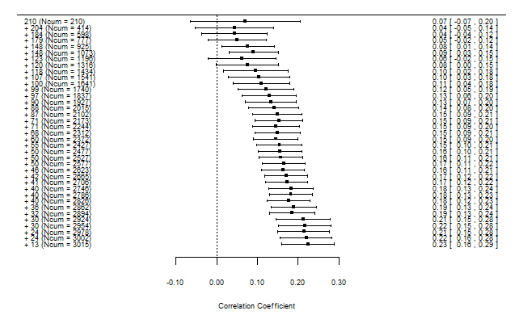 | 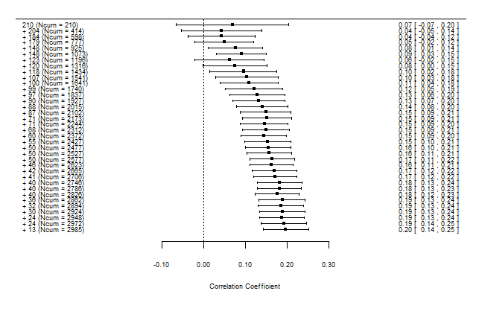
A1 (c)  All experiments (w/o 2 s) (k=36) | A1 (d)  All experiments (w/o 2 s), without identified outliers (k=35)
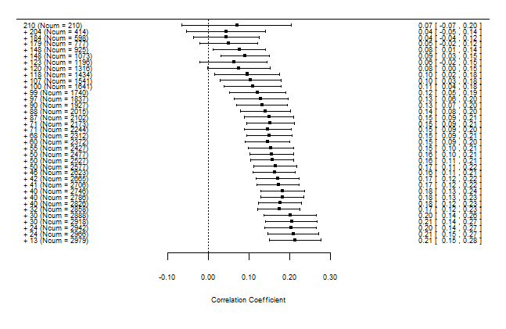 | 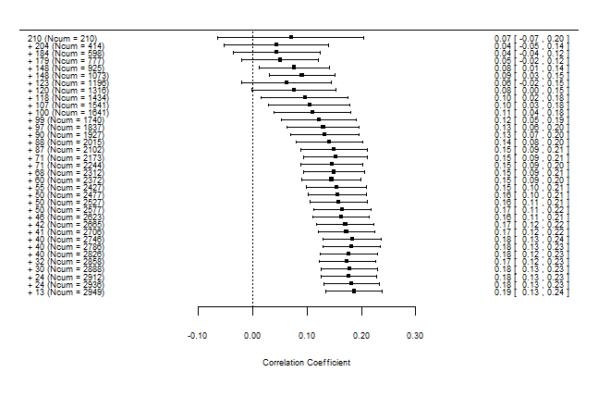
A1 (e)  Best experiments (k=21) | A1 (f)  Best experiments, without identified outliers (k=20)
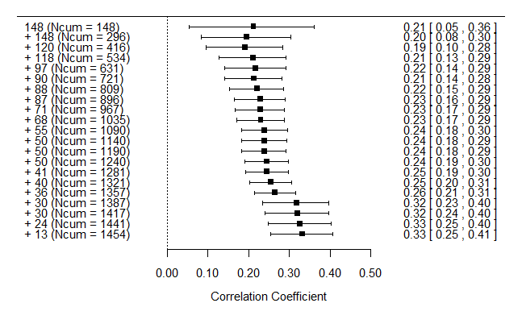 | 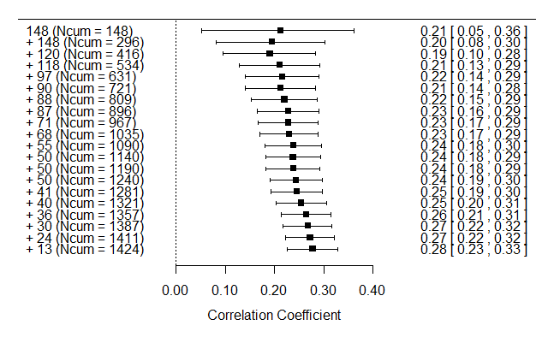
A1 (g)  Best experiments (w/o 2 s) (k=20) | A1 (h)  Best experiments (w/o 2 s), without identified outliers (k=19)
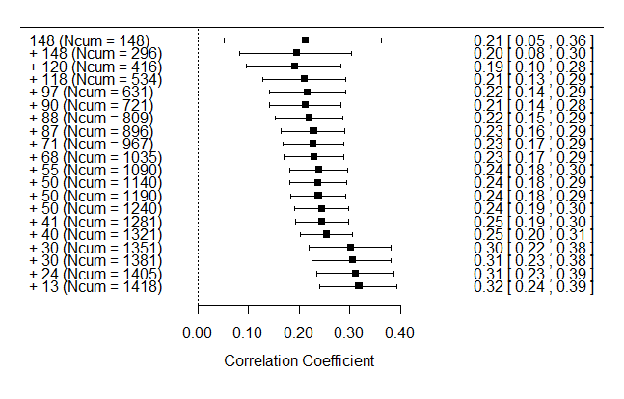 | 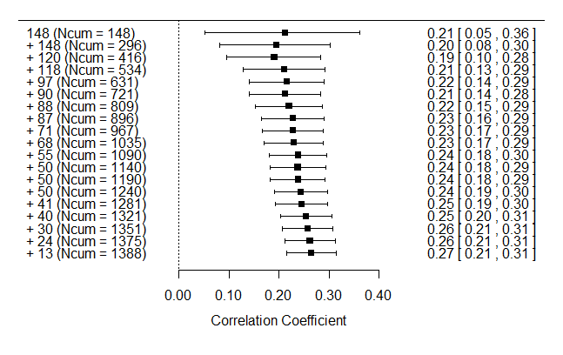
Note. To obtain the plots, the effect sizes were sorted from most precise to least precise (i.e., the samples were sorted from largest to smallest sample size) and entered into the meta-analysis one at a time in an iterative manner. The lines around the plotted means are the 95% confidence intervals for the meta-analytic means. The numbers on the left of each forest plot represent the sample size added at each stage of the cumulative meta-analysis. The corresponding cumulative sample size is presented in parentheses. The numbers on the right of each forest plot represent the weighted mean correlation following each iteration and its corresponding confidence interval. A drift from smaller to larger cumulative meta-analytic means are consistent with an inference of statistically insignificant correlations from smaller sample size studies being suppressed (i.e., publication bias); w/o 2 s: without the two studies excluded by Hilgard et al. (2017).

Figure A2. Aggressive cognition: Forest plots for the cumulative meta-analyses by precision

A2 (a)  All experiments (k=48) | A2 (b)  All experiments, without identified outliers (k=46)
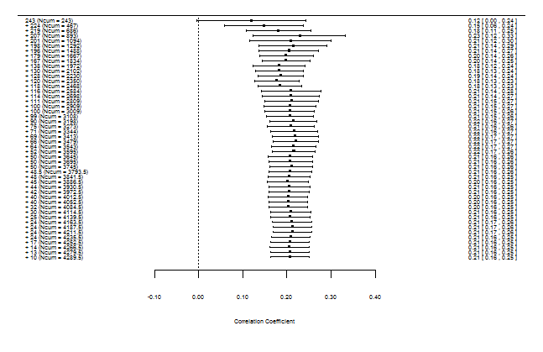 | 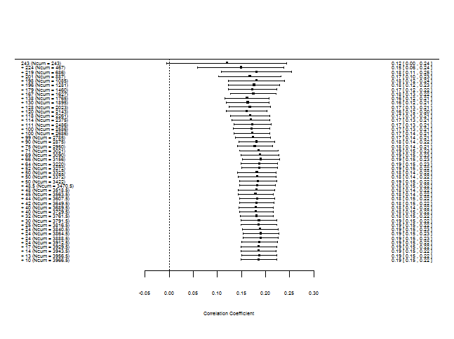
A2 (c)  All experiments (w/o 2 s) (k=47) | A2 (d)  All experiments (w/o 2 s), without identified outliers (k=46)
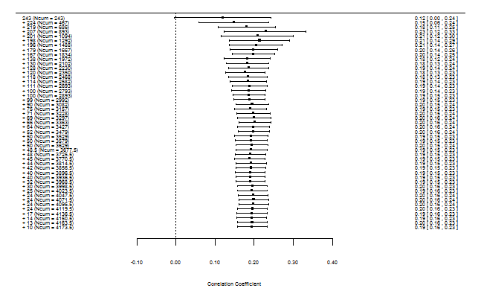
A2 (e)  Best experiments (k=24) | A2 (f)  Best experiments, without identified outliers (k=24)
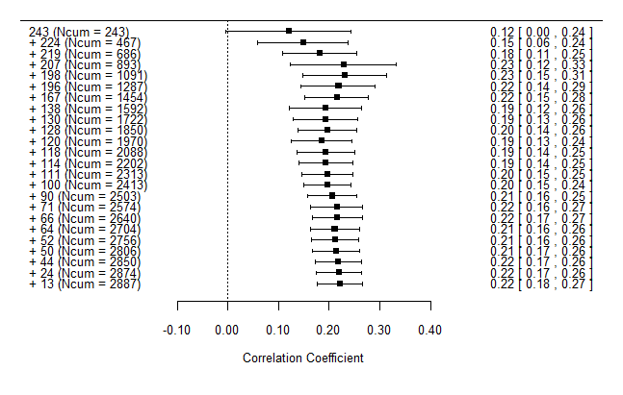 | (no outlier[s] identified)
A2 (g)  Best experiments (w/o 2 s) (k=24) | A2 (h)  Best experiments (w/o 2 s), without identified outliers (k=24)
(same results as with the two deleted studies) | (no outlier[s] identified)

Note. To obtain the plots, the effect sizes were sorted from most precise to least precise (i.e., the samples were sorted from largest to smallest sample size) and entered into the meta-analysis one at a time in an iterative manner. The lines around the plotted means are the 95% confidence intervals for the meta-analytic means. The numbers on the left of each forest plot represent the sample size added at each stage of the cumulative meta-analysis. The corresponding cumulative sample size is presented in parentheses. The numbers on the right of each forest plot represent the weighted mean correlation following each iteration and its corresponding confidence interval. A drift from smaller to larger cumulative meta-analytic means are consistent with an inference of statistically insignificant correlations from smaller sample size studies being suppressed (i.e., publication bias); w/o 2 s: without the two studies excluded by Hilgard et al. (2017).

Figure A3. Aggressive behavior: Forest plots for the cumulative meta-analyses by precision

A3 (a)  All experiments (k=45) | A3 (b)  All experiments, without identified outliers (k=43)
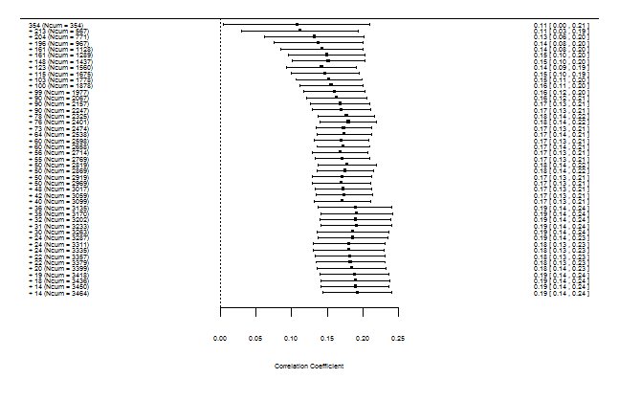 | 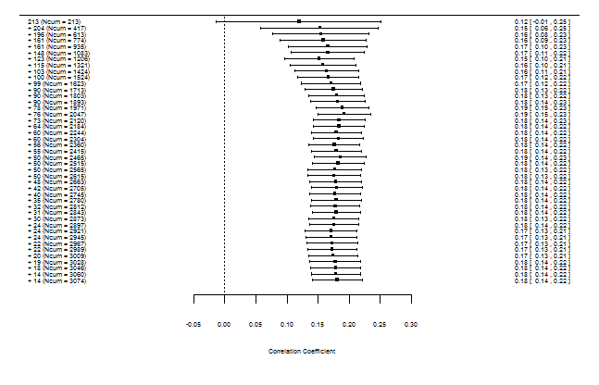
A3 (c)  All experiments (w/o 2 s) (k=44) | A3 (d)  All experiments (w/o 2 s), without identified outliers (k=43)
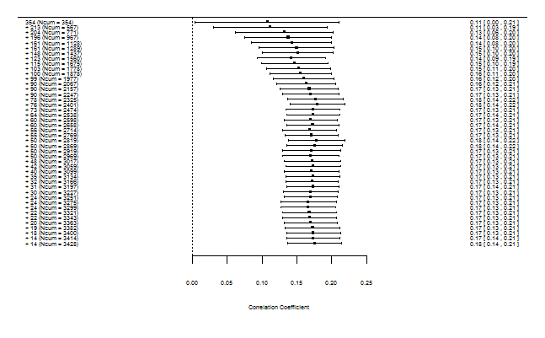 | (same results as with the two deleted studies)
A3 (e)  Best experiments (k=27) | A3 (f)  Best experiments, without identified outliers (k=26)
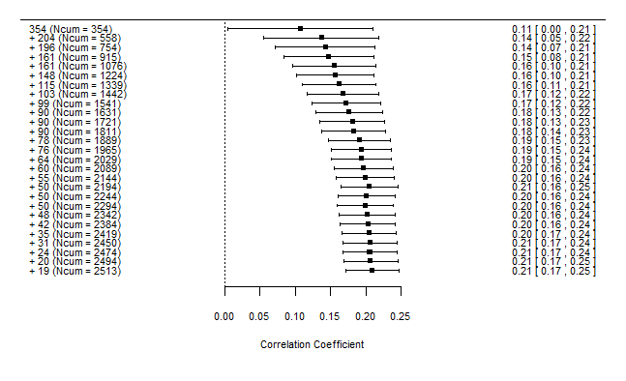 | 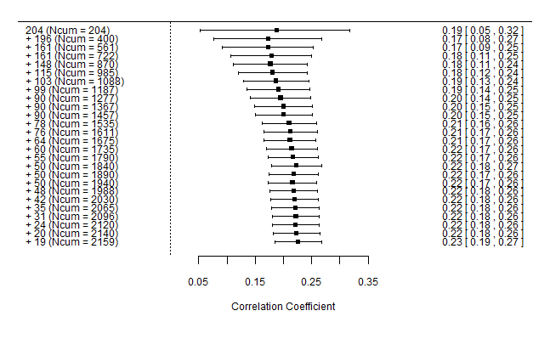
A3 (g)  Best experiments (w/o 2 s) (k=27) | A3 (h)  Best experiments (w/o 2 s), without identified outliers (k=26)
(same results as with the two deleted studies) | (same results as with the two deleted studies)

Note. To obtain the plots, the effect sizes were sorted from most precise to least precise (i.e., the samples were sorted from largest to smallest sample size) and entered into the meta-analysis one at a time in an iterative manner. The lines around the plotted means are the 95% confidence intervals for the meta-analytic means. The numbers on the left of each forest plot represent the sample size added at each stage of the cumulative meta-analysis. The corresponding cumulative sample size is presented in parentheses. The numbers on the right of each forest plot represent the weighted mean correlation following each iteration and its corresponding confidence interval. A drift from smaller to larger cumulative meta-analytic means are consistent with an inference of statistically insignificant correlations from smaller sample size studies being suppressed (i.e., publication bias); w/o 2 s: without the two studies excluded by Hilgard et al. (2017).

Figure A4. Physiological arousal: Forest plots for the cumulative meta-analyses by precision

A4 (a)  All experiments (k=29) | A4 (b)  All experiments, without identified outliers (k=28)
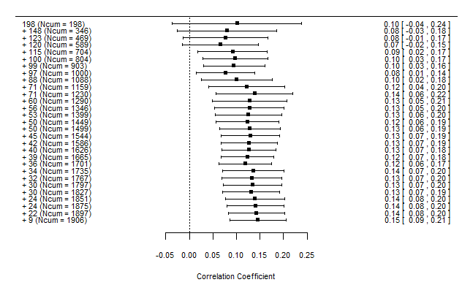 | 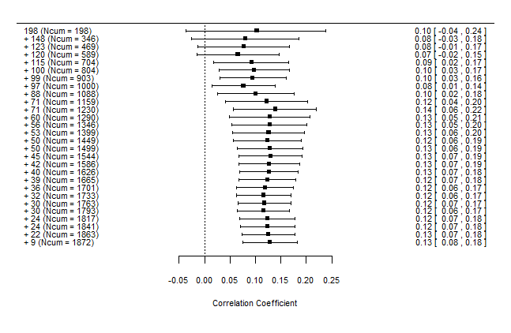
A4 (c)  All experiments (w/o 2 s) (k=28) | A4 (d)  All experiments (w/o 2 s), without identified outliers (k=27)
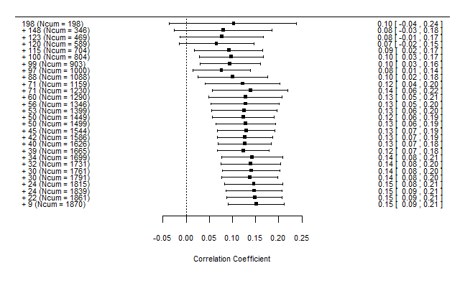 | 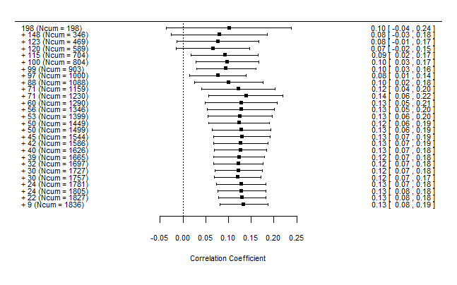
A4 (e)  Best experiments (k=15) | A4 (f)  Best experiments, without identified outliers (k=15)
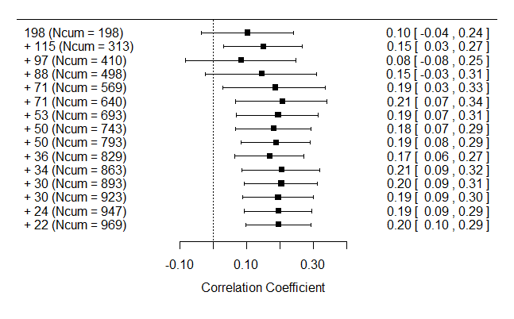 | (no outlier[s] identified)
A4 (g)  Best experiments (w/o 2 s) (k=14) | A4 (h)  Best experiments (w/o 2 s), without identified outliers (k=20)
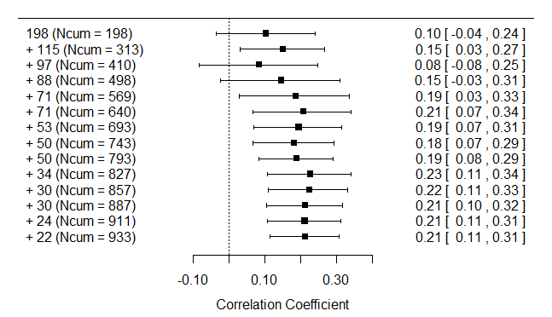 | (no outlier[s] identified)

Note. To obtain the plots, the effect sizes were sorted from most precise to least precise (i.e., the samples were sorted from largest to smallest sample size) and entered into the meta-analysis one at a time in an iterative manner. The lines around the plotted means are the 95% confidence intervals for the meta-analytic means. The numbers on the left of each forest plot represent the sample size added at each stage of the cumulative meta-analysis. The corresponding cumulative sample size is presented in parentheses. The numbers on the right of each forest plot represent the weighted mean correlation following each iteration and its corresponding confidence interval. A drift from smaller to larger cumulative meta-analytic means are consistent with an inference of statistically insignificant correlations from smaller sample size studies being suppressed (i.e., publication bias); w/o 2 s: without the two studies excluded by Hilgard et al. (2017).

