SUPPLEMENTAL MATERIAL

Age-Related Reversals in the Neural Support of Emotional Memory Vividness: New Evidence for Preparatory Prefrontal Activity During Memory Search

Leonard Faul¹, Samantha E. Williams², R. Gerald Monkman³, Brianna D. Lenza⁴, Cortney L. Flory⁵, Sandry Garcia¹, Elizabeth A. Kensinger¹, Jaclyn H. Ford¹
¹ Department of Psychology and Neuroscience, Boston College, Chestnut Hill, MA, USA
² Resource Systems Group, White River Junction, VT, USA
³ Department of Psychology, University of Oregon, Eugene, OR, USA
⁴ Department of Psychiatry, Massachusetts General Hospital, Charlestown, MA, USA
⁵ Cognitive Neuroscience Program, Florida International University, Miami, FL, USA

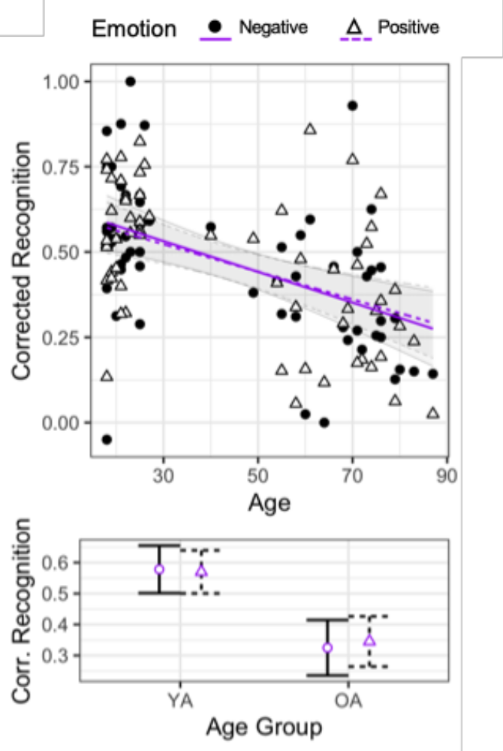
Figure S1. Corrected recognition (hit rate – false alarm rate) as a function of age and emotion. Linear regression lines are derived from the ANCOVA model. The top plot represents the continuous effect of age, while the bottom plot represents the group effects for younger (18-27) and older (60-87) adults. Error bars represents 95% confidence intervals.
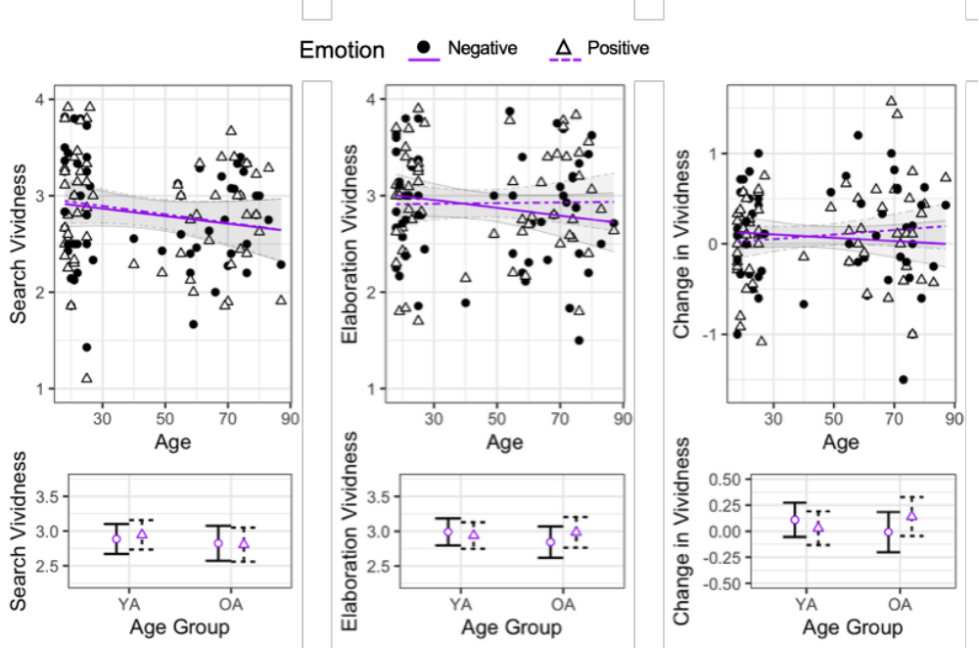
Figure S2. Average search vividness, elaboration vividness, and change in vividness ratings as a function of age and emotion. Note that linear regression lines are derived from the mixed-effects regression model, which was tested on trial-level data. The top plots represent the continuous effect of age, while the bottom plots represent the group effects for younger (18-27) and older (60-87) adults. Error bars represents 95% confidence intervals.

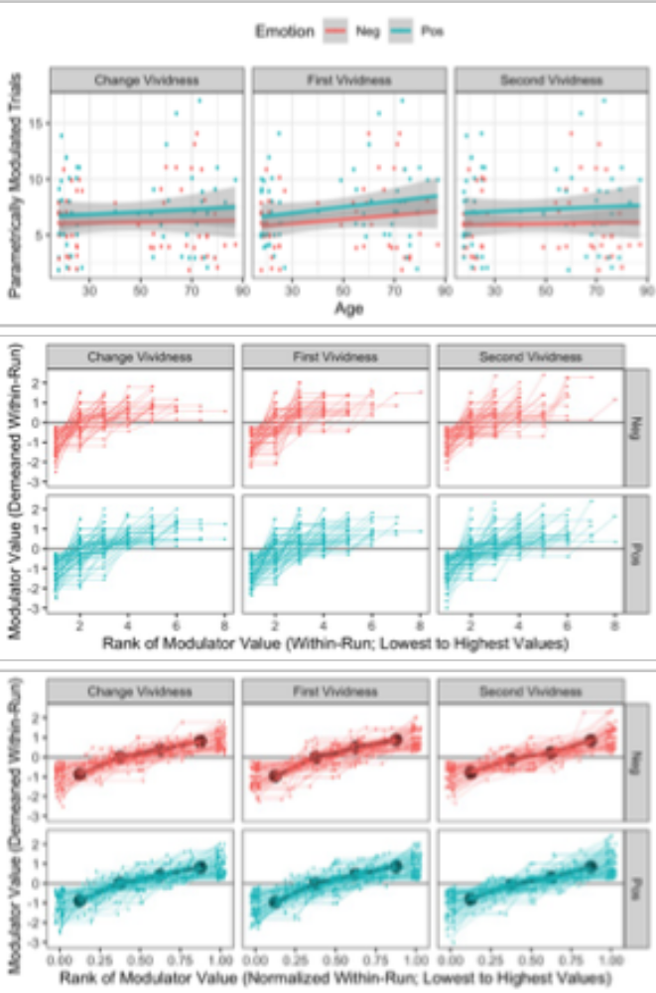
Figure S3. Top: Number of parametrically modulated trials as a function of age and emotion. No significant effects were observed (all ps > .05). Middle: Mean-centered modulator values, ordered from lowest to highest. Bottom: Mean-centered modulator values, ordered so that the lowest modulator is placed at 0 and the highest modulator at 1, with all other modulators proportionally spaced in-between. The black line depicts the average progression of modulator values within a run.
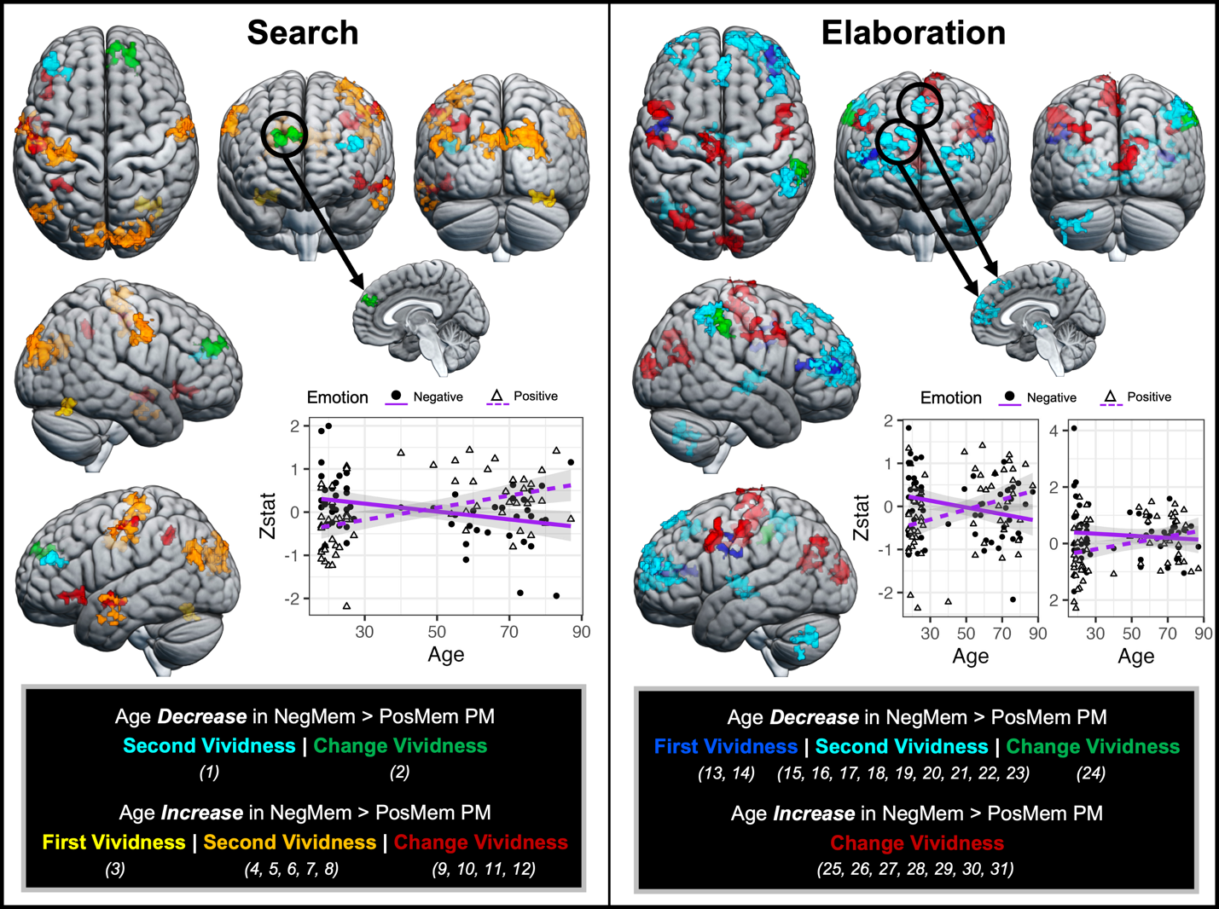
Figure S4. A depiction of Figure 1 without cluster numbers overlaid on brain images.

Table S1.
Additional clusters revealed by a group comparison (younger adults versus older adults) for the parametric modulation analyses.
Region | Hemi | x | y | z | Z | Cluster Size
Search: Age Decrease in Neg > Pos
Change Vividness
Angular Gyrus | R | 60.4 | -51.4 | 27.7 | 3.83 | 201
Search: Age Increase in Neg > Pos
Change Vividness
Middle Frontal Gyrus | L | -56.8 | 9.9 | 40.3 | 3.94 | 157
Elaboration: Age Increase in Neg > Pos
Second Vividness
Posterior Cingulate Cortex | L | -4.55 | -53.2 | 11.5 | 3.6 | 194

