Table S1
Mean post-mortem liver tissue n-3 and n-6 PUFA content.
Note. Significantly increased levels of GLA in deficient animals (p=0.0161). SEM values expressed in parentheses. ^ = all animals at lower limit of quantification (LLOQ). (adequate n=5 female, 3 male; deficient n= 4 female, 2 male; supplemented n= 5 female, 2 male)

Liver  μg/mL | DGLA | GLA | LA | AA | EPA | DHA | DPA | ALA
Adequate | 4.9 (1.16) | 2.0 (0.00)^ | 46.0 (8.97) | 59.9 (12.89) | 2.9 (0.76) | 25.5 (10.16) | 5.8 (0.82) | 2.1 (0.13)
Deficient | 3.0 (0.00)^ | 3.1 (0.53) | 40.3 (6.71) | 71.8 (11.52) | 2.0 (0.00)^ | 5.0 (0.00)^ | 5.0 (0.00)^ | 2.0 (0.00)^
Supplemented | 4.1 (0.37)^ | 2.0 (0.00)^ | 54.8 (12.80) | 64.1 (7.88) | 3.0 (0.00)^ | 24.0 (2.69) | 5.0 (0.00)^ | 2.0 (0.00)^

Figure S1
Stage III PPT seek and take action latencies
Note. (A) Supplemented subjects were faster to execute the risky action in risk blocks than adequate subjects. (B) No significant differences in take action latency (when not preceded by footshock) were seen between diets across blocks. ⁺p< .05 adequate vs supplemented, #p< .05 deficient vs supplemented.
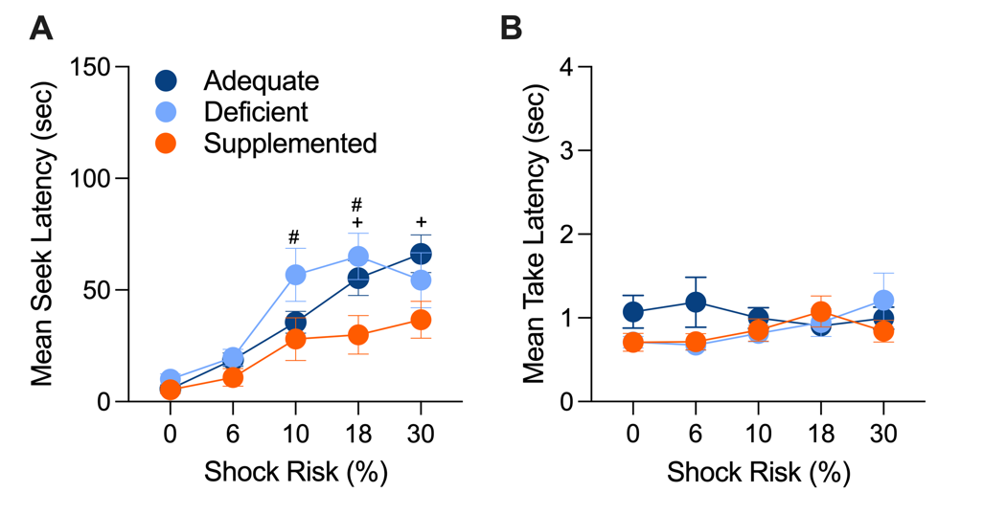

Figure S2
Stage III PPT take action latencies for trials preceded by footshock (i.e. trials were the seek action was punished)
Note. (A) No overall differences between diets were seen take action latency when preceded by footshock. (B) Female take action latencies following punishment of the seek action. No differences between diets were observed. (C) Male take latencies following punished seek action. No differences between diets were observed.
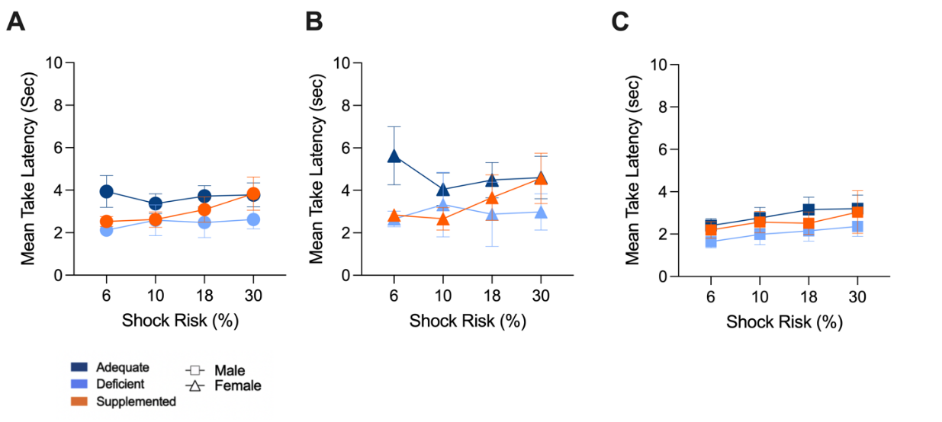

Figure S3
Microglial analysis split by sex across brain regions
Note. (A-E) No significant effect of diet across brain regions in female rats. (F-J) Dietary deficiency significantly affected male microglial morphology in the BLA (post hoc p= .0227) and SN (post hoc p=0.0205). In the DS, supplemented males had the highest total process length (post hoc p=0.0429). * p< 0.05. Only p values <0.2 are displayed on the graph.

