Supplemental Materials
Methods and Materials
Participants
Participants were excluded if they reported a history of seizures or neurological illness (unrelated to head injuries), a current diagnosis of schizophrenia spectrum or other psychotic disorders (unrelated to PTSD), a current diagnosis of bipolar or related disorder (unrelated to PTSD), had an unstable psychological diagnosis that would interfere with accurate data collection (as determined by consensus of two doctorate-level psychologists), active suicidal or homicidal ideation, a cognitive disorder due to a general medical condition other than traumatic brain injury (TBI), moderate or severe TBI, or if they were unable to undergo MRI due to ferromagnetic objects or pregnancy. Individuals were further excluded if they were missing psychiatric assessment data or if they failed the Medical Symptom Validity Test (MVST, Green, 2004; i.e., < 85 on immediate recall, delayed recall, or consistency), a sensitive and specific standalone effort measure (Clark et al., 2014).
Clinical and Cognitive Assessments
Military-related trauma exposure was measured with the Deployment Risk and Resilience Inventory (DRRI) Section I-Combat Experiences (King et al., 2006) during the time 1 session. The DRRI is a self-report questionnaire that measures experiences before, during, and after military deployment. The combat experiences component measures exposure to combat-related circumstances (e.g., firing a weapon, being fired on, etc.).
Treatment was defined as psychotropic medication management with at least one prescription refill and/or repeated psychotherapy sessions. Treatment (psychotherapy and medication management) was assessed based on participants’ clinical notes reported during the clinician-administered assessments of the data collection procedures at time 2. In addition, psychotropic medication management was further assessed using participants’ VA medical records dated after the time 1 assessment.
Statistical Analyses
To determine whether significant hippocampal subfield findings were better accounted for by other variables, several time 2 analyses were performed. First, to further test for regression to the mean effects, we ran time 2 analyses in which time 1 CAPS was added as a covariate to the first step of the model (along with age, sex, scanner, and eTIV) followed by the main effect of the CAPS residuals in the second step for whole hippocampal volume as well as each hippocampal subfield that showed a corrected-significant association with the CAPS residuals in the original model.
Next, for the whole hippocampal volume and each hippocampal subfield that showed a corrected-significant association with the CAPS residuals, additional regressions were conducted in which trauma exposure (as defined by combat exposure, n=243), treatment history (yes/no, n=74), or days between assessments (n=252) were included in the first step of the model along with age, sex, scanner, and eTIV.
The residual calculation of PTSD symptom severity changes of symptom clusters (re-experiencing, hyperarousal, and avoidance/numbing) involved subtracting the time 1 CAPS symptom clusters from the CAPS symptom clusters given at the time 2 time point. The residual calculation involved regressing the time 1 PTSD symptom severity (intensity and frequency) clusters onto the time 2 PTSD symptom severity (intensity and frequency) clusters and extracting the residuals.
Supplementary Results
Smaller Whole Hippocampal Volume is Associated with Greater Time 1 PTSD
To determine whether the association between PTSD and whole hippocampal volume remained when we examined PTSD diagnosis, we examined the association between Time 1 PTSD diagnosis and whole hippocampal volume (controlling for age, sex, scanner, and eTIV). There was no significant association between PTSD diagnosis at Time 1 and whole hippocampal volume (β=-0.06, p=0.225). There were no significant associations between time 1 PTSD diagnosis and hippocampal subfield ROIs (p-values>0.210).
Greater Hippocampal Volume is Associated with Less PTSD Symptom Improvement Over Time Regardless of Lateralization
To determine if there were any lateralizations in the findings between the CAPS residuals and Time 1 hippocampal subfield volumes, we conducted a Time 2 analysis that included left and right CA1-body volumes instead of bilateral estimates. Results revealed significant positive associations with the CAPS residuals and the left CA1-body volumes at Time 1 (β=0.25, p<0.001), Time 2 (β=0.24, p<0.001), and the average across timepoints (β=0.24, p<0.001). The association between the CAPS residuals and the right CA1-body were also significant at Time 1(β=0.23, p<0.001), Time 2 (β=0.23, p=0.001), and the average across timepoints (β=0.23, p<0.001).
We similarly repeated lateralization analyses of the CA2/3-body. Results revealed numerical positive associations between the left CA2/3-body and CAPS residuals at Time 1 (β=0.12, p=0.051) and the average across timepoints (β=0.14, p=0.046), though was only numerical at Time 2 (β=0.12, p=0.077). The association between the CAPS residuals and the right CA2/3-body were also significant in the average across timepoints (β=0.16, p=0.00=20), though only numerical at Time 1 (β=0.11, p=0.088) and Time 2 (β=0.13, p=0.061).
Ruling Out Alternative Explanations: Trauma Exposure, Treatment History, Days Between Assessments, Time Since Deployment, and Returning Sample Bias
Next, to determine if combat exposure accounted for the association between the CAPS residuals and whole hippocampal volume or bilateral CA1-body and CA2/3-body volumes, we ran time 2 hierarchical linear regressions in which combat trauma exposure was included as an additional covariate along with age, sex, scanner, and eTIV (n=242). The pattern of results was similarly non-significant for whole hippocampal volume (β=0.06, p=0.247), and did not change for bilateral CA1-body (β=0.15, p=0.017), or CA2/3-body (β=0.13, p=0.035) volumes at Time 1 when trauma exposure was included in the model.
Similarly, to determine if treatment had any effect on the association between the CAPS residuals and whole hippocampal volume or bilateral CA2/3-body and molecular layer HP-body volumes, we included treatment history (yes/no) as an additional covariate along with age, sex, scanner, and eTIV in a greatly reduced sample (n=73). Again, the pattern of results for the association between the CAPS residuals and bilateral CA1-body (β=0.27, p=0.022) at Time 1 and was numerically consistent in CA2/3-body at Time 1 (β=0.21, p=0.075), and whole hippocampal volume at Time 1 remained non-significant when treatment was included in the model (β=0.04, p=0.721).
Next, we included days between assessment as an additional covariate in the model (along with age, sex, scanner, and eTIV). The pattern of results did not change for the association between the CAPS residuals and bilateral CA1-body (β=0.16, p=0.009), or CA2/3-body (β=0.13, p=0.036) volumes at Time 1, and the whole hippocampal volume at Time 1 remained non-significant (β=0.07, p=0.199) when time since deployment was included in the model.
When we included time since deployment as an additional covariate in the model (along with age, sex, scanner, and eTIV), the pattern of results did not change for the association between the CAPS residuals and whole hippocampal (β=0.07, p=0.199), bilateral CA1-body (β=0.16, p=0.009), or bilateral CA2/3-body (β=0.17, p=0.016) volumes at Time 1.
When controlling for age, sex, scanner, and eTIV, but not CAPS residuals, there were no significant main effects of trauma exposure on whole hippocampal (β=-0.04, p=0.498) and CA2/3-body (β=-0.11, p=0.097) volume at Time 1, treatment on whole hippocampal (β=.08, p=0.426), bilateral CA1-body (β=0.18, p=0.122) and bilateral CA2/3-body (β=-0.01, p=0.954) volumes at Time 1, days between assessment on whole hippocampal (β=-0.06, p=0.282), bilateral CA1-body (β=-0.04, p=0.508) and bilateral CA2/3-body (β=-0.06, p=0.318) volumes at Time 1, or time since deployment on whole hippocampal (β=-0.02, p=0.739), bilateral CA1-body (β=-0.02, p=0.735) and bilateral CA2/3-body (β=-0.03, p=0.614) volumes at Time 1. There was a nominally significant main effect of trauma exposure on the bilateral CA1-body volume (β=-0.12, p=0.059) volume at Time 1.
Finally, in order to rule out whether examining data from the current sample introduced a sampling bias (i.e., by only sampling veterans who returned within 5-years), we compared demographic/clinical characteristics between the current sample of those who did return for Time 2 (64%) and a reduced sample of those from the original TRACTS cohort who did not return after >5 years (36%). Notably, the two samples had very similar demographics (see Supplementary Table S4), with the only significant difference being that the original cohort had been deployed more recently (M=14.62) compared to the current sample (M=39.40, t=7.97, p<.001). However, this was previously controlled for and found to be unrelated to the study’s main findings. In addition, this difference was expected given that the original cohort sample excludes those who had < 5 years to return.
Analysis of the Association Between Hippocampal Subfields and Changes in PTSD Symptoms Clusters
Based on our ROIs, we observed that, in addition to CA1-body, greater CA1-head was associated with greater avoidance/numbing symptom residuals (β=0.23, p<0.001) as well as reduced hyperarousal symptom residuals (β=-0.18, p=0.008).
In exploratory analyses, we also found that several other hippocampal subfields positively correlated with changes in avoidance/numbing symptom residuals, including volumes of the bilateral CA4-head (β=0.21, p=0.002, q=.026), molecular layer HP-head (β=0.24, p<0.001, q=.017) and molecular layer HP-body (β=0.24, p<0.001, q=.018). To check for robustness, we examined if the association between avoidance/numbing symptom residuals and the same hippocampal subfields remained significant at time 2 and the average volume across timepoints. Every subfield region replicated using Time 2 volumes; however, only CA4-head replicated using the average of Time 1 and Time 2 volumes. There were no corrected significant associations between re-experiencing or hyperarousal changes and hippocampal subfields (see Table S2).
Analysis of the Association Between Verbal Memory and Hippocampal Subfield Volumes
When we examined whether there were associations between bilateral CA1-body at time 1 with CVLT-II total learning trials at time 1 and changes in CVLT scores (β=-.01, .00; p-values=.847, .944, respectively), long delay free recall (β=-.05, .08; p-values =.466, .239, respectively), short delay free recall (β=-.03, .07; p-values=.645, .276, respectively), or recognition hits (β=-.04, .04; p-values=.504, .527, respectively).
Similarly, we found no associations between bilateral CA2/3-body with CVLT-II total learning trials at time 1 and changes in CVLT scores (β=-.03, .07; p-values =.644, .286, respectively), long delay free recall (β=-.08, .11; p-values=.217, .203 respectively), short delay free recall (β=-.03, .12; p-values=.623, .056, respectively), or recognition hits (β=-.07, .08; p-values=.296, .210, respectively).
Supplementary Figure S1
Hippocampal Volume by Time 1 CAPS Symptoms
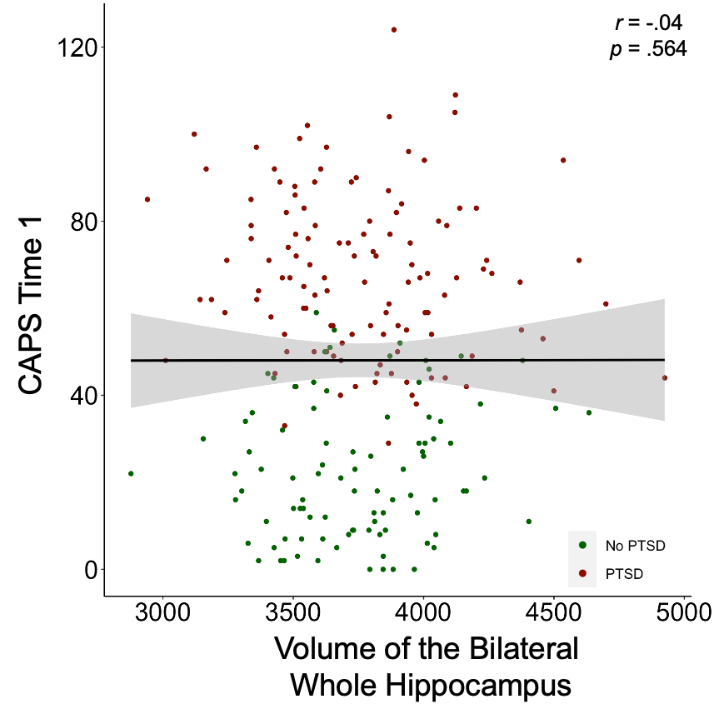

Supplementary Table S1.
Time 1 – Time 2 Volumetric Subfield Associations
Variable | r | p
Whole Hippocampus | 0.99 | <.001
Parasubiculum | 0.97 | <.001
Presubiculum-head | 0.96 | <.001
Presubiculum-body | 0.97 | <.001
Subiculum-head | 0.98 | <.001
Subiculum-body | 0.97 | <.001
CA1-head | 0.99 | <.001
CA1-body | 0.97 | <.001
CA2/3-head | 0.95 | <.001
CA2/3-body | 0.98 | <.001
CA4-head | 0.98 | <.001
CA4-body | 0.94 | <.001
GC-ML-DG-head | 0.98 | <.001
GC-ML-DG-body | 0.93 | <.001
Molecular layer HP-head | 0.99 | <.001
Molecular layer HP-body | 0.97 | <.001
HATA | 0.97 | <.001
Fimbria | 0.95 | <.001
Hippocampal tail | 0.98 | <.001
Hippocampal fissure | 0.81 | <.001

Supplemental Table S2. Bilateral Hippocampal Subfield Volume Associations with CAPS Residuals

Variable | Mean (SD) | B | β | r | P | q
Parasubiculum | 70.60 (11.13) | 0.02 | 0.03 | 0.04 | 0.549 | 0.595
Presubiculum-head | 147.36 (16.35) | 0.03 | 0.04 | 0.04 | 0.490 | 0.595
Presubiculum-body | 175.33 (27.15) | 0.06 | 0.04 | 0.05 | 0.440 | 0.595
Subiculum-head | 199.47 (27.84) | 0.05 | 0.04 | 0.04 | 0.544 | 0.595
Subiculum-body | 263.51 (30.40) | 0.11 | 0.07 | 0.08 | 0.214 | 0.590
CA1-head | 568.74 (66.97) | 0.1 | 0.03 | 0.03 | 0.605 | -
CA1-body | 136.65 (20.41) | 0.09 | 0.10 | 0.12 | 0.009 | -
CA2/3-head | 127.05 (18.06) | 0.11 | 0.12 | 0.13 | 0.062 | -
CA2/3-body | 93.41 (16.70) | 0.10 | 0.13 | 0.13 | 0.039 | -
CA4-head | 138.40 (15.94) | 0.05 | 0.06 | 0.07 | 0.291 | 0.595
CA4-body | 128.21 (13.68) | 0.05 | 0.07 | 0.08 | 0.227 | 0.590
GC-ML-DG-head | 166.94 (19.57) | 0.05 | 0.05 | 0.06 | 0.327 | -
GC-ML-DG-body | 144.67 (14.84) | 0.04 | 0.05 | 0.06 | 0.333 | -
Molecular layer HP-head | 359.20 (39.69) | 0.09 | 0.04 | 0.05 | 0.404 | 0.595
Molecular layer HP-body | 248.73 (24.81) | 0.16 | 0.13 | 0.14 | 0.024 | 0.312
HATA | 66.82 (8.91) | 0.02 | 0.04 | 0.05 | 0.464 | 0.595
Fimbria | 85.78 (17.35) | -0.06 | -0.07 | -0.08 | 0.226 | 0.590
Hippocampal tail | 620.12 (70.27) | 0.04 | 0.01 | 0.01 | 0.845 | 0.845
Hippocampal fissure | 158.27 (21.43) | 0.10 | 0.10 | 0.10 | 0.127 | 0.350
Note: ª=survived multiple testing correction, p < 0.05. Subfields were averaged across hemispheres to
generate bilateral estimates. FDR corrections across all 19 test were performed to correct for multiple comparisons. β represents the unstandardized betas. r indicates partial Pearson correlations. Age, sex, total estimated intracranial volume (eTIV), and scanner were included in the model as covariates. CA=Cornu Ammonis; GC-ML-DG=granule cell and molecular layer of the dentate gyrus; HATA=hippocampal amygdala transition area; HP=hippocampus.

Supplemental Table S3.
Bilateral Hippocampal Subfield Volume Associations with PTSD Symptom Severity Changes in Symptom Clusters.
 | Re-experiencing |  |  | Avoidance/Numbing |  |  | Hyperarousal
Variable | β | p | q | β | p | q | β | p | q
Parasubiculum | -0.11 | 0.304 | 0.474 | -0.01 | 0.952 | 0.952 | 0.16 | 0.150 | 0.344
Presubiculum-head | -0.08 | 0.253 | 0.449 | 0.13 | 0.060 | 0.213 | -0.04 | 0.571 | 0.742
Presubiculum-body | -0.12 | 0.073 | 0.237 | 0.09 | 0.194 | 0.420 | 0.05 | 0.450 | 0.657
Subiculum-head | -0.08 | 0.249 | 0.449 | 0.21 | 0.006 | 0.059 | -0.11 | 0.143 | 0.344
Subiculum-body | -0.08 | 0.265 | 0.449 | 0.15 | 0.032 | 0.139 | -0.02 | 0.734 | 0.848
CA1-head | -0.05 | 0.478 | - | 0.23 | <.001 | - | -0.18 | 0.008 | -
CA1-body | 0.03 | 0.737 | - | 0.29 | <.001 | - | -0.14 | 0.064 | -
CA2/3-head | 0.09 | 0.171 | - | 0.18 | 0.011 | - | -0.15 | 0.028 | -
CA2/3-body | 0.11 | 0.137 | - | 0.15 | 0.056 | - | -.12 | 0.142 | -
CA4-head | 0.01 | 0.826 | 0.848 | 0.21 | 0.002 | 0.026 | -0.17 | 0.010 | 0.065
CA4-body | -0.02 | 0.731 | 0.848 | 0.17 | 0.019 | 0.093 | -0.10 | 0.227 | 0.443
GC-ML-DG-head | 0.02 | 0.815 | - | 0.20 | 0.003 | - | -0.17 | 0.011 | -
GC-ML-DG-body | -0.07 | 0.302 | - | 0.17 | 0.017 | - | -0.06 | 0.360 | -
Molecular layer HP-head | -0.04 | 0.567 | 0.742 | 0.24 | <.001 | 0.017 | -0.18 | 0.009 | 0.065
Molecular layer HP-body | -0.03 | 0.612 | 0.770 | 0.24 | <.001 | 0.018 | -0.09 | 0.222 | 0.443
HATA | 0.02 | 0.767 | 0.848 | 0.02 | 0.818 | 0.848 | -0.11 | 0.125 | 0.325
Fimbria | -0.12 | 0.080 | 0.240 | -0.02 | 0.763 | 0.848 | 0.05 | 0.518 | 0.722
Hippocampal tail | -0.12 | 0.095 | 0.265 | 0.18 | 0.017 | 0.093 | -0.08 | 0.292 | 0.474
Hippocampal fissure | 0.02 | 0.796 | 0.848 | 0.16 | 0.049 | 0.191 | -0.06 | 0.455 | 0.657

Note: grayed background=survived multiple testing correction, p < 0.05. Subfields were averaged across hemispheres to generate bilateral estimates. FDR corrections across all 57 tests was performed to correct for multiple comparisons. All three PTSD symptom clusters (re-experiencing, avoidance/numbing, and hyperarousal) were included in the same model and were the residuals between time 1 and time 2. β represents the unstandardized betas. r indicates partial Pearson correlations. Age, sex, total estimated intracranial volume (eTIV), and scanner were included in the model as covariates. CA=Cornu Ammonis; GC-ML-DG=granule cell and molecular layer of the dentate gyrus; HATA=hippocampal amygdala transition area; HP=hippocampus.

Supplemental Table S4. Demographic and Clinical Characteristics
Variable | Total Sample (n=252) | TRACTS no returns after 5 years (n=140) | t | p
Age, M (SD) | 32.75 (8.49) | 31.93 (8.38) | 0.921 | 0.358
Sex
Males, n (%) | 227 (90) | 129 (92) | 0.32 | 0.746
Females, n (%) | 25 (10) | 11 (8)
Months since deployment, M (SD) ª | 39.40 (36.10) | 14.62 (9.30) | 7.97 | <.001
Military mTBI (yes), n (%) | 110 (44) | 59 (42) | 0.38 | 0.705
Lifetime mTBI (yes), n (%) | 163 (65) | 96 (69) | 0.47 | 0.640
PTSD diagnosis Time 1 (yes), n (%) | 146 (58) | 85 (61) | 0.57 | 0.567
CAPS Time 1, M (SD) | 48.34 (28.19) | 51.81 (29.89) | 1.14 | 0.254
DASS depression Time 1, M (SD) | 8.37 (9.56) | 8.47 (9.59) | 0.09 | 0.929
DASS anxiety Time 1, M (SD) | 6.24 (7.54) | 7.05 (7.43) | 1.02 | 0.306
Trauma exposure (DRRI-combat), M (SD)^{b} | 16.54 (11.86) | 17.35 (11.61) | 0.65 | 0.514
Note: CAPS=Clinician-Administered PTSD Scale; DRRI=Deployment Risk and Resiliency Inventory; eTIV=estimated total intracranial volume; mTBI=mild traumatic brain injury
References
Hinton-Bayre, A. D. (2016). Clarifying discrepancies in responsiveness between reliable change indices. Archives of Clinical Neuropsychology, 31(7), 754-768.
McSweeny, A. J., Naugle, R. I., Chelune, G. J., & Lüders, H. (1993). “T scores for change”: An illustration of a regression approach to depicting change in clinical neuropsychology. The Clinical Neuropsychologist, 7(3), 300-312.
Weathers, F. W., Keane, T. M., & Davidson, J. R. (2001). Clinician‐Administered PTSD Scale: A review of the first ten years of research. Depression and Anxiety, 13(3), 132-156.

