Supporting Online Material for:
Title: Child gender influences paternal behavior, language, and brain function

Authors: Jennifer S. Mascaro^{a, b}, Kelly E. Rentscher^{c}, Patrick D. Hackett^{d}, , Matthias R. Mehl^{c}, and James K. Rilling^{b, d, e}*

*To whom correspondence should be addressed. Email: jrilling@emory.edu

Figures S1 – S2

The authors received signed consent to publish the photographs of the child appearing in these figures.

Figure S1: Examples of picture stimuli for each condition.
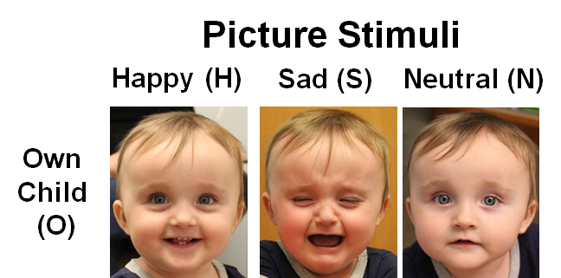

Figure S2: Schematic of Child task
