Online Appendix: Additional Analyses and Results
As mentioned in the paper, we conducted various additional analyses. Some of these analyses were robustness checks using an alternative approach; others were exploratory in nature. To improve the readability of this appendix, we have organized it in the order that these analyses are mentioned in the paper.
Team Size
As 48 studies did not report the average team size, we calculated it based on the information from the respective study (i.e., the number of individuals divided by the number of teams). However, as pointed out by a reviewer, the calculated average team size may be affected by imperfect response rates, which may be especially problematic when response rates are low. Although it is technically feasible to adjust the team size based on the response rate, many studies either did not report the response rate or used divergent operationalizations of response rate. In consequence, it was difficult to impute data based on the response rates. Given this issue, we excluded these 48 studies and reran the meta-regression analyses to assess the robustness of our original findings. Notably, we observed convergent results (Table A1). Therefore, we conclude that this issue did not affect the robustness of our findings.
Meta-Regression Analyses Using Observed Effect Sizes and Coefficient Alpha for Psychometric Corrections
Although we used corrected effect sizes for the meta-regression analyses to maintain consistency with the psychometric meta-analyses, using the observed effect sizes (i.e., no psychometric correction for either team conflict or team performance) in the meta-regression analyses offers important methodological advantages. Notably, correcting for measurement error can potentially obfuscate the interpretability of moderation analyses (Yuan et al., 2020). Specifically, as reliability may be substantively and systematically related to situational moderators (James et al., 1992; Köhler et al., 2015), researchers may inadvertently parse out meaningful variations in effect sizes created by situational moderators in the process of making psychometric corrections (Yuan et al., 2020). In consequence, psychometric corrections may defeat the very purpose of moderation analyses if effect size heterogeneity due to situational moderators is (at least partly) parsed out when the observed correlations are corrected for measurement error. Furthermore, as many studies did not report the ICC(2) values of team conflict dimensions, we had to impute the sample-size weighted mean for these studies. Considering the extent to which ICC(2) values were missing, it is warranted to evaluate the robustness of our findings by using coefficient alpha in the psychometric corrections for team conflict. In light of these important considerations, we reran all of the meta-regression analyses using both the observed effect sizes and the effect size corrected for measurement error based on coefficient alpha.
The results are reported in Tables A2–A4. For the vast majority of the analyses, we did not observe any notable differences. The only difference (see the shaded cells in these tables) pertaining to substantive moderators related to individualism. Specifically, the moderating effect of individualism in the relationship between process conflict and team performance was significant in our supplemental analyses (observed effect sizes: b = .006, t = 3.03, p < .01; corrected effect sizes based on coefficient alpha: b = .007, t = 2.85, p < .01), but nonsignificant in our main analyses (b = .006, t = 1.97, p = .06). However, considering that its significant moderating effect was convergent for both task conflict and relationship conflict in both the supplemental and main analyses, this minor difference did not fundamentally alter our hypothesis testing results regarding individualism. Overall, the convergent findings we observed in supplemental analyses added to the robustness of our substantive conclusions in the paper.
As for the methodological factors, the moderating impact of student team sample was not supported in our main analyses (task conflict: b = .10, t = 1.92, p = .06; relationship conflict: b = .07, t = 1.75, p = .08; process conflict: b = .16, p = 1.88, p = .07). However, it received good support in the supplemental analyses based on the observed effect sizes (task conflict: b = .07, t = 1.98, p = .05; relationship conflict: b = .07, t = 2.21, p = .03; process conflict: b = .13, p = 2.03, p = .05) and the corrected effect sizes using coefficient alpha (task conflict: b = .08, t = 1.98, p = .05; relationship conflict: b = .08, t = 2.32, p = .02; process conflict: b = .17, p = 2.26, p = .03). Although we found a significant difference in the task conflict–team performance relationship between studies that used Behfar et al.’s (2011) scale and those that used Jehn’s (1995) scale in our main analyses (b = .29, t = 2.85, p < .01), this was not the case in the supplemental analyses (observed effect sizes: b = .11, t = 1.55, p = .12; corrected effect sizes based on coefficient alpha: b = .12, t = 1.44, p = .15). Lastly, the moderating effect of cross-sectional design in the relationship between process conflict and team performance was nonsignificant in the main analyses (b = −.16, t = 1.85, p = .07), but significant in the supplemental analyses (observed effect sizes: b = −.14, t = 2.13, p = .04; corrected effect sizes based on coefficient alpha: b = −.16, t = 2.04, p = .05). Considering that the effects of these methodological factors were significant in some of these analyses, we encourage researchers to attend to their potential impact when designing future studies instead of ruling out their influence prematurely.
In light of the extent to which ICC(2) values were missing in the primary studies, we tested this factor [i.e., whether a study reported the ICC(2) value for team conflict] as an additional moderator of the observed team conflict–team performance relationships. Results indicated that this factor had negligible effects for task conflict (b = .00, t = .01, p = .99), process conflict (b = −.01, t = .16, p = .87), and status conflict (b = .11, t = 1.17, p = .26). For relationship conflict, studies that reported ICC(2) had more negative effect sizes (b = −.07, t = 2.18, p = .03) than those that did not. However, when we added this moderator to the simultaneous test, its effect became nonsignificant (b = −.07, t = 1.53, p = .13), suggesting its impact was likely not very robust. Given these results, we conclude that the availability of ICC(2) values from the primary studies should be considered an extraneous factor that did not meaningfully influence the team conflict–team performance relationships.
Lastly, we report the psychometric meta-analysis results based on coefficient alpha for the sake of completeness (see Table A5). Overall, the results based on coefficient alpha were convergent with those in our main analyses reported in the paper, although the effect sizes based on coefficient alpha were slightly weaker (task conflict: ρ = −.07 versus −.09; relationship conflict: ρ = −.23 versus −.28; process conflict: ρ = −.26 versus −.33; status conflict: ρ = −.32 versus −.38). This is most likely because the ICC(2) values were less than coefficient alpha. Furthermore, as different types of reliability estimates parse out different sources of measurement error, this directly affects the inferences that one can draw from psychometric meta-analysis findings (Schmidt & Hunter, 2015). We encourage readers to keep this important point in mind when interpreting findings based on ICC(2) and coefficient alpha, respectively.
Paired Comparison for Task Type and Team Performance Facet
As mentioned in the paper, upon finding a significant omnibus test, we changed the reference group for the set of dummy variables and retested their effects to provide detailed paired comparison analyses across the different categories. These detailed results are reported in Table A6. Furthermore, we report the results of subgroup psychometric meta-analyses for all categorical methodological moderators in Table A7–A9. Figure A1 summarizes the paired comparisons for task type as a moderator.
Intercorrelations Among Conflict Dimensions
We explored the intercorrelations among the team conflict dimensions by conducting another set of psychometric meta-analyses (Table A10). These findings should be considered preliminary, as those studies that included correlations among the conflict dimensions but did not measure team performance were excluded in our search process. Even so, the number of independent samples for these analyses represented a sizeable increase from those identified by de Wit et al. (2012): k = 164 versus 73 for the task conflict–relationship conflict correlation, k = 33 versus 19 for the task conflict–process conflict correlation, and k = 33 versus 18 for the relationship conflict–process conflict correlation. Therefore, analyzing the intercorrelations based on the included studies may offer some useful insights. The average intercorrelations ranged from .49 to .79, suggesting a strong empirical overlap among the conflict dimensions, especially between process conflict and relationship conflict (ρ = .65) and between process conflict and status conflict (ρ = .79). Moreover, the task conflict–relationship conflict (80% CV [.06, 1.00]) and task conflict–process conflict (80% CV [−.09, 1.00]) correlations demonstrated substantial cross-situation heterogeneity.
Moderators of the Task Conflict–Relationship Conflict Relationship
Among the moderators of the task conflict–team performance relationship, one factor that received consistent support in De Dreu and Weingart (2003), de Wit et al. (2012), and the current meta-analysis was the correlation between task conflict and relationship conflict (see Figure A2). In light of its pivotal role, we answered the call by de Wit et al. (2012) and further explored which contextual factors might explain the variation of the correlation between task conflict and relationship conflict across situations. We took a similar analytic approach (i.e., meta-regression) by testing the various moderators individually, followed by a simultaneous test of the significant factors. The results based on observed effect sizes are reported in Table A11. Notably, the choice of task conflict scale moderated this relationship, as studies that used Behfar et al.’s (2011) scale reported much weaker correlations between task conflict and relationship conflict (b = −.60, t = 6.37, p < .01) compared to those that used Jehn’s scales. Furthermore, the sample mean of task conflict weakened the positive correlation between task conflict and relationship conflict (b = −.96, t = 5.34, p < .01). In the simultaneous test, the effects of these two moderators were convergent with those from individual tests. Although uncertainty avoidance weakened the correlation between task conflict and relationship conflict in the individual test (b = .003, t = 2.16, p = .03), its effect in the simultaneous test was nonsignificant.
Temporal Dynamics of Team Conflict
Another important contingency of the team conflict–team performance relationships is the temporal dynamics (Farh et al., 2010; Jehn & Bendersky, 2003; Jehn & Mannix, 2001). Accordingly, we carried out a preliminary test of the temporal dynamics of team conflict using studies that measured conflict two or more times. Specifically, we conducted growth modeling analyses and examined the linear and curvilinear effects of time with the “nlme” package in R for linear mixed-effects models (Pinheiro et al., 2022). Consistent with the temporal perspective (Jehn & Bendersky, 2003), we used time (Time = 1, 2, 3, 4, 5 if applicable; Level 1) to predict the observed team conflict–team performance relationship from each study (Level 1), while between-study differences were at Level 2. In other words, unlike in our main analyses, where we created composites based on dependent effect sizes, we utilized each of these effect sizes at different time points in our growth modeling analyses. As the number of effect sizes was very small for process conflict (i.e., 12 effect sizes from 4 independent samples), we explored the effects of time only for task conflict and relationship conflict. The results are reported in Table A12. Although the linear effect of time was nonsignificant for task conflict (b = .01, t = .58, p = .57), it was negative for relationship conflict (b = −.07, t = 3.27, p < .01), indicating the negative relationship conflict–team performance correlation became stronger as more time passed. However, the curvilinear effects did not receive empirical support for task conflict (b = .01, t = .91, p = .37) or relationship conflict (b = −.01, t = .46, p = .65).
Screening for Statistical Outliers
To evaluate the robustness of our meta-regression findings, we screened for potential outliers using the “influence” command in the “metafor” package, which flags potential outliers based on various diagnostic statistics. Following prior recommendations for handling outliers (Aguinis et al., 2013), we ran the meta-regressions both with and without these cases to assess their impact on the study findings. This is an important step because the outlier cases marked by the “influence” command should not be automatically considered influential prediction outliers (Viechtbauer, 2010). If convergent results are observed, this would further add to the robustness of the study findings; however, if their exclusion leads to substantively different conclusions, these cases should be treated as influential prediction outliers (Aguinis et al., 2013).
Given the volume of our meta-regression analyses, we focused on screening for influential cases in the simultaneous tests based on observed effect sizes reported in Tables A2–A4. For moderators of the task conflict–team performance and process conflict–team performance relationships, we identified only a handful of influential cases. After excluding these cases from the analyses, we did not observe any meaningful differences that would lead to substantively different conclusions. In regard to the relationship conflict–team performance relationship, the effect of student team sample became nonsignificant when either the Amason et al. (2018) study or the Zhang and Hou (2012) study was excluded from the analyses. However, after a close inspection of these two studies, we could not identify any strong theoretical rationale to exclude them from the analyses. Therefore, we kept these studies in our analyses. Overall, when the findings across the three team conflict dimensions are considered together, the impact of influential cases was limited.
Publication Bias Tests
A recent review indicated that tests for publication bias continue to be under-utilized in applied psychology research, despite its apparent threat to the validity of meta-analytic findings (Siegel et al., 2022). However, among the methodologically acceptable bias detection methods, no single approach outperforms the others (Carter et al., 2019; Kepes et al., 2012). The recommended approach, therefore, is to employ multiple methods as part of sensitivity analyses (Vevea & Woods, 2005). Accordingly, we utilized the trim-and-fill method (Duval & Tweedie, 2000a, 2000b) and the cumulative meta-analysis method (Borenstein et al., 2009), both available in the “metafor” package, to test for publication bias.
The trim-and-fill method estimates the degree of symmetry in a funnel plot distribution, in which effect sizes from available studies are plotted along with their precision (Duval, 2005). If publication bias is absent, the distribution of observed effect sizes should be relatively symmetrical in the funnel plot. An asymmetrical distribution suggests that some studies may have been artificially suppressed in the literature; in such a case, the trim-and-fill method computes the estimated number of such missing studies, adds them back, and re-estimates the population mean. When we used this method, our trim-and-fill analyses did not find any evidence of an asymmetrical distribution for the task conflict–team performance relationship (Figure A3). However, this method estimated 48 studies were missing on the left side of the funnel plot for the relationship conflict–team performance relationship (see the white dots in Figure A4). After these studies were imputed, the re-estimated population mean became more negative (r = −.30). Similarly, 7 studies were estimated to be missing on the left side of the funnel plot for the process conflict–team performance relationship (see the white dots in Figure A5), thereby making the re-estimated population mean more negative (r = −.30). Lastly, 2 studies were estimated to be missing on the left side of the funnel plot for the status conflict–team performance relationship (see the white dots in Figure A6). The re-estimated population average was r = −.31. These re-estimates, however, would not lead to substantively different conclusions. Based on the guidelines for interpreting trim-and-fill results (McDaniel et al., 2006; Rothstein et al., 2005), these findings did not indicate that publication bias was a severe concern.
The cumulative meta-analysis method (Borenstein et al., 2009) sorts the effect sizes by a variable of interest (e.g., publication year) and re-estimates the cumulative mean effect size after each sample (e.g., published in the subsequent year) is added to the analysis one at a time. Throughout this process, if researchers observe a visible drift of the cumulative mean, it may be indicative of publication bias—that is, studies with more favorable results may have been more likely to get published subsequently, thus creating the directional drift. The forest plots are presented in Figures A7–A10. For task conflict (Figure A7) and relationship conflict (Figure A8), a visual inspection of the forest plots indicated no single, pervasive directional drift over the years. Although there appears to be a directional drift in earlier research on process conflict (Figure A9) and status conflict (Figure A10), this is not uncommon during the early stages of a research field’s development, as the overall estimate (based on a small number of studies) is easily influenced by newly conducted studies. Importantly, similar to task conflict and relationship conflict, the overall trend for process conflict and status conflict appears to have stabilized across recent studies. Based on these results, we conclude that the tests using the trim-and-fill method and cumulative meta-analysis did not identify any discernable, severe publication bias.
Average Team Conflict
Related to the moderating role of the correlation between task conflict and relationship conflict, a reviewer made an inquiry about the potential influence of average team conflict. That is, when all team conflict dimensions are strongly correlated with one another, the entrenched situation of “all-out” conflict may prove highly dysfunctional and, therefore, accentuate the negative task conflict–team performance relationships. To explore this notion, we used the sample of studies (k = 32) that measured task, relationship, and process conflict, and calculated the average correlation among them to capture average team conflict. In this process, we did not consider status conflict given the small number of studies that measured it along with the other three conflict dimensions. In other words, we operationalized average team conflict as the average correlation among task conflict, relationship conflict, and process conflict. Next, we conducted meta-regression analyses to examine the moderating role of average team conflict. The results indicated that this factor strengthened the negative task conflict–team performance relationship (b = −.58, t = 3.01, p < .01, k = 32, τ² = .075, R² = 23.05%), which is similar to the moderating effect of the correlation among conflict dimensions.
Further Exploring the Effect of Sample Mean of Task Conflict
The significant moderating effect of the sample mean of task conflict raised the possibility that this effect may have arisen at least partly due to range restriction (Lindell & Brandt, 2000). Specifically, as the sample mean approaches the theoretical minimum/maximum values of the scale, its standard deviation tends to decrease (Bliese & Halverson, 1998). In turn, this may attenuate the statistical relationship between two variables. To address this issue, we sought to examine the robustness of the effect of the sample mean of task conflict while controlling for its standard deviation. The results based on observed effect sizes are reported in Table A13. Similar to our treatment of the sample mean, the standard deviation across different studies was converted to a 0 to 1 metric prior to performing the data analyses. Overall, the results indicated the effect of the sample mean was not a by-product of the restricted range, as the effect of the sample mean was convergent with that found in our original analyses (task conflict–team performance relationship: b = .47, t = 3.41, p < .01; task conflict–relationship conflict correlation: b = −.97, t = 4.93, p < .01). Furthermore, the impact of sample standard deviation was nonsignificant (task conflict–team performance relationship: b = −.22, t = .43, p = .67; task conflict–relationship conflict correlation: b = .90, t = 1.33, p = .19).
Relatedly, we explored the curvilinear effect of the sample mean of task conflict. Prior to creating the squared term, the sample mean was grand-mean centered. The results indicated that the effect of the sample mean on the observed task conflict–team performance relationship was curvilinear (b = 2.06, t = 2.80, p < .01). To better understand the nature of this curvilinear effect, we plotted it in Figure A11 within the actual range of the sample mean. The curvilinear pattern indicated that with lower levels of the sample mean, the task conflict–team performance relationship was consistently negative. Only after the sample mean crossed a certain threshold (2.30 on a 5-point scale, to be exact) did the observed task conflict–team performance relationship start to increase. This may indicate that the overall sample mean of task conflict would need to reach a certain threshold before it can become motivating (cf., Farh et al., 2010). As for its moderating role in the task conflict–relationship conflict correlation, the curvilinear effect was nonsignificant (b = −1.74, t = 1.60, p = .11).
References
Aguinis, H., Gottfredson, R. K., & Joo, H. (2013). Best-practice recommendations for defining, identifying, and handling outliers. Organizational Research Methods, 16(2), 270–301. https://doi.org/10.1177/1094428112470848
Amason, A. C., Liu, J., & Fu, P. (2018). Value heterogeneity: An overlooked and important antecedent of TMT conflict and effectiveness. Journal of Managerial Issues, 30(2), 155–182.
Behfar, K. J., Mannix, E. A., Peterson, R. S., & Trochim, W. M. (2011). Conflict in small groups: The meaning and consequences of process conflict. Small Group Research, 42(2), 127–176. https://doi.org/10.1177/1046496410389194
Bliese, P. D., & Halverson, R. R. (1998). Group consensus and psychological well‐being: A large field study. Journal of Applied Social Psychology, 28(7), 563–580. https://doi.org/10.1111/j.1559-1816.1998.tb01720.x
Borenstein, M., Hedges, L. V., Higgins, J. P., & Rothstein, H. R. (2009). Introduction to meta-analysis. Wiley. http://dx.doi.org/10.1002/9780470743386
Carter, E. C., Schönbrodt, F. D., Gervais, W. M., & Hilgard, J. (2019). Correcting for bias in psychology: A comparison of meta-analytic methods. Advances in Methods and Practices in Psychological Science, 2(2), 115–144. https://doi.org/10.1177/2515245919847196
De Dreu, C. K. W., & Weingart, L. R. (2003). Task versus relationship conflict, team performance, and team member satisfaction: A meta-analysis. Journal of Applied Psychology, 88(4), 741–749. https://doi.org/10.1037/0021-9010.88.4.741
de Wit, F. R. C., Greer, L. L., & Jehn, K. A. (2012). The paradox of intragroup conflict: A meta-analysis. Journal of Applied Psychology, 97(2), 360–390. https://doi.org/10.1037/a0024844
Duval, S. J. (2005). The “trim and fill” method. In H. R. Rothstein, A. J. Sutton, & M. Borenstein (Eds.), Publication bias in meta-analysis: Prevention, assessment, and adjustments (pp. 127–144). Wiley.
Duval, S. J., & Tweedie, R. L. (2000a). A nonparametric “trim and fill” method of accounting for publication bias in meta-analysis. Journal of the American Statistical Association, 95(449), 89–98. https://doi.org/10.2307/ 2669529
Duval, S. J., & Tweedie, R. L. (2000b). Trim and fill: A simple funnel plot–based method of testing and adjusting for publication bias in meta-analysis. Biometrics, 56(2), 455–463. https://doi.org/10.1111/j.0006-341X.2000.00455.x
Farh, J. L., Lee, C., & Farh, C. I. C. (2010). Task conflict and team creativity: A question of how much and when. Journal of Applied Psychology, 95(6), 1173–1180. https://doi.org/10.1037/a0020015
James, L. R., Demaree, R. G., Mulaik, S. A., & Ladd, R. T. (1992). Validity generalization in the context of situational models. Journal of Applied Psychology, 77(1), 3–14. https://doi.org/10.1037/0021-9010.77.1.3
Jehn, K. A., & Bendersky, C. (2003). Intragroup conflict in organizations: A contingency perspective. Research in Organizational Behavior, 25, 189–244. https://doi.org/10.1016/S0191-3085(03)25005-X
Jehn, K. A., & Mannix, E. A. (2001). The dynamic nature of conflict: A longitudinal study of intragroup conflict and group performance. Academy of Management Journal, 44(2), 238–251. https://doi.org/10.5465/3069453
Kepes, S., Banks, G. C., McDaniel, M., & Whetzel, D. L. (2012). Publication bias in the organizational sciences. Organizational Research Methods, 15(4), 624–662. https://doi.org/10.1177/1094428112452760
Köhler, T., Cortina, J. M., Kurtessis, J. N., & Gölz, M. (2015). Are we correcting correctly? Interdependence of reliabilities in meta-analysis. Organizational Research Methods, 18(3), 355–428. https://doi.org/10.1177/1094428114563617
Lindell, M. K., & Brandt, C. J. (2000). Climate quality and climate consensus as mediators of the relationship between organizational antecedents and outcomes. Journal of Applied Psychology, 85(3), 331–348. https://doi.org/10.1037/0021-9010.85.3.331
McDaniel, M. A., Rothstein, H. R., & Whetzel, D. L. (2006). Publication bias: A case study of four test vendors. Personnel Psychology, 59(4), 927–953. https://doi.org/10.1111/j.1744-6570.2006.00059.x
Pinheiro, J., Bates, D., & R Core Team. (2022). nlme: Linear and nonlinear mixed effects models (version 3.1-157) [Computer software]. https://CRAN.R-project.org/package=nlme
Rothstein, H. R., Sutton, A. J., & Borenstein, M. (2005). Publication bias in meta-analyses. In H. R. Rothstein, A. J. Sutton, & M. Borenstein (Eds.), Publication bias in meta-analysis: Prevention, assessment, and adjustments (pp. 1–7). Wiley.
Siegel, M., Eder, J. S. N., Wicherts, J. M., & Pietschnig, J. (2022). Times are changing, bias isn’t: A meta-meta-analysis on publication bias detection practices, prevalence rates, and predictors in industrial/organizational psychology. Journal of Applied Psychology, 107(11), 2013–2039. https://doi.org/10.1037/apl0000991
Vevea, J. L., & Woods, C. M. (2005). Publication bias in research synthesis: Sensitivity analysis using a priori weight functions. Psychological Methods, 10(4), 428–443. https://doi.org/10.1037/1082-989X.10.4.428
Viechtbauer, W. (2010). Conducting meta-analyses in R with the metafor package. Journal of Statistical Software, 36(3), 1–48. https://doi.org/10.18637/jss.v036.i03
Yuan, Z., Morgeson, F. P., & LeBreton, J. M. (2020). Maybe not so independent after all: The possibility, prevalence, and consequences of violating the independence assumptions in psychometric meta‐analysis. Personnel Psychology, 73(3), 491–516. https://doi.org/10.1111/peps.12372
Zhang, Y., & Hou, L. (2012). The romance of working together: Benefits of gender diversity on group performance in China. Human Relations, 65(11), 1487–1508. https://doi.org/10.1177/0018726712453931

Table A1
Robustness Check of Average Team Size
Variable | b | S.E. | t | p | k | τ² | R² | Q_{M}
Task conflict–team performance relationship
Team size (original finding) | −.02 | .01 | 2.79 | <.01 | 207 | .117 | 3.31% | F(1, 205) = 7.81, p < .01
Team size (based on reported team size) | −.02 | .01 | 2.90 | <.01 | 166 | .115 | 4.45% | F(1, 164) = 8.43, p < .01
Relationship conflict–team performance relationship
Team size (original finding) | −.02 | .01 | 1.62 | .11 | 200 | .082 | .85% | F(1, 198) = 2.63, p = .11
Team size (based on reported team size) | −.02 | .01 | 1.91 | .06 | 171 | .085 | 1.58% | F(1, 169) = 3.64, p = .06
Process conflict–team performance relationship
Team size (original finding) | −.04 | .03 | 1.47 | .15 | 39 | .063 | 2.82% | F(1, 37) = 2.17, p = .15
Team size (based on reported team size) | −.03 | .02 | 1.27 | .21 | 32 | .050 | 1.72% | F(1, 30) = 1.61, p = .21
Note. k = number of independent samples; S.E. = standard error; τ² = estimated amount of residual heterogeneity; R² = amount of total heterogeneity accounted for by all moderators included in the model; Q_{M} = omnibus test of all moderators included in the model. Unstandardized coefficients (b) are reported. Intercepts are not reported for the sake of simplicity.

Table A2
Meta-Regression Results of Moderators of the Task Conflict–Team Performance Relationship Using Observed and Corrected Effect Sizes Based on Coefficient Alpha
 | Observed Effect Sizes |  |  |  |  | Corrected Effect Sizes  (Coefficient Alpha)
Variable | b | S.E. | t | p |  | b | S.E. | t | p
Cultural context
Power distance | .002 | .00 | 1.40 | .16 |  | .002 | .00 | 1.47 | .14
Masculinity | −.001 | .00 | .71 | .48 |  | −.001 | .00 | .86 | .39
Individualism | .005 | .00 | 3.66 | <.01 |  | .005 | .00 | 3.45 | <.01
Uncertainty avoidance | −.004 | .00 | 3.62 | <.01 |  | −.004 | .00 | 3.49 | <.01
Long-term orientation | .000 | .00 | .22 | .83 |  | .000 | .00 | .01 | .99
Tightness | .19 | .13 | 1.49 | .14 |  | .22 | .15 | 1.49 | .14
Team features
Team performance facet
Intercept (team effectiveness) | −.19 | .02 | 7.51 | <.01 |  | −.22 | .03 | 7.49 | <.01
Decision quality | .27 | .09 | 3.01 | <.01 |  | .32 | .11 | 3.00 | <.01
Financial performance | .22 | .09 | 2.41 | .02 |  | .25 | .11 | 2.36 | .02
Grades | .15 | .04 | 3.41 | <.01 |  | .17 | .05 | 3.32 | <.01
Innovativeness | .22 | .05 | 4.59 | <.01 |  | .26 | .06 | 4.62 | <.01
Simulation results | .18 | .07 | 2.70 | <.01 |  | .21 | .08 | 2.74 | <.01
Correlation between task and relationship conflict | −.28 | .06 | 4.71 | <.01 |  | −.32 | .07 | 4.69 | <.01
Correlation between task and process conflict | −.29 | .09 | 3.25 | <.01 |  | −.33 | .10 | 3.29 | <.01
Sample mean of task conflict | .47 | .13 | 3.56 | <.01 |  | .53 | .15 | 3.43 | <.01
Task conflict symmetry | .45 | .30 | 1.50 | .14 |  | .53 | .35 | 1.52 | .13
Methodological factors
Top management team sample | .07 | .06 | 1.13 | .26 |  | .08 | .07 | 1.12 | .27
Student team sample | .07 | .04 | 1.98 | .05 |  | .08 | .04 | 1.98 | .05
Team tenure | .00 | .00 | .99 | .33 |  | .00 | .00 | .95 | .34
Team size | −.02 | .01 | 3.53 | <.01 |  | −.02 | .01 | 3.48 | <.01
Task type
Intercept (production and service) | −.27 | .06 | 4.75 | <.01 |  | −.30 | .07 | 4.58 | <.01
Creativity | .20 | .07 | 2.75 | <.01 |  | .22 | .09 | 2.55 | .01
Decision making | .25 | .07 | 3.57 | <.01 |  | .27 | .08 | 3.43 | <.01
Mixed | .14 | .07 | 2.09 | .04 |  | .15 | .08 | 1.93 | .06
Project | .22 | .06 | 3.40 | <.01 |  | .24 | .07 | 3.25 | <.01
Task conflict scale
Intercept (Jehn) | −.09 | .02 | 4.39 | <.01 |  | −.10 | .02 | 4.37 | <.01
Behfar et al. (2011) | .11 | .07 | 1.55 | .12 |  | .12 | .09 | 1.44 | .15
Other | −.08 | .07 | 1.17 | .24 |  | −.09 | .08 | 1.14 | .25
Performance measurement method | −.17 | .04 | 3.89 | <.01 |  | −.19 | .05 | 3.82 | <.01
Cross-sectional design | −.09 | .04 | 2.31 | .02 |  | −.10 | .04 | 2.27 | .02
Note. As Hofstede’s (2001) cultural dimensions ranged from 8 to 104, we report results to three decimal places for these dimensions. Top management team: 1 = top management team sample; 0 = non–top management team sample. Student team sample: 1 = student team sample; 0 = non–student team sample. For task type, team performance facet, and task conflict scale, the reference group is indicated in the parentheses following the intercept, whereas other categories were dummy coded such that 1 = yes, 0 = no. Performance measurement method: 1 = team members’ self-report; 0 = non–self-report. Cross-sectional design: 1 = cross-sectional design; 0 = time-separated design. k = number of independent samples; S.E. = standard error. Unstandardized coefficients (b) are reported. Intercepts are not reported in the individual tests except for task type, team performance facet, and task conflict scale.

Table A3
Meta-Regression Results of Moderators of the Relationship Conflict–Team Performance Relationship Using Observed and Corrected Effect Sizes Based on Coefficient Alpha
 | Observed Effect Sizes |  |  |  |  | Corrected Effect Sizes  (Coefficient Alpha)
Variable | b | S.E. | t | p |  | b | S.E. | t | p
Cultural context
Power distance | −.002 | .00 | 1.58 | .12 |  | −.002 | .00 | 1.56 | .12
Masculinity | .001 | .00 | 2.51 | .01 |  | .001 | .00 | 2.44 | .02
Individualism | .003 | .00 | 2.39 | .02 |  | .003 | .00 | 2.52 | .01
Uncertainty avoidance | −.001 | .00 | .68 | .50 |  | −.001 | .00 | .61 | .55
Long-term orientation | −.002 | .00 | 2.85 | <.01 |  | −.002 | .00 | 2.84 | <.01
Tightness | −.12 | .11 | 1.04 | .30 |  | −.10 | .13 | .81 | .42
Team feature
Team performance facet
Intercept (team effectiveness) | −.27 | .02 | 12.39 | <.01 |  | −.31 | .03 | 12.36 | <.01
Decision quality | .24 | .09 | 2.75 | <.01 |  | .27 | .10 | 2.72 | <.01
Financial performance | .07 | .08 | .96 | .34 |  | .09 | .09 | 1.04 | .30
Grades | .10 | .04 | 2.33 | .02 |  | .11 | .05 | 2.29 | .02
Innovativeness | .09 | .05 | 1.97 | .05 |  | .10 | .05 | 1.97 | .05
Simulation results | .19 | .05 | 3.69 | <.01 |  | .22 | .06 | 3.79 | <.01
Correlation between task and relationship conflict | −.04 | .05 | .80 | .42 |  | −.05 | .06 | .87 | .39
Correlation between relationship and process conflict | −.01 | .15 | .07 | .94 |  | −.01 | .18 | .07 | .94
Sample mean of relationship conflict | −.10 | .12 | .86 | .39 |  | −.11 | .13 | .84 | .40
Relationship conflict symmetry | .52 | .19 | 2.69 | <.01 |  | .61 | .22 | 2.75 | <.01
Study design
Top management team sample | .05 | .06 | .90 | .37 |  | .06 | .06 | .92 | .36
Student team sample | .07 | .03 | 2.21 | .03 |  | .08 | .04 | 2.32 | .02
Team tenure | .00 | .00 | 1.17 | .25 |  | .00 | .00 | 1.23 | .22
Team size | −.01 | .01 | 1.71 | .09 |  | −.02 | .01 | 1.86 | .06
Task type
Intercept (mixed) | −.23 | .03 | 6.98 | <.01 |  | −.26 | .04 | 6.98 | <.01
Creativity | .04 | .06 | .75 | .45 |  | .05 | .07 | .77 | .44
Decision making | .06 | .05 | 1.25 | .21 |  | .07 | .05 | 1.40 | .16
Production and service | −.07 | .06 | 1.08 | .28 |  | −.08 | .07 | 1.16 | .25
Project | .03 | .04 | .71 | .48 |  | .04 | .05 | .74 | .46
Relationship conflict scale
Intercept (Jehn) | −.21 | .02 | 13.02 | <.01 |  | −.24 | .02 | 12.93 | <.01
Other | .05 | .06 | .82 | .41 |  | .06 | .07 | .84 | .40
Performance measurement method | −.15 | .04 | 3.98 | <.01 |  | −.17 | .04 | 4.02 | <.01
Cross-sectional design | −.03 | .03 | .94 | .35 |  | −.04 | .04 | 1.09 | .28
Note. As Hofstede’s (2001) cultural dimensions ranged from 8 to 104, we report results to three decimal places for these dimensions. Top management team sample: 1 = top management team sample; 0 = non–top management team sample. Student team sample: 1 = student team sample; 0 = non–student team sample. For task type, team performance facet, and relationship conflict scale, the reference group is indicated in the parentheses following the intercept, whereas other categories were dummy coded such that 1 = yes, 0 = no. Performance measurement method: 1 = team members’ self-report; 0 = non–self-report. Cross-sectional design: 1 = cross-sectional design; 0 = time-separated design. k = number of independent samples; S.E. = standard error. Unstandardized coefficients (b) are reported. Intercepts are not reported in the individual tests except for task type, team performance facet, and relationship conflict scale.

Table A4
Meta-Regression Results of Moderators of the Process Conflict–Team Performance Relationship Using Observed and Corrected Effect Sizes Based on Coefficient Alpha
 | Observed Effect Sizes |  |  |  |  | Corrected Effect Sizes  (Coefficient Alpha)
Variable | b | S.E. | t | p |  | b | S.E. | t | p
Cultural context
Power distance | −.001 | .00 | .28 | .78 |  | −.001 | .00 | .18 | .86
Masculinity | .001 | .00 | .49 | .63 |  | .001 | .00 | .40 | .70
Individualism | .006 | .00 | 3.03 | <.01 |  | .007 | .00 | 2.85 | <.01
Uncertainty avoidance | −.002 | .00 | .77 | .45 |  | −.002 | .00 | .87 | .39
Long-term orientation | −.002 | .00 | 1.19 | .24 |  | −.002 | .00 | .93 | .36
Tightness | .04 | .24 | .15 | .88 |  | .05 | .28 | .19 | .85
Team context
Team performance facet
Intercept (team effectiveness) | −.32 | .04 | 7.12 | <.01 |  | −.37 | .05 | 7.20 | <.01
Financial performance | .28 | .20 | 1.40 | .17 |  | .33 | .24 | 1.40 | .17
Grades | .10 | .08 | 1.26 | .21 |  | .12 | .09 | 1.36 | .18
Innovativeness | .27 | .11 | 2.46 | .02 |  | .32 | .13 | 2.48 | .02
Simulation results | .04 | .13 | .28 | .78 |  | .07 | .15 | .50 | .62
Correlation between task and process conflict | −.15 | .10 | 1.52 | .14 |  | −.16 | .11 | 1.38 | .18
Correlation between relationship and process conflict | −.19 | .14 | 1.35 | .19 |  | −.22 | .17 | 1.33 | .19
Sample mean of process conflict | −.17 | .31 | .56 | .58 |  | −.19 | .36 | .51 | .61
Process conflict symmetry | .79 | .65 | 1.20 | .24 |  | .67 | .76 | .88 | .39
Study design
Student team sample | .13 | .07 | 2.03 | .05 |  | .17 | .08 | 2.26 | .03
Team tenure | .00 | .00 | 1.76 | .09 |  | .00 | .00 | 1.36 | .19
Team size | −.02 | .02 | 1.22 | .23 |  | −.02 | .02 | .99 | .33
Task type
Intercept (mixed) | −.33 | .06 | 5.13 | <.01 |  | −.40 | .07 | 5.33 | <.01
Creativity | .11 | .11 | .98 | .33 |  | .14 | .13 | 1.09 | .28
Decision making | .00 | .13 | .01 | .99 |  | .00 | .15 | .03 | .98
Production and service | −.26 | .15 | 1.73 | .09 |  | −.24 | .17 | 1.40 | .17
Project | .15 | .08 | 1.93 | .06 |  | .19 | .09 | 2.14 | .04
Process conflict scale
Intercept (Jehn) | −.30 | .04 | 7.77 | <.01 |  | −.35 | .05 | 7.68 | <.01
Behfar et al. (2011) | .16 | .08 | 2.01 | .05 |  | .19 | .10 | 1.95 | .06
Other | .16 | .11 | 1.50 | .14 |  | .18 | .13 | 1.45 | .16
Performance measurement method | −.04 | .09 | .45 | .66 |  | −.08 | .10 | .86 | .39
Cross-sectional design | −.14 | .07 | 2.13 | .04 |  | −.16 | .08 | 2.04 | .05
Note. As Hofstede’s (2001) cultural dimensions ranged from 8 to 104, we report results to three decimal places for these dimensions. Student team sample: 1 = student team sample; 0 = non–student team sample. For task type, team performance facet, and process conflict scale, the reference group is indicated in the parentheses following the intercept, whereas other categories were dummy coded such that 1 = yes, 0 = no. Performance measurement method: 1 = team members’ self-report; 0 = non–self-report. Cross-sectional design: 1 = cross-sectional design; 0 = time-separated design. k = number of independent samples; S.E. = standard error. Unstandardized coefficients (b) are reported. Intercepts are not reported in the individual tests except for task type, team performance facet, and process conflict scale. The effects of top management team sample and decision quality (for team performance facet) were not tested, as they were both constants.

Table A5
Psychometric Meta-Analysis Results of Team Conflict–Team Performance Relationships Based on Coefficient Alpha
Variable | k | N | r | SD_{r} | ρ | SD_{ρ} | 80% CV | 95% CI
Task conflict | 211 | 17,667 | −.06 | .21 | −.07 | .24 | [−.37, .23] | [−.11, −.03]
Relationship conflict | 204 | 17,792 | −.20 | .19 | −.23 | .21 | [−.50, .05] | [−.26, −.19]
Process conflict | 40 | 3136 | −.23 | .15 | −.26 | .17 | [−.48, −.04] | [−.32, −.20]
Status conflict | 15 | 1264 | −.29 | .12 | −.32 | .14 | [−.50, −.14] | [−.41, −.23]
Note. k = number of independent samples; N = total sample size; r = population estimate corrected for sampling error; ρ = population estimate corrected for sampling error and unreliability; CV = credibility interval of ρ; CI = confidence interval of ρ.

Table A6
Meta-Regression Results of Task Type and Team Performance Facet as Moderators
Variable | b | S.E. | t | p | k | τ² | R² | Q_{M}
Task type moderating the task conflict–team performance relationship |  |  |  |  | 208 | .115 | 4.65% | F(4, 203) = 3.30, p = .01
Intercept (creativity) | −.10 | .07 | 1.53 | .13
Decision making | .05 | .08 | .60 | .55
Mixed | −.08 | .08 | .98 | .33
Production and service | −.24 | .10 | 2.33 | .02
Project | .04 | .08 | .54 | .59
Intercept (decision making) | −.05 | .05 | .93 | .35
Creativity | −.05 | .08 | .60 | .55
Mixed | −.13 | .08 | 1.77 | .08
Production and service | −.29 | .10 | 3.05 | <.01
Project | −.01 | .07 | .13 | .89
Intercept (mixed) | −.18 | .05 | 3.44 | <.01
Creativity | .08 | .08 | .98 | .33
Decision making | .13 | .08 | 1.77 | .08
Production and service | −.16 | .10 | 1.65 | .10
Project | .12 | .07 | 1.86 | .06
Intercept (production and service) | −.34 | .08 | 4.30 | <.01
Creativity | .24 | .10 | 2.33 | .02
Decision making | .29 | .10 | 3.05 | <.01
Mixed | .16 | .10 | 1.65 | .10
Project | .28 | .09 | 3.16 | <.01
Intercept (project) | −.06 | .04 | 1.43 | .15
Creativity | −.04 | .08 | .54 | .59
Decision making | .01 | .07 | .13 | .89
Mixed | −.12 | .07 | 1.86 | .06
Production and service | −.28 | .09 | 3.16 | <.01
Team performance facet moderating the task conflict–team performance relationship |  |  |  |  | 208 | .105 | 12.75% | F(5, 202) = 6.56, p < .01
Intercept (team effectiveness) | −.24 | .03 | 7.19 | <.01
Decision quality | .42 | .12 | 3.40 | <.01
Financial performance | .27 | .12 | 2.22 | .03
Grades | .16 | .06 | 2.67 | <.01
Innovativeness | .29 | .07 | 4.43 | <.01
Simulation results | .25 | .09 | 2.77 | <.01
Intercept (decision quality) | .17 | .12 | 1.47 | .14
Team effectiveness | −.42 | .12 | 3.40 | <.01
Financial performance | −.14 | .17 | .86 | .39
Grades | −.25 | .13 | 1.96 | .05
Innovativeness | −.12 | .13 | .93 | .35
Simulation results | −.17 | .14 | 1.19 | .23
Intercept (financial performance) | .03 | .12 | .25 | .80
Decision quality | .14 | .17 | .86 | .39
Team effectiveness | −.27 | .12 | 2.22 | .03
Grades | −.11 | .13 | .85 | .40
Innovativeness | .02 | .13 | .16 | .87
Simulation results | −.03 | .14 | .20 | .85
Intercept (grades) | −.08 | .05 | 1.55 | .12
Decision quality | .25 | .13 | 1.96 | .05
Team effectiveness | −.16 | .06 | 2.67 | <.01
Financial performance | .11 | .13 | .85 | .40
Innovativeness | .13 | .08 | 1.69 | .09
Simulation results | .08 | .10 | .84 | .40
Intercept (innovativeness) | .05 | .06 | .88 | .38
Decision quality | .12 | .13 | .93 | .35
Team effectiveness | −.29 | .07 | 4.43 | <.01
Financial performance | −.02 | .13 | .16 | .87
Grades | −.13 | .08 | 1.69 | .09
Simulation results | −.05 | .10 | .49 | .63
Intercept (simulation results) | .00 | .08 | .02 | .99
Decision quality | .17 | .14 | 1.19 | .23
Team effectiveness | −.25 | .09 | 2.77 | <.01
Financial performance | .03 | .14 | .20 | .85
Grades | −.08 | .10 | .84 | .40
Innovativeness | .05 | .10 | .49 | .63
Team performance facet moderating the relationship conflict–team performance relationship |  |  |  |  | 201 | .077 | 7.26% | F(5, 195) = 3.80, p < .01
Intercept (team effectiveness) | −.35 | .03 | 11.87 | <.01
Decision quality | .32 | .12 | 2.75 | <.01
Financial performance | .09 | .10 | .85 | .40
Grades | .10 | .06 | 1.84 | .07
Innovativeness | .11 | .06 | 1.71 | .09
Simulation results | .24 | .07 | 3.51 | <.01
Intercept (decision quality) | −.04 | .11 | .33 | .74
Team effectiveness | −.32 | .12 | 2.75 | <.01
Financial performance | −.23 | .15 | 1.56 | .12
Grades | −.22 | .12 | 1.78 | .08
Innovativeness | −.21 | .12 | 1.70 | .09
Simulation results | −.07 | .13 | .57 | .57
Intercept (financial performance) | −.27 | .10 | 2.76 | <.01
Decision quality | .23 | .15 | 1.56 | .12
Team effectiveness | −.09 | .10 | .85 | .40
Grades | .02 | .11 | .15 | .88
Innovativeness | .02 | .11 | .18 | .86
Simulation results | .16 | .12 | 1.37 | .17
Intercept (grades) | −.25 | .05 | 5.38 | <.01
Decision quality | .22 | .12 | 1.78 | .08
Team effectiveness | −.10 | .06 | 1.84 | .07
Financial performance | −.02 | .11 | .15 | .88
Innovativeness | .00 | .07 | .06 | .95
Simulation results | .14 | .08 | 1.82 | .07
Intercept (innovativeness) | −.25 | .05 | 4.51 | <.01
Decision quality | .21 | .12 | 1.70 | .09
Team effectiveness | −.11 | .06 | 1.71 | .09
Financial performance | −.02 | .11 | .18 | .86
Grades | .00 | .07 | .06 | .95
Simulation results | .14 | .08 | 1.65 | .10
Intercept (simulation results) | −.11 | .06 | 1.73 | .08
Decision quality | .07 | .13 | .57 | .57
Team effectiveness | −.24 | .07 | 3.51 | <.01
Financial performance | −.16 | .12 | 1.37 | .17
Grades | −.14 | .08 | 1.82 | .07
Innovativeness | −.14 | .08 | 1.65 | .10
Note. The reference group is indicated in the parentheses following the intercept, whereas other categories were dummy coded such that 1 = yes, 0 = no. k = number of independent samples; S.E. = standard error; τ² = estimated amount of residual heterogeneity; R² = amount of total heterogeneity accounted for by all moderators included in the model; Q_{M} = omnibus test of all moderators included in the model. Unstandardized coefficients (b) are reported.

Table A7
Subgroup Psychometric Meta-Analysis Results of Categorical Moderators (Task Conflict)
Variable | k | N | r | SD_{r} | ρ | SD_{ρ} | 80% CV | 95% CI
Top management team sample
Top management team sample | 23 | 2369 | −.07 | .27 | −.09 | .38 | [−.60, .41] | [−.27, .08]
Non–top management team sample | 95 | 7744 | −.09 | .21 | −.13 | .30 | [−.52, .25] | [−.20, −.06]
Student team sample
Student team sample | 96 | 7675 | −.03 | .19 | −.04 | .27 | [−.39, .30] | [−.11, .02]
Non–student team sample | 115 | 9992 | −.08 | .22 | −.12 | .32 | [−.53, .29] | [−.19, −.06]
Task type
Creativity | 29 | 2243 | −.07 | .17 | −.10 | .24 | [−.41, .21] | [−.21, .01]
Decision making | 44 | 3968 | −.05 | .24 | −.07 | .35 | [−.52, .38] | [−.19, .04]
Mixed | 43 | 3864 | −.10 | .18 | −.15 | .26 | [−.48, .19] | [−.24, −.05]
Production and service | 21 | 1304 | −.21 | .22 | −.30 | .32 | [−.72, .12] | [−.47, −.13]
Project | 74 | 6288 | −.01 | .20 | −.02 | .30 | [−.40, .37] | [−.09, .06]
Task conflict scale
Jehn (1995) | 180 | 15,044 | −.07 | .21 | −.10 | .30 | [−.48, .29] | [−.15, −.05]
Behfar et al. (2011) | 14 | 1197 | .12 | .13 | .17 | .19 | [−.09, .43] | [.03, .32]
Other | 17 | 1426 | −.14 | .20 | −.21 | .29 | [−.59, .18] | [−.37, −.04]
Performance measurement method
Team members’ self-report | 43 | 3002 | −.17 | .28 | −.24 | .41 | [−.77, .29] | [−.38, −.10]
Non–self-report | 168 | 14,665 | −.04 | .18 | −.06 | .26 | [−.40, .28] | [−.10, −.01]
Cross-sectional design
Cross-sectional design | 135 | 10,843 | −.09 | .21 | −.13 | .30 | [−.52, .25] | [−.19, −.08]
Time-separated design | 76 | 6824 | −.01 | .20 | −.02 | .29 | [−.40, .36] | [−.09, .06]
Note. k = number of independent samples; N = total sample size; r = population estimate corrected for sampling error; ρ = population estimate corrected for sampling error and unreliability; CV = credibility interval of ρ; CI = confidence interval of ρ.

Table A8
Subgroup Psychometric Meta-Analysis Results of Categorical Moderators (Relationship Conflict)
Variable | k | N | r | SD_{r} | ρ | SD_{ρ} | 80% CV | 95% CI
Top management team sample
Top management team sample | 20 | 2222 | −.20 | .17 | −.27 | .24 | [−.59, .05] | [−.40, −.14]
Non–top management team sample | 94 | 8105 | −.23 | .20 | −.32 | .28 | [−.69, .04] | [−.39, −.25]
Student team sample
Student team sample | 93 | 7586 | −.17 | .16 | −.24 | .22 | [−.52, .05] | [−.29, −.18]
Non–student team sample | 111 | 10,206 | −.22 | .20 | −.31 | .28 | [−.66, .04] | [−.37, −.25]
Task type
Creativity | 21 | 1683 | −.19 | .13 | −.26 | .18 | [−.49, −.02] | [−.37, −.15]
Decision making | 46 | 4350 | −.20 | .18 | −.27 | .25 | [−.60, .06] | [−.36, −.18]
Mixed | 45 | 4263 | −.20 | .24 | −.28 | .32 | [−.70, .14] | [−.39, −.17]
Production and service | 20 | 1319 | −.26 | .15 | −.37 | .20 | [−.64, −.09] | [−.49, −.24]
Project | 72 | 6177 | −.20 | .17 | −.27 | .24 | [−.57, .04] | [−.34, −.20]
Relationship conflict scale
Jehn (1995) | 190 | 16,623 | −.20 | .19 | −.28 | .26 | [−.61, .05] | [−.32, −.24]
Other | 14 | 1169 | −.17 | .20 | −.23 | .27 | [−.60, .13] | [−.42, −.05]
Performance measurement method
Team members’ self-report | 42 | 3414 | −.30 | .28 | −.42 | .38 | [−.92, .08] | [−.55, −.29]
Non–self-report | 162 | 14,378 | −.18 | .15 | −.25 | .20 | [−.51, .01] | [−.28, −.21]
Cross-sectional design
Cross-sectional design | 125 | 10,658 | −.21 | .21 | −.30 | .29 | [−.66, .07] | [−.35, −.24]
Time-separated design | 79 | 7134 | −.18 | .15 | −.25 | .20 | [−.51, .01] | [−.31, −.20]
Note. k = number of independent samples; N = total sample size; r = population estimate corrected for sampling error; ρ = population estimate corrected for sampling error and unreliability; CV = credibility interval of ρ; CI = confidence interval of ρ.

Table A9
Subgroup Psychometric Meta-Analysis Results of Categorical Moderators (Process Conflict)
Variable | k | N | r | SD_{r} | ρ | SD_{ρ} | 80% CV | 95% CI
Student team sample
Student team sample | 21 | 1891 | −.19 | .13 | −.26 | .19 | [−.51, −.01] | [−.37, −.15]
Non–student team sample | 19 | 1245 | −.31 | .17 | −.43 | .23 | [−.74, −.12] | [−.57, −.29]
Task type
Creativity | 5 | 304 | −.23 | .13 | −.32 | .18 | [−.59, −.05] | [−.63, −.01]
Decision making | 3 | 249 | −.32 | .13 | −.46 | .18 | [−.79, −.12] | [−1.00, .11]
Mixed | 10 | 564 | −.29 | .06 | −.40 | .09 | [−.52, −.28] | [−.54, −.26]
Production and service | 2 | 77 | −.49 | .24 | −.68 | .34 | [−1.00, .37] | [−1.00, 1.00]
Project | 20 | 1942 | −.20 | .17 | −.28 | .25 | [−.60, .05] | [−.41, −.14]
Process conflict scale
Jehn (1995) | 28 | 1793 | −.30 | .17 | −.42 | .24 | [−.74, −.10] | [−.53, −.31]
Behfar et al. (2011) | 8 | 1008 | −.15 | .03 | −.21 | .04 | [−.27, −.15] | [−.32, −.10]
Other | 4 | 335 | −.13 | .17 | −.19 | .24 | [−.58, .21] | [−.64, .27]
Performance measurement method
Team members’ self-report | 9 | 395 | −.26 | .15 | −.37 | .21 | [−.66, −.07] | [−.59, −.14]
Non–self-report | 31 | 2741 | −.23 | .16 | −.32 | .22 | [−.62, −.03] | [−.42, −.23]
Cross-sectional design
Cross-sectional design | 24 | 1457 | −.30 | .19 | −.42 | .27 | [−.78, −.07] | [−.56, −.29]
Time-separated design | 16 | 1679 | −.17 | .09 | −.24 | .12 | [−.41, −.08] | [−.34, −.15]
Note. k = number of independent samples; N = total sample size; r = population estimate corrected for sampling error; ρ = population estimate corrected for sampling error and unreliability; CV = credibility interval of ρ; CI = confidence interval of ρ.

Table A10
Psychometric Meta-Analysis Results of Intercorrelations Among Team Conflict Dimensions
Variable | k | N | r | SD_{r} | ρ | SD_{ρ} | 80% CV | 95% CI | % Var
Task conflict–relationship conflict | 164 | 14,194 | .47 | .32 | .54 | .37 | [.06, 1.00] | [.48, .60] | 7%
Task conflict–process conflict | 33 | 2632 | .42 | .40 | .49 | .45 | [−.09, 1.00] | [.33, .65] | 5%
Task conflict–status conflict | 5 | 533 | .48 | .07 | .55 | .06 | [.47, .64] | [.47, .64] | 64%
Relationship conflict–process conflict | 33 | 2632 | .58 | .25 | .65 | .28 | [.29, 1.00] | [.55, .75] | 8%
Relationship conflict–status conflict | 5 | 533 | .48 | .17 | .55 | .17 | [.33, .77] | [.39, .71] | 20%
Process conflict–status conflict | 3 | 318 | .69 | .06 | .79 | .00 | [.78, .79] | [.73, .85] | 100%
Note. k = number of independent samples; N = total sample size; r = population estimate corrected for sampling error; ρ = population estimate corrected for sampling error and unreliability; CV = credibility interval of ρ; CI = confidence interval of ρ; % Var = percentage of total variance accounted for by study artifacts. Psychometric corrections are based on coefficient alpha for all conflict dimensions.

Table A11
Meta-Regression Results of Moderators of the Task Conflict–Relationship Conflict Relationship
Variable | b | S.E. | t | p | k | τ² | R² | Q_{M}
Cultural context
Power distance | .000 | .00 | .07 | .94 | 142 | .084 | .00% | F(1, 140) = .01, p = .94
Masculinity | .000 | .00 | .17 | .86 | 142 | .084 | .00% | F(1, 140) = .03, p = .86
Individualism | −.001 | .00 | .32 | .75 | 142 | .084 | .00% | F(1, 140) = .10, p = .75
Uncertainty avoidance | .003 | .00 | 2.16 | .03 | 142 | .081 | 2.64% | F(1, 140) = 4.66, p = .03
Long-term orientation | .000 | .00 | .34 | .73 | 142 | .084 | .00% | F(1, 140) = .12, p = .73
Tightness | .04 | .17 | .24 | .81 | 135 | .088 | .00% | F(1, 133) = .06, p = .81
Team features
Team performance facet |  |  |  |  | 164 | .086 | 3.67% | F(5, 158) = 2.04, p = .08
Intercept (team effectiveness) | .52 | .03 | 14.99 | <.01
Decision quality | −.08 | .13 | .58 | .56
Financial performance | −.30 | .12 | 2.45 | .02
Grades | .01 | .06 | .17 | .87
Innovativeness | −.06 | .07 | .86 | .39
Simulation results | .12 | .09 | 1.43 | .16
Sample mean of task conflict | −.96 | .18 | 5.34 | <.01 | 136 | .066 | 18.09% | F(1, 134) = 28.51, p < .01
Sample mean of relationship conflict | −.08 | .20 | .40 | .69 | 135 | .082 | .00% | F(1, 133) = .16, p = .69
Task conflict symmetry | −.33 | .45 | .74 | .46 | 84 | .089 | .00% | F(1, 82) = .54, p = .46
Relationship conflict symmetry | −.03 | .37 | .09 | .93 | 83 | .080 | .00% | F(1, 81) = .01, p = .93
Methodological factors
Top management team sample | −.03 | .09 | .35 | .73 | 91 | .107 | .00% | F(1, 89) = .12, p = .73
Student team sample | .04 | .05 | .72 | .47 | 164 | .089 | .00% | F(1, 162) = .52, p = .47
Team tenure | .00 | .00 | .39 | .70 | 80 | .105 | .00% | F(1, 78) = .15, p = .70
Team size | .01 | .01 | 1.05 | .30 | 163 | .089 | .03% | F(1, 161) = 1.09, p = .30
Task type |  |  |  |  | 164 | .088 | .57% | F(4, 159) = 1.30, p = .27
Intercept (mixed) | .52 | .05 | 9.98 | <.01
Creativity | −.08 | .09 | .90 | .37
Decision making | .03 | .07 | .44 | .66
Production and service | .11 | .09 | 1.19 | .24
Project | −.05 | .07 | .80 | .43
Task conflict scale |  |  |  |  | 164 | .071 | 20.46% | F(1, 161) = 20.74, p < .01
Intercept (Jehn) | .55 | .02 | 23.93 | <.01
Behfar et al. (2011) | −.60 | .09 | 6.37 | <.01
Other | −.12 | .10 | 1.29 | .20
Relationship conflict scale |  |  |  |  | 164 | .089 | .00% | F(1, 162) = 1.01, p = .32
Intercept (Jehn) | .52 | .03 | 20.50 | <.01
Other | −.09 | .09 | 1.00 | .32
Performance measurement method | .03 | .06 | .51 | .61 | 164 | .089 | .00% | F(1, 162) = .26, p = .61
Cross-sectional design | .09 | .05 | 1.82 | .07 | 164 | .087 | 1.59% | F(1, 162) = 3.33, p = .07
Simultaneous test |  |  |  |  | 118 | .048 | 32.82% | F(4, 113) = 13.35, p < .01
Intercept | .64 | .10 | 6.60 | <.01
Uncertainty avoidance | .002 | .00 | 1.96 | .05
Task conflict scale
Behfar et al. (2011) | −.52 | .11 | 4.65 | <.01
Other | −.18 | .10 | 1.91 | .06
Sample mean of task conflict | −.45 | .19 | 2.41 | .02
Note. As Hofstede’s (2001) cultural dimensions ranged from 8 to 104, we report results to three decimal places for these dimensions. Top management team sample: 1 = top management team sample; 0 = non–top management team sample. Student team sample: 1 = student team sample; 0 = non–student team sample. For task type, team performance facet, and conflict scale, the reference group is indicated in the parentheses following the intercept, whereas other categories were dummy coded such that 1 = yes, 0 = no. Performance measurement method: 1 = team members’ self-report; 0 = non–self-report. Cross-sectional design: 1 = cross-sectional design; 0 = time-separated design. k = number of independent samples; S.E. = standard error; τ² = estimated amount of residual heterogeneity; R² = amount of total heterogeneity accounted for by all moderators included in the model; Q_{M} = omnibus test of all moderators included in the model. Unstandardized coefficients (b) are reported. Intercepts are not reported in the individual tests except for task type, team performance facet, and conflict scale.

Table A12
Growth Modeling Results of Temporal Dynamics
 | Task conflict–team performance correlation
 | b | S.E. | t | p
Intercept | −.04 | .06 | .65 | .52
Time | .01 | .02 | .58 | .57
Residual variance | .010
logLik | 15.33
 | b | S.E. | t | p
Intercept | .02 | .08 | .24 | .81
Time | −.05 | .07 | .71 | .49
Time² | .01 | .01 | .91 | .37
Residual variance | .010
logLik | 12.38
 | Relationship conflict–team performance correlation
 | b | S.E. | t | p
Intercept | −.01 | .07 | .13 | .90
Time | −.07 | .02 | 3.27 | <.01
Residual variance | .011
logLik | 10.37
 | b | S.E. | t | p
Intercept | −.04 | .09 | .42 | .68
Time | −.04 | .07 | .51 | .61
Time² | −.01 | .01 | .46 | .65
Residual variance | .012
logLik | 7.18
Note. For task conflict, n = 37 sample-level team conflict–team performance correlations from 14 samples; for relationship conflict, n = 38 sample-level team conflict–team performance correlations from 15 samples. Unstandardized coefficients (b) are reported. S.E. = standard error. logLik = log likelihood.

Table A13
Meta-Regression Results of Sample Mean of Task Conflict
Variable | b | S.E. | t | p | k | τ² | R² | Q_{M}
Sample mean moderating the task conflict–team performance relationship: Controlling for standard deviation |  |  |  |  | 162 | .049 | 7.27% | F(2, 159) = 5.92, p < .01
Intercept | −.27 | .08 | 3.25 | <.01
Sample mean of task conflict | .47 | .14 | 3.41 | <.01
Sample standard deviation of task conflict | −.22 | .52 | .43 | .67
Sample mean moderating the task conflict–team performance relationship: Exploring curvilinear effect |  |  |  |  | 175 | .047 | 12.19% | F(2, 172) = 10.51, p < .01
Intercept | −.14 | .02 | 6.24 | <.01
Sample mean of task conflict | .33 | .14 | 2.37 | .02
Sample mean of task conflict squared | 2.06 | .74 | 2.80 | <.01
Sample mean moderating the task conflict–relationship conflict correlation: Controlling for standard deviation |  |  |  |  | 124 | .070 | 17.51% | F(2, 121) = 13.11, p < .01
Intercept | .80 | .11 | 7.21 | <.01
Sample mean of task conflict | −.97 | .20 | 4.93 | <.01
Sample standard deviation of task conflict | .90 | .68 | 1.33 | .19
Sample mean moderating the task conflict–relationship conflict correlation: Exploring curvilinear effect |  |  |  |  | 136 | .065 | 19.30% | F(2, 133) = 15.69, p < .01
Intercept | .54 | .03 | 18.19 | <.01
Sample mean of task conflict | −.88 | .18 | 4.78 | <.01
Sample mean of task conflict squared | −1.74 | 1.09 | 1.60 | .11
Note. k = number of independent samples; S.E. = standard error; τ² = estimated amount of residual heterogeneity; R² = amount of total heterogeneity accounted for by all moderators included in the model; Q_{M} = omnibus test of all moderators included in the model. Unstandardized coefficients (b) are reported.

Figure A1
Task Type Moderating the Task Conflict–Team Performance Relationship
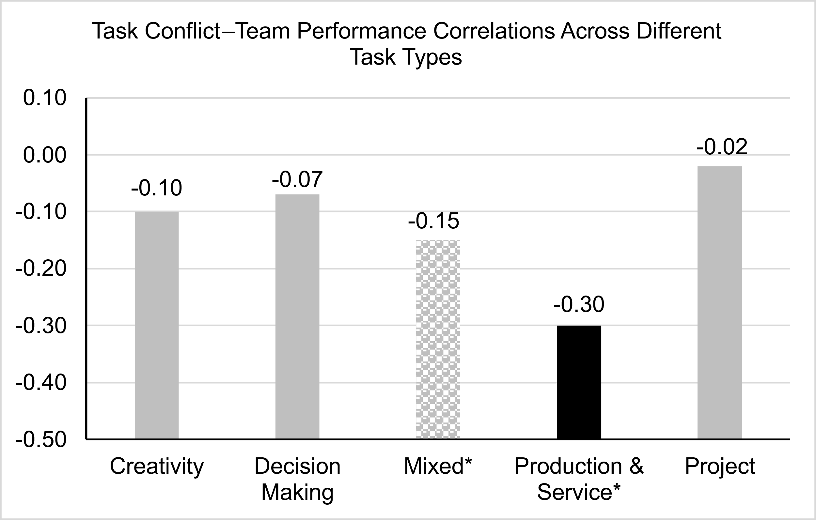

Note. The effect size for the production and service task (the black bar) was significantly different from the effect size for creativity, decision making, and project tasks (the solid gray bars), but not significantly different from that for mixed task (the dotted gray bars). Effect sizes that were significantly different from zero are indicated with *.
Figure A2
Correlation Between Task Conflict and Relationship Conflict Moderating the Task Conflict–Team Performance Relationship Based on Meta-Regression Results
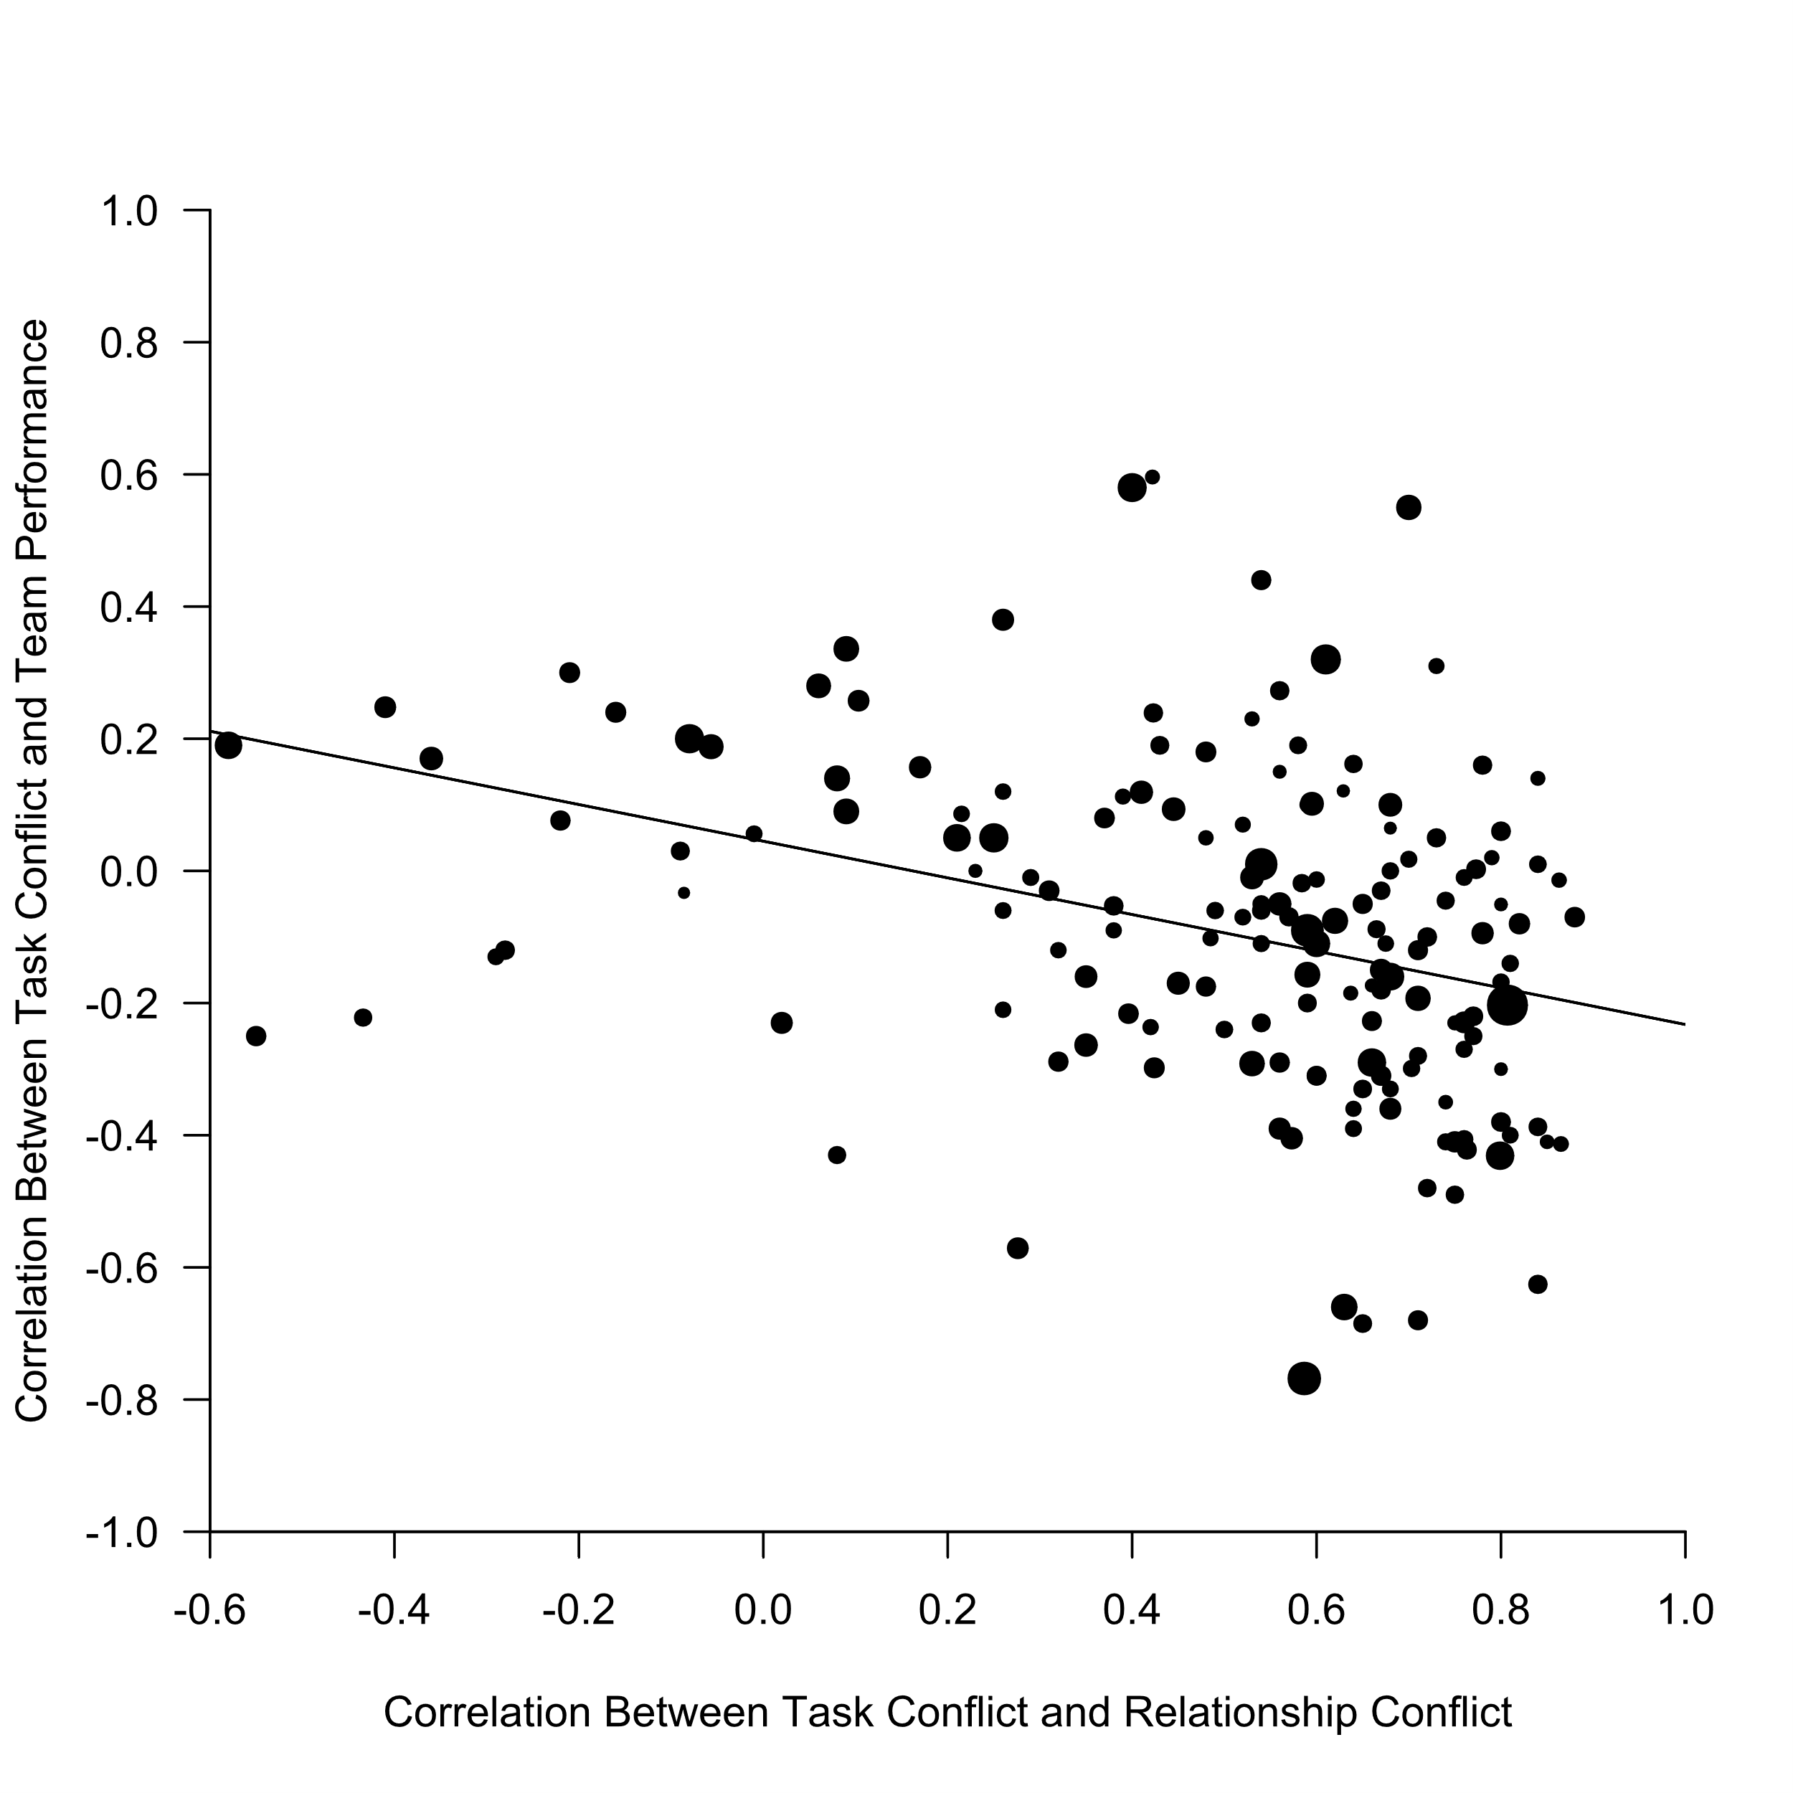
Note. The dots represent observed correlations between task conflict and team performance from 164 independent samples, which are plotted against the correlations between task conflict and relationship conflict from the respective samples. The size of each dot is proportionate to the weight of the respective correlation in the meta-regression analyses. The predicted effect as a function of the correlation between task conflict and relationship conflict is shown along the solid line.

Figure A3
Funnel Plot with Trim and Fill for the Task Conflict–Team Performance Relationship
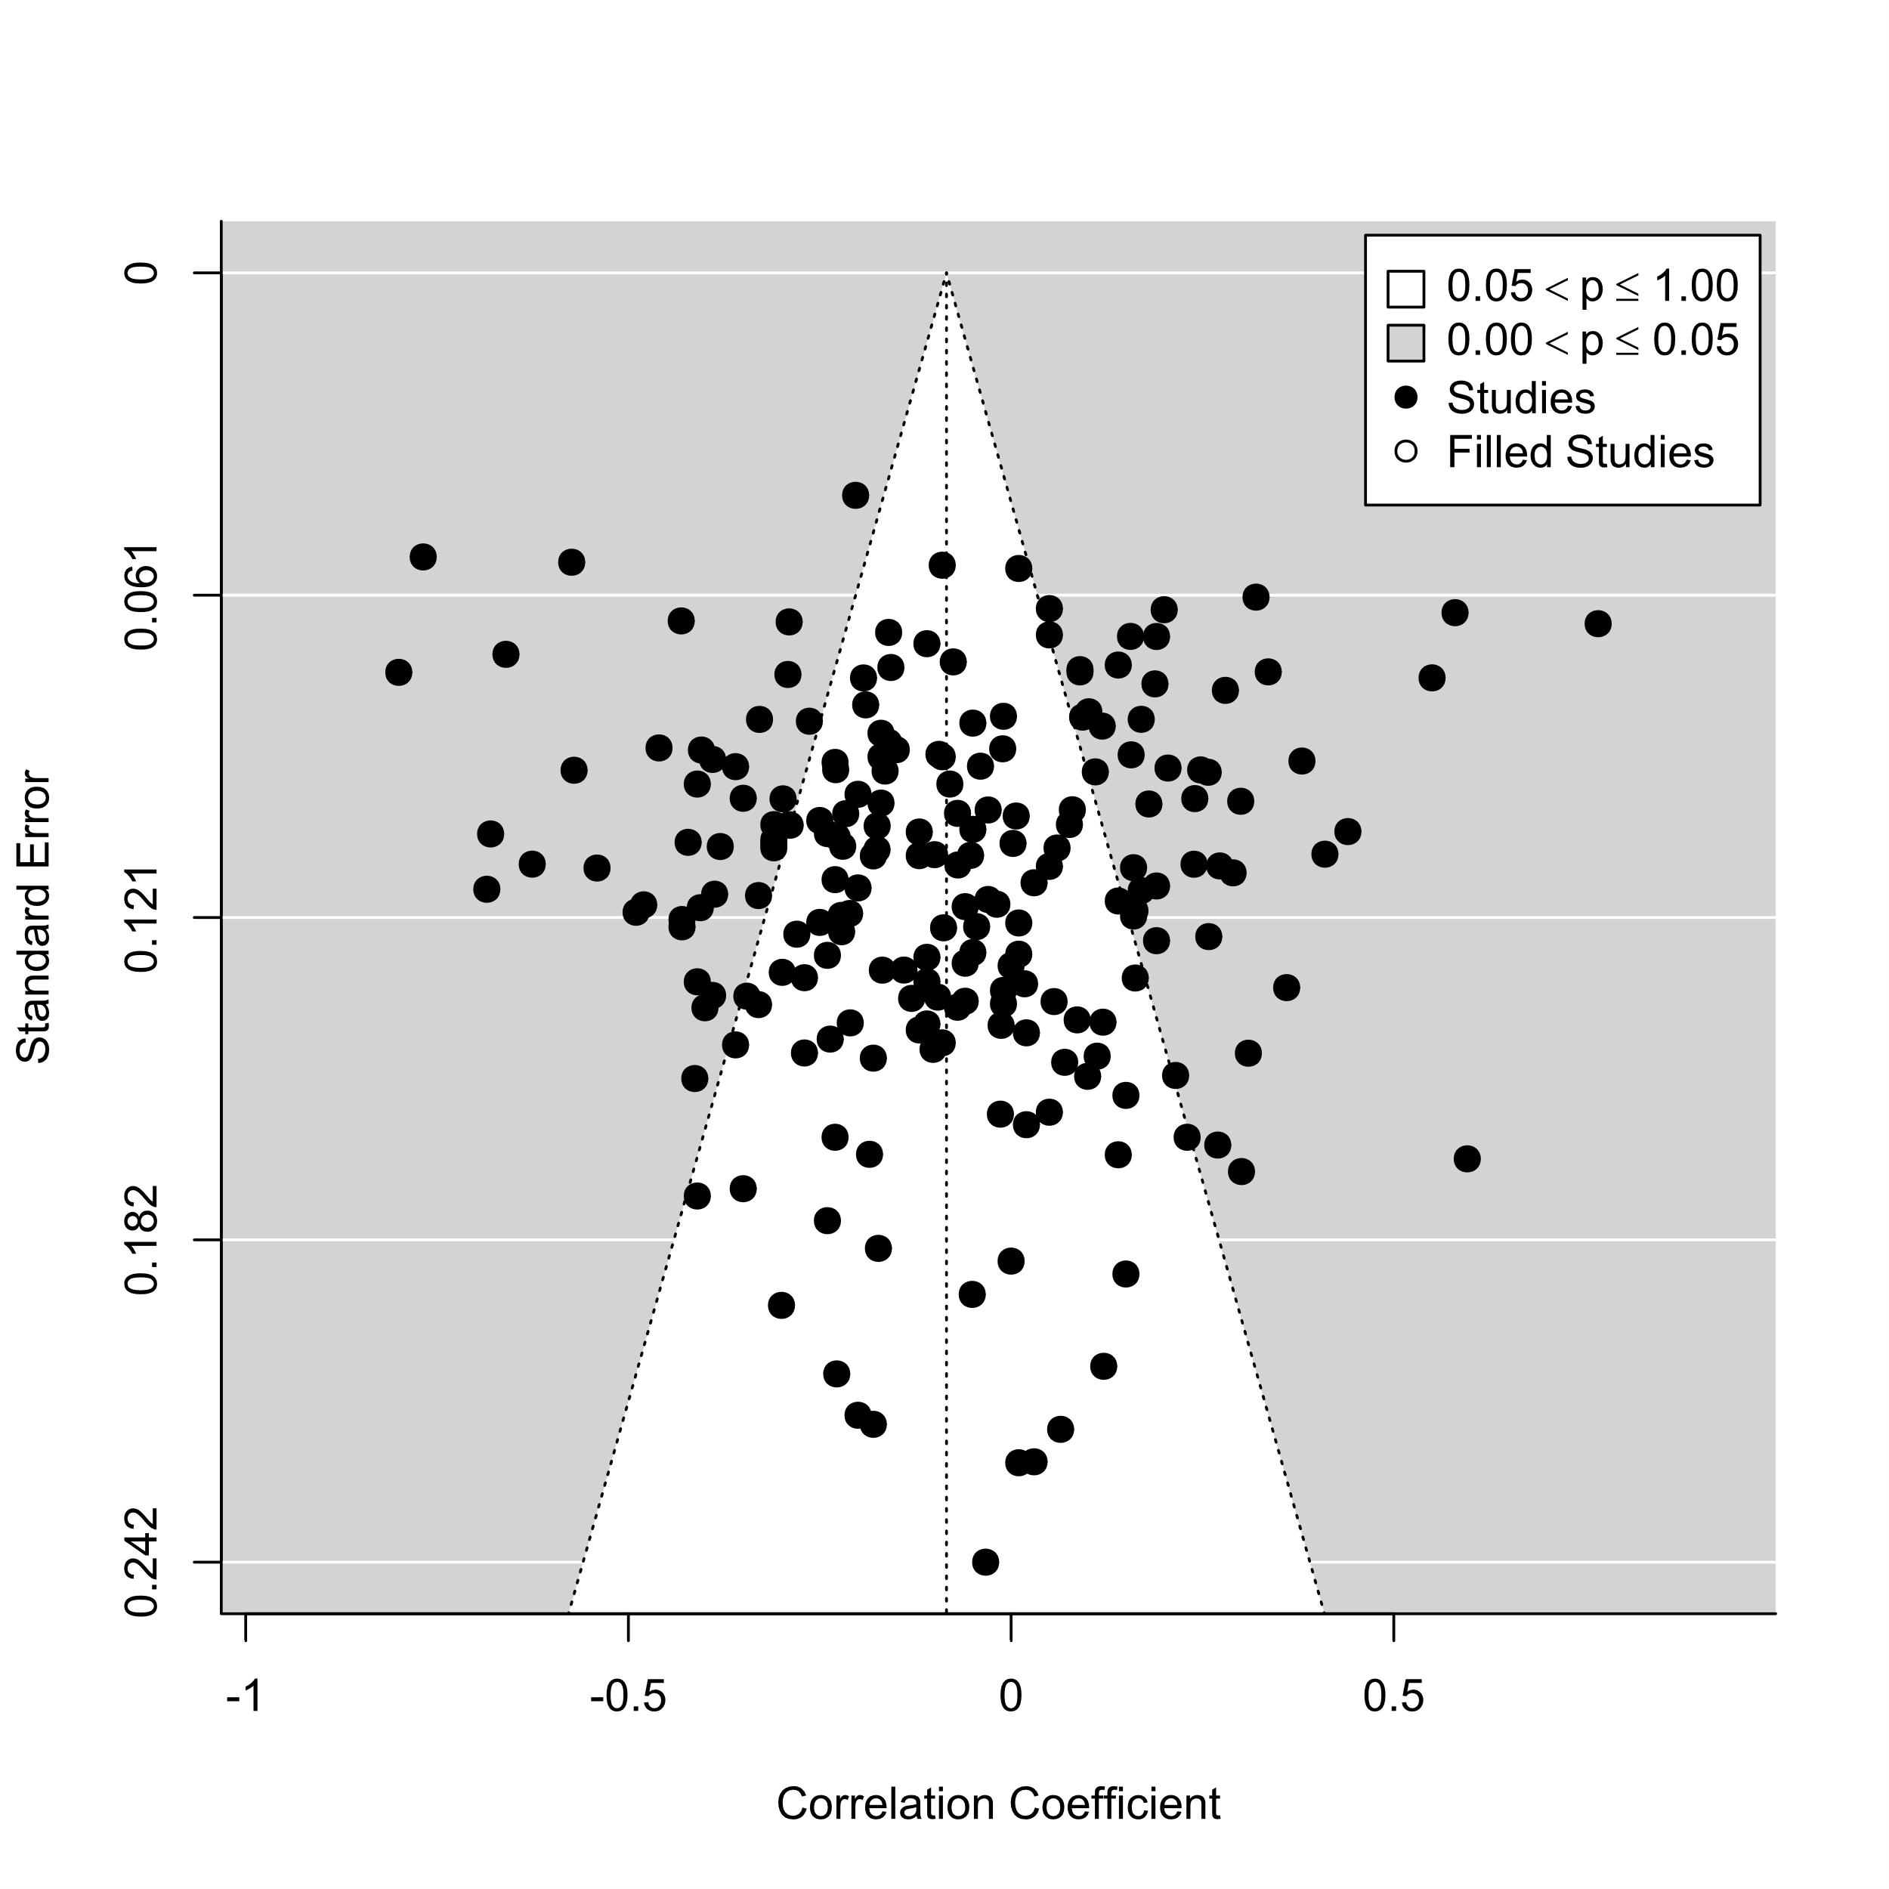
Note. Estimated number of missing studies on either side was 0.

Figure A4
Funnel Plot with Trim and Fill for the Relationship Conflict–Team Performance Relationship
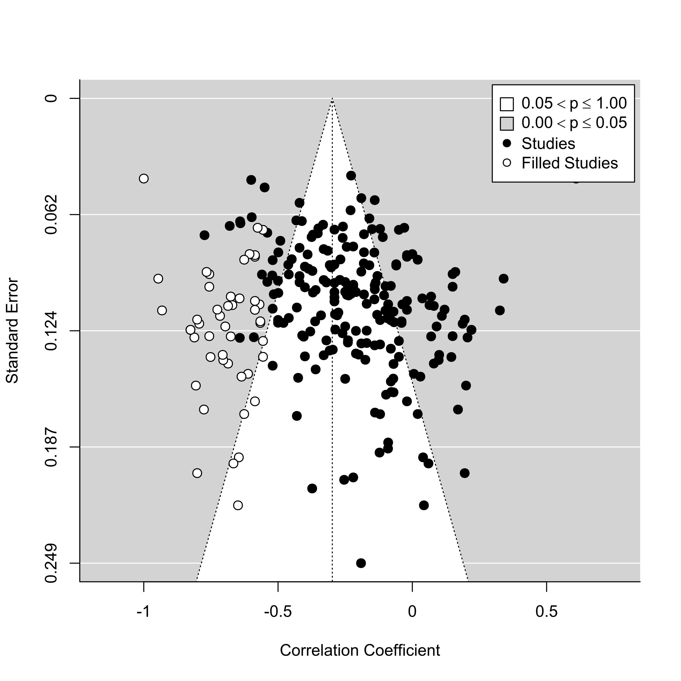
Note. Estimated number of missing studies on the left side was 48 (represented by white dots). The population estimate with the imputed studies included was r = −.30.

Figure A5
Funnel Plot with Trim and Fill for the Process Conflict–Team Performance Relationship
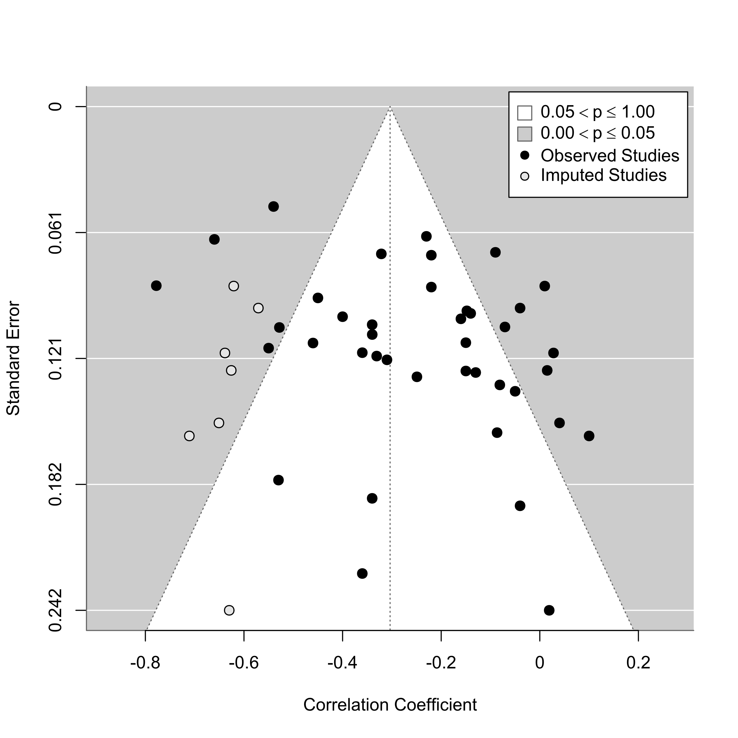
Note. Estimated number of missing studies on the left side was 7 (represented by white dots). The population estimate with the imputed studies included was r = −.30.

Figure A6
Funnel Plot with Trim and Fill for the Status Conflict–Team Performance Relationship
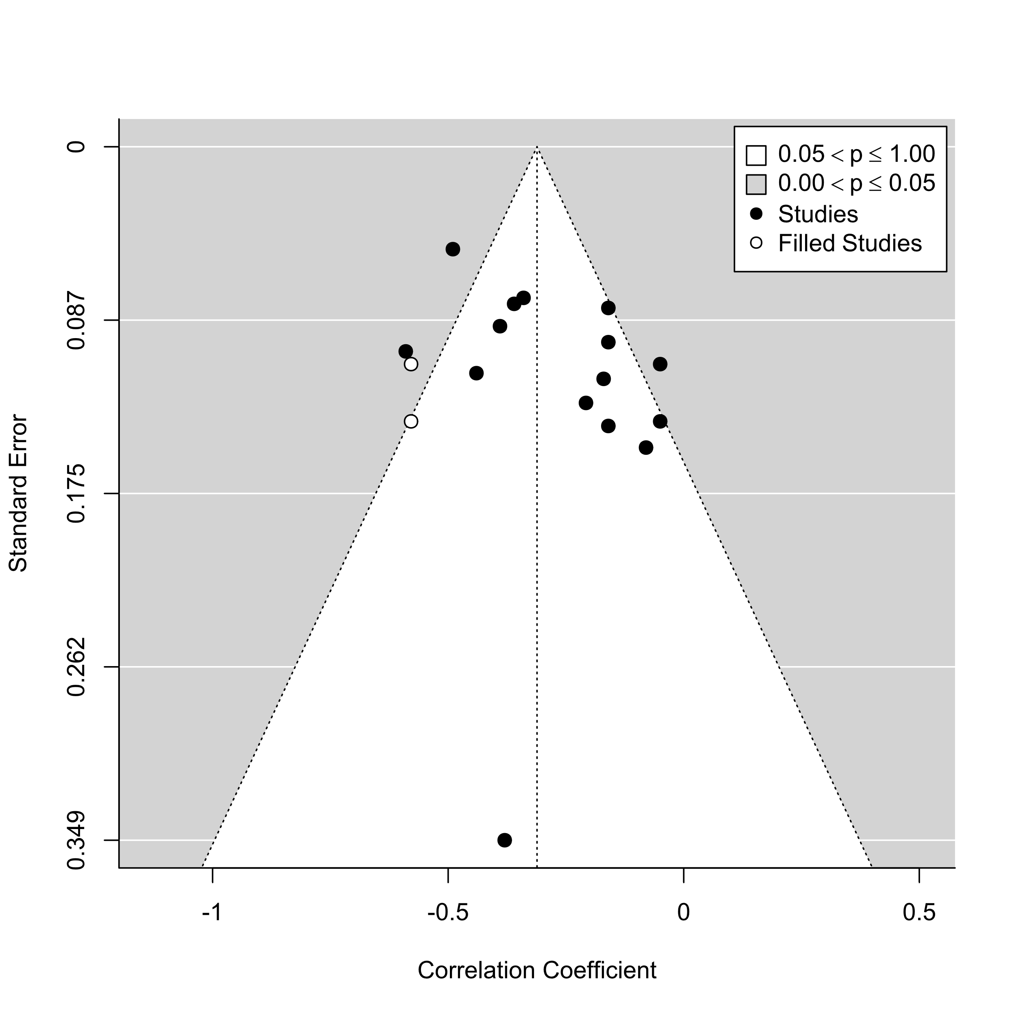
Note. Estimated number of missing studies on the left side was 2 (represented by white dots). The population estimate with the imputed studies included was r = −.31.

Figure A7
Cumulative Forest Plot for the Task Conflict–Team Performance Relationship
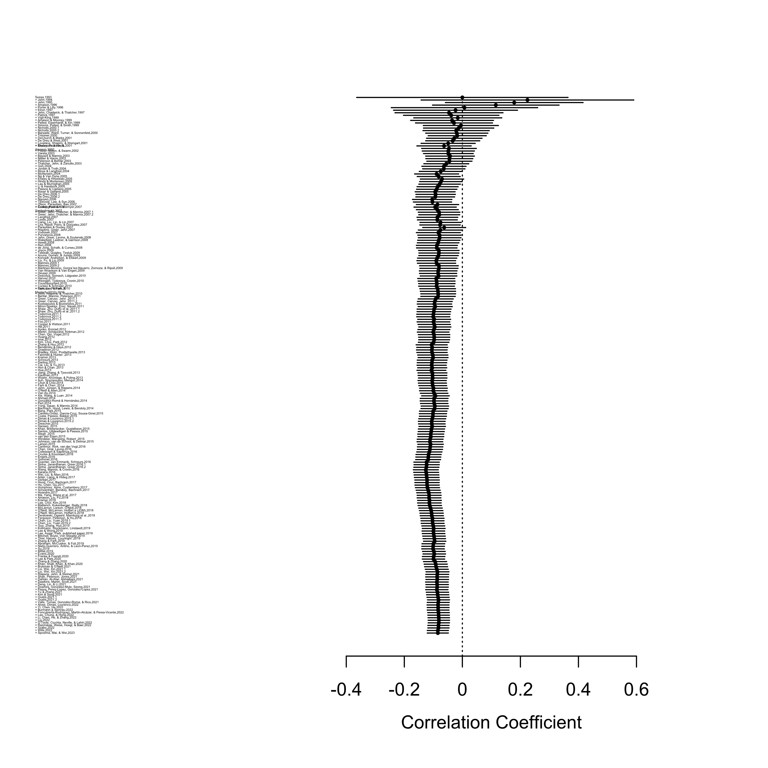
Note. Due to the large number of studies, we reduced the font size of the study information so as to fit all studies in one plot.

Figure A8
Cumulative Forest Plot for the Relationship Conflict–Team Performance Relationship
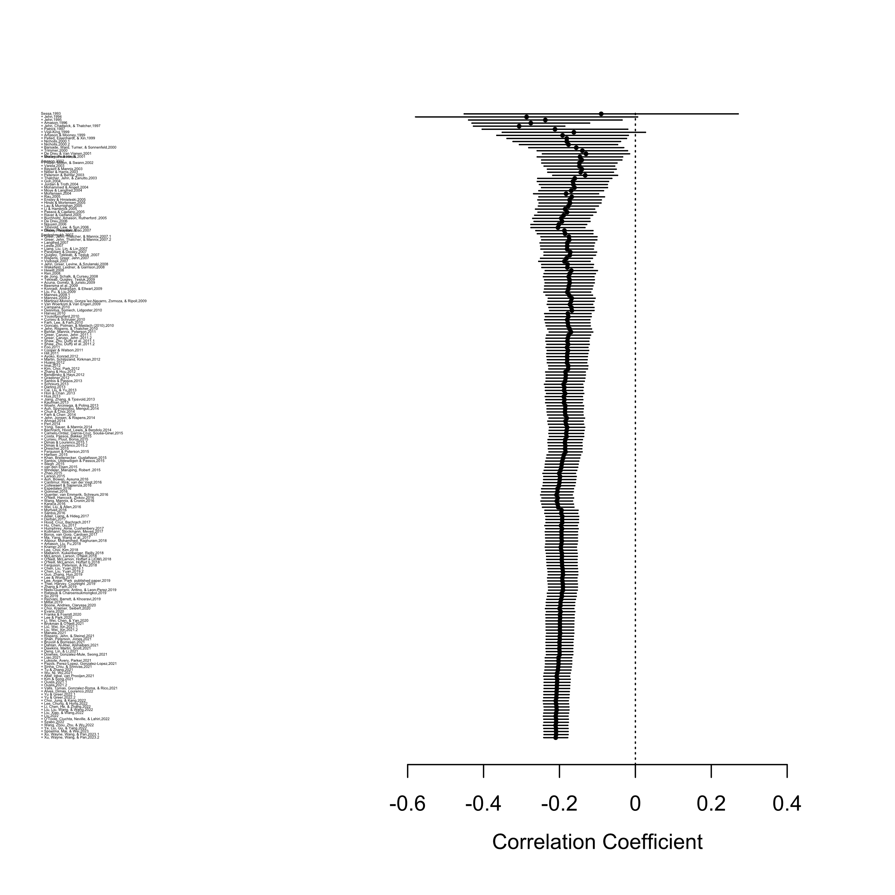
Note. Due to the large number of studies, we reduced the font size of the study information so as to fit all studies in one plot.

Figure A9
Cumulative Forest Plot for the Process Conflict–Team Performance Relationship
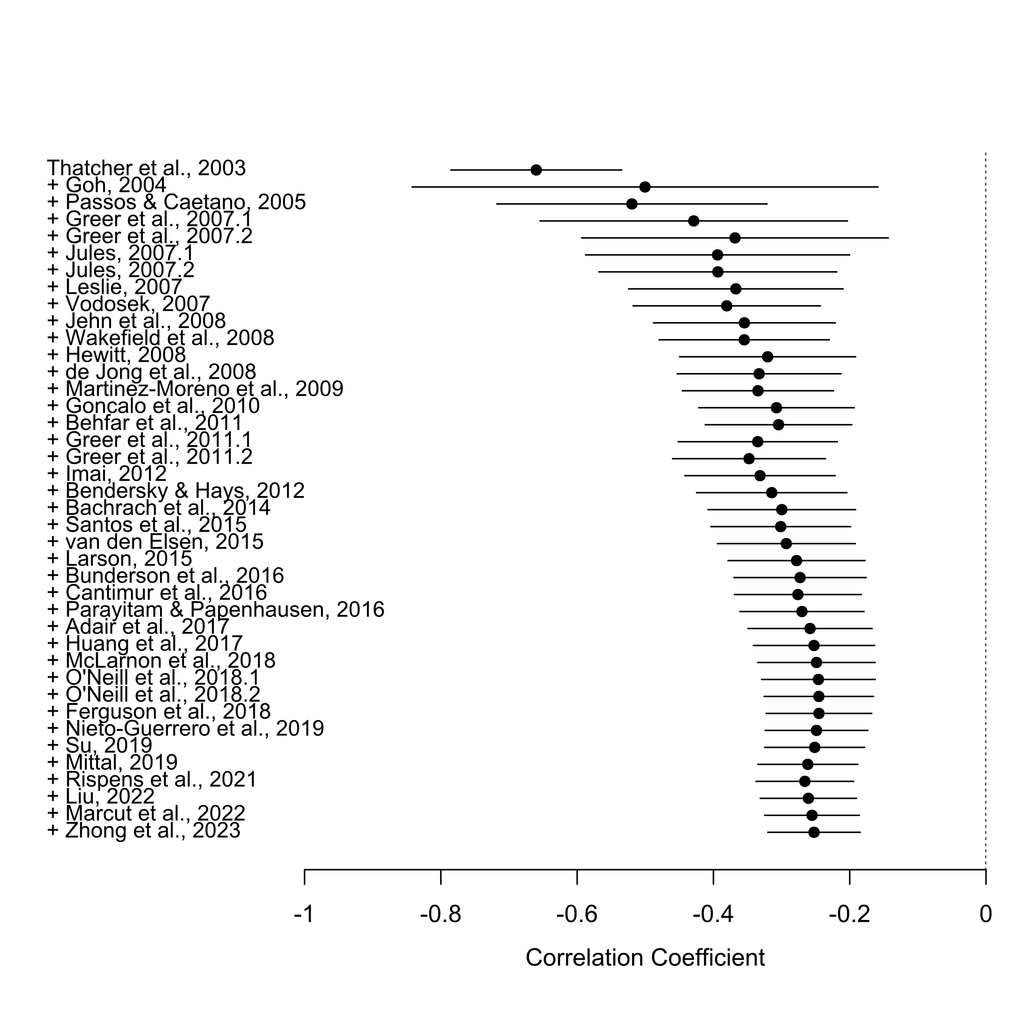

Figure A10
Cumulative Forest Plot for the Status Conflict–Team Performance Relationship
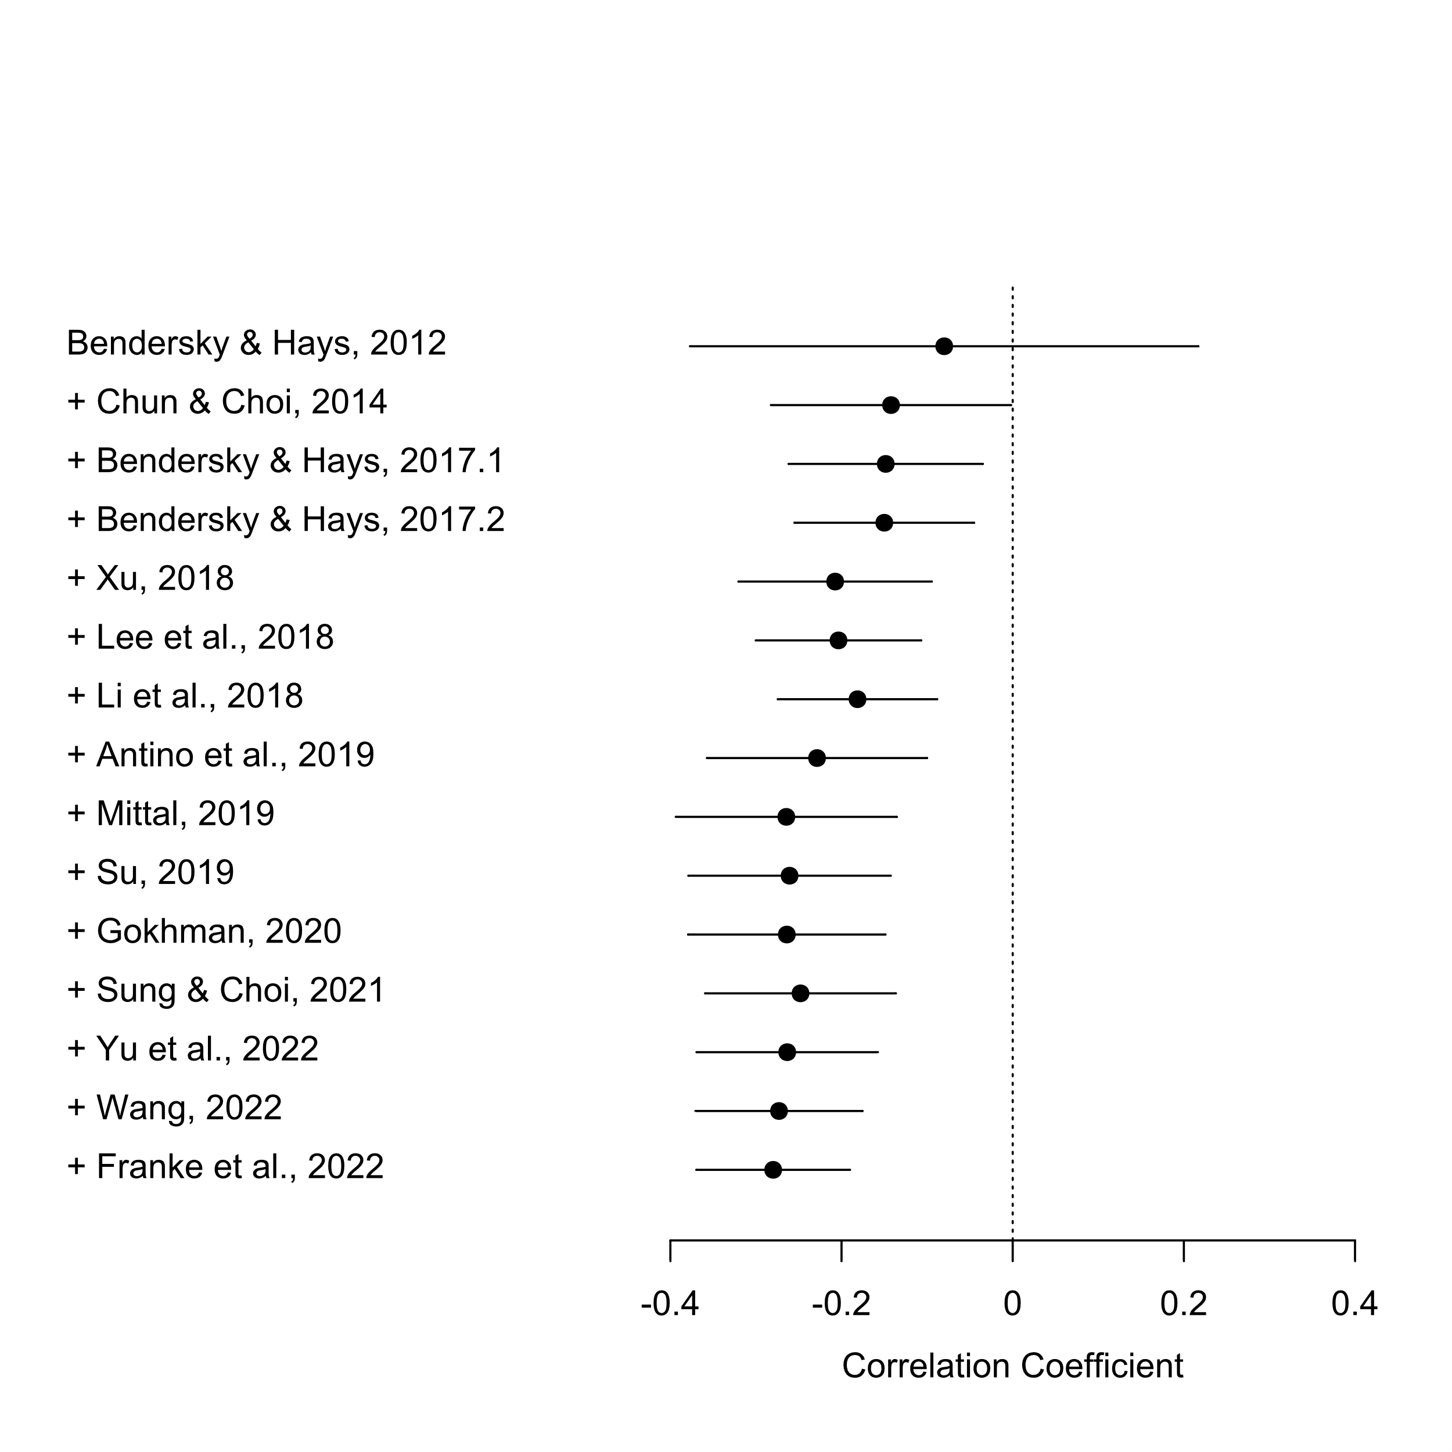

Figure A11
Curvilinear Effect of Sample Mean of Task Conflict

Note. The curvilinear effect is plotted within the actual range of the sample mean of task conflict.

