ONLINE SUPPLEMENT
Additional Details About the Relationships Examined
Figure S1 illustrates the relationships examined and their connections to the research questions. It also illustrates the direct and indirect effects of Cognitive Ability on Interviewee Performance. Our study also involves training Machine Learning Models on interviewees’ intellect as rated by zero-acquaintance observers serving as “interviewers.” Specifically, multiple (or k) “interviewers” watched the recordings and rated interviewee intellect, and we averaged those ratings together, as illustrated in Figure 1 (kth Interviewer’s Perception and k Interviewer Ratings), to form a third ground truth for the Machine Learning Models. Because Interviewer Perceptions and Ratings of cognitive ability, like the ML models, are based on interviewee behaviors, they are likely to be more accurately modeled than Cognitive Ability Test Scores that are based on information beyond behaviors displayed in the interview (Hickman, Bosch, et al., 2022).
Reliability estimates require relating test scores to themselves (e.g., from different test components or at a different time), as illustrated in Figure 1 by the arrow relating Machine Learning Model Scores to themselves. The most basic form of convergence is between the ML model assessments and the ground truth measure the model was trained to predict. Figure S1 illustrates these paths separately for relating Machine Learning Model Scores to Cognitive Ability Test Scores and the average of k Interviewer Ratings. Figure S1 illustrates how Cognitive Ability affects Standardized Test Scores and cognitive ability Self-Reports through Self Perceptions, and it shows how we use Standardized Test Scores and Self-Reports to further examine the convergent relations of Machine Learning Model Scores. We examine discriminant evidence by relating Machine Learning Model Scores to personality Self-Reports and the average of k Interviewer Ratings of interviewee personality traits. We use the Brunswik lens paradigm (1955) to compare how observed Cognitive Ability Test Scores, the average of k Interviewer Ratings, and Machine Learning Model Scores correlate with specific interviewee behaviors. In the present study, this involves examining how behavioral cues (i.e., interviewee behaviors) relate to observed construct scores (cue ecology), how behavioral cues relate to the AVI scores (cue utilization), and the match between the two (cue validity). Doing so illustrates the extent that judgments of psychological constructs are based on valid vs. invalid behavioral information.
Additional Method Details
Table S1 lists the additional operationalizations of verbal behavior that we explored. We detail them below.
Additional Details About the Mock Interview

Participants were first provided with a chance to familiarize themselves with the web-based recorder by recording their answer to the prompt, “Tell us about your dream job.” Responses to this prompt were not used for the study. Participants were then encouraged to prepare their responses by reflecting on their past work experiences and accomplishments and, if they did not have relevant work experiences, to think of experiences from school, volunteering, or other organized activities. The six interview questions were then presented in random order. The question corresponding to Extraversion is, “Do you prefer to work alone or in a team? Tell us about a time you had to work against your preference (e.g., had to work in a team when you prefer to work alone). What were the challenges you faced and were you able to overcome them?” The question corresponding to Agreeableness is, “Think of a time a coworker asked you to set aside your own work to help him or her with a project that was very important to them. What did you do? Why did you do that?” The question corresponding to Conscientiousness is, “Describe a long-term project that you managed. What did you do to keep everything moving along in a timely manner?” The question corresponding to Emotional Stability is, “Tell me about a recent uncomfortable or difficult work situation. How did you approach this situation? What happened?” The question corresponding to Openness is, “Think of a time you had a need to learn about something that was new to you? Why did you pursue it? What kept you persistent?” The question corresponding to cognitive ability is, “You have been tasked on your job to make product purchases for the company. Explain step-by-step how you would choose between two or three different products.”
Additional Details About the GMA Test
The test consisted of four three-dimensional rotation questions, four letter series questions, four matrix completion questions, and four verbal reasoning questions. The items were presented in random order. The items do not require specific domain knowledge (beyond basic algebra and English skills) so they represent an appropriate test of GMA. Participants were given 12 minutes to answer as many questions as possible, and there were no penalties for wrong answers. Reliability for this test and all other measures is provided in the diagonal of Tables S3 (Sample 1) and S4 (Sample 2). The scores were approximately normally distributed in Sample 1 (Figure S2). In Sample 1, on average across the four three-dimensional rotation questions, 13.5% of participants did not select an answer, and on average across the 12 remaining questions, 6.3% of participants did not select an answer. Although we use dominance scoring to combine the test item scores, in Sample 1 we confirmed that the data fit a higher order construct by taking the average of each type of item then treating those four scores as indicators of the higher order GMA construct. In that model, CFI = 1, TLI = 1, RMSEA = 0, SRMR = .01, and χ² = 1.27 (p = .53).
Additional Details About the Verbal Ability Test
We developed an initial bank of 22 items. These were reviewed and pilot tested by several undergraduate researchers and industrial-organizational psychology faculty. Three items were eliminated upon this review, leaving 19 items. In the first question type, two answers are selected that both complete a blank in the sentence. A sample question is, “Some social commentators have labeled bankers as ______ for their role in causing the 2008 financial crisis.” Answer options included: avaricious; rapacious; treacherous; impenitent; insensate; solicitous. In the second question type, one answer is selected for each of one to three blanks in a sentence. A sample question is, “The immigrant’s poor English skills are hardly an ____ problem; he can attend classes and improve within a few months.” Answer options included: insuperable; implausible; inconsequential; evocative; injudicious. The test consisted of nine of the first question type and 10 of the second question type. Within each question type, the questions were presented in random order. Participants received one point for each correct response in each question, with a maximum possible score of 37. The scores were approximately normally distributed in Sample 1 (Figure S3). In Sample 1, on average across the first set of questions, 0.7% of participants did not select an answer, and on average across the second set of questions (which were presented second), 5.3% of participants did not select an answer.
Verbal behavior
Beyond the operationalizations of verbal behavior in the manuscript, we tested several other methods of operationalizing verbal behavior.
We explored alternative operationalizations of n-grams. Specifically, in addition to the lemmatized n-grams with tf-idf transformation reported in the manuscript, we also tested a) stemmed n-gram counts, b) stemmed n-grams with tf-idf transformation, and c) lemmatized n-gram counts.
For Linguistic Inquiry and Word Count (LIWC; Pennebaker et al., 2015), we scored each question’s transcript using all variables included in the English LIWC 2015 dictionaries, then calculated both the mean across the questions and the standard deviation of these scores. LIWC scores a series of semantic and psychological dictionaries based on the proportion of text represented by those dictionaries.
Additionally, using the interview-level transcripts, we used the quanteda R package (Benoit et al., 2018) to calculate lexical diversity, readability, and the average number of syllables in each word. To calculate lexical diversity, we used Guiraud’s Root TTR (1954), which is calculated by dividing the number of unique words by the square root of the total number of words. To calculate readability, we needed an index that did not rely on sentence or paragraph length since the transcripts contain no punctuation. Coleman’s (1971) Readability Formula 1 and FORCAST (Caylor & Sticht, 1973) are mathematically equivalent and correlate r = .90 with Flesch’s Reading Ease Score. The FORCAST formula is simpler than Coleman’s (1971) formula:
 | $$FORCAST=20-\frac{\left(N_{wsy1}*150\right)}{(N_{w}*10)}$$ | (6)
$N_{wsy1}$ is the number of one-syllable words, and $N_{w}$ is the total number of words.
We applied the Universal Sentence Encoder (Cer et al., 2018) loaded from https://tfhub.dev/google/universal-sentence-encoder/4 to convert each question-level response into a 512-dimension embedding, which we then averaged across all available questions for each participant. USE is specifically designed for situations where limited training data is available. The model was trained using data from Wikipedia, internet news pages, internet question-answer pages, and internet discussion forums.
Alternative Model Results
Table S2 reports the convergent correlations obtained during k-fold cross-validation for additional models that are not reported in the manuscript. The majority of these models tested alternative operationalizations of verbal behavior, including LIWC with the readability, lexical diversity, and average number of syllables as predictors (listed as LIWC Plus); models that used the alternative operationalization of n-grams with LIWC Plus; models that used the USE embeddings; and models that used the RoBERTa embeddings alongside other predictors. Additionally, row 14 reports the results for the model presented in the manuscript, and the final row of Table S2 reports results for a model that used RoBERTa, lemmatized tf-idf transformed n-grams, LIWC Plus, paraverbal behaviors, and nonverbal behaviors together. As can be seen, there was almost no gain in convergence from using all predictors together and construct discrimination worsened.
Results
Descriptive Statistics and Cognitive Ability Test Validity (Samples 1 & 2)
Table S3 presents the descriptive statistics and intercorrelations of the variables for Sample 1, and Table S4 presents that information for Sample 2. In Sample 1, the Big Five self-reports and interviewer ratings exhibited low-to-moderate convergence. The convergent correlations between self-reports and interviewer ratings rs = .35, .21, .22, .25, and .14, for extraversion, agreeableness, conscientiousness, emotional stability, and openness, respectively.
The GMA test, verbal ability test, and intellect ratings generally exhibited expected patterns of intercorrelations with self-reported standardized test scores and academic performance. These measures of GMA, verbal ability, and intellect correlated significantly with college GPA (rs = .13, .21, & .14, respectively). The GMA test correlated higher with SAT math than SAT verbal scores (rs = .45 & .37, respectively). The verbal ability test correlated stronger with SAT verbal than SAT math scores (rs = .48 & .37, respectively). Intellect ratings correlated similarly with SAT math and SAT verbal scores (rs = .31 and .28, respectively). GMA, verbal ability, and intellect correlated moderately with ACT scores (rs = .40, .48, & .35, respectively). The GMA and verbal ability tests correlated moderately (r = .46), and intellect ratings correlated positively with GMA and verbal ability tests (r = .31 & .38, respectively).
In Sample 2 (Table A2), participants’ self-reported GMA correlated more highly with SAT math, SAT verbal, and ACT scores (rs ranging from .42 to .52 at time 1 and from .38 to .59 at time 2) than they did in Sample 1, perhaps due to the recency of taking the tests. Self-reported GMA also tended to be slightly more related to GMA and verbal ability tests (rs ranging from .30 to .41 for time 1 and from .35 to .42 for time 2). Again, the GMA and verbal ability tests generally exhibited expected intercorrelations, as the GMA test correlated more strongly with SAT math than SAT verbal scores (rs .50 & .35 at time 1 and .53 & .35 at time 2, respectively), while the verbal ability test correlated more strongly with SAT verbal than SAT math scores (rs .59 & .28 at time 1 and .54 & .29 at time 2, respectively). Both the GMA and verbal ability tests again correlated with self-reported ACT scores (rs .48 & .49 at time 1, and .38 & .46 at time 2, respectively). The intercorrelations among the GMA and verbal ability tests ranged from .35 (Time 1 GMA and Time 1 verbal ability) to .48 (Time 2 GMA and Time 2 verbal ability).
References

Benoit, K., Watanabe, K., Wang, H., Nulty, P., Obeng, A., Müller, S., & Matsuo, A. (2018). quanteda: An R package for the quantitative analysis of textual data. Journal of Open Source Software, 3(30), 1-4.
Brunswik, E. (1955). Representative design and probabilistic theory in a functional psychology. Psychological Review, 62(3), 193-217.
Caylor, J. S. & Sticht, T. G. (March, 1973). Development of a simple readability index for job reading material. Paper presented at the Annual Meeting of the American Educational Research Association. Available at https://files.eric.ed.gov/fulltext/ED076707.pdf
Cer, D., Yang, Y., Kong, S. Y., Hua, N., Limtiaco, N., John, R. S., Constant, N., Guajardo-Cespedes, M., Yuan, S., Tar, C., Strope, B., & Kurzweil, R. (2018, November). Universal sentence encoder for English. In Proceedings of the 2018 conference on empirical methods in natural language processing: system demonstrations (pp. 169-174).

Coleman, E. B. (1971). Developing a technology of written instruction: Some determiners of the complexity of prose. Verbal learning research and the technology of written instruction, 155-204.
Guiraud, P. (1954). Les caractères statistiques du vocabulaire: essai de méthodologie. Presses universitaires de France.
Pennebaker, J. W., Boyd, R. L., Jordan, K., & Blackburn, K. (2015). The development and psychometric properties of LIWC2015. Austin: University of Texas at Austin.

Table S1
Additional operationalizations of interviewee verbal behavior
Descriptive | Closed Vocabulary | Open Vocabulary
- Word count  - Unique word count (lexical diversity)  - Mean number of syllables per word  - Readability  - Lemmatized n-gram counts, where n = 1, 2, & 3  - Stemmed n-grams with tf-idf transformation, where n = 1, 2, & 3 | - Use LIWC to count conceptually related words to measure various constructs. For example:  - Cognitive processes  - Causation  - Certainty  - Achievement words  - Present focus words  - Perceptual processes  - Work  - Money  - Analytical  - Authentic | - Counts of 1, 2, and 3 word phrases (i.e., n-grams where n = 1, 2, & 3)  - Stemmed  - Lemmatized  - Raw counts  - tf-idf transformed counts  - 512 parameters from the Universal Sentence Encoder
Note: LIWC = Linguistic Inquiry and Word Count.

Table S2

Nested cross-validation convergent correlations of automated cognitive ability assessments by modality and method of operationalizing verbal behavior
 | GMA | Verbal ability | Intellect | Discriminant Correlations
1. Nonverbals
 | .19 | .24 | .37 | .63
2. Paraverbals
 | .16 | .26 | .38 | .78
3. LIWC Plus
 | .29 | .42 | .62 | .76
4. n-grams (stemmed, counts)
 | .36 | .49 | .58 | .68
5. Universal Sentence Encoder
 | .36 | .47 | .67 | .72
6. RoBERTa
 | .38 | .45 | .68 | .71
7. LIWC Plus & n-grams (stemmed, tf-idf)
 | .38 | .51 | .62 | .65
8. LIWC Plus & n-grams (lemmatized, counts)
 | .37 | .49 | .62 | .68
9. LIWC Plus & n-grams (lemmatized, tf-idf)
 | .39 | .50 | .63 | .65
10. LIWC Plus & n-grams (stemmed, counts)
 | .36 | .51 | .62 | .68
11. Nonverbals, Paraverbals, LIWC Plus, & n-grams (stemmed, counts)
 | .35 | .51 | .63 | .68
12. RoBERTa & LIWC
 | .39 | .48 | .66 | .71
13. RoBERTa & Plus (readability, lexical diversity, average syllables per word)
 | .38 | .45 | .69 | .72
14. RoBERTA & n-grams (lemmatized, tf-idf)
 | .41 | .51 | .67 | .64
15. RoBERTA & n-grams (lemmatized, tf-idf) using LASSO regression
 | .22 | .35 | .66 | .36
16. RoBERTa, LIWC Plus, & n-grams (lemmatized, tf-idf)
 | .41 | .52 | .67 | .64
17. Nonverbals, Paraverbals, RoBERTa, LIWC Plus, & n-grams (lemmatized, tf-idf)
 | .40 | .52 | .68 | .65
Note: LIWC = Linguistic Inquiry and Word Count. tf-idf = term frequency-inverse document frequency. LASSO = least absolute shrinkage and selection operator. Discriminant correlations are the average correlation between AVI GMA, verbal ability, and intellect measures. LIWC Plus is LIWC plus the readability, lexical diversity, and average number of syllables per word measures.

Table S3

Correlation matrix of observed variables in Sample 1
 | Mean | SD | 1 | 2 | 3 | 4 | 5 | 6 | 7 | 8 | 9 | 10 | 11 | 12 |  | 13 | 14 | 15 |  | 16 | 17 | 18 | 19 | 20 |  | 21
1. Gender | .64 | .48
2. Age | 23.91 | 8.94 | -.05
3. Self-rated GMA | 113.12 | 10.88 | -.10 | -.01
4. SAT verbal | 637.70 | 120.34 | .04 | -.27 | .16
5. SAT math | 628.10 | 134.42 | -.15 | -.29 | .21 | .68
6. ACT | 27.92 | 5.22 | -.08 | -.17 | .28 | .51 | .56
7. College GPA | 3.47 | .43 | .14 | .03 | .20 | .14 | .18 | .22
8. GMA | 7.65 | 3.27 | -.02 | -.20 | .21 | .37 | .45 | .40 | .13 | (.71)
9. Verbal ability | 18.08 | 7.68 | .06 | -.07 | .24 | .48 | .37 | .48 | .21 | .46 | (.85)
Self-reports
10. Extraversion | 3.26 | .85 | .04 | .01 | .14 | -.07 | -.06 | -.02 | -.04 | -.06 | -.09 | (.87)
11. Agreeableness | 3.94 | .61 | .14 | .05 | -.02 | -.10 | -.09 | -.14 | .01 | -.04 | -.02 | .16 | (.77)
12. Conscientiousness | 3.85 | .68 | .17 | .14 | .11 | -.04 | -.03 | -.01 | .24 | -.02 | -.01 | .16 | .43 | (.83)
13. Emotional Stability | 3.18 | .81 | -.16 | .09 | .09 | -.01 | .05 | -.03 | .00 | .03 | -.05 | .31 | .34 | .41 | (.84)
14. Openness | 3.72 | .58 | .00 | -.02 | .20 | .01 | -.04 | -.02 | -.01 | .00 | .06 | .27 | .22 | .09 | .07 |  | (.76)
Interviewer ratings
15. Intellect | 5.33 | .75 | .07 | -.18 | .14 | .28 | .31 | .35 | .14 | .31 | .38 | .11 | .03 | .13 | .07 |  | .09 | (.66)
16. Extraversion | 4.41 | 1.14 | .09 | -.07 | .11 | .06 | .05 | .02 | .01 | .03 | .03 | .35 | .14 | .08 | .14 |  | .08 | .31 | (.77)
17. Agreeableness | 4.99 | .88 | .09 | -.12 | .02 | .12 | .12 | .12 | .04 | .08 | .12 | .11 | .21 | .12 | .07 |  | .03 | .34 | .25 |  | (.67)
18. Conscientiousness | 5.51 | .80 | .22 | -.14 | .13 | .22 | .22 | .23 | .18 | .25 | .27 | .10 | .09 | .22 | .03 |  | .06 | .74 | .28 |  | .40 | (.67)
19. Emotional Stability | 4.85 | .85 | -.13 | .00 | .06 | .03 | .08 | .08 | .01 | .06 | .06 | .12 | .11 | .14 | .25 |  | .04 | .33 | .24 |  | .43 | .33 | (.59)
20. Openness | 4.69 | .84 | .11 | -.11 | .08 | .16 | .11 | .15 | .10 | .14 | .17 | .12 | .09 | .06 | -.01 |  | .14 | .44 | .40 |  | .37 | .47 | .21 |  | (.60)
Note: N = 1,034. SAT verbal and math, N = 617. ACT N = 597. College GPA N = 969. Reliabilities reported in the diagonal in parenthesis—for tests and self-reports, Cronbach’s alpha; for interviewer ratings, ICC(1, k). Gender coded as male = 0, female = 1.

Table S4

Correlation matrix of observed variables in Sample 2
 | Mean | SD | 1 | 2 | 3 | 4 | 5 | 6 | 7 | 9 | 10 | 11 | 12
1. Gender | .59 | .49
2. Age | 18.78 | 1.22 | -.14
3. Self-rated GMA: Time 1 | 109.88 | 9.84 | -.27 | .11
4. Self-rated GMA: Time 2 | 108.02 | 11.04 | -.31 | .06 | .80
5. SAT verbal | 626.03 | 69.43 | -.17 | .06 | .41 | .36
6. SAT math | 647.02 | 88.75 | -.32 | .03 | .43 | .41 | .58
7. ACT | 27.74 | 4.28 | -.26 | .21 | .52 | .58 | .63 | .71
8. GMA: Time 1 | 7.74 | 2.84 | -.14 | .15 | .31 | .37 | .34 | .50 | .48 | (.60)
9. GMA: Time 2 | 8.64 | 3.51 | -.22 | .14 | .29 | .34 | .34 | .53 | .39 | .66 | (.76)
10. Verbal ability: Time 1 | 15.47 | 6.53 | -.16 | .17 | .40 | .40 | .60 | .26 | .49 | .34 | .38 | (.79)
11. Verbal ability: Time 2 | 15.59 | 6.95 | -.08 | .11 | .38 | .39 | .55 | .27 | .47 | .36 | .47 | .80 | (.81)
Note: N = 201. SAT N = 160. ACT N = 98.

Table S5

Nested cross-validation correlation matrix (Sample 1)
 | 1 | 2 | 3 | 4 | 5 | 6 | 7 | 8 | 9 | 10 | 11
AVIs
1. GMA
2. Verbal | .68
3. Intellect | .60 | .66
4. Extraversion | .16 | .17 | .48
5. Agreeableness | .29 | .35 | .48 | .41
6. Conscientiousness | .54 | .58 | .90 | .49 | .53
7. Emotional Stability | .24 | .26 | .53 | .33 | .51 | .51
8. Openness | .35 | .43 | .59 | .57 | .55 | .61 | .32
Cognitive ability measures
9. GMA | .41 | .36 | .35 | .09 | .15 | .32 | .12 | .21
10. Verbal | .41 | .51 | .40 | .10 | .19 | .34 | .12 | .27 | .47
11. Self-rated GMA | .18 | .17 | .16 | .10 | .05 | .13 | .11 | .10 | .22 | .24
12. Interviewer-rated Intellect | .44 | .48 | .67 | .34 | .31 | .61 | .38 | .42 | .31 | .38 | .15
Interviewer Ratings
Extraversion | .07 | .08 | .26 | .47 | .23 | .27 | .18 | .33 | .03 | .03 | .11
Agreeableness | .17 | .19 | .24 | .23 | .37 | .25 | .24 | .31 | .07 | .12 | .02
Conscientiousness | .35 | .37 | .57 | .31 | .30 | .58 | .34 | .39 | .25 | .27 | .14
Emotional Stability | .12 | .10 | .27 | .18 | .26 | .27 | .45 | .17 | .06 | .06 | .06
Openness | .20 | .24 | .34 | .35 | .31 | .33 | .16 | .52 | .14 | .17 | .08
Self-reports
Extraversion | .00 | .02 | .10 | .22 | .05 | .10 | .05 | .14 | -.05 | -.09 | .14
Agreeableness | .00 | -.01 | .03 | .09 | .14 | .06 | .08 | .07 | -.04 | -.02 | -.02
Conscientiousness | .04 | .03 | .11 | .07 | .07 | .14 | .13 | .06 | -.02 | -.01 | .12
Emotional Stability | .03 | -.01 | .05 | .03 | -.02 | .04 | .14 | .00 | .03 | -.05 | .09
Openness | .03 | .06 | .08 | .07 | .06 | .04 | .07 | .13 | .00 | .06 | .20
Note: Calculated by averaging the correlation matrices from each test fold. Suppressed columns are in Table S3.
Table S6

Correlations between cognitive ability and behavior for the 25 predictors most strongly correlated with the ground truth
GMA |  |  |  |  | Verbal ability |  |  |  |  |  | Intellect
Test | Cue | AVI |  |  |  | Test | Cue |  | AVI |  |  | Ratings | Cue | AVI
.23 | X286_mean | .36 |  |  |  | -.27 | will |  | -.41 |  |  | .46 | X330_mean | .65
-.22 | X757_mean | -.36 |  |  |  | .25 | X330_mean |  | .42 |  |  | -.45 | X659_mean | -.61
-.22 | X636_mean | -.34 |  |  |  | -.24 | X478_mean |  | -.30 |  |  | .40 | X635_mean | .54
-.21 | X144_mean | -.34 |  |  |  | -.24 | X614_mean |  | -.36 |  |  | .38 | X610_mean | .46
.21 | X514_mean | .33 |  |  |  | .24 | X635_mean |  | .41 |  |  | .37 | X566_mean | .50
.21 | X566_mean | .33 |  |  |  | .23 | X286_mean |  | .34 |  |  | .37 | X551_mean | .45
.21 | X650_mean | .36 |  |  |  | .23 | of the |  | .31 |  |  | .36 | X265_mean | .47
.21 | X330_mean | .36 |  |  |  | .23 | X566_mean |  | .34 |  |  | -.36 | X144_mean | -.45
.21 | X610_mean | .33 |  |  |  | -.22 | X757_mean |  | -.35 |  |  | -.36 | X523_mean | -.47
.20 | X99_mean | .33 |  |  |  | .22 | X532_mean |  | .34 |  |  | -.36 | X80_mean | -.44
-.20 | X527_mean | -.36 |  |  |  | .22 | X90_mean |  | .30 |  |  | .35 | X215_mean | .47
.20 | X635_mean | .39 |  |  |  | .21 | X161_mean |  | .31 |  |  | .35 | X67_mean | .50
.20 | X67_mean | .34 |  |  |  | -.21 | X362_mean |  | -.33 |  |  | -.35 | X510_mean | -.50
-.20 | X659_mean | -.34 |  |  |  | -.21 | X510_mean |  | -.34 |  |  | -.34 | X636_mean | -.43
.20 | X90_mean | .29 |  |  |  | -.20 | i will |  | -.35 |  |  | .34 | X90_mean | .45
-.19 | X345_mean | -.34 |  |  |  | -.20 | X420_mean |  | -.32 |  |  | .34 | X622_mean | .43
.19 | X35_mean | .35 |  |  |  | .20 | X99_mean |  | .30 |  |  | -.34 | X64_mean | -.43
-.19 | X21_mean | -.30 |  |  |  | .20 | X444_mean |  | .26 |  |  | -.33 | X757_mean | -.47
-.19 | X146_mean | -.31 |  |  |  | .20 | X514_mean |  | .30 |  |  | .33 | X355_mean | .42
.19 | X180_mean | .32 |  |  |  | -.20 | X527_mean |  | -.31 |  |  | -.33 | X590_mean | -.41
.19 | X453_mean | .30 |  |  |  | .19 | X73_mean |  | .27 |  |  | .33 | X35_mean | .48
.19 | X699_mean | .33 |  |  |  | -.19 | X23_mean |  | -.28 |  |  | .33 | X650_mean | .42
.18 | X544_mean | .30 |  |  |  | -.19 | X563_mean |  | -.30 |  |  | -.33 | X482_mean | -.45
.18 | X462_mean | .25 |  |  |  | .19 | X35_mean |  | .31 |  |  | .32 | X514_mean | .41
-.18 | X497_mean | -.25 |  |  |  | -.19 | X482_mean |  | -.30 |  |  | .32 | X161_mean | .42

Table S7

Differential prediction of GPA by race (Black and White interviewees)
 | GMA |  |  | Verbal ability |  |  | Intellect
DV: GPA | 1 | 2 | 3 | 1 | 2 | 3 | 1 | 2 | 3
Ground truth
GMA | .11* | .07† | .10*
Verbal ability |  |  |  | .21** | .18** | .17**
Intellect |  |  |  |  |  |  | .17** | .15** | .11*
Race (Black = 1) |  | -.27** | -.31** |  | -.20* | -.19† |  | -.26** | -.25**
Predictor × race interaction |  |  | -.13 |  |  | .04 |  |  | .14
R² | .01 | .03 | .03 | .04 | .05 | .05 | .03 | .04 | .04
Adj. R² | .01 | .02 | .02 | .04 | .05 | .05 | .03 | .04 | .04
ΔR² (vs. Model 3) | .02** | .00 |  | .01† | .00 |  | .01** | .00
 | GMA |  |  | Verbal ability |  |  | Intellect
DV: GPA | 1 | 2 | 3 | 1 | 2 | 3 | 1 | 2 | 3
AVI
GMA | .12** | .08† | .09†
Verbal ability |  |  |  | .18** | .14** | .17**
Intellect |  |  |  |  |  |  | .17** | .15** | .15**
Race (Black = 1) |  | -.26** | -.27** |  | -.21* | -.23* |  | -.25** | -.25**
Predictor × race interaction |  |  | -.04 |  |  | -.09 |  |  | -.01
R² | .01 | .03 | .03 | .03 | .04 | .04 | .03 | .04 | .04
Adj. R² | .01 | .02 | .02 | .03 | .04 | .04 | .03 | .04 | .04
ΔR² (vs. Model 3) | .02* | .00 |  | .01† | .00 |  | .01* | .00
Note: White N = 468; Black N = 179.

Table S8

Differential prediction of GPA by race (Hispanic and White interviewees)
 | GMA |  |  | Verbal ability |  |  | Intellect
DV: GPA | 1 | 2 | 3 | 1 | 2 | 3 | 1 | 2 | 3
Ground truth
GMA | .11* | .10* | .11*
Verbal ability |  |  |  | .18** | .18** | .18**
Intellect |  |  |  |  |  |  | .12* | .11* | .12*
Race (Hispanic = 1) |  | -.14 | -.15 |  | -.12 | -.13 |  | -.14 | -.14
Predictor × race interaction |  |  | -.04 |  |  | -.04 |  |  | -.02
R² | .01 | .01 | .01 | .03 | .03 | .03 | .01 | .01 | .01
Adj. R² | .01 | .01 | .01 | .03 | .03 | .03 | .01 | .01 | .01
ΔR² (vs. Model 3) | .00 | .00 |  | .00 | .00 |  | .00 | .00
 | GMA |  |  | Verbal ability |  |  | Intellect
DV: GPA | 1 | 2 | 3 | 1 | 2 | 3 | 1 | 2 | 3
AVI
GMA | .09* | .09† | .09†
Verbal ability |  |  |  | .17** | .17** | .17**
Intellect |  |  |  |  |  |  | .15** | .15** | .15**
Race (Hispanic = 1) |  | -.15 | -.15 |  | -.11 | -.11 |  | -.15 | -.15
Predictor × race interaction |  |  | .03 |  |  | .01 |  |  | -.07
R² | .01 | .01 | .01 | .03 | .03 | .03 | .02 | .02 | .02
Adj. R² | .01 | .01 | .00 | .03 | .03 | .02 | .02 | .02 | .02
ΔR² (vs. Model 3) | .00 | .00 |  | .00 | .00 |  | .00 | .00
Note: White N = 468; Hispanic N = 60.

Table S9

Differential prediction of GPA by race (Asian and White interviewees)
 | GMA |  |  | Verbal ability |  |  | Intellect
DV: GPA | 1 | 2 | 3 | 1 | 2 | 3 | 1 | 2 | 3
Ground truth
GMA | .12** | .12** | .11*
Verbal ability |  |  |  | .22** | .22** | .18**
Intellect |  |  |  |  |  |  | .09* | .09* | .11*
Race (Asian = 1) |  | -.01 | -.01 |  | .05 | .05 |  | -.01 | -.00
Predictor × race interaction |  |  | .04 |  |  | .11 |  |  | -.06
R² | .01 | .01 | .01 | .05 | .05 | .05 | .01 | .01 | .01
Adj. R² | .01 | .01 | .01 | .04 | .04 | .05 | .01 | .00 | .00
ΔR² (vs. Model 3) | .00 | .00 |  | .00 | .00 |  | .00 | .00
 | GMA |  |  | Verbal ability |  |  | Intellect
DV: GPA | 1 | 2 | 3 | 1 | 2 | 3 | 1 | 2 | 3
AVI
GMA | .15** | .15** | .09†
Verbal ability |  |  |  | .15** | .16** | .16**
Intellect |  |  |  |  |  |  | .16** | .16** | .15**
Race (Asian = 1) |  | -.02 | -.03 |  | .03 | .03 |  | -.02 | -.03
Predictor × race interaction |  |  | .17* |  |  | -.02 |  |  | .05
R² | .02 | .02 | .03 | .02 | .02 | .02 | .02 | .02 | .03
Adj. R² | .02 | .02 | .02 | .02 | .02 | .02 | .02 | .02 | .02
ΔR² (vs. Model 3) | .01 | .01* |  | .00 | .00 |  | .00 | .00
Note: White N = 468; Asian N = 242.

Figure S1
Construct validation framework for automated video interview cognitive ability assessments
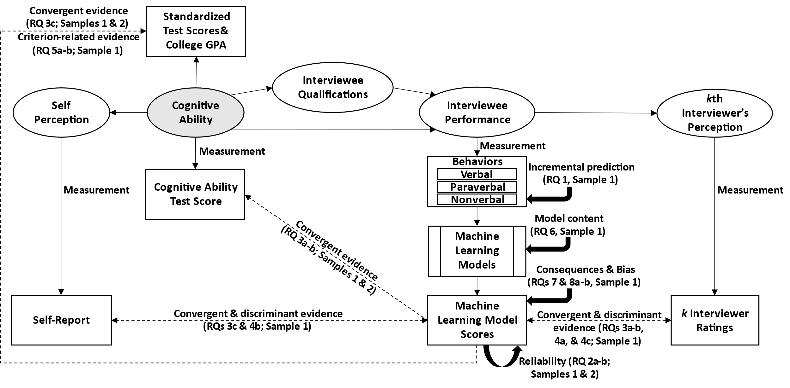
Note: Adapted and expanded from Hickman, Bosch, et al. (2022). Solid lines indicate conceptual, process, causal, and operational relationships; dashed lines indicate examined relationships.

Figure S2

Nested cross-validation procedure in Sample 1
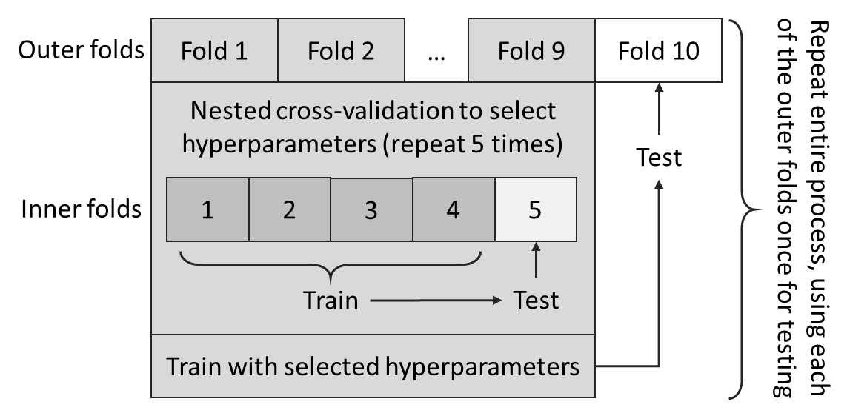

Figure S3

Histogram of GMA in Sample 1
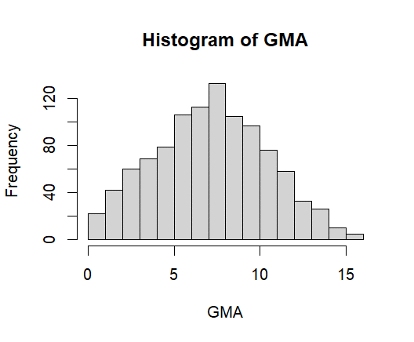

Figure S4

Histogram of verbal ability in Sample 1
