Online Supplement
Table of Contents

Item Page

Study 1 Survey 2
Simplified Chinese 2
English Translation 4

Study 1 Description of Control Variables 6

Study 1 Results with All Controls 12

Study 1 Correlation Table with All Controls 14

Study 1 Regression Table with All Controls 20

Study 2 Instructions 21

Study 3 Instructions 22

Study 4 Instructions 23

Study 1 Survey
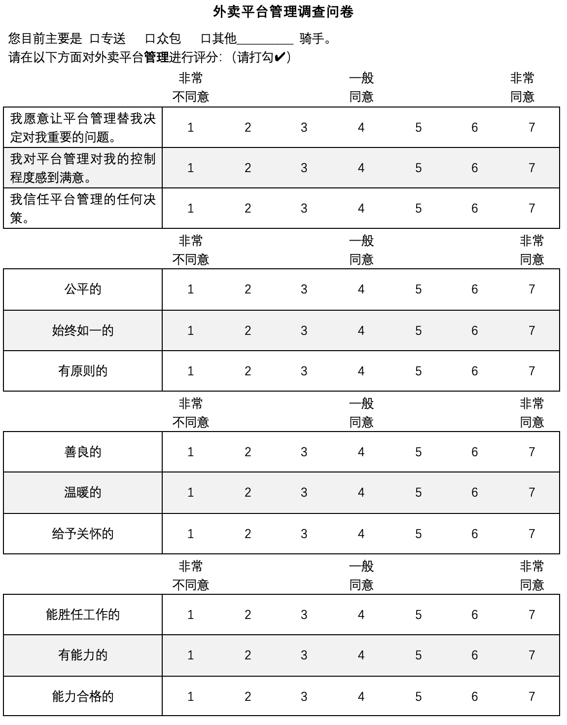
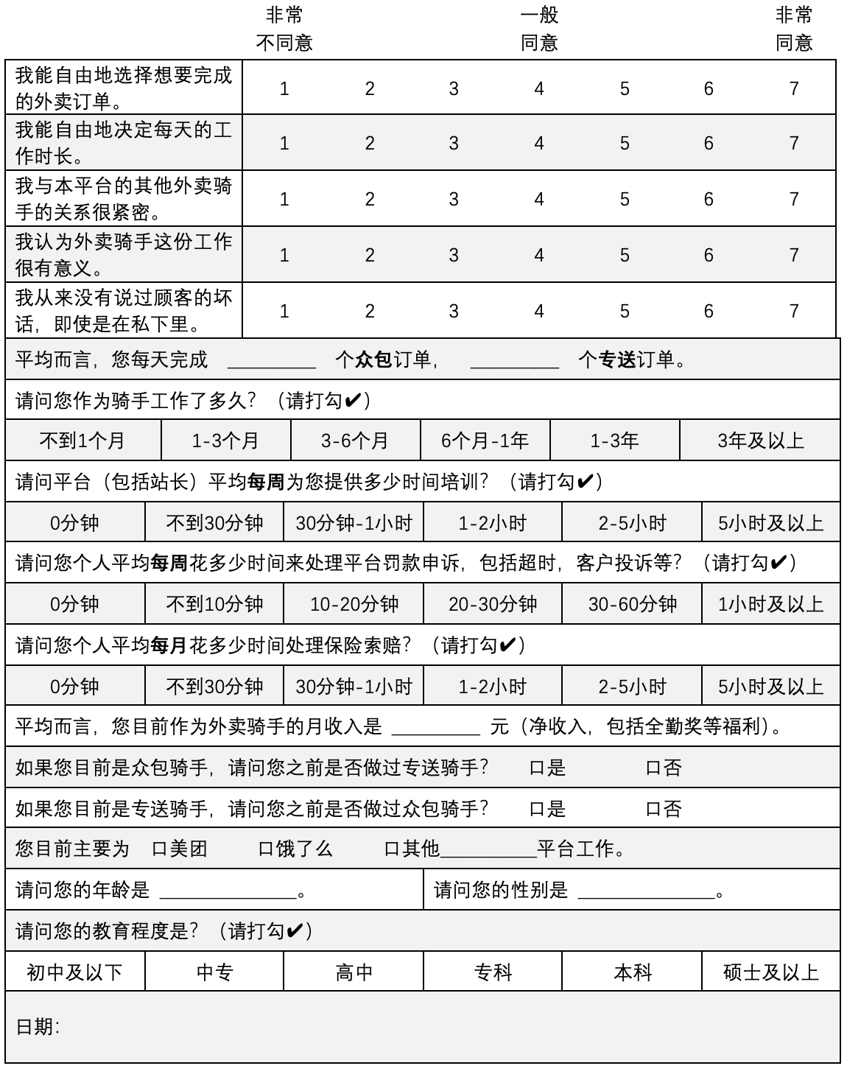

We present below the English translation of the survey where “Outsourced” refers to riders under AI + Human management and “Crowdsourced” refers to riders under AI management.
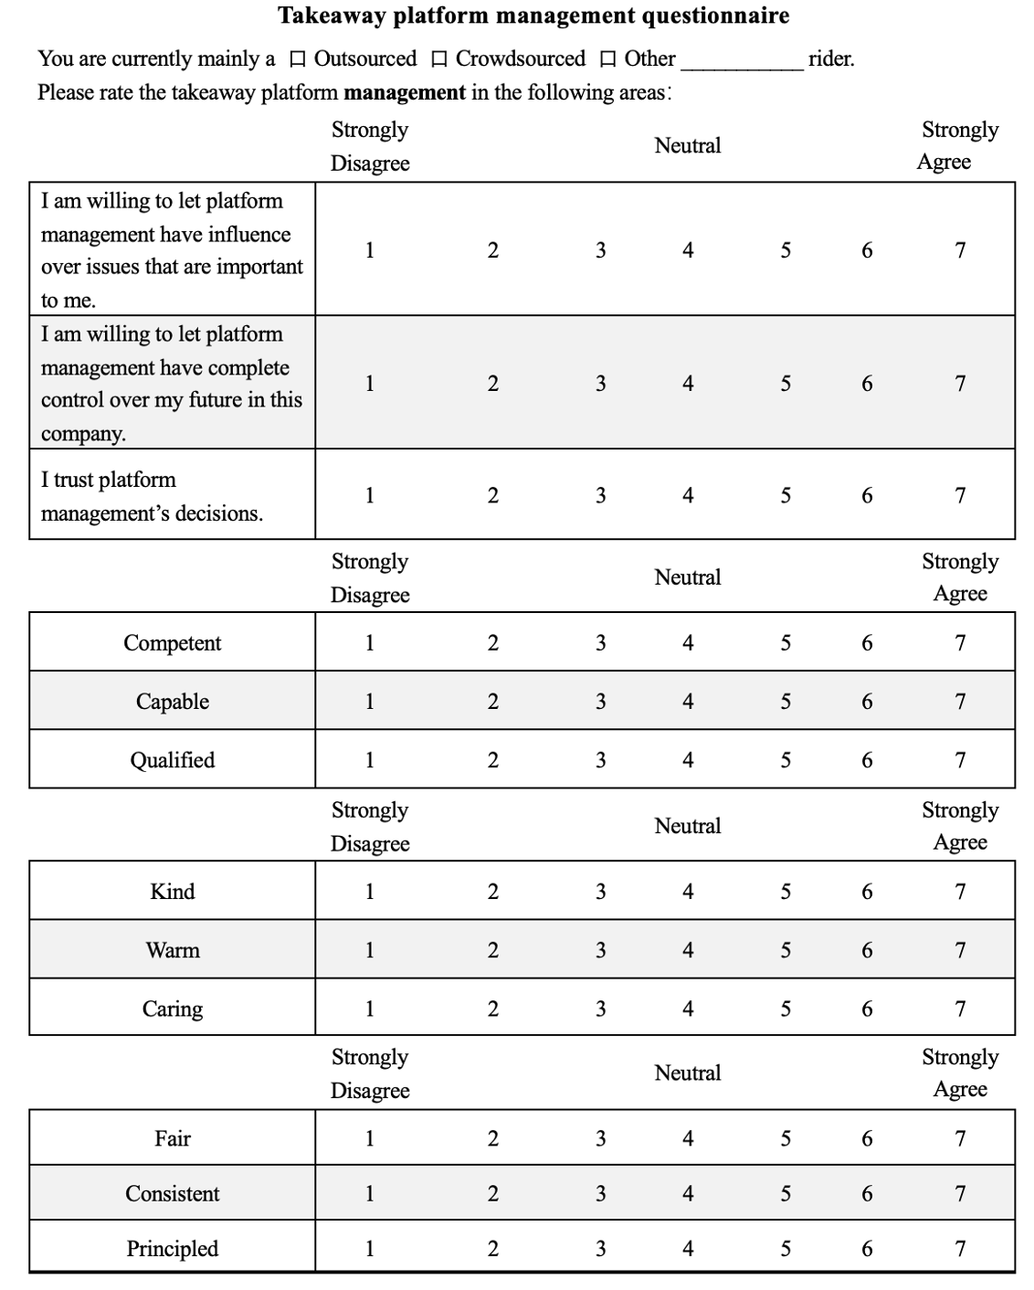
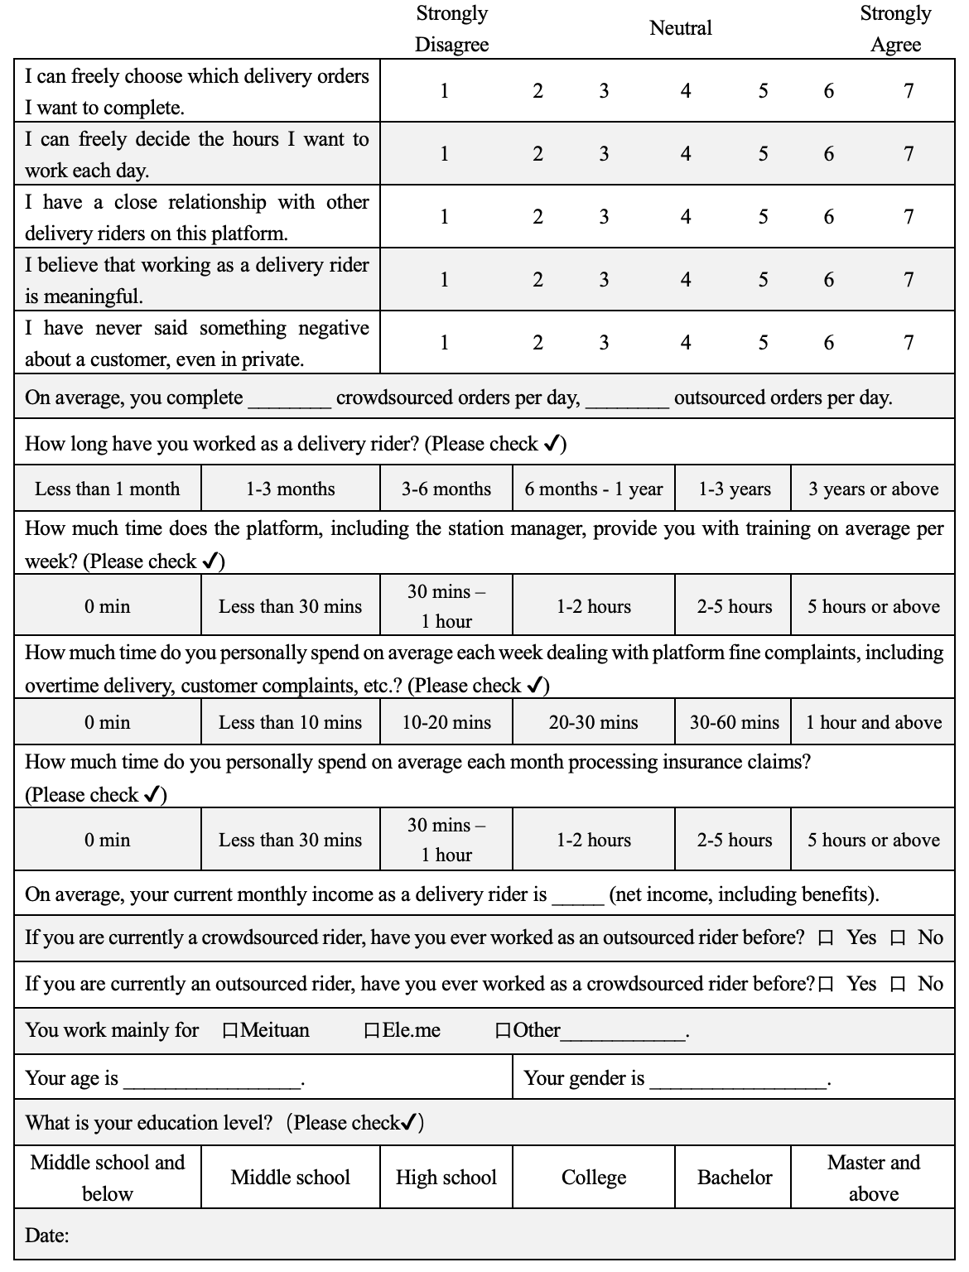

Study 1 Control Variables
We identified 19 control variables to control for differences between the two types of riders beyond the management mode (i.e., AI management vs. AI + Human management).
Platform
Rationale: Because different platforms use different AI-powered apps, we believe that this may affect participants’ perceptions of management’s overall ability, which in turn affects trust in management.
Measurement: “You work mainly for:”; “Meituan”, “Ele.Me”, or “Other Platform”.
In our analyses, we control for Platform 1 (1 = Platform 1, 0 = Platform 2, 0 = “Other Platform”) and Platform 2 (0 = Platform 1, 1 = Platform 2, 0 = “Other Platform”). We have concealed the names of the specific platforms in our data and analyses to protect the privacy of the delivery drivers.
Work Tenure
Rationale: Hoff & Bashir (2015) noted that people’s trust trajectory in virtual AI shows a tendency to be first higher and then lower, so we need to control for participants’ familiarity with the AI in order to minimize its noisy influence on our main effect. Additionally, trust of management, AI or human, will likely be correlated with tenure, given that individuals who do not trust management will likely leave the organization.
Measurement: “How long have you worked as a delivery rider?”; 1 = “Less than one month”, 2 = “One to three months”, 3 = “Three to six months’, 4 = “Six months to one year”, 5 = “One to three years”, and 6 = “More than three years”.

Prior Work Experience
Rationale: Whether participants had previous experience working as another type of rider would likely bias their evaluations of management. For example, a prior negative experience with a specific human manager could cause participants to switch from being an AI + Human management rider to an AI management rider.
Measurement: “If you are currently a crowdsourced rider, have you ever worked as an outsourced rider before?” and “If you are currently an outsourced rider, have you ever worked as a crowdsourced rider before?”; 0 = “No”, 1 = “Yes”.
Job Autonomy
Rationale: These two types of riders have different degrees of job freedom, and according to Hackman & Oldham (1976), job characteristics such as autonomy will influence employees’ job satisfaction, which in turn affects their perceptions of management.
Measurement: “I can freely choose which delivery orders I want to complete”, “I can freely decide the hours I want to work each day”; 7-point Likert: 1 = “Strongly Disagree”, 7 = “Strongly Agree”, ρ = 0.73.
Monthly Income, Order & Alternative Order
Rationale: Payment (including order volumes and monthly income) enhances the attractiveness of the job, which, in turn, might affect participants’ trust in platform management. We control for the number of orders they receive from management, the number of orders they receive working as the other type of rider (e.g., if they are an AI + human rider who also works as an AI rider), and salary to account for the fact that orders and salary might not be perfectly correlated given dynamic pricing and potential differences in the dynamic pricing for the two types of riders.
Measurement: “On average, your current monthly income as a delivery rider is ___ net income, including benefits.”, “On average, you complete ___ crowdsourced orders per day, ___ outsourced orders per day.” In our analysis, we control for orders (i.e., the number of orders they complete per day in their primary job) and alternative orders (i.e., the number of orders they complete per day if they also work as the other type of rider).
Training
Rationale: Receiving training may cause participants to trust management more, regardless of if the management type is AI + Human or AI. Our preliminary interviews with the drivers also revealed that the AI + Human management drivers tend to receive more training than the AI management drivers. Given that the difference in the amount of training is not inherently due to the presence or absence of a human, we control for it in our analysis.
Measurement: “How much time does the platform, including the station manager, provide you with training on average per week?”; 1 = “0 min”, 2 = “Less than thirty mins”, 3 = “Thirty mins to one hour”, 4 = “One to two hours”, 5 = “Two to five hours”, and 6 = “More than five hours”.
Fine Appeal
Rationale: The two types of riders follow different criteria for fines, which may affect participants’ trust in management, but this effect is not caused by the fact that management is AI or human.
Measurement: “How much time do you personally spend on average each week dealing with platform fine complaints, including overtime delivery, customer complaints, etc.?”; 1 = “0 min”, 2 = “Less than ten mins”, 3 = “Ten to twenty mins”; 4 = “Twenty to thirty mins”; 5 = “Thirty to sixty mins”, and 6 = “More than sixty mins”.
Insurance Claim
Rationale: The two types of riders follow different criteria for insurance, which may affect participants’ trust in management, but this effect is not caused by the fact that management is AI or AI + Human.
Measurement: “How much time do you personally spend on average each month processing insurance claims?”; 1 = “0 min”, 2 = “Less than thirty mins”, 3 = “Thirty mins to one hour”, 4 = “One to two hours”, 5 = “Two to five hours”, and 6 = “More than five hours”.
Group Identity
Rationale: Since AI + Human management riders are managed as groups and AI management riders are each individually interfaced with the platform, this can lead to different levels of closeness to their coworkers, which can lead to different levels of satisfaction with their work which might influence trust in platform management.
Measurement: “I have a close relationship with other delivery riders on this platform”; 7-point Likert: 1 = “Strongly Disagree”, 7 = “Strongly Agree”.
Job Meaning
Rationale: There might be individual level differences in the extent to which the riders find meaning from their job, leading to different levels of satisfaction with the job which might influence trust in the platform management.
Measurement: “I believe that working as a delivery rider is meaningful”; 7-point Likert: 1 = “Strongly Disagree”, 7 = “Strongly Agree”.
Social Desirability
Rationale: We controlled for social desirability to account for differences in the extent to which participants might feel comfortable being honest.
Measurement: “I have never said something negative about a customer, even in private”; 7-point Likert: 1 = “Strongly Disagree”, 7 = “Strongly Agree” (adapted from Crowne & Marlowe, 1960).
Age
Rationale: We controlled for age in case general optimism and trust of management might be correlated with age.
Gender
Rationale: Female participants may be more sensitive to the level of management benevolence, resulting in biased ratings. Additionally, given that the occupation tends to be male dominated, there could be factors related to gender which might influence the extent to which a rider views management as benevolent and trusts it.
Measurement: 0 = “Female”, 1 = “Male”.
Education
Rationale: Different levels of education may lead to different levels of understanding of the questionnaire by the participants, which in turn may affect the scores. Additionally, we thought that satisfaction with the job, and in turn trust of management, might be influenced by level of education.
Measurement: 1 = “Junior middle school graduate and below”, 2 = “Senior middle school graduate”, 3 = “High school graduate”, 4 = “Associate degree in college (2-year)”, 5 = “Bachelor’s degree in college (4-year)”, and 6 = “Master’s degree and above”.
Date
Rationale: The extent to which riders were busy varied by day (e.g., riders were busier on weekends than on weekdays). To account for the possibility that the extent to which participants might be satisfied with their job and trust management might vary depending on the particular day, we controlled for the date.
Measurement: 0 = “June 21”, 1 = “June 22”, 2 = “June 23”, 3 = “June 27”, 4 = “June 28”, 5 = “June 29”, and 6 = “idk”.
Survey Order
Rationale: To randomize the order of the ability, benevolence, and integrity scales, we created six versions of the survey. We randomly distributed each version of the survey to the drivers. To account for potential order effects, we recorded the survey order which was given to each rider.
Measurement: e.g., For “abi”, we asked participants to rate the ability of management, then benevolence, and then integrity; 0 = “abi”, 1 = “aib”, 2 = “bai”, 3 = “bia”, 4 = “iab”, and 5 = “iba”.
Location
Rationale: We control for location to account for potential differences in regional policies and job characteristics (e.g., how demanding the job might be, the extent to which customers are friendly) which might influence assessments of management.
Measurement: 0 = “Linyi”, 1 = “Shenzhen”.

Study 1 Results with All Controls
Trust. We find that ratings of trust are significantly lower in the AI Management group (M = 3.62, SD = 1.78) than in the AI + Human Management group (M = 4.33, SD = 1.79), β = -0.71, SE = 0.18, p < .001, η² = 0.04. Our results remain significant, β = -0.49, SE = 0.24, p = 0.046, η² = 0.01, with all control variables.
Benevolence. Participants rate the platform management as significantly lower in benevolence in the AI Management group (M = 3.44, SD = 1.82) than in the AI + Human Management group (M = 4.90, SD = 1.75), β = -1.46, SE = 0.18, p < .001, η² = 0.14. Our results remain significant, β = -1.09, SE = 0.23, p < .001, η² = 0.07, with all control variables.
Ability. Participants rate platform management as significantly lower in ability in the AI Management condition (M = 4.79, SD = 1.71) than in the AI + Human Management condition (M = 5.21, SD = 1.50), β = -0.42, SE = 0.16, p = .01, η² = 0.02. Our results are no longer significant, β = -0.09, SE = 0.21, p = .662, η² = 0.00, with all control variables.
Integrity. Participants rate the platform management as significantly lower in integrity in the AI Management condition (M = 4.35, SD = 1.75) than in the AI + Human Management group (M = 4.77, SD = 1.72), β = -0.42, SE = 0.17, p = .017, η² = 0.01. Our results are not significant, β = 0.23, SE = 0.23, p = .327, η² = 0.00, with all control variables.
Mediation. We conducted 10,000 simulation bootstrap analyses (Hayes & Preacher, 2014; Preacher & Hayes, 2004, 2008) to investigate whether ability, benevolence, and integrity mediate the relationship between management type and participants’ trust. More specifically, we examined trust as the dependent variable and management type (AI vs. AI + Human) as the independent variable, with ability, benevolence, and integrity as simultaneous mediators. We find significant indirect effects of ability (IE = -0.05, 95% CI [-0.13, -0.00]), benevolence (IE = -0.59, 95% CI [-0.83, -0.38]), and integrity (IE = -0.07, 95% CI [-0.17, -0.01]) on the relationship between management type and trust. After adding all control variables, we find a significant indirect effect of benevolence on the relationship between management type and trust (IE = -0.39, 95% CI [-0.63, -0.20]), but no significant indirect effects for ability (IE = -0.01, 95% CI [-0.07, 0.05]) and integrity (IE = 0.02, 95% CI [-0.04, 0.08]).

Table 1. Means, Standard Deviations, and Correlations for Study 1 (Full Controls).
Variable | M | SD | 1 | 2 | 3 | 4 | 5 | 6 | 7 | 8 | 9
1. Rider Typeª | 0.50 | 0.50 | -
2. Trust | 3.98 | 1.82 | -.195***  N = 400 | (0.87)
3. Ability | 5.00 | 1.62 | -.128*  N = 400 | .422***  N = 400 | (0.90)
4. Benevolence | 4.17 | 1.93 | -.380***  N = 400 | .566***  N = 400 | .512***  N = 400 | (0.93)
5. Integrity | 4.56 | 1.75 | -.119*  N = 400 | .437***  N = 400 | .542***  N = 400 | .493***  N = 400 | (0.90)
6. Platform 1 | 0.90 | 0.30 | .057  N = 391 | .009  N = 391 | .047  N = 391 | -.051  N = 391 | .001  N = 391 | -
7. Platform 2 | 0.11 | 0.31 | -.039  N = 391 | -.018  N = 391 | -.039  N = 391 | .026  N = 391 | -.024  N = 391 | -.864***  N = 391 | -
8. Platform 3 | 0.01 | 0.10 | -.053  N = 391 | -.027  N = 391 | -.010  N = 391 | .013  N = 391 | .034  N = 391 | -.301***  N = 391 | -.035  N = 391 | -
9. Work Tenure | 4.00 | 1.55 | .456***  N = 397 | -.177***  N = 397 | -.143**  N = 397 | -.250***  N = 397 | -.213***  N = 397 | -.060  N = 390 | .064  N = 390 | .082  N = 390 | -
10. Prior Work Experience | 0.43 | 0.50 | .255***  N = 390 | -.118*  N = 390 | -.098  N = 390 | -.087  N = 390 | -.119*  N = 390 | -.102*  N = 384 | .119*  N = 384 | .015  N = 384 | .307***  N = 389
11. Job Autonomy | 4.55 | 1.94 | .184***  N = 400 | .296***  N = 400 | .410***  N = 400 | .220***  N = 400 | .270***  N = 400 | .036  N = 391 | -.023  N = 391 | -.074  N = 391 | .078  N = 397
12. Order | 42.04 | 14.17 | .024  N = 380 | .062  N = 380 | .110*  N = 380 | .048  N = 380 | .149**  N = 380 | .054  N = 375 | -.081  N = 375 | .067  N = 375 | .074  N = 377
13. Alternative Order | 0.16 | 1.71 | .060  N = 380 | -.058  N = 380 | -.056  N = 380 | -.055  N = 380 | -.093  N = 380 | -.046  N = 375 | .047  N = 375 | -.010  N = 375 | .028  N = 377
14. Monthly Income | 6376.05 | 2094.51 | .068  N = 369 | -.012  N = 369 | .125*  N = 369 | .011  N = 369 | .000  N = 369 | -.032  N = 365 | .049  N = 365 | -.006  N = 365 | .241***  N = 368
15. Training | 2.95 | 1.37 | -.369***  N = 397 | .215***  N = 397 | .165***  N = 397 | .330***  N = 397 | .292***  N = 397 | -.005  N = 389 | -.012  N = 389 | .003  N = 389 | -.279***  N = 396
16. Fine Appeal | 2.69 | 1.48 | .015  N = 397 | -.036  N = 397 | -.059  N = 397 | -.068  N = 397 | -.129*  N = 397 | -.018  N = 389 | .021  N = 389 | .004  N = 389 | .022  N = 396
17. Insurance Claim | 1.54 | 1.01 | -.081  N = 397 | .126*  N = 397 | .010  N = 397 | .086  N = 397 | .021  N = 397 | .018  N = 389 | -.026  N = 389 | -.054  N = 389 | -.089  N = 396
18. Group Identity | 4.96 | 1.76 | -.060  N = 396 | .298***  N = 396 | .403***  N = 396 | .310***  N = 396 | .393***  N = 396 | -.001  N = 388 | .001  N = 388 | .045  N = 388 | -.009  N = 394
19. Job Meaning | 4.53 | 1.94 | -.146**  N = 395 | .444***  N = 395 | .487***  N = 395 | .509***  N = 395 | .443***  N = 395 | .062  N = 386 | -.099  N = 386 | .012  N = 386 | -.110*  N = 392
20. Social Desirability | 5.08 | 2.02 | .045  N = 397 | .248***  N = 397 | .273***  N = 397 | .182***  N = 397 | .158**  N = 397 | -.015  N = 388 | .018  N = 388 | -.029  N = 388 | .027  N = 394
21. Age | 29.92 | 8.29 | .194***  N = 391 | -.002  N = 391 | -.025  N = 391 | -.041  N = 391 | -.064  N = 391 | -.026  N = 386 | .024  N = 386 | .055  N = 386 | .410***  N = 388
22. Gender^{b} | 0.98 | 0.15 | -.017  N = 378 | .097  N = 378 | .054  N = 378 | .037  N = 378 | .052  N = 378 | -.054  N = 374 | .054  N = 374 | .016  N = 374 | .045  N = 378
23. Education 1 | 0.19 | 0.39 | .109*  N = 385 | .025  N = 385 | -.070  N = 385 | -.106*  N = 385 | -.071  N = 385 | .028  N = 381 | -.010  N = 381 | -.049  N = 381 | .083  N = 384
24. Education 2 | 0.21 | 0.40 | .033  N = 385 | .028  N = 385 | -.002  N = 385 | .035  N = 385 | .076  N = 385 | .000  N = 381 | -.025  N = 381 | .012  N = 381 | .026  N = 384
25. Education 3 | 0.37 | 0.48 | -.066  N = 385 | -.110*  N = 385 | -.025  N = 385 | -.022  N = 385 | -.071  N = 385 | -.028  N = 381 | .039  N = 381 | .028  N = 381 | .031  N = 384
26. Education 4 | 0.18 | 0.38 | -.045  N = 385 | .048  N = 385 | .058  N = 385 | .021  N = 385 | .027  N = 385 | .069  N = 381 | -.050  N = 381 | -.048  N = 381 | -.151**  N = 384
27. Education 5 | 0.05 | 0.22 | .007  N = 385 | .058  N = 385 | .068  N = 385 | .112*  N = 385 | .074  N = 385 | -.122*  N = 381 | .079  N = 381 | .095  N = 381 | .045  N = 384
28. Education 6 | 0.01 | 0.09 | -.091  N = 385 | .011  N = 385 | .030  N = 385 | .059  N = 385 | .060  N = 385 | .030  N = 381 | -.031  N = 381 | -.009  N = 381 | -.114*  N = 384
29. Survey Version 1 | 0.16 | 0.37 | .007  N = 400 | .033  N = 400 | .052  N = 400 | -.028  N = 400 | .026  N = 400 | .033  N = 391 | -.062  N = 391 | .094  N = 391 | -.001  N = 397
30. Survey Version 2 | 0.17 | 0.37 | .000  N = 400 | -.008  N = 400 | -.005  N = 400 | -.027  N = 400 | -.024  N = 400 | -.056  N = 391 | .047  N = 391 | -.045  N = 391 | .060  N = 397
31. Survey Version 3 | 0.17 | 0.38 | .000  N = 400 | .040  N = 400 | -.024  N = 400 | .003  N = 400 | -.001  N = 400 | .019  N = 391 | -.004  N = 391 | -.046  N = 391 | -.048  N = 397
32. Survey Version 4 | 0.17 | 0.38 | .000  N = 400 | -.010  N = 400 | -.066  N = 400 | -.003  N = 400 | -.021  N = 400 | .019  N = 391 | -.026  N = 391 | -.046  N = 391 | -.074  N = 397
33. Survey Version 5 | 0.17 | 0.37 | .000  N = 400 | -.050  N = 400 | -.029  N = 400 | .017  N = 400 | .028  N = 400 | -.028  N = 391 | .020  N = 391 | .022  N = 391 | .039  N = 397
34. Survey Version 6 | 0.17 | 0.37 | -.007  N = 400 | -.004  N = 400 | .073  N = 400 | .037  N = 400 | -.009  N = 400 | .012  N = 391 | .025  N = 391 | .024  N = 391 | .026  N = 397
35. Date 1 | 0.11 | 0.32 | .063  N = 400 | .191***  N = 400 | -.029  N = 400 | .027  N = 400 | .014  N = 400 | -.008  N = 391 | .002  N = 391 | -.037  N = 391 | .030  N = 397
36. Date 2 | 0.33 | 0.47 | .053  N = 400 | -.080  N = 400 | .075  N = 400 | .027  N = 400 | .211***  N = 400 | .113*  N = 391 | -.140**  N = 391 | .036  N = 391 | -.143**  N = 397
37. Date 3 | 0.06 | 0.24 | -.217***  N = 400 | .124*  N = 400 | .055  N = 400 | .171***  N = 400 | .104*  N = 400 | .054  N = 391 | -.057  N = 391 | -.027  N = 391 | -.074  N = 397
38. Date 4 | 0.23 | 0.42 | -.349***  N = 400 | -.034  N = 400 | -.019  N = 400 | .044  N = 400 | -.157**  N = 400 | -.045  N = 391 | .115*  N = 391 | -.054  N = 391 | -.047  N = 397
39. Date 5 | 0.15 | 0.36 | .221***  N = 400 | -.020  N = 400 | -.028  N = 400 | -.041  N = 400 | -.102*  N = 400 | -.180***  N = 391 | .147**  N = 391 | .096  N = 391 | .148**  N = 397
40. Date 6 | 0.09 | 0.28 | .257***  N = 400 | -.094  N = 400 | -.073  N = 400 | -.216***  N = 400 | -.081  N = 400 | .047  N = 391 | -.051  N = 391 | -.032  N = 391 | .137**  N = 397
41. Date 7 | 0.02 | 0.15 | .017  N = 400 | -.035  N = 400 | -.003  N = 400 | -.037  N = 400 | -.017  N = 400 | .049  N = 391 | -.050  N = 391 | -.015  N = 391 | .022  N = 397
42. Location^{c} | 0.50 | 0.50 | .000  N = 400 | -.104*  N = 400 | -.073  N = 400 | -.112*  N = 400 | -.256***  N = 400 | -.126*  N = 391 | .157**  N = 391 | .002  N = 391 | .145**  N = 397

Table 1. Continued Table
Variable | 10 | 11 | 12 | 13 | 14 | 15 | 16 | 17 | 18 | 19 | 20
10. Prior Work Experience | -
11. Job Autonomy | .056  N = 390 | (0.73)
12. Order | -.051  N = 372 | -.012  N = 380 | -
13. Alternative Order | .093  N = 372 | -.023  N = 380 | -.131*  N = 380 | -
14. Monthly Income | .130*  N = 361 | .080  N = 369 | .425***  N = 355 | -.063  N = 355 | -
15. Training | -.156**  N = 388 | .011  N = 397 | .124*  N = 377 | -.033  N = 377 | .011  N = 367 | -
16. Fine Appeal | .010  N = 388 | .035  N = 397 | .049  N = 377 | .069  N = 377 | .069  N = 367 | .160**  N = 396 | -
17. Insurance Claim | -.048  N = 388 | .017  N = 397 | -.068  N = 377 | .051  N = 377 | -.003  N = 367 | .145**  N = 396 | .341***  N = 396 | -
18. Group Identity | -.014  N = 387 | .307***  N = 396 | .202***  N = 376 | -.150**  N = 376 | .061  N = 366 | .150**  N = 394 | -.014  N = 394 | -.017  N = 394 | -
19. Job Meaning | -.084  N = 385 | .433***  N = 395 | .066  N = 376 | -.057  N = 376 | .049  N = 365 | .221***  N = 392 | -.098  N = 392 | .036  N = 392 | 456***  N = 393 | -
20. Social Desirability | -.017  N = 387 | .363***  N = 397 | .045  N = 377 | -.039  N = 377 | -.025  N = 366 | .111*  N = 394 | .007  N = 394 | .000  N = 394 | .206***  N = 395 | .280***  N = 394 | -
21. Age | .098  N = 381 | .017  N = 391 | .058  N = 375 | .074  N = 375 | -.003  N = 365 | -.065  N = 388 | -.046  N = 388 | -.036  N = 388 | .051  N = 387 | -.009  N = 386 | .131*  N = 388
22. Gender^{b} | .030  N = 370 | -.061  N = 378 | .006  N = 361 | .017  N = 361 | .090  N = 353 | -.007  N = 377 | -.010  N = 377 | .013  N = 377 | .126*  N = 376 | -.092  N = 375 | -.036  N = 376
23. Education 1 | .029  N = 377 | .072  N = 385 | -.086  N = 367 | .015  N = 367 | -.069  N = 360 | -.122*  N = 383 | -.024  N = 383 | .058  N = 383 | .059  N = 382 | .042  N = 380 | .116*  N = 382
24. Education 2 | .095  N = 377 | .011  N = 385 | .033  N = 367 | -.049  N = 367 | .039  N = 360 | -.042  N = 383 | .013  N = 383 | -.017  N = 383 | .102*  N = 382 | .098  N = 380 | -.062  N = 382
25. Education 3 | -.042  N = 377 | -.060  N = 385 | -.065  N = 367 | .075  N = 367 | -.011  N = 360 | .002  N = 383 | .018  N = 383 | .002  N = 383 | -.101*  N = 382 | -.107*  N = 380 | -.089  N = 382
26. Education 4 | -.001  N = 377 | -.020  N = 385 | .096  N = 367 | -.043  N = 367 | .098  N = 360 | .102*  N = 383 | -.016  N = 383 | -.048  N = 383 | -.072  N = 382 | -.069  N = 380 | .018  N = 382
27. Education 5 | -.125*  N = 377 | .025  N = 385 | .067  N = 367 | -.022  N = 367 | -.067  N = 360 | .059  N = 383 | .000  N = 383 | .027  N = 383 | .057  N = 382 | .073  N = 380 | .042  N = 382
28. Education 6 | -.017  N = 377 | -.010  N = 385 | .007  N = 367 | -.009  N = 367 | -.074  N = 360 | .131*  N = 383 | .019  N = 383 | -.046  N = 383 | .001  N = 382 | .067  N = 380 | .083  N = 382
29. Survey Version 1 | .108*  N = 390 | .065  N = 400 | -.029  N = 380 | -.007  N = 380 | -.009  N = 369 | -.034  N = 397 | -.108*  N = 397 | -.030  N = 397 | .053  N = 396 | .034  N = 395 | .033  N = 397
30. Survey Version 2 | -.030  N = 390 | .017  N = 400 | .024  N = 380 | -.041  N = 380 | -.041  N = 369 | -.092  N = 397 | .056  N = 397 | -.026  N = 397 | .033  N = 396 | -.034  N = 395 | -.031  N = 397
31. Survey Version 3 | -.105*  N = 390 | .072  N = 400 | .003  N = 380 | .105*  N = 380 | .056  N = 369 | .090  N = 397 | .072  N = 397 | .106*  N = 397 | -.009  N = 396 | .065  N = 395 | -.028  N = 397
32. Survey Version 4 | -.096  N = 390 | -.130**  N = 400 | -.046  N = 380 | -.021  N = 380 | -.093  N = 369 | -.022  N = 397 | -.019  N = 397 | .030  N = 397 | -.123*  N = 396 | -.064  N = 395 | .035  N = 397
33. Survey Version 5 | .039  N = 390 | -.038  N = 400 | .022  N = 380 | .006  N = 380 | .035  N = 369 | -.018  N = 397 | -.049  N = 397 | .014  N = 397 | -.040  N = 396 | -.003  N = 395 | -.065  N = 397
34. Survey Version 6 | .088  N = 390 | .015  N = 400 | .026  N = 380 | -.042  N = 380 | .052  N = 369 | .076  N = 397 | .046  N = 397 | -.097  N = 397 | .088  N = 396 | .001  N = 395 | .056  N = 397
35. Date 1 | .008  N = 390 | .078  N = 400 | -.067  N = 380 | .005  N = 380 | -.207***  N = 369 | .025  N = 397 | .027  N = 397 | -.024  N = 397 | .004  N = 396 | .024  N = 395 | .025  N = 397
36. Date 2 | -.128*  N = 390 | .000  N = 400 | .213***  N = 380 | -.067  N = 380 | -.196***  N = 369 | .034  N = 397 | -.113*  N = 397 | -.086  N = 397 | .237***  N = 396 | .070  N = 395 | -.052  N = 397
37. Date 3 | -.081  N = 390 | -.088  N = 400 | .149**  N = 380 | -.025  N = 380 | -.097  N = 369 | .139**  N = 397 | -.002  N = 397 | -.006  N = 397 | .047  N = 396 | .063  N = 395 | .072  N = 397
38. Date 4 | .018  N = 390 | -.080  N = 400 | -.208***  N = 380 | -.010  N = 380 | .140**  N = 369 | .077  N = 397 | .024  N = 397 | .095  N = 397 | -.159**  N = 396 | -.046  N = 395 | -.031  N = 397
39. Date 5 | .165**  N = 390 | .040  N = 400 | -.070  N = 380 | .004  N = 380 | .219***  N = 369 | -.143**  N = 397 | .027  N = 397 | .020  N = 397 | -.002  N = 396 | -.096  N = 395 | .034  N = 397
40. Date 6 | .015  N = 390 | .048  N = 400 | .006  N = 380 | -.029  N = 380 | .158**  N = 369 | -.132**  N = 397 | .065  N = 397 | -.036  N = 397 | -.130*  N = 396 | .003  N = 395 | .018  N = 397
41. Date 7 | .038  N = 390 | .014  N = 400 | -.060  N = 380 | .354***  N = 380 | .013  N = 369 | -.007  N = 397 | .043  N = 397 | .086  N = 397 | -.131**  N = 396 | -.015  N = 395 | -.040  N = 397
42. Location^{c} | .140**  N = 390 | -.008  N = 400 | -.240***  N = 380 | .072  N = 380 | .374***  N = 369 | -.107*  N = 397 | .098  N = 397 | .101*  N = 397 | -.239***  N = 396 | -.097  N = 395 | .005  N = 397

Table 1. Continued Table
Variable | 21 | 22 | 23 | 24 | 25 | 26 | 27 | 28 | 29 | 30 | 31
21. Age | -
22. Gender^{b} | .008  N = 376 | -
23. Education 1 | .218***  N = 380 | -.110*  N = 369 | -
24. Education 2 | -.027  N = 380 | .081  N = 369 | -.244***  N = 385 | -
25. Education 3 | -.036  N = 380 | .012  N = 369 | -.369***  N = 385 | -.391***  N = 385 | -
26. Education 4 | -.131*  N = 380 | -.017  N = 369 | -.224***  N = 385 | -.237***  N = 385 | -.359***  N = 385 | -
27. Education 5 | .005  N = 380 | .037  N = 369 | -.109*  N = 385 | -.116*  N = 385 | -.175***  N = 385 | -.106*  N = 385 | -
27. Education 6 | -.083  N = 380 | .014  N = 369 | -.043  N = 385 | -.045  N = 385 | -.068  N = 385 | -.041  N = 385 | -.020  N = 385 | -
29. Survey Version 1 | -.048  N = 391 | -.023  N = 378 | .014  N = 385 | .065  N = 385 | -.034  N = 385 | -.014  N = 385 | -.032  N = 385 | -.038  N = 385 | -
30. Survey Version 2 | -.003  N = 391 | .021  N = 378 | -.053  N = 385 | .084  N = 385 | .018  N = 385 | -.027  N = 385 | -.037  N = 385 | -.040  N = 385 | -.196***  N = 400 | -
31. Survey Version 3 | -.034  N = 391 | -.065  N = 378 | .043  N = 385 | -.013  N = 385 | -.027  N = 385 | .000  N = 385 | .022  N = 385 | -.041  N = 385 | -.199***  N = 400 | -.201***  N = 400 | -
32. Survey Version 4 | -.039  N = 391 | -.022  N = 378 | .026  N = 385 | -.064  N = 385 | .030  N = 385 | .000  N = 385 | -.010  N = 385 | .037  N = 385 | -.199***  N = 400 | -.201***  N = 400 | -.205***  N = 400
33. Survey Version 5 | .065  N = 391 | .071  N = 378 | -.038  N = 385 | -.023  N = 385 | -.016  N = 385 | .042  N = 385 | .025  N = 385 | .118*  N = 385 | -.196***  N = 400 | -.198***  N = 400 | -.201***  N = 400
34. Survey Version 6 | .060  N = 391 | .020  N = 378 | .007  N = 385 | -.048  N = 385 | .029  N = 385 | -.002  N = 385 | .031  N = 385 | -.039  N = 385 | -.198***  N = 400 | -.199***  N = 400 | -.203***  N = 400
35. Date 1 | .123*  N = 391 | -.050  N = 378 | .008  N = 385 | -.009  N = 385 | -.018  N = 385 | .058  N = 385 | -.047  N = 385 | -.033  N = 385 | -.031  N = 400 | .030  N = 400 | .004  N = 400
36. Date 2 | -.012  N = 391 | -.036  N = 378 | -.002  N = 385 | .021  N = 385 | -.067  N = 385 | .027  N = 385 | .042  N = 385 | .062  N = 385 | -.016  N = 400 | .008  N = 400 | -.001  N = 400
37. Date 3 | .042  N = 391 | -.028  N = 378 | -.045  N = 385 | .023  N = 385 | -.028  N = 385 | -.013  N = 385 | .135**  N = 385 | -.023  N = 385 | .082  N = 400 | -.003  N = 400 | -.007  N = 400
38. Date 4 | -.091  N = 391 | .040  N = 378 | -.022  N = 385 | -.092  N = 385 | .112*  N = 385 | .005  N = 385 | -.031  N = 385 | -.046  N = 385 | -.018  N = 400 | -.053  N = 400 | -.013  N = 400
39. Date 5 | -.029  N = 391 | .066  N = 378 | .051  N = 385 | .030  N = 385 | -.019  N = 385 | -.033  N = 385 | -.032  N = 385 | -.038  N = 385 | -.058  N = 400 | .052  N = 400 | -.010  N = 400
40. Date 6 | -.001  N = 391 | -.010  N = 378 | .011  N = 385 | .041  N = 385 | .000  N = 385 | -.054  N = 385 | -.030  N = 385 | .075  N = 385 | .079  N = 400 | .005  N = 400 | .025  N = 400
41. Date 7 | .036  N = 391 | .021  N = 378 | -.023  N = 385 | .016  N = 385 | .039  N = 385 | -.021  N = 385 | -.033  N = 385 | -.013  N = 385 | .025  N = 400 | -.067  N = 400 | .021  N = 400
42. Location^{c} | -.092  N = 391 | .081  N = 378 | .016  N = 385 | -.028  N = 385 | .096  N = 385 | -.059  N = 385 | -.076  N = 385 | -.027  N = 385 | -.007  N = 400 | -.013  N = 400 | .000  N = 400

Table 1. Continued Table
Variable | 32 | 33 | 34 | 35 | 36 | 37 | 38 | 39 | 40 | 41 | 42
32. Survey Version 4 | -
33. Survey Version 5 | -.201***  N = 400 | -
34. Survey Version 6 | -.203***  N = 400 | -.199***  N = 400 | -
35. Date 1 | .025  N = 400 | -.055  N = 400 | .027  N = 400 | -
36. Date 2 | .013  N = 400 | .037  N = 400 | -.040  N = 400 | -.250***  N = 400 | -
37. Date 3 | -.034  N = 400 | -.059  N = 400 | .022  N = 400 | -.093  N = 400 | -.179***  N = 400 | -
38. Date 4 | .050  N = 400 | .026  N = 400 | .007  N = 400 | -.198***  N = 400 | -.382***  N = 400 | -.142**  N = 400 | -
39. Date 5 | -.010  N = 400 | .052  N = 400 | -.026  N = 400 | -.154**  N = 400 | -.297***  N = 400 | -.111*  N = 400 | -.236***  N = 400 | -
40. Date 6 | -.046  N = 400 | -.090  N = 400 | .027  N = 400 | -.112*  N = 400 | -.215***  N = 400 | -.080  N = 400 | -.170***  N = 400 | -.133**  N = 400 | -
41. Date 7 | -.069  N = 400 | .069  N = 400 | .022  N = 400 | -.055  N = 400 | -.105*  N = 400 | -.039  N = 400 | -.084  N = 400 | -.065  N = 400 | -.047  N = 400 | -
42. Location^{c} | .000  N = 400 | .013  N = 400 | .007  N = 400 | -.329***  N = 400 | -.694***  N = 400 | -.258***  N = 400 | .550***  N = 400 | .428***  N = 400 | .310***  N = 400 | .118*  N = 400 | -

Note. Numbers in parentheses are Cronbach’s α coefficients (or Spearman-Brown coefficient) for each scale. M and SD are raw values. ªDummy-coded variable: 0 = AI + Human Riders, 1 = AI Riders. ^{b}Dummy-coded variable: 0 = female, 1 = male. ^{c}Dummy-coded variable: 0 = Linyi, 1 = Shenzhen. *p < .05, **p < .01, ***p < .001.
Table 2. Regression Table for Study 1 (Full Controls).
Variable | Trust
 | Model 1 |  | Model 2 |  | Model 3
 | β | SE | β | SE | β | SE
Constant | 0.724 | (1.070) | 0.614 | (1.066) | -0.228 | (0.982)
Rider Type |  |  | -0.487* | (0.242) | -0.105 | (0.232)
Ability |  |  |  |  | 0.094 | (0.069)
Benevolence |  |  |  |  | 0.361*** | (0.060)
Integrity |  |  |  |  | 0.084 | (0.063)
Platform 1 | -0.096 | (0.614) | 0.095 | (0.618) | 0.320 | (0.567)
Platform 2 | -0.096 | (0.620) | 0.023 | (0.619) | 0.203 | (0.568)
Work Tenure | -0.216** | (0.072) | -0.165* | (0.076) | -0.077 | (0.071)
Prior Work Experience | -0.137 | (0.195) | -0.072 | (0.197) | -0.101 | (0.181)
Job Autonomy | 0.155** | (0.053) | 0.173** | (0.054) | 0.107* | (0.051)
Order | 0.007 | (0.008) | 0.007 | (0.008) | 0.010 | (0.007)
Alternative Order | -0.056 | (0.111) | -0.040 | (0.111) | -0.065 | (0.102)
Monthly Income | 0.000 | (0.000) | 0.000 | (0.000) | 0.000 | (0.000)
Training | 0.048 | (0.075) | 0.010 | (0.077) | -0.061 | (0.072)
Fine Appeal | -0.047 | (0.065) | -0.046 | (0.064) | 0.007 | (0.060)
Insurance Claim | 0.253* | (0.102) | 0.256* | (0.102) | 0.198* | (0.094)
Group Identity | 0.112 | (0.061) | 0.103 | (0.061) | 0.045 | (0.057)
Job Meaning | 0.253*** | (0.059) | 0.246*** | (0.059) | 0.086 | (0.058)
Social Desirability | 0.072 | (0.048) | 0.075 | (0.047) | 0.061 | (0.044)
Age | 0.008 | (0.012) | 0.009 | (0.012) | 0.002 | (0.011)
Gender | 1.476* | (0.590) | 1.474* | (0.587) | 1.292* | (0.539)
Education 1 | -0.030 | (0.295) | -0.018 | (0.293) | -0.264 | (0.270)
Education 2 | -0.169 | (0.268) | -0.179 | (0.267) | -0.334 | (0.245)
Education 3 | 0.279 | (0.321) | 0.301 | (0.320) | -0.001 | (0.295)
Education 4 | 0.074 | (0.448) | 0.139 | (0.447) | -0.266 | (0.412)
Education 5 | -0.171 | (0.982) | -0.290 | (0.979) | -0.503 | (0.896)
Survey Version 1 | 0.174 | (0.318) | 0.164 | (0.316) | -0.045 | (0.291)
Survey Version 2 | -0.080 | (0.317) | -0.058 | (0.316) | -0.002 | (0.290)
Survey Version 3 | 0.219 | (0.314) | 0.248 | (0.313) | 0.006 | (0.288)
Survey Version 4 | -0.131 | (0.310) | -0.136 | (0.308) | -0.286 | (0.283)
Survey Version 5 | -0.019 | (0.320) | -0.036 | (0.318) | -0.213 | (0.293)
Date 1 | -1.466*** | (0.300) | -1.434*** | (0.299) | -1.388*** | (0.274)
Date 2 | 0.037 | (0.443) | -0.120 | (0.448) | -0.517 | (0.413)
Date 3 | 0.582 | (0.960) | 0.582 | (0.955) | 0.686 | (0.874)
Date 4 | 0.627 | (0.971) | 0.817 | (0.971) | 0.864 | (0.888)
Date 5 | 0.179 | (0.976) | 0.439 | (0.980) | 0.704 | (0.898)
Date 6 | 0.080 | (1.020) | 0.226 | (1.017) | 0.211 | (0.933)
Location | -1.408 | (0.964) | -1.555 | (0.962) | -1.508 | (0.880)
R-squared | 0.3782 |  | 0.3870 |  | 0.4927
Note. *p < .05, **p < .01, ***p < .001.

Study 2 Instruction
Scenario Overview: “Imagine that you are working as a delivery driver for Company X, a food delivery platform. Your job is to pick up customer orders from restaurants and to deliver them, on time, to their homes.”
Human Conditions: “Your manager, Ari (Company X’s regional manager), oversees your performance. Ari gives you the orders that you need to complete, tracks if you complete the orders on time, pays you for the orders you complete, and deducts money from your paycheck if you receive a customer complaint.”
AI Conditions: “Your manager, Ari (Company X’s AI powered system), oversees your performance. Ari gives you the orders that you need to complete, tracks if you complete the orders on time, pays you for the orders you complete, and deducts money from your paycheck if you receive a customer complaint.”
Management Conditions: We asked participants to rate Company X’s Management on trust, ability, benevolence, and integrity.
Manager Conditions: We asked participants to rate Ari on trust, ability, benevolence, and integrity.

Study 3 Instruction
Scenario Overview: “Please imagine that you are an employee at Company X. You have been working at Company X for six months. Imagine that you are working as a delivery driver for Company X, a food delivery platform. Your job is to pick up customer orders from restaurants and to deliver them, on time, to their homes.”
Human Conditions: “Your manager, Ari (Company X’s regional manager), oversees your performance. Ari gives you the orders that you need to complete, tracks if you complete the orders on time, pays you for the orders you complete, and deducts money from your paycheck if you receive a customer complaint.”
AI Conditions: “Your manager, Ari (Company X’s AI-powered employee management system), oversees your performance. Ari gives you the orders that you need to complete, tracks if you complete the orders on time, pays you for the orders you complete, and deducts money from your paycheck if you receive a customer complaint.”
High Empathy Conditions: “Imagine you are completing your last order for the day. While driving to the customer’s location, you are hit by someone who ran a red light.”
Low Empathy Conditions: “Imagine you are completing your last order for the day. While driving to the customer’s location, you do not encounter any issues.”

Study 4 Instructions
Pilot Study Instruction
Scenario Overview: “On the following pages, you will read a scenario and then answer some questions about it.”
High Empathy Conditions: “Please imagine that you are an employee at Company X. You have been working at Company X for six months. One day, during your afternoon break, you receive a text message informing you that your mother passed away. You are devastated and need to take next week off for the funeral and to help with the arrangements.”
Low Empathy Conditions: “Please imagine that you are an employee at Company X. You have been working at Company X for six months. You plan on taking next week off for vacation.”
Main Study Instructions
Scenario Overview: “Please imagine that you are an employee at Company X. You have been working at Company X for six months.”
High Empathy Conditions: “One day, during your afternoon break, you receive a text message informing you that your mother passed away. You are devastated and need to take next week off for the funeral and to help with the arrangements.
Company X requires employees to complete and submit a time-off form for management to evaluate and approve. In the form you need to put:
- Name
- Date(s)
- Time
- Reason”
Low Empathy Conditions: “You plan on taking next week off for vacation.
Company X requires employees to complete and submit a time-off form for management to evaluate and approve. In the form you need to put:
- Name
- Date(s)
- Time
- Reason”
Human Conditions: “You request was reviewed and approved by Senior Manager, Mike, who sends you an email confirming your request was approved.”
AI Conditions: “You request was reviewed and approved by Company X’s AI-powered employee management system, which sends you an email, composed using historical internal emails, confirming your request was approved.
You can review the email on the next page.”
High Empathy Conditions: Email
“I am writing to express my deepest condolences on the passing of your mother. Losing a loved one is never easy, and please know that we are here to support you during this difficult time.
I have received your request for a leave of absence, and I want to let you know that it has been approved today, March 29, 2023. Please take the time you need to grieve and take care of yourself and your family. Your job will be waiting for you when you return, and we will do everything we can to make your transition back to work as smooth as possible.
During your absence, we will ensure that your workload is covered by other team members, so that you can take the time you need to be with your family. If you need any further support, please do not hesitate to reach out to us. We are here to help in any way we can.
Once again, please accept my sincere condolences on your loss. We are thinking of you and your family during this difficult time.”
Low Empathy Conditions: Email
“I am writing to inform you that your leave of absence request has been approved today, March 29, 2023. We understand the importance of taking time off for personal and family reasons, and we want to support you in achieving a healthy work-life balance.
We ask that you ensure that all necessary arrangements have been made to ensure that your absence will not adversely affect the operations of the company during your time away.
We appreciate your contributions to the company, and we are confident that you will return to work with renewed energy and focus. If you have any questions or concerns, please do not hesitate to reach out to me or the HR department.
Thank you for your continued commitment to our company, and we wish you all the best during your leave.”

