Supplementary Materials

The following pages offer a visual illustration of the temporal patterns of study variables assessed on a weekly level. For ease of comparison Study 1 variables are followed by corresponding Study 2 variables (e.g., partner flow in Study 1 is followed by partner flow in Study 2).

Study 1 – Coworker work-family support (Actor-rated)

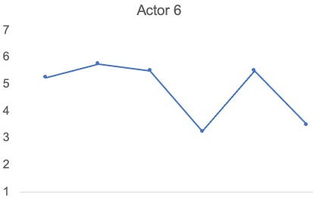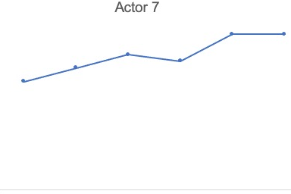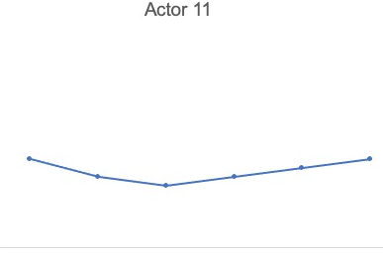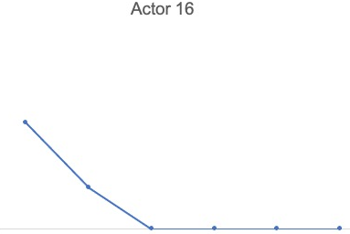
Coworker work-family support
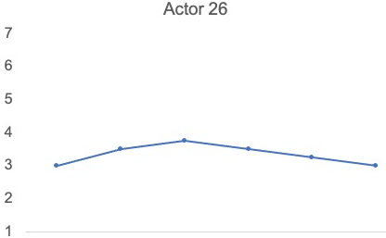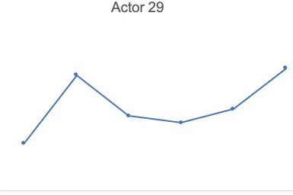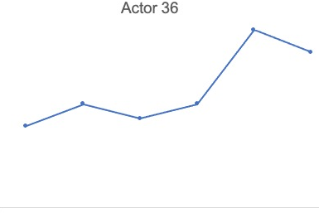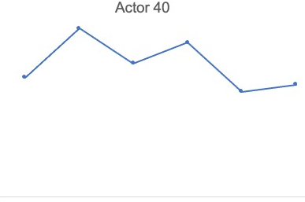
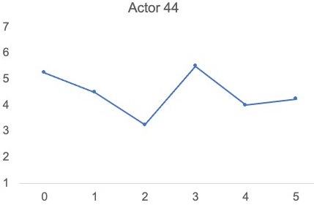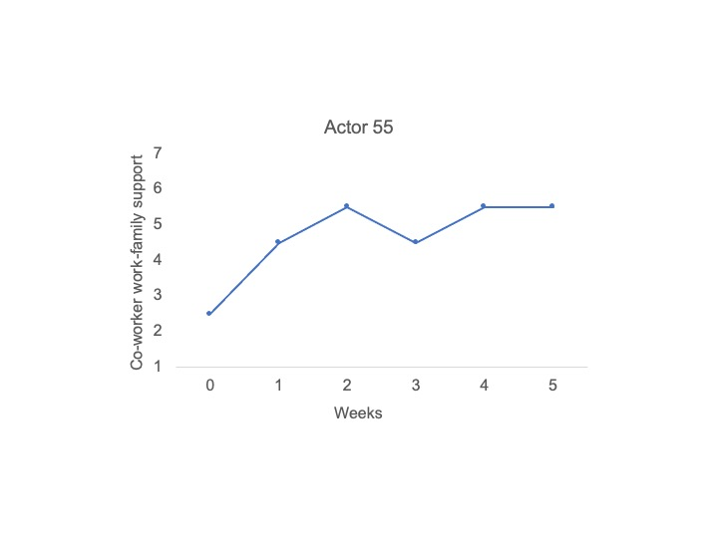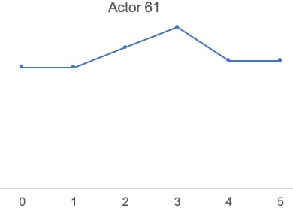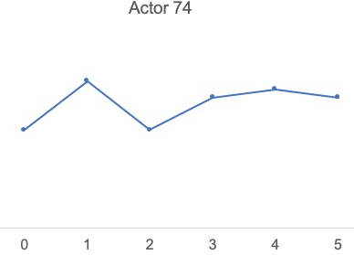
Time in Weeks
Study 2 – Coworker work-family support (Actor-rated)

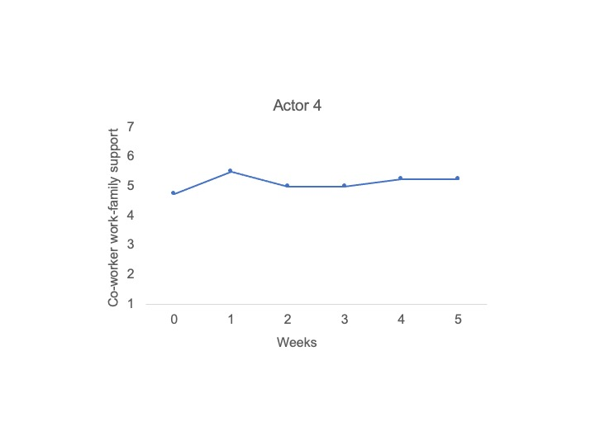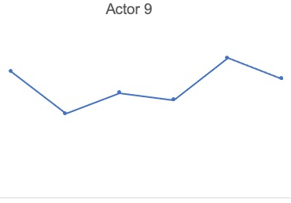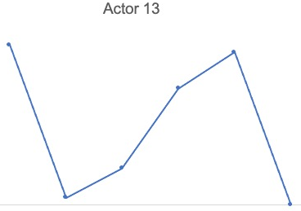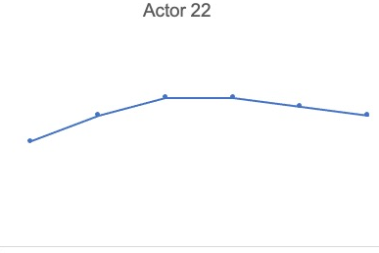
Coworker work-family support
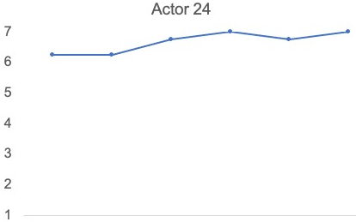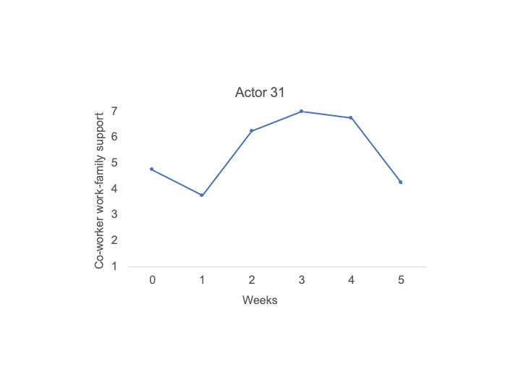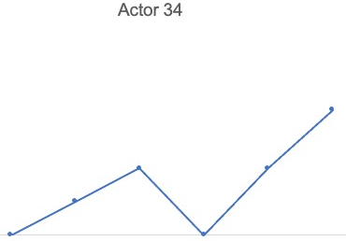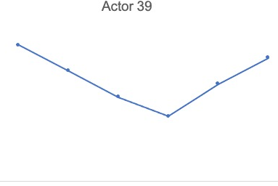
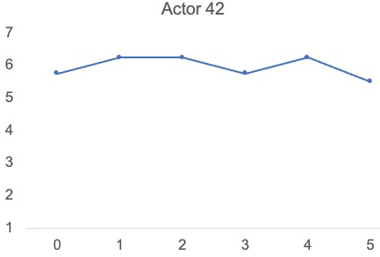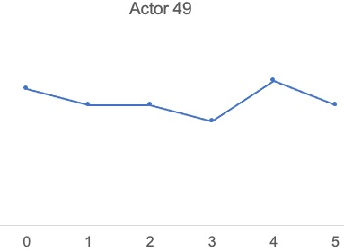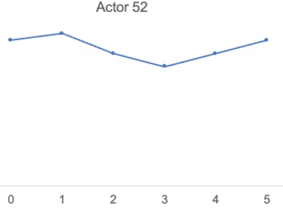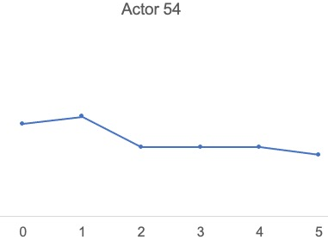
Time in Weeks

Study 1 – Actor work-family support provision

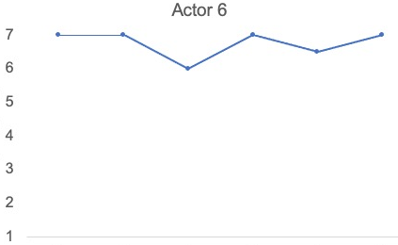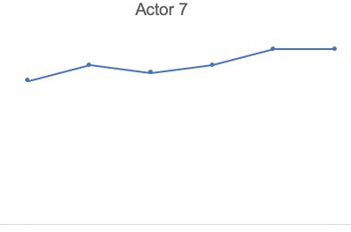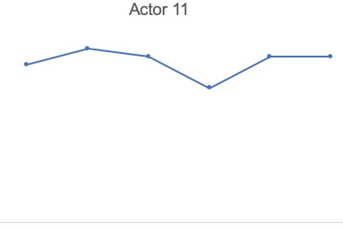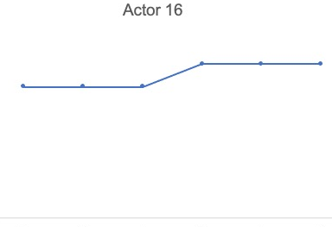
Actor work-family support provision
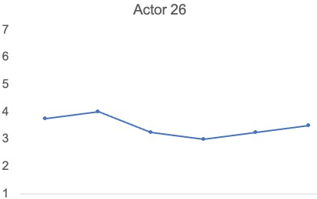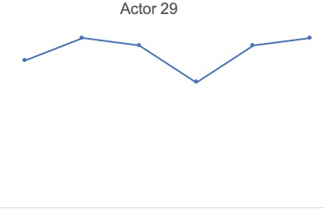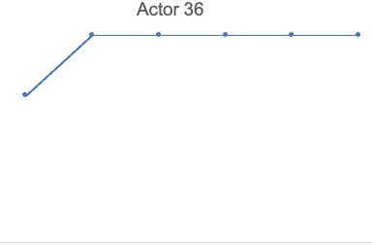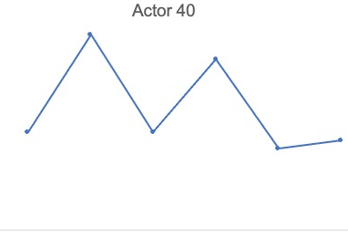
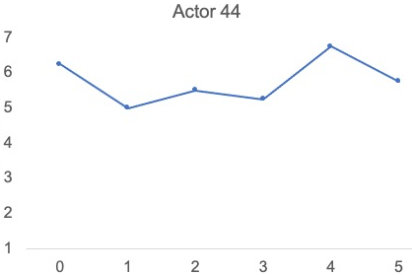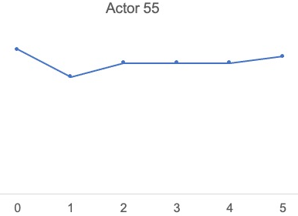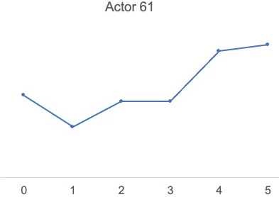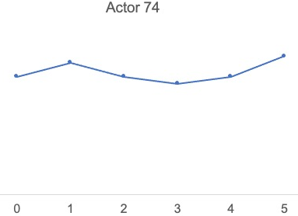
Time in Weeks

Study 2 – Actor work-family support provision

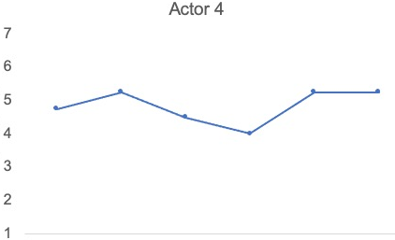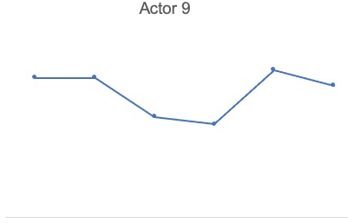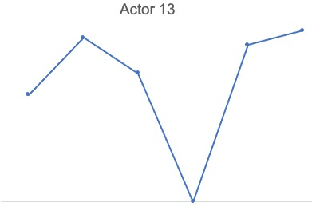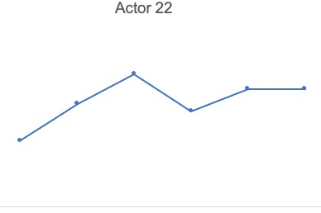
Actor work-family support provision
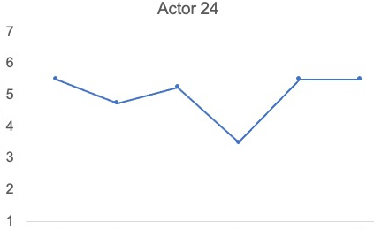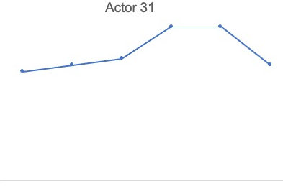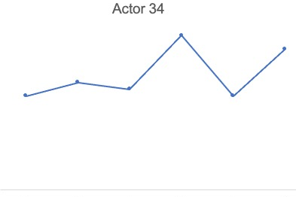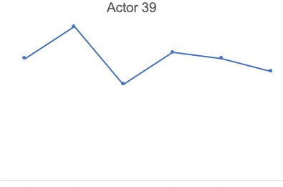
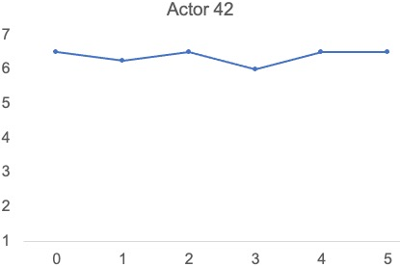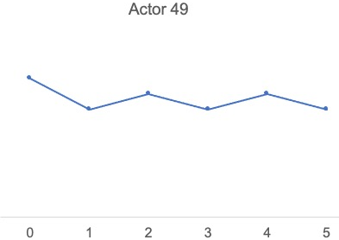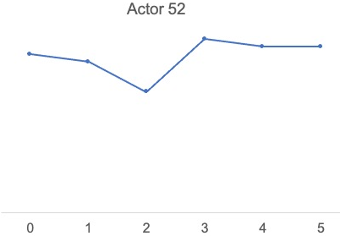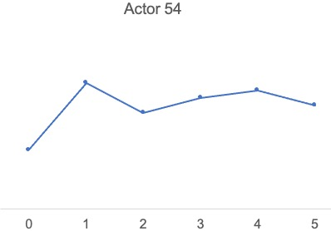
Time in Weeks

Study 1 – Partner work-family support receipt

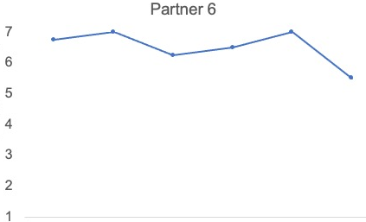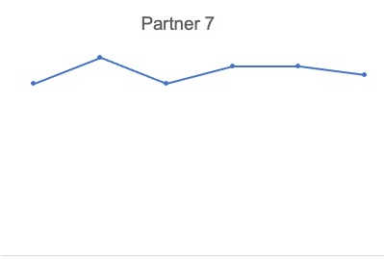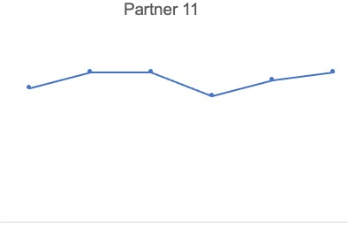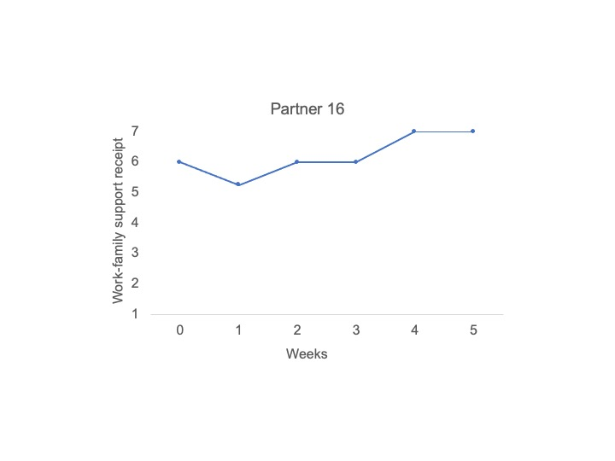
Partner work-family support receipt
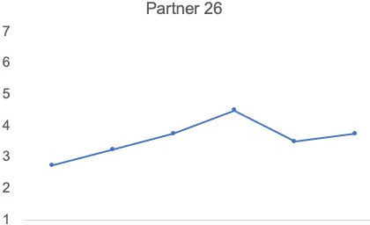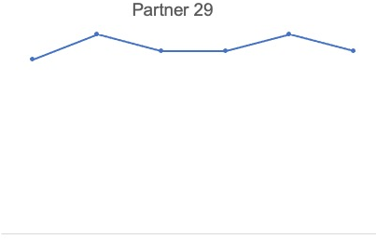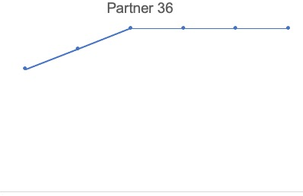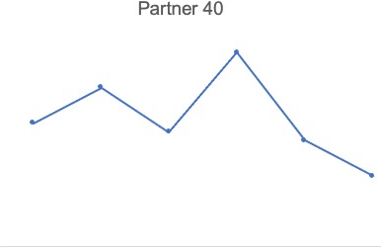
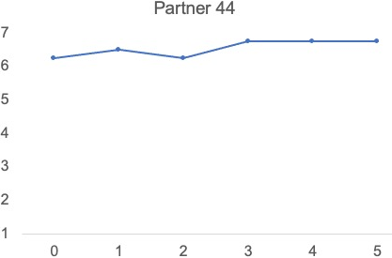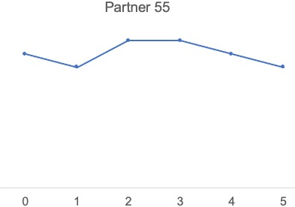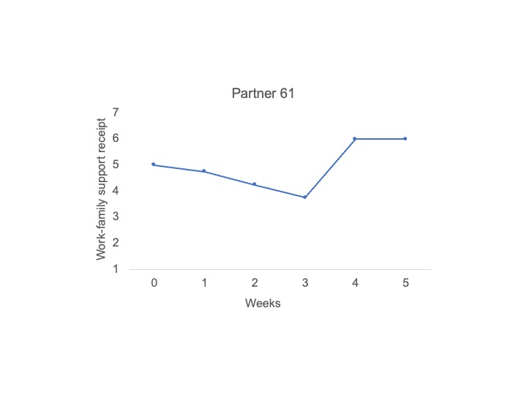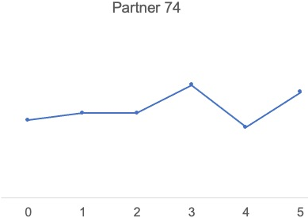
Time in Weeks

Study 2 – Partner work-family support receipt

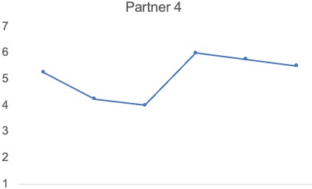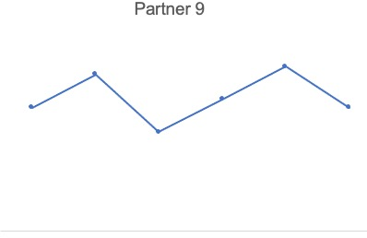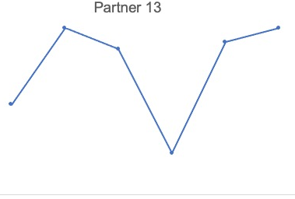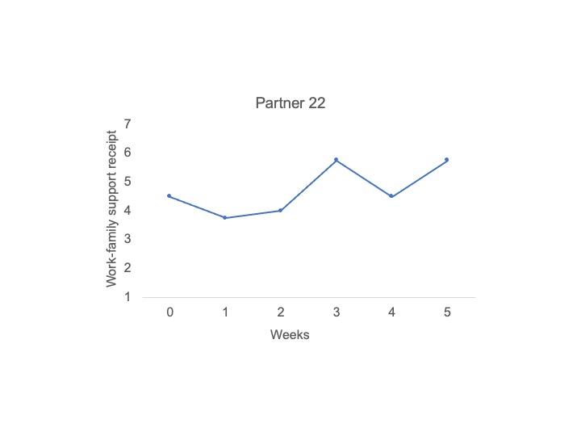
Partner work-family support receipt
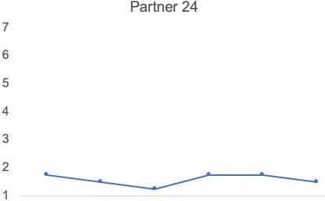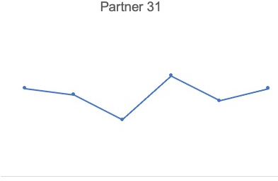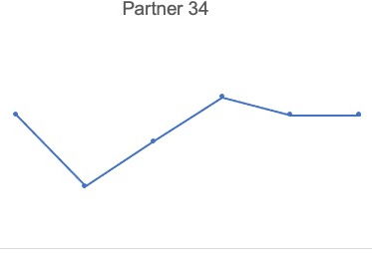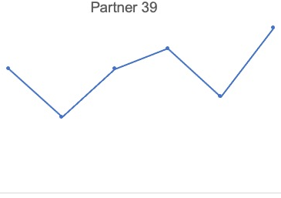
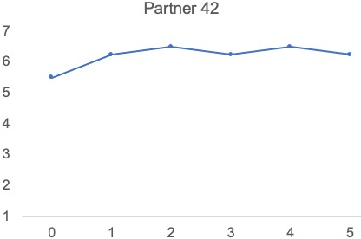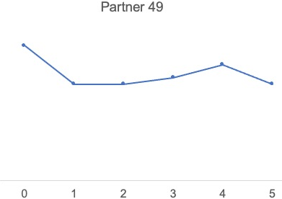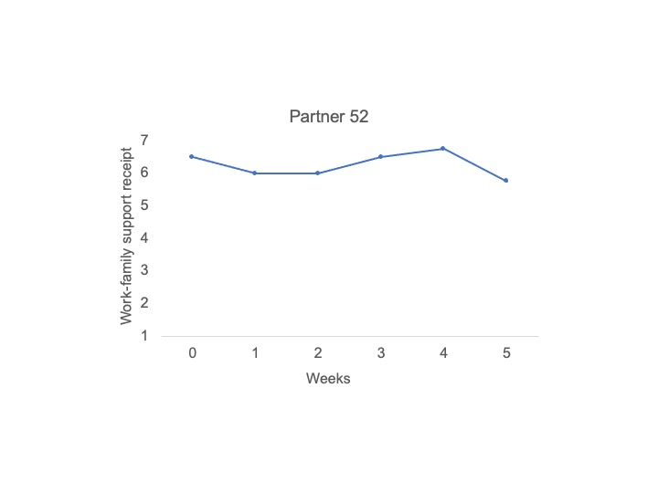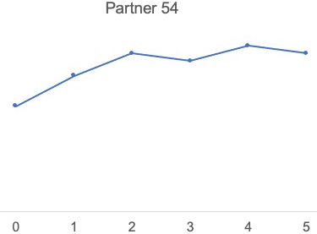
Time in Weeks

Study 1 – Partner work-related flow

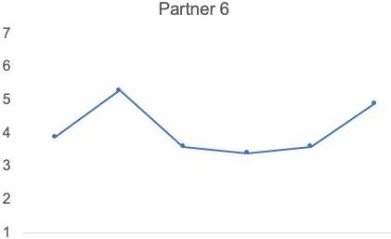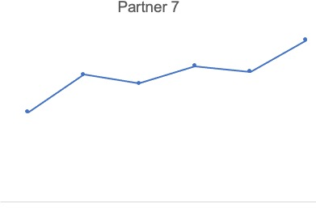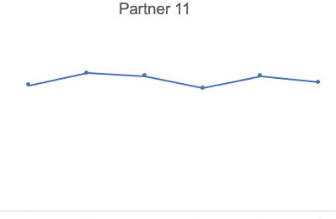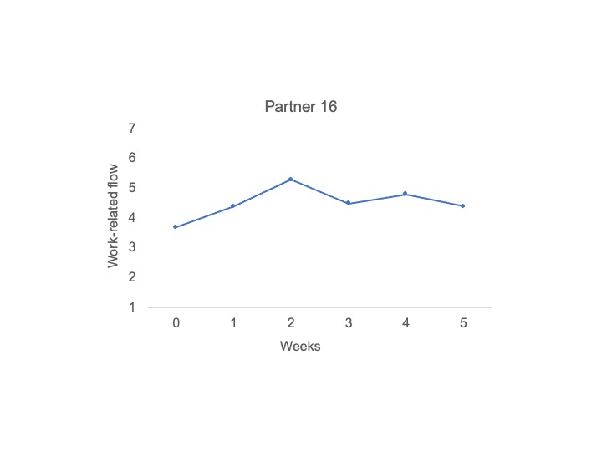
Partner work-related flow
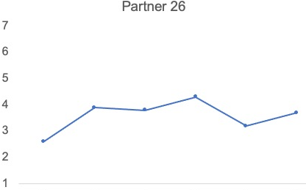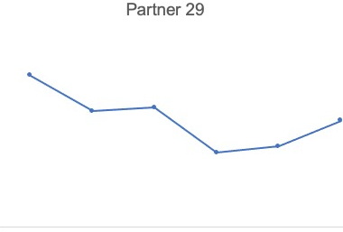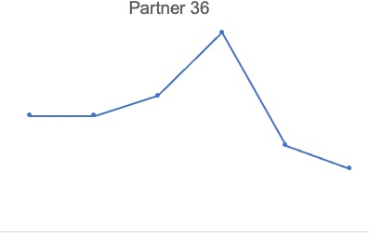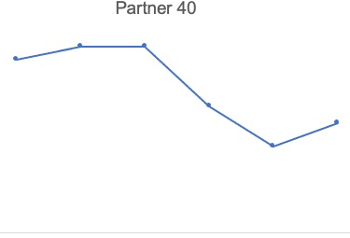
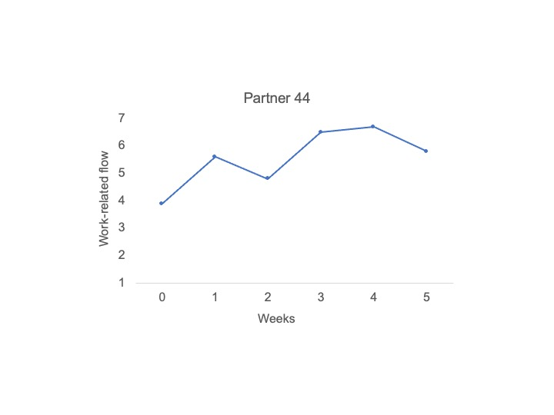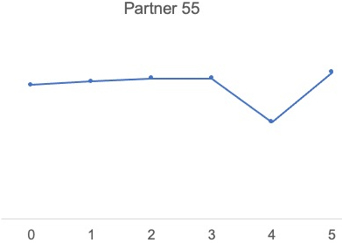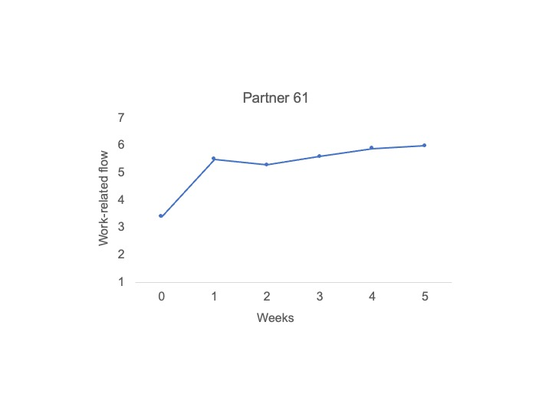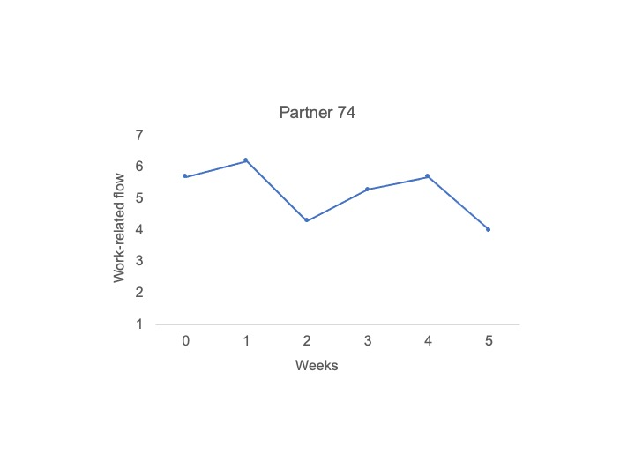
Time in Weeks

Study 2 – Partner work-related flow

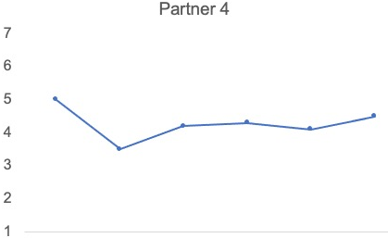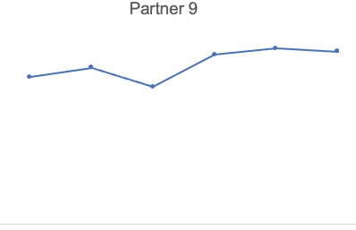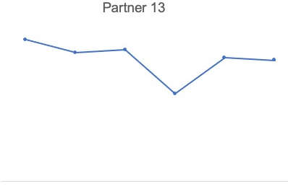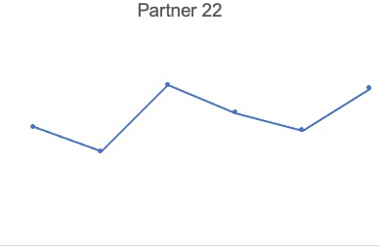
Partner work-related flow
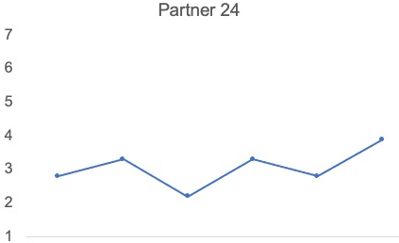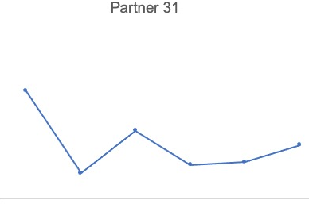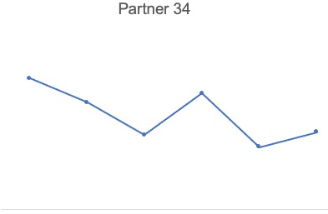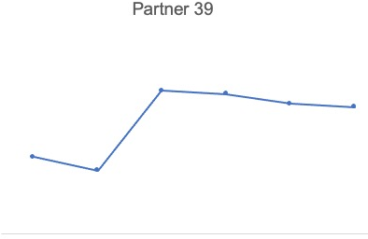
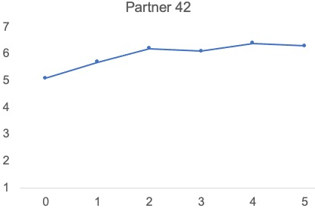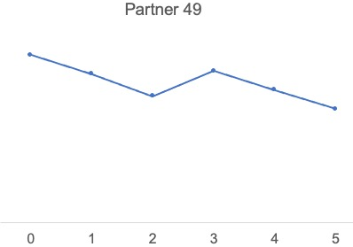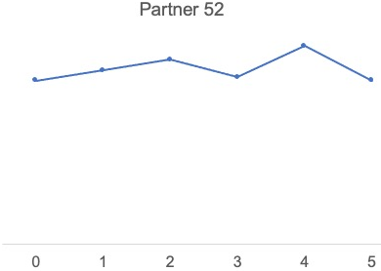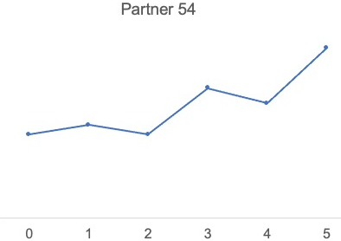
Time in Weeks

Study 1 – Partner work-related creativity

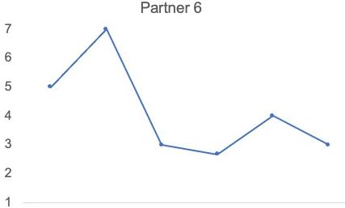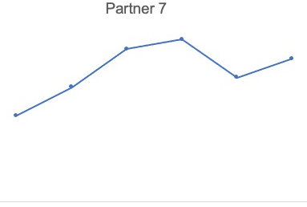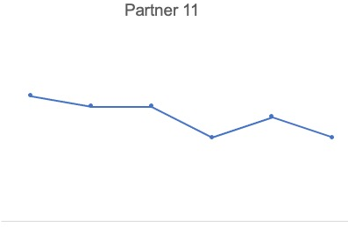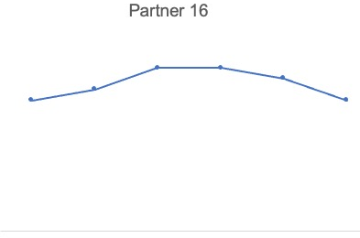
Partner work-related creativity
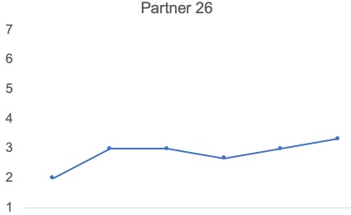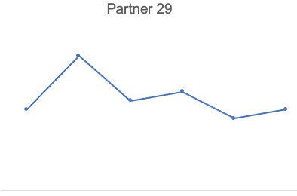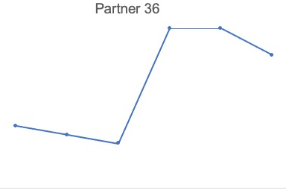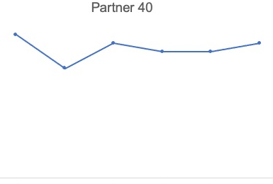
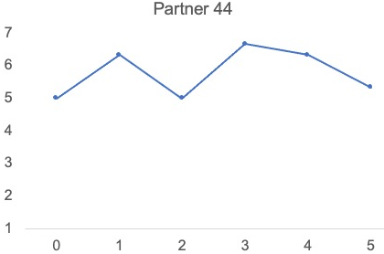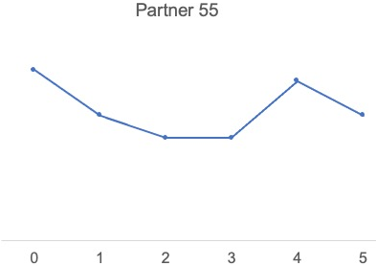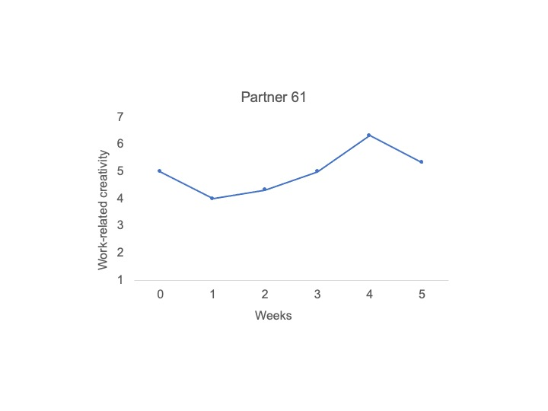
Time in Weeks

Study 2 – Partner work-related creativity

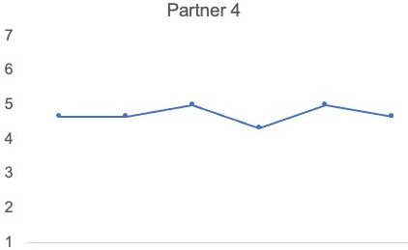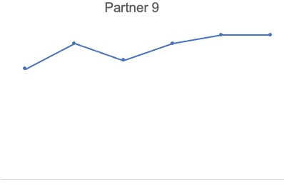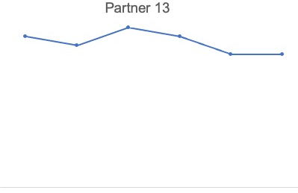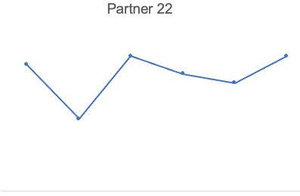
Partner work-related creativity
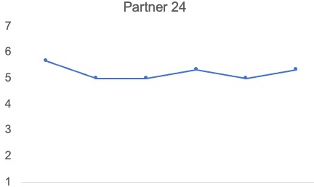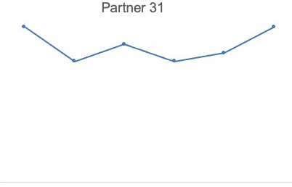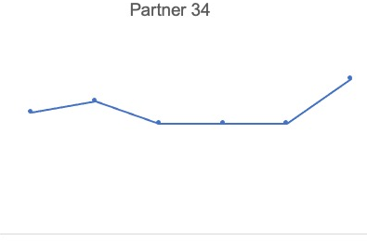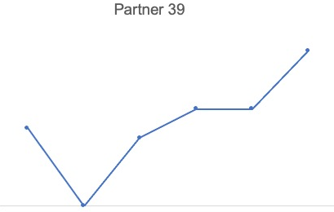
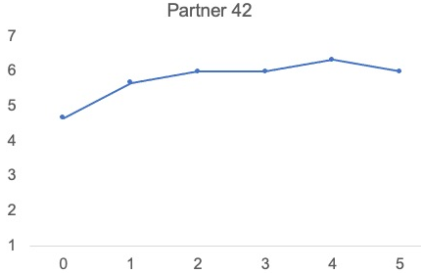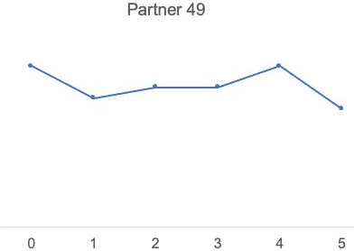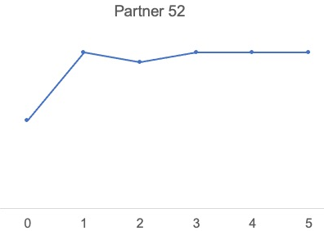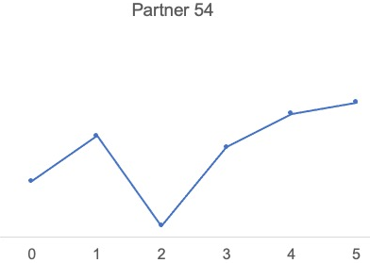
Time in Weeks

Study 2 – Supervisor work-family support (Actor-rated)

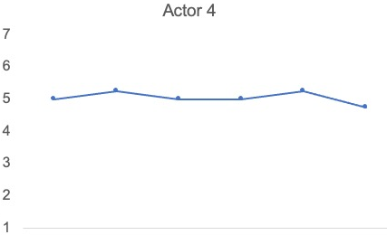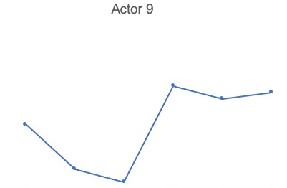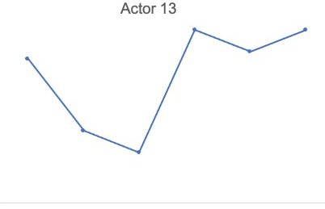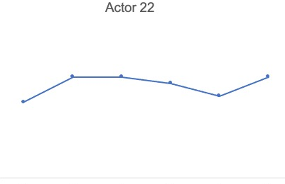
Supervisor work-family support
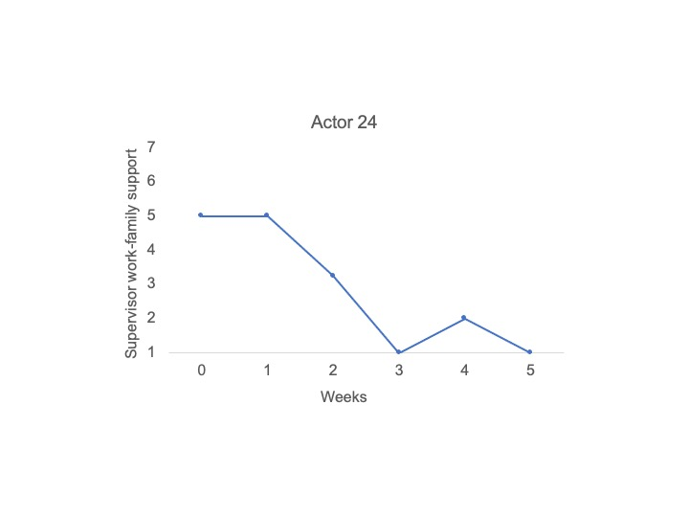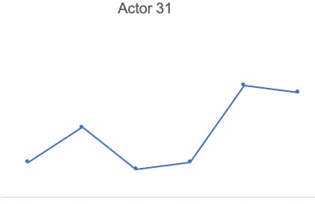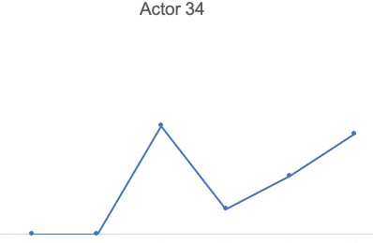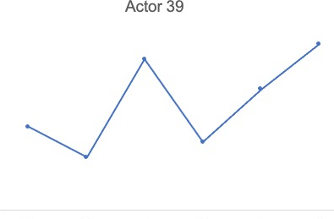
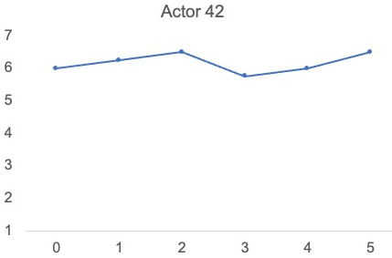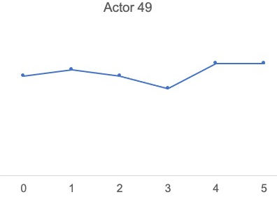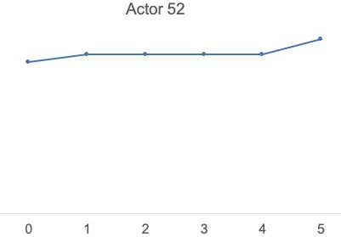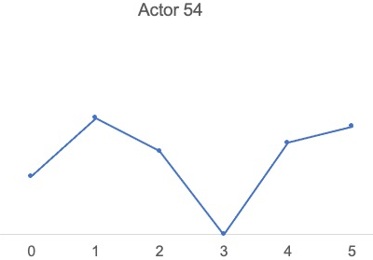
Time in Weeks

Study 2 – Partner positive affect

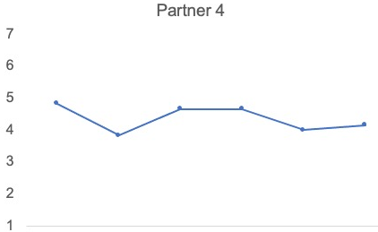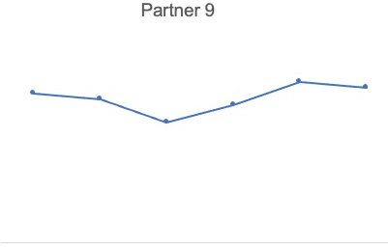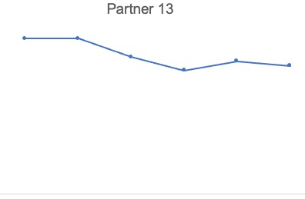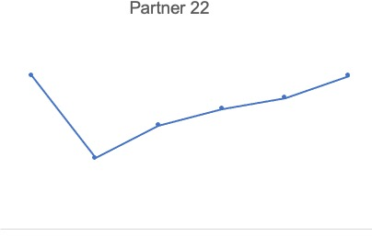
Partner positive affect
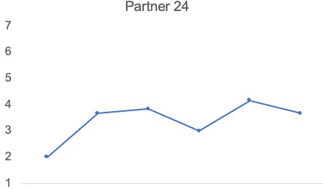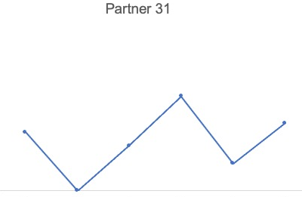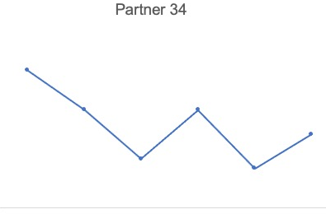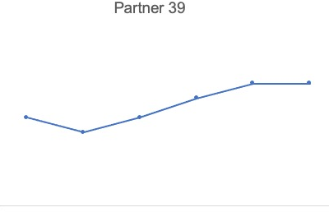
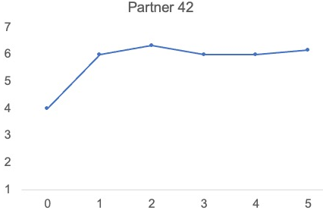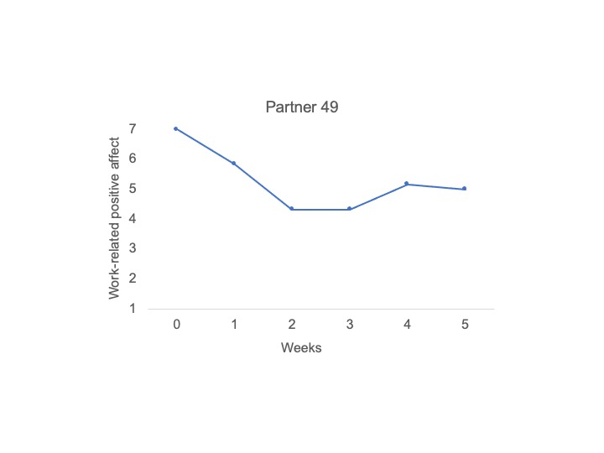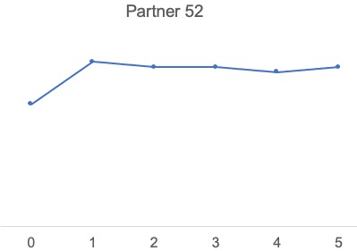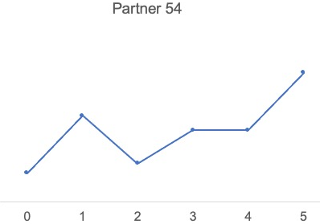
Time in Weeks

Study 2 – Partner need satisfaction

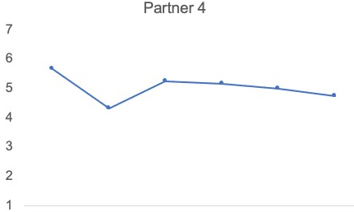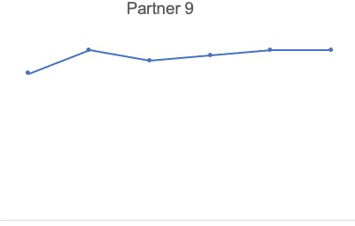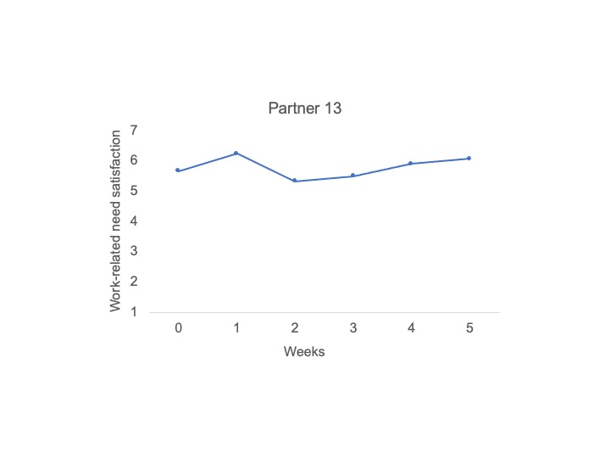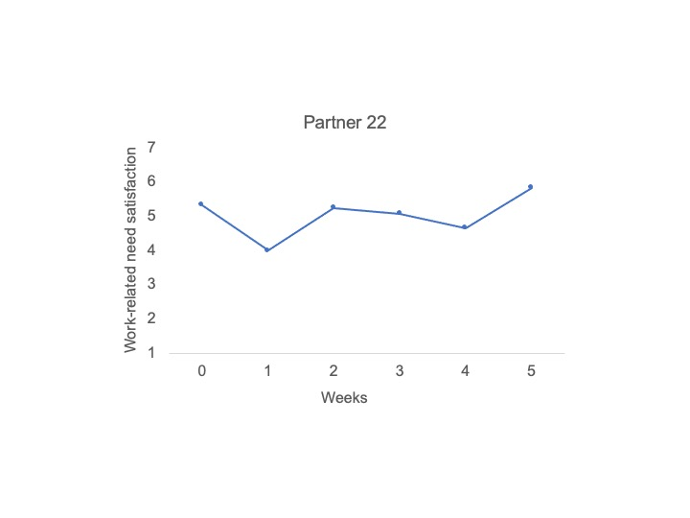
Partner need satisfaction
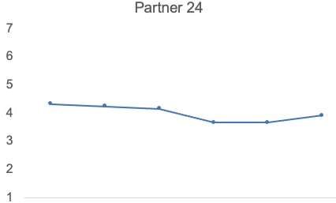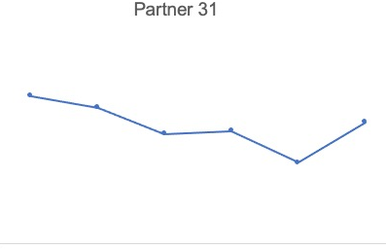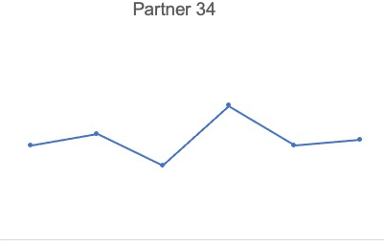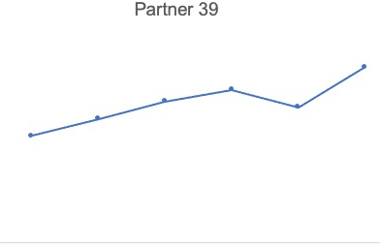
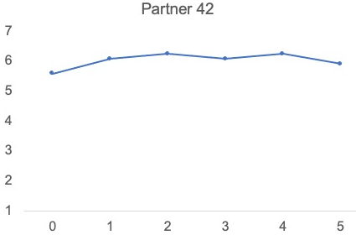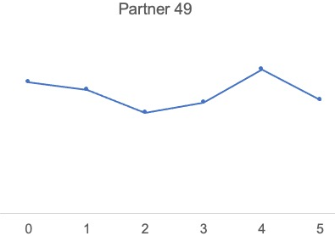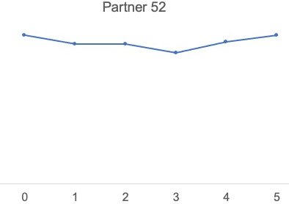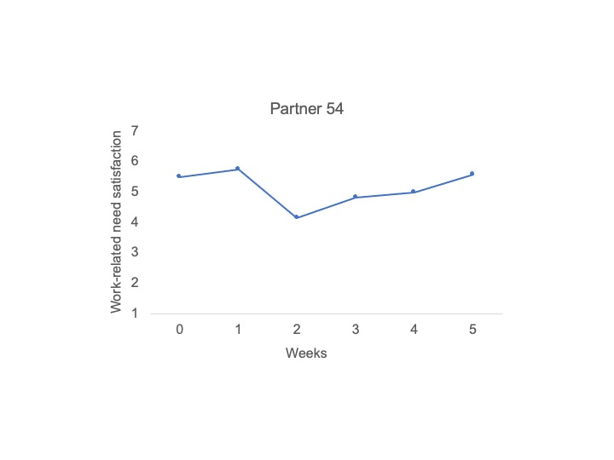
Time in Weeks

List of all measurement scales used in Studies 1-2

All items reported below were scored on a 7-point rating scale (ranging from 1 = not at all to 7 = very much). Unless mentioned otherwise, weekly measures were preceded by the introductory statement “This week”.

Measurement scales used in Study 1:

Coworker work-family support at work (adapted;Hammer, Kossek, Bodner, & Crain, 2013):
- At least one of your coworkers has made you feel comfortable talking about your conflicts between work and non-work.
- At least one of your coworkers has demonstrated effective behaviors in how to juggle work and non-work issues.
- At least one of your coworkers has worked effectively to creatively help you solving conflicts between work and non-work.
- At least one of your coworkers has helped to organize the work in your department or unit to jointly benefit employees and the company.

Actor work-family support provision at home (adapted;Hammer, Kossek, Bodner, & Crain, 2013):
- You have made your partner feel comfortable talking about his/her conflicts between work and non-work.
- You have demonstrated to your partner effective behaviors in how to juggle work and non-work issues.
- You have worked effectively to creatively solve your partner’s conflicts between work and non- work.
- You have put in effort to organize the work at home to jointly benefit the family and the work of your partner.

Partner work-family support receipt at home (adapted;Hammer, Kossek, Bodner, & Crain, 2013):
- Your partner has made you feel comfortable talking about your conflicts between work and non-work.
- Your partner has demonstrated effective behaviors in how to juggle work and non-work issues.
- Your partner has worked effectively to creatively solve your conflicts between work and non-work.
- Your partner has organized the work at home to jointly benefit the family and your work.

Partner flow at work (Rheinberg, 2008):
- You felt just the right amount of challenge.
- Your thoughts/activities ran fluidly and smoothly.
- You did not notice time passing.
- You had no difficulty concentrating.
- Your mind was completely clear.
- You were totally absorbed in what you were doing.
- The right thoughts/movements occurred of their own accord.
- You knew what you had to do at each step of the way.
- You felt that you had everything under control.
- You were completely lost in thought.

Partner creativity at work (Tierney, Farmer, & Graen, 1999):
- You have demonstrated originality in your work.
- You have generated novel but operable work-related ideas.
- You have tried out new ideas and approaches to problems.

Actor compassionate love for their partner (Hendrick, Hendrick, & Dicke, 1998):

Preceded by the statement: “To what extent do you agree with the following statements”
- I would rather suffer than let my partner suffer.
- I cannot be happy unless I place my partner's happiness before my own.
- I am (usually) willing to sacrifice my own wishes to let my partner achieve his/hers.
- I would endure all things for the sake of my partner.

Measurement scales used in Study 2:

The following measurement scales were used in Study 2 in addition to all measurement scales used in Study 1.

Partner positive affect at work (Burke, Brief, George, Roberson, & Webster, 1989):

Preceded by the statement: “To what extent did you experience the following feelings at work this week”.
- Active.
- Strong.
- Excited.
- Enthusiastic.
- Peppy.
- Elated.

Partner need satisfaction at work (Chiniara & Bentein, 2016):

Preceded by the statement: “Please indicate how satisfied you were with the following aspects of your work this week”.
- The opportunities to take personal initiatives in your work.
- The level of autonomy you have in your job.
- The opportunities to exercise your own judgment and your own actions at work.
- The degree of freedom you have to do your job the way you think it can be done best.
- The feeling of being competent at doing your job.
- The level of mastery that you can achieve at your work tasks.
- The level of confidence about your ability to execute your job properly.
- The sense that you can accomplish the most difficult work tasks.
- The positive social interactions you have at work with other people.
- The feeling of being part of a group at work.
- The close friends you have at work.
- The opportunities to talk with people about things that really matter to you.

Supervisor work-family support at work (Hammer, Kossek, Bodner, & Crain, 2013):
- Your supervisor made you feel comfortable talking to him/her about your conflicts between work and non-work.
- Your supervisor demonstrated effective behaviors in how to juggle work and non-work issues.
- Your supervisor worked effectively with employees to creatively solve conflicts between work and non-work.
- Your supervisor organized the work in your department or unit to jointly benefit employees and the company.

Organizational work-family culture (Thompson, Beauvaus, & Lyness, 1999):

Preceded by the statement: “To what extent do you agree with the following statements”
- In this organization employees are encouraged to strike a balance between their work and family lives.
- This organization is supportive of employees who want to switch to less demanding jobs for family reasons.
- In this organization it is generally okay to talk about one's family at work.
- In this organization employees can easily balance their work and family lives.
- This organization encourages employees to set limits on where work stops and home life begins.

Actor companionate love for their partner (Hendrick et al., 1998):

Preceded by the statement: “To what extent do you agree with the following statements”
- Our love is the best kind because it grew out of a long friendship.
- Our friendship merged gradually into love over time.
- Our love is really a deep friendship, not a mysterious, mystical emotion.
- Our love relationship is the most satisfying because it developed from a good friendship.

