**Supplementary Materials**

**TABLE S1** Results for Estimated Coefficients of the Mediation Model *(without control variables)*

|  |  |  |  |  |  |  |  |  |  |
| --- | --- | --- | --- | --- | --- | --- | --- | --- | --- |
| Variables | Mediator: Team cultural tightness (T2) | | | DV: Team deviance (T3) | | | DV: Team creativity (T3) | | |
| *b* | *SE* | *t* | *b* | *SE* | *t* | *b* | *SE* | *t* |
| Team COVID-19 talk (T1) | 0.25 | 0.06 | 4.19*** | -0.01 | 0.07 | -0.19 | 0.02 | 0.18 | 0.10 |
| Team cultural tightness (T2) |  |  |  | -0.45 | 0.11 | -4.18*** | -0.72 | 0.27 | -2.69** |
|  |  |  |  |  |  |  |  |  |  |
| Constant | 3.90 | 0.03 | 124.94*** | 3.20 | 0.42 | 7.63*** | 5.95 | 1.04 | 5.70*** |
|  |  |  |  |  |  |  |  |  |  |
| *R*2 |  | 0.15 |  |  | 0.18 |  |  | 0.08 |  |
| *F* |  | 17.58** |  |  | 10.62*** |  |  | 4.13* |  |

*Notes.* *n* = 103 teams. For gender, 0 = female, 1 = male. T1/2/3 = Time 1/2/3.

Unstandardized regression coefficients are reported.

* *p* < .05, ** *p* < .01, *** *p* < .001.

**TABLE S2** Results for Estimated Coefficients of the Moderated Mediation Model *(without control variables)*

|  |  |  |  |  |  |  |  |  |  |
| --- | --- | --- | --- | --- | --- | --- | --- | --- | --- |
| Variables | Mediator: Team cultural tightness (T2) | | | DV: Team deviance (T3) | | | DV: Team creativity (T3) | | |
| *b* | *SE* | *t* | *b* | *SE* | *t* | *b* | *SE* | *t* |
| Team COVID-19 talk (T1) | 0.30 | 0.06 | 5.03*** | -0.01 | 0.07 | -0.19 | 0.02 | 0.18 | 0.10 |
| Team virtuality | 0.01 | 0.02 | 0.30 |  |  |  |  |  |  |
| Team COVID-19 talk (T1) × Team virtuality | -0.13 | 0.04 | -3.37** |  |  |  |  |  |  |
| Team cultural tightness (T2) |  |  |  | -0.45 | 0.11 | -4.18*** | -0.72 | 0.27 | -2.69** |
| Constant | 3.91 | 0.03 | 131.08*** | 3.20 | 0.42 | 7.63*** | 5.95 | 1.04 | 5.70*** |
|  |  |  |  |  |  |  |  |  |  |
| *R*2 |  | 0.24 |  |  | 0.18 |  |  | 0.08 |  |
| *F* |  | 10.48*** |  |  | 10.62*** |  |  | 4.13* |  |

*Notes.* *n* = 103 teams. For gender, 0 = female, 1 = male. T1/2/3 = Time 1/2/3.

Unstandardized regression coefficients are reported.

* *p* < .05, ** *p* < .01, *** *p* < .001.

**TABLE S3** Summary of Indirect Effects and Conditional Indirect Effects *(without control variables)*

|  |  |  |  |
| --- | --- | --- | --- |
| Paths and effects | Estimates | SE | 95% confidence intervals |
| **Team COVID-19 talk (T1) 🡪 Team cultural tightness (T2) 🡪 Team deviance (T3)** |  |  |  |
| Simple indirect effect | -.11 | .04 | [-.20, -.05] |
| Moderated mediation |  |  |  |
| Lower team virtuality (–1 *SD*) | -.21 | .06 | [-.33, -.10] |
| Higher team virtuality (+1 *SD*) | -.05 | .03 | [-.13, .01] |
| Index of moderated mediation | .06 | .02 | [.02, .10] |
| **Team COVID-19 talk (T1) 🡪 Team cultural tightness (T2) 🡪 Team creativity (T3)** |  |  |  |
| Simple indirect effect | -.18 | .08 | [-.36, -.06] |
| Moderated mediation |  |  |  |
| Lower team virtuality (–1 *SD*) | -.33 | .12 | [-.59, -.11] |
| Higher team virtuality (+1 *SD*) | -.08 | .06 | [-.23, .01] |
| Index of moderated mediation | .09 | .04 | [.02, .18] |

*Notes.* *n* = 103 teams.

T1/2/3 = Time 1/2/3.

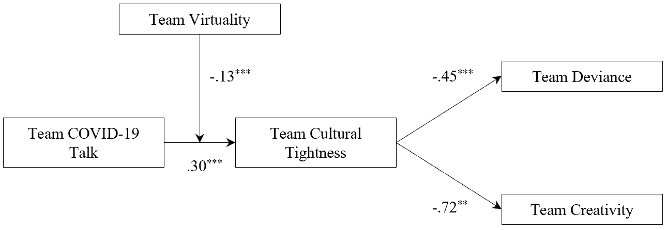

**FIGURE S1** The Entire Moderated Mediation Model by Structural Equation Modeling *(without control variables)*

*Notes.* Fit indices: *χ***2**(4) = 7.09, *p* = .13; CFI = .94, SRMR = .06, RMSEA = .09. Unstandardized coefficients are reported.