**Supplementary Materials**

No Guts, No Glory?

How Risk-taking Shapes Dominance, Prestige, and Leadership Endorsement

In this supplement we present additional measures and analyses that are not central to understanding or evaluating the arguments and results presented in the main text. Some of this material provides insight into research questions not central to the main argument, whereas other material attests to the robustness of the conclusions drawn in the main text, as detailed below. With regard to alternative analyses, we limit ourselves to reporting the results themselves; explanations of the statistical approaches used are provided in the main text.

**Study 1**

In Study 1 we used an implicit association test (IAT) to examine associations between risk-taking and leadership. As mentioned in the main text, four participants were removed from the data set prior to analyses (three of them were intoxicated and one was not a native speaker of Dutch, the language in which the study was administered). When retaining these participants, results are almost identical: *D* = 0.39, 95% CI [0.28, 0.49], *t*(139) = 7.29, *p* < .001.

We used the improved D600 scoring algorithm developed by Greenwald and colleagues (2003) to prepare the data for analysis. This approach consists of (1) eliminating *trials* with latencies > 10,000ms and (2) eliminating *participants* for whom more than 10% of trials have latencies < 300ms. In our data set, no cases met the exclusion criterion specified under point 2, and therefore no participants were dropped from the analyses. Trials with latencies > 10,000ms were excluded from the computation of the block means as per the established protocol. Not excluding these trials yielded very similar results: *D* = 0.37, 95% CI [0.26, 0.48], *t*(135) = 6.84, *p* < .001. Finally, we repeated the analyses while retaining the four excluded participants and trials with latencies > 10,000ms. Again, the results were similar: *D* = 0.38, 95% CI [0.28, 0.49], *t*(139) = 7.19, *p* < .001.

These additional analyses indicate that the IAT result reported in the main text – that risk is associated with leader roles and safety with follower roles – is robust and does not change depending on whether or not extreme values are excluded.

**Study 2**

In the main text of the paper we reported results of analyses without control variables, because initial analyses revealed that the control variables were unrelated to the variables of interest, and including them did not change the results. For the sake of transparency, alternative analyses controlling for gender, age in years (mean-centered), education in years (mean-centered), and self-assessed SES (-1 = below average, 0 = average, 1 = above average) are reported below.

**Intended leadership endorsement (voting intentions).** The logistic mixed-effect model revealed a positive association between perceived risk-taking and voting intentions. A 1 *SD* increase in a candidate’s perceived risk-taking predicted an increased likelihood of intending to vote for that candidate of *OR* = 1.61, Wald’s *z* = 4.02, *p* < .001. This result is consistent with Hypothesis 1a and inconsistent with Hypothesis 1b.

**Actual leadership endorsement (voting behavior).** Compared to a null, intercept-only model, adding perceived risk-taking as a predictor of voting behavior improved model fit (ΔAIC = -7.47). Perceiving a candidate’s risk-taking as 1 *SD* higher increased the likelihood of voting for that candidate by *OR* = 1.37, Wald’s *z* = 2.86, *p* = .004. These findings completely mirror the results for voting intentions, again favoring Hypothesis 1a over Hypothesis 1b.

**Dominance and prestige.** In line with Hypothesis 2, a linear mixed-effect model showed a positive association between candidates’ perceived risk-taking and dominance, β = 0.17, *t*(279.58) = 6.39, *p* < .001. In line with Hypothesis 3, a separate linear mixed-effect model showed a positive association between candidates’ perceived risk-taking and prestige, β = 0.15, *t*(262.98) = 5.58, *p* < .001.

**Mediation of leadership endorsement.** We found evidence for indirect paths from risk-taking to voting intentions via both dominance and prestige. Specifically, we found that risk-taking simultaneously *decreased* the likelihood of intending to vote for a candidate by increasing dominance perceptions (indirect *OR* = 0.84, 95% CI 0.80 to 0.87), and *increased* the likelihood of intending to vote for a candidate by increasing prestige perceptions (indirect *OR* = 1.26, 95% CI 1.19 to 1.33).

The results of these additional analyses are highly similar to those reported in the main text and yield identical conclusions. This demonstrates that the results reported in the main text are robust and do not change depending on whether or not control variables are included in the models.

**Study 3**

Besides the measures of leadership endorsement in cooperative and competitive intergroup contexts reported in the main text, Study 3 included a measure of leadership endorsement in cooperative intragroup contexts. This measure was dropped from the main text in light of comments obtained during the review process to enhance the focus of the paper. We report information about this additional measure here.

The measure of leadership endorsement in cooperative intragroup contexts consisted of the following five items: “To what extent would you endorse this person as front runner of a political party when the party leadership convenes to decide on the eligible candidates for the upcoming elections?”; “To what extent would you endorse this person as captain of a sports team during a joint team-building exercise?”; “To what extent would you endorse this person as president of an association of home owners when a decision must be made during a meeting with all associated home owners about the layout of the shared courtyard?”; “To what extent would you endorse this person as CEO of a large oil company when the company’s strategy for the coming period must be decided on during a meeting with the board of directors?”; and “To what extent would you endorse this person as ambassador of an animal welfare organization during the annual meeting when a brainstorm session for a new campaign must be chaired?”.

Including this measure in the mixed-model analysis testing effects of risk-taking on leadership endorsement does not change the conclusions reported in the main text. We found a significant main effect of risk (*F*[1, 147] = 12.26, *p* = .001), no significant effect of context (*F*[2, 4.48] = 4.64, *p* = .081), and a significant interaction between risk and context, *F*(2, 2074) = 62.78, *p* < .001. The interaction pattern, which is depicted in Figure S1, shows that risk-taking differentially impacted leadership endorsement depending on the context. As hypothesized, in the competitive intergroup context, participants reported greater endorsement for the risk-taker than for the risk avoider (*t*[280.61] = 8.55, *p* < .001); risk-taking did not significantly influence leadership endorsement in the cooperative intergroup (*t*[280.61] = -1.56, *p* = .119) or the cooperative intragroup context (*t*[280.61] = 1.929, *p* = .055).

**Study 4**

**Analyses on Full Sample without Exclusions**

As noted in the main text, ten participants were excluded from the analyses of Study 4 because they failed a-priori exclusion criteria. Specifically, six had a negative person-total correlation and four indicated that we should not use their data. The complete sample including these participants consisted of 222 women, 194 men, and five participants who identified differently, with a mean age of 35.50 years. Results of analyses on the full sample were very similar to those reported in the main text, as follows.

**Manipulation checks.** We foundthe anticipated main effect of context on the associated manipulation check, *F*(1, 3781) = 5251.10, *p* < .001, a marginal effect of risk-taking, *F*(1, 417) = 3.37, *p* = .067, and no interaction with gender, *F*(1, 3781) = 2.66, *p* = .103.

**Dominance and prestige.** A two-way ANOVA on dominance revealed a main effect of risk, *F*(1, 417) = 213.28, *p* < .001, η2 = .34, no effect of gender, *F*(1, 417) = 0.36, *p* = .549, η2 = .00, and no interaction, *F*(1, 417) = 2.04, *p* = .154, η2 = .00. Repeating the same analysis on prestige revealed a main effect of gender, *F*(1, 417) = 5.70, *p* = .017, η2 = .01, no effect of risk, *F*(1, 417) = 1.02, *p* = .313, η2 = .00, and no interaction, *F*(1, 417) = 0.53, *p* = .467, η2 = .00.

**Leadership endorsement.** Linear mixed-effect modeling with fixed effects for risk-taking, gender, context, and their interactions, random intercepts for participant and leadership role, and per-role random slopes for context revealed a significant main effect of risk, *F*(1, 417) = 12.89, *p* < .001, and the expected two-way risk × context interaction, *F*(1, 3777) = 345.23, *p* < .001. The high-risk protagonist was endorsed more than the low-risk protagonist in the competitive context, *t*(520) = 9.42, *p* < .001, whereas the reverse was true in the cooperative context, *t*(520) = -2.63, *p* = .018.

**Mediation analysis.** Multi-level mediation analysis accounting for the nested structure of the dependent variable revealed that risk-taking increased leadership endorsement via perceived dominance in competitive contexts, *ab* = 0.380 [0.254, 0.447]. Prestige was not a significant mediator in competitive contexts (*ab* = 0.003 [-0.034, 0.112]). Neither dominance (*ab* = 0.065 [-0.030, 0.148]) nor prestige (*ab* = 0.003 [-0.032, 0.105]) mediated the effects of risk in cooperative contexts.

**Additional Measures and Analyses**

Prompted by a reviewer comment, we included a measure of the Big Five personality traits (extraversion, agreeableness, conscientiousness, openness, and emotional stability) in Study 4 to explore whether risk-taking shapes personality inferences, and to test whether the hypothesized effects of risk-taking on perceived dominance, prestige, and leadership endorsement hold when controlling for such personality inferences. We measured respondents’ perceptions of the candidates’ Big Five personality traits using the brief scales developed by Gosling, Rentfrow, and Swann (2003): extraversion: *r* = .61, *p* < .001; agreeableness: *r* = .41, *p* < .001; conscientiousness: *r* = .53, *p* < .001; emotional stability: *r* = .20, *p* < .001; openness: *r* = .66, *p* < .001.

We used MANOVA to analyze the effects of risk-taking and gender on personality inferences. We found a large main effect of risk-taking, Pillai’s trace (*PT*) = 0.40, *F*(5, 403) = 54.25, *p* < .001, a small main effect of gender, *PT* = 0.03, *F*(5, 403) = 2.49, *p* = .031, and a small two-way interaction, *PT* = 0.04, *F*(5, 403) = 3.06, *p* = .010. The univariate effects are displayed in Figure S2. The data indicate that risk-taking decreased perceived agreeableness and conscientiousness, and increased perceived extraversion and openness. These effects were larger for male than female protagonists, but all simple effects of risk-taking on personality inferences were significant in the described direction for both the male and the female protagonist (*p*s < .001), except for one (the effect of risk-taking on perceived conscientiousness of the female protagonist). There were no significant effects on emotional stability.

To test whether personality inferences mediated the effects of risk-taking on leadership endorsement, we calculated average leadership endorsement in competitive (5 items, α = .84) and cooperative (5 items, α = .84) contexts and then analyzed each context in a separate multiple mediation analysis (*R* = 250,000). Adjusting alpha to .005 (.050/10) to adjust for multiple comparisons (two analyses testing five indirect effects each), the only significant mediator in competitive contexts was openness, *ab* = 0.36, 99.5% CI [0.124, 0.593], and the only significant mediator in cooperative contexts was conscientiousness, *ab* = -0.08, 99.5% CI [-0.192, -0.007].

We conclude that, compared to perceived dominance and prestige, Big Five personality inferences offer a less potent explanatory mechanism of the effects of risk-taking on leadership endorsement, which is the outcome of interest in the current project. However, we believe the observed effects of risk-taking on perceptions of agreeableness, conscientiousness, extraversion, and openness open up an interesting new direction for research on how perceptions of risk-takers are perceived by others in terms of personality traits.

*Figure S1*. Leadership endorsement as a function of risk-taking and context in Study 3. Error bars indicate standard errors associated with the plotted marginal means.

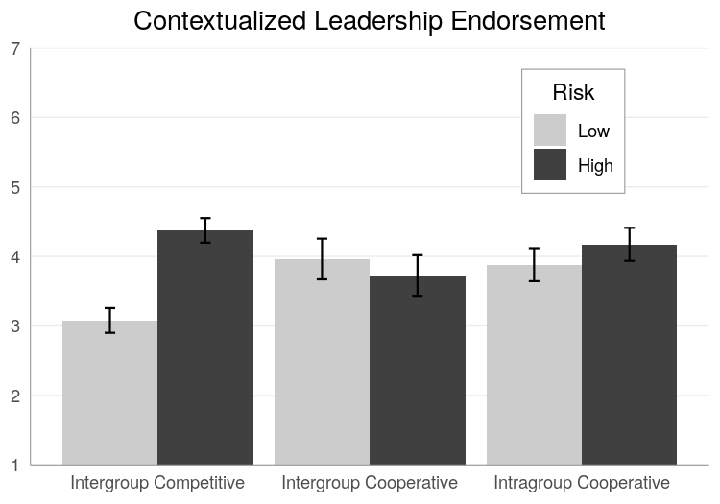

*Figure S2*. Personality inferences as a function of risk-taking and gender in Study 4.

