**Supplemental Materials**

**From Helping Hands to Harmful Acts: When and How Employee Volunteering Promotes Workplace Deviance**

1. Summary of SEM results for model isolating moral credentials (Study 1).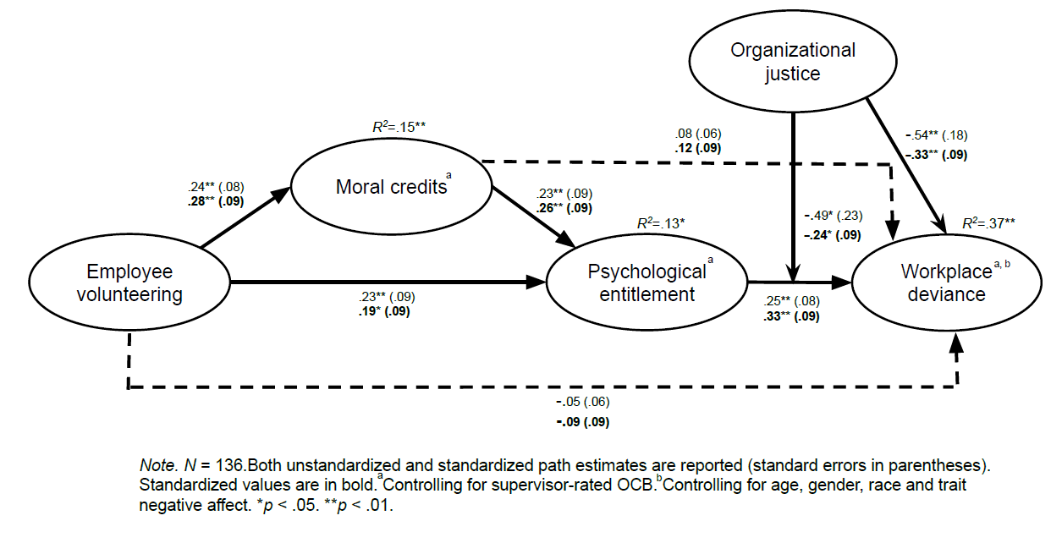
2. Summary of SEM results for model isolating moral credits (Study 1).

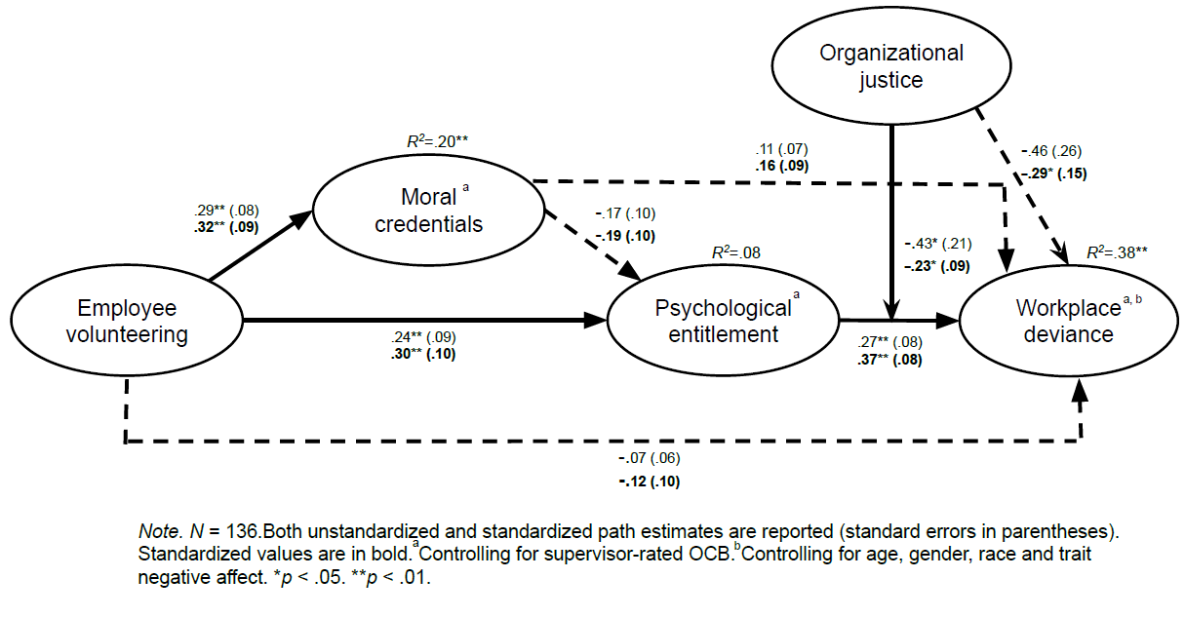

1. Summary of SEM results for model isolating moral credentials (Study 2).

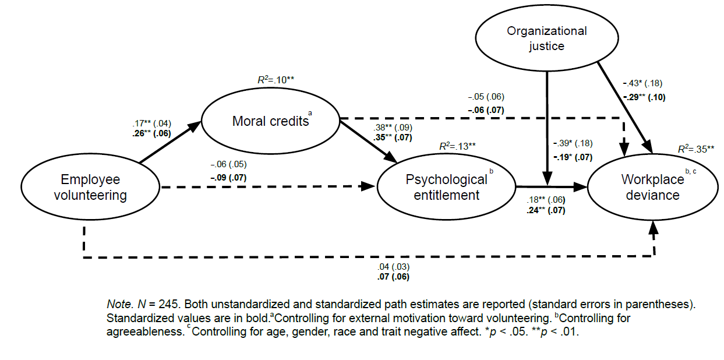

1. Summary of SEM results for model isolating moral credits (Study 2).

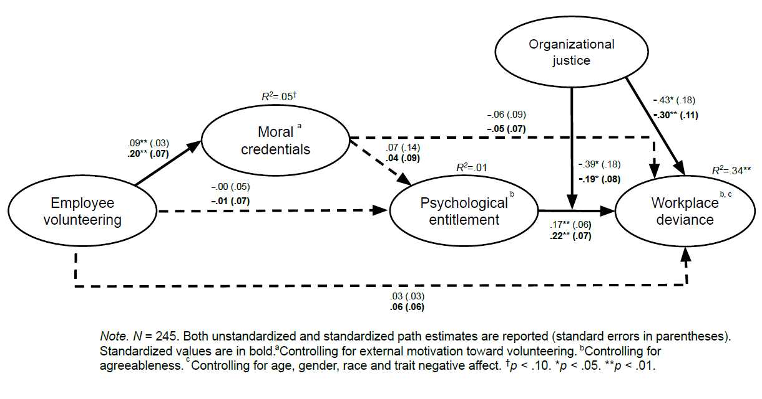

|  |  |  |
| --- | --- | --- |
| **Summary of Serial Indirect Effects and Conditional Serial Indirect Effects (Study 1 and Study 2)** | | |
|  | **Estimates** | **95% credibility intervals** |
| **Employee volunteering → moral credits → psychological entitlement → workplace deviance** | |  |
| **Study 1** |  |  |
| **Serial Indirect effect** | **.01** | **[.001, .032]** |
| Conditional serial indirect effect |  |  |
| High organizational justice | .00 | [-.010, .018] |
| **Low organizational justice** | **.02** | **[.003, .054]** |
| **Study 2** |  |  |
| **Serial Indirect effect** | **.01** | **[.002, .021]** |
| Conditional serial indirect effect |  |  |
| High organizational justice | .00 | [-.010, .011] |
| **Low organizational justice** | **.02** | **[.005, .039]** |
| **Employee volunteering → moral credentials → psychological entitlement → workplace deviance** | |  |
| **Study 1** |  |  |
| Serial Indirect effect | -.01 | [-.033, .001] |
| Conditional serial indirect effect |  |  |
| High organizational justice | -.00 | [-.019, .006] |
| Low organizational justice | -.02 | [-.053, .002] |
| **Study 2** |  |  |
| Indirect effect | .00 | [-.002, .005] |
| Conditional serial effect |  |  |
| High organizational justice | .00 | [-.002, .002] |
| Low organizational justice | .00 | [-.005, .011] |