**Detailed Methods for Study 2**

**Creating the Position Description**

We developed a position description for a basic entry-level office position called the *Graduate Accounts Clerk* using material drawn from O*Net Online and online employment search websites. The final advertisement/position description is shown below:

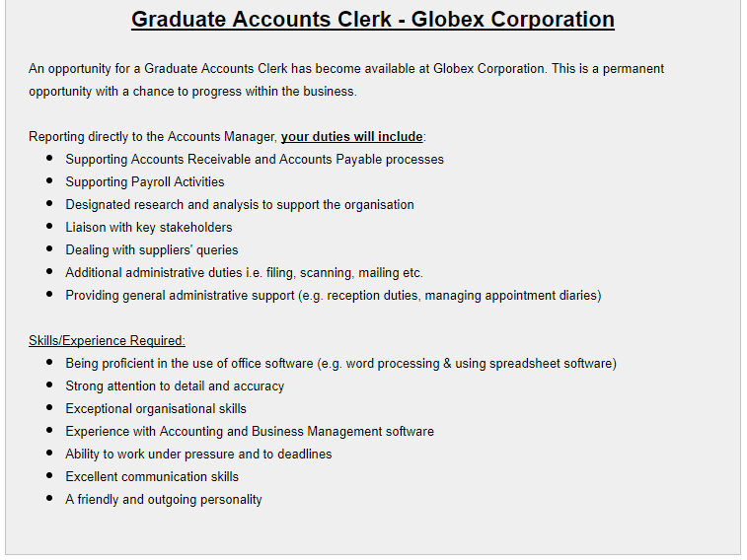

**Developing the Professional OCQ**

Having defined the target position (Graduate Accounts Clerk), we aimed to identify some candidate categories of OCQ topics that prospective applicants might perceive claiming knowledge as instrumental to improving their chances of being selected. Based on the requirements of the role, three of the authors brainstormed five overclaiming knowledge categories that were likely to be deemed as relevant to an entry level office job. These were:

1. Workplace Techniques, Strategies, & Business Terms,
2. Famous Business People,
3. Multinational Companies,
4. Equipment, Software, & Hardware, and
5. Computing & Technology.

For each of these five categories, approximately 20 target items were generated through a combination of brainstorming, consultation of relevant materials such as the BRW Rich List, Forbes Lists, and a list of Fortune 500 companies. Ten foil items were then created through a combination of a review of existing bogus items from published research on bogus items and brainstorming of new content.

Ultimately, we aimed to develop items that would appear as plausible candidates for that knowledge category. For example, in the category of Computing & Technology, a target item was “Cloud Computing”, and a foil was “Randomized Digital Arrays”. As per the process described by Paulhus (2011), a Google search was then performed on each foil to verify that it was bogus.

Initial item and category pilot testing was then conducted using a sample of 15 judges (mean age 31.9 years, 60% female). These judges were presented with the position description for the *Graduate Accounts Clerk* role (see the other supplemental document). Judges were then asked to rate each of the five generated categories and the ten categories from the *original* OCQ-150 (Paulhus, Harms, Bruce, & Lysy, 2003), based on how relevant they thought that knowledge of or familiarity with the topics listed would be to the target job on a 7-point scale ranging from 1 (*Not at all relevant*) to 7 (*Very relevant*). Mean ratings are shown in Table S1. From this initial piloting phase, the three job-relevant categories with the highest perceived job relevance were retained for use in the Professional OCQ in this study. These categories were Workplace Techniques, Strategies, & Business Terms; Equipment, Software, & Hardware; and Computing & Technology.

The judges were then asked to rate all of the generated items from each of the new job-relevant categories on the “extent to which each item seems as though it could be a legitimate item related to the topic of interest” on a scale of 1 (*Definitely seems fake*) to 7 (D*efinitely seems real*). These ‘plausibility ratings’ were collected to ensure that the foils that were selected for use in each topic were unlikely to be regarded as overly obscure or ridiculous and hence stand out as being obvious traps. For each of the three chosen ‘Professional’ categories, the three foil items with the highest plausibility ratings were selected for the final Professional OCQ. Twelve legitimate items in each category were also chosen, with the aim of selecting items with a range of plausibility ratings to ensure varying levels of item difficulty. The final list of 36 selected legitimate items and 9 foils are shown in Table S2.

**Developing the Academic OCQ**

The “Academic OCQ” was created by drawing from the content of the original OCQ that was rated as being least to the target job; these were: Fine Arts, Books & Poems, and Authors & Characters (9 foils and 36 targets).

Table S3.1.

*Mean Ratings of Relevance to the Graduate Accounts Clerk Role for New and Classical Overclaiming Questionnaire Topics.*

|  |  |  |
| --- | --- | --- |
| Source | Topic | *M* |
| New OCQ Topics | Famous Business People | 3.33 |
| Multinational Companies | 4.87 |
| Workplace Techniques, Strategies & Business Terms | 5.67 |
| Equipment, Software & Hardware | 5.87 |
| Computing & Technology | 5.93 |
| Classical OCQ Topics | Fine Arts | 1.60 |
| Books & Poems | 1.60 |
| Authors & Characters | 1.67 |
| 20th Century Culture Names | 1.73 |
| Philosophy | 1.93 |
| Physical Sciences | 1.93 |
| Historical Names & Events | 2.40 |
| Life Sciences | 2.80 |
| Social Science & Law | 4.40 |
| Language & Grammar | 5.73 |

*Note. N* = 15; OCQ = Overclaiming Questionnaire. Although the Language & Grammar topic within the original OCQ-150 exhibited a mean relevance rating that was higher than some of those of the new topics, we only considered the five new topics for possible inclusion in the Professional OCQ.

Table S3.2.

*Final Items of the Professional Overclaiming Questionnaire.*

|  |  |
| --- | --- |
| Topic: Workplace Techniques, Strategies and Business Terms | |
| Solvency matrices* | Stakeholder management |
| Fiscal binaries* | Key performance indicators |
| Tertiary clerical methods* | Bottom line |
| Accounts payable and receivable | Initial public offerings |
| Customer/client intervention | Core competencies |
| Calendar organization | Acquisitions and requisitions |
| Appointment setting | Corporate social responsibility |
| Accrual based accounting |  |
| Topic: Equipment, Software, and Hardware | |
| Transcriber* | Acrobat Reader |
| Mozilla Lightstream* | WinRAR |
| Finex Accountman* | Antivirus programs |
| MYOB | Binding machine |
| Intranet knowledgebase | Electronic planners |
| SAP ERP | Nitro Pro |
| MS Outlook | HitmanPro |
| OpenOffice |  |
| Topic: Computing and Technology | |
| Randomized digital arrays* | Open source |
| Reactionary memory* | HDMI |
| Corestate backup* | RSS feed |
| Firewall | Doodle |
| Paywall | Kaggle |
| LinkedIn | Yammer |
| Malware | Crowd sourcing |
| Defragmentation |  |

Notes. *Item is a foil. When completing the OCQ, items from the same topic were presented in random order.

**Instructions for Participants in Study 2**

**Honest Condition**

*General Instructions:*

For the following questions, please respond honestly and in a manner consistent with how you view yourself and your personality.

*Instructions that preceded the HEXACO-Personality Inventory:*

On the following pages you will find a series of statements about you. Please read each statement and decide how much you agree or disagree with that statement. Then select your response to the statement using the scale provided.

Please answer every statement, even if you are not completely sure of your response.

*Instructions that preceded the Overclaiming Questionnaires:*

**The General Knowledge Questionnaire**

Please read the following instructions carefully:

The following questionnaire is designed to measure your knowledge about various topics. When completing it, please rate your knowledge of each item by selecting the appropriate number from 0 to 2, as per the scale below:

0: I have never heard of this item

1: I understand what/who this item is when it is discussed.

2: I can talk intelligently about this item

EXAMPLES

1. If you’re asked about POLITICIANS and the item said “Bill Clinton”, you would probably select ‘1’ or ‘2’ to indicate that you know who this person is.

2. If the category was FAMOUS ATHLETES and the item said “Fred Gruneberg”, you would probably select ‘0’ because you have never heard of him (he is my next door neighbor).

When completing the General Knowledge Questionnaire, please respond to it honestly.

**Job Application Condition**

*General Instructions:*

On the following pages, you will find a series of questionnaires that you have been asked to complete as part of the application process for the role of Graduate Accounts Clerk at a large company called Globex Corporation. The advertisement for this job is contained below. Please take the time to familiarize yourself with the requirements of the role.

When responding to the questions that follow, you will be asked to imagine that you are a recent graduate, and that you are applying for several similar jobs in addition to this one.



*Instructions that preceded the HEXACO-Personality Inventory:*

**The Globex Personality Questionnaire**

On the following pages you will find a series of statements about you. Please read each statement and decide how much you agree or disagree with that statement. Then select your response to the statement using the scale provided.

Please answer every statement, even if you are not completely sure of your response.

*Instructions that preceded the Overclaiming Questionnaires:*

**The Globex General Knowledge Questionnaire**

Please read the following instructions carefully:

The following questionnaire is designed to measure your knowledge about various topics. When completing it, please rate your knowledge of each item by selecting the appropriate number from 0 to 2, as per the scale below:

0: I have never heard of this item

1: I understand what/who this item is when it is discussed.

2: I can talk intelligently about this item

EXAMPLES

1. If you’re asked about POLITICIANS and the item said “Bill Clinton”, you would probably select ‘1’ or ‘2’ to indicate that you know who this person is.

2. If the category was FAMOUS ATHLETES and the item said “Fred Gruneberg”, you would probably select ‘0’ because you have never heard of him (he is my next door neighbor).

**Evidence of the Convergent Validity of the Professional OCQ**

Table S3.3 shows the correlations of the *c* and *d′* indices from the job-relevant OCQ in both assessment conditions to those of the job-irrelevant OCQ. The job-irrelevant OCQ was constructed using content from the original Paulhus et al. (2004) measure (45 items from 3 topics). The most relevant correlations as far as validity is concerned are highlighted in color and there is key below the table to translate the highlighted cells.

If the job-relevant (i.e., new) OCQ is functioning in a similar way to the job-irrelevant OCQ (i.e., derived from the traditional OCQ), then under common conditions, the indices from these two measures should be positively and relatively strongly correlated. These correlations are highlighted in yellow, and were .42 and .48 for *d′* and .57 and .71 for *c*. That is, it appears there is considerable variance being shared in overclaiming on the two OCQs. Accuracy from the two OCQs is relatively more modestly correlated, but because these indexes represent participants’ knowledge in quite different domains, it is reasonable that these correlations are lower.

The correlations highlighted in green can be thought of as ‘test-retest’ correlations except that the assessment conditions are different from test to retest and hence these correlations should not be thought of as test-retest *reliability* coefficients per se. The lowest among these correlations was between the two *c* indices derived from the job-relevant OCQ, which is precisely what one would expect if the change in assessment conditions has more substantially altered the meaning of this index from a general overclaiming measure to a measure of faking than that of the job-irrelevant OCQ, as we have hypothesized.

The correlations in blue are somewhat less interesting with respect to answering the question of validity, as they show the correlations of the different overclaiming measures across the different conditions. The fact that these correlations were the smallest of the set is reassuring, however.

Table S3.3.

Correlations among overclaiming and accuracy indices across the 2 × 2 conditions of Study 2.

|  |  |  |  |  |  |  |  |
| --- | --- | --- | --- | --- | --- | --- | --- |
|  | d' Job-  Irrelevant Hon. | c Job-  Irrelevant Hon. | d' Job-  Relevant Hon. | c Job-  Relevant Hon. | d' Job-  Irrelevant JA | c Job-  Irrelevant JA | d' Job-  Relevant JA |
| d' Job-Irrelevant Hon. |  |  |  |  |  |  |  |
| c Job-Irrelevant Hon. | .589 |  |  |  |  |  |  |
| d' Job-Relevant Hon. | .422 | .138 |  |  |  |  |  |
| c Job-Relevant Hon. | .174 | .570 | .117 |  |  |  |  |
| d' Job-Irrelevant JA | .808 | .481 | .325 | .111 |  |  |  |
| c Job-Irrelevant JA | .268 | .531 | .008 | .380 | .061 |  |  |
| d' Job-Relevant JA | .370 | .188 | .581 | .196 | .480 | -.120 |  |
| c Job-Relevant JA | .121 | .286 | .027 | .384 | -.125 | .707 | -.269 |

*Note*.

*N* = 252; | *r* | > .14 is significant at *p* < .05.

|  |
| --- |
| Same overclaiming measure, different condition |
| Different overclaiming measure, same condition |
| Different overclaiming measure, different condition |

**References**

Paulhus, D. L. (2011). Overclaiming on personality questionnaires. In M. Ziegler, C. MacCann, & R. D. Roberts (Eds.), *New perspectives on faking in personality assessment* (pp. 151-164). New York, NY: Oxford University Press, Inc.

Paulhus, D. L., Harms, P. D., Bruce, M., & Lysy, D. C. (2003). The over-claiming technique: Measuring self-enhancement independent of ability. *Journal of Personality and Social Psychology, 84*(4), 890-904. doi:10.1037/0022-3514.84.4.890