Supplemental Materials
Power Analyses
Prior to data collection, we conducted power simulations to guide study design for the examination of parent-adolescent daily experiences. These simulations were based on longitudinal actor-partner interdependence models (L-APIM; Bolger & Laurenceau, 2013). Using Monte Carlo methods (Lafit et al., 2022), we modeled distinguishable partners with assumed effect sizes of 0.50 for within-person (actor) effects and 0.20 for between-partner (partner) effects. The results suggested that a design with 150 dyads measured across 28 time points would provide sufficient power (≈1.00) for detecting fixed effects and produce unbiased estimates of random effects. Although the current study focused only on adolescents and did not examine dyadic data, the analytic approach is simpler than those assumed in the original simulations. Therefore, even with a slightly smaller sample than the power simulations, the study is expected to have more than adequate power (well above the conventional 0.80 threshold) to detect within-person effects. It is important to note that the initial power analysis was not intended to evaluate between-person predictors (e.g., adolescents’ gender), as the primary goal was to examine within-person variability.
Model Equations
Each of the three multilevel models were specified as follows:
Level 1 (Within-Person):
${Outcome}_{it}= β_{0i}+ β_{1i}({RelatednessWithin}_{it}) + β_{2}({Day}_{it}) + e_{it}$ (1)
Level 2 (Between-Person):
$β_{0i}= γ_{00}+ γ_{01}\left({RelatednessBetween}_{i}\right)+ γ_{02}\left({Age}_{i}\right)+ γ_{03}({GenderMale}_{i}) +γ_{04}\left({GenderDiverse}_{i}\right)+ u_{0i}$ (2)
$β_{1i} = γ_{10}+γ_{11}({GenderMale}_{i}) +γ_{12}\left({GenderDiverse}_{i}\right) {+ u}_{1i}$ (3)
$β_{2} = γ_{20}$ (4)
In these equations, ${Outcome}_{it}$ represents a daily outcome of stress, purpose, or compassion for person i on day t. At Level 1, each person’s daily outcome is predicted by their person-specific intercept ($β_{0i}$), their person-specific within-person association with relatedness ($β_{1i})$, the day in the study ($β_{2}$), and a within-person residual ($e_{it}$). At Level 2, each person’s intercept is predicted by the grand mean ($γ_{00}$), their between-person (trait-level) relatedness ($γ_{01}$), their age ($γ_{02}$), their gender ($γ_{03} and γ_{04}$), and a random intercept ($u_{0i}$). Each person’s within-person relatedness association is predicted by the average within-person association ($γ_{10}$), their gender ($γ_{11}$and $γ_{12}$), and a random slope ($u_{1i}$). The daily residuals are assumed to be normally distributed, and the random effects are assumed to be multivariate normally distributed.
Multiple Imputation Process
To address missing data issues (n = 27 adolescents missing age information), we employed multiple imputation with 20 imputed datasets and 10 iterations per dataset. Given the multilevel structure of our data, we imputed only Level 2 (person-level) variables to avoid distorting the within-person covariance structure (Enders et al., 2016). Specifically, we imputed missing age values using predictive mean matching, while Level 1 variables (daily reports of relatedness and day in the study) and the outcome variables were not imputed. The multilevel models were then estimated on each of the 20 imputed datasets, and results were pooled using Rubin’s rules (Little & Rubin, 2019; Rubin, 1987) to obtain final parameter estimates, standard errors, and significance tests that appropriately account for uncertainty due to missing data. Because random effects and model fit indices cannot be directly pooled using Rubin’s rules, these parameters were averaged across the 20 imputed datasets to obtain final estimates of the random effects and overall model fit.
Imputation Results
We used multiple imputation to account for missing age data for 27 adolescents. Specifically, we imputed age values for each of our three models (stress, purpose, and compassion) that maintained the sample’s observed distributional patterns using information from the study day, within-person daily relatedness scores, between-person grand mean-centered relatedness scores, the relevant outcome measure, and adolescent age and gender. Following standard recommendations for continuous data, we applied predictive mean matching for all continuous variables since this technique maintains the original measurement scale and avoids generating unrealistic values. We created 20 imputed datasets, running 10 iterations for each using the mice package in R (van Buuren & Groothuis-Oudshoorn, 2011).
The imputation procedure ran successfully without generating warnings, and review of the output verified that the target variables were imputed as intended. We assessed the quality of our imputations by examining whether the iteration chains showed stable patterns (van Buuren & Groothuis-Oudshoorn, 2011). Examining kernel density plots (van Buuren & Groothuis-Oudshoorn, 2011; Sarkar, 2008) corresponding to the models reported in the main manuscript revealed substantial alignment between the observed and imputed age distributions for stress (Figures S1), purpose (Figure S3), and compassion (Figure S5). Notably, the imputed values retained the age-related trends typical of adolescents in our dataset. The convergence plots (van Buuren & Groothuis-Oudshoorn, 2011) tracking both means and standard deviations of imputed values throughout the iterations showed consistent, well-blended chains without signs of drift or computational problems for stress (Figure S2), purpose (Figure S4), and compassion (Figure S6). Together, these quality checks confirmed that our imputation process produced reasonable values and achieved proper convergence across all datasets.
Pooling Results from Multiple Imputation
After generating 20 imputed datasets, we fit separate multilevel models to each dataset and pooled the results. Fixed effects and standard errors were pooled using Rubin’s rules (Rubin, 1987) via the mice package (van Buuren & Groothuis-Oudshoorn, 2011), with 95% confidence intervals constructed based on the pooled estimates (Barnard & Rubin, 1999) using the broom.mixed package (Bolker and Robinson, 2022).
Because standard pooling procedures do not support random effects, variance components (random intercept, random slope, and residual variances) were extracted from each of the 20 models using the nlme package (Pinheiro et al., 2023) and averaged across imputations. Confidence intervals for variance components and model fit statistics (AIC, BIC, log-likelihood) were similarly extracted and averaged. This approach provides descriptive summaries of the multilevel structure while acknowledging that formal inference on variance components after multiple imputation remains an area of active development (Grund et al., 2018).
R Packages
All analyses were conducted in R (R Core Team, 2025) using the lme4 package (Bates et al., 2015) for model estimation, the mice and broom.mixed packages (Bolker and Robinson, 2022; van Buuren & Groothuis-Oudshoorn, 2011) for multiple imputation, the dplyr package (Wickham et al., 2026) for data management, the ggplot2 package (Wickham, 2016) for data visualization, and the psych package (Revelle, 2025) for descriptive statistics.

Table S1
Multilevel Model Results for the Association between Daily Relatedness and Daily Stress, Compassion, and Purpose with Age Moderation of Within-Person Relatedness Effect
 | Stress |  | Compassion |  | Purpose
Parameters | Est | CI | Est | CI | Est | CI
Fixed Effects
Intercept, $γ_{00}$ | 41.29* | [36.12, 46.46] | 62.50* | [55.90, 69.11] | 54.62* | [47.97, 61.27]
Relatedness - Between, $γ_{01}$ | −10.87* | [−14.48, −7.27] | 12.45* | [7.89, 17.00] | 17.49* | [12.86, 22.13]
Relatedness - Within, $γ_{10}$ | −5.35* | [−7.52, −3.19] | 4.82* | [2.55, 7.10] | 6.52* | [4.43, 8.61]
Relatedness – Within * Age, $γ_{13}$ | −0.47 | [−1.85, 0.90] | 0.70 | [−0.99, 2.39] | 0.35 | [−1.01, 1.71]
Relatedness – Within * Gender (male), $γ_{11}$ | 0.79 | [−2.20, 3.78] | −0.15 | [−3.15, 2.85] | −1.46 | [−4.20, 1.28]
Relatedness – Within * Gender (diverse), $γ_{12}$ | 2.02 | [−5.40, 9.44] | 0.61 | [−7.12, 8.33] | 3.14 | [−3.91, 10.19]
Day, $γ_{20}$ | −0.16* | [−0.26, −0.07] | −0.01 | [−0.10, 0.10] | −0.12* | [−0.20, −0.03]
Age, $γ_{02}$ | 0.74 | [−2.28, 3.77] | 1.15 | [−1.25, 3.56] | 0.55 | [−1.29, 2.39]
Gender (male), $γ_{03}$ | −12.84* | [−19.32, −6.36] | −3.73 | [−12.00, 4.53] | 11.80* | [3.51, 20.10]
Gender (diverse), $γ_{04}$ | −15.85* | [−30.54, −1.15] | −12.86 | [−32.78, 7.07] | −11.03 | [−30.83, 8.78]
Random Effects | SD | CI | SD | CI | SD | CI
Intercept,${ σ}_{u0}$ | 17.34 | [14.99, 19.50] | 22.80 | [19.86, 25.55] | 22.90 | [20.01, 25.62]
Relatedness - Within,${ σ}_{u1}$ | 5.25 | [3.73, 6.60] | 5.07 | [3.44, 6.47] | 4.94 | [3.48, 6.20]
Residual,${ σ}_{e}$ | 18.74 | [18.20, 19.29] | 20.40 | [19.84, 20.97] | 17.56 | [17.08, 18.04]
Model Fit
AIC | 22349.62 |  | 24915.26 |  | 24548.05
BIC | 22431.27 |  | 24998.15 |  | 24631.18
Note. Stress: N = 2,520 daily observations nested within 135 adolescents. Compassion: N = 2,754 daily observations nested within 138 adolescents; Purpose: N = 2,801 daily observations nested within 137 adolescents; Est = unstandardized estimate; SD = standard deviation; CI = 95% confidence interval; AIC = Akaike Information Criterion; BIC = Bayesian Information Criterion. Relatedness - Between represents each person’s grand-mean centered average relatedness across all days. Relatedness - Within represents daily deviations from each person’s own mean. Gender was dummy coded with girls as the reference category. * indicates p < .05.

Table S2
Multilevel Model Results for the Association between Daily Relatedness and Daily Stress, Compassion, and Purpose with Age Moderation of Within-Person Relatedness Effect and Gender Moderation of Between-Person Relatedness Effect
 | Stress |  | Compassion |  | Purpose
Parameters | Est | CI | Est | CI | Est | CI
Fixed Effects
Intercept, $γ_{00}$ | 41.42* | [36.15, 46.68] | 62.60* | [55.87, 69.34] | 55.07* | [48.37, 61.76]
Relatedness - Between, $γ_{01}$ | -10.05* | [-16.27, -3.84] | 13.07* | [5.02, 21.13] | 22.14* | [13.48, 30.79]
Relatedness – Between * Gender (male), $γ_{05}$ | -2.44 | [-10.36, 5.48] | -1.31 | [-11.35, 8.72] | -7.13 | [-17.59, 3.33]
Relatedness – Between * Gender (diverse), $γ_{06}$ | 7.20 | [-6.90, 21.30] | 2.89 | [-17.19, 22.97] | -0.87 | [-21.11, 19.38]
Relatedness - Within, $γ_{10}$ | -5.32* | [-7.50, -3.14] | 4.84* | [2.56, 7.12] | 6.52* | [4.43, 8.60]
Relatedness – Within * Age, $γ_{13}$ | -0.30 | [-1.79, 1.19] | 0.74 | [-1.16, 2.64] | 0.32 | [-0.82, 1.47]
Relatedness – Within * Gender (male), $γ_{11}$ | 0.75 | [-2.25, 3.75] | -0.17 | [-3.17, 2.82] | -1.45 | [-4.19, 1.29]
Relatedness – Within * Gender (diverse), $γ_{12}$ | 1.92 | [-5.53, 9.37] | 0.56 | [-7.17, 8.28] | 3.21 | [-3.83, 10.25]
Day, $γ_{20}$ | -0.16* | [-0.26, -0.07] | -0.00 | [-0.10, 0.10] | -0.12* | [-0.20, -0.03]
Age, $γ_{02}$ | 0.85 | [-1.79, 3.50] | 0.81 | [-1.87, 3.48] | 0.30 | [-1.69, 2.29]
Gender (male), $γ_{03}$ | -12.95* | [-19.50, -6.41] | -3.85 | [-12.23, 4.54] | 11.40* | [3.08, 19.73]
Gender (diverse), $γ_{04}$ | -16.99* | [-31.79, -2.18] | -13.98 | [-34.58, 6.61] | -12.49 | [-32.84, 7.86]
Random Effects | SD | CI | SD | CI | SD | CI
Intercept, ${ σ}_{u0}$ | 17.15 | [14.89, 19.38] | 22.68 | [19.87, 25.57] | 22.65 | [19.86, 25.43]
Relatedness - Within, ${ σ}_{u1}$ | 5.14 | [3.78, 6.65] | 4.95 | [3.44, 6.47] | 4.84 | [3.47, 6.19]
Residual, ${ σ}_{e}$ | 18.74 | [18.20, 19.29] | 20.40 | [19.84, 20.97] | 17.56 | [17.08, 18.05]
Model Fit
AIC | 22341.96 |  | 24907.66 |  | 24539.32
BIC | 22435.27 |  | 25002.34 |  | 24634.33
Note. Stress: N = 2,520 daily observations nested within 135 adolescents. N = 2,531 daily observations nested within 139 adolescents. Purpose: N = 2,801 daily observations nested within 137 adolescents; Compassion: N = 2,754 daily observations nested within 138 adolescents; Est = unstandardized estimate; SD = standard deviation; CI = 95% confidence interval; AIC = Akaike Information Criterion; BIC = Bayesian Information Criterion. Relatedness - Between represents each person’s grand-mean centered average relatedness across all days. Relatedness - Within represents daily deviations from each person’s own mean. Gender was dummy coded with girls as the reference category. p < .05.

Table S3
Multilevel Model Results for the Association of Lagged and Same Day Relatedness on Daily Stress, Compassion, and Purpose
 | Stress |  | Compassion |  | Purpose
Parameters | Est | CI | Est | CI | Est | CI
Fixed Effects
Intercept, $γ_{00}$ | 44.30* | [9.39, 79.21] | 60.41* | [21.59, 99.23] | 34.39* | [3.71, 65.08]
Relatedness (Between), $γ_{01}$ | −10.60* | [−14.33, −6.87] | 17.20* | [12.41, 21.99] | 11.52* | [6.88, 16.16]
Relatedness (Within, same day), $γ_{10}$ | −5.68* | [−8.08, −3.28] | 6.64* | [4.35, 8.92] | 3.98* | [1.52, 6.44]
Relatedness (Within, lagged), $γ_{20}$ | 0.17 | [−1.38, 1.72] | 1.09 | [−0.39, 2.58] | 0.87 | [−0.84, 2.59]
Relatedness (same day) × Gender (male), $γ_{11}$ | 1.15 | [−2.17, 4.48] | −1.77 | [−4.77, 1.23] | 0.96 | [−2.31, 4.24]
Relatedness (same day) × Gender (diverse), $γ_{12}$ | 1.33 | [−7.10, 9.76] | 3.05 | [−4.58, 10.69] | −0.29 | [−8.81, 8.23]
Relatedness (lagged) × Gender (male), $γ_{21}$ | 0.12 | [−2.11, 2.34] | −0.84 | [−2.86, 1.18] | 0.44 | [−1.92, 2.80]
Relatedness (lagged) × Gender (diverse), $γ_{22}$ | 7.46* | [0.52, 14.41] | −4.36 | [−10.17, 1.45] | −1.67 | [−8.51, 5.17]
Day, $γ_{30}$ | −0.18* | [−0.29, −0.08] | −0.15* | [−0.24, −0.06] | 0.03 | [−0.08, 0.14]
Age, $γ_{02}$ | −0.07 | [−2.29, 2.16] | −0.32 | [−2.79, 2.15] | 1.77 | [−0.16, 3.70]
Gender (male), $γ_{03}$ | −14.74* | [−21.49, −8.00] | 11.05* | [2.49, 19.60] | −3.91 | [−12.31, 4.48]
Gender (diverse), $γ_{04}$ | −18.02* | [−33.03, −3.01] | −12.38 | [−32.51, 7.74] | −11.90 | [−31.90, 8.10]
Random Effects | SD | CI | SD | CI | SD | CI
Intercept,${ σ}_{u0}$ | 17.59 | [15.13, 19.86] | 22.66 | [19.67, 25.45] | 23.18 | [20.17, 25.99]
Relatedness - Within,${ σ}_{u1}$ | 5.76 | [4.19, 7.25] | 5.21 | [3.32, 6.85] | 5.22 | [3.68, 6.63]
Residual, ${ σ}_{e}$ | 18.63 | [18.04, 19.21] | 20.40 | [19.78, 21.01] | 17.22 | [16.70, 17.73]
Model Fit
AIC | 19168.94 |  | 21239.53 |  | 20810.30
BIC | 19259.79 |  | 21331.69 |  | 20902.70
Note. Stress: N = 2,520 daily observations nested within 135 adolescents. Compassion: N = 2,754 daily observations nested within 138 adolescents; Purpose: N = 2,801 daily observations nested within 137 adolescents; Est = unstandardized estimate; SD = standard deviation; CI = 95% confidence interval; AIC = Akaike Information Criterion; BIC = Bayesian Information Criterion. Relatedness - Between represents each person’s grand-mean centered average relatedness across all days. Relatedness - Within represents daily deviations from each person’s own mean. Gender was dummy coded with girls as the reference category. * indicates p < .05
Figure S1
Kernal Density Plots Comparing Observed and Imputed Age Values for the Stress Model
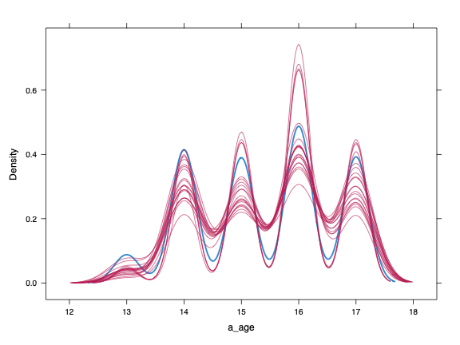
Note. The plot shows kernel density estimates by adolescent age. Imputed datasets (n = 20) appear in red, while observed data appear in blue. The strong correspondence between these curves demonstrates that predictive mean matching generated plausible age values and preserved the distributional characteristics of the observed age data.

Figure S2
Convergence Trace Plots Showing the Mean and Standard Deviation of Imputed Age for the Stress Model across Iterations
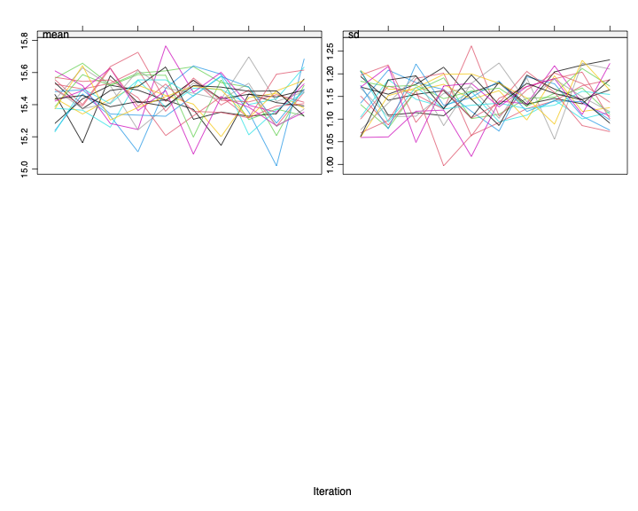
Note. The trace plots display the means (left panel) and standard deviations (right panel) of the imputed values across the 20 imputed datasets over 10 iterations. Each colored line represents one imputed dataset. The stable, well-mixed traces and absence of systematic trends indicate satisfactory convergence of the multiple imputation procedure (van Buuren & Groothuis-Oudshoorn, 2011).

Figure S3
Kernal Density Plots Comparing Observed and Imputed Age Values for the Purpose Model
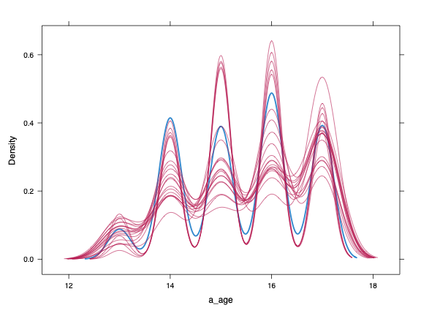
Note. The plot shows kernel density estimates by adolescent age. Imputed datasets (n = 20) appear in red, while observed data appear in blue. The strong correspondence between these curves demonstrates that predictive mean matching generated plausible age values and preserved the distributional characteristics of the observed age data.

Figure S4
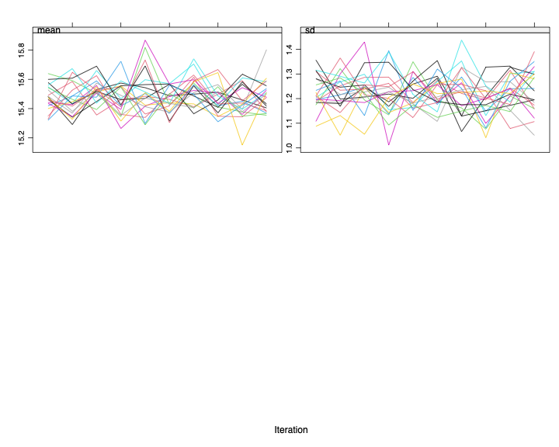
Convergence Trace Plots Showing the Mean and Standard Deviation of Imputed Age for the Purpose Model across Iterations
Note. The trace plots display the means (left panel) and standard deviations (right panel) of the imputed values across the 20 imputed datasets over 10 iterations. Each colored line represents one imputed dataset. The stable, well-mixed traces and absence of systematic trends indicate satisfactory convergence of the multiple imputation procedure (van Buuren & Groothuis-Oudshoorn, 2011).

Figure S5
Kernal Density Plots Comparing Observed and Imputed Age Values for the Compassion Model
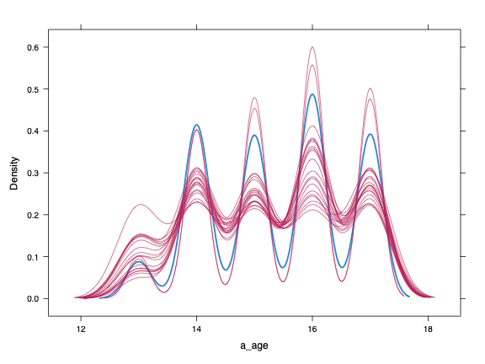
Note. The plot shows kernel density estimates by adolescent age. Imputed datasets (n = 20) appear in red, while observed data appear in blue. The strong correspondence between these curves demonstrates that predictive mean matching generated plausible age values and preserved the distributional characteristics of the observed age data.

Figure S6
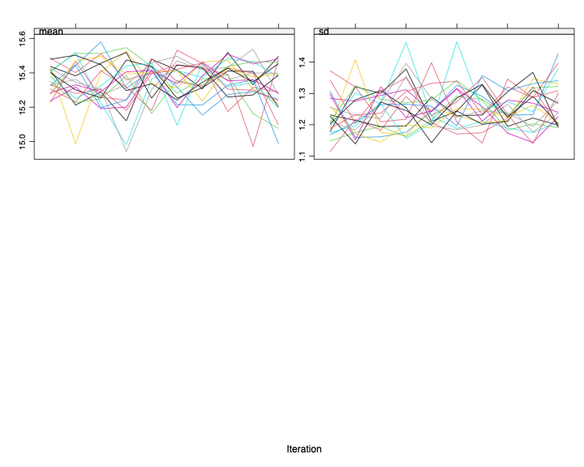
Convergence Trace Plots Showing the Mean and Standard Deviation of Imputed Age for the Compassion Model across Iteration
Note. The trace plots display the means (left panel) and standard deviations (right panel) of the imputed values across the 20 imputed datasets over 10 iterations. Each colored line represents one imputed dataset. The stable, well-mixed traces and absence of systematic trends indicate satisfactory convergence of the multiple imputation procedure (van Buuren & Groothuis-Oudshoorn, 2011).

References
Barnard, J., & Rubin, D. B. (1999). Miscellanea. Small-sample degrees of freedom with multiple imputation. Biometrika, 86(4), 948-955. https://doi.org/10.1093/biomet/86.4.948
Bates, D., Mächler, M., Bolker, B., & Walker, S. (2015). Fitting linear mixed-effects models using lme4. Journal of Statistical Software, 67(1), 1-48. https://doi.org/10.18637/jss.v067.i01
Bolger, N., & Laurenceau, J.-P. (2013). Intensive longitudinal methods: An introduction to diary and experience sampling research. Guilford Press.
Bolker, B., & Robinson, D. (2022). broom.mixed: Tidying methods for mixed models. R package version 0.2.9.4. https://CRAN.R-project.org/package=broom.mixed
Enders, C. K., Mistler, S. A., & Keller, B. T. (2016). Multilevel multiple imputation: A review and evaluation of joint modeling and chained equations imputation. Psychological Methods, 21(2), 222-240. https://doi.org/10.1037/met0000063
Grund, S., Lüdtke, O., & Robitzsch, A. (2018). Multiple imputation of missing data for multilevel models: Simulations and recommendations. Organizational Research Methods, 21(1), 111-149. https://doi.org/10.1177/1094428117703686
Lafit, G., Sels, L., Adolf, J. K., Loeys, T., & Ceulemans, E. (2022). PowerLAPIM: An application to conduct power analysis for linear and quadratic longitudinal actor–partner interdependence models in intensive longitudinal dyadic designs. Journal of Social and Personal Relationships, 39(10), 3085-3115. https://doi.org/10.1177/02654075221080128
Little, R. J., & Rubin, D. B. (2019). Statistical analysis with missing data (3rd ed.). John Wiley & Sons.
Pinheiro, J., Bates, D., & R Core Team (2023). nlme: Linear and nonlinear mixed effects models. R package version 3.1-164. https://CRAN.R-project.org/package=nlme
R Core Team. (2024). R: A language and environment for statistical computing. R Foundation
for Statistical Computing. https://www.R-project.org/
Revelle, W. (2025). psych: Procedures for psychological, psychometric, and personality research
(R package version 2.5.6). Northwestern University. https://CRAN.R-
project.org/package=psych
Rubin, D. B. (1987). Multiple imputation for nonresponse in surveys. John Wiley & Sons.
Sarkar, D. (2008). Lattice: Multivariate data visualization with R. Springer. https://doi.org/10.1007/978-0-387-75969-2
van Buuren, S., & Groothuis-Oudshoorn, K. (2011). mice: Multivariate imputation by chained
equations in R. Journal of Statistical Software, 45(3), 1-67. https://doi.org/10.18637/jss.v045.i03
Wickham, H. (2016). ggplot2: Elegant graphics for data analysis. Springer-Verlag.
Wickham, H., François, R., Henry, L., Müller, K., & Vaughan, D. (2023). dplyr: A grammar of data manipulation (R package version 1.1.4). https://CRAN.R-project.org/package=dplyr
Wickham H, François R, Henry L, Müller K, Vaughan D (2026). dplyr: A Grammar of Data Manipulation. R package version 1.2.1, https://dplyr.tidyverse.org.

