Supplementary File
1 Supplementary Material of Method 3
1.1 Development of the Internet-Based Emotion Regulation Intervention 3
1.2 User Recruitment 7
1.3 Procedures of the Daily Practice of the “PauseLab EBP for Emotion” 8
2 Supplementary Material of Network Analysis with Subgroups 9
2.1 Changes in Network Connectivity in the Residualized Symptom Change Sensitivity Analysis 9
2.2 Changes in Network Connectivity Stratified by Clinical Diagnosis History 10
2.3 Changes in Network Connectivity Stratified by Age Groups 12
2.4 Changes in Network Connectivity for Individuals with Clinically Important Improvement 15
3 Supplementary Tables 17
Table S1 All the Components of the Daily Practices 17
Table S2 Differences in Individual Depressive Symptoms and Total Scores Between Pre- and Post-Intervention Assessments (N = 26643) 20
Table S3 Node Expected Influence (EI) Centrality Invariance Test Between Pre- and Post-Intervention 21
Table S4 Edge Invariance Test Between Pre- and Post-Intervention 22
Table S5 Description and Comparison of Demographics Between the “Symptom Reduction” (n = 20743) and “Symptom Non-Reduction” (n = 5900) Groups 23
Table S6 Node Expected Influence (EI) Centrality Invariance Test Between Pre- and Post-Intervention 24
Table S7 Edge Invariance Test Between Pre- and Post-Intervention in the “Symptom Reduction” and “Symptom Non-Reduction” Groups 25
4 Supplementary Figures 26
Figure S1 The Theoretical Model of the “PauseLab EBP for Emotion” 26
Figure S2 Evidence-Based Components of the “PauseLab EBP for Emotion” 27
Figure S3 Procedures of the Daily Practice of the “PauseLab EBP for Emotion” 28
Figure S4 User Interfaces of the “PauseLab EBP for Emotion” 29
Figure S5 Forms of the Support of the “PauseLab EBP for Emotion” 30
Figure S6 Accuracy of Edge Weights for Depression Networks in Pre- and Post-Intervention 31
Figure S7 Stability of Node Expected Influence (EI) Centrality for Depression Networks in Pre- and Post-Intervention 32
Figure S8 Edge Weight Difference Test for Depression Networks in Pre- and Post-Intervention 33
Figure S9 Node Expected Influence (EI) Centrality Difference Test for Depression Networks in Pre- and Post-Intervention 34
Figure S10 Accuracy of Edge Weights for Depression Networks in Pre- and Post-Intervention for “Symptom Reduction” and “Symptom Non-Reduction” Groups 35
Figure S11 Stability of Node Expected Influence (EI) Centrality for Depression Networks in Pre- and Post-Intervention for “Symptom Reduction” and “Symptom Non-Reduction” Groups 36
Figure S12 Edge Weight Difference Test for Depression Networks in Pre- and Post-Intervention for “Symptom Reduction” and “Symptom Non-Reduction” Groups 37
Figure S13 Node Expected Influence (EI) Centrality Difference Test for Depression Networks in Pre- and Post-Intervention for “Symptom Reduction” and “Symptom Non-Reduction” Groups 38
Figure S14 Expected Influence (EI) Centrality in Pre- and Post-Intervention Depression Networks with Covariates 39
Figure S15 Expected Influence (EI) Centrality in Pre- and Post-Intervention Depression Networks with Covariates for the “Symptom Reduction” and “Symptom Non-Reduction” Groups 40
5 Use of Artificial Intelligence 41

1 Supplementary Material of Method

1.1 Development of the Internet-Based Emotion Regulation Intervention
The design and development of the internet-based emotion regulation intervention used in this study (i.e., PauseLab Evidence-Based Practice (EBP) for Emotion) closely follow a recent comprehensive guideline for the effective development and delivery of e-mental health services (Seiferth et al., 2023).
Theoretical Basis of the Emotion Regulation Intervention
Theoretically, the intervention is based on the Extended Process Model of Emotion Regulation (Gross, 2014). According to the model, emotions are generated via attending to a situation, appraising it, and producing responses. Specifically, when an emotion-eliciting situation from the internal or external world arises (the “situation” or the “world” component), individuals selectively attend to certain aspects of the information from the situation (the “attention” or the “perception” component). Then, individuals assign valences to the attended information based on the perceived benefits and costs shaped by past experiences and learning processes (the “appraisal” or the “value” component). Once the discrepancy between the current and desired states is addressed, individuals execute mental, physiological, or behavioral responses (the “response” or the “action” component). More importantly, the aforementioned processes could be dynamic: the actions produced by a given cycle could be the “situation” or “world” of another cycle, triggering another series of emotional processes. The emotion regulation process functions as a second-level valuation system. It begins with the evoked emotional response tendencies, and then perceives, values, and acts to modify the activity in the first-level valuation (i.e., the emotion-generation) system.
For individuals with heightened emotional distress, when an event happens, they might be more likely to focus on the negative information, which elicits negative appraisal and rumination, leading to the adoption of maladaptive experiential and behavioral responses (see Figure S1, the first-level valuation cycle). The “PauseLab EBP for Emotion” targets the three key processes of the model – “perception”, “value”, and “action” – so as to break the vicious cycle and build an adaptive emotional system (Figure S1, the second-level valuation cycle). Specifically, the intervention first trains the users to be aware of what happened in the external world and their internal experiences, especially positive aspects that may otherwise be overlooked by individuals with heightened emotional distress. Then, users complete practices to help them accept their feelings in the mind, trying to objectively appraise and interpret them. Next, users are trained to develop more adaptive response patterns, acting in a value-aligned direction even when accompanied by discomfort. These practices may reduce emotional distress, prevent depression, and enhance wellbeing by reshaping users’ valuation system.
Target Group, Technical Development Process, and Evidence-Based Daily Practices
The intervention is designed for individuals seeking to reduce current emotional distress as well as those who aim to enhance their emotion regulation capacity and prevent potential future emotional distress.
The development team included professionals in psychology, design, user experience, audio editing, and development. Psychologists first designed the core content, followed by collaborative discussions on delivery and user engagement. All materials and program updates were reviewed by the team prior to release, followed by internal user testing involving representative users who provided valuable feedback.
The intervention is grounded in evidence-based practices, incorporating elements from cognitive-behavioral therapy (CBT), mindfulness-based stress reduction (MBSR), mindfulness-based cognitive therapy (MBCT), acceptance and commitment therapy (ACT), and positive psychology interventions (PPI). These diverse therapeutic techniques have been systematically combined to guide users’ engagement with the intervention (see Supplementary Figure S2 for more details).
Daily practices of the intervention consist of two main forms: an audio practice and a writing practice (see Supplementary Figure S3). The audio practice includes psychoeducational readings (Figure S3A) and 10- to 15-minute daily audio exercises (Figure S3B). The readings introduce foundational mindfulness concepts and techniques for applying mindfulness in daily life to manage mental distress. The audio exercises guide formal mindfulness practices, with the 21-day curriculum covering various modules (e.g., mindful breathing, body scan, mindful eating, mindful walking, mindful yoga). The writing practice (Figure S3C) provides a set of designed prompts each day (e.g., recording positive events, differentiating thoughts and emotions, clarifying values and goals) along with explanatory readings on the intentions and hypothesized benefits of each exercise. Day 0 of the intervention is the launch day when users are required to complete the pre-intervention assessment and the “My original intention and commitment” section. Day 1 through Day 21 contain daily practices and users are required to complete the practices on the corresponding day (see Supplementary Table S1 for a list of all the daily practices and Figure S4 for the user interfaces of the daily intervention).
Intervention Delivery Platform
The intervention is delivered via an online platform (ebp.gesedna.com) accessible through electronic devices such as smartphones, tablets, and computers. Recognizing the widespread use of WeChat—China's most popular social media platform—the intervention also provides a shortcut link within the official WeChat subscription account and sends daily practice reminders through WeChat’s template messaging feature. This platform was selected for its accessibility, broad reach, and seamless integration with WeChat, which enhances user engagement by sending reminders and notifications. The content is fully integrated into the WeChat ecosystem, requiring no additional downloads or installations. The platform’s design emphasizes ease of access, user-friendly navigation, and compatibility with users’ existing technological habits.
Data Flow, Data Storage, Access, and Data Security
Participants accessed the platform exclusively through encrypted links distributed via social media, ensuring that no data exchange occurred on third-party platforms. To maintain participant privacy, identity verification details (e.g., login account credentials) and research data were securely stored in physically segregated systems, with two distinct datasets being managed: 1) personal order and account information, which is accessible only to customer service personnel for troubleshooting, and 2) anonymized research data, including practice records, surveys, and assessments, which are securely stored for analytical purposes. This helps prevent any technical or administrative means of linking participants’ social media profiles with their study responses. In addition, the platform intentionally excluded the collection of digital identifiers, such as IP addresses, further enhancing participant anonymity.
During the registration process, users were presented with a detailed privacy policy, clearly outlining the collection and use of their data for scientific research purposes, as well as the potential publication of aggregated, non-identifiable results. Users were required to provide consent to these practices before proceeding. All research data were anonymized using randomized identifiers, ensuring that no personal information was disclosed. Any summary results that were published for scientific purposes were sufficiently aggregated to prevent identification of individual participants.
Safety Plan
The suicide risk assessment protocol employs a validated two-stage screening process, consistent with the Columbia Suicide Severity Rating Scale (C-SSRS; Posner et al., 2007). Upon registration, all participants first complete two screening questions (0 = no, 1 = yes) to evaluate recent suicidal ideation (“Have you experienced suicidal ideation in the past month?”) and perceived worthlessness (“Do you currently believe that your life is worthless?”). Affirmative responses to either of these questions trigger a secondary assessment, which involves two additional items (0 = no, 1 = yes) assessing suicide planning (“Have you formulated a specific suicide plan within the past month?”) and means preparation (“Have you acquired the means to implement suicide?”). In both stages, an answer is classified as positive if the participant responds “yes” to either question; otherwise, it is classified as negative.
Following risk stratification, participants are provided with information based on their assessed risk levels: (a) participants identified as “no risk” (negative on the first stage screening) are given standard crisis resources and informed that these resources are permanently available; (b) participants identified as “low risk” (positive on the first stage but negative on the second stage) engage in guided safety planning using the Stanley-Brown template and confirm their readiness before proceeding; this safety plan remains accessible on their dashboard during the intervention; (c) participants who screened positive at both stages were classified as positive for suicidal ideation. These individuals were not permitted to access the intervention content unless they reported ongoing, stable care from a licensed healthcare professional. Participants who did not report current professional care were provided with immediate guidance to seek clinical evaluation, offered a refund, and directed to appropriate crisis services. Participants who reported ongoing professional care were permitted to continue participation under existing clinical supervision.
To further support participant safety during the intervention, the program incorporated a guided self-help component through moderated WeChat groups. Each group was facilitated by trained coaches holding master’s degrees in clinical psychology. Participants were encouraged to report distressing experiences, adverse reactions, or concerns related to the practices, and coaches provided timely psychoeducation, normalization, and guidance. This structure ensured ongoing human oversight and provided a direct channel for support, reducing risks associated with fully unguided digital interventions.
All participants were provided with 24/7 crisis hotline information at onboarding and throughout the intervention. All staff involved in user support, including coaches and customer service personnel, received regular crisis management training and ongoing supervision by licensed clinical psychologists.
Consistent with prior reports that mindfulness-based practices may occasionally elicit transient emotional or bodily discomfort, the intervention emphasized gradual engagement and encouraged participants to communicate any distress through the guided support channels. These procedures were designed to support safe and constructive engagement with the intervention rather than to replace professional mental health care.
Support Systems
The intervention is structured in a self-help format with optional human support. Participants can seek guidance through two forms of support: 1) a moderated online WeChat group, where participants can ask questions and interact with fellow users, moderated by assistants with master’s degrees in psychology who have undergone extensive training, and 2) live weekly Q&A sessions hosted online by the intervention designers. These live sessions, held five to six times during each 21-day intervention period, allow users to submit questions ahead of time and join live interactions based on their availability. All questions submitted via the WeChat group or live sessions are addressed promptly (see Supplementary Figure S5A and S5B).
To facilitate engagement with the writing exercises, each prompt is accompanied by example responses from the designers and virtual peer examples. The designer examples offer clear demonstrations of how to complete the exercises, while the virtual peer examples are fictionalized representations based on common experiences across diverse demographics. These peer examples aim to provide relatable, realistic scenarios that help users visualize the process of applying the techniques to their own lives (see Supplementary Figure S5C). In addition, the audio and writing practices are supported by a comprehensive Q&A database about commonly encountered issues, which participants can access at any time (see Supplementary Figure S5D).

1.2 User Recruitment
The intervention program runs in periodic cycles, each lasting 35 days. Users discover and purchase the intervention services through social media or recommendations from friends. After purchasing, they must wait until the next cycle begins before starting the exercises.
The standard registration fee is 699 RMB (about $95), with discounts varying based on how the service was acquired. The registration fee covers the costs of the exercises, human support, and motivational support. Participants who complete 22 days of the program (which includes the introductory task and 21 days of exercises) within a cycle are rewarded with 100 RMB (about $14). During registration, users must provide basic information.
Users can choose to confirm their participation in the next intervention cycle or wait for a more convenient time. The enrollment deadline for each cycle is three days after it begins. Those who do not actively select the next cycle still retain eligibility and are privately reminded by a customer service representative before each new cycle starts.

1.3 Procedures of the Daily Practice of the “PauseLab EBP for Emotion”
All procedures of daily practice are shown in Figure S3. Completion of tasks is determined by user behavior. For psychoeducational readings, participants must click a “Finished” button upon completion (Figure S3A). Audio exercises require participants to complete an experience rating scale afterward (Figure S3B). Responses to the writing exercises must be submitted in the specified formats (Figure S3C). Tests require completion of designated questions. On the task completion page, frequently asked questions and answers related to the practices are provided (Figure S3D). Once all tasks are finished for the day, participants receive a motivational quote card as a reward for completing the day’s interventions (Figure S4C). This allows participants to conveniently access the intervention content daily through popular digital platforms. The variety of task types and the daily progression system help maintain engagement. Tracking task completion based on user behavior allows for precise measurement of adherence.

2 Supplementary Material of Network Analysis with Subgroups

2.1 Changes in Network Connectivity in the Residualized Symptom Change Sensitivity Analysis
At the pre-intervention stage, network comparison tests revealed no significant group differences in global connectivity. Specifically, there was no difference in global strength (S = 0.053, p = .136) or overall network structure (M = 0.039, p = .067) between the “greater-than-expected reduction” and “less-than-expected reduction” groups. For local connectivity, the node invariance test with FDR correction indicated generally no difference in EI centrality between the two groups (PHQ1 Anhedonia: Δ = 0.023, p = .891; PHQ2 Depressed mood: Δ = −0.002, p = .934; PHQ3 Sleep disturbance: Δ = −0.005, p = .891; PHQ4 Fatigue: Δ = −0.007, p = .891; PHQ5 Weight disturbance: Δ = −0.012, p = .891; PHQ6 Worthlessness: Δ = −0.016, p = .891; PHQ7 Concentration difficulties: Δ = 0.006, p = .891; PHQ8 Psychomotor disturbance: Δ = 0.005, p = .891), except for a higher EI centrality of Suicidality (PHQ9; Δ = 0.074, p = .018) in the “less-than-expected reduction” group compared to the “greater-than-expected reduction” group.
In contrast, post-intervention comparisons revealed significant differences between the two groups in both global and local connectivity. The “less-than-expected reduction” group exhibited significantly higher global strength (S = 0.741, p < .001) and a distinct overall network structure (M = 0.087, p < .001) compared to the “greater-than-expected reduction” group. For local connectivity, the node invariance test with FDR correction indicated that all nine nodes showed higher EI centrality in the “less-than-expected reduction” group compared to the “greater-than-expected reduction” group, including Anhedonia (PHQ1; Δ = 0.089, p = .001), Depressed mood (PHQ2; Δ = 0.198, p = .001), Sleep disturbance (PHQ3; Δ = 0.125, p = .001), Fatigue (PHQ4; Δ = 0.188, p = .001), Weight disturbance (PHQ5; Δ = 0.151, p = .001), Worthlessness (PHQ6; Δ = 0.206, p = .001), Concentration difficulties (PHQ7; Δ = 0.066, p = .002), Psychomotor disturbance (PHQ8; Δ = 0.181, p = .001), and Suicidality (PHQ9; Δ = 0.277, p = .001).
In the “greater-than-expected reduction” group, network comparison tests revealed a significant decrease in global strength following the intervention (S = −0.913, p < .001), along with a significant change in overall network structure (M = 0.160, p < .001). At the local level, the node invariance test with FDR correction indicated that after the intervention, the EI centrality of all nine PHQ-9 symptoms significantly decreased, including Anhedonia (PHQ1; Δ = −0.178, p < .001), Depressed mood (PHQ2; Δ = −0.332, p < .001), Sleep disturbance (PHQ3; Δ = −0.205, p < .001), Fatigue (PHQ4; Δ = −0.255, p < .001), Weight disturbance (PHQ5; Δ = −0.243, p < .001), Worthlessness (PHQ6; Δ = −0.219, p < .001), Concentration difficulties (PHQ7; Δ = −0.089, p < .001), Psychomotor disturbance (PHQ8; Δ = −0.167, p < .001), and Suicidality (PHQ9; Δ = −0.138, p < .001).
In the “less-than-expected reduction” group, network comparison tests revealed a significant decrease in global strength following the intervention (S = −0.226, p < .001), along with a significant change in overall network structure (M = 0.079, p < .001). At the local level, the node invariance test with FDR correction indicated that after the intervention, the EI centrality of five symptoms significantly decreased, including Anhedonia (PHQ1; Δ = −0.112, p = .002), Depressed mood (PHQ2; Δ = −0.132, p = .002), Sleep disturbance (PHQ3; Δ = −0.076, p = .002), Fatigue (PHQ4; Δ = −0.060, p = .004), and Weight disturbance (PHQ5; Δ = −0.081, p = .002). In contrast, the EI centrality of Suicidality (PHQ9; Δ = 0.065, p = .004) significantly increased. No significant changes in EI were observed for Worthlessness (PHQ6; Δ = 0.003, p = .889), Concentration difficulties (PHQ7; Δ = −0.029, p = .167), or Psychomotor disturbance (PHQ8; Δ = 0.008, p = .787).

2.2 Changes in Network Connectivity Stratified by Clinical Diagnosis History
Individuals with Self-Reported Prior Diagnostic Experience
Among individuals with self-reported prior diagnostic experience, network comparison tests for global connectivity revealed a significant increase in global strength following the intervention (S = 0.071, p < .001), along with a significant change in overall network structure (M = 0.104, p < .001). At the local level, the node centrality invariance test with FDR correction revealed no difference in EI centrality after the intervention (PHQ1 Anhedonia: Δ = −0.043, p = .240; PHQ2 Depressed mood: Δ = −0.044, p = .240; PHQ3 Sleep disturbance: Δ = 0.044, p = .240; PHQ4 Fatigue: Δ = 0.042, p = .240; PHQ5 Weight disturbance: Δ = 0.029, p = .357; PHQ6 Worthlessness: Δ = 0.042, p = .240; PHQ7 Concentration difficulties: Δ = 0.061, p = .207; PHQ8 Psychomotor disturbance: Δ = 0.027, p = .382; PHQ9 Suicidality: Δ = 0.066, p = .207).
In the “symptom-reduction” subgroup, network comparison tests showed no significant change in global strength (S = −0.016, p = .629), while there was a significant change in overall network structure (M = 0.131, p < .001). At the local level, the node invariance test with FDR correction indicated that after the intervention, the EI centrality of Depressed mood (PHQ2; Δ = −0.090, p = .036) reduced, while Concentration difficulties (PHQ7; Δ = 0.091, p = .027) increased. No significant changes in EI were observed for Anhedonia (PHQ1; Δ = −0.066, p = .104), Sleep disturbance (PHQ3; Δ = 0.066, p = .083), Fatigue (PHQ4; Δ = 0.069, p = .083), Weight disturbance (PHQ5; Δ = 0.007, p = .962), Worthlessness (PHQ6; Δ = 0.019, p = .845), Psychomotor disturbance (PHQ8; Δ = 0.001, p = .980), or Suicidality (PHQ9; Δ = 0.008, p = .962).
In the “symptom non-reduction” subgroup, the overall network structure did not change significantly following the intervention (M = 0.103, p = .491), although there was a significant increase in global strength (S = 0.145, p = .037). At the local level, the FDR-corrected node invariance test revealed no difference in EI centrality after the intervention (PHQ1 Anhedonia: Δ = 0.002, p = .986; PHQ2 Depressed mood: Δ = 0.038, p = .986; PHQ3 Sleep disturbance: Δ = −0.002, p = .986; PHQ4 Fatigue: Δ = −0.012, p = .986; PHQ5 Weight disturbance: Δ = 0.077, p = .986; PHQ6 Worthlessness: Δ = 0.113, p = .836; PHQ7 Concentration difficulties: Δ = 0.032, p = .986; PHQ8 Psychomotor disturbance: Δ = −0.013, p = .986; PHQ9 Suicidality: Δ = 0.055, p = .986).
Individuals without Self-Reported Prior Diagnostic Experience
Among individuals without self-reported prior diagnostic experience, network comparison tests for global connectivity revealed a significant increase in global strength following the intervention (S = 0.037, p = .029), along with a significant change in overall network structure (M = 0.109, p < .001). At the local level, the node invariance test with FDR correction indicated that after the intervention, the EI centrality of Anhedonia (PHQ1; Δ = −0.054, p = .009) and Depressed mood (PHQ2; Δ = −0.127, p = .002) reduced, while Concentration difficulties (PHQ7; Δ = 0.078, p = .002), Psychomotor disturbance (PHQ8; Δ = 0.079, p = .002), and Suicidality (PHQ9; Δ = 0.071, p = .002) increased. No significant changes in EI were observed for Sleep disturbance (PHQ3; Δ = 0.006, p = .985), Fatigue (PHQ4; Δ = −0.013, p = .581), Weight disturbance (PHQ5; Δ = 0.0003, p = .985), or Worthlessness (PHQ6; Δ = 0.039, p = .060).
In the “symptom-reduction” subgroup, network comparison tests showed a significant decrease in global strength (S = −0.094, p < .001) and a significant change in overall network structure (M = 0.128, p < .001). At the local level, the node invariance test with FDR correction indicated that after the intervention, the EI centrality of Anhedonia (PHQ1; Δ = −0.065, p = .009) and Depressed mood (PHQ2; Δ = −0.170, p = .004) reduced, while Concentration difficulties (PHQ7; Δ = 0.103, p = .004) increased. No significant changes in EI were observed for Sleep disturbance (PHQ3; Δ = 0.012, p = .626), Fatigue (PHQ4; Δ = 0.007, p = .810), Weight disturbance (PHQ5; Δ = −0.041, p = .070), Worthlessness (PHQ6; Δ = 0.004, p = .851), Psychomotor disturbance (PHQ8; Δ = 0.038, p = .106), or Suicidality (PHQ9; Δ = −0.014, p = .626).
In the “symptom non-reduction” subgroup, the overall network structure did not change significantly following the intervention (M = 0.069, p = .227), although there was a significant increase in global strength (S = 0.318, p < .001). At the local level, the node invariance test with FDR correction indicated that after the intervention, the EI centrality of Weight disturbance (PHQ5; Δ = 0.116, p = .009), Concentration difficulties (PHQ7; Δ = 0.150, p = .004), and Psychomotor disturbance (PHQ8; Δ = 0.215, p = .004) increased. No significant changes in EI were observed for Anhedonia (PHQ1; Δ = −0.019, p = .682), Depressed mood (PHQ2; Δ = −0.016, p = .704), Sleep disturbance (PHQ3; Δ = 0.059, p = .123), Fatigue (PHQ4; Δ = −0.019, p = .682), Worthlessness (PHQ6; Δ = 0.070, p = .123), or Suicidality (PHQ9; Δ = 0.080, p = .090).

2.3 Changes in Network Connectivity Stratified by Age Groups
Individuals Aged 18–25 Years
Among individuals aged 18–25 years, network comparison tests for global connectivity revealed no difference in global strength following the intervention (S = 0.050, p = .470), but a significant change in overall network structure (M = 0.087, p = .003). At the local level, the node invariance test with FDR correction indicated that after the intervention, the EI centrality of Concentration difficulties (PHQ7; Δ = 0.138, p = .009) and Psychomotor disturbance (PHQ8; Δ = 0.074, p = .027) increased. No significant changes in EI were observed for Anhedonia (PHQ1; Δ = −0.050, p = .132), Depressed mood (PHQ2; Δ = −0.066, p = .058), Sleep disturbance (PHQ3; Δ = 0.010, p = .764), Fatigue (PHQ4; Δ = −0.008, p = .764), Weight disturbance (PHQ5; Δ = 0.066, p = .058), Worthlessness (PHQ6; Δ = 0.051, p = .132), or Suicidality (PHQ9; Δ = 0.049, p = .132).
In the “symptom-reduction” subgroup, network comparison tests for global connectivity revealed no difference in global strength following the intervention (S = 0.032, p = .638), but a significant change in overall network structure (M = 0.102, p < .001). At the local level, the node invariance test with FDR correction indicated that after the intervention, the EI centrality of Depressed mood (PHQ2; Δ = −0.152, p = .004) reduced, while Concentration difficulties (PHQ7; Δ = 0.133, p = .004) increased. No significant changes in EI were observed for Anhedonia (PHQ1; Δ = −0.059, p = .142), Sleep disturbance (PHQ3; Δ = 0.065, p = .069), Fatigue (PHQ4; Δ = 0.008, p = .774), Weight disturbance (PHQ5; Δ = 0.026, p = .599), Worthlessness (PHQ6; Δ = 0.017, p = .703), Psychomotor disturbance (PHQ8; Δ = 0.042, p = .323), or Suicidality (PHQ9; Δ = −0.016, p = .704).
In the “symptom non-reduction” subgroup, network comparison tests revealed no significant differences in global connectivity following the intervention. Specifically, there was no difference in global strength (S = 0.122, p = .078) or overall network structure (M = 0.088, p = .811). At the local level, the node invariance test with FDR correction indicated that after the intervention, the EI centrality of Concentration difficulties (PHQ7; Δ = 0.216, p = .009) increased. No significant changes in EI were observed for Anhedonia (PHQ1; Δ = −0.086, p = .309), Depressed mood (PHQ2; Δ = 0.034, p = .695), Sleep disturbance (PHQ3; Δ = −0.063, p = .397), Fatigue (PHQ4; Δ = −0.042, p = .649), Weight disturbance (PHQ5; Δ = 0.142, p = .063), Worthlessness (PHQ6; Δ = 0.093, p = .309), Psychomotor disturbance (PHQ8; Δ = 0.103, p = .309), or Suicidality (PHQ9; Δ = 0.027, p = .711).
Individuals Aged 26–35 Years
Among individuals aged 26–35 years, network comparison tests for global connectivity showed no significant change in global strength (S = 0.017, p = .315), while there was a significant change in overall network structure (M = 0.112, p < .001). At the local level, the node invariance test with FDR correction indicated that after the intervention, the EI centrality of Anhedonia (PHQ1; Δ = −0.057, p = .013) and Depressed mood (PHQ2; Δ = −0.123, p = .003) reduced, while Worthlessness (PHQ6; Δ = 0.043, p = .048), Concentration difficulties (PHQ7; Δ = 0.082, p = .003), Psychomotor disturbance (PHQ8; Δ = 0.062, p = .004), and Suicidality (PHQ9; Δ = 0.077, p = .003) increased. No significant changes in EI were observed for Sleep disturbance (PHQ3; Δ = 0.027, p = .117), Fatigue (PHQ4; Δ = 0.015, p = .459), or Weight disturbance (PHQ5; Δ = −0.009, p = .646).
In the “symptom-reduction” subgroup, network comparison tests showed a significant decrease in global strength (S = −0.088, p < .001) and a significant change in overall network structure (M = 0.137, p < .001). At the local level, the node invariance test with FDR correction indicated that after the intervention, the EI centrality of Anhedonia (PHQ1; Δ = −0.058, p = .034), Depressed mood (PHQ2; Δ = −0.164, p = .004) and Weight disturbance (PHQ5; Δ = −0.045, p = .038) reduced, while Sleep disturbance (PHQ3; Δ = 0.047, p = .027) and Concentration difficulties (PHQ7; Δ = 0.107, p = .004) increased. No significant changes in EI were observed for Fatigue (PHQ4; Δ = 0.029, p = .219), Worthlessness (PHQ6; Δ = 0.023, p = .376), Psychomotor disturbance (PHQ8; Δ = 0.020, p = .391), or Suicidality (PHQ9; Δ = 0.007, p = .725).
In the “symptom non-reduction” subgroup, the overall network structure did not change significantly following the intervention (M = 0.056, p = .756), although there was a significant increase in global strength (S = 0.277, p < .001). At the local level, the node invariance test with FDR correction indicated that after the intervention, the EI centrality of Weight disturbance (PHQ5; Δ = 0.095, p = .039), Concentration difficulties (PHQ7; Δ = 0.133, p = .013), and Psychomotor disturbance (PHQ8; Δ = 0.154, p = .013) increased. No significant changes in EI were observed for Anhedonia (PHQ1; Δ = −0.029, p = .526), Depressed mood (PHQ2; Δ = −0.017, p = .669), Sleep disturbance (PHQ3; Δ = 0.037, p = .414), Fatigue (PHQ4; Δ = −0.043, p = .382), Worthlessness (PHQ6; Δ = 0.085, p = .126), or Suicidality (PHQ9; Δ = 0.054, p = .382).
Individuals Older than 35 Years
Among individuals older than 35 years, network comparison tests for global connectivity showed no significant change in global strength (S = 0.016, p = .542), while there was a significant change in overall network structure (M = 0.109, p < .001). At the local level, the node invariance test with FDR correction indicated that after the intervention, the EI centrality of Depressed mood (PHQ2; Δ = −0.098, p = .009) and Fatigue (PHQ4; Δ = −0.067, p = .027) reduced. No significant changes in EI were observed for Anhedonia (PHQ1; Δ = −0.015, p = .774), Sleep disturbance (PHQ3; Δ = −0.009, p = .819), Weight disturbance (PHQ5; Δ = −0.002, p = .935), Worthlessness (PHQ6; Δ = 0.052, p = .119), Concentration difficulties (PHQ7; Δ = 0.041, p = .141), Psychomotor disturbance (PHQ8; Δ = 0.062, p = .090), or Suicidality (PHQ9; Δ = 0.068, p = .057).
In the “symptom-reduction” subgroup, network comparison tests showed no significant change in global strength (S = −0.051, p = .115), but a significant change in overall network structure (M = 0.123, p < .001). At the local level, the node invariance test with FDR correction indicated that after the intervention, the EI centrality of Depressed mood (PHQ2; Δ = −0.136, p = .009) reduced. No significant changes in EI were observed for Anhedonia (PHQ1; Δ = −0.012, p = .820), Sleep disturbance (PHQ3; Δ = 0.005, p = .852), Fatigue (PHQ4; Δ = −0.039, p = .518), Weight disturbance (PHQ5; Δ = −0.014, p = .820), Worthlessness (PHQ6; Δ = 0.028, p = .820), Concentration difficulties (PHQ7; Δ = 0.064, p = .148), Psychomotor disturbance (PHQ8; Δ = 0.022, p = .820), or Suicidality (PHQ9; Δ = −0.020, p = .820).
In the “symptom non-reduction” subgroup, network comparison tests showed a significant increase in global strength (S = 0.336, p < .001) and a significant change in overall network structure (M = 0.134, p = .011). At the local level, the node invariance test with FDR correction revealed no difference in EI centrality after the intervention (PHQ1 Anhedonia: Δ = 0.041, p = .679; PHQ2 Depressed mood: Δ = −0.002, p = .975; PHQ3 Sleep disturbance: Δ = 0.019, p = .804; PHQ4 Fatigue: Δ = −0.032, p = .730; PHQ5 Weight disturbance: Δ = 0.079, p = .332; PHQ6 Worthlessness: Δ = 0.028, p = .730; PHQ7 Concentration difficulties: Δ = 0.093, p = .141; PHQ8 Psychomotor disturbance: Δ = 0.162, p = .090; PHQ9 Suicidality: Δ = 0.133, p = .117).

2.4 Changes in Network Connectivity for Individuals with Clinically Important Improvement
Baseline-Sensitive Clinically Anchored Improvement Criterion
Clinically important improvement was first defined using a baseline-sensitive criterion: a ≥5-point reduction on the PHQ-9 for individuals with baseline scores ≥10, or a ≥50% reduction for individuals with baseline scores <10, consistent with prior literature. Among individuals meeting this criterion, network comparison tests showed a significant decrease in global network strength (S = −0.113, p < .001) and a significant change in overall network structure (M = 0.148, p < .001) from pre- to post-intervention. At the local level, the node invariance test with FDR correction indicated that after the intervention, the EI centrality of Depressed mood (PHQ2; Δ = −0.188, p = .004) and Fatigue (PHQ4; Δ = −0.051, p = .012) reduced, while Sleep disturbance (PHQ3; Δ = 0.037, p = .049) and Concentration difficulties (PHQ7; Δ = 0.069, p = .004) increased. No significant changes in EI were observed for Anhedonia (PHQ1; Δ = −0.042, p = .056), Weight disturbance (PHQ5; Δ = −0.016, p = .405), Worthlessness (PHQ6; Δ = 0.021, p = .371), Psychomotor disturbance (PHQ8; Δ = 0.029, p = .175), or Suicidality (PHQ9; Δ = −0.015, p = .405).
Uniform 5-Point PHQ-9 Reduction Criterion
As an additional sensitivity analysis, clinically important improvement was also defined using a uniform ≥5-point reduction on the PHQ-9, applied to all participants regardless of baseline symptom severity. Among individuals meeting this criterion, network comparison tests revealed a significant increase in global network strength from pre- to post-intervention (S = 0.154, p < .001), along with a significant change in overall network structure (M = 0.148, p < .001). At the local level, the node invariance test with FDR correction indicated that the EI centrality of Depressed mood (PHQ2; Δ = −0.128, p = .002) and Suicidality (PHQ9; Δ = −0.043, p = .018) decreased after the intervention. In contrast, the EI centrality of Sleep disturbance (PHQ3; Δ = 0.130, p = .002), Fatigue (PHQ4; Δ = 0.116, p = .002), Weight disturbance (PHQ5; Δ = 0.052, p = .016), Worthlessness (PHQ6; Δ = 0.098, p = .002), Concentration difficulties (PHQ7; Δ = 0.178, p = .002), and Psychomotor disturbance (PHQ8; Δ = 0.048, p = .018) increased. No significant change in EI centrality was observed for Anhedonia (PHQ1; Δ = 0.018, p = .434).

3 Supplementary Tables

Table S1

All the Components of the Daily Practices
Components of daily practices
Getting started
Day-0
Starting point: Preparations before officially beginning
My original intentions and commitments
Stage 1
/Opening the space of awareness/
Day-1 Connecting with the present moment through breathing and visual cues
Mindful breathing: Initial mindfulness experience
Pleasant experiences list: Vision
Reading: What is mindfulness?
Day-2 Experiencing focus and joy while eating
Mindful eating: Cultivating curiosity
Pleasant experiences list: Taste
Day-3 Returning to the present and establishing positive connections through touch
Mindful breathing: Bringing attention back to the present
Pleasant experiences list: Touch
Reading: Formal mindfulness practice and living mindfully
Day-4 Accumulating positive olfactory experiences through breathing
Mindful smelling: Feeling the scent of the breath
Pleasant experiences list: Smell
Day-5 Resting the mind while walking
Mindful walking: Resting while walking
Pleasant experiences list: Exercise
Reading: The non-judgemental attitude
Day-6 Letting go of thoughts in the mind and collecting happiness from life
Mindful breathing: From thoughts back to the present
Happiness list: Activating actions
Reading: The power of simplicity in mindful breathing
Day-7 Immersing in real life and taking stock of achievements
Mindful breathing: Letting thoughts come and go
Achievements list: Improving self-evaluation
Day-8 Recap: Accumulating positive resources and landing safely from emotional storms
Mindful walking: Landing in emotions
Recap: Accumulating positive resources
Reading: Returning to the present moment when encountering difficulties
Stage 2
/Understanding emotions from new perspectives/
Day-9 Reconnecting with the body and identifying one’s emotions
Body scan: Reconnecting with the body
Emotion rating: Quantifying emotion intensity
Day-10 Understanding the functions of emotions and signals from emotions
Body scan: Letting go of mental worries
Emotion rating: Exploring the functions of emotions
Reading: Non-judging listening to body signals
Day-11 Controlling the direction of attention and breaking down emotional processes
Body scan: Controlling attention’s direction
ABC worksheet: Organizing emotional processes
Reading: Starting from controlling attention to act consciously
Day-12 Recognizing body cues and recording changes in emotions
Body scan: The relation between body and emotions
Emotion weather map: Observing the changes of emotions
Day-13 Maintaining distance from emotions and implementing cognitive defusion
Mindful breathing: Coexisting with feelings
Labeling thoughts: Cognitive defusion
Reading: Letting go of the aversion towards unpleasant experiences
Day-14 Recap: Understanding the meaning of acceptance and practicing self-care
Body scan: Treating yourself kindly
Experience labeling: Integrated application of cognitive defusion
Reading: Being kind to myself
Stage 3
/Acting autonomously and effectively/
Day-15 Confronting feelings in stress and reducing avoidance
Mindful breathing: Feelings the ebb and flow of emotions
Cost-benefit analysis of behaviors: Short- and long-term analysis
Reading: Coexisting with unpleasant experiences
Day-16 Confronting emotions in stress and clarifying expectations
Mindful breathing: Coexisting with emotions
Clarifying expectations: Choosing appropriate behaviors
Day-17 Identifying thoughts in stress and finding valued directions
Mindful breathing: Coexisting with thoughts
Value-based actions: Clarifying my values
Day-18 Allowing discomfort to exist and practicing personal goals
Standing stretches: Facing inner experiences
Value-based actions: Making action plans
Day-19 Recap: Facing emotional stress in completely new ways
Standing stretches: Coexisting with discomfort
Application: Coping with emotional distress
Reading: Acting mindfully
Day-20 recap: Moving forward with emotions and creating desired life
Integrated mindfulness practice: Body scan
Application: Acting towards the values
Day-21 The end: Patiently cultivating the “Emotional Skill Tree”
Integrated mindfulness practice: Mindful breathing
Summary: Reviewing achievements and acting towards the goals persistently

Table S2

Differences in Individual Depressive Symptoms and Total Scores Between Pre- and Post-Intervention Assessments (N = 26,643)
Variable | Abbr. | Pre | Post |  | Statistic |  | Effect size
Variable | Abbr. | M (SD) | M (SD) |  | t | p | Cohen's d
Anhedonia | PHQ1 | 1.35 (0.90) | 0.82 (0.70) |  | 98.65 | <.001 | 0.66
Depressed mood | PHQ2 | 1.44 (0.82) | 0.93 (0.64) |  | 98.84 | <.001 | 0.70
Sleep disturbance | PHQ3 | 1.44 (0.98) | 0.96 (0.82) |  | 81.02 | <.001 | 0.53
Fatigue | PHQ4 | 1.75 (0.90) | 1.13 (0.74) |  | 111.67 | <.001 | 0.76
Weight disturbance | PHQ5 | 0.96 (0.94) | 0.62 (0.76) |  | 59.78 | <.001 | 0.40
Worthlessness | PHQ6 | 1.16 (0.96) | 0.64 (0.74) |  | 96.03 | <.001 | 0.62
Concentration difficulties | PHQ7 | 1.31 (1.02) | 0.87 (0.80) |  | 72.80 | <.001 | 0.48
Psychomotor disturbance | PHQ8 | 0.61 (0.81) | 0.43 (0.65) |  | 35.45 | <.001 | 0.24
Suicidality | PHQ9 | 0.32 (0.62) | 0.20 (0.50) |  | 31.60 | <.001 | 0.21
Total score | − | 10.35 (5.26) | 6.60 (4.21) |  | 134.98 | <.001 | 0.79

Table S3

Node Expected Influence (EI) Centrality Invariance Test Between Pre- and Post-Intervention
Node | Abbr. | Pre | Post | Difference | p
Anhedonia | PHQ1 | 0.997 | 0.955 | −0.043 | 0.004
Depressed mood | PHQ2 | 0.995 | 0.885 | −0.110 | 0.002
Sleep disturbance | PHQ3 | 0.604 | 0.616 | 0.011 | 0.403
Fatigue | PHQ4 | 1.009 | 0.998 | −0.012 | 0.403
Weight disturbance | PHQ5 | 0.703 | 0.706 | 0.003 | 0.852
Worthlessness | PHQ6 | 0.963 | 1.005 | 0.042 | 0.004
Concentration difficulties | PHQ7 | 0.650 | 0.721 | 0.072 | 0.002
Psychomotor disturbance | PHQ8 | 0.691 | 0.752 | 0.061 | 0.002
Suicidality | PHQ9 | 0.578 | 0.642 | 0.064 | 0.002
Note. p values are corrected for multiple comparisons using the false discovery rate (FDR) method. Differences were computed by subtracting the pre-intervention EI centrality value from the corresponding post-intervention value.
Table S4

Edge Invariance Test Between Pre- and Post-Intervention
Edge between |  | Pre | Post | Difference | p
PHQ1 | PHQ2 | 0.389 | 0.284 | −0.105 | 0.007
PHQ1 | PHQ4 | 0.281 | 0.236 | −0.045 | 0.007
PHQ1 | PHQ6 | 0.102 | 0.150 | 0.049 | 0.007
PHQ2 | PHQ6 | 0.254 | 0.212 | −0.042 | 0.007
PHQ2 | PHQ7 | −0.010 | 0.023 | 0.033 | 0.007
PHQ3 | PHQ7 | 0.051 | 0.079 | 0.028 | 0.027
PHQ1 | PHQ8 | 0.025 | 0.050 | 0.026 | 0.025
PHQ6 | PHQ8 | 0.102 | 0.128 | 0.026 | 0.020
PHQ1 | PHQ9 | 0.025 | 0.052 | 0.027 | 0.015
PHQ4 | PHQ9 | 0.003 | 0.011 | 0.008 | 0.015
PHQ5 | PHQ9 | 0.067 | 0.101 | 0.035 | 0.018
PHQ7 | PHQ9 | 0.000 | 0.011 | 0.011 | 0.026
Note. Only statistically significant results (p < 0.05), corrected for multiple comparisons using the false discovery rate (FDR) method, are reported. Differences were computed by subtracting the pre-intervention edge weight from the corresponding post-intervention edge weight. PHQ1, Anhedonia; PHQ2, Depressed mood; PHQ3, Sleep disturbance; PHQ4, Fatigue; PHQ5, Weight disturbance; PHQ6, Worthlessness; PHQ7, Concentration difficulties; PHQ8, Psychomotor disturbance; PHQ9, Suicidality.

Table S5

Description and Comparison of Demographics Between the “Symptom Reduction” (n = 20743) and “Symptom Non-Reduction” (n = 5900) Groups
Demographic variables |  | Symptom Reduction |  | Symptom Non-Reduction |  |  | Comparison
 |  | n | Percentage | n | Percentage |  | χ²/t | p | effect size  φ/V
Gender | Male | 3457 | 16.67% | 914 | 15.49% |  | 4.56 | 0.033 | 0.01
Gender | Female | 17282 | 83.31% | 4986 | 84.51% |  | 4.56 | 0.033 | 0.01
Gender | Missing | 4 | 0.02% | 0 | 0% |  | 4.56 | 0.033 | 0.01
Age | 18–25 | 4521 | 21.80% | 1052 | 17.83% |  | 14.24 | <.001 | 0.22
Age | 26–30 | 5850 | 28.20% | 1454 | 24.64% |  | 14.24 | <.001 | 0.22
Age | 31–35 | 5161 | 24.88% | 1427 | 24.19% |  | 14.24 | <.001 | 0.22
Age | 36–40 | 2856 | 13.77% | 893 | 15.14% |  | 14.24 | <.001 | 0.22
Age | 41–50 | 1882 | 9.07% | 818 | 13.86% |  | 14.24 | <.001 | 0.22
Age | 51–60 | 405 | 1.95% | 222 | 3.76% |  | 14.24 | <.001 | 0.22
Age | >60 | 68 | 0.33% | 34 | 0.58% |  | 14.24 | <.001 | 0.22
Region | Chinese Mainland | 19360 | 93.33% | 5580 | 94.58% |  | 11.20 | <.001 | 0.02
Region | Other | 1261 | 6.08% | 290 | 4.92% |  | 11.20 | <.001 | 0.02
Region | Missing | 122 | 0.59% | 30 | 0.51% |  | 11.20 | <.001 | 0.02
Experience with psychological counselling | Yes | 2479 | 11.95% | 788 | 13.36% |  | 8.35 | 0.004 | 0.02
Experience with psychological counselling | No | 17917 | 86.38% | 5012 | 84.95% |  | 8.35 | 0.004 | 0.02
Experience with psychological counselling | Missing | 347 | 1.67% | 100 | 1.69% |  | 8.35 | 0.004 | 0.02
Current use of clinical medication for mental illness | Yes | 1298 | 6.26% | 346 | 5.86% |  | 0.90 | 0.343 | 0.01
Current use of clinical medication for mental illness | No | 17438 | 84.07% | 4942 | 83.76% |  | 0.90 | 0.343 | 0.01
Current use of clinical medication for mental illness | Missing | 2007 | 9.68% | 612 | 10.37% |  | 0.90 | 0.343 | 0.01
Clinical diagnosis of a mental disorder | Yes | 3910 | 18.85% | 969 | 16.42% |  | 15.41 | <.001 | 0.03
Clinical diagnosis of a mental disorder | No | 12648 | 60.97% | 3677 | 62.32% |  | 15.41 | <.001 | 0.03
Clinical diagnosis of a mental disorder | Missing | 4185 | 20.18% | 1254 | 21.25% |  | 15.41 | <.001 | 0.03

Table S6

Node Expected Influence (EI) Centrality Invariance Test Between Pre- and Post-Intervention
Group | Node | Abbr. | Pre | Post | Difference | p
Symptom reduction | Anhedonia | PHQ1 | 0.969 | 0.923 | −0.046 | 0.012
Symptom reduction | Depressed mood | PHQ2 | 0.979 | 0.827 | −0.153 | 0.004
Symptom reduction | Sleep disturbance | PHQ3 | 0.566 | 0.604 | 0.038 | 0.013
Symptom reduction | Fatigue | PHQ4 | 0.959 | 0.968 | 0.009 | 0.573
Symptom reduction | Weight disturbance | PHQ5 | 0.683 | 0.657 | −0.026 | 0.173
Symptom reduction | Worthlessness | PHQ6 | 0.944 | 0.961 | 0.018 | 0.376
Symptom reduction | Concentration difficulties | PHQ7 | 0.610 | 0.702 | 0.092 | 0.004
Symptom reduction | Psychomotor disturbance | PHQ8 | 0.684 | 0.707 | 0.022 | 0.216
Symptom reduction | Suicidality | PHQ9 | 0.585 | 0.577 | −0.008 | 0.573
Symptom non-reduction | Anhedonia | PHQ1 | 1.010 | 0.990 | −0.019 | 0.636
Symptom non-reduction | Depressed mood | PHQ2 | 0.940 | 0.924 | −0.016 | 0.636
Symptom non-reduction | Sleep disturbance | PHQ3 | 0.584 | 0.599 | 0.015 | 0.636
Symptom non-reduction | Fatigue | PHQ4 | 1.024 | 1.032 | 0.008 | 0.736
Symptom non-reduction | Weight disturbance | PHQ5 | 0.653 | 0.743 | 0.090 | 0.006
Symptom non-reduction | Worthlessness | PHQ6 | 0.978 | 1.050 | 0.072 | 0.038
Symptom non-reduction | Concentration difficulties | PHQ7 | 0.620 | 0.751 | 0.131 | 0.004
Symptom non-reduction | Psychomotor disturbance | PHQ8 | 0.654 | 0.793 | 0.139 | 0.004
Symptom non-reduction | Suicidality | PHQ9 | 0.621 | 0.685 | 0.064 | 0.085
Note. p values are corrected for multiple comparisons using the false discovery rate (FDR) method. Differences were computed by subtracting the EI centrality observed at pre-intervention from the corresponding post-intervention values.
Table S7

Edge Invariance Test Between Pre- and Post-Intervention in the “Symptom Reduction” and “Symptom Non-Reduction” Groups
Group | Edge between |  | Pre | Post | Difference | p
Symptom reduction | PHQ1 | PHQ2 | 0.390 | 0.264 | −0.126 | 0.005
Symptom reduction | PHQ1 | PHQ4 | 0.272 | 0.223 | −0.048 | 0.005
Symptom reduction | PHQ1 | PHQ6 | 0.097 | 0.154 | 0.057 | 0.005
Symptom reduction | PHQ2 | PHQ6 | 0.253 | 0.195 | −0.057 | 0.005
Symptom reduction | PHQ2 | PHQ7 | −0.019 | 0.024 | 0.042 | 0.005
Symptom reduction | PHQ3 | PHQ7 | 0.041 | 0.076 | 0.035 | 0.005
Symptom reduction | PHQ1 | PHQ8 | 0.018 | 0.047 | 0.029 | 0.013
Symptom reduction | PHQ2 | PHQ9 | 0.107 | 0.077 | −0.031 | 0.016
Symptom reduction | PHQ4 | PHQ9 | 0.003 | 0.019 | 0.015 | 0.005
Symptom non-reduction | PHQ4 | PHQ8 | 0.042 | 0.000 | −0.042 | 0.036
Note. Only statistically significant results (p < 0.05), corrected for multiple comparisons using the false discovery rate (FDR) method, are reported. Differences were computed by subtracting the edge weights observed at pre-intervention from those at post-intervention. PHQ1, Anhedonia; PHQ2, Depressed mood; PHQ3, Sleep disturbance; PHQ4, Fatigue; PHQ5, Weight disturbance; PHQ6, Worthlessness; PHQ7, Concentration difficulties; PHQ8, Psychomotor disturbance; PHQ9, Suicidality.

4 Supplementary Figures

Figure S1

The Theoretical Model of the “PauseLab EBP for Emotion”
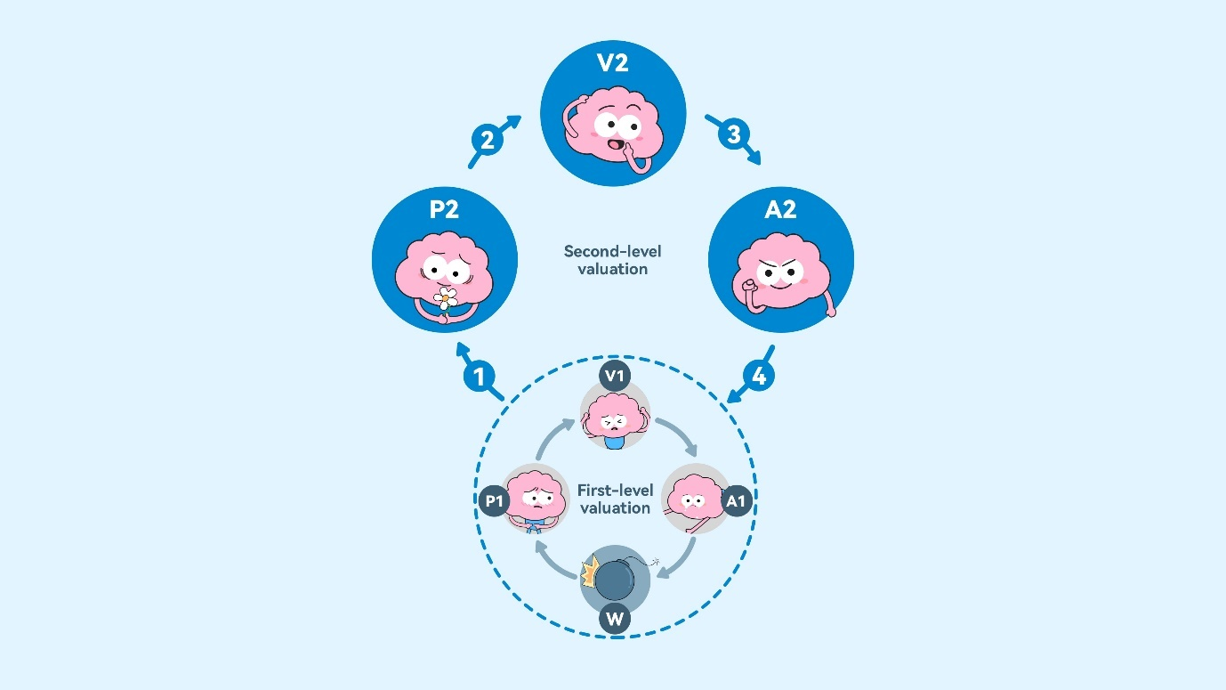
Note. W = emotion-eliciting situation; P1 = maladaptive perception (e.g., failure, loss, deterioration); V1 = maladaptive value (e.g., awful, hopeless, terrible); A1 = maladaptive action (e.g., depressed mood, fatigue, avoidance); P2 = more adaptive perception (e.g., not a bad thing, “Is it a failure?”); V2 = more adaptive value (e.g., “Is it awful?”, “What are my true feelings?”, “Thoughts are just thoughts, which may not happen”); A2 = more adaptive action (e.g., “Have a try.”, “I can do it.”)
①=Be aware of events in the external world and one’s internal experiences, especially positive aspects that may otherwise be overlooked
②=Accept the feelings and try to appraise and interpret them objectively
③=Act in a value-aligned direction even when accompanied by discomfort
④= Shift from self-defeating to self-enhancing recursive cycles

Figure S2

Evidence-Based Components of the “PauseLab EBP for Emotion”
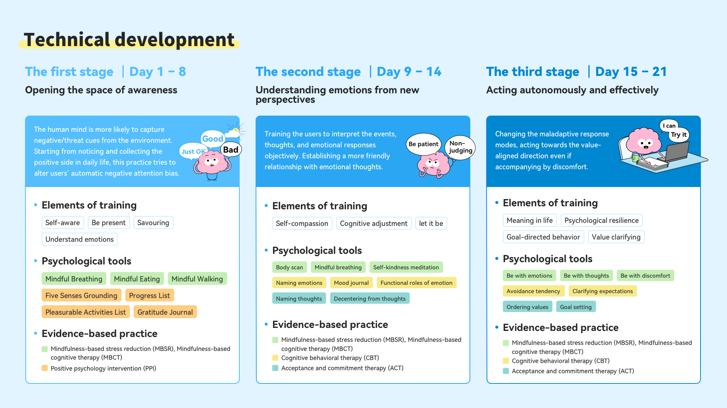

Figure S3

Procedures of the Daily Practice of the “PauseLab EBP for Emotion”
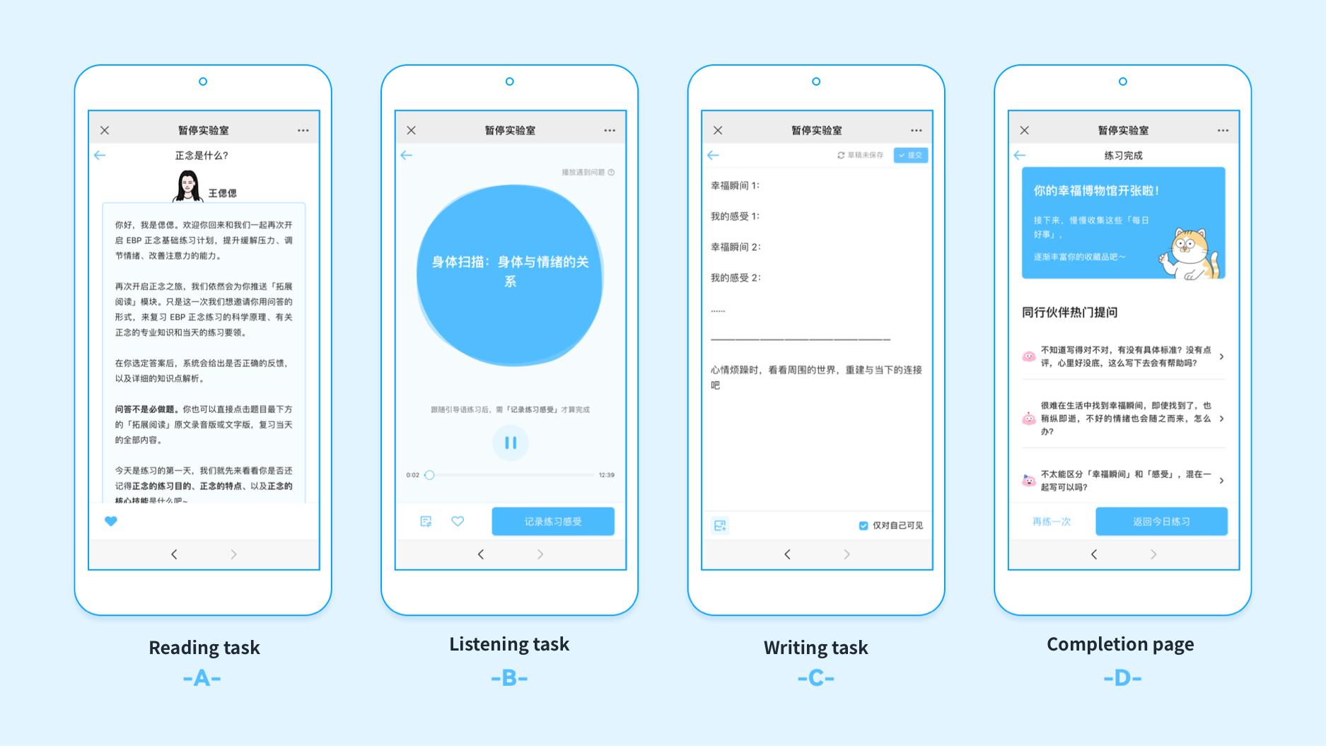

Figure S4

User Interfaces of the “PauseLab EBP for Emotion”
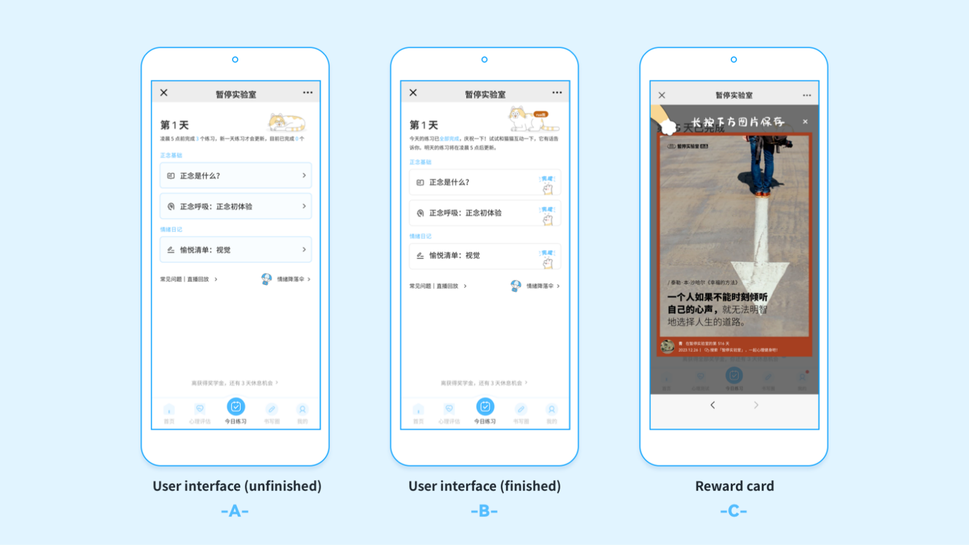
Note. (A) User interface before completion of any daily practice component; (B) user interface after completion of all daily practice components; and (C) user interface displaying the daily motivational quote card.
Figure S5

Forms of the Support of the “PauseLab EBP for Emotion”

Note. (A) Live Q&A with the lead experts; in this picture, the lead experts of the development team were answering the questions that were frequently asked by users. (B) Real-time Q&A in user communities; in the upper part of the picture, one user asked a question in the user community; the teaching assistant’s response appears below the question. (C) Example responses from the virtual peers. (D) FAQ section embedded in the program; in this picture, the user was searching for answers to their questions in the program (“Cannot concentrate during the practice”); below the search box were potentially matching answers provided by the team.

Figure S6

Accuracy of Edge Weights in Pre- and Post-Intervention Depression Networks
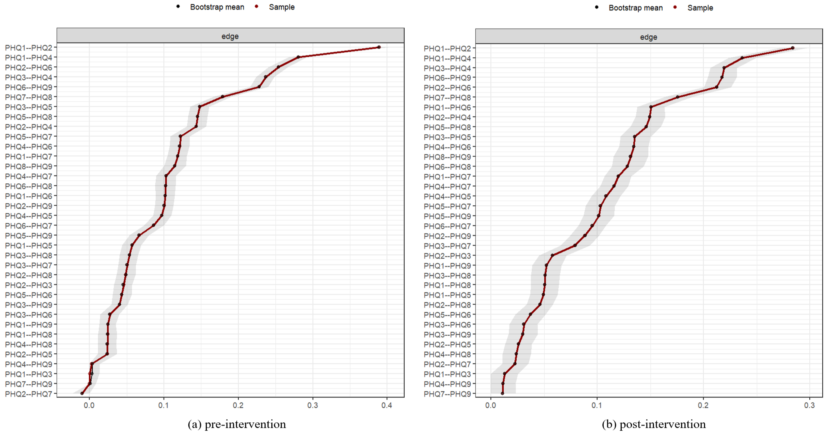
Note. The red line indicates the sample values and the gray area indicates the 95% bootstrapped confidence intervals of the estimated edge weights. Each horizontal line represents one edge of the network, ordered from the edge with the highest weight to the edge with the lowest weight. PHQ1, Anhedonia; PHQ2, Depressed mood; PHQ3, Sleep disturbance; PHQ4, Fatigue; PHQ5, Weight disturbance; PHQ6, Worthlessness; PHQ7, Concentration difficulties; PHQ8, Psychomotor disturbance; PHQ9, Suicidality.

Figure S7

Stability of Node Expected Influence (EI) Centrality for Depression Networks in Pre- and Post-Intervention
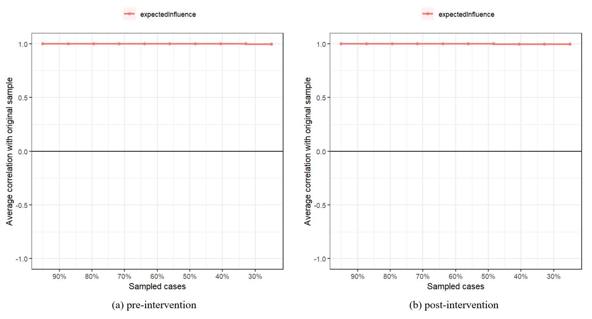
Note. The figure shows the average correlations between EI centrality estimates from case-dropping bootstrap samples and those from the original sample. Lines indicate the means and areas indicate the range from the 2.5th quantile to the 97.5th quantile.
Figure S8

Edge Weight Difference Test for Depression Networks in Pre- and Post-Intervention
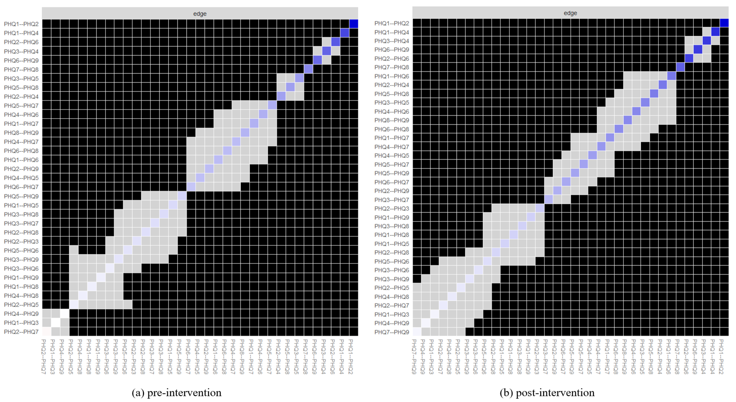
Note. The gray box represents edges that do not differ significantly from one another, while the black box represents edges that do differ from one another. Colored boxes represent edge weights that correspond to the color in the network structure plot. PHQ1, Anhedonia; PHQ2, Depressed mood; PHQ3, Sleep disturbance; PHQ4, Fatigue; PHQ5, Weight disturbance; PHQ6, Worthlessness; PHQ7, Concentration difficulties; PHQ8, Psychomotor disturbance; PHQ9, Suicidality.

Figure S9

Node Expected Influence (EI) Centrality Difference Test for Depression Networks in Pre- and Post-Intervention
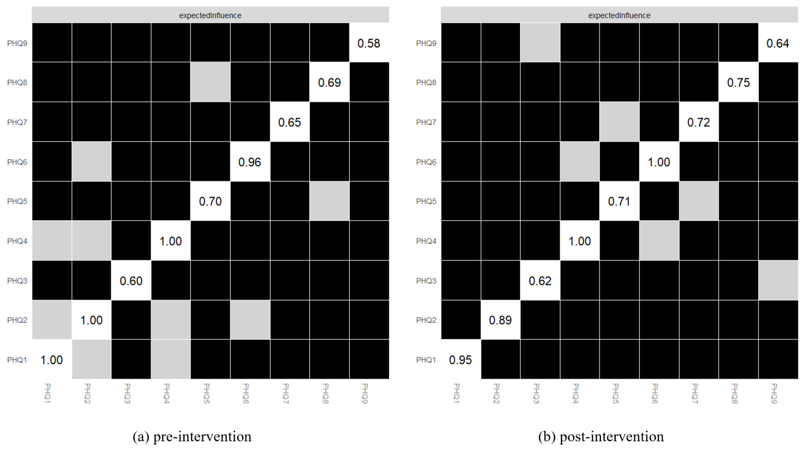
Note. The gray boxes indicate nodes that do not significantly differ from each other, while the black boxes represent nodes that do show significant differences. The values in the white boxes denote the expected influence (EI) of each node. PHQ1, Anhedonia; PHQ2, Depressed mood; PHQ3, Sleep disturbance; PHQ4, Fatigue; PHQ5, Weight disturbance; PHQ6, Worthlessness; PHQ7, Concentration difficulties; PHQ8, Psychomotor disturbance; PHQ9, Suicidality.
Figure S10

Accuracy of Edge Weights for Depression Networks in Pre- and Post-Intervention for “Symptom Reduction” and “Symptom Non-Reduction” Groups
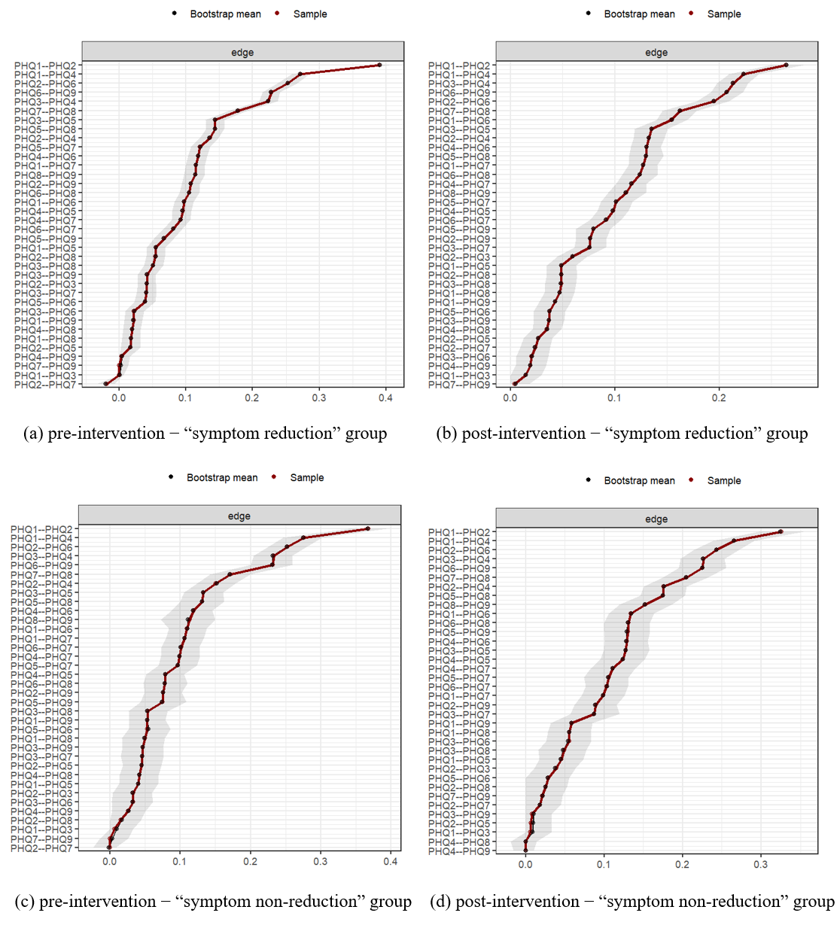
Note. The red line indicates the sample values and the gray area indicates the 95% bootstrapped confidence intervals of the estimated edge weights. Each horizontal line represents one edge of the network, ordered from the edge with the highest edge weight to the edge with the lowest edge weight. PHQ1, Anhedonia; PHQ2, Depressed mood; PHQ3, Sleep disturbance; PHQ4, Fatigue; PHQ5, Weight disturbance; PHQ6, Worthlessness; PHQ7, Concentration difficulties; PHQ8, Psychomotor disturbance; PHQ9, Suicidality.

Figure S11

Stability of Node Expected Influence (EI) Centrality for Depression Networks in Pre- and Post-Intervention for “Symptom Reduction” and “Symptom Non-Reduction” Groups
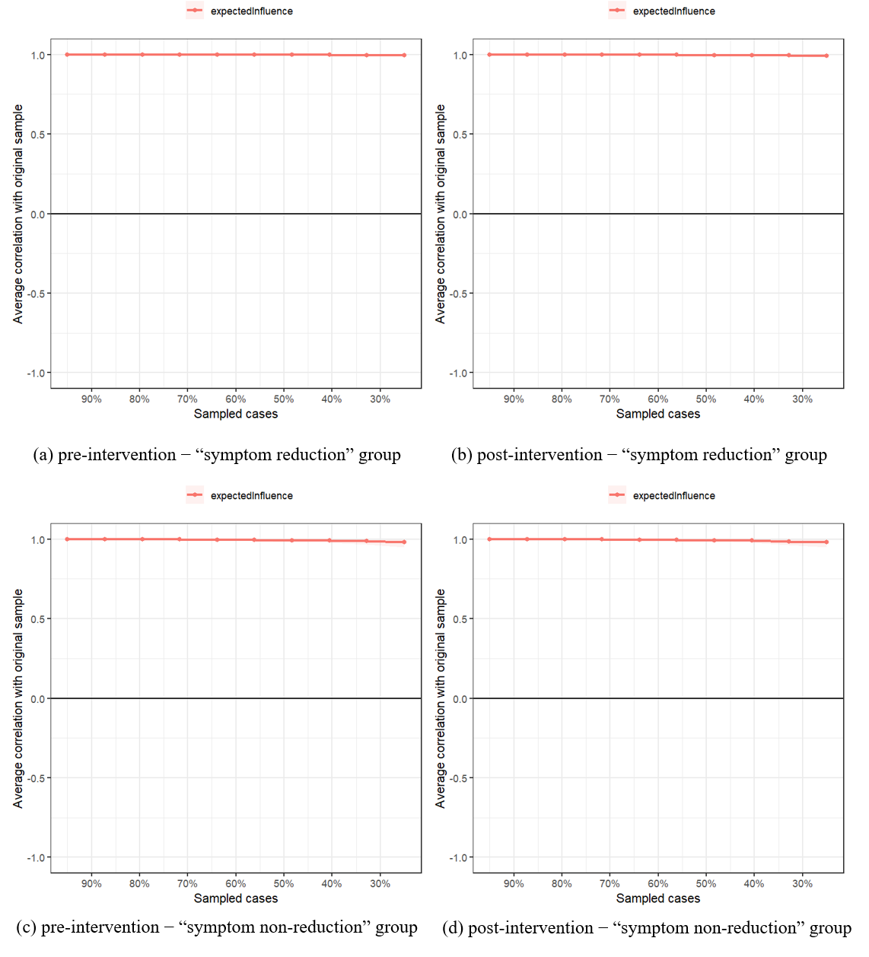
Note. The figure shows the average correlations between EI centrality estimates from case-dropping bootstrap samples and those from the original sample. Lines indicate the means and areas indicate the range from the 2.5th quantile to the 97.5th quantile.

Figure S12

Edge Weight Difference Test for Depression Networks in Pre- and Post-Intervention for “Symptom Reduction” and “Symptom Non-Reduction” Groups
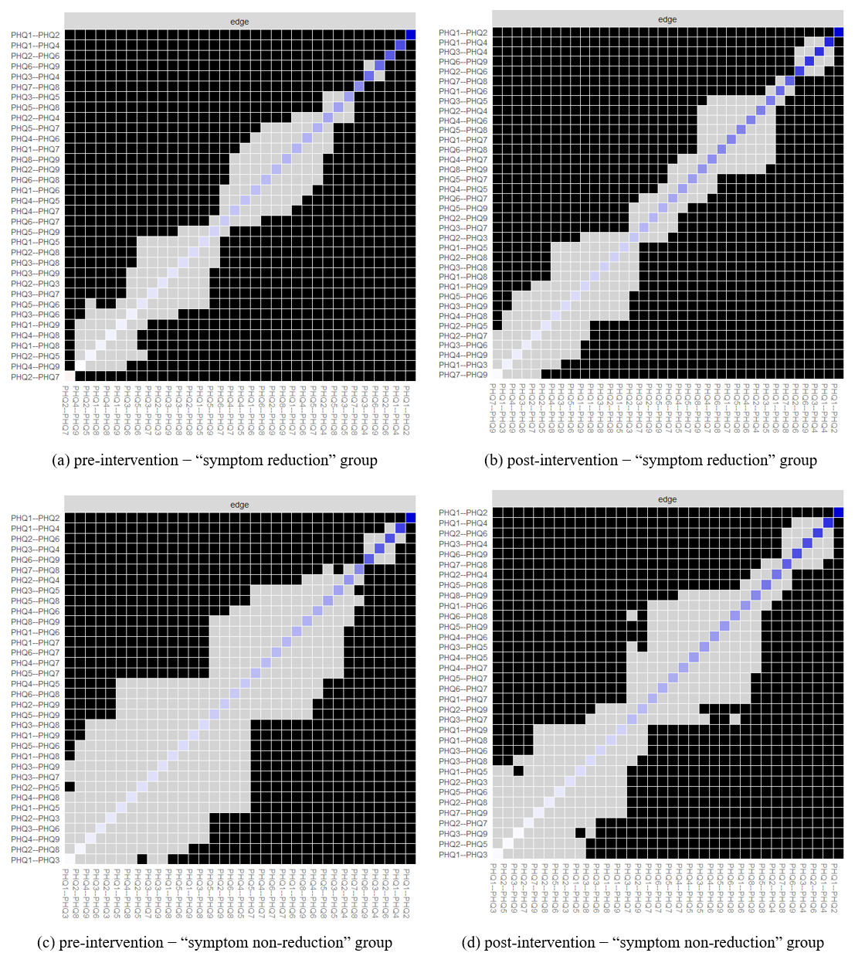
Note. The gray box represents edges that do not differ significantly from one another, while the black box represents edges that do differ from one another. Colored boxes represent edge weights corresponding to the edge colors in the network plots. PHQ1, Anhedonia; PHQ2, Depressed mood; PHQ3, Sleep disturbance; PHQ4, Fatigue; PHQ5, Weight disturbance; PHQ6, Worthlessness; PHQ7, Concentration difficulties; PHQ8, Psychomotor disturbance; PHQ9, Suicidality.

Figure S13

Node Expected Influence (EI) Centrality Difference Test for Depression Networks in Pre- and Post-Intervention for “Symptom Reduction” and “Symptom Non-Reduction” Groups
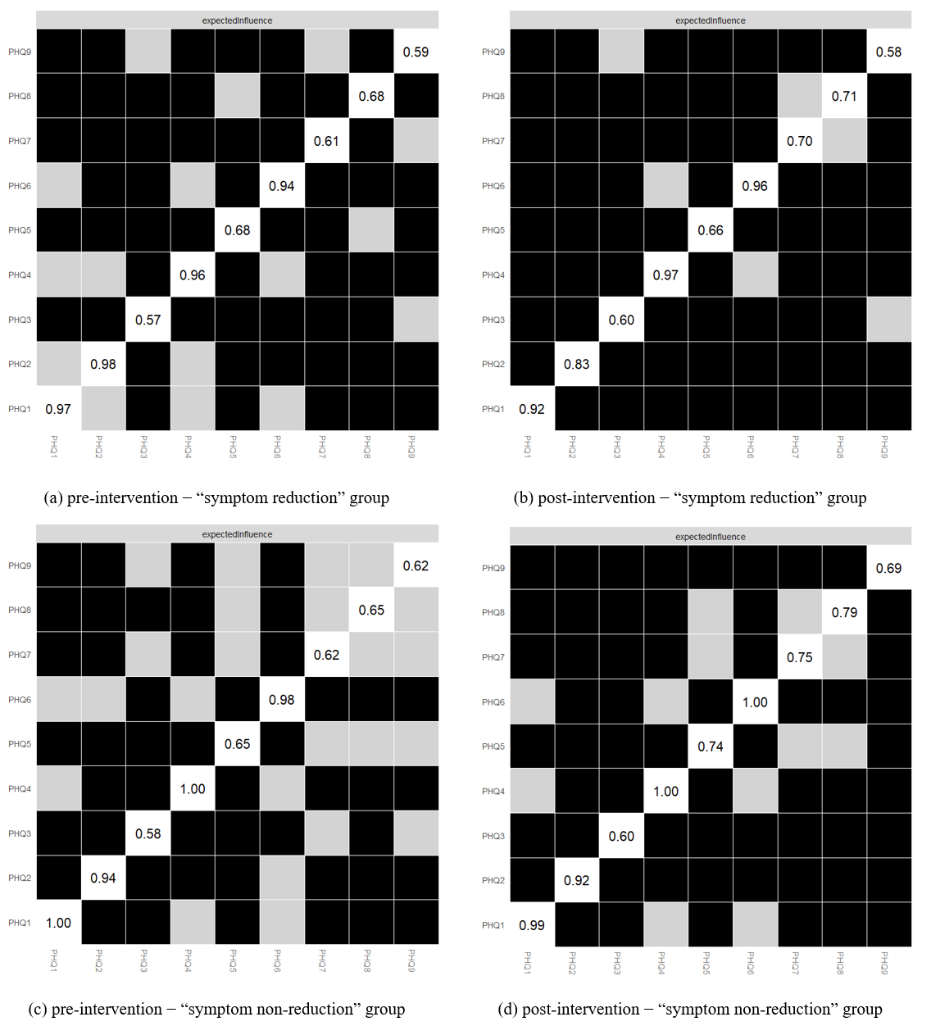
Note. The gray boxes indicate nodes that do not significantly differ from each other, while the black boxes represent nodes that do show significant differences. The values in the white boxes denote the expected influence (EI) of each node. PHQ1, Anhedonia; PHQ2, Depressed mood; PHQ3, Sleep disturbance; PHQ4, Fatigue; PHQ5, Weight disturbance; PHQ6, Worthlessness; PHQ7, Concentration difficulties; PHQ8, Psychomotor disturbance; PHQ9, Suicidality.

Figure S14

Expected Influence (EI) Centrality in Pre- and Post-Intervention Depression Networks with Covariates
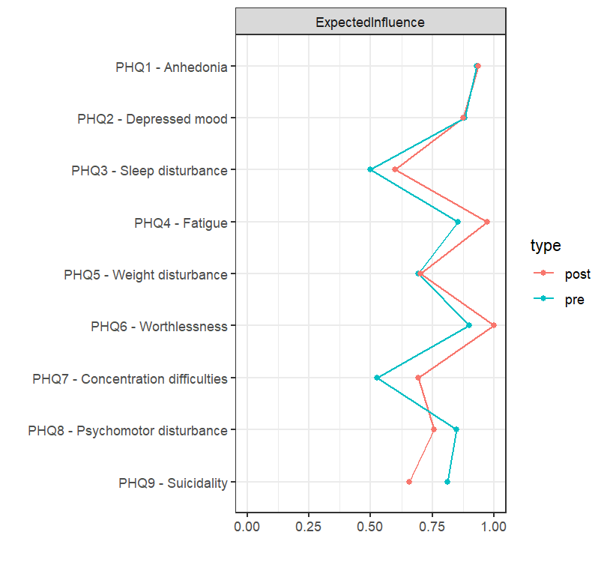
Note. The green line represents EI in the pre-intervention network, and the red line represents EI in the post-intervention network.

Figure S15

Expected Influence (EI) Centrality in Pre- and Post-Intervention Depression Networks with Covariates for the “Symptom Reduction” and “Symptom Non-Reduction” Groups
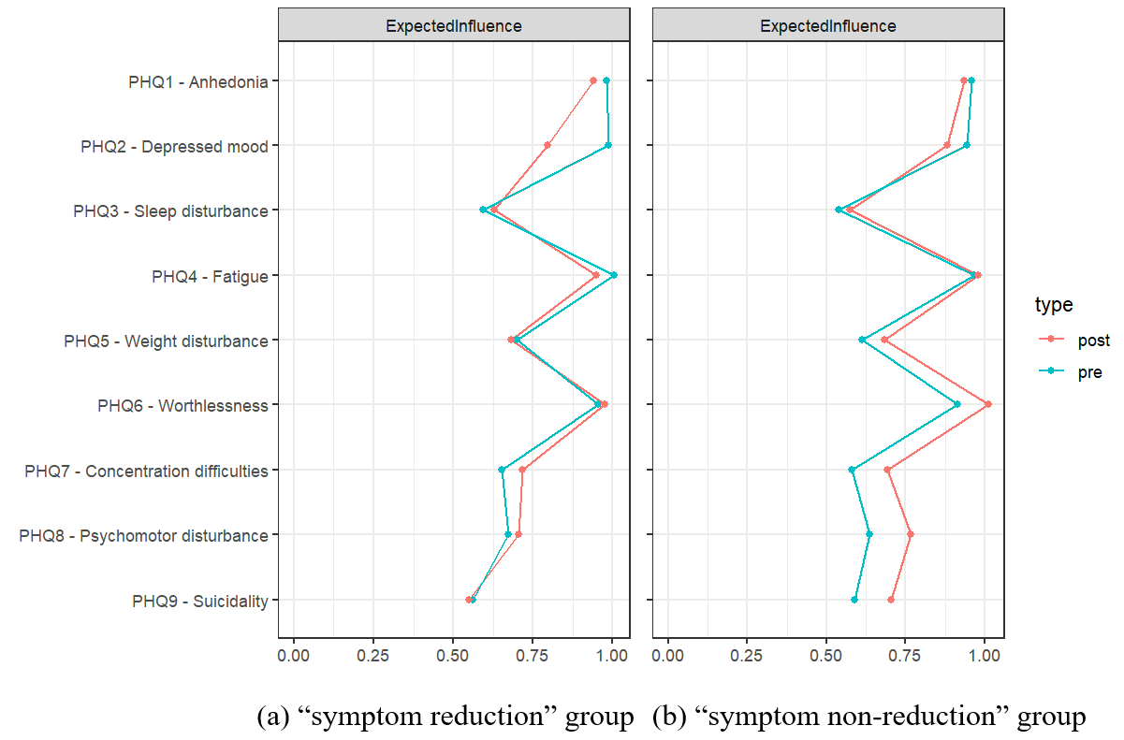
Note. The green line represents EI in the pre-intervention network, and the red line represents EI in the post-intervention network. Covariates include gender, age, region, experience with psychological counselling, and the standard deviation of pre-intervention depression score.

5 Use of Artificial Intelligence
ChatGPT-5 (OpenAI) was used solely for language editing purposes, including checking grammar, improving clarity, and enhancing the overall readability of the manuscript. The tool was not used to generate any research ideas, data, analyses, or interpretations. All original research content, results, and conclusions are entirely the authors’ own.
The prompt provided to the AI instructed it to function as a professional academic communication improvement editor, logic editor, and grammar editor specializing in scholarly communication with expertise in English academic writing conventions.
“As a professional academic communication improvement editor, logic editor, grammar editor specializing in scholarly communication with expertise in English academic writing conventions, follow these requirements:
- Use formal academic American/English vocabulary appropriate for the field.
- Preserve key technical terms with English translations in parentheses where needed.
- Keep numerical data and statistical values exactly as presented.
- Match the paragraph structure of the original.
- Ensure proper English punctuation conventions (including the correct use of full-width punctuation marks).
- Please polish it to conform to academic standards, enhancing its spelling, grammar, clarity, conciseness, and overall readability. If needed, sentences should be rewritten.
After translation, verify that all key findings and methodological details are accurately conveyed.”
Only minor linguistic edits suggested by the AI were incorporated into the manuscript. The authors reviewed and approved all revisions to ensure the scientific accuracy and integrity of the content.

