SUPPLEMENTARY ONLINE MATERIALS

Table of Contents
Appendix A: Additional Measures and Analyses, Study 1 2
Additional Measures 2
Diagnosis-Specific Measures 3
Vignettes 3
Analyses 6
Results 7
Diagnosis-Specific Measures 7
Vignettes 8
Appendix B. Additional Analyses, Study 2 8
Results 9
Figure S1. 10
Figure S2. 11
Figure S3. 12
Figure S4. 13
Figure S5. 14
Appendix C. Pilot Study for Experimental Manipulation 15
Method 15
Results 19
Discussion 25
Appendix D. Vignettes used in Study 3 26
Appendix E: Items Used to Measure General and Economic System Justification 29
Supplementary Tables 32
Table S1 32
Table S2 33
Table S3 33
Table S4 35
Table S5 36
Table S6 37
Table S7 39
Table S8 40
Table S9 41
Table S10 41
Table S11 42
Table S12 43
Table S13 44
Table S14 45
Table S15 46
References 47

Appendix A: Additional Measures and Analyses, Study 1

Additional Measures
In addition to the measures reported in the main text, which asked participants about mental illness at a general level, additional measures consisted of two broad categories: Questionnaires probing participants' attitudes, beliefs and behavioral intentions toward (1) individuals carrying one of two diagnostic labels, and (2) individuals described in two detailed vignettes, each meeting the diagnostic criteria for one of two psychiatric conditions. As diagnostic labels, we chose depression and schizophrenia, both commonly recognized among the general public. Depression is often seen as a prototypical example of mood disorders, and schizophrenia of highly stigmatized psychotic conditions commonly perceived as ‘severe’ mental disorders.
Except where otherwise specified, participants were asked in all questions to indicate their agreement or disagreement with presented statements on a 1-5 scale (on which 1= "strongly agree", 5 = "strongly disagree"). For presentation purposes, all responses were reverse-recoded such that higher values indicate higher endorsement of the statements. Except where specified, scale means calculated from all items were used for analyses.
The questionnaires about mental illness were presented in a prespecified order, such that the more general items (beliefs about mental illness without further specifications, reported in the main text) were presented first, followed by diagnosis-specific questions about depression and schizophrenia, and vignettes describing individuals meeting the diagnostic criteria for depression and schizophrenia. The presentation order of individual items within each questionnaire was randomized. The data set can be accessed here:
https://osf.io/yz2e6/?view_only=e577ab9883084e44a842f071154d3f06.

Diagnosis-Specific Measures
Public perceptions of individuals with mental illness are known to vary according to diagnostic category (Crisp et al., 2000; Link et al., 1999). Therefore, a second category of measures asked participants about individuals with particular diagnostic labels. Diagnosis-specific beliefs and attitudes toward individuals with the diagnostic labels of depression and schizophrenia were assessed with six items used by Crisp et al. (2000), comprising three items related to negative stereotypes, one about blame and two about recovery and outcomes. The items asking about depression were presented first, followed by the ones about schizophrenia. Before the items were presented, participants were given the following instructions: "The next questions are about severe depression [schizophrenia]."
The first three items ("An individual with severe depression [schizophrenia] is dangerous to others", "is unpredictable", and "is hard to talk with") were grouped together to form subscales of diagnosis-specific negative stereotypes. The items "An individual with severe depression [schizophrenia] will have a poor outcome", and "will respond to treatment" were grouped together for subscales of diagnosis-specific recovery pessimism, the latter item reverse-scored. For both subscales, means were calculated from all items and used for analyses. Because beliefs about blame can change without necessarily affecting other aspects of mental illness stigma (Lebowitz & Appelbaum, 2019), the item, "An individual with severe depression [schizophrenia] has only him/herself to blame" was analyzed separately from outcome beliefs.
Vignettes
In addition to general and diagnosis-specific questions, case vignettes were used because they allow presenting the participants with more detailed stimuli that can be designed to align with certain diagnostic criteria (see Link et al., 2004, for a discussion of different measures and their advantages). Two vignettes were adapted from Link and colleagues (1999), one describing an individual meeting the American Psychiatric Association’s DSM-IV criteria for major depression, and a second one those for schizophrenia. A sentence stating the formal diagnosis given by a physician was added to the end of both vignettes to remove any ambiguity of the diagnostic status. The vignettes were the following:
Vignette A. The next questions are about a man named John. Please read the following passage describing John.
For the past two weeks John has been feeling really down. He wakes up in the morning with a flat heavy feeling that sticks with him all day long. He isn't enjoying things the way he normally would. In fact nothing gives him pleasure. Even when good things happen, they don't seem to make John happy. He pushes on through his days, but it is really hard. The smallest tasks are difficult to accomplish. He finds it hard to concentrate on anything. He feels out of energy and out of steam. And even though John feels tired, when night comes he can't go to sleep. John feels pretty worthless and very discouraged. John's family has noticed that he hasn't been himself for about the last month and that he has pulled away from them. John just doesn't feel like talking. When he went to see the doctor, he was given a diagnosis of severe depression.
Vignette B. The next questions are about a man named Michael. Please read the following passage describing Michael.
Up until a year ago, life was pretty okay for Michael. But then, things started to change. He thought that people around him were making disapproving comments and talking behind his back. Michael was convinced that people were spying on him and that they could hear what he was thinking. Michael lost his drive to participate in his usual work and family activities and retreated to his home, eventually spending most of his day in his room. Michael was hearing voices even though no one else was around. These voices told him what to think. He has been living this way for six months. When he went to see the doctor, he was given a diagnosis of schizophrenia.
After each vignette, participants were presented questionnaires probing their Attitudinal social tolerance (the reverse of social distance, Link et al., 1999; 5 items; sample item, "I would be willing to move next door to John [Michael]") from the individual in the vignette.
Participants' emotional responses were assessed using 9 items asking, "How does John [Michael] make you feel? Please rate how well each of the following items describes your emotional reaction to John [Michael]" (Angermeyer & Matschinger, 1996; 1-5 scale on which 1= "completely"; 5 = "not at all"). The items asked about three categories of emotions using three items each: aggressive emotions (anger, amusement, irritation; i.e., "I feel angry"), feelings of anxiety (anxiousness, uneasiness, insecurity) and prosocial reactions (wanting to help, sympathy, wanting to keep out of things – reverse-coded). Category means were used for analyses.
In addition to the measures of primary interest, the participants were also asked about their attitudes toward structural discrimination; to what extent they believe the depicted problems are on a continuum with problems most people experience; and to what extent the problems can be attributed to biogenetic causes. Structural discrimination attitudes were assessed with the items, “If John [Michael] does not consent to medical treatment, he should receive compulsory treatment” and, “John [Michael] should not be allowed to have a driving license”. Continuum beliefs were assessed with the items, “Sometimes we are all at least a little like John [Michael], it is only a question of how pronounced this state is”, and, “To some extent most people will experience problems that are similar to John’s [Michael’s]”. Biogenetic causal beliefs regarding the vignette characters’ problems were assessed using Kvaale and Haslam’s (2016) Biogenetic causal beliefs scale, consisting of nine items designed to measure endorsement of genetic, neurochemical and general biogenetic explanations. The items include the statements, “John's problems are caused by his genetic makeup”, and, “John's problems are caused by neurotransmitter imbalance in his brain.”

Analyses
To examine whether political orientation, system-justifying beliefs and beliefs in genetic determinism predicted perceptions of mental illness, and to estimate the relative contributions of different predictors against each other, we conducted hierarchical linear regression analyses for the dependent variables. The main predictors of interest were self-reported personal experience with the mental health services, beliefs in genetic determinism, political orientation, general system justification, and economic system justification. We adjusted for age, sex, race, level of education, and family income in the past year.
All demographic variables were entered first (Model 1), personal experience in the second step (Model 2), belief in genetic determinism, political orientation and general system justification in the third (Model 3), and economic system justification last (Model 4), along with the previous predictors.
Sex was coded as 0 = not female, 1 = female; race as 0 = not white, 1 = white; and personal experience with the mental health services as 0 = no 1 = yes. Education and family income were both coded on 8-point scales (1 = "12th grade or less", 2 = "high school diploma or equivalent", 3 = "some college but no degree", 4 = "Associate degree", 5 = "Bachelor's degree", 6 = "Master's degree", 7 = "Professional school degree (e.g., MD, JD)", 8 = "Doctorate degree", and 1 = $0-$14,999, 2=$15,000-24,999, 3 = $25,000-49,999, 4 = $50,000-74,999, 5 = $75,000-$99,999, 6 = $100,000-$149,999, 7 = $150,000-$199,999, 8 = over $200,000, respectively).

Results
Descriptive statistics for the additional measures from Study 1 are shown in Table S2. As can be seen in the table, respondents generally responded more negatively to schizophrenia than to depression, both according to diagnostic labels and vignette characters meeting the diagnostic criteria.
Hierarchical regression models (see Tables S3-S6) showed that the results very similar to those from the general-level measures reported in the main text. Relative to other ideological beliefs, ESJ emerged as the best unique predictor of stigma across all measures. A notable exception were biogenetic causal beliefs for which, not surprisingly, the strongest unique predictor was BGD. Personal experience of mental health services predicted less stigmatizing responses on nearly all variables after all predictors had been taken into consideration.

Diagnosis-Specific Measures
For diagnosis-specific measures (Table S3), hierarchical regression models showed that relative to other factors, ESJ was the strongest unique predictor across measures. ESJ predicted higher levels of negative stereotypes, higher outcome pessimism, and higher blame for both depression and schizophrenia. GSJ was also a unique predictor of negative stereotypes for schizophrenia, but less strongly than ESJ. GSJ was also associated with more optimistic expectations for schizophrenia outcomes with treatment, but less strongly than ESJ was with outcome pessimism.
Other singular predictors were occasionally associated with some outcomes. For example, political conservatism was associated with higher endorsement of negative stereotypes for schizophrenia. By contrast, BGD was associated with lower attributions of blame in depression. However, no other variable was as consistently predictive of diagnostic-specific measures as ESJ once demographic and all other predictors were added to the model.

Vignettes
For measures based on character vignettes (Tables S4-S6), hierarchical regression models showed that, overall, ESJ was the best unique predictor of stigma relative to other variables once all predictors were entered. For example, ESJ was the strongest unique predictor for social tolerance and all emotional responses toward the character with depression, and for (more) aggressive emotions and (less) prosocial emotions toward the character with schizophrenia. While other measures were sometimes predictive of measures of stigma, such as political conservatism for decreased social tolerance for the character with depression, its contribution was weaker than that of ESJ once it was entered.
There were some exceptions on individual measures, such as for anxious emotions toward the vignette character with schizophrenia, for which being female was the sole unique predictor once all factors were included in the same model. As two other similar exceptions, personal experience and political conservatism were the strongest unique predictors for social tolerance and structural discrimination, respectively, toward the character with schizophrenia.
Not surprisingly, BGD was the strongest unique predictor for biogenetic causal beliefs regarding the vignette characters (Table S6). Thus, while BGD was mostly not predictive of stigmatizing responses, it was strongly predictive of biogenetic causal attributions, as would be expected.

Appendix B. Additional Analyses, Study 2
We investigated whether race/ethnicity, sex, age, education, family income, and political orientation moderated the relation between ESJ and stigma. The analyses were conducted using R packages library(haven), library(interactions), library(ggplot2), library(broom), and library(patchwork). In all models, we adjusted the moderations for all the above variables and for general system justification.

Results
The results are depicted in Figures S1–S5. Age was a significant moderator for all dependent variables in their relation with ESJ (p’s ≤ .015). Race moderated the relation between ESJ and social tolerance and recovery pessimism (p’s ≤ .037), and political orientation moderated the relation between ESJ and recovery pessimism and exclusionary sentiments (p’s ≤ .0077). For details, coefficients, and p-values, see Figures S1–S5.

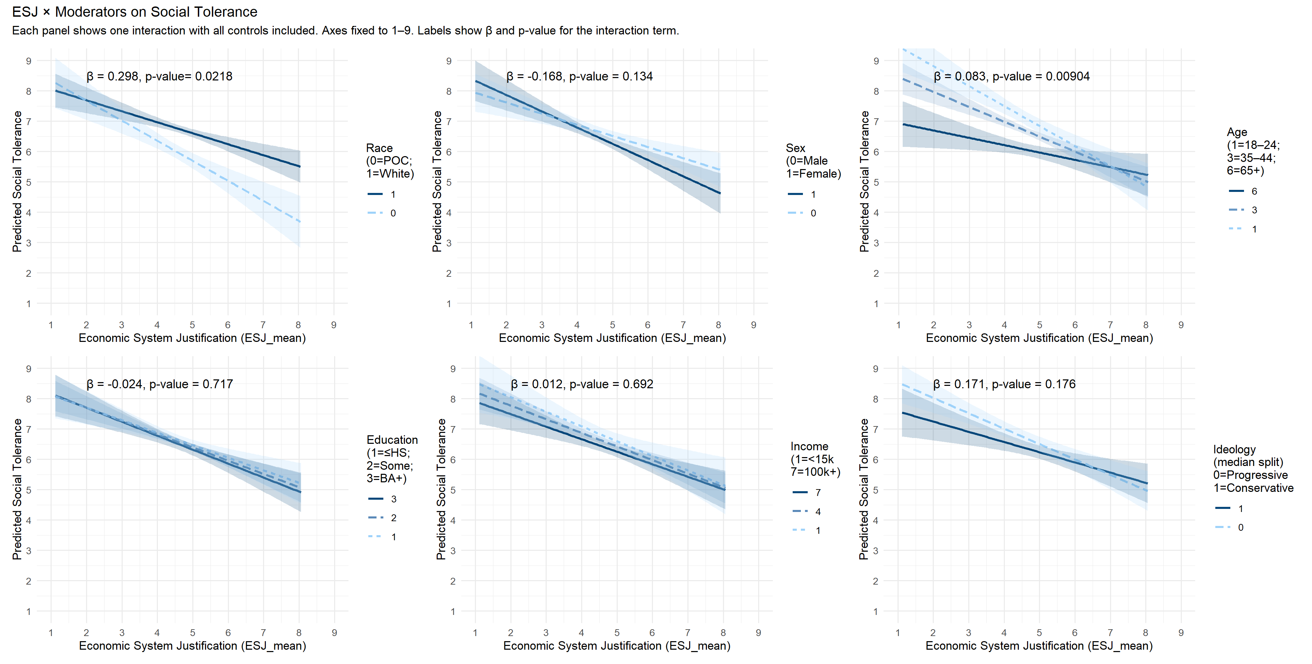

Figure S1. Moderation analyses of the relation between economic system justification and social tolerance. The panels depict the relation at different levels of the moderator.

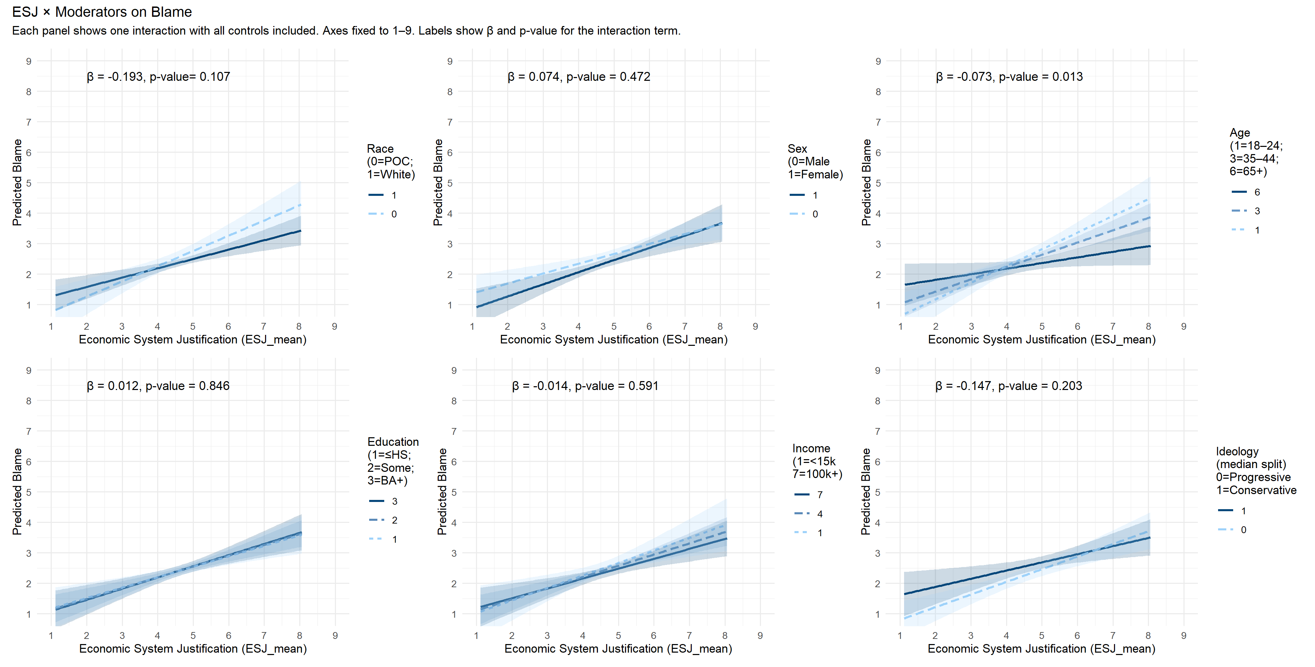

Figure S2. Moderation analyses of the relation between economic system justification and blame. The panels depict the relation at different levels of the moderator.

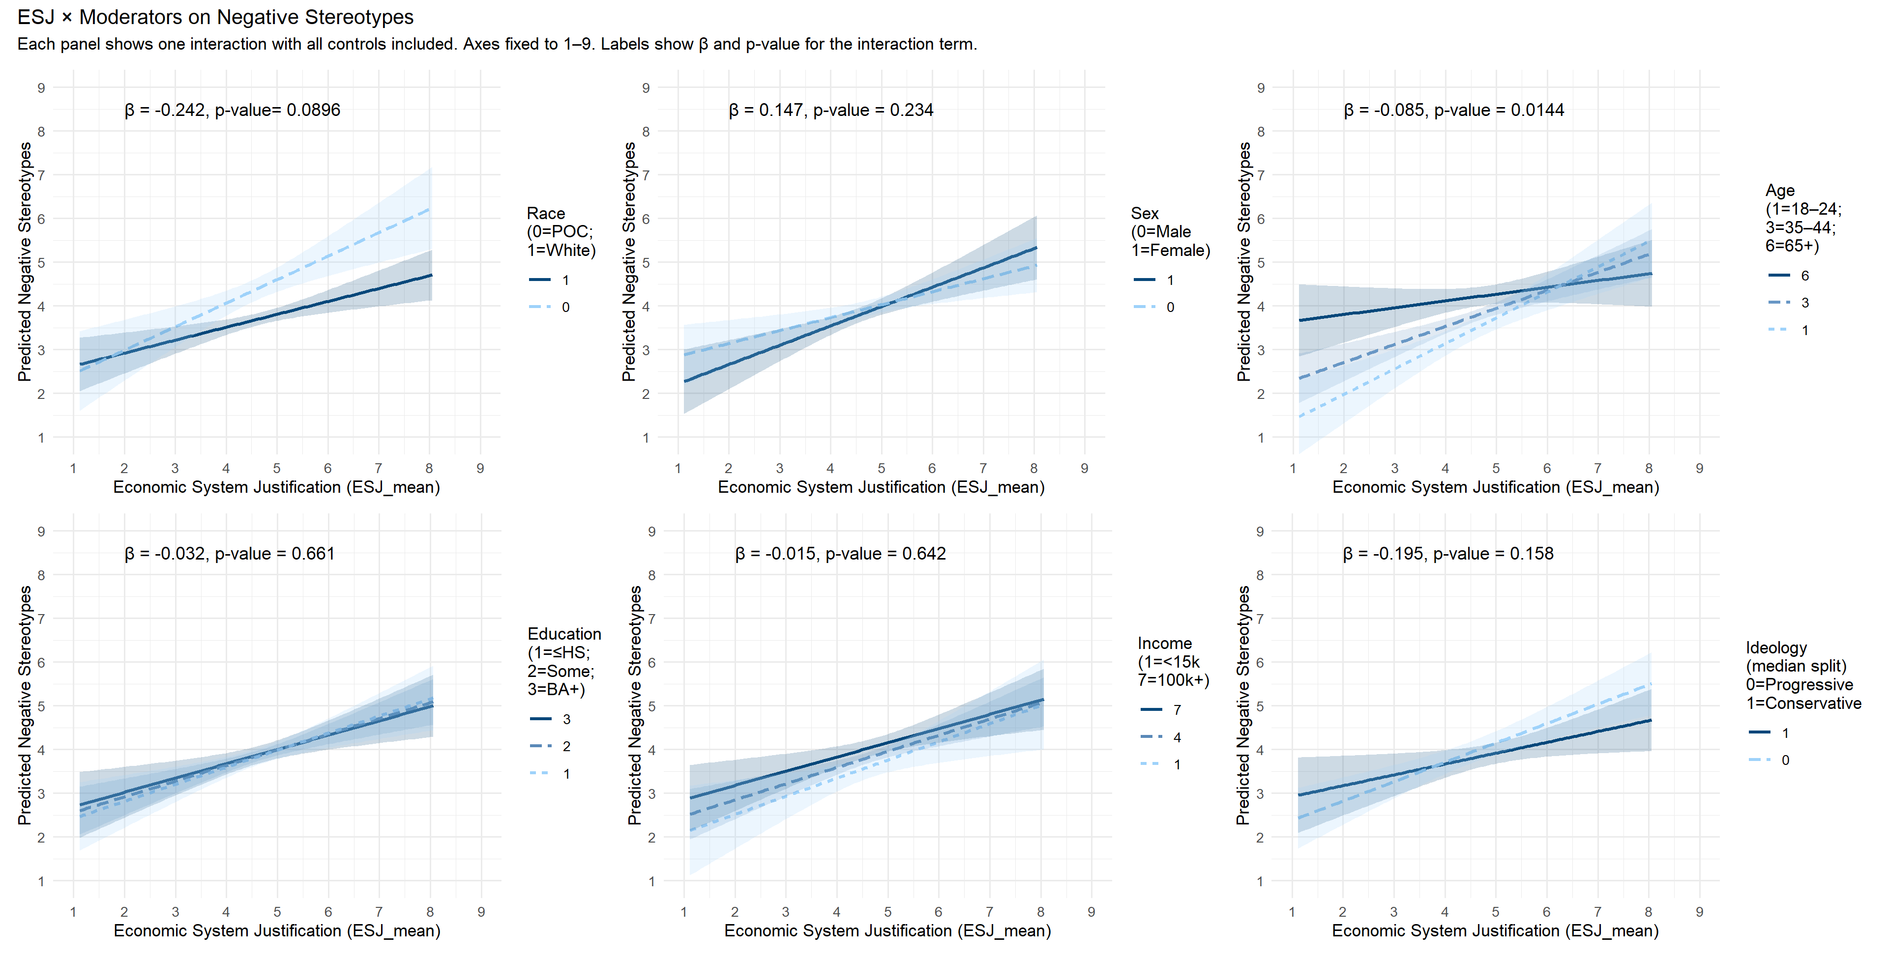

Figure S3. Moderation analyses of the relation between economic system justification and negative stereotypes. The panels depict the relation at different levels of the moderator.

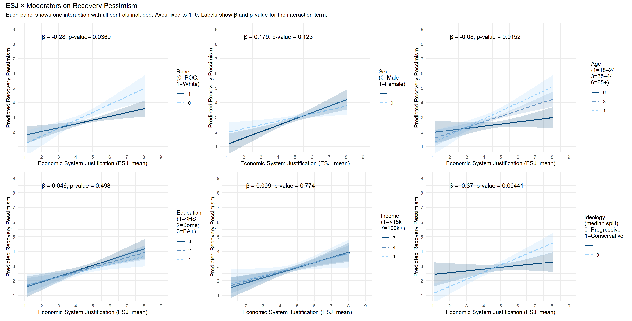

Figure S4. Moderation analyses of the relation between economic system justification and recovery pessimism. The panels depict the relation at different levels of the moderator.

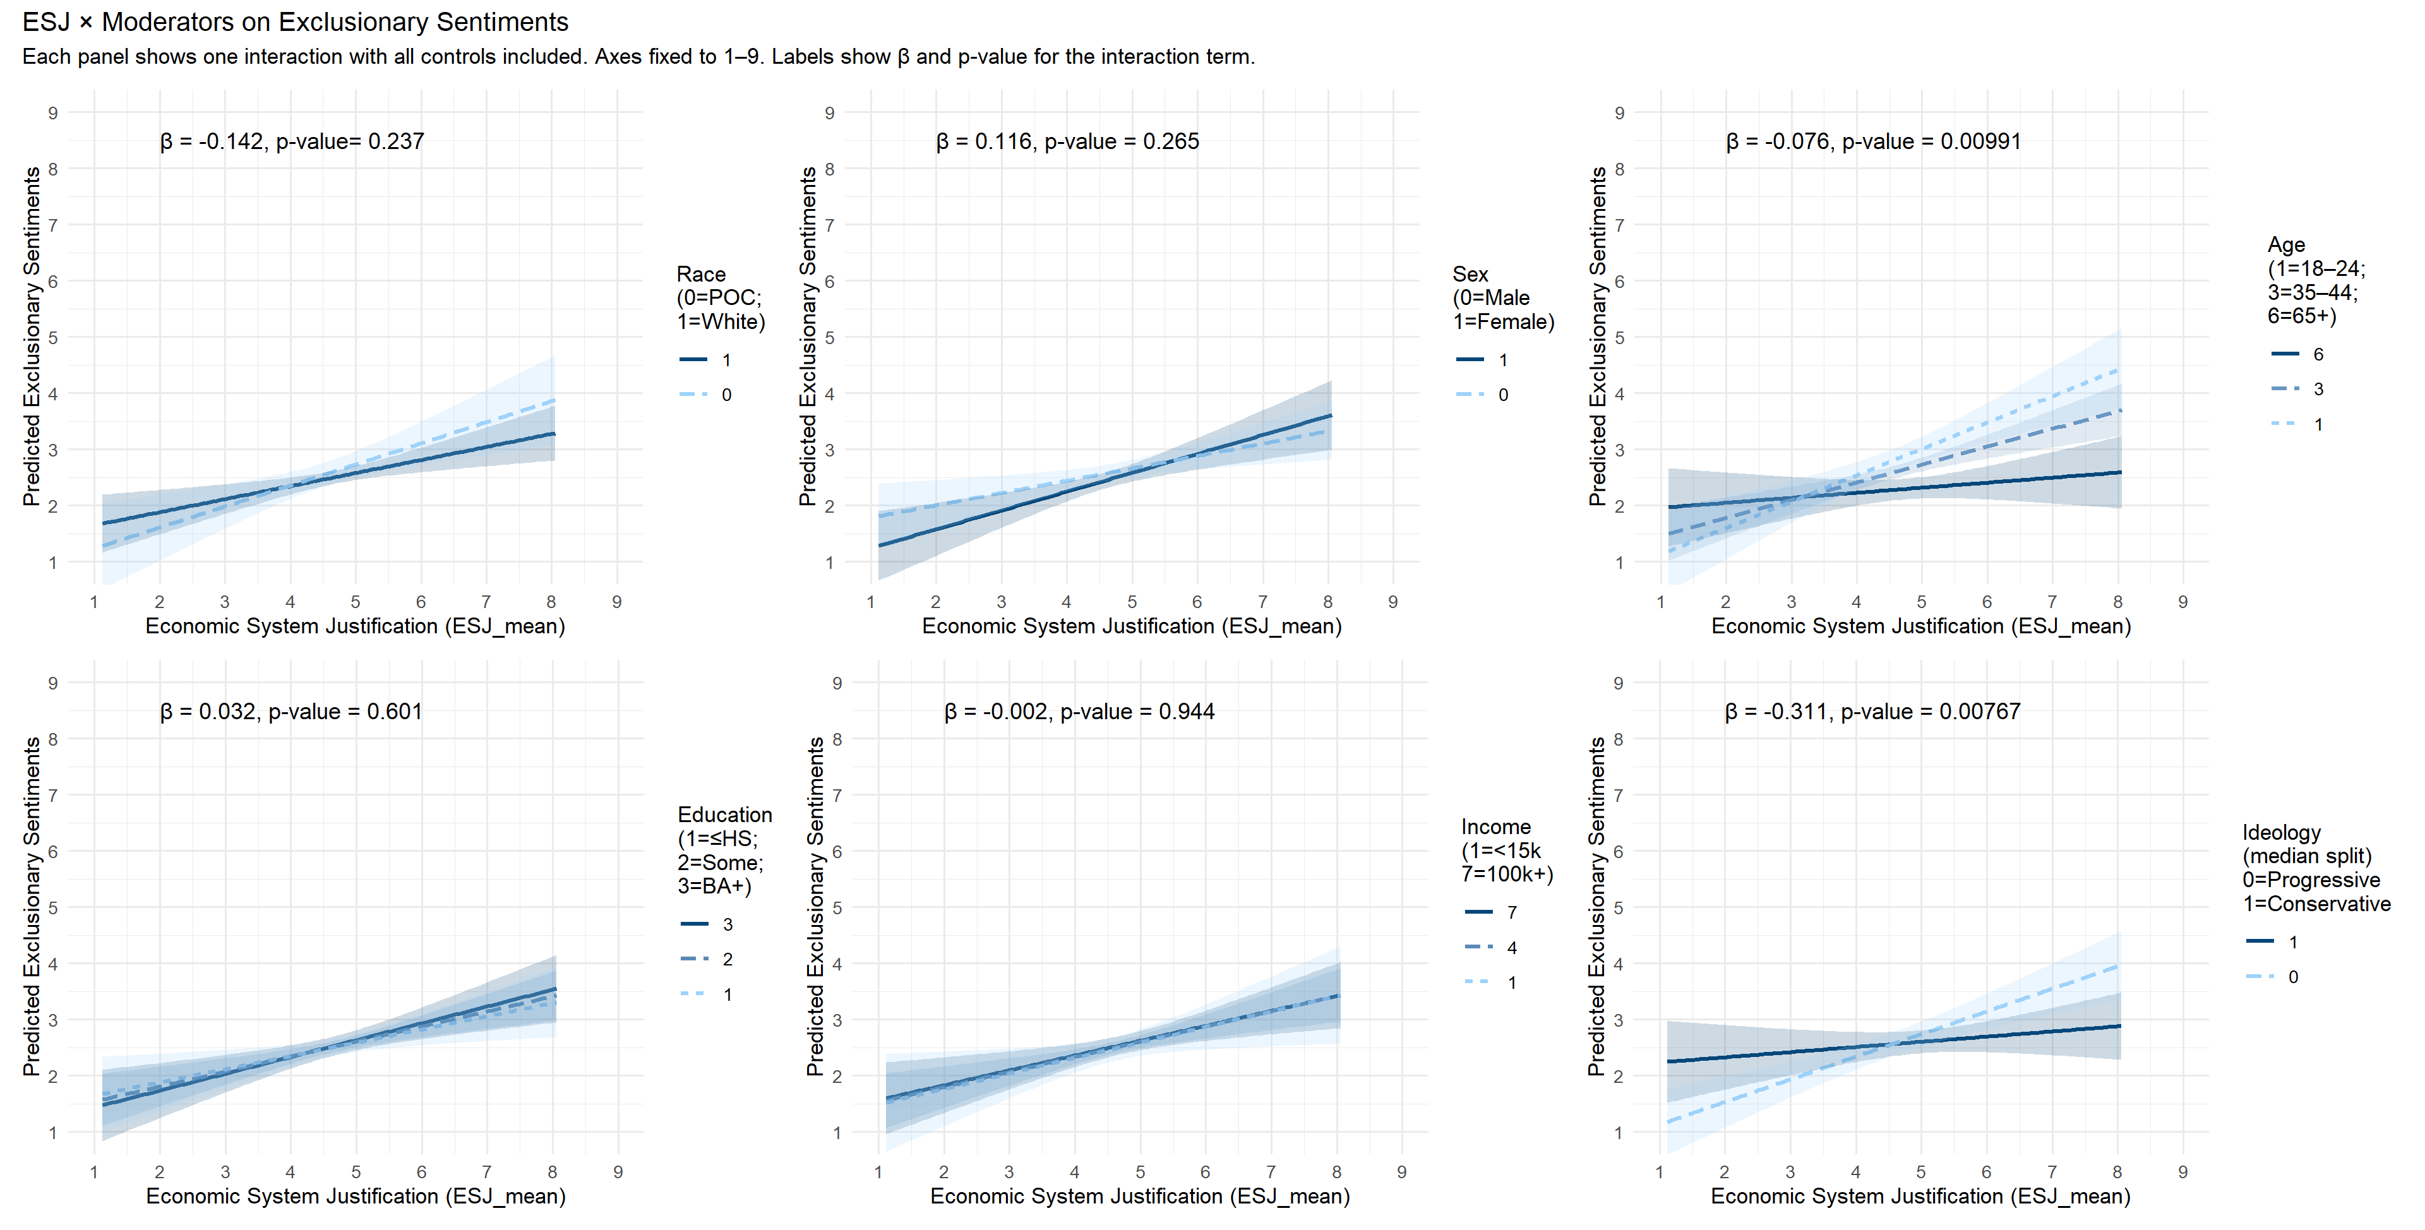

Figure S5. Moderation analyses of the relation between economic system justification and exclusionary sentiments. The panels depict the relation at different levels of the moderator.

Appendix C. Pilot Study for Experimental Manipulation
To investigate the effect of financial status on stigma, we conducted a pilot study in which we tested using vignettes describing two different psychiatric problems: One meeting the diagnostic criteria for major depression, a less stigmatized condition, and another meeting those for schizophrenia, a very severely stigmatized one.

Method
Participants
In late August of 2019, participants were recruited throughout the U.S. using Amazon's Mechanical Turk platform (N = 421) and paid $0.85 for participating. Twelve participants were excluded for failing an attention check, leaving a total of 409 participants (median age 36; age range 18–76; 227 female, 171 male, and 11 nonbinary/other/missing). The modal level of education was a bachelor’s degree (42.3%). The median family income bracket was $50,000–$74,999. The racial/ethnic breakdown was 72.1% white, 12.5% Black or African American, 0.5% American Indian or Alaska Native, 6.4% Asian, 5.1% Hispanic/Latino/e, 1.7% more than one race, and 0.2% other/preferred not to say.
Materials and Procedure
The study consisted of two parts: (a) an experimental vignette in which we manipulated the economic position of a character with mental illness, and (b) a survey of attitudes about system justification and mental illness. A single multiple-choice item (the same as in Study 1) was administered between (a) and (b) to assess whether the participants read the questions carefully.
Experimental vignette. Building on work by Lebowitz and Ahn (2014), we presented participants with detailed vignettes of four fictitious characters (named Alex, Terry, Michael, and Nicholas) who varied in terms of diagnosis (major depression or schizophrenia) and financial status (economically self-sufficient or not). The vignettes did not include diagnostic labels, but the descriptions were designed so that the symptoms met the DSM-IV diagnostic criteria for either major depressive disorder or schizophrenia.
The vignettes were the following:
Major depression, vignette 1. Terry is a 28-year-old woman who is seeking treatment because she has felt deeply sad for the past 4 weeks. She reports that she has lost interest in activities that normally bring her pleasure, such as cooking and going to movies. She states that ever since the current period of sadness began, she has had difficulty with her memory and concentration. She has canceled plans with friends several times because she felt too tired to go out. She reports that her outlook on life has become quite pessimistic; she describes feeling hopeless about the future and perceiving herself to be totally worthless. She has reportedly experienced similar symptoms (a low mood that lasted several weeks) on three previous occasions in her life.
Major depression, vignette 2. Alex is a 29-year-old woman who is seeking treatment because she has reportedly “lost the ability to take pleasure in anything”. She states that she began “feeling blue” approximately a month ago, and has spent most of her free time since then in her apartment because she is uninterested in any of her usual social or recreational activities. She says that her negative mood has left her “in a fog”, unable to focus. As such, she has been neglecting schoolwork for the graduate program in which she is enrolled and falling behind as a result. She feels overwhelmed by guilt and describes herself as “a complete failure”. She recalls two previous periods in her life, each lasting several weeks, when she suffered from similar symptoms.
Schizophrenia, vignette 1. Michael is an 18-year-old student who is seeking treatment at the urging of his family. His parents became worried when he began talking about mysterious “spies” who he believes are controlling his thoughts. More recently, he has been claiming that he can hear conversations between the “spies” using special powers that allow him to pick up radio signals through his ears. His family has also noticed that he has become more withdrawn socially and does not seem to enjoy anything he does anymore. His voice has even taken on a dull, monotonous quality. Michael’s teachers report that his grades have been slipping drastically this year, as he seems to have extreme difficulty concentrating or even making sense when he speaks.
Schizophrenia, vignette 2. Nicholas is a 19-year-old student whose parents have brought him in for treatment after he began to exhibit what they consider to be highly unusual symptoms. Nicholas has started to refer to himself as having a variety of supernatural powers, such as the ability to control others’ thoughts and behaviors. He has also claimed that he secretly possesses vast amounts of wealth, but refuses to provide any details. He has told his parents that he is afraid to enter certain rooms of their house because the floors have turned into quicksand. His face no longer seems to display any expressions of emotion, and he speaks much less than usual. Nicholas’s parents also report that their son’s memory has worsened significantly.
To keep work status constant, all four characters were described as employed (and two were described as attending college at the same time). In the low financial status conditions, the characters were described as making very little money and having financial problems. In the high financial status conditions, by contrast, they were described as making very good money and having no financial problems. The descriptions of financial status, inserted within the vignettes, were the following:
“He/she has been working outside of the home for years [for very little / a lot of] money. He/she has [trouble / no trouble] making ends meet.”
“He/she has a job close to where he/she lives that pays [poorly / very well]. He [has to worry about money a lot / doesn’t have to worry about money].”
“He/she has been working for a company for a long time in a position that [is very / is not at all] lucrative. She typically [can / can’t] afford to buy what she wants.”
“…who works near campus and makes [very little / quite good] money. He/she [can / can’t] afford things many other people can’t.”
Thus, there were four experimental conditions, manipulated in a within-participants fashion: (1) depression, high financial status; (2) schizophrenia, high financial status; (3) depression, low financial status; and (4) schizophrenia, low financial status. Pairings were counterbalanced across participants, so that each character was presented equally often as having a low and a high financial status. The presentation order of the four vignettes was semi-randomized separately for each participant, so that an equal count of presentations was maintained for each order.
Social tolerance. Our primary interest was in investigating whether the individual’s position within the economic system affected the extent to which they were stigmatized. We assessed this using measures of social tolerance (the opposite of attitudinal social distance). Participants were asked to use a scale ranging from 1 (“strongly disagree”) to 5 (“strongly agree”) to answer the following questions about each of the characters in the vignettes: “I would be willing to move next door to [NAME]”; “I would be willing to spend an evening socializing with [NAME]”; “I would be willing to make friends with [NAME]”; “I would be willing to start working closely with [NAME]”; and “I would be willing to have [NAME] marry into the family.”
Survey questions. The second part of the study included the same questions about political orientation, general system justification, and economic system justification used in Study 1. Because some participants in the first study had commented that it was ambiguous whether the question about personal experience was meant to be about one’s own mental health or those of close friends and/or family members, in this study we asked whether participants whether they had personally experienced (a) mental illness, (b) mental health treatment, and (c) whether their close family members or friends had mental illness. Because the results were remarkably consistent across a wide range of measures in Study 1, we selected a subset of dependent measures for replication to keep the survey relatively brief. We selected the AMIS 1, AMIS 2, and RIBS questionnaires to assess negative stereotypes, recovery beliefs and behavioral intentions, respectively.

Results
Because the second (survey) part of the study served as a replication of the first two studies, we report the results of that part before moving onto the results for the experimental component. Descriptive statistics are provided in Table S13. Nearly one-third of participants reported having experienced mental illness (n = 117; 28.6%) and receiving mental health treatment (31.5%). Slightly more (42.8%) reported having a close family member or close friend who had experienced mental illness. Political orientation and both measures of system justification were correlated with all dependent variables (see Table S13), r’s > |.12|, p < .01, except for the fact that GSJ was uncorrelated with recovery beliefs r = -.06, p = .11. Personal experience of mental illness was negatively correlated with political conservatism; personal experience and experience of someone close having a mental illness were both negatively correlated with ESJ; and all three personal experience items were negatively correlated with GSJ.
Analysis of Survey Questions
To investigate how PO, GSJ, ESJ and were associated with perceptions of mental illness, we conducted hierarchical linear regression analyses of predictors of negative stereotypes, recovery beliefs, and intended behaviors, as in Study 1. We adjusted for age, gender, race, level of education, and family income over the previous year. Apart from using gender rather than sex, all items were coded for analyses the same way as in Study 1. The variables were entered in four steps. Demographic variables were entered first, variables about personal experience in the second step, PO and GSJ in the third, and ESJ in the fourth.
As shown in Table S14, ESJ was once again the most consistent and strongest predictor of negative reactions to individuals with mental illness. ESJ significantly predicted stigmatizing reactions to individuals with mental illness on all three measures: negative stereotypes, recovery beliefs, and behavioral intentions, adjusting for all other variables. The final model, which included all four categories of variables, accounted for a statistically significant amount of variance in all three outcomes (adj R² = .134; .166; and .133, respectively).
Whereas ESJ was a negative predictor, GSJ was a positive predictor of recovery beliefs in the multivariate model, possibly because GSJ is associated with general optimism. Likewise, ESJ predicted less tolerance on the behavioral intentions (RIBS) scale, whereas GSJ predicted more tolerance. Personal experiences of mental illness remained a unique predictor of tolerance on all three measures. With respect to demographic variables, being young, female, and white predicted more tolerance on the RIBS measure, and a higher income predicted more positive recovery beliefs. However, compared to all other predictors—including demographic variables, GSJ, and personal experience of mental illness—ESJ was consistently the strongest and most robust predictor of stigmatization of people with mental illness.
Analysis of Experimental Effects
Descriptive statistics for each of the social tolerance measures as a function of experimental condition are provided in Table S15.
Consistent with the notion that schizophrenia is more stigmatized than major depression, a 2x2x5 repeated-measures ANOVA with problem type (depression vs. schizophrenia), financial status (low vs. high) and type of social engagement (5 social tolerance measures) showed that social tolerance scores were lower for the characters with schizophrenia than for those with major depression, F(1,408) = 617.98, p < .001, η_{p}² = .602. The type of social engagement had a significant main effect on social tolerance, F(3.35,1366.87) = 135.945, p < .001, η_{p}² = .250: Participants were markedly more willing to move next door, to spend an evening and to make friends with the individual than they were to work closely with them or to have them marry into the family (see Table S15).
The results were less clear regarding our factor of main interest, the manipulation of financial status. While neither the main effect of financial status nor the interaction between problem type and financial status was statistically significant (F[1,408] = 1.97, p = .16; F[1,408] = 2.86, p = .09, for interaction and main effect, respectively), it did not seem clear that the manipulation had been entirely irrelevant for the results. As can be seen in Table S15, social tolerance scores were consistently greater numerically in the high (vs. low) financial status condition in 9 instances of 10. Moreover, the pattern of results suggested that the differences were quite clear and consistent for depression, while they were smaller and less consistent for schizophrenia. This seemed theoretically plausible, as prior studies consistently show that schizophrenia is much more harshly stigmatized than depression.
To examine this possibility closer, we analyzed the results separately for depression to inform our subsequent studies. When analyzed in this way, a 2x5 repeated-measures ANOVA with financial status (high vs. low) and type of social engagement (5 social tolerance measures) showed that the participants were more willing to engage with the depressed individual socially when the individual was well off than when the person was struggling financially, F(1,408) = 6.89, p < .01, η_{p}² = .017. As the pattern of results had suggested (see Table S15), higher financial status increased social tolerance uniformly across the different types of social engagements relative to the low financial status condition (i.e., no interaction between financial status and type of social engagement, F[3.95,1613.41] = 1.54, p = .19).
By contrast to the depression vignettes, a 2x5 repeated-measures ANOVA with financial status (low vs. high) and type of social engagement (5 social tolerance measures) showed that the main effect of financial status was not significant in the schizophrenia vignettes, F(1,408) = 0.11, p = .74. There was no interaction between financial status and type of social engagement, F(3.89,1586.05) = 0.59, p = .67. As in the depression vignettes, however, the type of social engagement affected participants’ social tolerance also in the schizophrenia vignettes, F(3.49,1424.94) = 91.56, p < .001, η_{p}² = .183 (see Table S15): Participants were much more willing to move next door, spend an evening socializing with, and to make friends with the characters than to start working closely with them or to have them marry into the family.
Financial Status and ESJ. To investigate whether ESJ moderated the effect of financial status, we analyzed the results using a repeated-measures ANCOVA with ESJ as a covariate. As the effect of financial status had not seemed as clear in the schizophrenia vignettes as in the depression vignettes, we analyzed the depression and schizophrenia vignettes separately.
The results showed that for both depression and schizophrenia, social tolerance depended on ESJ scores (see Figure S1): The higher the participants scored on ESJ, the lower their social tolerance was for the individuals described in the vignettes. However, the effect was considerably stronger in the depression than in the schizophrenia vignettes (between-subjects main effect F[1,403] = 29.22, p < .001, η_{p}² = .743, and F[1,403] = 4.68, p = .031, η_{p}² = .011 for depression and schizophrenia, respectively).
The effect of financial status did not differ among participants depending on their ESJ scores (interaction between ESJ and financial status F[1,403] = 1.28, p = .26 and F[1,403] = 0.37, p = .54 for depression and schizophrenia, respectively). That is, the characters with higher financial status were better tolerated (relative to the characters with low financial status) regardless of participants’ ESJ scores in both vignettes.

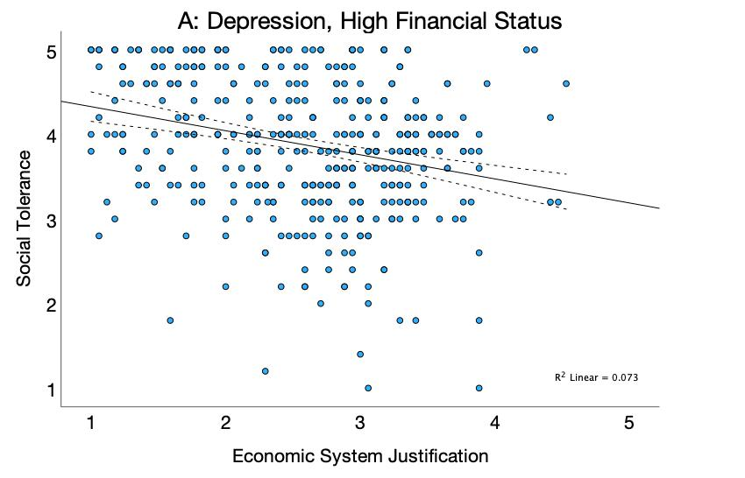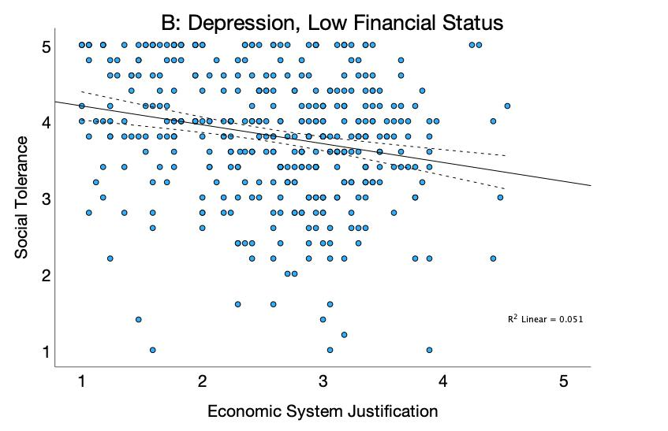
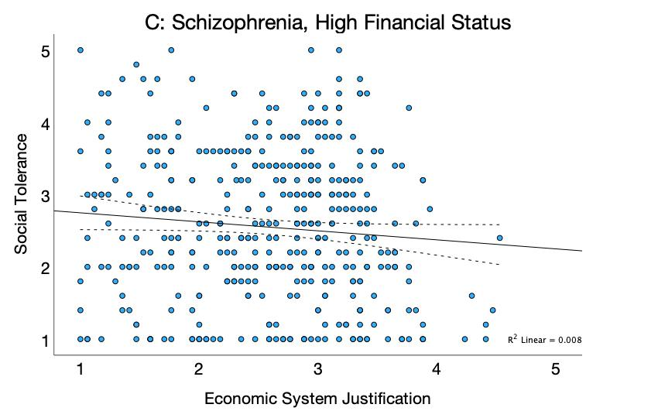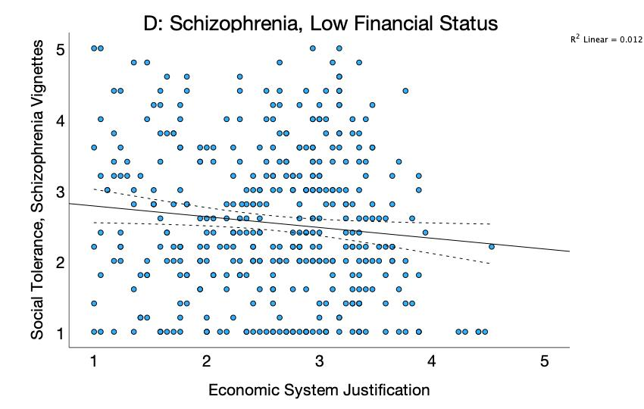
Figure S1. The association between justification of the economic system and social tolerance towards vignette characters meeting the diagnostic criteria for psychiatric conditions: Participants high in economic system justification exhibited lower social tolerance for the characters suffering from depression (A, B) and schizophrenia (C, D), when the individual’s financial status was high (A, C) and when it was low (B, D). Dotted lines around regression slopes depict 95% confidence bands.

Discussion
The survey results again showed with a new sample of participants that ESJ was the strongest and most consistent unique predictor of stigmatizing reactions across measures. ESJ significantly predicted negative reactions to individuals with mental illness on all three measures: negative stereotypes, recovery beliefs, and behavioral intentions, adjusting for demographic variables. Also as in Study 1, personal experience was again a consistent predictor of less stigmatizing reactions across measures.
We also experimentally manipulated the economic position of vignette characters to investigate its effects on the stigmatization. Two of four vignette characters were depicted as suffering from problems that met the DSM criteria for major depression and two for schizophrenia. In the case of depression, a high financial status—simply making more money—directly alleviated stigma: Participants were more willing to engage with the characters socially when their financial status was high relative to when it was low.
The results also showed that social tolerance depended on the respondents’ dispositional tendency to justify the economic system. That is, the higher participants were dispositionally in ESJ, the more they wanted to distance themselves socially from the characters. ESJ did not moderate the effect of financial status, showing that the psychological effects of an individual’s economic positioning did not differ according to how highly motivated participants were to defend current economic arrangements.
By contrast, the effect of the manipulation of financial status was less clear for schizophrenia. Our data do not speak to why this was the case, but one possibility is that the relationship between financial status and stigma may be more complex for more versus less severely stigmatized conditions.
While the defining features of other stigmatizing attributes for various forms of mental distress are beyond the scope of the current paper, we wanted to clarify the experimental findings in a follow-up study using conditions that are more comparable to each other in terms of how harshly the described conditions are stigmatized. That is, in Study 3 we wanted to replicate our tentative finding that at least for less stigmatized disorders, an individual’s position in the economic system is relevant for stigma. Thus, we revised our stimulus materials for Study 3 (see main text) such that we replaced the schizophrenia vignettes with ones describing social phobia, a condition perceived as more similar to depression than schizophrenia.

Appendix D. Vignettes used in Study 3
The vignettes used in Study 3 were as follows (from Lebowitz & Ahn, 2014):
Major depression, vignette 1. Terry is a 28-year-old woman who is seeking treatment because she has felt deeply sad for the past 4 weeks. She reports that she has lost interest in activities that normally bring her pleasure, such as cooking and going to movies. She states that ever since the current period of sadness began, she has had difficulty with her memory and concentration. She has canceled plans with friends several times because she felt too tired to go out. She reports that her outlook on life has become quite pessimistic; she describes feeling hopeless about the future and perceiving herself to be totally worthless. She has reportedly experienced similar symptoms (a low mood that lasted several weeks) on three previous occasions in her life.
Major depression, vignette 2. Alex is a 29-year-old woman who is seeking treatment because she has reportedly “lost the ability to take pleasure in anything”. She states that she began “feeling blue” approximately a month ago, and has spent most of her free time since then in her apartment because she is uninterested in any of her usual social or recreational activities. She says that her negative mood has left her “in a fog”, unable to focus. As such, she has been neglecting schoolwork for the graduate program in which she is enrolled and falling behind as a result. She feels overwhelmed by guilt and describes herself as “a complete failure”. She recalls two previous periods in her life, each lasting several weeks, when she suffered from similar symptoms.
Social phobia, vignette 1. Michelle is a 21-year-old college student who has decided to seek treatment for what she calls “crippling shyness”. For many years she has felt extremely nervous any time she has had to speak in front of a group or meet new people. This has made it very difficult for her to form new friendships, give presentations as part of her coursework, or even participate in classroom discussions. She is always afraid that she will embarrass herself or that others will judge her negatively. Her overwhelming shyness has gotten much worse in recent years; she is now careful not to take any courses that require class presentations and avoids almost all situations in which she might have to meet new people.
Social phobia, vignette 2. Nicole is a 22-year-old recent college graduate who is seeking treatment because she becomes extremely anxious whenever she must interact with strangers. In general, she is concerned that she will make a fool of herself any time she has to talk to anyone she does not know. This fear is especially pronounced in situations involving speaking with people in positions of authority, but it is also present in other social situations, such as those involving peers. For example, she avoids parties and other social situations that could involve people she does not know.

Appendix E: Items Used to Measure General and Economic System Justification

General System Justification (8 items; Kay & Jost, 2003)

(1) In general, I find society to be fair.

Strongly disagree 1------2------3------4------5------6------7------8------9 Strongly agree

(2) In general, the American system operates as it should.

Strongly disagree 1------2------3------4------5------6------7------8------9 Strongly agree

(3) American society needs to be radically restructured.±

Strongly disagree 1------2------3------4------5------6------7------8------9 Strongly agree

(4) The United States is the best country in the world to live in.

Strongly disagree 1------2------3------4------5------6------7------8------9 Strongly agree

(5) Most policies serve the greater good.

Strongly disagree 1------2------3------4------5------6------7------8------9 Strongly agree

(6) Everyone has a fair shot at wealth and happiness.

Strongly disagree 1------2------3------4------5------6------7------8------9 Strongly agree

(7) Our society is getting worse every year.±

Strongly disagree 1------2------3------4------5------6------7------8------9 Strongly agree

(8) Society is set up so that people usually get what they deserve.

Strongly disagree 1------2------3------4------5------6------7------8------9 Strongly agree

±Note: Responses to items 3 and 7 were reverse-scored prior to computing an average score.

Economic System Justification (17 items; Jost & Thompson, 2000)

(1) If people work hard, they almost always get what they want.

Strongly disagree 1------2------3------4------5------6------7------8------9 Strongly agree

(2) The existence of widespread economic differences does not mean that they are inevitable. ±

Strongly disagree 1------2------3------4------5------6------7------8------9 Strongly agree

(3) Laws of nature are responsible for differences in wealth in society.

Strongly disagree 1------2------3------4------5------6------7------8------9 Strongly agree

(4) There are many reasons to think that the economic system is unfair. ±

Strongly disagree 1------2------3------4------5------6------7------8------9 Strongly agree

(5) It is virtually impossible to eliminate poverty.

Strongly disagree 1------2------3------4------5------6------7------8------9 Strongly agree

(6) Poor people are not essentially different from rich people. ±

Strongly disagree 1------2------3------4------5------6------7------8------9 Strongly agree

(7) Most people who don’t get ahead in our society should not blame the system; they have only themselves to blame.

Strongly disagree 1------2------3------4------5------6------7------8------9 Strongly agree

(8) Equal distribution of resources is a possibility for our society. ±

Strongly disagree 1------2------3------4------5------6------7------8------9 Strongly agree

(9) Social class differences reflect differences in the natural order of things.

Strongly disagree 1------2------3------4------5------6------7------8------9 Strongly agree

(10) Economic differences in the society reflect an illegitimate distribution of resources. ±

Strongly disagree 1------2------3------4------5------6------7------8------9 Strongly agree

(11) There will always be poor people, because there will never be enough jobs for everybody.

Strongly disagree 1------2------3------4------5------6------7------8------9 Strongly agree

(12) Economic positions are legitimate reflections of people’s achievements.

Strongly disagree 1------2------3------4------5------6------7------8------9 Strongly agree

(13) If people wanted to change the economic system to make things equal, they could. ±

Strongly disagree 1------2------3------4------5------6------7------8------9 Strongly agree

(14) Equal distribution of resources is unnatural.

Strongly disagree 1------2------3------4------5------6------7------8------9 Strongly agree

(15) It is unfair to have an economic system which produces extreme wealth and extreme poverty at the same time. ±

Strongly disagree 1------2------3------4------5------6------7------8------9 Strongly agree

(16) There is no point in trying to make incomes more equal.

Strongly disagree 1------2------3------4------5------6------7------8------9 Strongly agree

(17) There are no inherent differences between rich and poor; it is purely a matter of the circumstances into which you are born. ±

Strongly disagree 1------2------3------4------5------6------7------8------9 Strongly agree

±Note: Responses to items 2, 4, 6, 8, 10, 13, 15, and 17 were reverse-scored prior to computing an average score.

Supplementary Tables

Table S1

Descriptive Statistics, Including Bivariate Correlations, for Variables in Study 1

Variable | n | M | SD | 1 | 2 | 3 | 4 | 5 | 6 | 7 | 8 | 9 | 10 | 11 | 12 | 13 | 14 | 15 | 16 | 17
1. Age | 368 | 36.01 | 11.64 | –
2. Sex | 368 | .57 | .50 | .02 | –
3. Race | 368 | .79 | .41 | .13* | .02 | –
4. Education | 368 | 4.33 | 1.32 | .04 | .09 | -.05 | –
5. Family income | 367 | 3.97 | 1.55 | .02 | .03 | .08 | .28** | –
6. Personal experience | 368 | .37 | .48 | .07 | .11* | .11* | .01 | -.11* | –
7. BGD | 368 | 3.13 | .60 | .16** | .05 | .07 | -.05 | -.05 | -.09 | –
8. PO | 368 | 2.68 | 1.09 | .15** | -.09 | .16** | -.07 | .07 | -.16** | .13* | –
9. GSJ | 368 | 2.79 | .75 | .13* | -.05 | .09 | .06 | .12* | -.03 | .03 | .39** | –
10. ESJ | 368 | 2.68 | .65 | -.01 | -.10 | .03 | -.03 | .03 | -.14** | .08 | .56** | .59** | –
11. Negative Stereotypes | 368 | 2.79 | 0.84 | .07 | -.15** | -.02 | -.05 | .04 | -.17** | .07 | .23** | .21** | .33** | –
12. Recovery Beliefs | 368 | 3.84 | 1.01 | -.01 | .10 | .02 | -.03 | -.09 | .11* | .07 | -.19** | -.20** | -.40** | -.40** | –
13. Reported and Intended Behaviors | 368 | 3.77 | 1.05 | -.02 | .10* | .00 | .01 | -.05 | .19** | .01 | -.19** | -.25** | -.39** | -.55** | .79** | –
14. CAMI: Authoritarianism | 368 | 2.24 | 0.73 | -.07 | -.12* | -.03 | .00 | .05 | -.20** | -.04 | .26** | .24** | .42** | .48** | -.67** | -.69** | –
15. CAMI: Benevolence | 368 | 3.95 | 0.84 | .09 | .13* | .02 | .02 | -.04 | .19** | .09 | -.23** | -.26** | -.48** | -.41** | .72** | .69** | -.85** | –
16. CAMI: Social Restrictiveness | 368 | 2.22 | 0.82 | -.01 | -.12* | -.04 | .01 | .04 | -.22** | .00 | .26** | .24** | .42** | .57** | -.73** | -.79** | .87** | -.86** | –
17. CAMI: Community Mental Health Ideology | 368 | 3.64 | 0.81 | .01 | .08 | .02 | -.03 | -.12* | .27** | -.04 | -.26** | -.20** | -.41** | -.51** | .62** | .72** | -.76** | .77** | -.86** | –

Note. Personal experience = personal experience of mental health services, BGD = Belief in genetic determinism, PO = Political orientation (mean; 1 = extremely liberal, 5= extremely conservative), GSJ = general system justification, ESJ = economic system justification, CAMI = The Community Attitudes Towards the Mentally Ill Scale. Sex coded 0 = not female, 1 = female; race 0 = not white, 1 = white; personal experience coded 0 = no, 1 = yes; education and family income both coded on an 8-point scale. * p < .05; ** p < .01

Table S2
Descriptive Statistics for Additional Measures from Study 1
 | Depression |  |  | Schizophrenia
 | n | M | SD | n | M | SD
Diagnosis-level measures
Negative stereotypes | 368 | 2.77 | 0.84 | 368 | 3.38 | 0.84
Outcome pessimism | 368 | 2.38 | 0.79 | 368 | 2.61 | 0.82
Blame | 368 | 1.65 | 1.06 | 368 | 1.56 | 0.95
Vignette measures
Social tolerance | 368 | 3.78 | 0.92 | 368 | 3.09 | 1.09
Aggressive emotions | 368 | 1.43 | 0.78 | 368 | 1.40 | 0.77
Anxious emotions | 368 | 1.91 | 0.94 | 368 | 2.52 | 1.10
Prosocial emotions | 368 | 3.94 | 0.83 | 368 | 3.66 | 0.91
Structural discrimination | 368 | 2.04 | 0.84 | 368 | 2.99 | 1.01
Continuum beliefs | 368 | 3.71 | 0.91 | 368 | 2.06 | 0.99
Biogenetic causal beliefs | 368 | 2.98 | 0.75 | 368 | 3.41 | 0.75

Table S3
Hierarchical Regression Models of Predictors of Diagnosis-Specific Measures in Study 1

 | Depression: Negative Stereotypes |  |  |  | Depression: Outcome Pessimism |  |  |  | Depression: Blame
Predictors | Model 1 | Model 2 | Model 3 | Model 4 | Model 1 | Model 2 | Model 3 | Model 4 | Model 1 | Model 2 | Model 3 | Model 4
Age | .050 | .059 | .034 | .068 | -.104* | -.100 | -.118* | -.087 | -.045 | -.041 | -.058 | -.020
Sex | -.111* | -.093 | -.082 | -.072 | -.122* | -.113* | -.099 | -.089 | -.075 | -.067 | -.042 | -.029
Race | -.036 | -.018 | -.039 | -.024 | -.040 | -.031 | -.049 | -.035 | -.035 | -.026 | -.045 | -.028
Education | -.073 | -.065 | -.061 | -.060 | .034 | .038 | .041 | .041 | .053 | .056 | .050 | .051
Family income | .130* | .108* | .094 | .107* | .093 | .082 | .065 | .077 | .087 | .076 | .042 | .057
Personal experience |  | -.166** | -.147** | -.133** |  | -.085 | -.071 | -.058 |  | -.077 | -.073 | -.057
BGD |  |  | .001 | -.007 |  |  | -.048 | -.055 |  |  | -.145** | -.153**
PO |  |  | .092 | -.021 |  |  | .098 | -.004 |  |  | .089 | -.039
GSJ |  |  | .092 | -.039 |  |  | .092 | -.027 |  |  | .212*** | .064
ESJ |  |  |  | .285*** |  |  |  | .259*** |  |  |  | .323***
adj. R² | .019 | .043 | .057 | .096 | .025 | .029 | .046 | .078 | .007 | .010 | .084 | .135
ΔR² | .032 | .026 | .022 | .040 | .038 | .007 | .024 | .033 | .021 | .006 | .080 | .052
ΔF | 2.40* | 10.14** | 2.80* | 16.39*** | 2.88* | 2.59 | 3.11* | 13.29*** | 1.53 | 2.12 | 10.70*** | 21.96***

 | Schizophrenia: Negative Stereotypes |  |  |  | Schizophrenia: Outcome Pessimism |  |  |  | Schizophrenia: Blame
Predictors | Model 1 | Model 2 | Model 3 | Model 4 | Model 1 | Model 2 | Model 3 | Model 4 | Model 1 | Model 2 | Model 3 | Model 4
Age | .009 | .016 | -.050 | -.030 | -.027 | -.023 | -.060 | -.019 | -.077 | -.074 | -.099 | -.056
Sex | -.088 | -.073 | -.061 | -.055 | -.108* | -.099 | -.088 | -.075 | -.100 | -.093 | -.077 | -.063
Race | -.048 | -.033 | -.081 | -.073 | -.052 | -.043 | -.075 | -.057 | -.040 | -.033 | -.053 | -.034
Education | -.006 | -.000 | .017 | .018 | -.011 | -.007 | .008 | .009 | .000 | .003 | .001 | .002
Family income | -.011 | -.030 | -.046 | -.039 | .034 | .023 | .013 | .029 | .033 | .024 | .001 | .017
Personal experience |  | -.139** | -.084 | -.076 |  | -.082 | -.045 | -.028 |  | -.063 | -.050 | -.033
BGD |  |  | .131* | .127* |  |  | .048 | .039 |  |  | -.046 | -.056
PO |  |  | .208*** | .143* |  |  | .182** | .044 |  |  | .073 | -.071
GSJ |  |  | .117* | .042* |  |  | .024 | -.136* |  |  | .172** | .006
ESJ |  |  |  | .164* |  |  |  | .349*** |  |  |  | 0.362***
adj. R² | -.003 | .013 | .098 | .109 | .003 | .007 | .037 | .096 | .006 | .007 | .043 | .107
ΔR² | .011 | .019 | .091 | .013 | .016 | .006 | .038 | .060 | .019 | .004 | .043 | .065
ΔF | .78 | 6.87** | 12.24*** | 5.50* | 1.21 | 2.39 | 4.75** | 24.49*** | 1.43 | 1.39 | 5.50** | 26.73***

Note. Personal experience = personal experience of mental health services, BGD = Belief in genetic determinism, PO = Political orientation (mean; 1 = extremely liberal, 5= extremely conservative), GSJ = general system justification, ESJ = economic system justification. Sex coded 0 = not female, 1 = female; race 0 = not white, 1 = white; personal experience coded 0 = no, 1 = yes; education and family income both coded on an 8-point scale. * p < .05; ** p < .01

Table S4
Hierarchical Regression Models of Predictors of Social Tolerance and Emotional Reactions to Depression Vignettes in Study 1

 | Social Tolerance |  |  |  | Aggressive Emotions
Predictors | Model 1 | Model 2 | Model 3 | Model 4 | Model 1 | Model 2 | Model 3 | Model 4
Age | .005 | -.003 | .027 | .003 | -.134* | -.131* | -.151** | -.115*
Sex | .085 | .069 | .047 | .040 | -.045 | -.040 | -.028 | -.016
Race | .052 | .036 | .073 | .062 | .029 | .035 | .019 | .035
Education | -.023 | -.030 | -.048 | -.049 | .079 | .081 | .079 | .080
Family income | -.055 | -.035 | -.014 | -.023 | .024 | .018 | .000 | .014
Personal experience |  | .152** | .114* | .105* |  | -.048 | -.038 | -.023
BGD |  |  | .070 | .076 |  |  | -.030 | -.039
PO |  |  | -.270*** | -.192** |  |  | .053 | -.069
GSJ |  |  | -.004 | .087 |  |  | .138* | -.003
ESJ |  |  |  | -.198** |  |  |  | .308***
adj. R² | < .001 | .020 | .082 | .99 | .013 | .012 | .031 | .076
ΔR² | .014 | .022 | .069 | .019 | .026 | .002 | .026 | .047
ΔF | 0.99 | 8.23** | 9.16*** | 7.89** | 1.94 | .82 | 3.30* | 18.66***
 | Anxious Emotions |  |  |  | Prosocial Emotions
Predictors | Model 1 | Model 2 | Model 3 | Model 4 | Model 1 | Model 2 | Model 3 | Model 4
Age | -.055 | -.052 | -.069 | -.036 | -.020 | -.030 | .017 | -.010
Sex | -.004 | .001 | .005 | .015 | .132* | .114* | .102 | .093
Race | .032 | .037 | .025 | .039 | -.066 | -.084 | -.049 | -.061
Education | .093 | .095 | .098 | .099 | -.084 | -.092 | -.102* | -.103*
Family income | -.006 | -.012 | -.018 | -.006 | .067 | .089 | .105* | .095
Personal experience |  | -.047 | -.034 | -.021 |  | .169** | .131* | .121*
BGD |  |  | .026 | .018 |  |  | -.064 | -.058
PO |  |  | .046 | -.063 |  |  | -.154** | -.064
GSJ |  |  | .047 | -.080 |  |  | -.108 | -.004
ESJ |  |  |  | .277*** |  |  |  | -.227***
adj. R² | -.002 | -.003 | -.005 | .032 | .014 | .039 | .082 | .106
ΔR² | .011 | .002 | .006 | .038 | .028 | .027 | .050 | .026
ΔF | .820 | .764 | .782 | 14.48*** | 2.06 | 10.45** | 6.63*** | 10.47**

Note. Personal experience = personal experience of mental health services, BGD = Belief in genetic determinism, PO = Political orientation (mean; 1 = extremely liberal, 5= extremely conservative), GSJ = general system justification, ESJ = economic system justification. Sex coded 0 = not female, 1 = female; race 0 = not white, 1 = white; personal experience coded 0 = no, 1 = yes; education and family income both coded on an 8-point scale. * p < .05; ** p < .01

Table S5
Hierarchical Regression Models of Predictors of Social Tolerance for and Emotional Reactions to Schizophrenia Vignettes in Study 1

 | Social Tolerance |  |  |  | Aggressive Emotions
Predictors | Model 1 | Model 2 | Model 3 | Model 4 | Model 1 | Model 2 | Model 3 | Model 4
Age | .007 | -.007 | .045 | .026 | -.150** | -.148** | -.176*** | -.145**
Sex | .037 | .010 | -.003 | -.009 | -.024 | -.019 | -.005 | .004
Race | .095 | .068 | .110* | .102* | -.010 | -.005 | -.027 | -.014
Level of education | .022 | .011 | -.007 | -.008 | .103 | .104 | .105 | .106
Family income | -.060 | -.027 | -.013 | -.020 | -.051 | -.056 | -.076 | -.064
Personal experience |  | .251*** | .203*** | .195*** |  | -.038 | -.020 | -.008
BGD |  |  | -.074 | -.069 |  |  | -.018 | -.025
PO |  |  | -.219*** | -.155* |  |  | .084 | -.017
GSJ |  |  | -.058 | .016 |  |  | .149** | .031
ESJ |  |  |  | -.160* |  |  |  | .256***
adj. R² | -.001 | .058 | .115 | .126 | .019 | .018 | .047 | .078
ΔR² | .013 | .060 | .063 | .013 | .033 | .001 | .036 | .033
ΔF | .962 | 23.47*** | 8.73*** | 5.35* | 2.45* | .51 | 4.65** | 12.95***
 | Anxious Emotions |  |  |  | Prosocial Emotions
Predictors | Model 1 | Model 2 | Model 3 | Model 4 | Model 1 | Model 2 | Model 3 | Model 4
Age | -.003 | -.001 | -.036 | -.026 | -.015 | -.023 | .032 | .005
Sex | .106* | .110* | .112* | .115* | .077 | .061 | .049 | .041
Race | .067 | .071 | .045 | .050 | .030 | .013 | .055 | .043
Level of education | .022 | .024 | .037 | .038 | -.039 | -.046 | -.061 | -.062
Family income | .009 | .004 | .002 | .006 | .041 | .061 | .076 | .066
Personal experience |  | -.035 | -.001 | .003 |  | .151** | .104* | .093
BGD |  |  | .105 | .102 |  |  | -.095 | -.089
PO |  |  | .124* | .091 |  |  | -.186*** | -.097
GSJ |  |  | .001 | -.038 |  |  | -.097 | .006
ESJ |  |  |  | .084 |  |  |  | -.226***
adj. R² | .004 | .002 | .021 | .022 | -.004 | .015 | .073 | .097
ΔR² | .017 | .001 | .027 | .004 | .009 | .022 | .065 | .025
ΔF | 1.26 | .432 | 3.31* | 1.33 | .68 | 8.06** | 8.55*** | 10.29**

Note. Personal experience = personal experience of mental health services, BGD = Belief in genetic determinism, PO = Political orientation (mean; 1 = extremely liberal, 5= extremely conservative), GSJ = general system justification, ESJ = economic system justification. Sex coded 0 = not female, 1 = female; race 0 = not white, 1 = white; personal experience coded 0 = no, 1 = yes; education and family income both coded on an 8-point scale. * p < .05; ** p < .01

Table S6
Hierarchical Regression Models of Predictors of Attitudes toward Structural Discrimination, Continuum Beliefs, and Biogenetic Causal Beliefs Regarding Vignette Characters with Depression and Schizophrenia in Study 1

 | Structural Discrimination
 | Depression |  |  |  | Schizophrenia
 | Model 1 | Model 2 | Model 3 | Model 4 | Model 1 | Model 2 | Model 3 | Model 4
Age | .049 | .054 | .024 | .052 | .079 | .084 | .028 | .032
Sex | -.051 | -.042 | -.036 | -.027 | -.045 | -.035 | -.025 | -.024
Race | -.094 | -.084 | -.107* | -.095 | -.109* | -.099 | -.144** | -.142**
Level of education | -.020 | -.016 | -.008 | -.007 | -.098 | -.094 | -.073 | -.073
Family income | .053 | .041 | .034 | .044 | .081 | .069 | .058 | .060
Personal experience |  | -.088 | -.062 | -.050 |  | -.089 | -.036 | -.035
BGD |  |  | .055 | .048 |  |  | .113* | .112*
PO |  |  | .103 | .010 |  |  | .224*** | .211***
GSJ |  |  | .050 | -.058 |  |  | .038 | .023
ESJ |  |  |  | .235** |  |  |  | .033
adj. R² | .001 | .006 | .017 | .043 | .014 | .019 | .082 | .080
ΔR² | .015 | .007 | .019 | .027 | .028 | .008 | .069 | .001
ΔF | 1.06 | 2.70 | 2.40 | 10.50** | 2.05 | 2.86 | 9.21*** | .22
 | Continuum Beliefs
 | Depression |  |  |  | Schizophrenia
 | Model 1 | Model 2 | Model 3 | Model 4 | Model 1 | Model 2 | Model 3 | Model 4
Age | .065 | .066 | .053 | .028 | -.030 | -.030 | -.024 | .004
Sex | .059 | .063 | .054 | .046 | -.087 | -.087 | -.088 | -.078
Race | .029 | .032 | .023 | .012 | -.134* | -.133* | -.126* | -.114*
Level of education | -.118* | -.117* | -.103 | -.104 | .020 | .020 | .013 | .014
Family income | -.022 | -.026 | -.012 | -.022 | -.021 | -.021 | -.022 | -.011
Personal experience |  | -.033 | -.012 | -.022 |  | .000 | -.011 | .001
BGD |  |  | .116* | .122* |  |  | -.014 | -.021
PO |  |  | .065 | .149* |  |  | -.060 | -.156*
GSJ |  |  | -.116* | -.019 |  |  | .041 | -.069
ESJ |  |  |  | -.213** |  |  |  | .242***
adj. R² | .010 | .008 | .026 | .046 | .015 | .013 | .008 | .035
ΔR² | .023 | .001 | .025 | .023 | .029 | < .001 | .004 | .029
ΔF | 1.73 | .38 | 3.15* | 8.64** | 2.15 | < .001 | .43 | 11.02***
 | Biogenetic Causal Beliefs
 | Depression |  |  |  | Schizophrenia
 | Model 1 | Model 2 | Model 3 | Model 4 | Model 1 | Model 2 | Model 3 | Model 4
Age | .041 | .031 | .008 | .000 | .033 | .025 | .011 | -.003
Sex | .096 | .076 | .048 | .045 | .072 | .058 | .034 | .030
Race | .071 | .052 | .058 | .054 | .053 | .038 | .042 | .036
Level of education | .040 | .031 | .029 | .029 | -.004 | -.010 | -.006 | -.006
Family income | -.035 | -.011 | .016 | .013 | .086 | .104 | .130* | .124*
Personal experience |  | .179*** | .186*** | .183*** |  | .133* | .143** | .138**
BGD |  |  | .306*** | .308*** |  |  | .237*** | .240***
PO |  |  | -.181** | -.153** |  |  | -.097 | -.050
GSJ |  |  | .018 | .052 |  |  | -.069 | -.014
ESJ |  |  |  | -.073 |  |  |  | -.119
adj. R² | .005 | .034 | .137 | .137 | .004 | .019 | .080 | .084
ΔR² | .019 | .031 | .108 | .003 | .018 | .017 | .067 | .007
ΔF | 1.40 | 11.66*** | 15.34*** | 1.11 | 1.33 | 6.36* | 8.89*** | 2.81

Note. Personal experience = personal experience of mental health services, BGD = Belief in genetic determinism, PO = Political orientation (mean; 1 = extremely liberal, 5= extremely conservative), GSJ = general system justification, ESJ = economic system justification. Sex coded 0 = not female, 1 = female; race 0 = not white, 1 = white; personal experience coded 0 = no, 1 = yes; education and family income both coded on an 8-point scale. * p < .05; ** p < .01

Table S7
Representativeness of the Sample in Study 2
Demographic | Brackets | Census CPS % | Expected Sample Frequencies | Observed Frequencies | Expected vs. Observed Frequencies | Expected vs. Observed %
Age | 18 to 24 | 11.78 | 118 | 126 | 8 | 6.78
Age | 25 to 34 | 18.00 | 180 | 182 | 2 | 1.11
Age | 35 to 44 | 16.32 | 163 | 170 | 7 | 4.29
Age | 45 to 54 | 16.67 | 167 | 169 | 2 | 1.20
Age | 55 to 64 | 16.73 | 167 | 165 | -2 | -1.20
Age | 65 to 80+ | 20.50 | 205 | 216 | 11 | 5.37
Education | Less than high school or High school graduate | 39.54 | 395 | 394 | -1 | -0.25
Education | Some college, less than 4-yr degree | 28.20 | 282 | 296 | 14 | 4.96
Education | Bachelor’s degree or higher | 32.25 | 322 | 338 | 16 | 4.97
Sex | Female | 51.56 | 516 | 538 | 22 | 4.26
Sex | Male | 48.44 | 484 | 490 | 6 | 1.24
Income | Less than $15,000 | 11.01 | 110 | 115 | 5 | 4.55
Income | $15,000 to $24,999 | 9.31 | 93 | 98 | 5 | 5.38
Income | $25,000 to $34,999 | 9.10 | 91 | 97 | 6 | 6.59
Income | $35,000 to $49,999 | 12.66 | 127 | 134 | 7 | 5.51
Income | $50,000 to $74,999 | 17.60 | 176 | 184 | 8 | 4.55
Income | $75,000 to $99,999 | 12.52 | 125 | 131 | 6 | 4.80
Income | $100,000 or more | 27.80 | 278 | 269 | -9 | -3.24

Table S8
Descriptive Statistics, Including Bivariate Correlations, Between Demographic and Independent Variables in Study 2

Variable | n | M | SD | 1 | 2 | 3 | 4 | 5 | 6 | 7 | 8
1. Age | 1,028 | 3.69 | 1.70 | –
2. Sex | 1,028 | .52 | .50 | -.17*** | –
3. Race/ethnicity | 1,028 | .75 | .43 | .32*** | .01 | –
4. Education | 1,028 | 1.95 | .84 | .13*** | -.15*** | .05 | –
5. Family income | 1,028 | 4.60 | 2.04 | .06 | -.15*** | .10** | .36*** | –
6. PO | 1,028 | 54.56 | 30.98 | .17*** | .02 | .17*** | -.10** | .02 | –
7. GSJ | 1,028 | 4.60 | 1.56 | .36*** | -.20*** | .12*** | .12*** | .16*** | .29*** | –
8. ESJ | 1,028 | 4.67 | 1.00 | .20*** | -.13*** | .11*** | .01 | .11*** | .50*** | .48*** | –

Note. PO = Political orientation (0 = strongly liberal, 100 = strongly conservative), GSJ = General system justification, ESJ = Economic system justification. Age coded 1-6 (1 = 18-24 to 6 = older than 65); sex as 0 = not female, 1 = female; race as 0 = not white, 1 white; education 1-3 (1 = high school graduate or less, 2 = some college, 3 = Bachelor’s degree or higher); and family income 1-7 (1 = less than $15,000 to 7 = $100,000 or more).
* p < .05, ** p < .01, ***p < .001.

Table S9
Descriptive Statistics of Dependent Variables According to Subcategory in Study 2

 | Depression |  |  |  |  |  | Mental illness
 | Social Tolerance | Only has him/  herself to blame | Will not improve | A danger to others | Should be isolated from society | Should be sterilizedª | Social Tolerance | Only has him/herself to blame | Will not improve | A danger to others | Should be isolated from society | Should be sterilizedª
n | 525 | 525 | 525 | 525 | 525 | 525 | 503 | 503 | 503 | 503 | 503 | 503
M | 6.65 | 2.64 | 2.81 | 3.77 | 2.37 | 2.45 | 6.42 | 2.23 | 2.82 | 3.99 | 2.54 | 2.74
SEM | 0.081 | 0.080 | 0.083 | 0.089 | 0.076 | 0.084 | 0.084 | 0.071 | 0.086 | 0.092 | 0.086 | 0.092
Md | 7.00 | 3.00 | 3.00 | 4.00 | 1.00 | 1.00 | 7.0000 | 1.00 | 3.00 | 4.00 | 2.00 | 2.00
Mode | 7 | 1 | 1 | 5 | 1 | 1 | 7 | 1 | 1 | 5 | 1 | 1
SD | 1.86 | 1.83 | 1.91 | 2.05 | 1.74 | 1.93 | 1.88 | 1.60 | 1.92 | 2.07 | 1.94 | 2.06

ª The item was presented identically in both conditions (“Persons with hereditary defects and mental disorders should be sterilized”).

Table S10
Hierarchical Regression Models of Predictors of Social Tolerance According to Subcategory in Study 2

Social Tolerance
 | Depression |  |  | Mental illness
 | Model 1 | Model 2 | Model 3 | Model 1 | Model 2 | Model 3
Age | -.226*** | -.186*** | -.192*** | -.234*** | -.178*** | -.173***
Education | -.002 | -.016 | -.031 | -.020 | -.034 | -.022
Family income | -.054 | -.047 | -.031 | -.145** | -.119* | -.115*
Gender | -.030 | -.023 | -.034 | -.039 | -.063 | -.082
Race/ethnicity | .155** | .172*** | .177*** | .167*** | .175*** | .169***
PO |  | -.131** | -.048 |  | -.089 | .012
GSJ |  | -.058 | .009 |  | -.140** | -.036
ESJ |  |  | -.203*** |  |  | -.270***
adj. R² | .042 | .060 | .086 | .072 | .100 | .141
ΔR² | .051 | .022 | .027 | .082 | .031 | .042
ΔF | 5.61*** | 6.03** | 15.42*** | 8.85*** | 8.86*** | 24.79***

Note. PO = Political orientation (0 = strongly liberal, 100 = strongly conservative), GSJ = General system justification, ESJ = Economic system justification. Age coded 1-6 (1 = 18-24 to 6 = older than 65); sex as 0 = not female, 1 = female; race as 0 = not white, 1 white; education 1-3 (1 = high school graduate or less, 2 = some college, 3 = Bachelor’s degree or higher); and family income 1-7 (1 = less than $15,000 to 7 = $100,000 or more).
* p < .05, ** p < .01, ***p < .001.

Table S11
Hierachical Regression Models of Predictors of Blame and Negative Stereotypes According to Subcategory in Study 2

 | Blame |  |  |  |  |  |  | Negative Stereotypes
 | Depression |  |  | Mental illness |  |  |  | Depression |  |  | Mental illness
 | Model |  |  | Model |  |  |  | Model |  |  | Model
 | 1 | 2 | 3 |  | 1 | 2 | 3 | 1 | 2 | 3 | 1 | 2 | 3
Age | 0.078 | -0.039 | -0.032 |  | -0.005 | -0.102* | -0.104* | 0.182*** | 0.113* | 0.119* | 0.187*** | 0.114* | 0.111*
Education | -0.012 | -0.003 | 0.018 |  | -0.004 | 0.013 | 0.007 | -0.012 | 0.007 | 0.023 | -0.035 | -0.005 | -0.011
Family income | -0.013 | -0.042 | -0.064 |  | 0.044 | 0.002 | 0.000 | 0.086 | 0.074 | 0.057 | 0.124** | 0.087 | 0.085
Gender | -0.090* | -0.081 | -0.066 |  | -0.121** | -0.076 | -0.067 | -0.028 | -0.036 | -0.024 | -0.056 | -0.030 | -0.020
Race/  ethnicity | -0.035 | -0.063 | -0.069 |  | -0.014 | -0.023 | -0.020 | -0.118* | -0.144** | -0.148*** | -0.114* | -0.137** | -0.134**
PO |  | 0.155** | 0.045 |  |  | 0.112* | 0.064 |  | 0.196*** | 0.112* |  | 0.193*** | 0.141**
GSJ |  | 0.267** | 0.179*** |  |  | 0.262*** | 0.214*** |  | 0.109* | 0.043 |  | 0.145** | 0.092
ESJ |  |  | 0.270*** |  |  |  | 0.128* |  |  | 0.205*** |  |  | 0.139*
adj. R² | .006 | .101 | .147 |  | .008 | .092 | .099 | .031 | .081 | .107 | .050 | .115 | .124
ΔR² | .016 | .097 | .047 |  | .018 | .086 | .010 | .040 | .054 | .027 | .059 | .068 | .011
ΔF | 1.65 | 28.27*** | 29.14*** |  | 1.84 | 23.81*** | 5.30* | 4.32*** | 15.33*** | 15.97*** | 6.23*** | 19.25*** | 6.43*

Note. PO = Political orientation (0 = strongly liberal, 100 = strongly conservative), GSJ = General system justification, ESJ = Economic system justification. Age coded 1-6 (1 = 18-24 to 6 = older than 65); sex as 0 = not female, 1 = female; race as 0 = not white, 1 white; education 1-3 (1 = high school graduate or less, 2 = some college, 3 = Bachelor’s degree or higher); and family income 1-7 (1 = less than $15,000 to 7 = $100,000 or more).
* p < .05, ** p < .01, ***p < .001.

Table S12
Hierarchical Regression Models of Predictors of Recovery Beliefs and Social Restrictiveness According to Subcategory in Study 2

 | Recovery Beliefs |  |  |  |  |  | Social Restrictiveness
 | Depression |  |  | Mental illness |  |  | Depression |  |  | Mental illness
 | Model |  |  | Model |  |  | Model |  |  | Model
 | 1 | 2 | 3 | 1 | 2 | 3 | 1 | 2 | 3 | 1 | 2 | 3
Age | -0.054 | -0.146** | -0.143** | -0.036 | -0.120* | -0.124** | 0.000 | -0.071 | -0.066 | 0.052 | -0.046 | -0.048
Education | 0.038 | 0.054 | 0.062 | 0.004 | 0.024 | 0.012 | 0.019 | 0.035 | 0.051 | 0.004 | 0.036 | 0.031
Family income | 0.050 | 0.031 | 0.022 | -0.007 | -0.045 | -0.049 | -0.033 | -0.047 | -0.063 | 0.101* | 0.054 | 0.053
Gender | -0.032 | -0.035 | -0.029 | -0.114* | -0.078 | -0.060 | 0.004 | -0.001 | 0.011 | -0.154*** | -0.115** | -0.106*
Race/  ethnicity | -0.053 | -0.082 | -0.084 | -0.080 | -0.093* | -0.087 | 0.027 | 0.003 | -0.002 | -0.025 | -0.047 | -0.044
PO |  | 0.196*** | 0.155** |  | 0.131** | 0.035 |  | 0.177*** | 0.093 |  | 0.201*** | 0.157**
GSJ |  | 0.178*** | 0.145** |  | 0.210*** | 0.113* |  | 0.125** | 0.057 |  | 0.223*** | 0.178***
ESJ |  |  | 0.101 |  |  | 0.256*** |  |  | 0.206*** |  |  | 0.118*
adj. R² | .003 | .076 | .080 | .012 | .078 | .114 | -.008 | .039 | .065 | .037 | .140 | .146
ΔR² | .013 | .075 | .007 | .022 | .069 | .038 | .002 | .050 | .028 | .047 | .105 | .008
ΔF | 1.34 | 21.28*** | 3.79 | 2.19 | 18.74*** | 21.60*** | .165 | 13.74*** | 15.54*** | 4.85*** | 30.62*** | 4.78*

Note. PO = Political orientation (0 = strongly liberal, 100 = strongly conservative), GSJ = General system justification, ESJ = Economic system justification. Age coded 1-6 (1 = 18-24 to 6 = older than 65); sex as 0 = not female, 1 = female; race as 0 = not white, 1 white; education 1-3 (1 = high school graduate or less, 2 = some college, 3 = Bachelor’s degree or higher); and family income 1-7 (1 = less than $15,000 to 7 = $100,000 or more).
* p < .05, ** p < .01, ***p < .001.

Table S13
Descriptive Statistics, Including Bivariate Correlations, Between Demographic and Independent Variables in Pilot Study for Experimental Manipulation

Variable | n | M | SD | 1 | 2 | 3 | 4 | 5 | 6 | 7 | 8 | 9 | 10 | 11 | 12 | 13 | 14
1. Age | 403 | 39.79 | 13.55 | –
2. Gender | 409 | .56 | 0.50 | .15** | –
3. Race | 409 | .72 | 0.45 | .21** | .04 | –
4. Education | 403 | 4.41 | 1.39 | .13** | -.04 | .02 | –
5. Family income | 403 | 3.77 | 1.49 | -.07 | -.02 | .03 | .24** | –
6. Personal exp | 403 | .29 | 0.45 | -.09 | .06 | .13* | -.10 | -.09 | –
7. Exp MH services | 402 | .32 | 0.47 | .01 | .16** | .14** | -.01 | -.05 | .62** | –
8. Exp family/friends | 400 | .44 | 0.50 | -.01 | .17** | .01 | -.01 | -.01 | .34** | .37** | –
9. PO | 409 | 2.70 | 1.17 | .10* | -.09 | .08 | -.01 | .11* | -.16** | -.09 | -.07 | –
10. GSJ | 408 | 2.86 | 0.91 | .09 | -.07 | .06 | .05 | .19** | -.23** | -.13** | -.16** | .47** | –
11. ESJ | 405 | 2.58 | 0.77 | -.04 | -.15** | .08 | .02 | .16** | -.16** | -.09 | -.14** | .59** | .64** | –
12. AMIS 1 | 409 | 3.09 | 0.82 | .01 | -.06 | -.10* | .07 | .07 | -.26** | -.19** | -.12* | .25** | .21** | .31** | –
13. AMIS 2 | 409 | 4.14 | 0.67 | .06 | .16** | .02 | -.06 | .05 | .20** | .15** | .16** | -.14** | -.06 | -.31** | -.34** | –
14. RIBS | 409 | 3.68 | 0.81 | -.10* | .15** | .11* | -.02 | -.04 | .23** | .19** | .13** | -.16** | -.12* | -.25** | -.49** | .55** | –

Note. Personal exp = personal experience of mental illness, Exp MH services = personal experience of mental health services, Exp family/friends = experience of family members or friends with a mental illness, PO = Political orientation, GSJ = general system justification, ESJ = economic system justification, AMIS 1 = Attitudes toward mental illness scale 1: Negative stereotypes; AMIS 2 = Attitudes toward mental illness scale 2: Recovery; RIBS = Reported and intended behavior scale. Gender coded as 0 = not female, 1 = female; race as 0 = not white, 1 white; personal experience of mental illness as 0 = no, 1 = yes. Education coded 1–8 (“12th grade or less” to “Doctorate degree”). Family income coded 1–8 (from “$0–$14,999” to “over $200,000”). Political orientation coded 1–5 (from 1, “extremely liberal” to 5, “extremely conservative”).
* p < .05. ** p < .01.

Table S14
Hierarchical Regression Analyses of Predictors of Negative Stereotypes of Mental Illness, Recovery Beliefs and Behavioral Intentions in Pilot Study for Experimental Manipulation

 | Negative Stereotypes (AMIS 1) |  |  |  | Recovery Beliefs (AMIS 2) |  |  |  | Reported Intended Behaviors (RIBS)
 | Model 1 | Model 2 | Model 3 | Model 4 | Model 1 | Model 2 | Model 3 | Model 4 | Model 1 | Model 2 | Model 3 | Model 4
Age | .039 | .007 | -.020 | .014 | .047 | .075 | .086 | .030 | -.168** | -.142** | -.131* | -.168***
Gender | -.057 | -.034 | -.008 | .010 | .157** | .132** | .121* | .091 | .181*** | .158** | .147** | .127*
Race | -.103* | -.064 | -.083 | -.095 | .010 | -.021 | -.013 | -.008 | .150** | .117* | .125* | .139**
Education | .038 | .029 | .046 | .044 | -.074 | -.067 | -.075 | -.071 | .026 | .032 | .024 | .027
Family income | .065 | .044 | .010 | .005 | .069 | .087 | .095 | .104* | -.055 | -.038 | -.025 | -.019
Personal exp |  | -.205** | -.159* | -.154* |  | .179** | .165* | .156* |  | .159* | .141* | .135*
Exp MH services |  | -.029 | -.036 | -.044 |  | .006 | .007 | .021 |  | .042 | .044 | .054
Exp family/friends |  | -.032 | -.027 | -.017 |  | .073 | .077 | .060 |  | .033 | .032 | .021
PO |  |  | .205*** | .101 |  |  | -.129* | .043 |  |  | -.105 | -.011
GSJ |  |  | .055 | -.071 |  |  | .038 | .247*** |  |  | -.003 | .139*
ESJ |  |  |  | .275*** |  |  |  | -.456*** |  |  |  | -.308***
adj. R² | .020 | .054 | .102 | .134 | .024 | .063 | .071 | .166 | .053 | .085 | .091 | .133
ΔR² | .020 | .053 | .051 | .034 | .036 | .046 | .013 | .094 | .064 | .039 | .010 | .043
ΔF | 1.60 | 7.50*** | 11.32*** | 15.68*** | 2.97* | 6.46*** | 2.78 | 44.83*** | 5.43*** | 5.64*** | 2.30 | 19.65***

Note. Personal exp = personal experience of mental illness, Exp MH services = personal experience of mental health services, Exp family/friends = experience of family members or friends with a mental illness, PO = Political orientation, GSJ = general system justification, ESJ = economic system justification, AMIS 1 = Attitudes toward mental illness scale 1: Negative stereotypes; AMIS 2 = Attitudes toward mental illness scale 2: Recovery; RIBS = Reported and intended behavior scale. Gender coded as 0 = not female, 1 = female; race as 0 = not white, 1 white; personal experience as 0 = no, 1 = yes. Education coded 1–8 (“12th grade or less” to “Doctorate degree”). Family income coded 1–8 (from “$0–$14,999” to “over $200,000”). Political orientation coded 1–5 (from 1, “extremely liberal” to 5, “extremely conservative”).
* p < .05. ** p < .01, *** p < .001.

Table S15
Social Tolerance According to Vignette Type, Financial Status, and Type of Social Engagement in Pilot Study for Experimental Manipulation

 | Depression |  |  |  |  |  |  |  | Schizophrenia
 | High Financial Status |  |  |  | Low Financial Status |  |  |  | High Financial Status |  |  |  | Low Financial Status
 | M | SE | 95% CI |  | M | SE | 95% CI |  | M | SE | 95% CI |  | M | SE | 95% CI
 | M | SE | LL | UL | M | SE | LL | UL | M | SE | LL | UL | M | SE | LL | UL
Move next door to | 4.07 | 0.05 | 3.98 | 4.15 | 3.97 | 0.05 | 3.88 | 4.07 | 2.67 | 0.06 | 2.56 | 2.79 | 2.65 | 0.06 | 2.53 | 2.77
Spend an evening socializing with | 4.04 | 0.05 | 3.95 | 4.13 | 4.00 | 0.05 | 3.91 | 4.10 | 2.74 | 0.06 | 2.62 | 2.86 | 2.72 | 0.06 | 2.60 | 2.85
Make friends with | 4.03 | 0.05 | 3.95 | 4.12 | 3.99 | 0.05 | 3.90 | 4.08 | 2.74 | 0.06 | 2.62 | 2.86 | 2.78 | 0.06 | 2.65 | 2.90
Start working closely with | 3.81 | 0.05 | 3.71 | 3.91 | 3.77 | 0.05 | 3.67 | 3.87 | 2.49 | 0.06 | 2.38 | 2.61 | 2.47 | 0.06 | 2.35 | 2.59
Have marry into family | 3.45 | 0.05 | 3.35 | 3.56 | 3.33 | 0.06 | 3.22 | 3.45 | 2.10 | 0.06 | 1.99 | 2.21 | 2.08 | 0.06 | 1.97 | 2.19
Note. CI = confidence interval; LL = lower limit; UL = upper limit.

References
Angermeyer, M. C., & Matschinger, H. (1996). The effect of personal experience with mental illness on the attitude towards individuals suffering from mental disorders. Social Psychiatry and Psychiatric Epidemiology, 31(6), 321-326. https://doi.org/10.1007/BF00783420
Crisp, A. H., Gelder, M. G., Rix, S., Meltzer, H. I., & Rowlands, O. J. (2000). Stigmatisation of people with mental illnesses. British Journal of Psychiatry, 177, 4-7. https://doi.org/10.1192/bjp.177.1.4
Kvaale, E. P., & Haslam, N. (2016). Motivational orientations and psychiatric stigma: Social motives influence how causal explanations relate to stigmatizing attitudes. Personality and Individual Differences, 89, 111-116. https://doi.org/10.1016/j.paid.2015.09.044
Lebowitz, M. S., & Ahn, W.-k. (2014). Effects of biological explanations for mental disorders on clinicians’ empathy. Proceedings of the National Academy of Sciences, 111(50), 17786-17790. https://doi.org/10.1073/pnas.1414058111
Lebowitz, M. S., & Appelbaum, P. S. (2019). Biomedical explanations of psychopathology and their implications for attitudes and beliefs about mental disorders. Annual Review of Clinical Psychology, Vol 15, 15, 555-577. https://doi.org/10.1146/annurev-clinpsy-050718-095416
Link, B. G., Phelan, J. C., Bresnahan, M., Stueve, A., & Pescosolido, B. A. (1999). Public conceptions of mental illness: Labels, causes, dangerousness, and social distance. American Journal of Public Health, 89(9), 1328-1333. https://doi.org/10.2105/Ajph.89.9.1328
Link, B. G., Yang, L. H., Phelan, J. C., & Collins, P. Y. (2004). Measuring mental illness stigma. Schizophrenia Bulletin, 30(3), 511-541. https://doi.org/10.1093/oxfordjournals.schbul.a007098

A seventh item ("can pull him/herself together") was dropped on theoretical grounds, because we found it to be ambiguous about whether support or treatment was required for the outcome.
The DSM-IV has since then been updated to the DSM-5, but no changes have been made that would be expected to affect the results of our research program.
The Huynh-Feldt (ε = .84) correction was used because the assumption of sphericity was violated, χ²(9) = 185.66, p < .001.
The Huynh-Feldt (ε = .99) correction was used because the assumption of sphericity was violated, χ²(9) = 17.59, p = .04.
The Huynh-Feldt (ε = .97) correction was used because the assumption of sphericity was violated, χ²(9) = 29.93, p < .001.
The Huynh-Feldt (ε = .87) correction was used because the assumption of sphericity was violated, χ²(9) = 129.69, p < .001.

