Supplementary Material
Part 1: Measurement and Evaluation of Divergent Thinking
Example item
Please imagine what glass looks like. The size and quantity of the glass are unlimited. Try to come up with as many creative and practical uses of glass in daily life as you can within 5 minutes.
Please write your ideas on the lines below, one idea per line. If necessary, you may explain how each use could be realized so that others can better understand your ideas.
Coding table
The coding table was developed based on the entire sample pool through joint discussions among several experts in the field of creativity, which is a common practice in divergent thinking assessment. After its development, three raters scored each response according to the coding table. The complete coding table in Chinese is shown in the Figure S1 below, and a partial English translation is provided in Table S1 for reference.
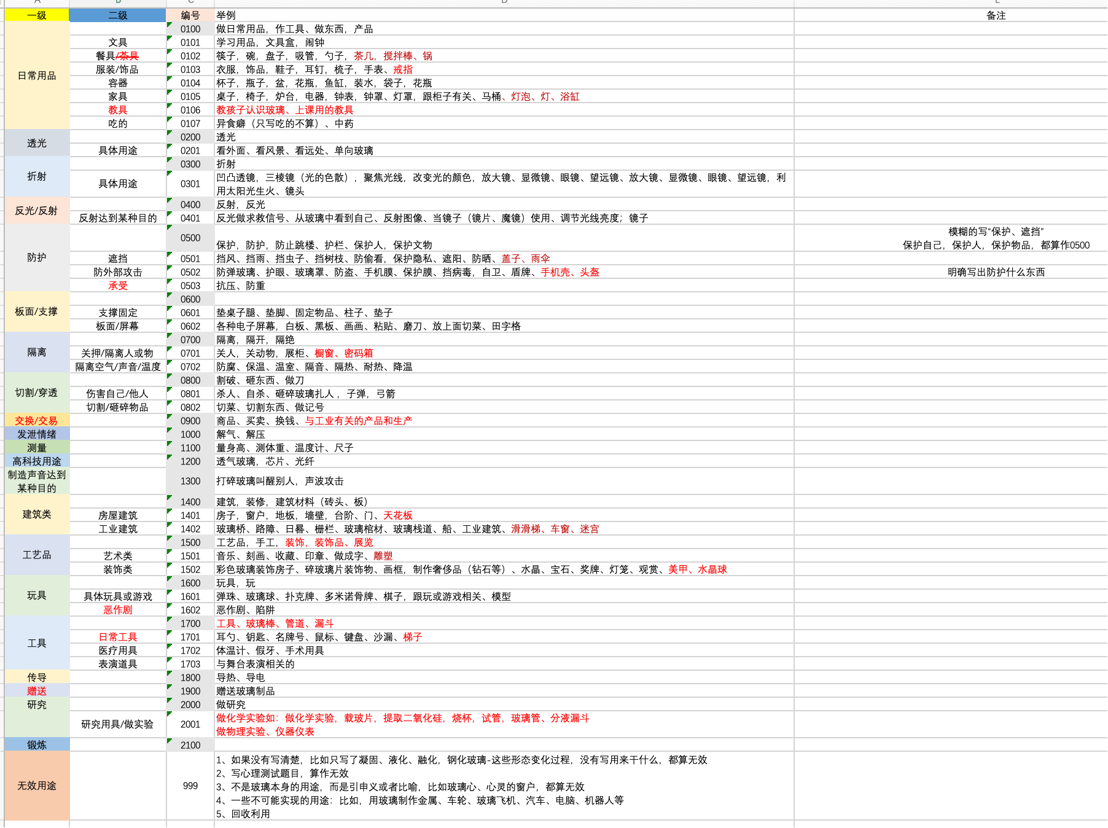
Figure S1. The Coding Table for Divergent Thinking (Chinese Version)

Table S1. Partial English version of the divergent thinking coding table
Primary Category | Secondary Category | Code | Examples
Daily necessities |  | 0100 | Making everyday items, tools, products
 | Stationery | 0101 | Study supplies, pencil case, alarm clock
 | Tableware | 0102 | Chopsticks, bowls, plates, straws, spoons, tea table, stir sticks, pots
 | Clothing / Accessories | 0103 | Clothes, accessories, shoes, earrings, combs, watches, rings
 |  | 0104 | Cups, bottles, basins, vases, fish tanks, water containers, bags, flower vases
  Containers
…… | …… | …… | ……
Calculate fluency, flexibility, and originality
Scoring Tool: Excel
- Fluency: Count the total number of valid responses (use the COUNT function).
Note: Exclude missing values and invalid codes (e.g., 99/999).
- Flexibility: Count the total number of distinct coding categories (first sort the data for each participate, then count how many different codes appear).
Quick method: Use “Remove Duplicates” to delete repeated codes in bulk, then apply the COUNT function to calculate the number of unique codes.
- Originality: Calculate the frequency of each code across the entire sample code and assign a score to each code based on its occurrence rate. Sum the originality scores of all responses.
Scoring criteria: Appears in less than 3% of the total sample → 2 points；Appears in 3%–5% of the total sample → 1 point；Appears in more than 5% of the total sample → 0 points.

Part 2: Measurement and Evaluation of Convergent Thinking
Item
Below are six pre-drawn shapes. You need to use at least four of them to create a picture. Try to make your drawing as unique as possible. After finishing, please give your artwork a title and use a pen of a different color to circle each shape you used in your drawing, explaining what each shape represents in your work. You have 10 minutes to complete this task.
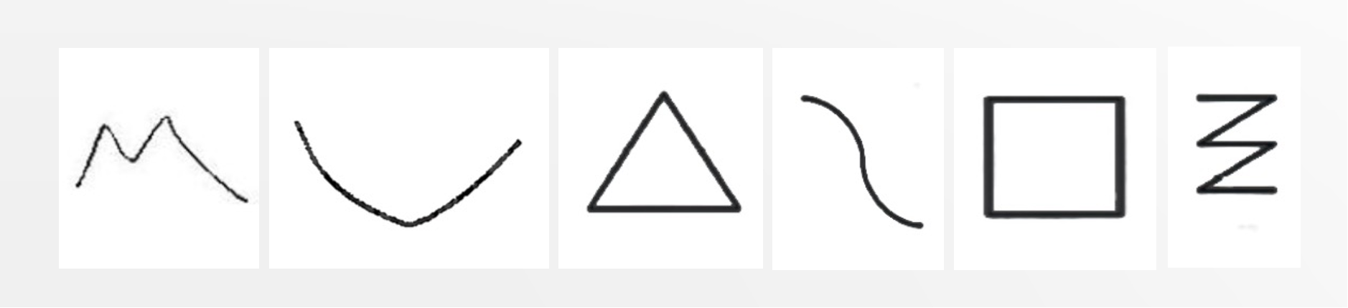
Standardized Scoring Manual Based on the Sample Pool of the Present Study
The drawing task was scored using a 7-point Likert scale. A creative drawing is defined as one that demonstrates novelty while also adhering to the task constraints—that is, usefulness: “Each drawing must incorporate at least four of the six given shapes.”
To help you evaluate the drawings produced by college students, we recommend using the following criteria to assess the creativity of each drawing. In this manual, you will also find example drawings from college students corresponding to each score level.
Score 1: Very Low Creativity — Complete Lack of Ideas (Overall creativity: 0; Use of shapes: 0)
– The participant merely arranged the shapes together or used fewer than the required number.
– The participant simply copied the given shapes without adding any meaningful content to the drawing.
For example：
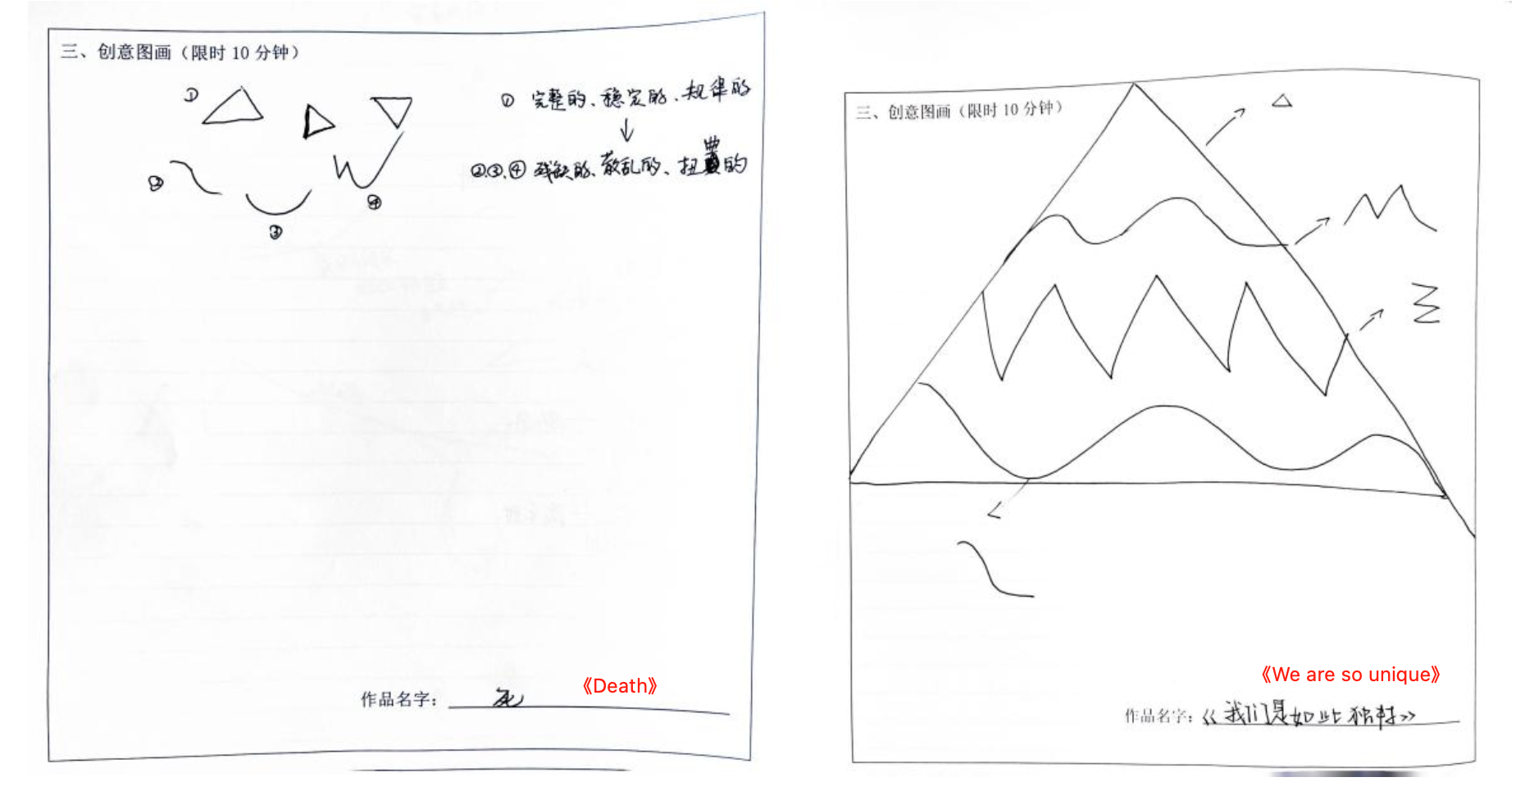
Score 2: Low Creativity — The Provided Shapes Have Limited Meaning (Overall creativity: 1; Use of shapes: 1)
– The participant integrated the required number of different shapes into one drawing; however, the overall composition and the individual shapes lack distinctiveness.
– The participant combined different shapes to form certain objects, but these elements fail to come together into a coherent story or meaningful theme.
For example：
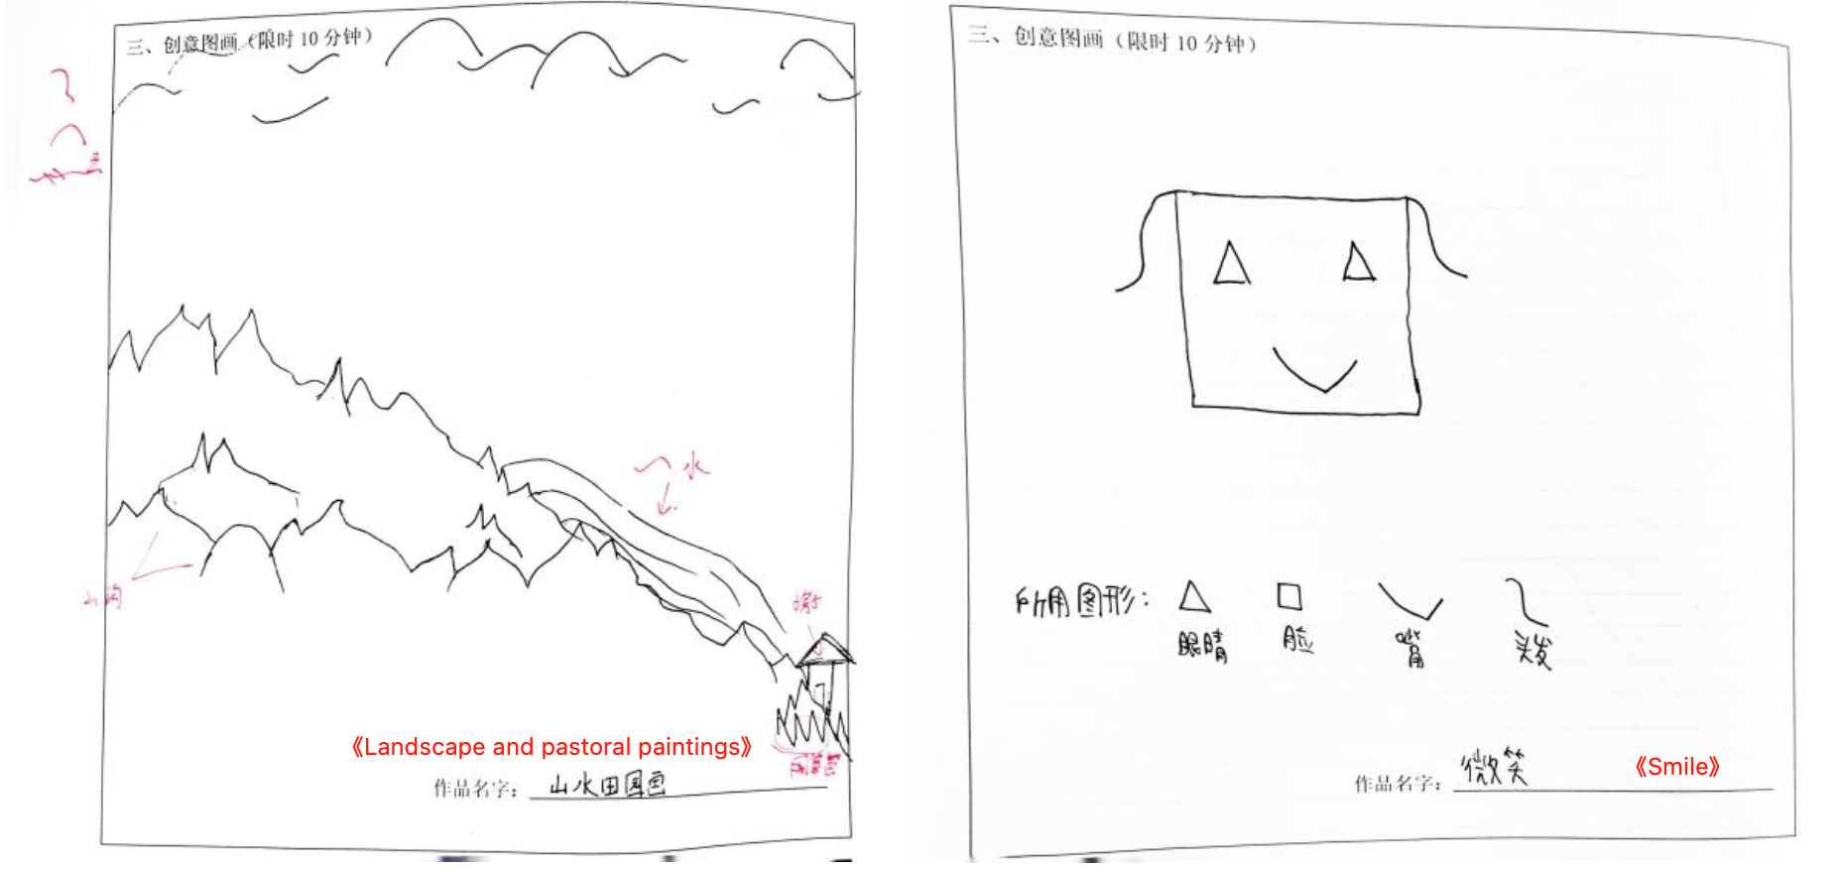
Score 3: Below Average Creativity — Some Original Ideas in the Use of Individual Shapes (Overall creativity: 60-; Use of shapes: 60+ or Overall creativity: 60+; Use of shapes: 60-)
– The participant integrated the required number of different shapes into one drawing, and the use of at least one shape is original.
– While the use of shapes within the drawing is relatively ordinary, the overall story or the title of the artwork is distinctive.
For example：
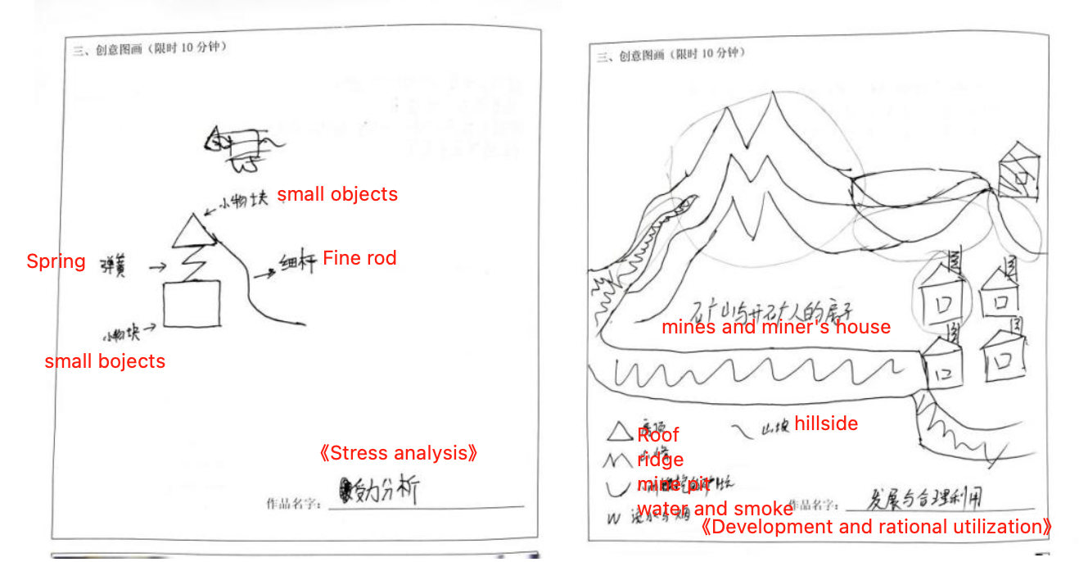
Score 4: Average Creativity — Original Ideas in the Use of Two or More Shapes (Overall creativity: 60+; Use of shapes: 60+)
– The participant’s drawing successfully integrates different shapes into a single composition, and demonstrates original ideas in the use of two or more shapes. However, the overall work lacks distinctiveness, the ideas are not fully focused, and the integration of shapes appears somewhat unnatural.
For example：
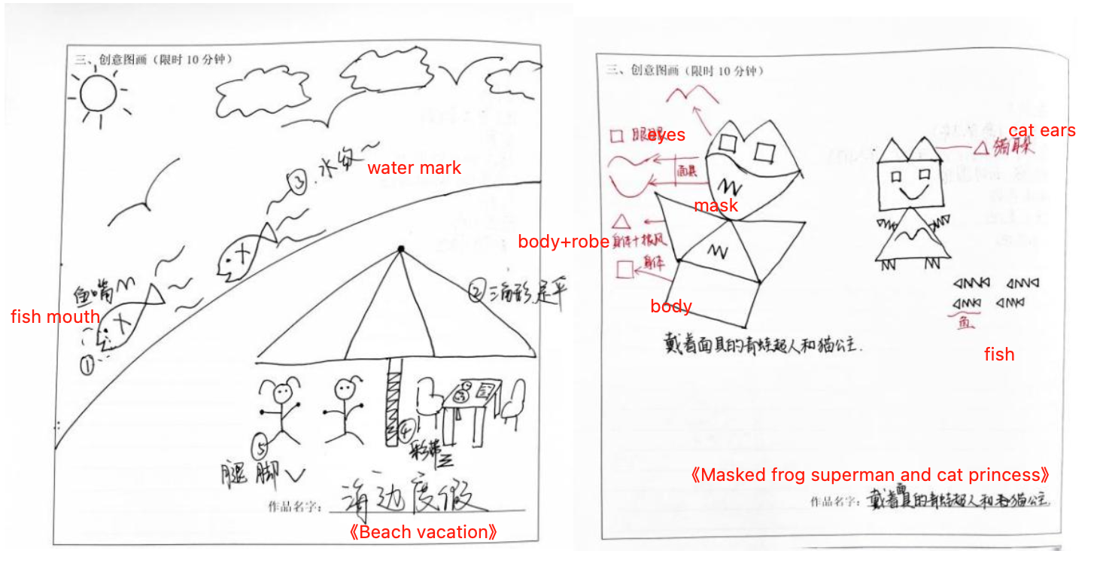
Score 5: Above Average Creativity — Integration of Multiple Shapes into a Fairly Unique Idea (Overall creativity: 80+; Use of shapes: 60+ or Overall creativity: 60+; Use of shapes: 80+)
– The participant is able to integrate different shapes effectively, and the overall drawing conveys a story with some originality, although the use of certain shapes may lack uniqueness.
– Each shape used by the participant demonstrates originality, but the drawing does not present a complete story or a clearly defined theme.
For example：
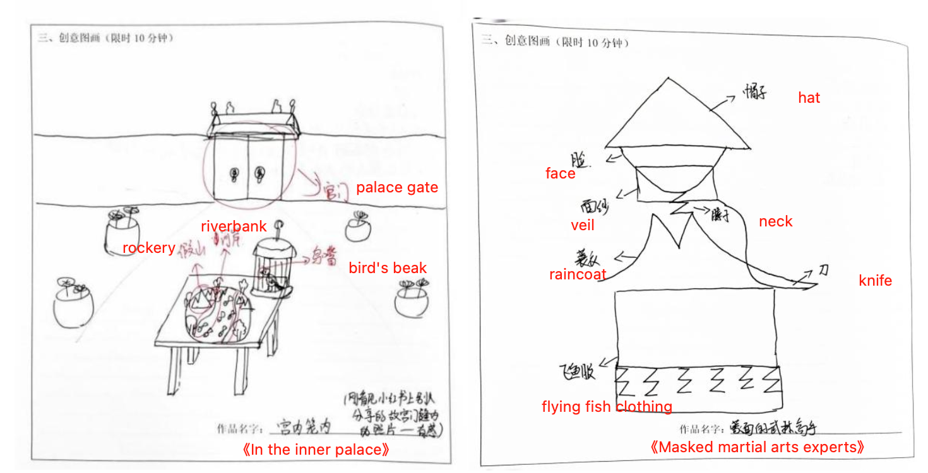
Score 6: High Creativity — Effective Integration of Different Shapes into a Clearly Original Idea (Overall creativity: 80+; Use of shapes: 80+)
– Each shape is well integrated with the others. The drawing focuses on a single idea, with a clear theme and a complete story, and demonstrates originality in the use of shapes.
For example：
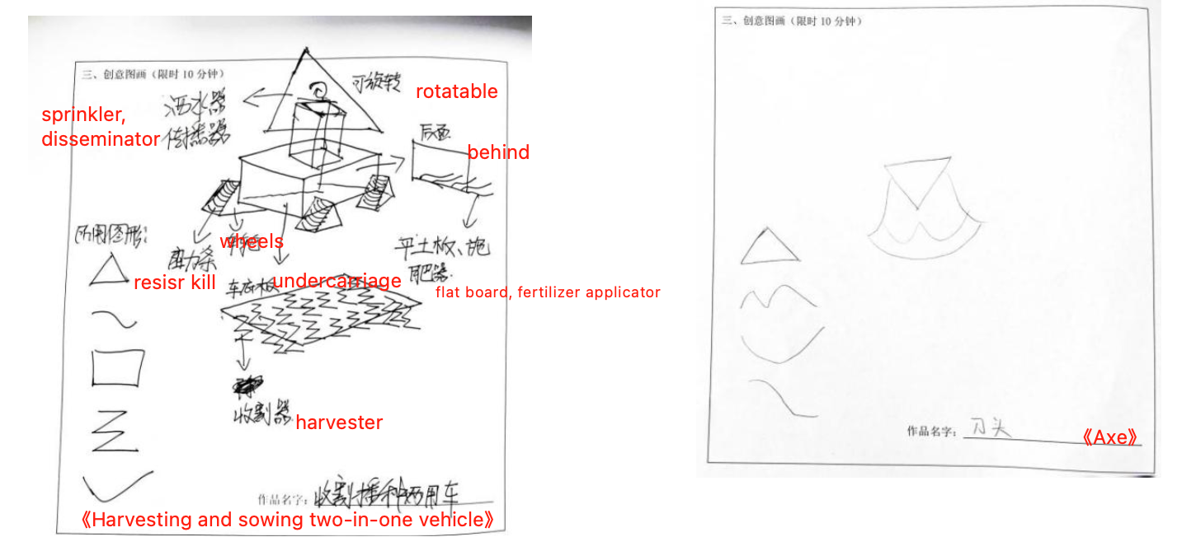
Score 7: Exceptional Creativity — Innovative Integration of All Shapes into a Highly Original Idea (Overall creativity: 95+; Use of shapes: 95+)
– The participant’s drawing perfectly integrates all the shapes, conveying a truly unique idea.
– Each shape may be used in multiple ways, demonstrating a high degree of originality.
For example：
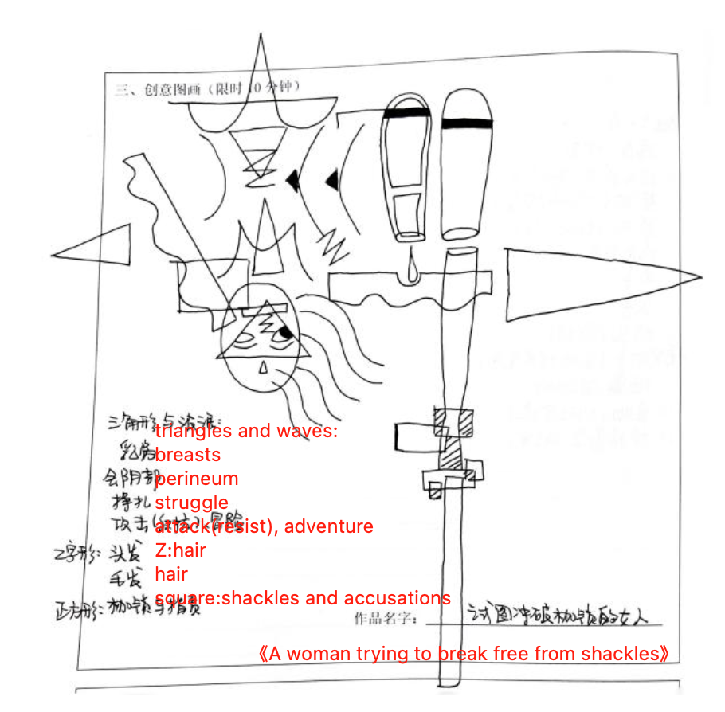

Part 3: Measurement and Evaluation of Creative Intelligence
Book Covers Example
Please imagine that the images below are the covers of children’s storybooks. What do you think these books would be about? Please imagine and describe the stories that might be written inside these books. Let your imagination run wild! There are no right or wrong answers. You have 5 minutes to respond.
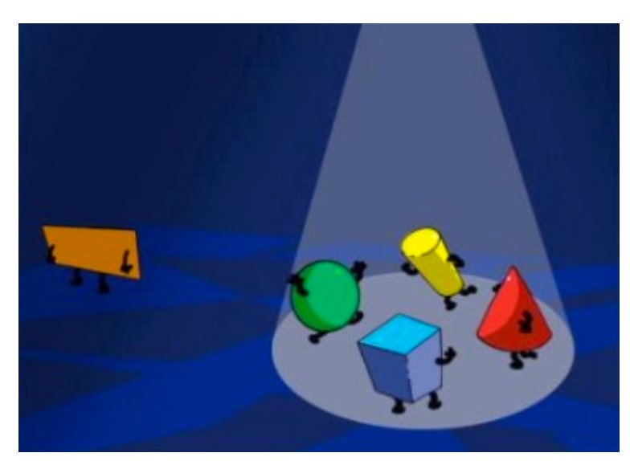
Book Covers Scoring Manual
Accuracy
- Score 0: Completely Incorrect. Deviates from the task (neither describing the images nor creating a story) or is nonsensical. (For example: the task requires writing a story, but the participant draws instead.)
- Score 1: Completely Correct. Provides a relatively clear response, addressing at least one element from the images.
Ability
- Score 0: Deviates from the task or is nonsensical, including drawings that are completely off-topic or meaningless.
- Score 1: Only one element from the images is described, without any imaginative extension. Does not constitute a concrete story.
- Score 2: Uses only the original elements from the images to create a very simple story. Includes an explanation or elaboration of the elements, based solely on the images provided.
- Score 3: The images’ content forms part of the story, including two or more explanatory or elaborative elements, but the structure is incomplete. Represents a relatively complete story; metaphors are basic, but the story shows creativity and some twists.
- Score 4: Includes two or more explanatory or elaborative elements, with a relatively complete structure, representing a full narrative story.

Number Talk Example
Please read the prompt and use your imagination to answer the question creatively. There are no right or wrong answers! You have 5 minutes to respond.
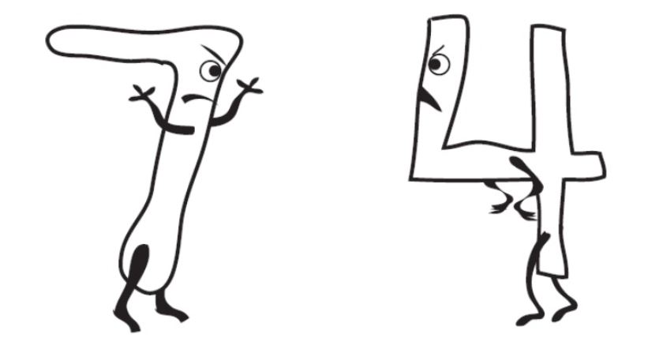
The numbers 7 and 4 really annoy each other.
—Why can’t 7 and 4 get along?
7 and 4 cannot get along because .
Number Talk Scoring Manual
Accuracy
- Score 0: Off task or utterly nonsensical, including responses which consist only of incorrect math.
- Score 1: Any expression related to the image.
Ability
- Score 0: Off-task or utterly nonsensical (does not answer the question logically; may include just simple math equations).
- Score 1: Only basic math OR a very vague description OR an incomplete explanation.
- Score 2: Either only a simple social description with neither math nor acknowledgment of numeric values OR acknowledgement of only numeric values with a slightly social overtone OR a simple acknowledgement of only the numbers’ shapes/names OR a logical response using unusual or more complex mathematical relationships.
- Score 3: Either an elaborate social description with neither math nor acknowledgement of numeric values OR a simple but logical incorporation of math or numeric values (or number shapes/names) within the social situation.
- Score 4: Elaborate response that incorporates both knowledge of numeric values (not just shape) and personification of the numbers: employs complex math operations and/or intricate social situations (including adding characters), OR makes a clever joke/pun to logically answer the questions.

