Supplementary Content

sMaterials. Individual Items Included in the Early Life Stress Questionnaire
sTable 1. Participant Demographic Characteristics for Individuals With and Without Adverse Childhood Experiences (ACEs)
sTable 2. Longitudinal Growth Mixture Modelling Results Using Different Growth Parameters and Class Solutions
sTable 3. Baseline Participant Demographic Characteristics for the Wellbeing Trajectory Classes
sTable 4. Interacting Associations between Age and ACE-Risk Membership
sFigure 1. Age and Somatic Symptom Interaction in the ACE-Subsample
sFigure 2. Age and Physical Quality of Life Interaction in the ACE-Subsample
sMaterials. Individual Items Included in the Early Life Stress Questionnaire
ELSQ items: (Yes/No) | Label:
Were you adopted? | Adoption
Did you undergo major surgery or repeated hospitalization? | Surgery/hospitalization
Did you experience a life-threatening illness or injury? | Health trauma
Did you experience sustained bullying or rejection by schoolmates? | Bullying/peer rejection
Were you physically abused? | Physical abuse
Were you sexually abused? | Sexual abuse
Were you emotionally abused? | Emotional abuse
Did you experience extreme poverty or neglect? | Neglect/poverty
Did you witness first-hand a natural disaster such as earthquake, flood or fire? | Disaster
Was your house destroyed by fire or other means? | Home destroyed
Did you witness warfare? | Warfare
Did your parents divorce or separate? | Parental divorce/separation
Were you separated for a long period from a parent, brother or sister? | Sibling separation
Was there sustained conflict within your family? | Sustained conflict
Did one of your parents, a brother or sister die? | Death in family
Did one of your parents, a brother or sister experience a life-threatening illness? | Family health trauma
Did you witness domestic violence within your family? | DV

Cohen, R. A., Hitsman, B. L., Paul, R. H., McCaffery, J., Stroud, L., Sweet, L., Gunstad, J., Niaura, R., MaCfarlane, A., Bryant, R. A., & Gordon, E. (2006). Early Life Stress and Adult Emotional Experience: An International Perspective. The International Journal of Psychiatry in Medicine, 36(1), 35-52. https://doi.org/10.2190/5r62-9pqy-0nel-tlpa

sTable 1. Participant Demographic Characteristics for Individuals With and Without Adverse Childhood Experiences (ACEs)

 | ACE-subsample | Non-ACE-subsample
Categorical variables | N (%) | N (%)
Baseline | n = 889 | n = 779
Sex
Female | 504 (57%) | 478 (61%)
Male | 385 (43%) | 301 (39%)
Relationship status
In a relationship | 543 (61%) | 502 (64%)
Divorced / separated | 70 (8%) | 44 (6%)
Single | 263 (30%) | 229 (29%)
Widowed | 4 (1%) | 3 (1%)
Highest education
Secondary school | 232 (26%) | 211 (27%)
Post-school diploma / qualification | 268 (30%) | 194 (25%)
Bachelor's degree | 222 (25%) | 231 (30%)
Postgraduate degree | 160 (18%) | 136 (17%)
Time 3 and 4 | n = 314 | n = 280
Sex
Female | 197 (63%) | 186 (66%)
Male | 117 (37%) | 94 (34%)
Relationship status
In a relationship | 245 (78%) | 233 (83%)
Divorced / separated | 24 (8%) | 20 (7%)
Single | 41 (13%) | 24 (9%)
Widowed | 4 (1%) | 3 (1%)
Highest education
Secondary school | 32 (10%) | 30 (11%)
Post-school diploma / qualification | 92 (30%) | 85 (32%)
Bachelor's degree | 121 (40%) | 100 (37%)
Postgraduate degree | 57 (19%) | 54 (20%)
Medical conditions
Mental health condition | 73 (23%) | 44 (16%)
Cancer | 12 (4%) | 13 (5%)
Endocrine | 83 (26%) | 70 (25%)
Nervous condition | 19 (6%) | 8 (3%)
Episodic | 80 (25%) | 52 (19%)
Cardiac | 108 (34%) | 69 (25%)
Respiratory | 130 (41%) | 116 (41%)
Gastrointestinal | 41 (13%) | 21 (8%)
Skin | 38 (12%) | 21 (8%)
Musculoskeletal | 70 (22%) | 50 (18%)
Genitourinary | 20 (6%) | 18 (6%)
Allergy | 104 (33%) | 64 (23%)
Continuous variables | Mean (SD) | Mean (SD)
Age at Time 1 | 39.7 (12.7) | 39.6 (12.8)
Age at Time 3 | 52.1 (12.3) | 51.5 (12.5)
Wellbeing (COMPAS-W) at Time 1 | 98.4 (9.7) | 102 (10.9)
Wellbeing (COMPAS-W) at Time 2 | 101 (10.4) | 99.4 (11.4)
Wellbeing (COMPAS-W) at Time 3 | 102 (10.3) | 99.2 (11.4)
Wellbeing (COMPAS-W) at Time 4 | 102 (10.3) | 98.4 (11.3)

- Age, sex, relationship status and education data presented from baseline measurement. Wellbeing (measured with COMPAS-W Scale); data from all four timepoints. Physical and mental health outcomes coded from ICD-10 classifications; data collected at Time 3 and 4.

sTable 2. Longitudinal Growth Mixture Modelling Results Using Different Growth Parameters and Class Solutions

Form of growth | Class number | AIC | saBIC | aLMR-LRT (p) | % in smallest class
ACE-subsample
Linear | 1 | 14943.39 | 14972.13 | - | -
Linear | 2 | 14881.33 | 14902.32 | <.001 | 27%
Linear | 3 | 14878.77 | 14911.06 | 0.03 | 1%
Linear | 4 | 14880.52 | 14924.10 | 0.12 | 3%
Latent Basis | 1 | 14942.38 | 14955.14 | - | -
Latent Basis | 2 | 14875.35 | 14902.79 | <.001 | 34%
Latent Basis | 3 | 14864.61 | 14906.59 | 0.04 | 3%
Latent Basis | 4 | 14877.61 | 14934.11 | 0.09 | 3%
Quadratic | 1 | 14933.28 | 14981.18 | - | -
Quadratic | 2 | 14871.89 | 14905.86 | <.001 | 24%
Quadratic | 3 | 14879.82 | 14931.48 | 0.26 | 3%
Quadratic | 4 - *Convergence issues
Non-ACE-subsample
Linear | 1 | 13142.76 | 13151.66 | - | -
Linear | 2 | 13085.50 | 13104.77 | <.001 | 15%
Linear | 3 | 13078.07 | 13107.72 | <.001 | 1%
Linear | 4 | 13089.01 | 13129.04 | 0.89 | 1%
Latent Basis | 1 | 13146.32 | 13158.18 | - | -
Latent Basis | 2 | 13079.18 | 13104.39 | <.001 | 7%
Latent Basis | 3 | 13062.27 | 13100.82 | <.001 | 1%
Latent Basis | 4 – *Convergence issues
Quadratic | 1 | 13145.88 | 13160.70 | - | -
Quadratic | 2 | 13085.50 | 13104.77 | <.001 | 9%
Quadratic | 3 | 13084.76 | 13132.20 | 0.006 | 3%
Quadratic | 4 – *Convergence issues

- AIC: Akaike Information Criterion; saBIC: sample size adjusted Bayesian Information Criterion; aLMR-LRT: adjust Lo-Mendell-Rubin likelihood ratio test comparing to model of same specifications, with one less class.

sTable 3. Baseline Participant Demographic Characteristics for the Wellbeing Trajectory Classes
ACE-subsample
Categorical outcomes | ACE-resilient [N (%)] | ACE-risk [N (%)] | Test statistic (X²) | p value
 | n = 585 | n = 304
Sex |  |  | 1.59 | 0.21
Female | 341 (58%) | 163 (54%)
Male | 244 (42%) | 141 (46%)
Highest education |  |  | 24.73 | <.001
High school | 134 (23%) | 98 (32%)
Post-secondary diploma / certificate | 167 (29%) | 101 (33%)
Bachelors degree | 157 (27%) | 65 (21%)
Postgraduate degree | 122 (21%) | 38 (13%)
Other | 2 (<1%) | 2 (1%)
Continuous outcomes | ACE-resilient [% (sd)] | ACE-risk [% (sd)] | Test statistic (t) | p value
Age | 40.6 (12.6) | 37.9 (12.8) | 2.97 | 0.003
Non-ACE-subsample
Categorical outcomes | non-ACE-well [N (%)] | non-ACE-vulnerable [N (%)] | Test statistic (X²) | p value
 | n = 660 | n = 119
Sex |  |  | 4.56 | 0.032
Female | 394 (60%) | 84 (71%)
Male | 266 (40%) | 35 (29%)
Highest education |  |  | 6.29 | 0.18
High school | 172 (26%) | 39 (33%)
Post-secondary diploma / certificate | 160 (24%) | 34 (29%)
Bachelors degree | 201 (31%) | 30 (25%)
Postgraduate degree | 122 (19%) | 14 (12%)
Other | 3 (<1%) | 1 (1%)
Continuous outcomes | non-ACE-well [% (sd)] | non-ACE-vulnerable [% (sd)] | Test statistic (t) | p value
Age | 40.1 (12.8) | 36.7 (12.4) | 2.72 | 0.007
sTable 4. Interacting Associations between Age and ACE-Risk Membership

Outcome | Beta (ACE-resilient vs ACE-risk) | p value | 95% confidence interval
SPHERE x Age | 0.16 | 0.008 | (0.05, 0.29)
Physical QoL (WHOQoL) x Age | -0.04 | 0.021 | (-0.07, -0.01)

- SPHERE, Somatic and Psychological Health Report; Wijeratne, C., Hickie, I., & Davenport, T. (2006). Is there an independent somatic symptom dimension in older people? Journal of Psychosomatic Research, 61(2), 197-204. https://doi.org/https://doi.org/10.1016/j.jpsychores.2006.01.012
- World Health Organisation Quality of Life Questionnaire (WHOQOL); Skevington, S. M., Lotfy, M., & O'Connell, K. A. (2004). The World Health Organization's WHOQOL-BREF Quality of Life Assessment: Psychometric Properties and Results of the International Field Trial A Report from the WHOQOL Group. Quality of Life Research, 13(2), 299-310. https://doi.org/10.1023/b:qure.0000018486.91360.00
- Analysis adjusted for sex, zygosity, and twin relatedness, and other WHOQOL-Bref subscales.

sFigure 1. Age and Somatic Symptom Interaction in the ACE-Subsample

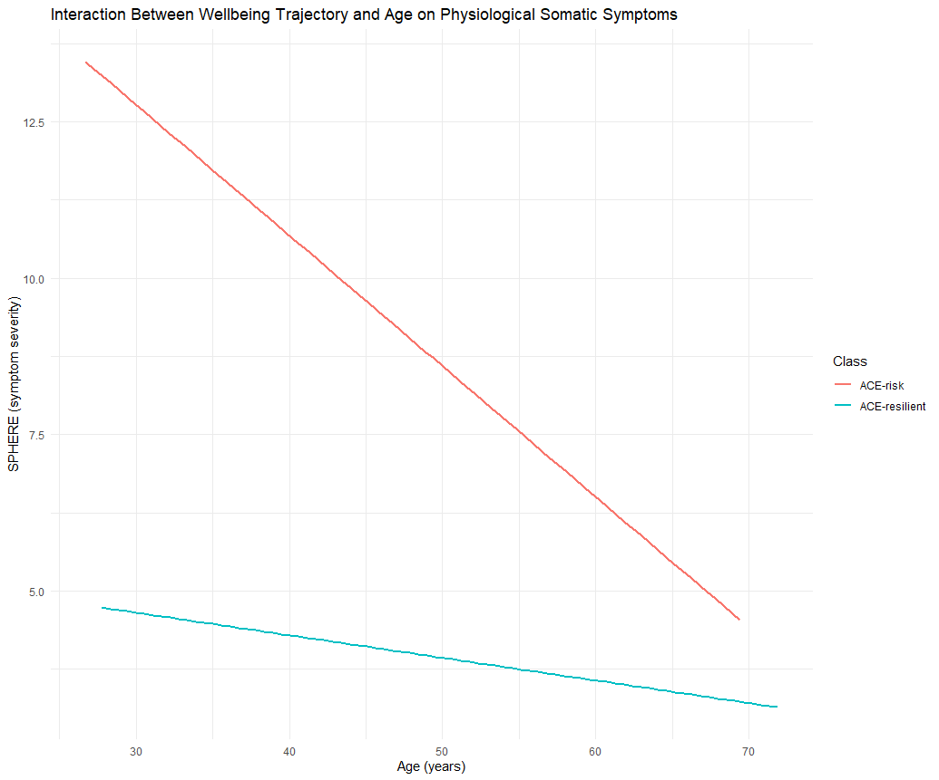
  - SPHERE, Somatic and Psychological Health Report.
  - Analysis adjusted for sex, zygosity, and twin relatedness

sFigure 2. Age and Physical Health Quality of Life Interaction in the ACE-Subsample
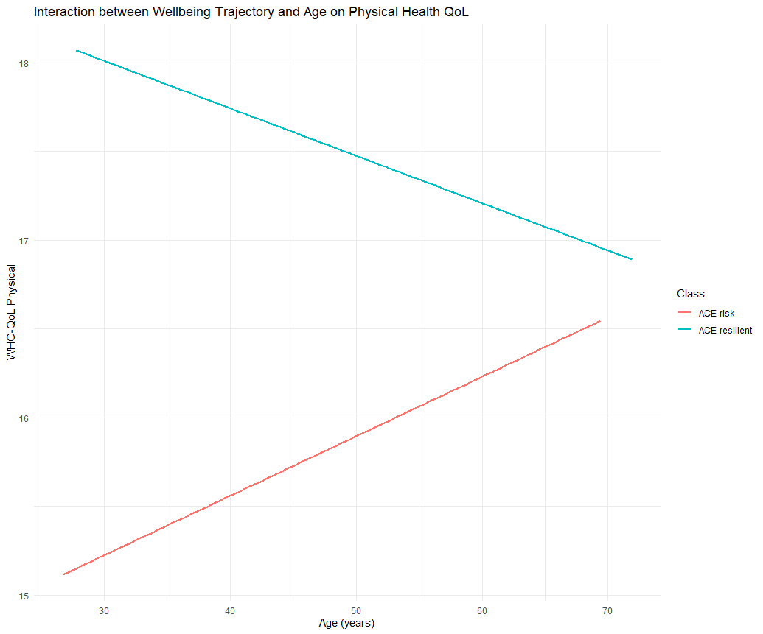
  - WHOQOL-Physical, physical health subscale of the WHOQOL
  - Analysis adjusted for sex, zygosity, twin relatedness, and other WHOQOL subscales.

