Supplemental Materials

The following tables and figures provide a detailed overview of all relevant descriptives and results reported in the main text.

Table S1
Distribution of Nationalities Based on Country of Birth
 | Children’s country of birth
 | Netherlands | England | China | United States | Romania | Guatemala | Poland
n | 320 | 3 | 3 | 2 | 1 | 1 | 1
% | 96.4 | 0.9 | 0.9 | 0.6 | 0.3 | 0.3 | 0.3
Note. N = 332 children (also includes children who did not participate in the group task). One value was missing.

Table S2
Distribution of Children Across Age Groups
 | Elemetary school |  |  |  |  |  |  | Secondary school
 | Children’s age |  |  |  |  |  |  | Children’s age
 | 7 | 8 | 9 | 10 | 11 | 12 |  | 12 | 13 | 14
n | 1 | 41 | 51 | 35 | 44 | 5 |  | 37 | 72 | 35
% | 0.6 | 23.2 | 28.8 | 19.8 | 24.9 | 2.8 |  | 25.7 | 50.0 | 24.3
Note. N = 321 children. The proportion of children per age group (%) is provided for elementary and secondary school separately.

Table S3
Sex Composition of the Group
 | Follower sex
Leader sex | Both boys | One boy and one girl | Both girls
Boy | 11  (10.2%) | 27  (25.2%) | 13  (12.1%)
Girl | 10  (9.3%) | 27  (25.2%) | 19  (17.7%)
Note. N = 107 groups.

Table S4
Means, Standard Deviations, and Correlations of Study Variables
Variables | M | SD | Range | 1 | 2 | 3 | 4 | 5 | 6 | 7 | 8 | 9 | 10 | 11 | 12 | 13 | 14
1. Leader narcissismª | 1.31 | 0.55 | 0.00-2.80 | -
2. Follower self-esteem^{b} | 2.22 | 0.50 | 0.40-3.00 | .05 | -
Follower perceptions of leader
3. Perceived leader effectiveness^{c} | 2.03 | 0.73 | 0.00-3.00 | .06 | -.09 | -
4. Future leader preference^{c} | 2.19 | 0.83 | 1.00-3.00 | .03 | -.16* | .42** | -
5. Follower perceived leader inclusion^{c} | 2.62 | 0.58 | 0.00-3.00 | .11 | .22** | .27** | .29** | -
6. Follower perceived leader verbal bullying^{c} | 0.13 | 0.46 | 0.00-3.00 | -.10 | -.12 | -.27** | -.23** | -.58** | -
Follower well-being
7. Follower state self-esteem (pre-task)^{b} | 2.31 | 0.60 | 0.00-3.00 | -.01 | .58** | .03 | -.14* | .09 | -.07 | -
8. Follower state self-esteem (post-task)^{b} | 2.37 | 0.56 | 0.67-3.00 | .09 | .42** | .12 | -.09 | .09 | -.12 | .65** | -
9. Follower positive affect (pre-task)^{b} | 2.43 | 0.59 | 0.00-3.00 | .11 | .41** | .10 | .04 | .05 | -.08 | .71** | .47** | -
10. Follower positive affect (post-task)^{b} | 2.42 | 0.59 | 0.00-3.00 | .12 | .33** | .23** | .06 | .18** | -.26** | .53** | .65** | .58** | -
11. Follower perceived group cohesion^{b} | 2.60 | 0.55 | 0.00-3.00 | .02 | .17* | .38** | .17* | .44** | -.55** | .21** | .42** | .24** | .52** | -
Follower and leader observed behavior
12. Follower exclusion of others^{d} | 0.19 | 0.60 | 0.00-3.00 | -.04 | .09 | -.04 | -.11 | -.30** | .26** | .14* | .10 | .12 | .09 | -.08 | -
13. Leader aggression^{d} | 0.07 | 0.20 | 0.00-1.50 | -.14* | -.04 | -.16* | -.18* | -.30** | .49** | .06 | .12 | -.06 | -.02 | -.23** | .57** | -
14. Leader exclusion of followers^{d} | 0.24 | 0.77 | 0.00-4.00 | -.13 | -.03 | -.16* | -.19** | -.38** | .51** | .03 | .09 | -.01 | -.07 | -.28** | .53** | .75**
15. Leader arrogance^{d} | 0.05 | 0.15 | 0.00-1.10 | -.08 | .01 | -.16* | -.12 | -.24** | .47** | .01 | .04 | -.03 | .00 | -.21** | .41** | .52** | .46**
Note. Variables 1, 12, 14-15 N = 106-107, variables 2-11, 13 N = 210-214.
ª Self-report by leaders; ^{b} Self-report by followers; ^{c} Informant report of leaders by followers; ^{d} Coded by independent observers.
*p < .05, **p < .01.
Table S5
Interaction Between Leader Narcissism and Follower Self-Esteem on Follower Perceptions of Leader
 | F(4, 812) | p | Conditional R² | Marginal R²
Leader sexª | 2.41 | .048
Follower sexª | 3.05 | .017
Group age | 10.48 | <.001
Leader narcissism | 1.39 | .234
Follower self-esteem | 3.81 | .004
Leader narcissism x Follower self-esteem | 2.46 | .044 | .47 | .19
 |  |  | Parameter estimates for simple slope analysis [95%CI]
Simple slope analysis |  |  | B_{perceived leader effectiveness} | B_{future leader preference} | B_{perceived leader inclusion} | Bperceived leader verbal bullying
Lower self-esteem followers (–1SD) | 3.69 | .006 | 0.41**  [0.119, 0.699] | 0.39*  [0.050, 0.733] | 0.38**  [0.165, 0.589] | -0.24*  [-0.437, -0.033]
Higher self-esteem followers (+1SD) | 0.40 | .810 | -0.16  [-0.452, 0.139] | -0.20  [-0.548, 0.147] | -0.07  [-0.280, 0.148] | 0.07  [-0.133, 0.275]
Note. ª 0 = boy, 1 = girl. The total variance explained by the model is given by the conditional R², and the total variance explained by the fixed effects is given by the marginal R² (Nakagawa & Schielzeth, 2013). Follow-up simple slope analysis is reported for the effect of leader narcissism for lower self-esteem followers (–1SD below mean) and for higher self-esteem followers (+1SD above mean). Measures of perceptions of leader include: perceived leader effectiveness; future leader preference; perceived leader inclusion; perceived leader verbal bullying.
*p < .05, **p < .01.

Table S6
Interaction Between Leader Narcissism and Follower Self-Esteem on Follower Well-Being
 | F(3, 609) | p | Conditional R² | Marginal R²
Leader sexª | 1.16 | .323
Follower sexª | 0.50 | .683
Group age | 4.22 | .006
Leader narcissism | 0.91 | .437
Follower self-esteem | 0.69 | .561
Leader narcissism x Follower self-esteem | 3.48 | .016 | .39 | .37
 |  |  | Parameter estimates for simple slope analysis [95%CI]
Simple slope analysis |  |  | B_{follower state self-esteem} | B_{follower state positive affect} | Bfollower perceived group cohesion
Lower self-esteem followers (–1SD) | 3.50 | .015 | 0.17*  [0.011, 0.335] | 0.26**  [0.090, 0.436] | 0.23†  [-0.022, 0.479]
Higher self-esteem followers (+1SD) | 1.35 | .256 | -0.01  [-0.172, 0.157] | -0.14  [-0.313, 0.037] | -0.18  [-0.431, 0.075]
Note. ª 0 = boy, 1 = girl. The total variance explained by the model is given by the conditional R², and the total variance explained by the fixed effects is given by the marginal R² (Nakagawa & Schielzeth, 2013). Follow-up simple slope analysis is reported for the effect of leader narcissism for lower self-esteem followers (–1SD below mean) and for higher self-esteem followers (+1SD above mean). Measures of follower well-being include: follower state self-esteem; follower state positive affect; follower perceived group cohesion.
†p < .10, *p < .05, **p < .01.

Table S7
Interaction Between Leader Narcissism and Follower Self-Esteem on Follower and Leader Observed Behavior
 | F(4, 96) | p | η_{p}²
Follower and Leader Behavior
Leader sexª | 0.84 | .501 | .03
Follower sex^{b} | 0.92 | .500 | .04
Group age | 2.82 | .029 | .11
Leader narcissism | 0.72 | .580 | .03
Follower self-esteem | 1.07 | .378 | .04
Leader narcissism x Follower self-esteem | 2.08 | .089 | .08
 | F(3, 97) | p | η_{p}²
Follower and Leader Antagonistic Behavior
Leader sexª | 0.96 | .414 | .03
Follower sex^{b} | 0.65 | .689 | .02
Group age | 3.68 | .015 | .10
Leader narcissism | 0.97 | .411 | .03
Follower self-esteem | 1.41 | .245 | .04
Leader narcissism x Follower self-esteem | 2.78 | .045 | .08
 |  |  |  | Parameter estimates for simple slope analysis [95%CI]
Simple slope analysis |  |  |  | B_{follower exclusion of others} | B_{leader aggression} | B_{leader exclusion of followers}
Lower self-esteem followers (–1SD) | 3.51 | .018 | .10 | -0.35*  [-0.617, -0.081] | -0.16**  [-0.268, -0.048] | -0.63**  [-1.040, -0.222]
Higher self-esteem followers (+1SD) | 0.61 | .612 | .02 | 0.17  [-0.099, 0.441] | 0.05  [-0.066, 0.155] | 0.22  [-0.190, 0.634]
Note. ª 0 = boy, 1 = girl. ^{b} 0 = both boys, 1 = one boy and one girl, 2 = both girls. Follow-up simple slope analysis is reported for the effect of leader narcissism for lower self-esteem followers (–1SD below mean) and for higher self-esteem followers (+1SD above mean). Measures of follower and leader observed (antagonistic) behavior include: follower exclusion of others; leader aggression; leader exclusion of followers; leader arrogance.
*p < .05, **p < .01.
Table S8
Checking for 2-Way, 3-Way and 4-Way Interaction Effects with Sex
Outcome Variables | Leader sex × Follower sex |  |  |  | Sex composition of group × Leader narcissism ×  Follower self-esteem |  |  |  | Leader sex × Follower sex × Leader narcissism ×  Follower self-esteem
 | F | (df_{n}, df_{d}) | p |  | F | (df_{n}, df_{d}) | p |  | F | (df_{n}, df_{d}) | p
Follower perceptions of leader | 0.35 | (4, 808) | .842 |  | 0.68 | (12, 772) | .772 |  | 1.83 | (4, 776) | .121
Follower well-being | 0.88 | (3, 606) | .452 |  | 1.40 | (9, 579) | .183 |  | 0.58 | (3, 582) | .626
Follower and leader behavior | 0.58 | (8, 190) | .797 |  | 0.79 | (12, 267) | .659 |  | 0.76 | (8, 160) | .640
Follower and leader antagonistic behavior | 0.71 | (6, 192) | .640 |  | 1.00 | (9, 270) | .439 |  | 0.91 | (6, 162) | .491
Note. Leader and follower sex: 0 = boy, 1 = girl. For observed behavior follower sex: 0 = both boys, 1 = one boy and one girl, 2 = both girls. Sex composition of group: 0 = all boys, 1 = majority boys, 2 = majority girls, 3 = all girls.

Table S9
Summary of Three-way Interaction Effects Between Leader Narcissism, Follower Self-Esteem and Group Age
Outcome Variables | F | (df_{n}, df_{d}) | p | Conditional R² | Marginal R² | η_{p}²
Follower perceptions of leader | 2.91  4.65 | (4, 800)  (4, 800) | .021  .001 | .48  .48 | .14  .20
Leader narcissism x follower self-esteem interaction within group age
Elementary school  Younger (–1SD) | 3.50  4.47 | (4, 800)  (4, 800) | .008  .001
Secondary school  Older (+1SD) | 1.71  2.57 | (4, 800)  (4, 800) | .145  .037
Follower well-being | 2.32  2.64 | (3, 600)  (3, 600) | .074  .049 | .39  .39 | .38  .39
Leader narcissism x follower self-esteem interaction within group age
Elementary school  Younger (–1SD) | 5.35  6.20 | (3, 600)  (3, 600) | .001  <.001
Secondary school  Older (+1SD) | 0.23  0.21 | (3, 600)  (3, 600) | .875  .893
Follower and leader antagonistic behavior | 2.27  2.23 | (3, 94)  (3, 94) | .085  .090 |  |  | .07  .07
Leader narcissism x follower self-esteem interaction within group age
Elementary school  Younger (–1SD) | 4.77  4.67 | (3, 94)  (3, 94) | .004  .004 |  |  | .13  .13
Secondary school  Older (+1SD) | 0.03  0.21 | (3, 94)  (3, 94) | .992  .893 |  |  | .00  .01
Follower and leader behavior | 1.74  1.66 | (4, 93)  (4, 93) | .148  .166 |  |  | .07  .07
Note. The moderating effect of group age was tested twice, once with group age as a categorical variable (0 = elementary school, 1 = secondary school), reported above as the first row in each analysis, and once with group age as a continuous variable, reported above as the second row in each analysis. The total variance explained by the multilevel models is given by the conditional R², and the total variance explained by the fixed effects is given by the marginal R² (Nakagawa & Schielzeth, 2013). Where the three-way interaction is significant (p < .05) or marginally significant (p < .10), further follow-up results are reported below for the two-way interaction between leader narcissism and follower self-esteem for each group age category (i.e., elementary school and secondary school separately) and for younger (–1SD below mean) and for older group age (+1SD above mean).

Figure S1
Interaction between Leader Narcissism and Follower Self-Esteem on Follower Perceptions of the Leader
(a) (b)
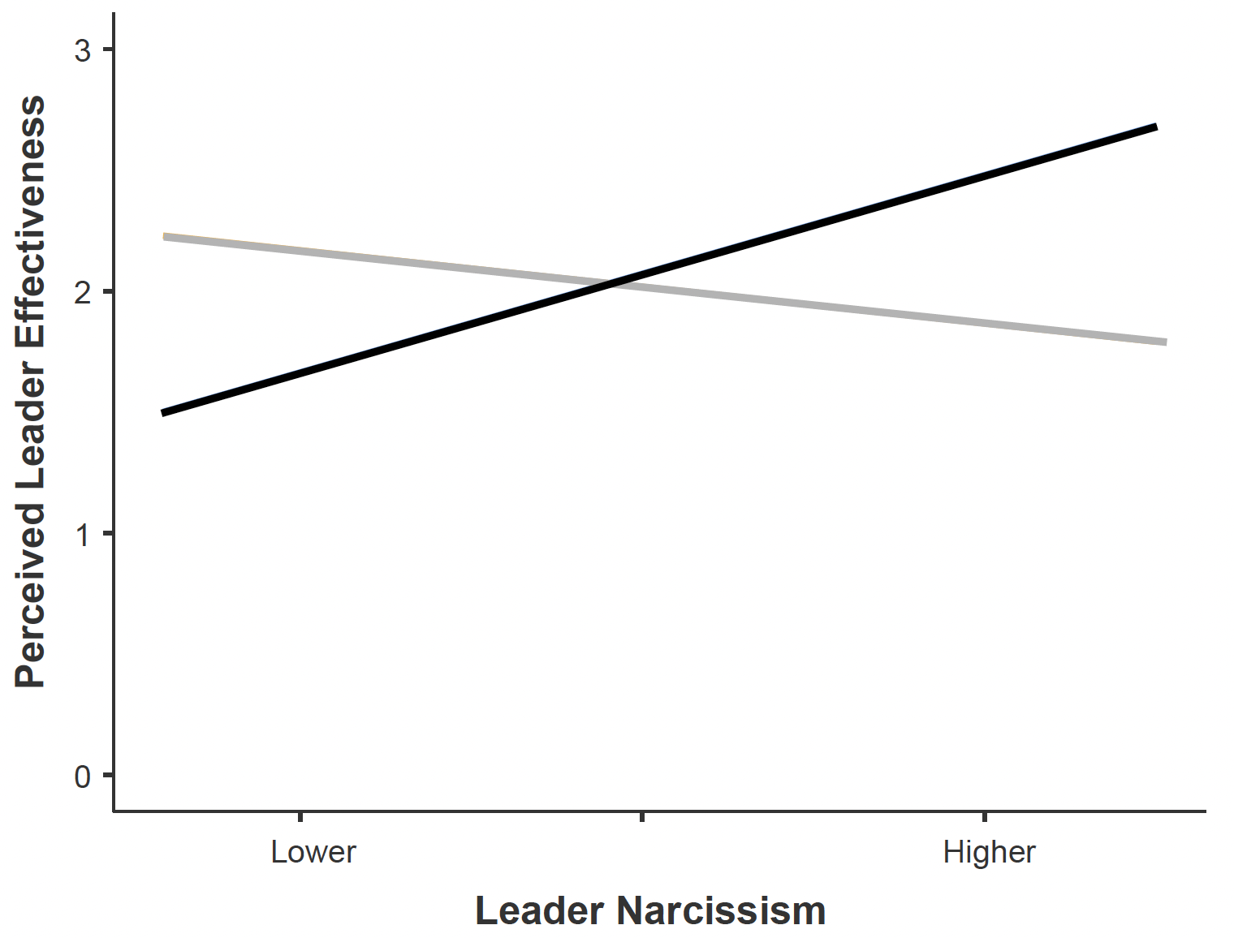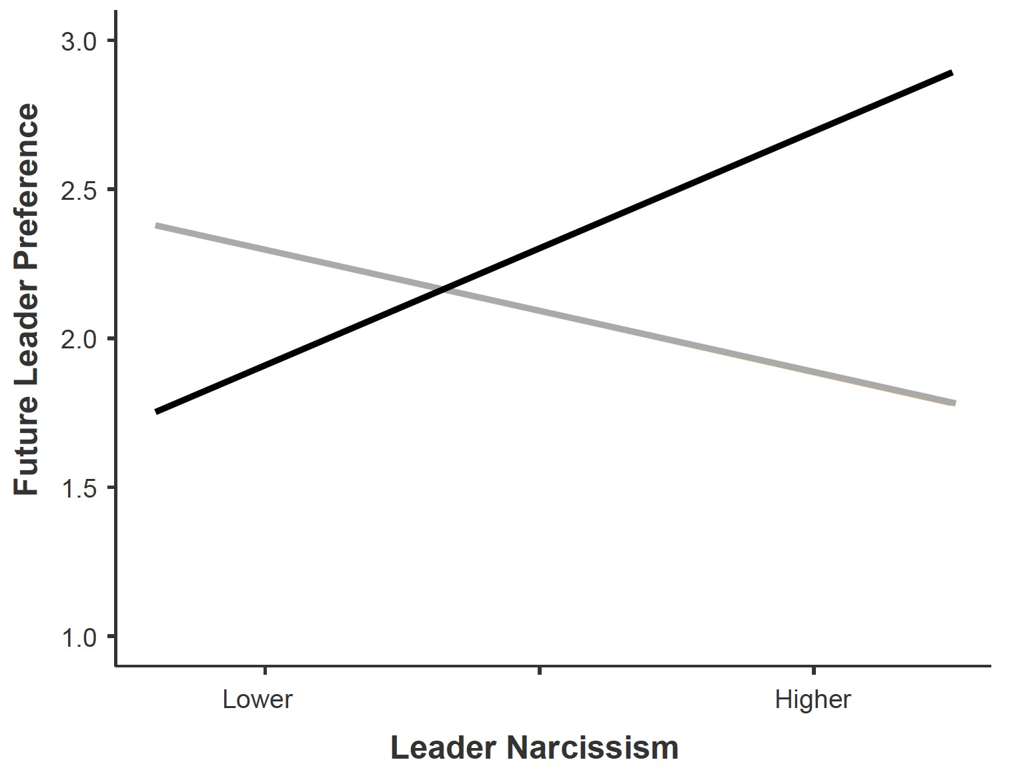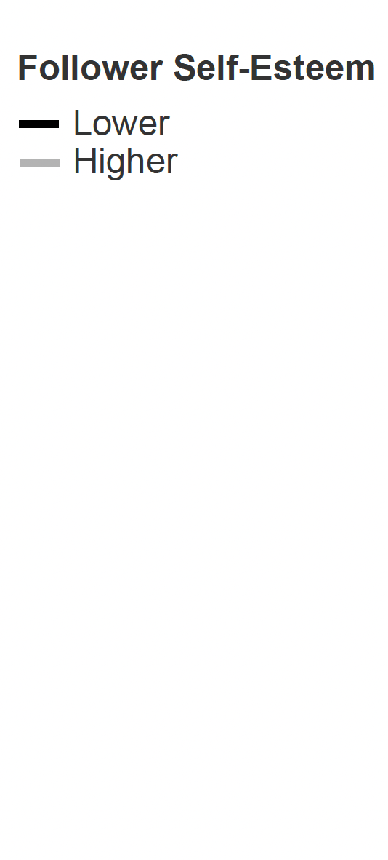
(c) (d)
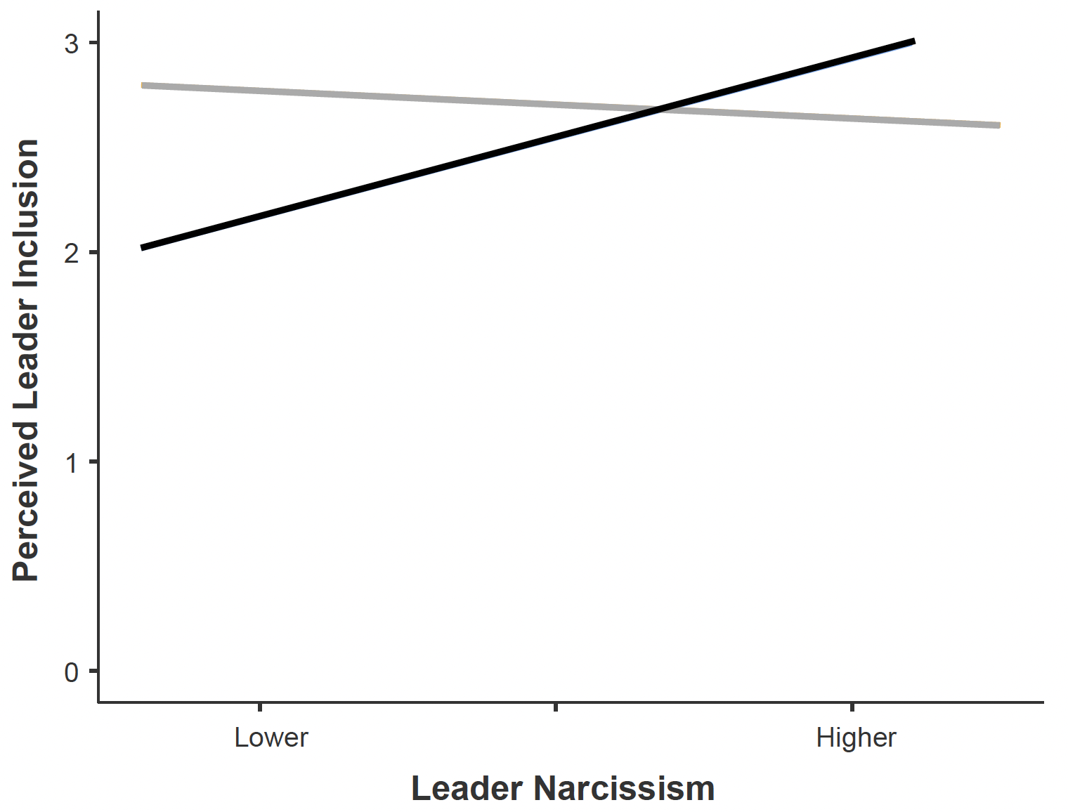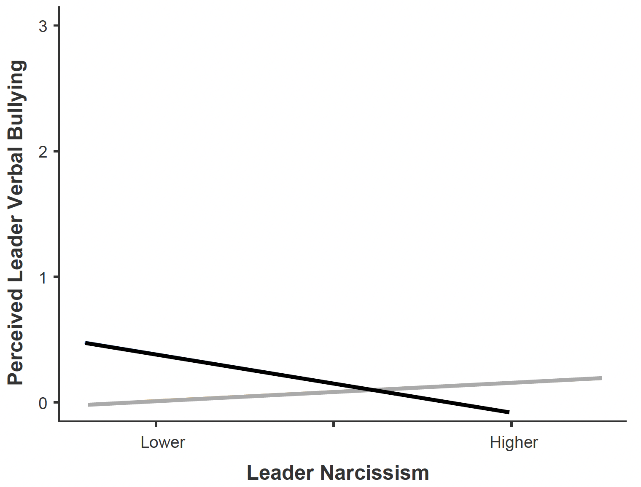
Note. Outcome variables include (a) Perceived leader effectiveness; (b) Future leader preference; (c) Perceived leader inclusion; (d) Perceived leader verbal bullying. The future leader preference y-axis runs from 1 (no followers would prefer the leader) to 3 (both followers would prefer the leader). The other y-axes run from 0 (not at all true) to 3 (completely true).
Figure S2
Interaction between Leader Narcissism and Follower Self-Esteem on Follower Well-Being
(a) (b)
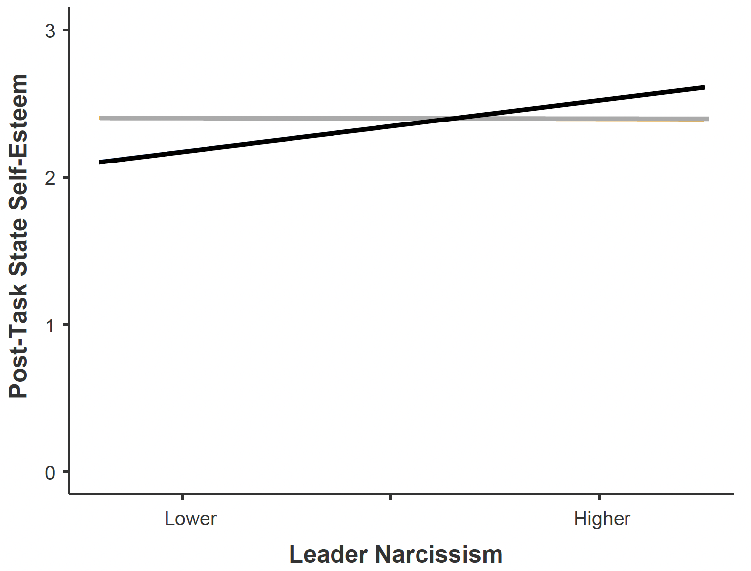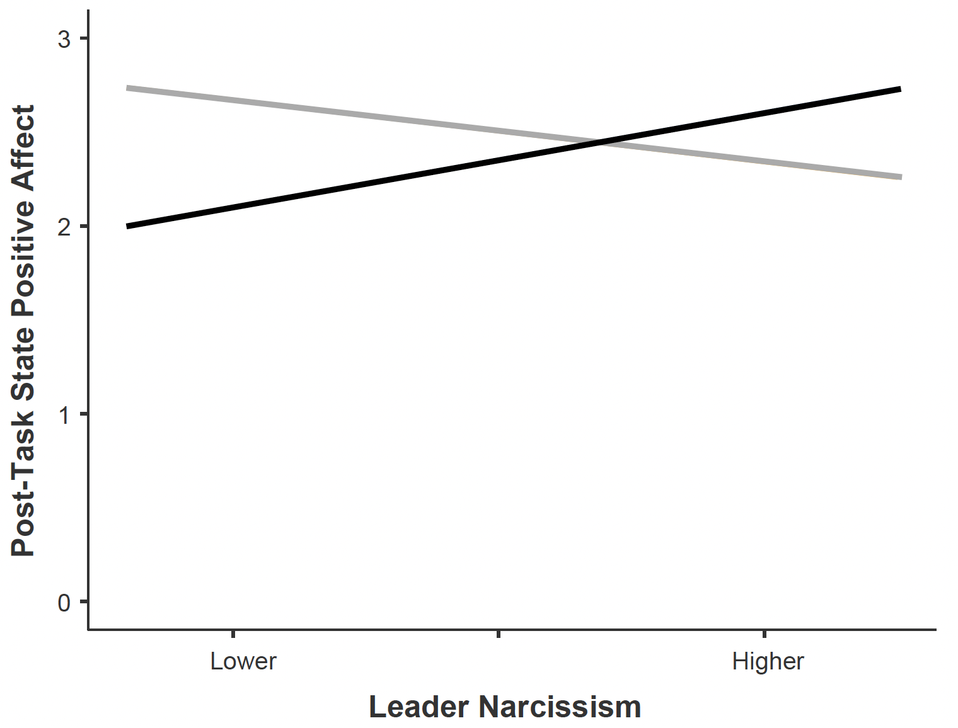
(c)
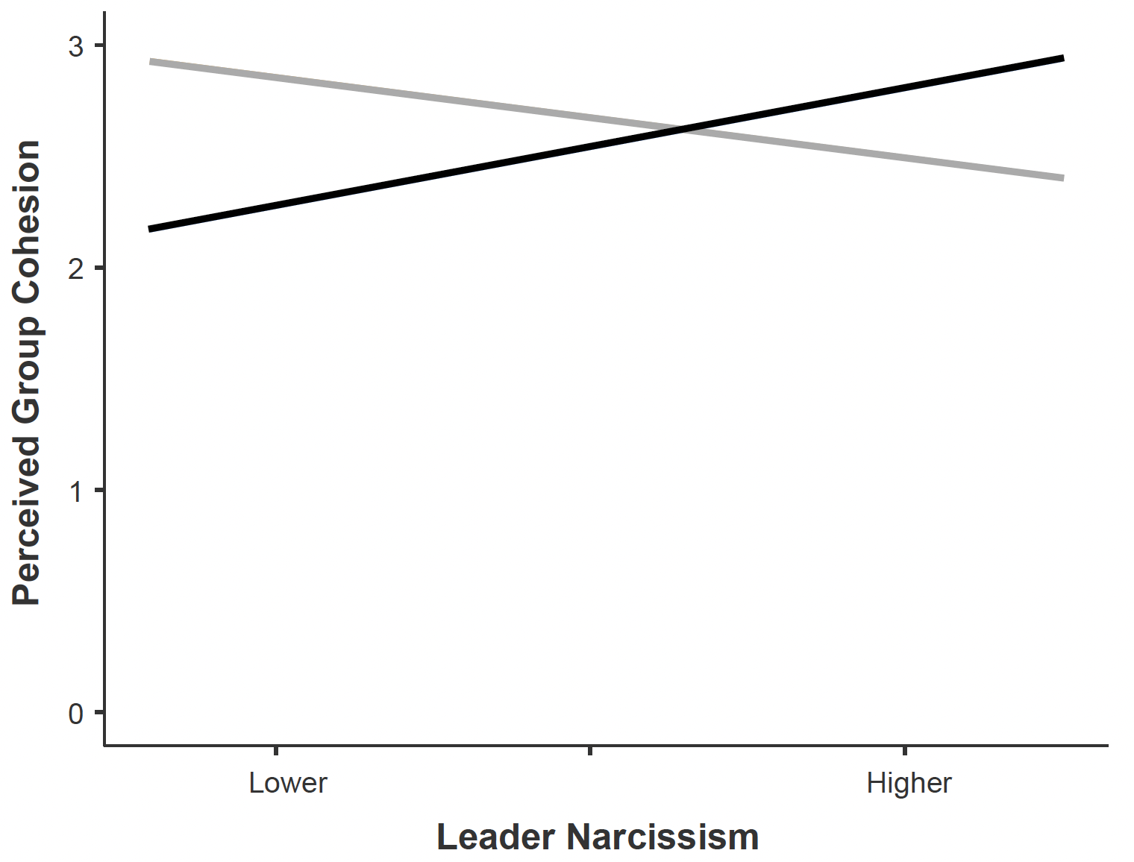
Note. Outcome variables include (a) Follower post-task state self-esteem; (b) Follower post-task state positive affect; (c) Follower perceived group cohesion. All y-axes run from 0 (not at all true) to 3 (completely true).
Figure S3
Interaction between Leader Narcissism and Follower Self-Esteem on Follower and Leader Observed Behavior
- (b)
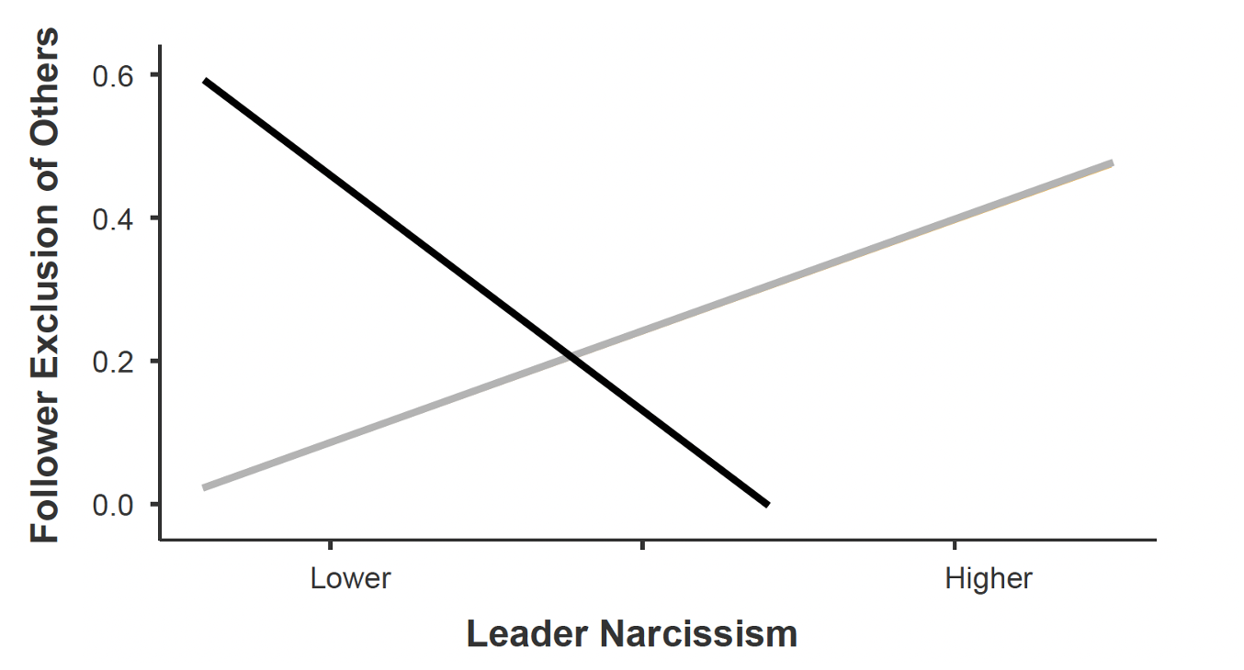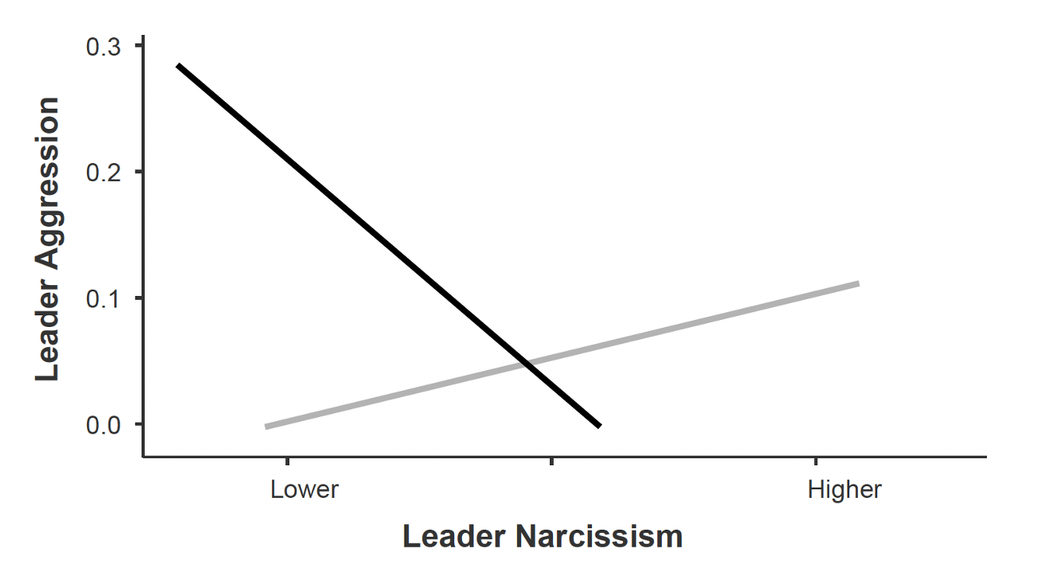
(c) (d)
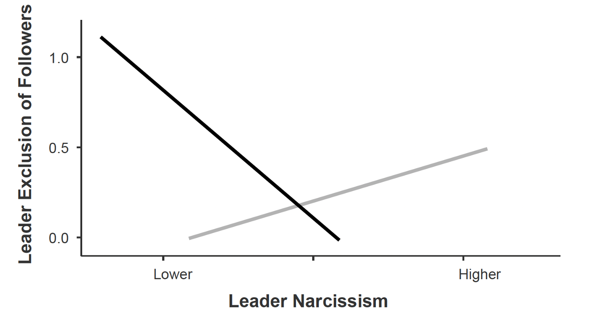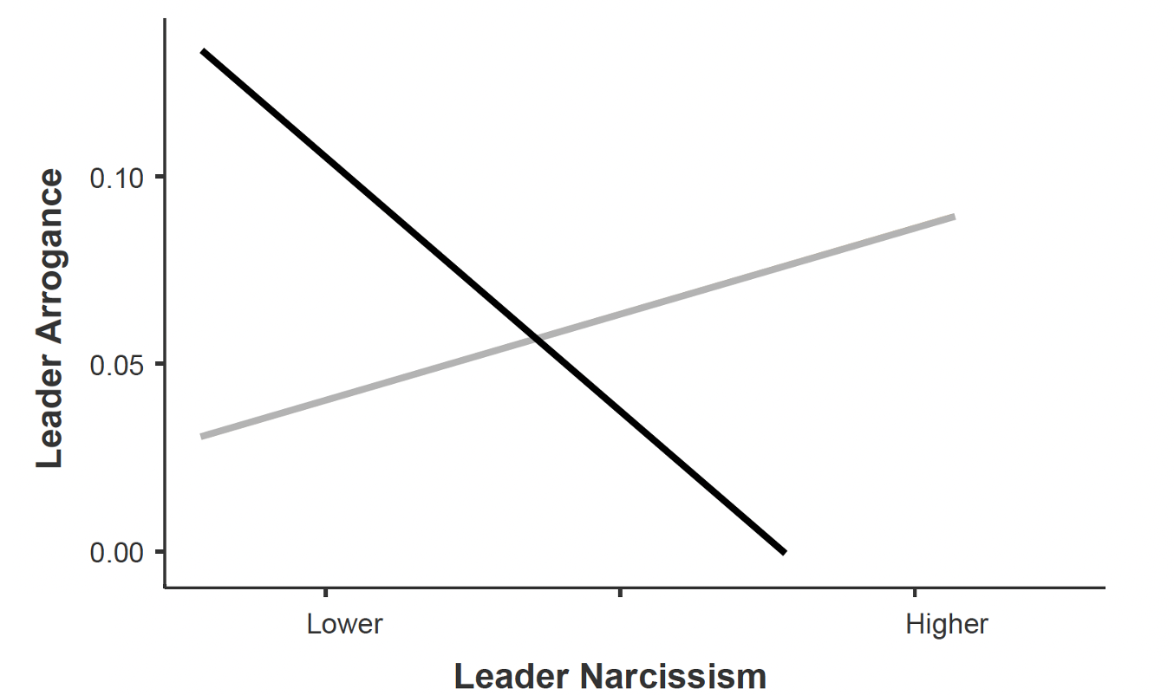
Note. Outcome variables include (a) Follower exclusion of others; (b) Leader aggression; (c) Leader exclusion of followers; (d) Leader arrogance. The follower exclusion of others and leader exclusion of followers y-axes reflect the observed frequencies of behaviors during the group discussion. The leader aggression and leader arrogance y-axes reflect observed behavior frequency coded every 30 seconds (0 = none, 3 = very much) during the group discussion and averaged over the length of the group discussion.
References
Supplemental Materials

Nakagawa, S., & Schielzeth, H. (2013). A general and simple method for obtaining R2 from generalized linear mixed-effects models. Methods in Ecology and Evolution, 4(2), 133–142. https://doi.org/10.1111/j.2041-210x.2012.00261.x

The main effect of leader sex was found to be significant for perceived leader effectiveness, B = -0.26, t(812) = -2.39, p = .017, 95%CI[-0.469, -0.046] and perceived leader inclusion, B = -0.16, t(812) = -2.03, p = .043, 95%CI[-0.313, -0.005], with girl leaders receiving higher ratings than boy leaders.
The main effect of follower sex was found to be significant for perceived leader effectiveness, B = 0.20, t(812) = 2.12, p = .034, 95%CI[0.015, 0.390], with boy followers rating their leaders higher than girl followers.
Here we additionally checked for the direct leader sex and follower sex interaction effects on our outcomes.
Please note that –1SD below the mean group age (= 9.65) and +1SD above the mean group age (= 13.52) map onto the average ages within each of the group age categories (i.e., elementary school average age = 10.03; secondary school average age = 13.49). Thus, for interpretation of the findings we refer to group age categories.

