Supplementary Information for
The Gender Gap in the Care Economy is Larger in Highly Developed Countries:
Socio-Cultural Explanations for Paradoxical Findings

SECTION 1: 3
Study 1 Exploratory Variables & Analyses 3
Analyses with Alternative Development Indicators 3
SECTION 2: Study 1 - Additional analyses on gender equality 6
SECTION 3: 11
Study 2 Deviations from the Pre-Registration 11
SECTION 4: 14
Study 2 Additional Details on Variables 14
Variables 14
Multi-Level Scale Reliability 19
SECTION 5: 21
Study 2 Summary Statistics of Key Variables 21
SECTION 6: 23
Study 2 Additional Analyses on the Development Paradox 23
SECTION 7: 25
Study 2 Additional Analyses on the Gender Equality vs. Development Paradox 25
SECTION 8: 29
Study 2 Robustness Checks for Key Results 29
SECTION 9: 35
Study 2 Alternative Self-Expression Measures 35
SECTION 10: 38
Study 2 Parallel Analyses on STEM 38
SECTION 11: 44
Study 2 Additional Details on Analyses with Values 44
SECTION 12: 55
Sampling Information 55
SECTION 13: Multiple Imputations 72
References 73

SECTION 1:

Study 1 Exploratory Variables & Analyses

Analyses with Alternative Development Indicators
As stated in the main paper, HDI is our preferred indicator of country-level development since it encompasses several dimensions of development that should relate both to structural forces and cultural beliefs. For exploratory purposes, we conducted additional analyses with alternative country-level indicators of development focusing on economic wealth (GDP) and labor market structure (PILMS).
GDP. Gross Domestic Product (GDP; obtained from the Human Development Program website) provides a country-level indicator of economic wealth. For consistency with other indicators, we chose to use GDP data from 2017. While we initially thought we would have to transform this variable due to a non-normal distribution, skewness (0.83) and kurtosis (-0.56) for this variable were acceptable in our sample (George & Mallery, 2003), leading us not to transform it.
PILMS. Post-Industrial Market Structure (PILMS, 2017 data) has been used by past research (Charles, 1992, 2003) to reflect the complex and hierarchical nature of labor markets. Following past research, our measure of this construct consisted of two indicators: a) the percentage of all workers who are in the service industry, and b) the percentage of all workers who are waged or salaried workers. Data on these two indicators, r = .88, p < .001, were obtained from the World Bank, standardized, and then averaged.
Results. Results from linear regression analyses are presented in Table S1. When predicting the percentage of women in the care economy, both HDI and PILMS reveal evidence of a development paradox, whereas GDP shows similar but non-significant patterns. When predicting women’s representation in STEM, only PILMS (but not HDI or GDP) predicted the non-paradoxical pattern whereby (controlling for women’s labor market participation) a stronger post-industrial labor market structure predicted a higher percentage of women in STEM occupations.
Table S1
Study 1 Analyses Comparing HDI, GDP, and PILMS as Predictors of the Development Paradox
 | % women care economy |  |  |  | % women STEM
Variable | B | SE | 95% CI | p | B | SE | 95% CI | p
Model A
HDI | 4.42 | 0.96 | 2.50 – 6.33 | <.001 | 1.17 | 0.72 | -0.26 – 2.60 | .107
% women in labor force | 3.69 | 0.96 | 1.77 – 5.60 | <.001 | 2.72 | 0.72 | 1.29 – 4.15 | <.001
Model B
GDP | 0.58 | 1.09 | -1.60 – 2.76 | .596 | -0.56 | 0.72 | -2.00 – 0.88 | .443
% women in labor force | 4.93 | 1.09 | 2.75 – 7.10 | <.001 | 3.26 | 0.72 | 1.82 – 4.70 | <.001
Model C
PILMS | 4.00 | 0.95 | 2.11 – 5.90 | <.001 | 1.49 | 0.68 | 0.12 – 2.86 | .033
% women in labor force | 4.23 | 0.95 | 2.34 – 6.13 | <.001 | 2.77 | 0.68 | 1.40 – 4.14 | <.001

SECTION 2: Study 1 - Additional analyses on gender equality

We conducted additional analyses to examine whether specific indicators of gender equality would show a gender equality paradox (over and above HDI) either for the gender segregation in the care economy or in STEM. Specifically, it was important to assess whether other broad gender equality predictors (aside from GGGI) or specific gender equality indicators that do not take into account women’s participation in education and the labor market, might be better predictors of paradoxical patterns. We thus tested whether different measures of both broad gender equality and equality more specific to the health sphere and/or in the political sphere would predict gender segregation better than development (HDI). Step 1 and 2 in Table S2 represent analyses from the main manuscript, additionally we then ran regression models that tested whether HDI remained a significant predictor when adding the political equality sub-measure of the GGGI (Step 3a), the health equality sub-indicator of the GGGI (Step 3b), the Gender Equity Index (GEI; European Institute for Gender Equality, 2017, Step 3c), or the Gender Inequality Index (GII; United Nations Human Development Program, 2017, Step 3d). The results from these analyses, detailed in Table S2, suggest that none of the tested gender equality predictor overrode the development paradox for the care economy (i.e., HDI remained the strongest predictor of more women in the care economy). Interestingly, gender equality in the political sphere predicted more gender equality in the care economy (i.e., more men in the care economy), whereas gender equality in the health sphere predicted less gender equality in the care economy (i.e., fewer men in the care economy). For STEM, no paradoxical patterns were found and indeed more gender equality in the health sphere predicted more gender equality (i.e., more women) in STEM.
Table S2
Study 1 Linear Regression Analyses Predicting Gender Segregation in Labor Markets from Economic Development (HDI) and Different Gender Equality Indices (GGGI subindices; N = 70

 | % women care economy |  |  |  | % women STEM
Labor Market Indicator | B | SE | 95% CI | p | B | SE | CI | p
Step 1
HDI | 5.60 | 1.00 | 3.61 – 7.59 | <.001 | 2.04 | 0.74 | 0.56 – 3.52 | .008
Step 2
HDI | 4.42 | 0.96 | 2.50 – 6.33 | <.001 | 1.17 | 0.72 | -0.26 – 2.60 | .107
% women in labor force | 3.69 | 0.96 | 1.77 – 5.60 | <.001 | 2.72 | 0.72 | 1.29 – 4.15 | <.001
Step 3a (Political GGGI)
HDI | 4.83 | 0.95 | 2.93 – 6.72 | <.001 | 1.28 | 0.73 | -0.18 – 2.74 | .085
% women in labor force | 4.07 | 0.95 | 2.18 – 5.97 | <.001 | 2.82 | 0.73 | 1.36 – 4.28 | <.001
Political representation | -2.06 | 0.93 | -3.92 – -0.20 | .031 | -0.56 | 0.72 | -1.99 – 0.87 | .439
Step 3b (Health GGGI)
HDI | 5.12 | 0.86 | 3.39 – 6.84 | <.001 | 1.57 | 0.68 | 0.21–2.94 | .025
% women in labor force | 2.36 | 0.90 | 0.56 – 4.16 | .011 | 1.96 | 0.71 | 0.54 – 3.38 | .008
Health | 3.78 | 0.86 | 2.08-5.49 | <.001 | 2.16 | 0.68 | 0.81 – 3.51 | .002
Step 3c - Gender Equity Index¹
HDI | 4.41 | 1.19 | 2.03–6.78 | <.001 | 0.77 | 0.90 | -1.03–2.56 | .398
% women in labor force | 2.70 | 1.29 | 0.12–5.29 | .041 | 1.79 | 0.98 | -0.16–3.75 | .072
GEI | 1.58 | 1.58 | -1.58–4.74 | .320 | 1.52 | 1.20 | -0.88–3.91 | .210
Step 3d - Gender Inequality Index
HDI | 6.33 | 1.98 | 2.38–10.28 | .002 | 0.85 | 1.49 | -2.12–3.83 | .568
% women in labor force | 4.22 | 1.07 | 2.08–6.37 | <.001 | 2.63 | 0.81 | 1.01–4.24 | .002
GII | 2.37 | 2.14 | -1.91–6.65 | .273 | -0.39 | 1.61 | -3.61–2.83 | .808
¹ N = 66
Table S3
Study 1 Correlations for All Country-Level Indicators
 |  | 1. | 2. | 3. | 4. | 5. | 6. | 7. | 8. | 9.
1. | GDP | - | - | - | - | - | - | - | - | -
2. | HDI | .74*** | - | - | - | - | - | - | - | -
3. | PILMS | .67*** | .88*** | - | - | - | - | - | - | -
4. | % women in labor force | .30* | .32** | .22 | - | - | - | - | - | -
5. | GGGI overall | .42*** | .33** | .23 | .62*** | - | - | - | - | -
6. | GGGI political | .38** | .26* | .16 | .25* | .87*** | - | - | - | -
7. | GGGI health | -.26* | -.07 | -.01 | .29* | .14 | -.04 | - | - | -
8. | % women in care economy | .21 | .56*** | .49*** | .51*** | .30* | .02 | .41*** | - | -
9. | % women in STEM | .07 | .32** | .32** | .48*** | .32** | .08 | .41*** | .72*** | -
Note. Correlations computed using Pearson-method with pairwise-deletion. *p < .05 **p < .01***p < .001, two-tailed.

SECTION 3:

Study 2 Deviations from the Pre-Registration
We pre-registered a number of hypotheses as well as a detailed data analysis plans before the end of data collection (https://osf.io/aqfe9/?view_only=c1e1da78e39f473bb79d78da2dd9f92c). Although we tried to anticipate a number of major decisions with this complex dataset, we had to make small deviations from our pre-registered plans after the data were collected and preliminary analyses began. These deviations, detailed below, did not substantially affect how our key hypotheses were tested, and should not change substantive conclusions.
Countries Retained. To test our hypotheses about country-level gender differences, we had initially planned to have at least 50 participants per gender in each country after exclusions. A sample of at least 50 men and 50 women in a given country provides 80% power to detect a medium sized (d = 0.50) gender difference, which we felt was an adequate starting point and reasonable given realistic constraints of obtaining samples from so many countries. One country, Denmark, fell slightly short of this goal with 42 men after exclusions. Because country-level degrees of freedom are extremely valuable in our planned analyses and because Denmark was only 8 participants under the goal, we opted (before analyses began) to retain the sample from Denmark and included Danish data in all analyses.
Excluding “Stray” Participants. We had instructed collaborators to only collect data from their home institutions, with some collaborators granted permission to collect data from 2 to 4 universities with the stipulation to get roughly equal numbers from each (leading to higher overall sample sizes). However, a few participants who indicated currently attending high school (as far as we could identify with their write-in response) or a university that was not planned to be included made it into the dataset. Because we planned to control for university-level variation in demographics, we made the decision (before analyses began) to exclude any participants attending high school or universities represented in our sample by less than 6 participants. This only excluded 0.75% of our data (after accounting for all other exclusions).
Fixing Effects of Control Variables. We had initially planned to allow the effects of demographic control variables (i.e., age, subjective socioeconomic status (SES), major, university status) to vary by university. However, these models proved too complex (as too many slopes were allowed to vary) and did not converge in most instances. Because the effects of control variables are not substantive to our questions, but may account for some variance in career interest, we fixed slopes for all control variables (and, as planned, we controlled for deviation within as well as between universities), which allowed us to control for individual and university-level variance in these demographics.
Alternate Measure of “Prosocial” Values. We obtained data on gender differences in “pro-sociality” from Falk and Hermle’s (2018) report using data from the Global Preference Survey. We had preregistered exploratory analyses to examine whether country-level gender differences in pro-sociality would predict gender differences in care economy interest (similar to our predictions for communal values). However, in the pre-registration, we stated our reservation that these pro-sociality items (e.g., an item asking for the value of a thank-you gift that the respondent is willing to give in return for help by a stranger) are likely related to, but distinct from, “communal values”, which were our key focus. (From our pre-registration: “…Falk & Hermle (2018) have data on country-level gender differences in values that are similar to what we conceptualise as communal values. Whereas these data are representative on the country-level, they do not exactly fit the kind of communal values we think would best predict care economy/STEM interest, thus not being the ideal way to test our hypothesis.”). In addition, because we did not have a score from Falk and Hermle’s data for 15 of our 49 countries, a large amount of data (31%) had to be imputed on this measure. Because of these compounding uncertainties, we provide these exploratory analyses here rather than in the main paper. Our analyses suggest that this measure of pro-sociality did not significantly predict country-level gender differences in care economy interest, either alone, B = 0.04, SE = 0.03, t(47.27) = 1.40, p = .199, CI.95 [-.02, .10], or when controlling for the effect of HDI, B = -0.001, SE = 0.03, t(46.79) = -0.12, p = .682, CI.95[-.06, .06]. Patterns of these interactions were, however, in the same direction as for gender differences in communal values.
Additional Analyses Controlling for Agentic Values. Although not pre-registered, we thought it was important to run additional models examining whether gender differences in communal values would still predict gender differences in care economy interest after controlling for dominance and competence (i.e., agentic) values. This allowed us to isolate the unique effect of communal values, which was a significant predictor with or without these controls. These analyses do not change the interpretation of our pre-registered results, but rather add more certainty as additional robustness checks (see Table S13).

SECTION 4:

Study 2 Additional Details on Variables

Variables
Career interest. Our key measure of career interest described in the main paper was preceded by the following general instruction: “People can have interests in many different things, including things they are not currently doing themselves. Even if we choose one career for ourselves, there might be other careers we could imagine for ourselves. In this question, we are NOT asking which profession you currently expect to have in your future. Instead, we would like you to consider each career on this list separately and think about whether you could imagine that career being of interest to you.”
Perceived Relative Pay of Care Economy Careers. As an exploratory variable, we also included a measure of the perceived relative pay of care economy careers in our survey. Participants were asked: “Compared to the average pay of all jobs in [country], how well-paid is [career]?” Participants then rated each of the three care economy careers on a scale ranging from 0 (lowest paying job) to 100 (highest paying job). The ratings for these three careers were averaged into a composite score of perceived relative pay of care economy careers. Country-level perceived relative pay of care economy careers was obtained by extracting country-level intercepts on this variable from a multi-level model controlling for age, subjective SES, major, and university status. Parallel procedures were employed for the measure perceived relative pay of STEM careers.
Age. Participants reported their age in response to the following question: “How old are you?”
Subjective SES. Participants were asked to indicate their subjective socio-economic status (SES) on the MacArthur Subjective Status Scale (Adler et al., 2000). Specifically, we asked: “Please think about where your family stands in comparison to others in [country]. This ladder conceptually represents society where those with the highest socioeconomic status (Rung 10; i.e., those with the most money, highest education, and best jobs) are at the top and those with the lowest socioeconomic status (Rung 1; i.e., those with the least money, least education, and worst jobs) are at the bottom. Please choose the number that best represents where your family is on this ladder compared to others in [country].” Participants gave their answer on a scale ranging from 1 (low SES) to 10 (high SES). In Belgium and the Netherlands, the scale erroneously ranged from 0 to 10. To make the scale comparable across sites, 0 was recoded as 1 (affecting a total of 3 responses).
Major. To be able account for participants’ field of study, we asked: “What field most closely describes your major or aspired major? If you have not decided yet, please select what is most likely out of the choices.” Participants had a choice of the following options, which (in line with pre-registered procedures) were later coded into five broad categories: “Science (Chemistry, Biology, etc.)”, “Mathematics/Statistics”, “Computer Science”, “Engineering” (all coded as “STEM” category); “Psychology (General)”, “Psychology with the goal to be a clinical practitioner”, “Medicine with goal to become doctor”, “Other Health/Social work professions”, “Education/Teaching” (all coded as “Care Economy Field” category); “Other Social Sciences (History, Sociology, etc.)” (coded as “Social Sciences” category); “Business” (coded as “Business” category); “Law”, “Sport Sciences”, “Fine Arts (Music, Painting, Literature)”, “Theology/Religious Studies”, and “Other” (all coded as “Other” category). These five categories were effect coded for all statistical models.
Degree Progress. Based on participants’ self-reported year of study and what that meant for their degree progress in their country (e.g., in some countries major is declared at year 1, in some in year 2, etc.), participants were assigned a score between 1 and 3 for degree progress; 1 = Undergraduate - major NOT declared, 2 = Undergraduate - major declared, 3 = Master student.
University Status. In the site survey sent to each collaborator after data collection, collaborators rated each university from which they collected data on the following question: “How would you best describe the status of [name of university] in relation to other universities in your country? Think of the ladder below as representative of the standing of different universities in your country. At the top of the ladder are the universities which are the best off - those which have the most prestige, the best academic ranking, and whose graduates get the most attractive jobs. At the bottom are the universities which are the worst off - those which have the least prestige, the worst academic ranking, and whose graduates get the least attractive jobs. The higher up your university is on this ladder, the closer it is to the top universities; the lower your university is, the closer it is to the worse off universities. Where would you place your university on this ladder?”. Ratings were made on a 5-point scale ranging from 1 (lowest) to 5 (highest).
Degree Requirements. Countries vary in what kind of degree people require to pursue specific careers. We initially suspected that the specific level of degree requirement in a country for a given care economy or STEM career could relate to baseline interest. For example, in a country where nursing is not a university degree, university students should be generally less interested in nursing, as they might not be in university if they wanted to become a nurse. Thus, in the site survey, we asked our collaborators to report the required degree in their respective country for each care economy career we asked about. Answers were coded on a 0-3 scale; 0 = Zero of the careers require a university degree, 1 = One of the careers requires a university degree, 2 = Two of the careers require a university degree, 3 = Three (all) of the careers require a university degree. In line with pre-registered procedures, we conducted analyses to examine whether this variable would predict levels of interest in care economy careers. Since this variable did not predict care economy interest, B = -0.02, SE = .05, t(49.08) = 0.33, p = .746, CI.95 [-.12, .34], it was not included in further analyses. It should be noted that training requirements also did not moderate gender differences in care economy interest, B = 0.04, SE = .03, t(40.28) = 1.32, p = .196, CI.95 [-.02, .10].
GDP. See Section 1.
PILMS. See Section 1.
Country-Level Indicators of Gender Equality. Several country-level indicators included in our dataset captured aspects of gender equality across countries. Broad gender equality was measured with the Global Gender Gap Index (GGGI, 2017 data, scale ranges from 0 - 1; Schwab et al., 2017), which captures gender gaps in health, education, economic advancement, and political representation (higher values indicate greater economic and social gender equality). To better capture the specific effect of women in power positions, we also examined the political and economic sub-indices of the GGGI (combined into an index we called "female empowerment”). Finally, to capture cross-national variability in policies and practices that alleviate work-life conflict we also assessed the percentage of women working part-time (from ILO, 2017 data; International Labour Office, 2017), leave available to mothers (i.e., days of maternity leave added to the days of total parental leave, subtracting out days of leave exclusive to fathers; International Labour Office, 2013), and leave available to fathers (i.e., days of paternity leave added to the days of parental leave exclusive to fathers; International Labour Office, 2013).
Self-Expression Measure. Two sources provided measures of country-level self-expression values: the World Value Survey (WVS) and Schwartz’s (2008) data on cultural values. The self-expression scale from the WVS combines five variables: 1. Respondent gives priority to economic and physical security over self-expression and quality of life, 2. Respondent describes themselves as not very happy, 3. Respondent believes homosexuality is never justifiable, 4. Respondent has not and would not sign a petition, and 5. Respondent believes that you have to be very careful about trusting people. As these items are reverse-coded before they are combined. Thus, higher scores on this measure indicate stronger self-expression (vs. survival) values. Schwartz’s measure of intellectual autonomy is a composite score of the extent to which respondents value four constructs: 1. Freedom, 2. Creativity, 3. Broad Mindedness, 4. Curiosity. As per our pre-registration, we standardized and combined these two measures into an overall measure of “self-expression culture”. In additional exploratory analysis, we focused on Schwartz’s measure of "affective autonomy” (i.e., the extent to which people in a culture are allowed to make free choices to seek affectively positive experiences; Schwartz, 1999).

Multi-Level Scale Reliability
As per our pre-registration, we went through a number of steps to ensure that the key scales from our survey showed good reliability in most, if not all, countries in our sample. Evidence for good fit based on multilevel confirmatory factor analyses as well as additional examination of Cronbach’s alphas by country is summarized below.
Care Economy Interest. Multi-level confirmatory factor analyses for each of the two interest items (affinity and career-fit) using structural equation modelling (SEM) yielded excellent fit for a two-factor (care economy vs. STEM) model, CFI_{affinity} = .99, RMSEA_{affinity} = .06, SRMR_{affinity} = .03, and CFI_{fit} = .99, RMSEA_{fit} = .07, SRMR_{fit} = .03, respectively. Constraining loadings to be constant across countries did not substantially reduce fit for affinity, CFI_{affinity} = .97, RMSEA_{affinity} = .07, SRMR_{affinity} = .08, or for the fit items, CFI_{fit} = .98, RMSEA_{fit} = .08, SRMR_{fit} = .10. Overall, most of the countries in our sample showed acceptable fit (all countries’ CFIs > .90, RMSEAs < .10, SRMRs < .10) for care economy affinity (100% of countries pass thresholds) and care economy fit (78% of countries pass thresholds). Note that the lowest reliabilities are coming from Ethiopia, which was excluded in additional exploratory analyses to show that results hold without this country.
Values. A confirmatory factor analysis in SEM supported our pre-registered plan to treat communal, dominance, and competence items as three distinct value categories, CFI = .95, RMSEA = .09, SRMR = .05. Constraining loadings to be constant across countries did not substantially reduce fit, CFI = .91, RMSEA = .11, SRMR = .12. The averages of the three standardized items for each value form highly reliable scores (average α_{communal} = .86; range_{communal} = .70-.94, average α_{dominance} = .80; range_{dominance} = .49-.91, average α_{competence} = .71; range_{competence} = .44-.89, respectively). Note that the lowest reliabilities are again coming from Ethiopia, which was excluded in additional exploratory analyses to show that results hold without this country.

SECTION 5:

Study 2 Summary Statistics of Key Variables
Table S4
Means and Standard Deviations for Key Individual-Level Variables
Variable | M_{overall}(SD) | M_{men}(SD) | M_{women}(SD)
1. Care economy interest | 0.00 (0.90) | -0.31 (0.93) | 0.18 (0.84)
2. STEM interest | 0.00 (0.88) | 0.22 (0.84) | -0.13 (0.87)
3. Communal values | 0.00 (0.89) | -0.21 (0.96) | 0.12 (0.81)
4. Dominance values | 0.00 (0.86) | 0.10 (0.87) | -0.06 (0.85)
5. Competence values | 0.00 (0.77) | -0.02 (0.79) | 0.01 (0.76)
6. Age | 20.52 (2.38) | 20.90 (2.26) | 20.30 (2.26)
7. Subjective SES | 6.11 (1.59) | 6.12 (1.66) | 6.10 (1.55)
8. Degree progress | 1.88 (0.56) | 1.92 (0.57) | 1.86 (0.55)
Note. Means of variables 1-5 are zero and standard deviations are close to one since these variables were created by first standardizing each individual item and then averaging the three standardized items into a composite score.
Table S5
Correlations of Key and Exploratory Country-Level Variables
 |  | 1. | 2. | 3. | 4. | 5. | 6. | 7. | 8. | 9. | 10. | 11.
1. | Gender differences care economy interest | - | - | - | - | - | - | - | - | - | - | -
2. | Gender differences STEM interest | -.24 | - | - | - | - | - | - | - | - | - | -
3. | HDI | .39** | -.07 | - | - | - | - | - | - | - | - | -
4. | GDP | .24 | -.08 | .79*** | - | - | - | - | - | - | - | -
5. | PILMS | .35* | -.07 | .91*** | .71*** | - | - | - | - | - | - | -
6. | GGGI | .30* | .08 | .61*** | .61*** | .49*** | - | - | - | - | - | -
7. | Gender differences communal values | .58*** | -.03 | .35* | .22 | .28 | .53*** | - | - | - | - | -
8. | Gender differences competence values | .15 | -.16 | -.01 | .04 | .04 | -.05 | .25 | - | - | - | -
9. | Gender differences dominance values | .07 | -.00 | -.03 | -.08 | .02 | -.14 | -.10 | .41** | - | - | -
10. | Individualism | .39** | -.20 | .73*** | .72*** | .71*** | .50*** | .38** | .13 | -.02 | - | -
11. | Self-expression | .05 | .04 | .72*** | .78*** | .63*** | .69*** | .20 | -.12 | -.11 | .68*** | -
Note. These correlations were run on each of the 10 imputed datasets of country-level variables and then averaged across these imputed datasets. Scores for gender differences in care economy preference and gender differences in communal values are country-level estimates of the gender effect extracted from multi-level models adjusting for individual- and site-level demographics. *p < .05, **p < .01, ***p < .001.

SECTION 6:

Study 2 Additional Analyses on the Development Paradox
On an exploratory basis, we used two alternative indicators of economic development to further probe H1: PILMS (Charles, 2003), B = 0.07, SE = 0.03, t(52.83) = 2.66, p = .011, CI.95 [0.01, 0.13], and GDP, B = 0.04, SE = 0.03, t(39.76) = 1.60, p = .119, CI.95 [-0.02, 0.10]. Both yielded similar interaction patterns with gender, though the interaction for GDP did not reach statistical significance (see Table S6).
Table S6
Different Development Indicators Predicting Gender Differences in Care Economy Interest
Development indicator | HDI |  |  | PILMS |  |  | GDP
 | B | SE | p | B | SE | p | B | SE | p
Step 1
Gender | 0.34 | 0.03 | <.001 | 0.34 | 0.03 | <.001 | 0.34 | 0.03 | <.001
Development | 0.87 | 0.31 | .008 | 0.06 | 0.04 | .025 | 0.12 | 0.04 | .003
Step 2
Gender x Development | 0.64 | 0.22 | .005 | 0.07 | 0.03 | .011 | 0.04 | 0.03 | .119
Step 3
Gender x Development | - | - | - | -0.01 | 0.07 | .831 | -0.05 | 0.04 | .289
Gender x HDI | - | - | - | 0.74 | 0.60 | .189 | 0.94 | 0.35 | .012
Note. This table shows results for multilevel modelling analyses where different measures relating to economic development are used as predictors of gender difference in care economy interest alone (Step 2), and over and above HDI (Step 3). The top row specifies which development indicator is used in each analysis. HDI = Human Development Index, PILMS = Post-Industrial Labor Market Structure (see Section 1 for more details), GDP = Gross Domestic Product. All analyses contain the same control variables. Control variables are omitted here for the sake of readability, but can be found in Table S13.

SECTION 7:

Study 2 Additional Analyses on the Gender Equality vs. Development Paradox
Additional pre-registered analyses tested whether different indicators of gender equality could predict the gender gap in care economy interest better than HDI. As pre-registered, we obtained the following measures of overall gender equality (GGGI, 2017; Schwab et al., 2017), female empowerment (i.e., an average of the economic and political sub-scores of the GGGI), days of maternity leave available in a country (International Labour Office, 2013), days of paternity leave available in a country (International Labour Office, 2013), percentage of women working part-time in a country (International Labour Office, 2017), and percentage of male workers in care-economy careers (i.e., an average of the percentage of men in the occupational categories “healthcare” and “education”; International Labour Office, 2017).
Analyses summarized in Table S7 suggested that there was little evidence for a distinct “gender equality paradox”. When entering indicators of gender equality as sole predictors of the gender gap in care economy interest, a number of these indicators predicted a greater gender gap in care economy interest, in line with past evidence (e.g., Stoet & Geary, 2018). When entering different indicators of gender equality together with HDI, however, no indicator of gender equality predicted the size of the gender gap in care economy interest better than HDI itself. Specifically, the effects of HDI predicting a larger gender gap in care economy interest remained of similar magnitude and statistically significant or marginal (not surprising given lowered degrees of freedom) after accounting for gender equality indices. This finding suggests that women’s higher interest in care economy careers in more developed countries is likely not a function of broader encouragement of rights and/or opportunities for women in these countries. One notable exception is that incentives for women to segregate into more family-friendly occupations (i.e., those offering leave) could play a role in career choices, even over and above general economic development.

Table S7
Effects of Gender Equality vs. HDI in Predicting Gender Differences in Care Economy Interest
Equality indicator | GGGI |  |  | Female empowerment |  |  | Maternity leave |  |  | Paternity leave |  |  | % women part-time |  |  | % men care-economy
 | B | SE | p | B | SE | p | B | SE | p | B | SE | p | B | SE | p | B | SE | p
Step 1
Gender | 0.34 | 0.03 | <.001 | 0.34 | 0.03 | <.001 | 0.34 | 0.03 | <.001 | 0.34 | 0.03 | <.001 | 0.34 | 0.03 | <.001 | 0.34 | 0.03 | <.001
Equality indicator | 2.17 | 0.60 | .001 | 0.14 | 0.04 | .002 | -0.06 | 0.03 | .055 | 0.002 | 0.002 | .377 | 0.01 | 0.002 | .004 | 0.07 | 0.17 | .644
Step 2
Gender x Equality indicator | 0.99 | 0.44 | .034 | 0.06 | 0.03 | .052 | 0.06 | 0.02 | .010 | 0.001 | 0.002 | .601 | -0.002 | 0.002 | .296 | 0.21 | 0.11 | .287
Step 3
Gender x Equality indicator | 0.35 | 0.54 | .531 | 0.02 | 0.03 | .532 | 0.05 | 0.02 | .038 | -0.001 | 0.001 | .735 | -0.004 | 0.002 | .031 | 0.15 | 0.12 | .350
Gender x HDI | 0.54 | 0.27 | .059 | 0.55 | 0.25 | .038 | 0.57 | 0.22 | .012 | 0.71 | 0.23 | .003 | 0.78 | 0.22 | .001 | 0.52 | 0.24 | .088
Note. Results from multilevel models testing different gender equality indicators as moderators of gender differences in care economy interest alone (Step 2), and over and above HDI (Step 3). Main effects are included at each step, but omitted for readability. GGGI = Global Gender Gap Index, female empowerment = political and economic sub-indices of the GGGI, maternity leave = days of maternity leave available in a given country, paternity leave = days of paternity leave available in a given country, % women part-time = percentage of employed women working part time in a given country, % men in care economy = percentage of men employed in healthcare and education sectors (broadly defined according to ILO) in a given country. All analyses contain the same control variables. Control variables are omitted here for the sake of readability, but can be found in Table S13. Coefficients for maternity leave and paternity leave are standardized because the variable has a large range and standard deviation. Analyses on these two variables also had 48 instead of 49 countries since we did not impute missing data on these exploratory variables.

SECTION 8:

Study 2 Robustness Checks for Key Results
Although the main paper detailed the pre-registered analyses, we also conducted additional exploratory robustness checks after we had examined our key predicted effects (Model 1, Tables S8 and S9).
First, it is plausible that the inclusion of items about perceived career-fit (e.g., “A career in social work would match my values.”) in our overall career interest measure could artificially inflate the relationship of this measure with communal values, because it specifically assessed interest in a career in terms of how much the career is congruent with one’s personal values. (Note that this account of our results does not address why cross-cultural variations in communal values predicted country-level gender differences in care economy interest better than cross-cultural variations in competence and dominance values). However, as summarized in Tables S8 and S9 (Model 2), the results for the original models are essentially unchanged if we use only the most face valid measure of career affinity (“In another life, I could imagine [career] being an interesting career for me.”) as the outcome measure for care economy interest.
Second, we found that one country in our sample, Ethiopia, was an outlier in two ways: 1. Ethiopia was the only country to score 3 SDs below the mean of HDI in our sample, suggesting that it is an outlier on economic development, 2. Though overall confirmatory factor analyses suggested that scales fitted well across countries (see SI Section 3), Ethiopia consistently had much lower scale reliabilities than other countries (notably α = .21 for the measure of care-economy career affinity which was part of our key outcome). However, as summarized in Tables S8 and S9 (Model 3), our original model was robust even when we excluded Ethiopia from the analyses.
Third, to gain a more precise focus on interest in care economy careers (as opposed to reporting higher career interest generally or the ability to imagine oneself in a range of careers), we also re-ran models controlling for individual variability in STEM interest. Again, as seen in Tables S8 and S9 (Model 4), results on care economy interest outcome were robust even when controlling for STEM interest.
Fourth, some might argue that care economy careers are paid more in some countries than others, and that this could explain the effects of HDI. Therefore, we repeated our analyses with country-level perceived relative pay of care economy careers (see Section 2 for variable details). Results are summarized in Table S8 (Model 6). These analyses suggested that people in countries where care economy careers are perceived as higher in pay tended to show a significantly higher mean level of interest in care economy careers. However, our predicted gender by HDI interaction held controlling for the perceived pay variable.
Finally, as summarized in Tables S8 and S9 (Model 5), results were also robust to controlling for a country’s population size in 2017, indicating that the effects of economic development are not merely a function of living in a larger, more populous country.
Table S8
Evidence for Robustness of Gender x HDI Predicting Care Economy Interest
 | Model 1:  Original |  |  | Model 2:  Affinity only measure |  |  | Model 3:  Exclude Ethiopia |  |  | Model 4:  Control for STEM  interestª |  |  | Model 5:  Control for population size^{b} |  |  | Model 6:  Control for perceived relative pay (country-level)
Variable | B | SE | p | B | SE | p | B | SE | p | B | SE | p | B | SE | p | B | SE | p
Step 1
Gender | 0.34 | 0.03 | <.001 | 0.24 | 0.02 | <.001 | 0.35 | 0.03 | <.001 | 0.34 | 0.03 | <.001 | 0.34 | 0.03 | <.001 | 0.34 | 0.03 | <.001
HDI | 0.87 | 0.31 | .008 | 0.52 | 0.24 | .037 | 0.87 | 0.35 | .016 | 0.87 | 0.31 | .008 | 0.87 | 0.31 | .008 | 0.87 | 0.31 | .008
Step 2
Gender x HDI | 0.64 | 0.22 | .005 | 0.49 | 0.19 | .016 | 0.57 | 0.24 | .024 | 0.61 | 0.22 | .009 | 0.64 | 0.22 | .005 | 0.64 | 0.20 | .005
STEM interest | - | - | - | - | - | - | - | - | - | 0.17 | 0.01 | <.001 | - | - | - | - | - | -
Population size | - | - | - | - | - | - | - | - | - | - | - | - | -0.01 | 0.02 | .796 | - | - | -
Perceived pay^{c} | - | - | - | - | - | - | - | - | - | - | - | - | - | - | - | .01 | 0.1 | .359
Note. All analyses contain the same control variables. Control variables are omitted here for the sake of readability, but can be found in Table S13. STEM interest was entered as an individual-level predictor, whereas population size was entered as a country-level predictor.
ª Degrees of freedom for the model controlling for STEM interest are slightly lower because a number of participants from Ireland (n = 87) were missing this measure.
^{b} B for population size is a standardized coefficient since the raw coefficient was < .001, which is not surprising given that population size has a large standard deviation.
^{c} Perceived relative pay is the country-level intercept of this variable controlling for individual- and site-level demographics. However, results when entering perceived pay as an individual (Level 1) predictor are the same (i.e., the gender x HDI interaction holds).

Table S9
Evidence for Robustness of Gender x Country-Level Gender Differences in Communal Values Predicting Care Economy Interest
 | Model 1:  Original |  |  | Model 2:  Affinity only Measure |  |  | Model 3:  Exclude Ethiopia |  |  | Model 4:  Control for STEM interestª |  |  | Model 5:  Control for population size^{b} |  |  | Model 6:  Control for perceived relative pay^{c}
Variable | B | SE | p | B | SE | p | B | SE | p | B | SE | p | B | SE | p | B | SE | p
Step 1
Gender | 0.34 | 0.03 | <.001 | 0.24 | 0.02 | <.001 | 0.35 | 0.03 | <.001 | 0.34 | 0.03 | <.001 | 0.34 | 0.03 | <.001 | 0.34 | 0.03 | <.001
HDI | 0.83 | 0.31 | .016 | 0.40 | 0.26 | .060 | 0.82 | 0.38 | .037 | 0.83 | 0.31 | .016 | 0.83 | 0.31 | .016 | 0.83 | 0.31 | .016
Gender differences in communal values | 0.29 | 0.31 | .357 | 0.04 | 0.24 | .871 | 0.28 | 0.32 | .384 | 0.29 | 0.31 | .357 | 0.29 | 0.31 | .357 | 0.29 | 0.31 | .357
Step 2
Gender x  Gender differences in communal values | 0.75 | 0.19 | <.001 | 0.60 | 0.17 | .001 | 0.77 | 0.19 | <.001 | 0.74 | 0.20 | .001 | 0.75 | 0.19 | <.001 | 0.75 | 0.19 | <.001
Gender x HDI | 0.41 | 0.20 | .052 | 0.30 | 0.18 | .116 | 0.28 | 0.23 | .227 | 0.39 | 0.22 | .078 | 0.41 | 0.20 | .052 | 0.41 | 0.20 | .053
STEM interest | - | - | - | - | - | - | - | - | - | 0.17 | 0.04 | <.001 | - | - | - | - | - | -
Population size | - | - | - | - | - | - | - | - | - | - | - | - | -0.002 | 0.03 | .948 | - | - | -
Perceived pay | - | - | - | - | - | - | - | - | - | - | - | - | - | - | - | .01 | 0.01 | .302
Note. All analyses contain the same control variables. Control variables are omitted here for the sake of readability, but can be found in Table S13. STEM interest was entered as an individual-level predictor, whereas population size was entered as a country-level predictor.
ª Degrees of freedom for the model controlling for STEM interest are slightly lower because a number of participants from Ireland (n = 87) were missing this measure.
^{b} B for population size is a standardized coefficient, since the raw coefficient was < .001, which is not surprising given that population size has a large standard deviation.
^{c} Perceived relative pay is the country-level intercept of this variable controlling for individual- and site-level demographics. Note, however, that convergence problems in this model suggested that entering this additional predictor might be overfitting the data. Additionally, results when entering perceived pay as an individual (Level 1) predictor are the same (i.e., the gender x HDI interaction holds).

SECTION 9:

Study 2 Alternative Self-Expression Measures
Below we detail analyses comparing our pre-registered measure of country-level self-expression that combined data from the WVS and Schwartz’s intellectual autonomy measure (Model A) with analyses that only used Schwartz’s intellectual autonomy measure (Model B) or Schwartz’s affective autonomy measure (Model C). As summarized in Table S10a, none of the self-expression measures moderated gender differences in care economy interest. Furthermore, as summarized in Table S10b, in no case did controlling for any of these self-expression measures statistically account for the development paradox (i.e., the gender x HDI interaction). Finally, after accounting for HDI (as before), none of the measures showed the paradoxical pattern whereby greater country-level self-expression predicted a wider gender gap in care economy interest. Rather, our full measure of self-expression as well as the intellectual autonomy measure related to smaller gender differences in care economy interest once we accounted for HDI. Affective autonomy was also unrelated to care economy interest.
Table S10a
Alternative Measures of Self-Expression as Moderators of Gender Differences in Care Economy Interest, without Controlling for HDI
Self-expression indicator | Model A:  Full measure (pre-registered WVS + Intellectual Autonomy) |  |  | Model B:  Intellectual autonomy |  |  | Model C:  Affective autonomy
Self-expression indicator | B | SE | p | B | SE | p | B | SE | p
Gender | 0.34 | 0.03 | <.001 | 0.34 | 0.03 | <.001 | 0.34 | 0.03 | <.001
Self-expression indicator | .15 | .04 | <.001 | .09 | .04 | .038 | .04 | .40 | .350
Gender x Self-expression indicator | .009 | .003 | .725 | .007 | .03 | .735 | .04 | .03 | .109
Note. All analyses contain the same control variables. Control variables are omitted here for the sake of readability, but can be found in Table S13. For ease of analyses, Schwarz values were standardized.

Table S10b
Alternative Measures of Self-Expression as Moderators of Gender Differences in Care Economy Interest, over and above HDI
Self-expression indicator | Model A:  Full measure |  |  | Model B:  Intellectual autonomy |  |  | Model C:  Affective autonomy
 | B | SE | p | B | SE | p | B | SE | p
Gender | 0.34 | 0.02 | <.001 | 0.34 | 0.02 | <.001 | 0.34 | 0.02 | <.001
HDI | -0.87 | 0.44 | .059 | -0.20 | 0.45 | .644 | 0.27 | 0.50 | .597
Self-expression indicator | 0.23 | 0.06 | <.001 | 0.10 | 0.05 | .080 | 0.02 | 0.06 | .715
Gender x HDI | 1.19 | 0.29 | <.001 | 1.01 | 0.26 | <.001 | 0.70 | 0.30 | .032
Gender x Self-expression indicator | -0.10 | 0.04 | .016 | -0.07 | 0.03 | .048 | -0.01 | 0.03 | .574
Note. All analyses contain the same control variables. Control variables are omitted here for the sake of readability, but can be found in Table S13. For ease of analyses, Schwartz’s values were standardized.

SECTION 10:

Study 2 Parallel Analyses on STEM
Paradox in STEM? Though this project was planned to focus on explaining country-level gender differences in care economy interest, we conducted parallel analyses on STEM interest (M = 0.00, SD = 0.88) as an outcome variable. There were two notable deviations in how we conducted these analyses. First, one country (Ireland) had a large amount of missing data due to the omission of a STEM item in the survey (that was later corrected, leaving only 87 participants with the variable completed). In addition, after initial models yielded convergence issues with error messages suggesting a variance close to zero (i.e., singularity, suggesting that the data might be over-fitted), we fixed the random intercept of university in all models for STEM, which successfully resolved this issue.
The results showed that after accounting for the same control variables as in the other analyses, women in the sample were on average less interested in STEM careers than were men, B = -0.24, t(42.82) = -9.27, p < .001,. As can be seen in Figure S1, this gender difference varied considerably by country (SD of gender effect = 0.15), with women in one country (Costa Rica) being descriptively more interested in STEM than men. However, as summarized in Table S11, none of the key economic or gender equality variables were significant predictors of gender differences in STEM interest, with or without controlling for HDI. We thus found no evidence for either a gender equality or economic development paradox in STEM interest of undergraduate students. While not the focus of the paper from the outset of this project, our failure to find a gender equality paradox or economic development paradox in the gender segregation of STEM interest is in line with recent arguments that past evidence for gender equality paradoxes in math self-concept arise through illusory correlations (Marsh et al., 2020).
Communal Values and STEM interest. Despite the absence of a relationship between HDI and gender differences in STEM interest, we still wanted to explore whether country-level gender differences in communal values would predict gender differences in STEM interest, like they do on the individual level within countries (see Diekman et al., 2020 for a review). These analyses are summarized in Table S12. In contrast to what might be expected from past goal congruity theory work, we did not find that country-level gender differences in communal values moderated gender differences in STEM interest, either when entered alone (Model A), or when entered together with HDI (Model B). Further, neither country-level gender differences in dominance nor competence values moderated gender differences in STEM interest (Model C).
Individual Differences in Values Predicting Interest. Additionally, we explored whether higher individual communal values would, on average, predict lower STEM interest like they tend to do in North American samples (e.g., Diekman et al., 2020). For this, we entered individual-level communal values (standardised) as a predictor of STEM interest, accounting for individual- and site-level demographics (as we did in our key analyses). Results are summarized in Table S12. To get average effects, the slopes of gender and individual communal values were allowed to vary by country. In contrast to what has been found in North American samples, our international sample showed no significant relationship between communal values and STEM interest, B = 0.02, SE = .01, t(27.84) = 1.67, p = .106, CI.95[.00, .04]. However, exploratory analyses pitting communal values against dominance and competence values suggest that, across nations, individuals (controlling for participant gender) with higher dominance values, B = 0.06, SE = .01, t(33.68) = 4.92 , p < .001, and competence values, B = 0.06, SE = .01, t(28.01) = 7.20, p < .001, tend to be more interested in STEM careers. In contrast, and as reported in the main paper, individual differences in communal values (but not dominance and competence values) significantly predicted interest in care economy careers, B = 0.31, SE = .01, t(38.37) = 28.72 , p < .001. Together, these patterns suggest that dominance and competence values predict STEM interest, but that only communal values predict the gender gap in care economy interest.
Table S11
Interactions of Gender with Different Country-Level Indicators Predicting STEM preference
Indicator | HDI |  |  | PILMS |  |  | GDP |  |  | GGGI
 | B | SE | p | B | SE | p | B | SE | p | B | SE | p
Step 1
Indicator | -0.27 | 0.20 | .182 | -0.03 | 0.02 | .270 | -0.04 | 0.02 | .121 | -0.27 | 0.40 | .510
Gender | -0.24 | 0.03 | <.001 | -0.24 | 0.03 | <.002 | -0.24 | 0.03 | <.001 | -0.24 | 0.03 | <.001
Step 2
Gender x Indicator | -0.11 | 0.23 | .643 | -0.01 | 0.03 | .707 | -0.01 | 0.03 | .667 | 0.22 | 0.47 | .639
Step 3
Gender x Indicator | - | - | - | 0.01 | 0.07 | .924 | -0.004 | 0.05 | .929 | 0.56 | 0.58 | .354
Gender x HDI | - | - | - | -0.15 | 0.59 | .794 | -0.09 | 0.39 | .827 | -0.27 | 0.29 | .356
Note. Results from multilevel models testing the extent to which different variables moderate gender differences in STEM interest alone (Step 2), and over and above HDI (Step 3). HDI = Human Development Index, PILMS = Post-Industrial Labor Market Structure, GDP = Gross Domestic Product, GGGI = Global Gender Gap Index, Gender differences in communal values = country-level gender differences in communal values extracted from multi-level models accounting for individual- and site-level demographics. All analyses contain the same control variables. Control variables are omitted here for the sake of readability, but can be found in Table S13.
Table S12
Values as Moderators of Gender Differences in STEM Interest
 |  | Model A |  |  | Model B |  |  | Model C
 | Variable | B | SE | p | B | SE | p | B | SE | p
Gender |  | -0.24 | 0.03 | <.001 | -0.24 | 0.03 | <.001 | -0.24 | 0.03 | <.001
Communal differences |  | 0.11 | 0.19 | .557 | 0.21 | 0.20 | .299 | 0.16 | 0.20 | .430
Dominance differences |  | - | - | - | - | - | - | 0.24 | 0.32 | .458
Competence differences |  | - | - | - | - | - | - | 0.43 | 0.30 | .162
HDI |  | - | - | - | -0.31 | 0.21 | .140 | -0.30 | 0.20 | .141
Gender x HDI |  | - | - | - | -0.09 | 0.25 | .721 | -0.11 | 0.24 | .663
Gender x Communal differences |  | -0.12 | 0.22 | .586 | -0.09 | 0.23 | .708 | 0.00 | 0.24 | .986
Gender x Dominance differences |  | - | - | - | - | - | - | 0.13 | 0.39 | .741
Gender x Competence differences |  | - | - | - | - | - | - | -0.53 | 0.36 | .151

Figure S1
Estimated Country-Level Gender Differences in STEM
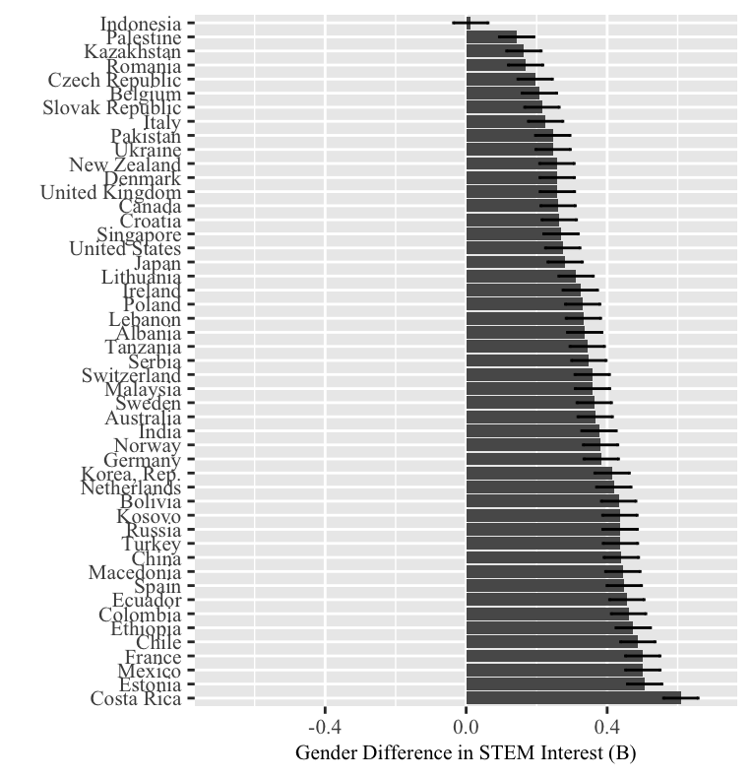
Note. Values graphed reflect estimated raw country-level coefficients (B) for gender predicting STEM interest (M = 0.00, SD = .88), extracted from a multi-level model accounting for the effects of individual- and site-level demographics. Gender coded 0 = men, 1= women. Values below 0 mean that men reported more interest in STEM careers than women did. Error bars represent 95% confidence intervals.

SECTION 11:

Study 2 Additional Details on Analyses with Values
Figure S2
Cross-National Variability in the Gender Gap in Communal Values
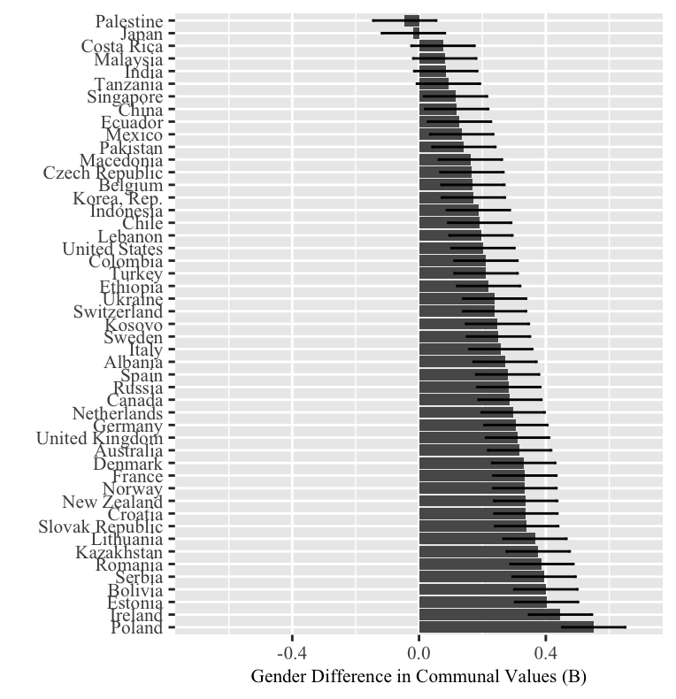
Note. Values graphed reflect estimated raw country-level coefficients (B) for gender predicting communal values, extracted from a multi-level model accounting for the effects of individual- and site-level demographics. Gender coded 0 = men, 1= women. Higher positive values indicate that women endorsed communal values more strongly than men did. Error bars represent 95% confidence intervals.
Figure S3
Cross-National Variability in the Gender Gap in Dominance Values
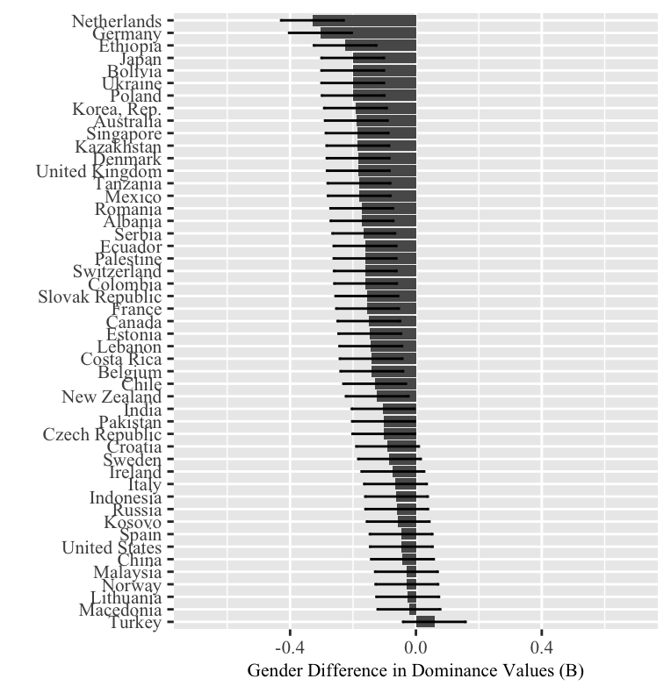
Note. Values graphed reflect estimated raw country-level coefficients (B) for gender predicting dominance values, extracted from a multi-level model accounting for the effects of individual- and site-level demographics. Gender coded 0 = men, 1= women. Lower negative values indicate that men endorsed dominance values more strongly than women did. Error bars represent 95% confidence intervals.
Figure S4
Cross-National Variability in the Gender Gap in Competence Values
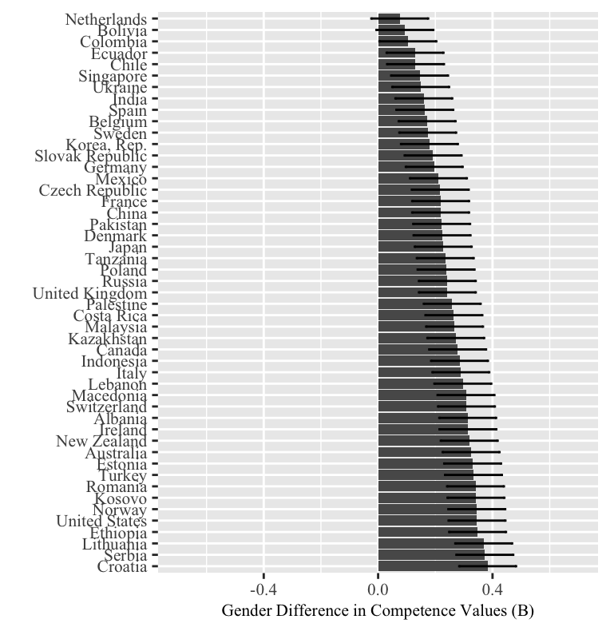
Note. Values graphed reflect estimated raw country-level coefficients (B) for gender predicting competence values, extracted from a multi-level model accounting for the effects of individual- and site-level demographics. Gender coded 0 = men, 1= women. Higher positive values indicate that women endorsed competence values more strongly than men did. Error bars represent 95% confidence intervals.
Figure S5
HDI x Gender Predicting Communal Values
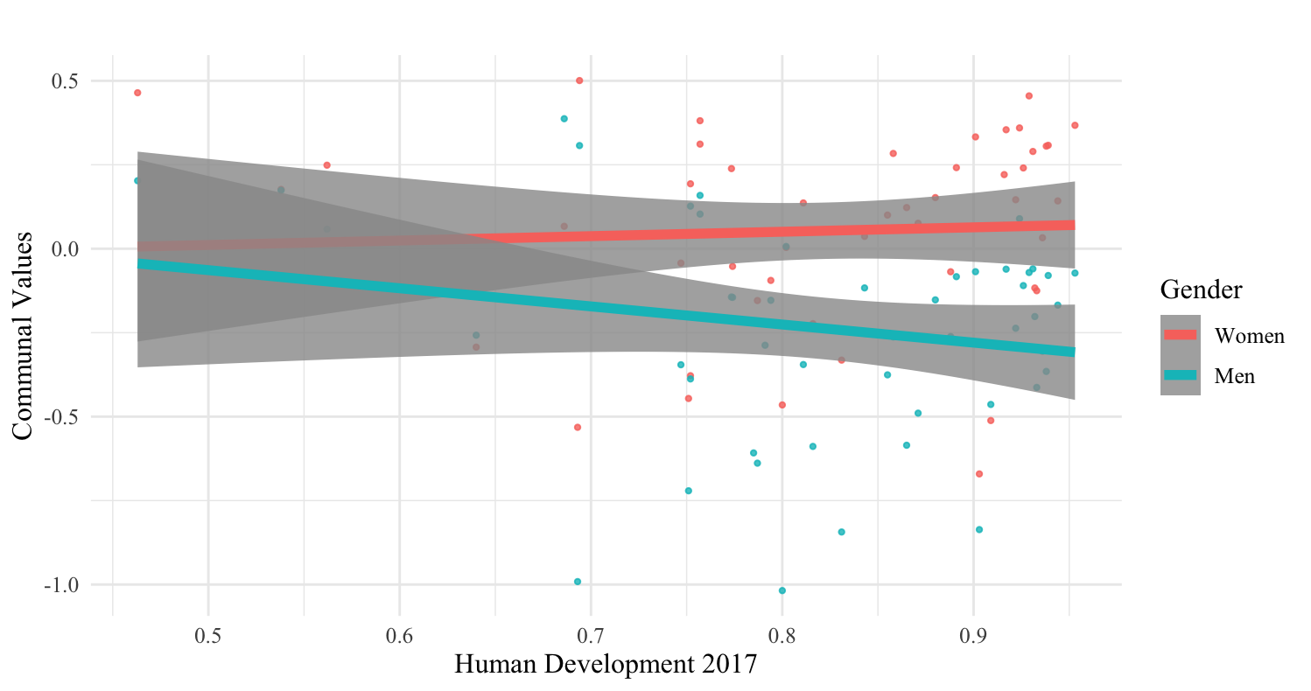
Note. Graph shows how raw scores on communal values are predicted by HDI for men and women in a simple regression line. Plotted dots are averaged communal values for a given gender in a given country.

Figure S6
HDI x Gender Predicting Dominance Values
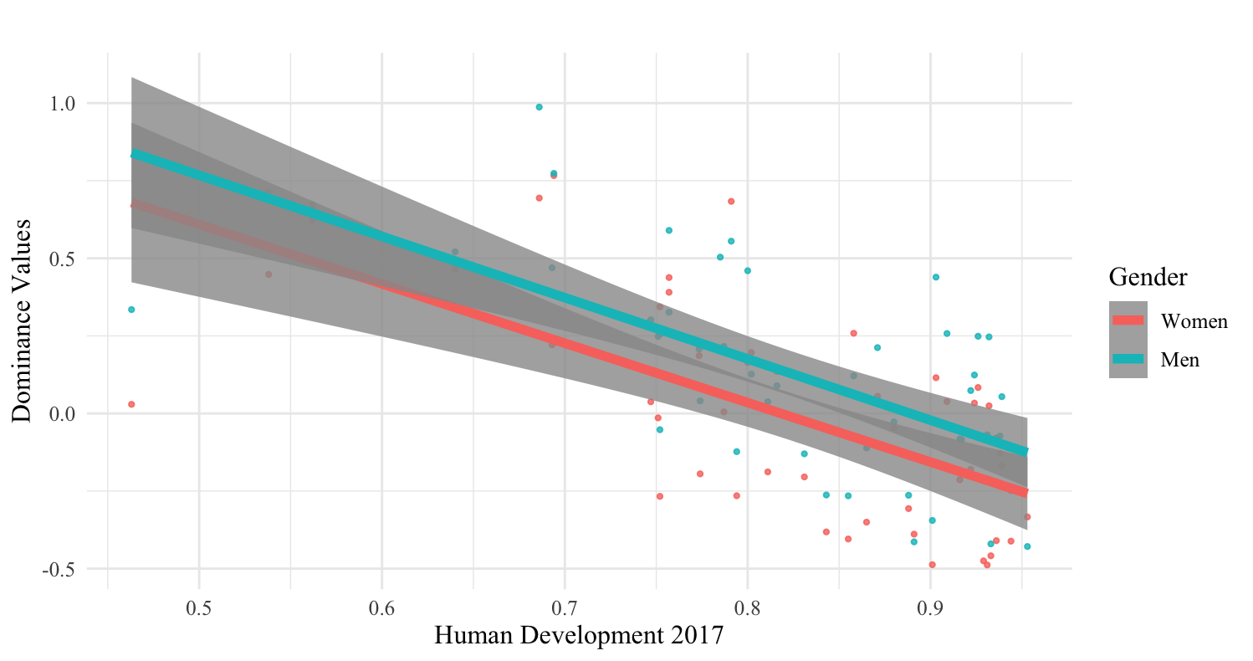
Note. Graph shows how raw scores on dominance values are predicted by HDI for men and women in a simple regression line. Plotted dots are averaged dominance values for a given gender in a given country.

Figure S7
HDI x Gender Predicting Competence Values
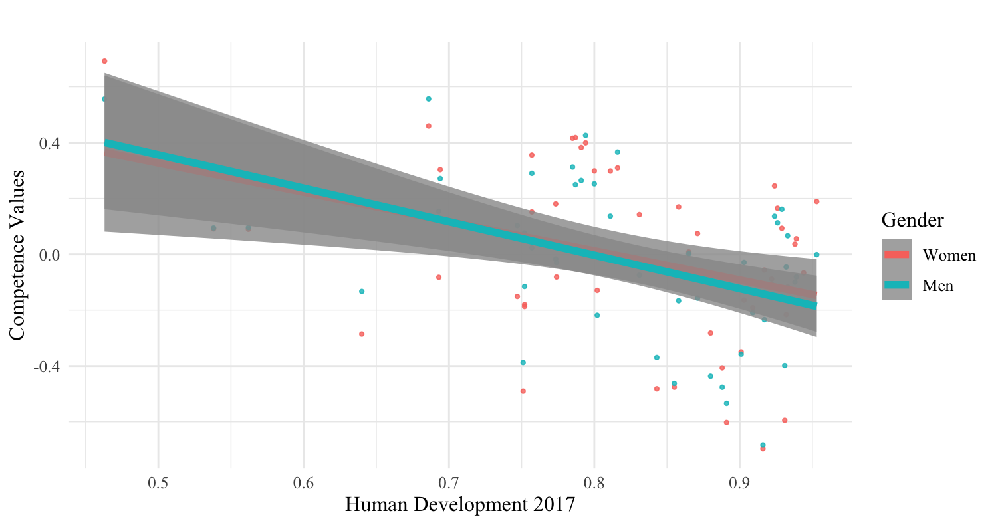
Note. Graph shows how raw scores on competence values are predicted by HDI for men and women in a simple regression line. Plotted dots are averaged competence values for a given gender in a given country.
Table S13
Gender x Country-Level Gender Differences in Values Predicting Care Economy Interest
 | Model A |  |  | Model B |  |  | Model C
Variable | B | SE | p | B | SE | p | B | SE | p
Step 1
1. Age | 0.010 | 0.003 | 0.003 | 0.010 | 0.003 | 0.003 | 0.010 | 0.003 | 0.003
2. Subjective SES | -0.01 | 0.004 | .181 | -0.01 | 0.004 | .182 | -0.01 | 0.004 | .182
3. Degree progress | 0.01 | 0.02 | .507 | 0.01 | 0.02 | .506 | 0.01 | 0.02 | .508
4. Major - STEM | -0.23 | 0.01 | <.001 | -0.23 | 0.01 | <.001 | -0.23 | 0.01 | <.001
5. Major - Social Science | 0.22 | 0.02 | <.001 | 0.22 | 0.02 | <.001 | 0.22 | 0.02 | <.001
6. Major - Business | -0.28 | 0.02 | <.001 | -0.28 | 0.02 | <.001 | -0.28 | 0.02 | <.001
7. Major - Other | -0.02 | 0.02 | .408 | -0.02 | 0.02 | .410 | -0.02 | 0.02 | .411
8. University mean age | -0.01 | 0.02 | .694 | -0.01 | 0.02 | .531 | -0.01 | 0.02 | .509
9. University mean SES | -0.002 | 0.04 | .965 | -0.01 | 0.04 | .864 | -0.01 | 0.04 | .823
10. University mean degree progress | 0.07 | 0.07 | .312 | 0.08 | 0.07 | .270 | 0.08 | 0.07 | .270
11. University status | -0.03 | 0.02 | .101 | -0.03 | 0.02 | .094 | -0.03 | 0.02 | .093
12. Gender | 0.34 | 0.02 | <.001 | 0.34 | .02 | <.001 | 0.34 | 0.03 | <.001
13. Communal differences | 0.42 | 0.31 | .183 | 0.29 | 0.31 | .357 | 0.36 | 0.34 | .294
14. HDI | - | - | - | 0.83 | 0.33 | .016 | 0.80 | 0.34 | .023
15. Dominance differences | - | - | - | - | - | - | -0.05 | 0.55 | .933
16. Competence differences | - | - | - | - | - | - | -0.44 | 0.52 | .405
Step 2
17. Gender x Communal differences | 0.85 | 0.19 | <.001 | 0.75 | 0.19 | <.001 | 0.80 | 0.20 | <.001
18. Gender x HDI | - | - | - | 0.41 | 0.20 | .052 | 0.41 | 0.21 | .053
19. Gender x Dominance differences | - | - | - | - | - | - | 0.40 | 0.32 | .216
20. Gender x Competence differences | - | - | - | - | - | - | -0.11 | 0.30 | .717
Note. Results from multilevel models testing whether country-level gender differences in communal values moderate country-level gender differences in care economy interest (Model A), over and above the effect of HDI (Model B), and over and above the effects of country-level gender differences in dominance and competence values (Model C). 1-3 are fixed individual level effects. 4-7 are effect codes corresponding to 4 major categories that were compared against care economy careers (reference group). 8-11 are fixed university-level effects. 13-16 are country-level variables. 17-20 are cross-level interactions. The effect of gender was allowed to vary by country. Communal differences, competence differences, and dominance differences refer to country-level gender differences in each respective value extracted from multilevel models adjusting for individual- and site-level demographics.
Table S14
Cultural Indicators Predicting Gender Differences in Communal Values
Cultural indicator | HDI |  |  | Individualism |  |  | Self-Expression
 | B | SE | p | B | SE | p | B | SE | p
Step 1
Cultural indicator | -0.16 | 0.34 | .649 | 0.002 | 0.001 | .246 | 0.06 | 0.04 | .227
Gender | 0.24 | 0.03 | <.001 | 0.24 | 0.03 | <.001 | 0.24 | 0.03 | <.001
Step 2
Gender x Cultural indicator | 0.57 | 0.23 | .014 | 0.002 | 0.001 | .011 | 0.04 | 0.03 | .162
Step 3
Gender x Cultural indicator | - | - | - | 0.002 | 0.001 | .245 | -0.02 | 0.04 | .654
Gender x HDI | - | - | - | 0.28 | 0.33 | .417 | 0.68 | 0.33 | .046
Note. Results from multi-levels models testing whether different cultural indicators moderate gender differences in communal values (Step 2), over and above HDI (Step 3). All analyses contain the same control variables. Control variables are omitted here for the sake of readability, but can be found in Table S13.
Table S15
Cultural Indicators Predicting Gender Differences in Care Economy Interest
Cultural indicator | Self-expression |  |  | Individualism
 | B | SE | p | B | SE | p
Step 1
Gender | 0.34 | 0.03 | <.001 | 0.34 | 0.03 | <.001
Cultural indicator | 0.15 | 0.04 | <.001 | 0.004 | 0.001 | .005
Step 2
Gender x Cultural indicator | 0.01 | 0.03 | .725 | 0.002 | 0.001 | .014
Step 3
Gender x Cultural indicator | -0.10 | 0.04 | .016 | 0.001 | 0.001 | .397
Gender x HDI | 1.19 | 0.29 | <.001 | 0.43 | 0.31 | .215
Note. Results from multi-levels models testing whether different cultural indicators moderate gender differences in care economy interest (Step 2), over and above HDI (Step 3). All analyses contain the same control variables. Control variables are omitted here for the sake of readability, but can be found in Table S13.

SECTION 12:

Sampling Information
Study Coordination and Sampling Process. This large multinational project was made possible through the coordination and infrastructure provided by a core research team and a global network of collaborators who assisted with translation, recruitment, and data collection. The core team consisted of 9 researchers (faculty and graduate students) across 3 countries who collaborated on the initial design of the project (REDACTED NAMES). This core team defined the project scope and goals, designed a questionnaire to address our central research questions, and piloted this questionnaire in Canada, Belgium, Norway, and Germany to ensure reliable and valid measurements in different contexts. After the piloting process, the questionnaire was revised and finalized.
We subsequently began recruiting collaborators, starting with researchers who study gender-related processes from within the core team’s professional networks. To ensure broad coverage of different regions of the world, we then contacted researchers from specific regions who had published in closely related research areas. Once collaborators committed, Drs. xx, xx, and xxx (REDACTED) coordinated translation procedures (see details in next section), survey set-up, and data collection with each of the collaborators. After obtaining ethics approval in line with the procedures required by each collaborator’s country and institution, collaborators were responsible for meeting recruitment targets for the student population of their university.
We initially asked our collaborators to choose from two general sampling strategies: a) recruiting 160 psychology students, or b) recruiting 80 students from care economy-related majors and 80 students from STEM-related majors. However, this was not always possible to follow these sampling guidelines 100%. In light of this, we also pre-registered the current study with controls for participants’ major in our analyses.
Since all participants were students at the collaborators' respective institutions, the vast majority of collaborators recruited students through their universities’ participant pools, which offered study credit or small monetary compensation for completing the survey. While this mostly took place online, some universities required even online surveys to be taken in person (e.g., at the {university redacted}, students had to participate in some in-person studies, so a portion of participants completed the online survey on a computer while sitting in our lab room). In lieu of a formally established “research participant pool,” some collaborators recruited students on their campus to participate. In isolated cases, this led to students from other institutions taking the survey, who were then excluded as per the pre-registration. At the end of data collection, each collaborator filled out a detailed questionnaire that asked specific questions about their institution, country, and data collection process.
Translation Details. The survey was originally first devised in English by the code-collaborator team and piloted in English, German, Dutch, and Norwegian to ensure scale reliability in different countries. For the other languages, collaborators who had published in English worked together in teams to produce a high-quality translation of the survey into their native language. We required at least one collaborator who had published in English to do the initial translation and at least one other collaborator who had published in English to check the integrity of the translation. Table S16 details which languages were used by each collaborator team. Each team of collaborators completed a site questionnaire after data collection, in which they were asked to report how confident they were in the accuracy of their translation/the translated file they received on a scale that ranged from 1 (not confident at all) to 7 (very confident). Collaborators indicated a high degree of confidence on this question, range: 6-7; M = 6.41, and reported no systematic issues after the use of the survey.

Table S16
Overview of Languages
Country code | Site_MainCollaboratorLastName | Language of survey
ALB | Albania_Jasini | Albanian
AUS | Australia_Anderson | English
AUS | Australia_DarNimrod | English
BEL | Belgium_Vangrootel | Dutch
BOL | Bolivia_Schulmeyer | Spanish
CAN | Canada_Block | English
CAN | Canada_Hall | English
CAN | Canada_Steele | English
CAN | Canada_Bergsieker | English
CHE | Switzerland_Kulich | French
CHE | Switzerland_Haessler | German
CHE | Switzerland_Nikitin | German
CHE | Switzerland_Sczesny | German
CHL | Chile_Gonzalez | Spanish
CHL | Chile_Sirlopu | Spanish
CHN | China_Zhao | Mandarin
COL | Colombia_Lopez | Spanish
COL | Colombia_Meister | Spanish
CRI | CostaRica_Smith-Castro | Spanish
CZE | Czech_Klocova | Czech
DEU | Germany_Hoppe | German
DEU | Germany_Steffens | German
DEU | Germany_Schuster | German
DNK | Denmark_Morton | Danish
ECU | Ecuador_Orrego | Spanish
ESP | Spain_Gartzia | Spanish
ESP | Spain_Lemus | Spanish
EST | Estonia_Ainsaar | Estonian
ETH | Ethiopia_Lemma | English
FRA | France_Redersdorff | French
FRA | France_Regner | French
GBR | UK_Kirby | English
HRV | Croatia_Sucic | Croatian
IDN | Indonesia_Avicenna | Indonesian
IND | India_Rani | English
IRL | Ireland_Bosak | English
ITA | Italy_Maricchiolo | Italian
JPN | Japan_Sakata | Japanese
JPN | Japan_Ishii | Japanese
KAZ | Kazakhstan_Samekin | Russian
KOR | Korea_Choi | Korean
LBN | Lebanon_Saab | English
LTU | Lithuania_Mickuviene | Lithuanian
LTU | Lithuania_Rasa | Lithuanian
MEX | Mexico_Eller | Spanish
MKD | Macedonia_Gjoneska | English
MYS | Malaysia_Ramis | English
NLD | Netherlands_Otten | Dutch
NLD | Netherlands_Vink | Dutch
NOR | Norway_Olsson | Norwegian
NZL | NewZealand_McNamara | English
PAK | Pakistan_Hassan | English
POL | Poland_Adamus | Polish
POL | Poland_Kosakowska | Polish
POL | Poland_Pyrkosz | Polish
PSE | Palestine_Marwan | Arabic
ROU | Romania_Birneanu | Romanian
RUS | Russia_Ryabichenko | Russian
SGP | Singapore_Lee | Mandarin
SRB | Serbia_Jaksic | Bosnian
SRB | Serbia_Zezelj | Bosnian
SVK | Slovakia_Fedakova | Slovak
SWE | Sweden_Back | Swedish
TUR | Turkey_Gungor | Turkish
TUR | Turkey_Kunurgu | Turkish
TZA | Tanzania_Mkamwa | English
UKR | Ukraine_Kozytska | Ukrainian
USA | USA_Croft | English
USA | USA_Xian | English
USA | USA_Bosson | English
USA | USA_Devos | English
USA | USA_Diekman | English
USA | USA_Germano | English
USA | USA_Rivera-Rodriguez | English
XKX | Kosovo_Maloku | Albanian

Additional Sample Characteristics. As seen in Tables S17a and S17b, sample sizes ranged from 119 participants (Tanzania: 53 men/66 women) to 3299 participants (USA: 1130 men/2169 women) per country. The 49 countries in our sample represent a variety of cultural regions spanning six continents, but have higher human development scores than the world on average (HDI_{mean} = .82, SD = .11, range = .46 - .82).
On average, participants in the sample were 20.52 years old (SD = 2.38). In addition, participants were either 1st year undergraduates (40.82%), 2nd year undergraduates (24.32%), 3rd year undergraduates (15.79%), 4th year undergraduates (8.6%), or master’s students (6.88%). Participants indicated majoring in care-economy-related fields (60.1%), STEM (23.7%), business (6.30%), other social sciences (4.70%), and “other” majors (5.2%). Because our collaborators recruited varying numbers of participants from the different majors, it was particularly important for us to control for majors in all analyses. In the sample, 91.00% of participants self-identified as heterosexual.
Table S17a
Participant Numbers after Exclusions by Country
Country | N_{total} | N_{men} | N_{women}
Albania | 154 | 68 | 86
Australia | 448 | 171 | 277
Belgium | 382 | 95 | 287
Bolivia | 335 | 169 | 166
Canada | 1327 | 542 | 785
Chile | 434 | 167 | 267
China | 158 | 72 | 86
Colombia | 402 | 185 | 217
Costa Rica | 214 | 89 | 125
Croatia | 416 | 228 | 188
Czech Republic | 217 | 78 | 139
Denmark | 156 | 42 | 114
Ecuador | 176 | 87 | 89
Estonia | 210 | 78 | 132
Ethiopia | 203 | 96 | 107
France | 427 | 163 | 264
Germany | 677 | 217 | 460
India | 148 | 73 | 75
Indonesia | 251 | 85 | 166
Ireland | 302 | 128 | 174
Italy | 300 | 114 | 186
Japan | 494 | 203 | 291
Kazakhstan | 149 | 72 | 77
Korea, Rep. | 155 | 88 | 67
Kosovo | 238 | 97 | 141
Lebanon | 185 | 78 | 107
Lithuania | 180 | 79 | 101
Macedonia | 159 | 71 | 88
Malaysia | 340 | 82 | 258
Mexico | 182 | 62 | 120
Netherlands | 553 | 144 | 409
New Zealand | 241 | 111 | 130
Norway | 297 | 115 | 182
Pakistan | 213 | 110 | 103
Palestine | 119 | 50 | 69
Poland | 508 | 146 | 391
Romania | 234 | 88 | 146
Russia | 182 | 78 | 104
Serbia | 773 | 193 | 580
Singapore | 208 | 90 | 118
Slovak Republic | 266 | 108 | 158
Spain | 375 | 168 | 207
Sweden | 196 | 102 | 94
Switzerland | 1085 | 376 | 709
Tanzania | 119 | 66 | 53
Turkey | 568 | 174 | 394
Ukraine | 304 | 122 | 182
United Kingdom | 281 | 54 | 227
United States | 3299 | 1130 | 2169
Table S17b
Participant Numbers After Exclusions by Country and University
Country | University | N_{total} | N_{men} |  | N_{women}
Albania | Polytech University of Tirana | 26 |  | 0 |  | 26
Albania | University of Tirana | 128 |  | 68 |  | 60
Australia | Australia Catholic University | 174 |  | 85 |  | 89
Australia | University of Sydney | 274 |  | 86 |  | 188
Belgium | KU Leuven (University of Leuven) | 382 |  | 95 |  | 287
Bolivia | Universidad Privada de Santa Cruz de la Sierra UPSA | 335 |  | 169 |  | 166
Canada | University of British Columbia | 461 |  | 226 |  | 235
Canada | University of Toronto | 228 |  | 86 |  | 142
Canada | University of Waterloo | 318 |  | 121 |  | 197
Canada | York University | 320 |  | 109 |  | 211
Chile | Mayor University | 40 |  | 17 |  | 23
Chile | Pontifical Catholic University of Chile | 174 |  | 67 |  | 107
Chile | Universidad de Chile | 30 |  | 15 |  | 30
Chile | Universidad de Concepción | 17 |  | 2 |  | 15
Chile | University of Desarrollo | 173 |  | 81 |  | 92
China | Beijing Normal University | 90 |  | 48 |  | 42
China | Nanjing Normal University | 40 |  | 8 |  | 32
China | Shenzhen University | 10 |  | 5 |  | 5
China | Sichuan Normal University | 9 |  | 2 |  | 7
China | Southwest Jiaotong University | 9 |  | 9 |  | 0
Colombia | Pontificia Universidad Javeriana | 241 |  | 99 |  | 142
Colombia | Universidad de Los Andes | 161 |  | 86 |  | 75
Costa Rica | University of Costa Rica | 214 |  | 89 |  | 125
Croatia | University of Zagreb | 416 |  | 228 |  | 188
Czech Republic | Brno University of Technology | 27 |  | 19 |  | 8
Czech Republic | Masaryk University | 190 |  | 59 |  | 131
Denmark | University of Copenhagen | 156 |  | 42 |  | 114
Ecuador | Pontificia Universidad Católica del Ecuador | 176 |  | 87 |  | 89
Estonia | University of Tartu | 210 |  | 78 |  | 132
Ethiopia | Bahir Dar University | 203 |  | 96 |  | 107
France | Aix-Marseille University | 220 |  | 85 |  | 135
France | University of Clermont Auvergne | 207 |  | 78 |  | 129
Germany | Friedrich-Alexander-University of Erlangen-Nürnberg | 14 |  | 13 |  | 1
Germany | FSU Jena | 9 |  | 1 |  | 8
Germany | Heidelberg University | 18 |  | 10 |  | 8
Germany | JGU Mainz | 7 |  | 1 |  | 6
Germany | Leuphana University | 254 |  | 65 |  | 189
Germany | MLU Halle | 6 |  | 1 |  | 5
Germany | University of Leipzig | 158 |  | 78 |  | 80
Germany | University of Koblenz-Landau | 201 |  | 46 |  | 155
Germany | University of Mannheim | 10 |  | 2 |  | 8
India | Madras School of Social Work | 68 |  | 29 |  | 39
India | Vellore Institute of Technology | 80 |  | 44 |  | 36
Indonesia | State Islamic University Sunan Gunung Djati Banung | 18 |  | 2 |  | 16
Indonesia | State Islamic University Syarif Hidayatullah Jakarta | 197 |  | 75 |  | 122
Indonesia | University of Mercu Buana | 7 |  | 1 |  | 6
Indonesia | University of Muhammadiyah | 29 |  | 7 |  | 22
Ireland | Dublin City University | 181 |  | 95 |  | 86
Ireland | Maynooth University | 121 |  | 33 |  | 88
Italy | La Sapienza University | 22 |  | 16 |  | 6
Italy | Roma Tre University | 9 |  | 0 |  | 9
Italy | University of Perugia | 269 |  | 98 |  | 171
Japan | Hiroshima University | 243 |  | 95 |  | 148
Japan | Kobe University | 179 |  | 73 |  | 106
Japan | Nagoya University | 72 |  | 35 |  | 37
Kazakhstan | L.N. Gumilyov Eurasian National University | 73 |  | 32 |  | 41
Kazakhstan | S. Toraighyrov Pavlodar State University | 76 |  | 40 |  | 36
Korea, Rep. | Seoul National University | 155 |  | 88 |  | 67
Kosovo | University for Business and Technology | 14 |  | 14 |  | 0
Kosovo | University of Prishtina | 224 |  | 83 |  | 141
Lebanon | American University of Beirut | 185 |  | 78 |  | 107
Lithuania | Kauno Technologijos Universitetas | 96 |  | 64 |  | 32
Lithuania | LSMU | 84 |  | 15 |  | 69
Macedonia | European University of Skopje (Private) | 16 |  | 8 |  | 8
Macedonia | Ss. Cyril and Methodius University of Skopje (Public) | 143 |  | 63 |  | 80
Malaysia | HELP University | 340 |  | 82 |  | 258
Mexico | UNAM | 182 |  | 62 |  | 120
Netherlands | University of Groningen | 330 |  | 81 |  | 249
Netherlands | Utrecht University | 223 |  | 63 |  | 160
New Zealand | Victoria University of Wellington | 241 |  | 111 |  | 130
Norway | UiT | 297 |  | 115 |  | 182
Pakistan | Comsats University | 96 |  | 67 |  | 29
Pakistan | International Islamic University Islamabad | 101 |  | 34 |  | 67
Pakistan | University of Wah | 16 |  | 9 |  | 7
Palestine | Islamic University of Gaza | 119 |  | 50 |  | 69
Poland | AGH University of Science and Technology | 196 |  | 72 |  | 124
Poland | Ignatianum Academy | 9 |  | 0 |  | 9
Poland | Jagiellonian University | 109 |  | 11 |  | 98
Poland | Pedagogical University of Krakow | 6 |  | 1 |  | 5
Poland | University of Gdansk | 188 |  | 33 |  | 155
Romania | Universitatea de Vest | 234 |  | 88 |  | 146
Russia | Moscow City Teacher Training University | 28 |  | 21 |  | 7
Russia | Moscow State University of Psychology and Education | 15 |  | 3 |  | 12
Russia | National Research University Higher School of Economics | 124 |  | 46 |  | 78
Russia | State Academic University for the Humanities | 15 |  | 8 |  | 7
Serbia | Singidunum | 6 |  | 5 |  | 1
Serbia | University of Belgrade | 558 |  | 158 |  | 400
Serbia | University of Kragujevac | 33 |  | 7 |  | 26
Serbia | University of Nisu | 121 |  | 20 |  | 101
Serbia | University of Novi Sad | 49 |  | 3 |  | 46
Serbia | University of Zagreb | 6 |  | 0 |  | 6
Singapore | Nanyang Technological University | 202 |  | 87 |  | 115
Singapore | National University of Singapore | 6 |  | 3 |  | 3
Slovak Republic | Commenius University | 77 |  | 9 |  | 68
Slovak Republic | Constantine the Philosopher University | 21 |  | 7 |  | 14
Slovak Republic | Economic University | 22 |  | 5 |  | 17
Slovak Republic | Masaryk University | 1 |  | 0 |  | 1
Slovak Republic | Slovak University of Agriculture | 17 |  | 12 |  | 5
Slovak Republic | Technical University Kosiciach | 73 |  | 57 |  | 16
Slovak Republic | Technical University Trnave | 13 |  | 3 |  | 10
Slovak Republic | The University of Presov | 6 |  | 2 |  | 4
Slovak Republic | Univerzita Pavla Jozefa Safarika | 36 |  | 13 |  | 23
Spain | Deusto Business School | 205 |  | 87 |  | 118
Spain | University of Granada | 170 |  | 81 |  | 89
Sweden | Chalmers University of Technology | 10 |  | 9 |  | 1
Sweden | Lund University | 22 |  | 6 |  | 16
Sweden | University of Gothenburg | 164 |  | 87 |  | 77
Switzerland | Technical University of Zurich (ETH) | 76 |  | 23 |  | 53
Switzerland | University of Basel | 101 |  | 57 |  | 44
Switzerland | University of Bern | 195 |  | 76 |  | 119
Switzerland | University of Geneva | 387 |  | 95 |  | 292
Switzerland | University of Zurich | 306 |  | 119 |  | 187
Switzerland | Zurich University of Applied Science | 20 |  | 6 |  | 14
Tanzania | St. Augustine University of Tanzania | 119 |  | 66 |  | 53
Turkey | Izmr Katip Celebi University | 428 |  | 145 |  | 283
Turkey | Yasar University | 140 |  | 29 |  | 111
Ukraine | Dragomanov University | 9 |  | 9 |  | 0
Ukraine | Taras Shevchenko National University of Kyiv | 295 |  | 113 |  | 182
United Kingdom | University of Exeter | 281 |  | 54 |  | 227
United States | Indiana University | 387 |  | 118 |  | 269
United States | Miami University | 185 |  | 83 |  | 102
United States | San Diego State University | 431 |  | 158 |  | 273
United States | University of Arizona | 657 |  | 143 |  | 514
United States | University of Kansas | 540 |  | 226 |  | 314
United States | University of Massachusetts Amherst | 245 |  | 109 |  | 136
United States | University of South Florida | 324 |  | 99 |  | 225
United States | University of Washington | 530 |  | 194 |  | 336

SECTION 13: Multiple Imputations
As some countries in our sample had missing data on one or more country-level indicator(s), we pre-registered imputing missing values with multiple imputation procedures (m = 10 imputed datasets). To maximize the information that was available for imputations, we ran imputations with Amelia II in R, based on a larger dataset of countries including a number of cross-national variables that were relevant for different pre-registrations of the larger consortium (see https://osf.io/b52uv for an example). In accordance with procedures for working with imputed datasets, all analyses were repeated 10 times (one with each imputed version). The 10 results were then averaged. Notably, some variables had relatively higher degree of missingness (see Table S18). Given the degree to which some variables are imputed, results using those variables should be interpreted with caution.

Table S18
Number of Missing Values (of 49 Countries) that were Imputed
Variable | N_{missing}
GDP | 0
HDI | 1
% of workers in wage and salaried positions | 1
% of workers in the service industry | 1
# parental leave weeks | 1
# maternity leave days | 1
GGGI overall score | 2
% women in education | 2
Individualism | 11
Intellectual autonomy | 11
% men in STEM | 12
% women in care economy | 12
Self-expression | 14
Pro-sociality | 15

References
Adler, N. E., Epel, E. S., Castellazzo, G., & Ickovics, J. R. (2000). Relationship of subjective and objective social status with psychological and physiological functioning: Preliminary data in healthy, White women. Health Psychology, 19(6), 586–592. https://doi.org/10.1037/0278-6133.19.6.586
Charles, M. (1992). Cross-national variation in occupational sex segregation. American Sociological Review, 57(4), 483–502. https://doi.org/10.2307/2096096
Charles, M. (2003). Deciphering sex segregation: Vertical and horizontal inequalities in ten
national labor markets. Acta Sociologica, 46(4), 267–287. https://doi.org/10.1177/0001699303464001
Diekman, A. B., Joshi, M. P., & Benson-Greenwald, T. M. (2020). Goal congruity theory: navigating the social structure to fulfil goals. Advances in Experimental Social Psychology, 62, 189–244. https://doi.org/10.1016/bs.aesp.2020.04.003
Falk, A., & Hermle, J. (2018). Relationship of gender differences in preferences to economic development and gender equality. Science, 362(6412). https://doi.org/10.1126/science.aas9899
George, D., & Mallery, P. (2003). Reliability analysis. SPSS for Windows, step by step: a simple guide and reference (14th ed., pp. 222–232). Allyn & Bacon.
International Labour Office. (2013). Global Employment Trends 2013: Recovering from a second jobs dip. International Labour Organization. https://www.ilo.org/wcmsp5/groups/public/---dgreports/---dcomm/---publ/documents/publication/wcms_202326.pdf
International Labour Office. (2017). World employment and social outlook: Trends 2017. International Labour Organization. https://www.ilo.org/wcmsp5/groups/public/---dgreports/---dcomm/---publ/documents/publication/wcms_541211.pdf
Marsh, H. W., Parker, P. D., Guo, J., Basarkod, G., Niepel, C., & Van Zanden, B. (2020). Illusory gender-equality paradox, math self-concept, and frame-of-reference effects: new integrative explanations for multiple paradoxes. Journal of Personality and Social Psychology, 121(1), 168–183. https://doi.org/10.1037/pspp0000306
Schwab, K., Samans, R., Zahidi, S., Leopold, T. A., Ratcheva, V., Hausmann, R., & Tyson, L. D. (2017). The global gender gap report 2017. World Economic Forum. https://www3.weforum.org/docs/WEF_GGGR_2017.pdf
Schwartz, S. H. (1999). A theory of cultural values and some implications for work. Applied Psychology, 48(1), 23–47. https://doi.org/10.1111/j.1464-0597.1999.tb00047.x
Schwartz, S. H. (2008). The 7 Schwartz cultural value orientation scores for 80 countries [Dataset]. https://doi.org/10.13140/RG.2.1.3313.3040
Stoet, G., & Geary, D. C. (2018). The gender-equality paradox in science, technology, engineering, and mathematics education. Psychological Science, 29(4), 581–593. https://doi.org/10.1177/0956797617741719

