SOM Section 1. Additional Information about the Cohorts Used in Each Analysis
Table S1.

Description of Cohorts Used in Each Analysis
 | Cohort Assignment |  |  |  |  |  | Time Coding for Accelerated Longitudinal Design model
 | Year |  |  |  |  |  |  | Year
Grade | 2015 | 2016 | 2017 | 2018 |  |  | Grade | 2015 | 2016 | 2017 | 2018
4 | C1 |  |  |  |  |  | 4 | 0
5 | C2 | C1 |  |  |  |  | 5 | 1 | 1
6 | C3 | C2 | C1 |  |  |  | 6 | 2 | 2 | 2
7 | C4 | C3 | C2 | C1 |  |  | 7 | 3 | 3 | 3 | 3
8 | C5 | C4 | C3 | C2 |  |  | 8 | 4 | 4 | 4 | 4
9 | C6 | C5 | C4 | C3 |  |  | 9 | 5 | 5 | 5 | 5
10 |  | C6 | C5 | C4 |  |  | 10 |  | 6 | 6 | 6
11 |  |  | C6 | C5 |  |  | 11 |  |  | 7 | 7
12 |  |  |  | C6 |  |  | 12 |  |  |  | 8
Note. For the Accelerated Longitudinal Design model, one single model pooling all cohorts together is estimated.
SOM Section 2. Background on the CORE Data
The CORE SEC measurement at scale began when the districts received a waiver from the U.S. Department of Education freeing six of the CORE districts from various No Child Left Behind (NCLB) requirements in return for developing innovative approaches to school accountability. To serve their “whole child” approach, the districts decided to include SECs in their accountability system. Under the waiver, the SEL surveys were assigned weights and used in conjunction with the other academic measures to create a school composite used to identify schools for improvement. However, with the passage of The Every Student Succeeds Act (ESSA), the districts are no longer beholden to the waiver, and therefore no longer create composite school scores or attach consequences to the SEL surveys. Nonetheless, the districts still administer SEL surveys to students in Grades 4–12 and use them in a multiple-measures framework to support students and schools.
SOM Section 3. Additional Information about the Data Analytic Approach
Question 1: How much growth occurs in SECs from grades 4-12?
Accelerated Longitudinal Design (pooling across cohorts)
Model Specification. Given SEC surveys were administered during consistent windows each spring, the time variable was coded as zero in year one for our youngest cohort (students in grade 4 in 2015) and counted up by one for each grade level and year increased (see Table S1 in the SOM for the timing coding). Under this model, the IRT-based SEC score $y_{tij}$for student i at timepoint t was modeled as a function of years elapsed (${time}_{ti}).$ To allow for potential nonlinearity in growth patterns across time, we compared the fit of linear, quadratic, and cubic specifications in the model. For simplicity, we describe the cubic model only below.
At level 1, the growth model can be expressed as:
$y_{ti}= π_{0i}+π_{1i}{time}_{ti}+π_{2i}{time}_{ti}^{2}+π_{2i}{time}_{ti}^{3}+e_{ti}.$

The intercept $(π_{0i})$ is the predicted score for student i in spring of the first year (t=0), $π_{1i}$is the average instantaneous rate of change at in spring of the first year, and $π_{2ij}$is the average rate of change of the linear growth term at the first timepoint for a one-unit change in time (i.e., the acceleration or deceleration in growth) , and $π_{3ij}$ is the cubic term. At level 2 the model, the intercept, linear, and quadratic growth parameters were allowed to vary among students. However, we observed almost no between-student variation in the cubic term and so the cubic growth parameter was treated as fixed across students.
Level-2 Model (student (i)):
$$π_{0i}=β_{00}+r_{0i}$$
$$π_{1i}=β_{10}+r_{1i}$$
$$π_{2i}=β_{20 }+r_{2i}$$
$$π_{3i}=β_{30 }$$

Variance component specification:

$e_{ti} \sim N\left(0, σ^{2}\right), r_{i}\sim MVN\left(0, τ\right)$.

Model assumptions. While ALD models allow one to make inferences about a much broader developmental timeline, they also require assumptions. As noted by Estrada and Ferrer (2019), ALD assumes that all the overlapping cohorts share a common longitudinal trajectory in the variables of interest, and this trajectory can be studied by aggregating the information provided by the different cohorts. Thus, ALD is often conceptualized as being conducted through a “convergence” analysis of the longitudinal and cross-sectional information (McArdle & Bell, 2000). While such assumptions are not trivial and untestable (a noted limitation), they are nonetheless theoretically justified, paving the way for ALD to be used in many educational and psychological studies, especially looking at youth development. For example, Watt (2008) used an ALD to describe different trajectories for adolescent boys and girls in their perceptions and values associated with English and math. Despite the growing use of ALD in psychological research, we nonetheless conducted analyses to test the sensitivity of our results to ALD assumptions. As described in the Separate Cohort Growth Model section below, we also estimated GCMs separately by cohort to confirm that results were mostly consistent even without smoothing over cohort differences. Additionally, we assume homogeneity of residual variance at level 1 (a typical assumption in hierarchical or mixed linear modeling).
Model estimation. The ALD GCM was estimated separately by SEC construct using restricted maximum likelihood estimation in Mplus Version 8.3 (Muthén & Muthén, 2022). Model fit was compared using the Akaike information criterion [AIC] and Bayesian information criterion [BIC] to select the best functional form. That is, the model was specified in different ways (building from an intercept-only model to sequentially include a slope, quadratic, and cubic) and then the best-fitting model was selected. For the ALD models, the cubic model always fit the data best. Parameter estimates for the ALDs can be found in Table S2 and the model-based growth trajectories for each ALD model are shown in Figure 1 of the main paper as dotted black lines. The key parameters are $β_{00}$ (mean score at time 1), $β_{10}$ (linear change in scores per year of school), and $β_{20}$ (quadratic change in scores per year of school). In addition, we examined the variability in growth rates (in the form of random effect variances in the$τ$ matrix) and the relationship between initial status and growth (the correlation term within the random effect variance-covariance matrix).
Separate Cohort Growth Model
Model Specification. We also estimated growth across the four-year span for each SEC within each of our six grade cohorts separately (cohort structure shown in Table S1 in the SOM). Time in the cohort-specific growth models was coded as 0 in 2015 up to 3 in 2018. Using the same latent GCM framework as in the prior analyses, we estimated the model for each cohort/construct as an intercept only, linear, and quadratic specification (cubic was not possible given only four available timepoints).
Model estimation. The GCMs by cohort/SEC were also estimated using Mplus Version 8.3 (Muthén & Muthén, 2022). The latent means, variances, and correlation estimates are shown in Table S2 through S5 of the SOM. The model-based growth trajectories for each cohort/SEC are also visualized in Figure 1 (of the main paper) as solid lines. Comparison of the model fit for each cohort and construct is shown in Table S4. In all cases, the quadratic model showed superior fit (lower AIC and BIC).
Research Question 2: Do initial status and growth differ by parent educational attainment and gender?
In Question 2, we examined how growth trajectories for each construct differed by parental education and student gender. Specifically, we first re-estimated our ALD model conditioning on parental education attainment (i.e., high school completion or not). At level-2:
Level-1 Model (time points (t) within student (i)):
$y_{ti}= π_{0i}+π_{1i}{time}_{ti}+π_{2i}{time}_{ti}^{2}+π_{2i}{time}_{ti}^{3}+e_{ti}.$

Level-2 Model (student (i)):
$$π_{0i}=β_{00}+β_{01}ParentEd_{i}+r_{0i}$$
$$π_{1i}=β_{10}+β_{11}ParentEd_{i}+r_{1i}$$
$$π_{2i}=β_{20 }+β_{21}ParentEd_{i}+r_{2i}$$
$$π_{3i}=β_{30 }$$

The intercept $(β_{00})$ in this model is the predicted score in spring of the first year (t=0) for the reference group (e.g., the students whose parents did not complete high school), $β_{10}$is the average instantaneous rate of change in spring of the first year for the reference group, and $β_{20 }$is the quadratic term for the reference group. The terms $β_{01}$, $β_{11}, β_{21}$ represent the differences between students whose parents did and did not complete high school in the intercept, slope, and quadratic respectively. In this model, we do not assume the cubic term ($β_{30 })$ varies by group status.
We used the parameter estimates from this model to produce the average growth trajectories for each group shown in Figure 2a of the main paper. Since students whose parents did not complete high school are the reference group in the model, their growth trajectory calculated based on the growth parameters for the reference group ($\hat{β_{00}}$ +$\hat{β_{10}}time+\hat{β_{20}}time^{2}+\hat{β_{30}}time^{3}$). The average trajectory for the students whose parents did complete high school is calculated by added in the coefficients representing the parent educational attainment difference in intercept and slope (($\hat{β_{00}}$ +$\hat{β_{01}}$)+$\left(\hat{β_{10}}+\hat{β_{11}}\right)time+(\hat{β_{20}}+\hat{β_{21}})time^{2}+(\hat{β_{30}}+\hat{β_{31}})time^{3}$). The same calculations were also done to produce the trajectories by gender (Figure 2b of the main paper), where female students are the reference group and male students’ growth is calculated based on adding together the reference group parameters and male-female difference estimates.
We quantified the degree to which our observed covariates can be used to explain heterogeneity in the trajectories for each construct using the using the pseudo R². Specifically, we calculated a pseudo-R² estimate for the intercept and linear slope term for each construct. Pseudo R² statistics provide an indication of the amount of variance accounted for in the model by comparing the variance component of the unconditional model to the same variance component in the conditional growth model (Raudenbush & Bryk, 2002):
$$Pseudo R^{2}=\frac{σ_{uncond}^{2}-σ_{cond}^{2}}{σ_{uncond}^{2}}.$$
We estimated the pseudo R² separately for the parental educational attainment and gender variables, as well as for a model containing both covariates (parental education, gender).

SOM Section 4. Additional Results, Including for Growth Curve Models Estimated by Cohort

Table S2
Estimates from Accelerated Longitudinal Design Models by Construct
Model | Intercept | Linear | Quadratic | Cubic | Variance (Intercept) | Variance (Slope) | Variance (Quadratic) | Correlation of Intercept & Slope
Growth mindset | 0.003 (0.008) | 0.174  (0.007) | -0.023 (0.002) | 0.001 (0.000) | 0.911 (0.016) | 0.155 (0.005) | 0.001 (0.000) | -0.399 (0.003)
Self-efficacy | 0.254 (0.008) | 0.011  (0.007) | -0.046 (0.002) | 0.005 (0.000) | 0.904 (0.014) | 0.136 (0.004) | 0.001 (0.000) | -0.485 (0.003)
Self-management | 0.287 (0.008) | -0.031 (0.006) | -0.018 (0.002) | 0.002 (0.000) | 1.080 (0.016) | 0.145 (0.004) | 0.001 (0.000) | -0.478 (0.003)
Social awareness | 0.165 (0.008) | -0.185 (0.006) | 0.003  (0.002) | 0.002 (0.000) | 1.010 (0.014) | 0.148 (0.004) | 0.001 (0.000) | -0.569 (0.003)

Note. The cubic term was fixed (e.g., variance was assumed to be zero) so we do not report the variance (or covariances) for the cubic term. The standard errors are shown below each estimate in parentheses.

Table S3

Parameter Estimates for the Cohort-Specific Growth Curve Models

Construct | Cohort | Grade at time 1 | Grade at time 4 | Intercept | Linear | Quadratic | Variance (Intercept) | Variance (Slope) | Variance (Quadratic) | Corr. (Intercept & Slope)
GM | 1 | 4 | 7 | -0.019 (0.009) | 0.473 (0.011) | -0.110 (0.003) | 0.563 (0.012) | 0.338 (0.024) | 0.017 (0.002) | 0.087 (0.002)
GM | 2 | 5 | 8 | 0.205 (0.009) | 0.077 (0.010) | 0.006 (0.003) | 0.820 (0.012) | 0.415 (0.018) | 0.023 (0.002) | -0.221 (0.003)
GM | 3 | 6 | 9 | 0.266 (0.009) | 0.065 (0.009) | 0.007 (0.003) | 0.847 (0.013) | 0.331 (0.019) | 0.015 (0.002) | -0.193 (0.003)
GM | 4 | 7 | 10 | 0.191 (0.008) | 0.204 (0.008) | -0.036 (0.003) | 0.767 (0.011) | 0.212 (0.016) | 0.010 (0.002) | 0.050 (0.002)
GM | 5 | 8 | 11 | 0.317 (0.009) | 0.112 (0.008) | -0.017 (0.003) | 0.840 (0.011) | 0.288 (0.014) | 0.018 (0.001) | -0.079 (0.002)
GM | 6 | 9 | 12 | 0.395 (0.009) | 0.077 (0.009) | -0.001 (0.003) | 0.829 (0.012) | 0.319 (0.018) | 0.026 (0.002) | -0.006 (0.002)
SA | 1 | 4 | 7 | 0.054 (0.009) | 0.093 (0.010) | -0.072 (0.003) | 0.774 (0.014) | 0.240 (0.018) | 0.011 (0.002) | -0.311 (0.003)
SA | 2 | 5 | 8 | 0.059 (0.009) | -0.207 (0.009) | 0.018 (0.002) | 0.802 (0.013) | 0.368 (0.016) | 0.018 (0.001) | -0.383 (0.003)
SA | 3 | 6 | 9 | -0.101 (0.008) | -0.341 (0.008) | 0.087 (0.002) | 0.659 (0.011) | 0.233 (0.014) | 0.014 (0.001) | -0.202 (0.003)
SA | 4 | 7 | 10 | -0.359 (0.007) | -0.112 (0.007) | 0.045 (0.002) | 0.615 (0.010) | 0.131 (0.013) | 0.007 (0.001) | -0.014 (0.002)
SA | 5 | 8 | 11 | -0.475 (0.007) | 0.006 (0.006) | 0.026 (0.002) | 0.651 (0.010) | 0.093 (0.009) | 0.005 (0.001) | -0.089 (0.003)
SA | 6 | 9 | 12 | -0.460 (0.007) | 0.058 (0.007) | 0.015 (0.002) | 0.563 (0.010) | 0.034 (0.012) | 0.002 (0.001) | 0.202 (0.002)
SE | 3 | 6 | 9 | 0.182 (0.009) | -0.240 (0.010) | 0.031 (0.003) | 0.735 (0.013) | 0.364 (0.025) | 0.027 (0.002) | -0.236 (0.003)
SE | 4 | 7 | 10 | 0.008 (0.009) | -0.124 (0.009) | 0.002 (0.003) | 0.720 (0.013) | 0.222 (0.022) | 0.013 (0.002) | -0.215 (0.003)
SE | 5 | 8 | 11 | -0.088 (0.009) | -0.206 (0.009) | 0.041 (0.003) | 0.734 (0.012) | 0.270 (0.021) | 0.020 (0.002) | -0.288 (0.003)
SE | 6 | 9 | 12 | -0.180 (0.009) | -0.179 (0.010) | 0.057 (0.003) | 0.638 (0.012) | 0.163 (0.022) | 0.011 (0.002) | -0.146 (0.003)
SM | 1 | 4 | 7 | 0.091 (0.009) | 0.142 (0.009) | -0.057 (0.003) | 0.804 (0.014) | 0.171 (0.017) | 0.012 (0.002) | -0.135 (0.003)
SM | 2 | 5 | 8 | 0.271 (0.009) | -0.133 (0.009) | 0.006 (0.003) | 0.877 (0.013) | 0.454 (0.018) | 0.027 (0.002) | -0.336 (0.003)
SM | 3 | 6 | 9 | 0.294 (0.009) | -0.284 (0.009) | 0.060 (0.003) | 0.861 (0.013) | 0.371 (0.016) | 0.025 (0.002) | -0.297 (0.003)
SM | 4 | 7 | 10 | 0.128 (0.009) | -0.092 (0.008) | 0.017 (0.002) | 0.823 (0.013) | 0.222 (0.017) | 0.011 (0.002) | -0.309 (0.003)
SM | 5 | 8 | 11 | 0.066 (0.008) | -0.060 (0.008) | 0.023 (0.002) | 0.751 (0.012) | 0.180 (0.015) | 0.010 (0.002) | -0.318 (0.003)
SM | 6 | 9 | 12 | 0.065 (0.008) | 0.058 (0.009) | -0.012 (0.003) | 0.590 (0.011) | 0.176 (0.018) | 0.012 (0.002) | -0.211 (0.003)

Note. GM is Growth Mindset, SE is Self-Efficacy, SM is Self-Management, SA is Social Awareness

Table S4

Model Fit and Best-Fitting Model for the Cohort-specific Growth Curve Models
 |  | Model 1 – Linear |  |  |  | Model 2(a) - Quadratic |  |  |  | Model 2 (b) - Quadratic with random slope/quadratic term
Construct | Cohort | AIC | BIC | Log-likelihood |  | AIC | BIC | Log-likelihood |  | AIC | BIC | Log-likelihood
GM | 1 | 106127 | 106179 | -53057 |  | 104704 | 104764 | -52345 |  | 103638 | 103725 | -51809
GM | 2 | 101830 | 101882 | -50909 |  | 101831 | 101892 | -50909 |  | 100983 | 101069 | -50481
GM | 3 | 96351 | 96403 | -48170 |  | 96351 | 96411 | -48168 |  | 95476 | 95562 | -47728
GM | 4 | 94030 | 94081 | -47009 |  | 93765 | 93826 | -46876 |  | 93094 | 93180 | -46537
GM | 5 | 85493 | 85544 | -42740 |  | 85430 | 85490 | -42708 |  | 84712 | 84797 | -42346
GM | 6 | 82167 | 82218 | -41078 |  | 82168 | 82227 | -41077 |  | 81651 | 81736 | -40816
SE | 1 | 105194 | 105246 | -52591 |  | 104529 | 104590 | -52258 |  | 104327 | 104414 | -52154
SE | 2 | 102897 | 102949 | -51443 |  | 102899 | 102959 | -51442 |  | 102185 | 102271 | -51082
SE | 3 | 96673 | 96725 | -48331 |  | 96583 | 96643 | -48284 |  | 96106 | 96192 | -48043
SE | 4 | 95427 | 95478 | -47707 |  | 95429 | 95489 | -47707 |  | 95133 | 95219 | -47556
SE | 5 | 87830 | 87881 | -43909 |  | 87632 | 87691 | -43809 |  | 87421 | 87506 | -43701
SE | 6 | 80478 | 80529 | -40233 |  | 80145 | 80205 | -40066 |  | 80021 | 80105 | -40000
SM | 1 | 98665 | 98717 | -49326 |  | 98145 | 98206 | -49066 |  | 97925 | 98011 | -48952
SM | 2 | 97225 | 97277 | -48606 |  | 97227 | 97287 | -48606 |  | 95978 | 96064 | -47979
SM | 3 | 89936 | 89987 | -44962 |  | 89377 | 89437 | -44682 |  | 88478 | 88564 | -44229
SM | 4 | 88935 | 88987 | -44462 |  | 88894 | 88954 | -44440 |  | 88321 | 88407 | -44150
SM | 5 | 79394 | 79446 | -39691 |  | 79311 | 79371 | -39648 |  | 79046 | 79132 | -39513
SM | 6 | 74564 | 74615 | -37276 |  | 74545 | 74604 | -37266 |  | 74414 | 74498 | -37197
SA | 1 | 95250 | 95302 | -47619 |  | 94413 | 94473 | -47199 |  | 94078 | 94164 | -47029
SA | 2 | 92350 | 92401 | -46169 |  | 92321 | 92381 | -46154 |  | 91216 | 91302 | -45598
SA | 3 | 84727 | 84779 | -42358 |  | 83387 | 83448 | -41687 |  | 82781 | 82867 | -41380
SA | 4 | 82142 | 82193 | -41065 |  | 81770 | 81830 | -40878 |  | 81343 | 81429 | -40662
SA | 5 | 72304 | 72356 | -36146 |  | 72159 | 72219 | -36072 |  | 71990 | 72076 | -35985
SA | 6 | 67602 | 67653 | -33795 |  | 67571 | 67631 | -33779 |  | 67483 | 67567 | -33731
Note. GCM refers to Growth Curve Models, GM is Growth Mindset, SE is Self-Efficacy, SM is Self-Management, SA is Social Awareness, AIC refers to Alternative Bayesian Information Criterion, BIC refers to Bayesian Information Criterion.

Table S5(a)

Correlations among SEC Scores and Demographic Variables, Growth Mindset

 | GM.4 | GM.5 | GM.6 | GM.7 | GM.8 | GM.9 | GM.10 | GM.11 | GM.12 | Gender | ParentEd | Black | Hisp | Asian | Other
GM.4 | 1.00
GM.5 | 0.57 | 1.00
GM.6 | 0.53 | 0.70 | 1.00
GM.7 | 0.46 | 0.59 | 0.77 | 1.00
GM.8 |  | 0.48 | 0.64 | 0.81 | 1.00
GM.9 |  |  | 0.55 | 0.69 | 0.82 | 1.00
GM.10 |  |  |  | 0.61 | 0.72 | 0.84 | 1.00
GM.11 |  |  |  |  | 0.63 | 0.74 | 0.85 | 1.00
GM.12 |  |  |  |  |  | 0.70 | 0.76 | 0.83 | 1.00
Gender | -0.03 | -0.03 | -0.02 | -0.01 | -0.01 | 0.01 | 0.01 | 0.01 | 0.00 | 1.00
ParentEd | -0.05 | -0.13 | -0.13 | -0.13 | -0.10 | -0.10 | -0.08 | -0.08 | -0.09 | -0.01 | 1.00
Black | -0.01 | 0.03 | 0.04 | 0.05 | 0.05 | 0.05 | 0.07 | 0.06 | 0.05 | 0.00 | -0.14 | 1.00
Hispanic | -0.09 | -0.15 | -0.16 | -0.16 | -0.14 | -0.13 | -0.12 | -0.09 | -0.07 | -0.01 | 0.27 | -0.48 | 1.00
Asian | 0.01 | 0.04 | 0.04 | 0.04 | 0.03 | 0.03 | 0.01 | 0.00 | 0.00 | 0.00 | -0.08 | -0.09 | -0.43 | 1.00
Other | -0.01 | 0.02 | 0.01 | 0.03 | 0.02 | 0.03 | 0.03 | 0.03 | 0.04 | 0.00 | -0.08 | -0.05 | -0.25 | -0.05 | 1.00
Note. ParentEd refers to parental educational attainment where 1 = less than high school education, 0 = high school education or higher.

Table S5(b)

Correlations among SEC Scores and Demographic Variables, Self-efficacy

 | SE.4 | SE.5 | SE.6 | SE.7 | SE.8 | SE.9 | SE.10 | SE.11 | SE.12 | Gender | ParentEd | Black | Hisp | Asian | Other
SE.4 | 1.00
SE.5 | 0.60 | 1.00
SE.6 | 0.51 | 0.59 | 1.00
SE.7 | 0.40 | 0.47 | 0.66 | 1.00
SE.8 |  | 0.42 | 0.56 | 0.71 | 1.00
SE.9 |  |  | 0.47 | 0.57 | 0.68 | 1.00
SE.10 |  |  |  | 0.50 | 0.59 | 0.71 | 1.00
SE.11 |  |  |  |  | 0.52 | 0.59 | 0.71 | 1.00
SE.12 |  |  |  |  |  | 0.55 | 0.62 | 0.71 | 1.00
Gender | -0.03 | 0.00 | 0.04 | 0.10 | 0.12 | 0.14 | 0.16 | 0.15 | 0.16 | 1.00
SES | -0.05 | -0.11 | -0.10 | -0.08 | -0.08 | -0.06 | -0.06 | -0.04 | -0.06 | -0.01 | 1.00
Black | 0.02 | 0.05 | 0.05 | 0.04 | 0.05 | 0.04 | 0.04 | 0.03 | 0.03 | 0.00 | -0.14 | 1.00
Hisp | -0.08 | -0.12 | -0.13 | -0.13 | -0.14 | -0.12 | -0.11 | -0.07 | -0.08 | -0.01 | 0.27 | -0.48 | 1.00
Asian | -0.03 | 0.00 | 0.00 | 0.01 | 0.03 | 0.01 | 0.02 | 0.00 | 0.00 | 0.00 | -0.08 | -0.09 | -0.43 | 1.00
Other | -0.02 | 0.03 | 0.02 | 0.03 | 0.04 | 0.04 | 0.03 | 0.04 | 0.04 | 0.00 | -0.08 | -0.05 | -0.25 | -0.05 | 1.00
Note. ParentEd refers to parental educational attainment where 1 = less than high school education, 0 = high school education or higher.

Table S5(c)

Correlations among SEC Scores and Demographic Variables, Self-management

 | SM.4 | SM.5 | SM.6 | SM.7 | SM.8 | SM.9 | SM.10 | SM.11 | SM.12 | Gender | ParentEd | Black | Hisp | Asian | Other
SM.4 | 1.00
SM.5 | 0.71 | 1.00
SM.6 | 0.65 | 0.72 | 1.00
SM.7 | 0.53 | 0.57 | 0.77 | 1.00
SM.8 |  | 0.49 | 0.64 | 0.79 | 1.00
SM.9 |  |  | 0.56 | 0.65 | 0.77 | 1.00
SM.10 |  |  |  | 0.54 | 0.67 | 0.76 | 1.00
SM.11 |  |  |  |  | 0.58 | 0.64 | 0.75 | 1.00
SM.12 |  |  |  |  |  | 0.58 | 0.63 | 0.73 | 1.00
Gender | -0.21 | -0.21 | -0.19 | -0.14 | -0.14 | -0.13 | -0.13 | -0.14 | -0.14 | 1.00
ParentEd | -0.04 | -0.10 | -0.10 | -0.08 | -0.08 | -0.07 | -0.06 | -0.06 | -0.04 | -0.01 | 1.00
Black | -0.07 | -0.04 | -0.04 | -0.02 | -0.03 | -0.02 | -0.02 | -0.02 | -0.03 | 0.00 | -0.14 | 1.00
Hisp | -0.07 | -0.10 | -0.13 | -0.13 | -0.13 | -0.11 | -0.09 | -0.07 | -0.04 | -0.01 | 0.27 | -0.48 | 1.00
Asian | 0.03 | 0.06 | 0.07 | 0.09 | 0.09 | 0.08 | 0.07 | 0.06 | 0.04 | 0.00 | -0.08 | -0.09 | -0.43 | 1.00
Other | 0.02 | 0.04 | 0.04 | 0.05 | 0.04 | 0.03 | 0.02 | 0.03 | 0.02 | 0.00 | -0.08 | -0.05 | -0.25 | -0.05 | 1.00
Note. ParentEd refers to parental educational attainment where 1 = less than high school education, 0 = high school education or higher.

Table S5(d)

Correlations among SEC Scores and Demographic Variables, Social Awareness

 | SA.4 | SA.5 | SA.6 | SA.7 | SA.8 | SA.9 | SA.10 | SA.11 | SA.12 | Gender | ParentEd | Black | Hisp | Asian | Other
SA.4 | 1.00
SA.5 | 0.67 | 1.00
SA.6 | 0.53 | 0.70 | 1.00
SA.7 | 0.44 | 0.56 | 0.76 | 1.00
SA.8 |  | 0.47 | 0.64 | 0.80 | 1.00
SA.9 |  |  | 0.58 | 0.69 | 0.81 | 1.00
SA.10 |  |  |  | 0.58 | 0.72 | 0.81 | 1.00
SA.11 |  |  |  |  | 0.64 | 0.74 | 0.84 | 1.00
SA.12 |  |  |  |  |  | 0.67 | 0.75 | 0.83 | 1.00
Gender | -0.16 | -0.13 | -0.12 | -0.09 | -0.09 | -0.11 | -0.11 | -0.14 | -0.13 | 1.00
ParentEd | -0.01 | -0.07 | -0.07 | -0.07 | -0.07 | -0.06 | -0.06 | -0.06 | -0.04 | -0.01 | 1.00
Black | -0.04 | -0.02 | -0.03 | -0.02 | -0.03 | -0.04 | -0.03 | -0.02 | -0.02 | 0.00 | -0.14 | 1.00
Hisp | -0.01 | -0.06 | -0.06 | -0.07 | -0.07 | -0.07 | -0.07 | -0.07 | -0.04 | -0.01 | 0.27 | -0.48 | 1.00
Asian | -0.02 | 0.02 | 0.01 | 0.02 | 0.04 | 0.04 | 0.04 | 0.03 | 0.04 | 0.00 | -0.08 | -0.09 | -0.43 | 1.00
Other | 0.00 | 0.02 | 0.02 | 0.03 | 0.03 | 0.03 | 0.02 | 0.02 | 0.01 | 0.00 | -0.08 | -0.05 | -0.25 | -0.05 | 1.00
Note. ParentEd refers to parental educational attainment where 1 = less than high school education, 0 = high school education or higher.

SOM Section 5. Results by Race/Ethnicity
Reviewers of this manuscript pointed out the value of analyzing CORE data by race/ethnicity. The authors considered this issue carefully and the data are presented here in the supplemental on-line materials with caveats and a call for action. We are illustrative, not exhaustive in raising the limitations of these findings.
First, the CORE measures have evidence for validity for students of color. Based on psychometric work, it appears that the CORE measures are valid for making racial comparisons (Soland & Sandilos, 2021). However, just because we can does not mean we should. The SEC constructs chosen are those valued by a majority white society and they are all constructs likely to be higher in white students. The constructs do not highlight strengths of youth of color. For instance, the measures used do not tap into students’ racial or language codeswitching (McCluney et al. 2021; Rodriguez-Fornells et al., 2012), show racial perspective taking ability (Quintana, 2008), tap into youths’ ability to negotiate cross-racial friendships (Strauss & Cross, 2005), or measure ethnic racial identity development (Umaña‐Taylor et al., 2014). If the goal is to compare student SECs by race and ethnicity, we need to choose measures that are culturally attuned to allow a strength-based, not only deficit-based approaches to understanding development. Many researchers work with districts measuring SECs in schools. This project is one of many that use white-centric measures that lead to deficit, not a strength-based conclusions. Going forward, we ask researchers to discuss this issue with school research offices, state departments of education, and others taking on large scale measurement projects.
Second, not surprisingly, we observe differences in students’ self-perceptions by race/ethnicity and these are multi-determined. As just one factor, these self-perceptions are shaped by socializing factors such as stereotypes. As we look at the mean differences for minoritized students, it is possible that these differences reflect not an internalized limitation in youth but instead, an accurate perception that society negatively stereotypes their abilities.
Third, to examine growth by ethnicity and race, it is important to use state-of-the-art measures that include ethnic and racial subcategories and include biracial and multiracial categories beyond what is available from the school administrative records from CORE.
With these important caveats, the race/ethnicity findings are described below in Table S6 and are represented in Figure S1 in the SOM. We estimated these coefficients using an ALD comparable to the one described above for the parental education findings. However, in this case, the intercept, slope, and quadratic are regressed on indicator variables for whether the student is Black, Hispanic, or Asian (White students served as an omitted reference category against which estimates are compared). For example, per Table S6, Hispanic students began with growth mindset scores that were, on average, .38 SDs lower than for White students, and their linear slopes were -.06 SD lower than for White students. Importantly, for each SEC, race/ethnicity explained little of the variance in the intercepts (2% or less) and virtually none of the variance in the growth rates (slightly more than 0%).

Table S6

Accelerated Longitudinal Design Estimates for Subgroup Analyses for Race and Ethnicity
 | Growth mindset | Self efficacy | Self management |  | Social awareness
 | Race/ethnicity
Intercept | 0.323 (0.019)*** | 0.542 (0.019)*** | 0.565 (0.018)*** |  | 0.274 (0.018)***
Black | -0.277 (0.030)*** | -0.159 (0.031)*** | -0.443 (0.029)*** |  | -0.143 (0.029)***
Hispanic | -0.379 (0.020)*** | -0.352 (0.021)*** | -0.325 (0.020)*** |  | -0.121 (0.019)***
Asian | -0.284 (0.030)*** | -0.373 (0.030)*** | -0.141 (0.030)*** |  | -0.128 (0.028)***
Linear | 0.218 (0.011)*** | 0.040 (0.011)*** | -0.005 (0.010) |  | -0.134 (0.009)***
Black | 0.001 (0.014) | -0.013 (0.015) | 0.007 (0.013) |  | -0.071 (0.013)***
Hispanic | -0.064 (0.009)*** | -0.035 (0.010)*** | -0.043 (0.009)*** |  | -0.063 (0.009)***
Asian | 0.002 (0.014) | 0.044 (0.014)** | 0.062 (0.013)*** |  | -0.003 (0.012)
Quadratic | -0.033 (0.002)*** | -0.054 (0.002)*** | -0.025 (0.002)*** |  | -0.003 (0.002)
Black | 0.005 (0.002)** | 0.004 (0.002)* | 0.005 (0.002)** |  | 0.008 (0.001)***
Hispanic | 0.011 (0.001)*** | 0.008 (0.001)*** | 0.010 (0.001)*** |  | 0.008 (0.001)***
Asian | 0.002 (0.002) | -0.002 (0.002) | -0.005 (0.001)** |  | 0.002 (0.001)
Cubic | 0.002 (0.000)*** | 0.005 (0.000)*** | 0.003 (0.000)*** |  | 0.002 (0.000)***

Figure S1

Growth Trajectories by Racial/Ethnic Group
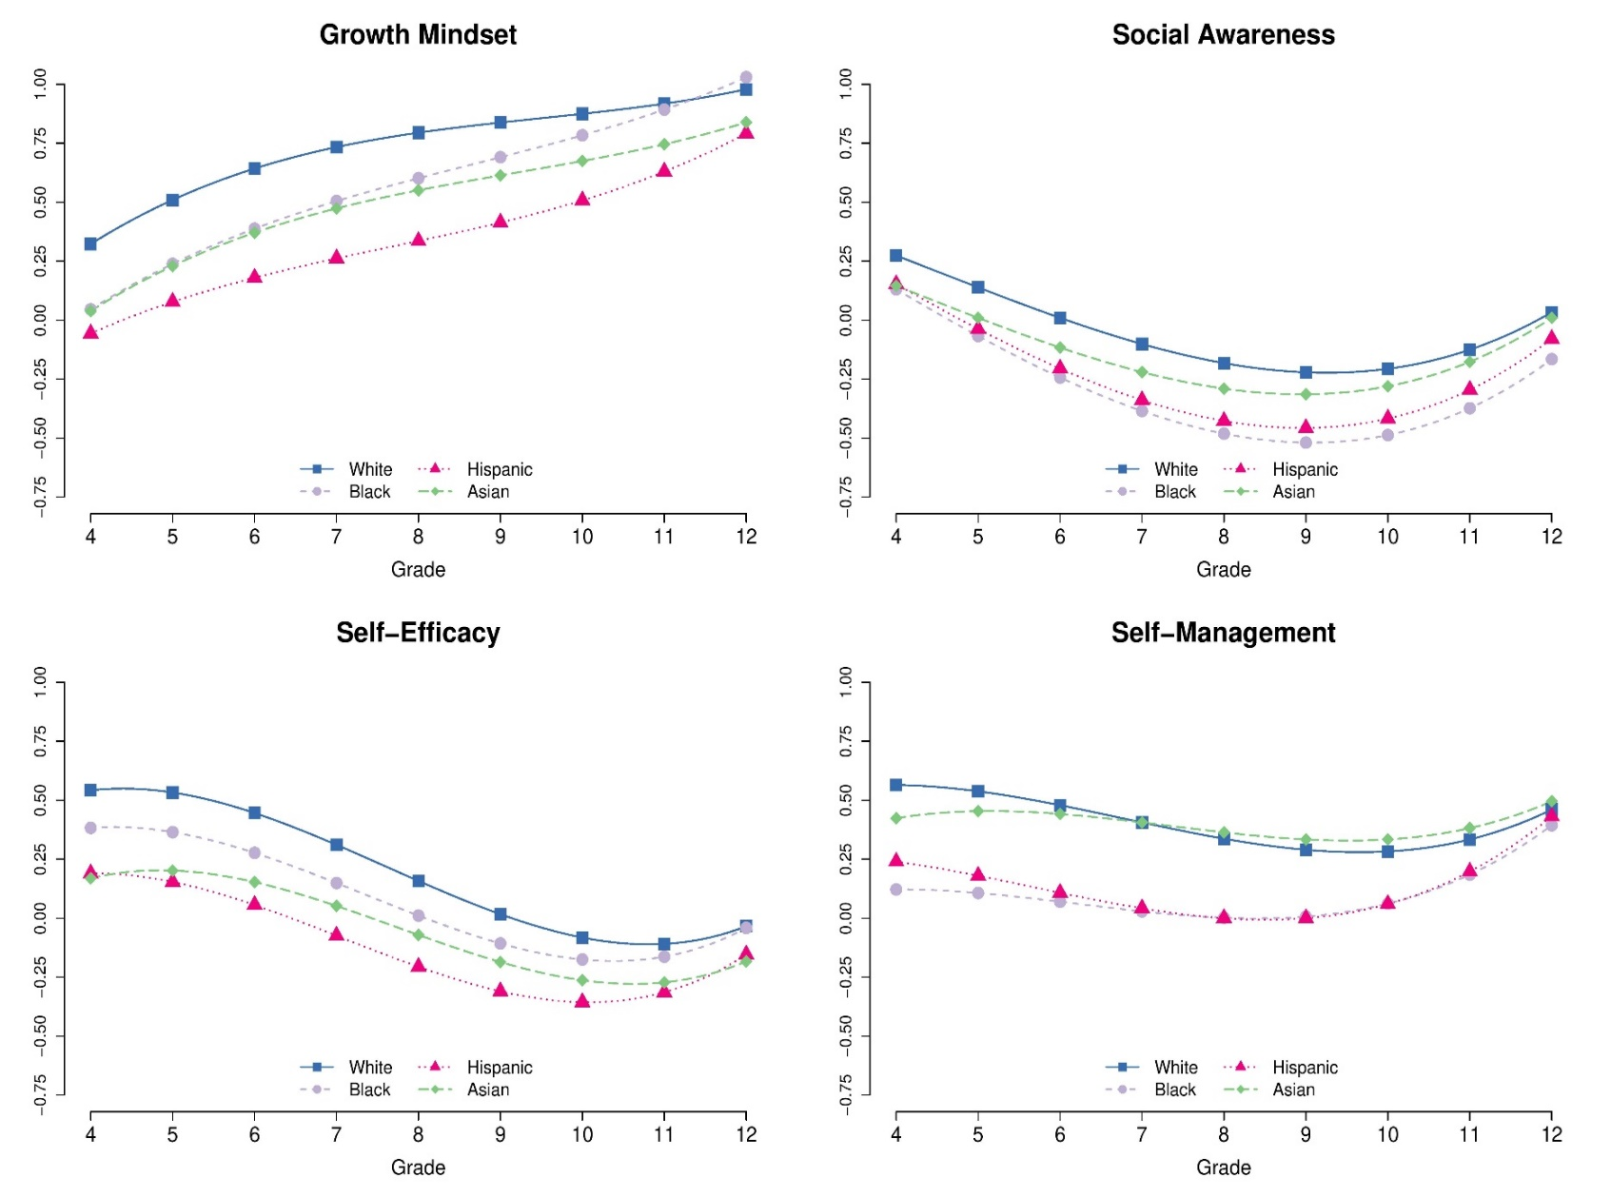

SOM Section 6. Further Limitations
There are methodological choices we made that could affect results. The ALD analyses depend on assumptions, including that growth is comparable by cohort. As a robustness check, we estimated models that did not pool across cohorts, but instead estimated growth by cohort. Results were similar, as stated above. Further, the data rely on self-report measures, focus on only four SECs out of many important related constructs, and include data that are not complete for all students at all timepoints (though sensitivity analyses were conducted to assuage concerns about this issue).
We considered using multilevel Bayesian additive regression tree (BART) models to help account for uncertainty in the functional form. We did not rely on such approaches primarily in part because less is known about their performance in the context of accelerated longitudinal designs, which by necessity include large amounts of missing data. Additionally, the plots in Figure S2 on the following page show that our model-based trajectories track quite well with those based on nonparametric plots, as well as with the sample means. Nonetheless, future research could examine whether our results shift when using different modeling approaches.
On a similar note, we also do not account for clustering at the school or district level. We made that decision based on prior research indicating that little of the variance in gains in SECs is attributable to the school. For example, Soland et al. (2019) examined ICCs quantifying how much of the variance in scores for the same four SECs constructs was between versus within schools. They found that the ICCs ranged from .01 to .04, indicating that the vast majority of the variance within each item is between students within schools, rather than between schools. Results were similar when examining gains in SEC scores between years. Similarly, Loeb et al. (2019) found that the across-school variance in the average level of the same SEC measures was proportionally much smaller than that for academic measures, though also did not rule out important school effects. Nonetheless, future additional research might investigate how much of the variance in student SEC growth occurs within versus between schools and districts.
We have limited information about the survey administration. The CORE data were gathered as a part of an accountability system developed as part of a No Child Left Behind Title 1 accountability waiver. Therefore, the survey was administered in a way that resembles a standardized state assessment. The assessment was given to every student and parents are allowed to opt out. Also, we do not have access to achievement data for students, which prevents us from comparing SEC growth between higher and lower achieving students.

Figure S2
Plots of Growth Trajectories Including Nonparametric and Sample Means
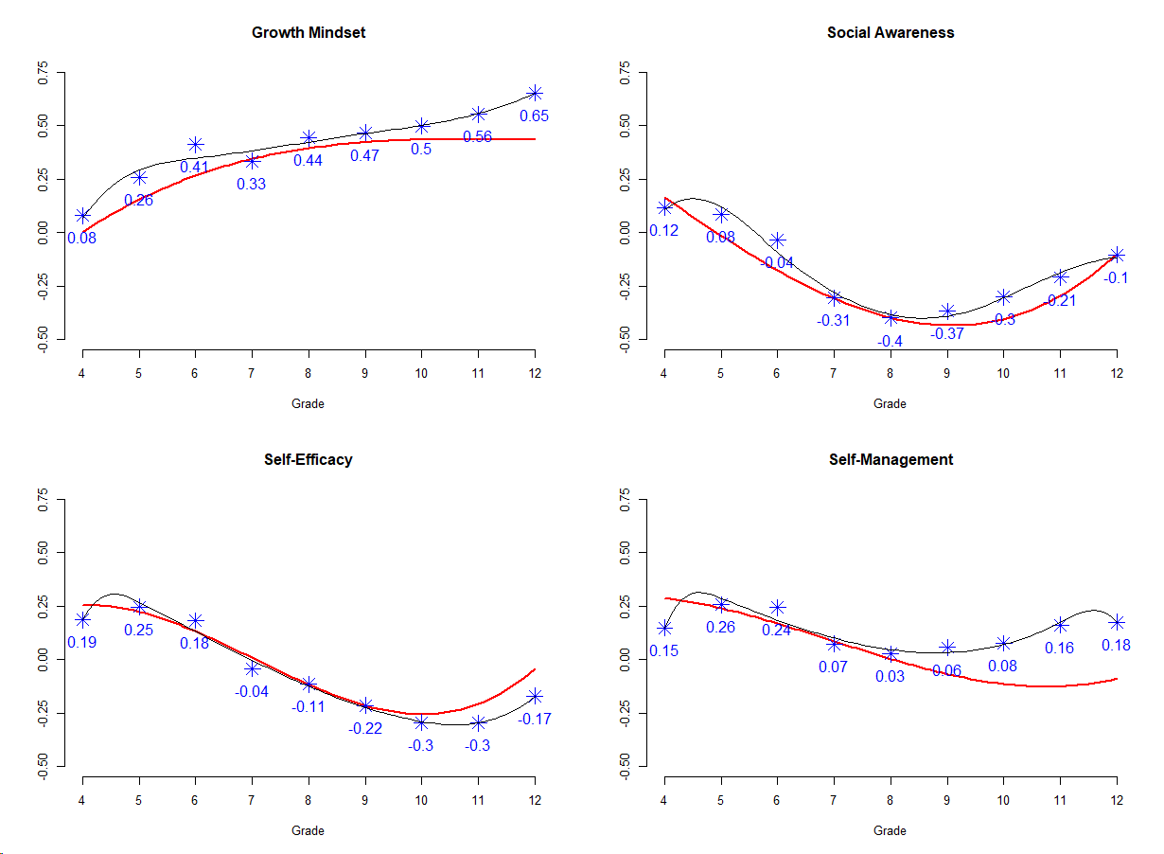
Note. Intraclass correlations (timepoints nested within individuals) or ICCs: GM=.69, SE=.57, SM=.68, SA=.69
SOM Section 7: Additional References in the SOM and Related to the Paper
Almlund, M., Duckworth, A. L., Heckman, J., & Kautz, T. (2011). Personality psychology and economics. In E. Hanushek, S. Machin & L. Woessmann (Eds.), Handbook of the Economics of Education. (pp. 1-181). Elsevier.
Davis-Kean, P. E., Tang, S., & Waters, N. E. (2019). Parent education attainment and parenting. In M. H. Bornstein (Ed.), Handbook of parenting: Biology and ecology of parenting (pp. 400–420). Routledge/Taylor & Francis Group.
Engels, M. C., Colpin, H., Van Leeuwen, K., Bijttebier, P., Van Den Noortgate, W., Claes, S., ... & Verschueren, K. (2016). Behavioral engagement, peer status, and teacher–student relationships in adolescence: A longitudinal study on reciprocal influences. Journal of Youth and Adolescence, 45, 1192-1207.
Loeb, S., Christian, M. S., Hough, H., Meyer, R. H., Rice, A. B., & West, M. R. (2019). School differences in social–emotional learning gains: Findings from the first large-scale panel survey of students. Journal of Educational and Behavioral Statistics, 44(5), 507-542.
Mahoney, J., Weissberg, R., Greenberg, M., Dusenbury, L., Jagers, R., Niemi, K., Schlinger, M.,
Schlund, J., Shriver, T., VanAusdal, K., & Yoder, N. (2021). Systemic social and emotional learning: Promoting educational success for all preschool to high school students. American Psychologist, 76(7), 1128–1142.
McCluney, C. L., Durkee, M., Smith, R. E., Robotham, K., Sai-Lai Lee, S. (2021) To be, or not to be…Black: The effects of racial codeswitching on perceived professionalism in the workplace, Journal of Experimental Social Psychology, 97, 104199.
Muthén & Muthén (2022). Mplus. https://www.statmodel.com/
Quintana, S. M. (2008). Racial perspective taking ability: Developmental, theoretical, and empirical trends. Handbook of Race, Racism, and the Developing Child, 16-36.
Rodriguez-Fornells, A., Krämer, U.M., Lorenzo-Seva, U., Festman, J. and Münte, T.F., 2012. Self-assessment of individual differences in language switching. Frontiers in Psychology, 2, 1-15.
Soland, J., Hamilton, L., & Stecher, B. M. (2013). Measuring 21st century competencies: Guidance for educators. Global Cities Education Network Report.
Soland, J., & Sandilos, L. E. (2021). English language learners, self-efficacy, and the achievement gap: Understanding the relationship between academic and social-emotional growth. Journal of Education for Students Placed at Risk, 26(1), 20-44.
Strauss, L. C., & Cross, W. E., Jr. (2005). Transacting Black identity: A two-week daily diary study. In G. Downey, J. S. Eccles, & C. M. Chatman (Eds.), Navigating the future: Social identity, coping, and life tasks (pp. 67–95). New York, NY: Russell Sage Foundation.
Umaña‐Taylor, A. J., Quintana, S. M., Lee, R. M., Cross Jr, W. E., Rivas‐Drake, D., Schwartz, S. J. (2014). Ethnic and racial identity during adolescence and into young adulthood: An integrated conceptualization. Child Development, 85(1), 21-39.
Wan, S., & Zhang, G. (2023). Estimating treatment effects over time with causal forests: An application to the ACIC 2022 data challenge. Observational Studies 9(3), 59-71.
Watt, H. M. (2008). A latent growth curve modeling approach using an accelerated longitudinal design: The ontogeny of boys' and girls' talent perceptions and intrinsic values through adolescence. Educational Research and Evaluation, 14(4), 287-304.
Wigfield, A., & Wagner, A. (2005). Competence, motivation, and identity development during adolescence. In A. Elliott & C. Dweck, Handbook of Competence and Motivation. (pp.222-239).

