Supplementary Materials
For: Kosinski, M., Khambatta, P., Wang, Y. (2023) Facial recognition technology and human raters can predict political orientation from images of expressionless faces even when controlling for demographics and self-presentation. American Psychologist.
Study 1
Party affiliation. Apart from responses to the political orientation scale, a subset of 589 participants provided their party affiliation. (“What is your political party affiliation, if any?” with eight possible response options: “Democratic” (n=341), “Republican” (n=49), “Green” (n=3), “Libertarian” (n=10), “Other left-wing” (n=12), “Other right-wing” (n=1), “Registered independent” (n=43), and “Unaffiliated” (n=130).) Supplementary Figure S1 presents the density distribution of the political orientation scale decorrelated with age and gender, across four of the most popular party affiliations. It shows that Republicans are all located on the conservative end of the scale, Democrats are on the liberal side, and independents and unaffiliated are in the middle.
Figure S1. Distribution density of the political orientation scale decorrelated with age and gender across four of the most popular party affiliations.
Table S1. Regression models and their cross-validated accuracy in a subset of Caucasian participants
Regression coefficients |  |  |  |  | Models’ cross-validated accuracy
Variable | Estimate | SE | p |  | n | r | CI_{95%} | p | RMSE
Model 1A: predicting political orientation (Caucasians only)
Intercept | -.14 | .19 | .49 |  | 436 | .22 | [.13,.31] | <.001 | .974
Gender | .51 | .10 | <.001
Age | -.01 | .01 | .38
Model 2A: predicting political orientation (Caucasians only)
Face descriptors (k=256) | Non-zero coefficients: 29 |  |  |  | 436 | .17 | [.08,.26] | <.001 | .998
Model 3A: predicting political orientation decorrelated with age and gender (Caucasians only)
Face descriptors (k=256) | Non-zero coefficients: 24 |  |  |  | 436 | .22 | [.13,.31] | <.001 | .975
Model 4A: predicting political orientation (Caucasians only)
Intercept | -.15 | .19 | .42 |  | 436 | .30 | [.21,.38] | <.001 | .954
Gender | .50 | .09 | <.001
Age | -.01 | .01 | .38
Predicted values from Model 3A | .90 | .20 | <.001
Note: Regression parameters estimated on the entire sample; separate models were fitted in each cross-validation fold.

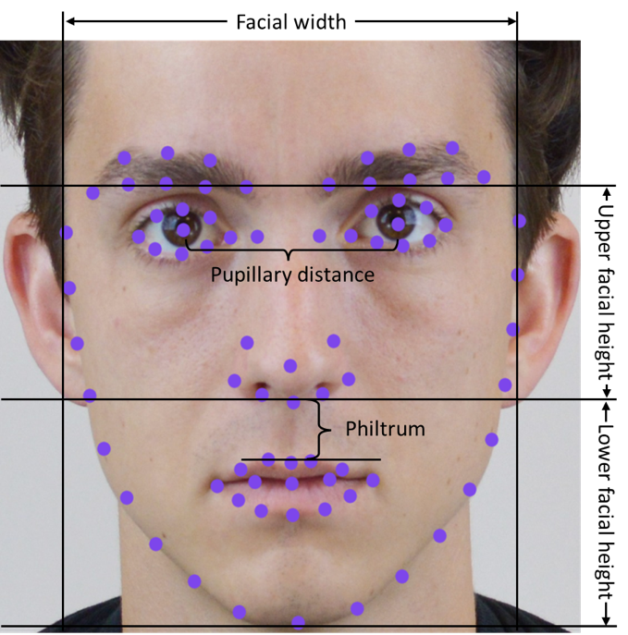
Figure S2. Standardized facial image (used with permission) overlaid with the facial landmarks produced by Face++ and facial dimensions referred to in the text.
Study 2
Instructions. Raters were presented with the following instructions: “The following page contains phrases describing people’s behaviors. Please use the rating scale next to each phrase to describe how accurately each statement describes the person in the picture. Describe this individual as the person generally is now, not as the individual may wish to be in the future. Describe the person as you see him or her, in relation to other people you know of the same sex as them, and roughly the same age. So that you can describe them in an honest manner, your responses will be kept in absolute confidence. Please read each statement carefully, and then click the circle that corresponds to the accuracy of the statement.”

Table S2. Accuracy of human ratings when predicting political orientation from standardized images, while controlling for age, gender, and ethnicity. Results obtained for the subset of Caucasian participants.
Raters per image | Unique images | r | CI_{95%} | P
1 | 436 | .01 | [-.08, .11] | .77
2 | 436 | .02 | [-.07, .12] | .66
3 | 434 | .03 | [-.07, .12] | .61
4 | 426 | .03 | [-.06, .13] | .49
5 | 403 | .04 | [-.06, .14] | .39
6 | 367 | .06 | [-.05, .16] | .27
7 | 332 | .10 | [-.01, .20] | .08
8 | 275 | .11 | [-.01, .22] | .08
9 | 206 | .16 | [.02, .29] | .02
10 | 152 | .19 | [.03, .34] | .02
11 | 103 | .25 | [.06, .42] | .01
12 | 63 | .22 | [-.03, .33] | .09
13 | 38 | .11 | [-.22, .42] | .51
14 | 24 | .24 | [-.18, .59] | .26
15 | 10 | -.06 | [-.67, .59] | .86

