Supplemental Online Material – Integral

Supplemental Methods

Recording the vocal bursts. Vocal bursts were recorded from 56 untrained individuals in four countries (27 USA, 9 India, 13 Kenya, 7 Singapore). Each individual was asked to imagine being present in a subset of specific scenarios written to elicit each of the 30 emotions of interest and also varying widely in terms of 13 commonly measured affective appraisals (for details, see Tables S1-2), and then to vocalize the non-linguistic sound most appropriate to each scenario. 426 of the vocal bursts were previously recorded from 44 professional actors for the VENEC corpus (Laukka et al., 2013), who, on average of 9.7, produced vocal bursts, each from a scenario targeting a distinct emotion (standard deviation = 6). For the present experiment on the recognition of vocal emotion, given that imbalances in vocalizations per speaker do not affect the interpretation of results regarding the reliable recognition of vocal emotion, 11 additional subjects, naïve volunteers living in the USA, freely produced as many distinct vocal bursts per scenario as desired. For these subjects, in addition to vocal bursts elicited directly by each scenario, we collected 1606 widely varying vocal bursts uttered spontaneously during the session (e.g., laughter at the extreme nature of a sad scenario, relief expressed in response to praise of a participant’s performance, emotions expressed upon spontaneously recalling scenarios from earlier in the session, and so forth). Sessions often blurred into emotional conversation, so we are unable to make a confident assessment of the degree to which each vocal burst was attributable to a given scenario. We excluded utterances that included words or were deemed unnatural or inauthentic-sounding by both the actor and experimenter during the recording session, a necessary step in using laboratory-derived expressions to study emotion perception (Scherer & Banziger, 2010). Importantly, we did not select for resemblance to category prototypes or appropriateness to the scenario. Here, the number of vocal bursts included averaged 146 vocal bursts per subject (standard deviation = 59.1).

Individual vocal burst audio segments were recorded, saved, and separately extracted using standard recording tools. The separate vocal burst audio files were then intensity normalized using the Replay Gain algorithm to be perceived at roughly the same volume.

Observer judgments of vocal bursts. Emotion judgments of the vocal bursts were obtained using Amazon Mechanical Turk. A total of 1017 raters ages 18-76 (545 female, mean age = 36) participated. Three separate surveys were used: one for categorical judgments of 30 emotions, one for affective appraisal judgments, and one for free response judgments. Participants rated vocal bursts one after another at their own pace and were free to perform as many surveys as desired but never rated the same vocal burst twice.
The categorical judgment survey was used to obtain 30-way forced-choice judgments of the vocal burst audio segments in terms of the following emotions: adoration, amusement, anger, awe, confusion, contempt, contentment, desire, disappointment, disgust, distress, ecstasy, elation, embarrassment, fear, guilt, interest, love, neutral, pain, pride, realization, relief, sadness, serenity, shame, surprise (negative), surprise (positive), sympathy, and triumph. Each of the 2032 vocal bursts was judged by 12 observers in terms of the 30 categories, which were sometimes presented with synonyms for clarity (see Table S3 for details). The individual survey each observer provided data for contained 30 vocal bursts, ordered randomly. Observers were allowed to complete as many of versions of the survey as desired, with different vocal bursts presented in each. Payment for each survey was 45 cents.
The free response judgment survey was used to collect free response judgments of the emotions recognized from vocal bursts. A separate sample of observers, 12 each for the different expressions, rated each vocal burst with 600 free response terms (listed in Dataset S1). Observers labeled each vocal burst by typing into a blank box. As observers typed, a drop-down menu appeared displaying all emotion terms containing the currently typed substring. For example, typing the substring “lov-” caused the following terms to be displayed: love, “brotherly love,” “feeling loved,” “loving sympathy,” “maternal love,” “romantic love,” and “self-love.” Importantly, observers could select as many emotion terms as desired. The individual survey each observer provided data for contained 30 vocal bursts, ordered randomly. Payment for each survey was 50 cents.
The affective appraisal judgment survey was used to obtain judgments of the vocal burst audio segments in terms of approach, arousal, certainty, commitment, control, dominance, fairness, focus, identity, improvement, obstruction, safety, and valence. A separate sample of observers, nine each for the different vocal bursts, rated each vocal burst along 13 affective appraisal scales. The ratings were each obtained on a 9-point Likert scale with the number 5 anchored at neutral (see Table S4 for details). For these ratings, because they were more numerous, observers provided data for 12 vocal bursts, ordered randomly. Payment for each survey was 80 cents.

Assessing interrater agreement significance levels for categorical judgments. Interrater agreement levels were defined as the proportion of raters who judged a particular vocal burst as belonging to each category. Overall interrater agreement for a vocal burst was taken as the maximal interrater agreement among categories selected in response to that vocal burst. Thus, if 70% of the raters chose “awe” and 30% chose “interest” for a given vocal burst, we would consider the overall interrater agreement for this vocal burst to be 70%, and the interrater agreement for each individual category to be 70% and 30%, respectively.

To test the null hypothesis that observed interrater agreement levels resulted from random selection, we conducted a simulation in which 12 random categorical judgments were obtained for 1 million hypothetical vocal bursts from a multinomial distribution with probabilities equal to the average rates of category selection in our actual data. In our simulation, we then calculated the proportion of vocal bursts for which maximal interrater agreement levels exceeded each increment of 1/12 from 0 to 1, excluding instances in which there was a tie between two maximal agreed-upon categories. FDR values were subsequently calculated using Benjamini-Hochberg correction.

Regression between categorical and dimensional judgments. To assess how well the categorical judgments explained the dimensional judgments and vice- versa, we used both linear and non-linear regression methods to predict one from the other. Linear methods capture explicit linear relationships between input and output—for example, how vocal bursts rated highly in amusement tend to be proportionately higher in valence. The vast majority of statistical tests used in psychology (e.g. correlation, ANOVA, ANCOVA) test for linear relationships. Non-linear methods capture other kinds of relationships. For example, if the category of “amusement” delineated a specific range of valence and arousal levels, above or below which vocal bursts fall into other categories, the relationship between amusement and valence would be nonlinear.

For linear regression, we used ordinary least squares (OLS); for non-linear regression, we used k-nearest neighbors (kNN) with the parameter k varying from 1 to 50. Each regression method was trained and tested using leave-one-out cross-validation (LOOCV). Predicted categorical or dimensional judgment ratings in the left-out test samples were concatenated and correlated with the observed judgment ratings to obtain a measure of explained variance (R or, by squaring it, R²).

Explainable variance calculation. Calculating explainable variance is necessary to adjust for downward bias in correlation values. For example, if raw correlations were used to measure the relationship between mean ratings of valence and mean ratings of amusement of vocal bursts, an experiment with a larger sample of raters would on average estimate a stronger relationship, given that there would be less sampling error in the estimated means. By contrast, after adjusting for explainable variance, the correlation estimates would on average be invariant to sample size (although the confidence interval would change). In other words, correlations adjusted for explainable variance are estimates of the correlations that would be obtained with an infinite sample size.
To calculate explainable variance, we note that the variance of a given rating across stimuli is equal to the explainable variance plus the unexplainable variance. The unexplainable variance can be estimated as the mean of the standard errors (from the standard deviation estimate normalized by N) across stimuli. Hence, the proportion of explainable variance can be estimated by simply dividing the mean of the standard errors by the total variance and subtracting this quantity from one.
We also corrected for the explainable variance of prediction estimates. When using linear regression, we calculated the explainable variance of prediction estimates by bootstrapping across ratings of each individual category and dimension and then repeatedly using these bootstrap resamples to produce the same prediction estimates. Here, we only ran the regression itself once across the original dataset, which means we did not correct for the unexplainable variance in regression weights. When using k-nearest neighbors, we adjusted for explainable variance of the averaged neighbors. Thus, for example, when averaging five nearest neighbors to generate a prediction, we estimated the explainable variance of that prediction by computing the explainable variance in the mean ratings of those five vocal bursts. We also adjusted for the optimal performance that could be obtained by choosing the actual nearest neighbors in the output space. However, we did not adjust for error in the choice of neighbors in the predictor space.

t-distributed Stochastic Neighbor Embedding (t-SNE). t-SNE on the categorical vocal burst judgments was implemented using the Matlab Toolbox for Dimensionality Reduction by Laurens van der Maaten. The data were first preprocessed using PCA to reduce it to 24 dimensions and then t-SNE was applied with a default perplexity parameter of 40. After repeating t-SNE 500 times, the minimum error solution was selected.

Stimulus set and data availability. The stimuli and data that support the findings of this study are available upon request. Please visit https://goo.gl/forms/LCyrCVPgStH483Mk1.

Supplemental Discussion

Terminology: “affective appraisals”. We use “affective appraisals” as an umbrella term for the various conceptually broader processes that have been proposed in constructivist, appraisal, and componential theories to constitute and distinguish emotion categories. Affective appraisals are more domain-general than emotion categories in that they are also theorized to underlie non-emotion-specific processes, such as decision-making, attitudes, and reward. They include proposed properties of core affect, such as valence and arousal, motivational processes, such as approach-avoidance and commitment, and cognitive appraisal-based inferences, such as safety. Affective appraisals are measured along scales. Hence, we use the term “affective appraisal scales” or “affective scales” to refer to the psychometric scales used to collect ratings of affective appraisals.

Moving beyond comparing “discrete categories” to “continuous dimensions.” In past literature, affective features such as valence and arousal have been called “dimensions” and distinguished from “discrete” emotion categories such as fear. These terminological choices can be problematic. They assume a priori that valence and arousal vary continuously and independently, whereas emotion categories are discrete and mutually exclusive. These are ideas we opt to examine empirically. Here, we use the word “dimension” in a more mathematically informed sense, referring to the number of coordinates needed to describe a point within a space—in this case, a state space of emotion. Such dimensions can potentially be conceptualized in terms of affective appraisals, emotion categories, or both.

On laboratory-induced vocal bursts versus naturalistic vocal bursts from real world contexts. Many theorists have discussed potential distinctions posed and spontaneous vocal bursts (Anikin & Lima, 2017; Juslin, Laukka, & Bänziger, 2018; Sauter & Fischer, 2018; Scherer, 2013). We avoid classifying the vocal bursts studied here using these terms, for several reasons. First, laboratory-induced vocal bursts are often spontaneous—for example, an imagined scenario inducing an authentic laugh—and in many cases it is difficult to determine whether specific laboratory-induced vocal bursts are spontaneous or posed (see Supplemental Methods). Second, vocal bursts found in the real world are often posed (e.g., a polite laugh). Here, we study laboratory-induced vocal bursts in Experiment 1 along with vocal bursts found in the real, external world (from YouTube videos) in Experiment 2. We test whether findings regarding laboratory-induced vocal bursts extend to vocal bursts found in the real world, a test of their ecological validity, rather than comparing posed to spontaneous vocalizations.

Moving beyond factor analytic approaches. Past studies have used factor analytic approaches to estimate the dimensionality of emotion recognition (e.g. Jack et al., 2014). These approaches are based on correlations between judgments (Ferguson & Cox, 1993) but do not take into consideration the reliability of individual judgments—e.g., they would be unable to identify whether an individual category, like awe, is reported differently than every other category.

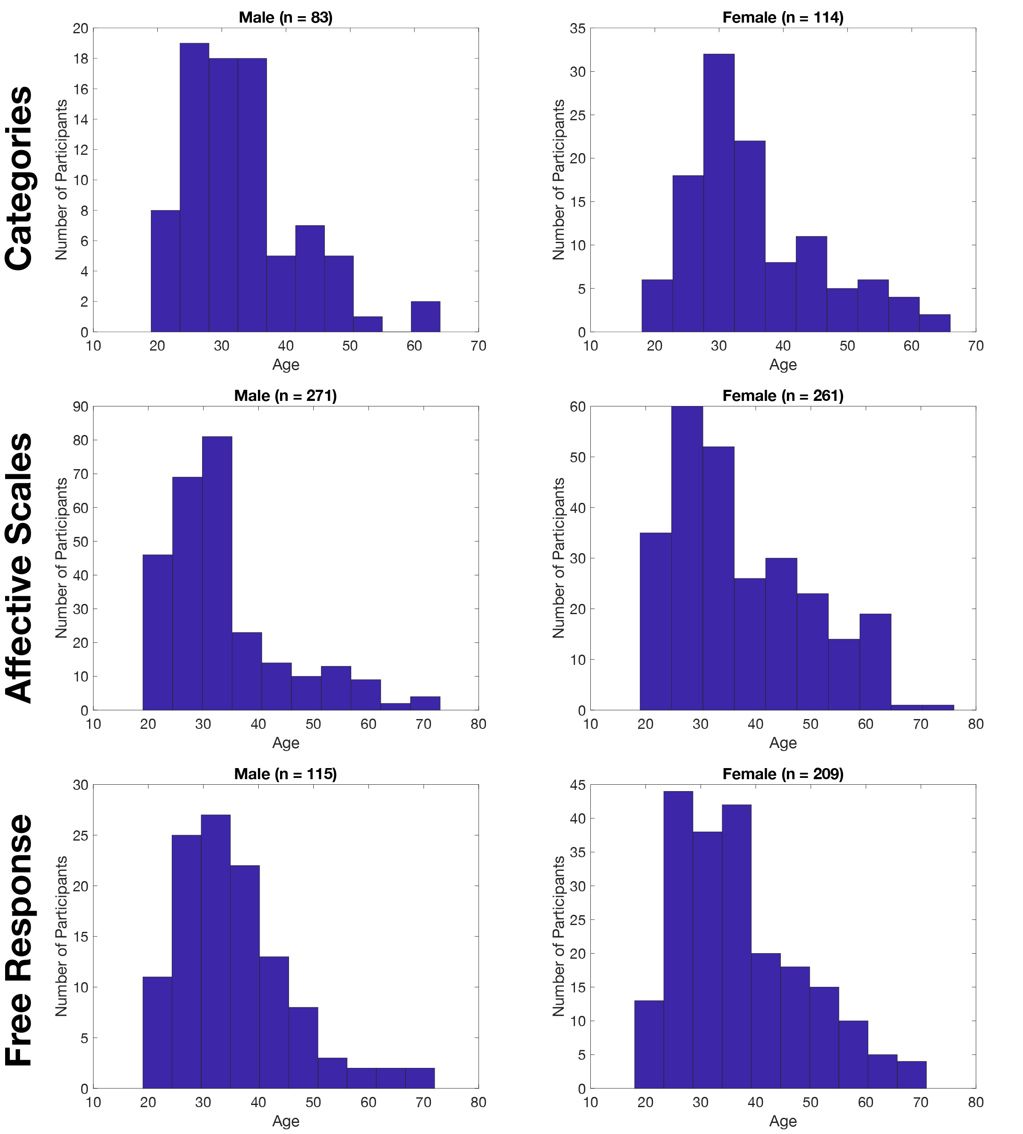
Figure S1. Breakdown of participant demographics per response format. Histograms of age of participants are shown per gender, per response type. An insubstantial proportion of participants did not report age or gender (4, 12, and 13 participants in the category, dimension, and free response tasks respectively). Any chance or systematic variability in the survey population per response type, together with potential individual differences in the perception of the vocal bursts, would only serve to lower the reliability of associations among different responses. Hence, such variability would only lead to underestimates of the fit of our models of the reliable conceptualization, dimensionality, and structure of the semantic space of vocal emotion. Note that we do not report the duration of survey work or of breaks taken (as these are unknown), nor the listening mode (headphones, etc.), both of which could also produce systematic variability that could only lead to downward bias in model fits. 69 raters participated in two or more response formats (e.g., both categories and free response) but did not rate any individual vocal burst in multiple formats.
Figure S2. A. Interrater agreement rates by culture in which vocal bursts were recorded. The VENEC database included previously recorded vocal bursts from four cultures: India, Kenya, Singapore and the USA. The mean interrater agreement rates for these previously recorded vocal bursts from each culture varied from 43% (Singapore) to 46% (India). Judgments of newly recorded vocal bursts had a marginally higher rate of interrater agreement (49%). Error bars represent standard error. Dotted line represents chance level (based on 10,000 simulated ratings with the same baseline probabilities of selection of each category). B. Percentage breakdown of category judgments across all vocal bursts. Response rates vary from .5% (pride) to 7.6% (amusement).
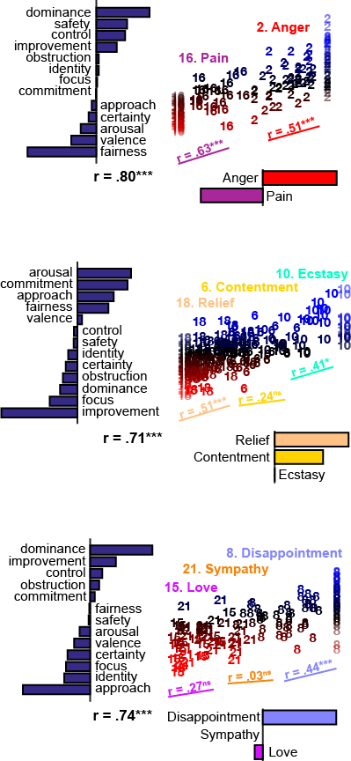
Figure S3. Scatterplots of canonical correlations between example categories and 13 affective appraisals for four example sets of categories, quantifying the smooth relationships between categories and affective appraisals. Each plot shows the relationship between category ratings and appraisal ratings among vocal bursts modally rated with certain categories (e.g., rated “anger” or “pain” by the majority of participants in the first plot), as captured using canonical correlations between vocal bursts’ categorical and appraisal ratings. Numbers within each scatterplot are individual vocal bursts.
Each canonical correlation yields a linear combination of categories (x axis) and a linear combination of affective appraisals (y axis). If the categories were perceived as discrete, one might expect the affective meaning of each vocal burst to more closely reflect its modal category assignment, shifting more abruptly across category boundaries. Instead, the dimensions correlate smoothly with the proportion of judgments assigned to each category, even within the same modal category. Specifically, the correlations between categorical and dimensional variates within each modal category are indicated by the colored lines and r values below the points in each plot.
One might ask whether these results are explained entirely by inter-observer ambiguity in the perception of discrete categories—i.e., if each exemplar is perceived by some proportion participants as purely one category (“anger”) and another proportion of participants as purely another category (“pain”). If this were the case, then across exemplars rated modally as “anger”, the degree of similarity in affective appraisal ratings to “pain” would be accounted for by the standard deviation in affective appraisal ratings. However, here we test the significance of the partial correlation between the categorical and affective appraisal ratings, controlling for the standard deviation in the affective appraisal ratings, and find that the correlation is typically still significant. * = FDR q < .05, *** = FDR q < 10⁻³, t-test for partial correlations between dimensional and categorical variates using leave-one-out-cross-validation, controlled for standard deviation in the affective appraisal variate. Many apparently discrete emotions in fact seem to occupy dimensional gradients across categorical boundaries.

Figure S4. Experiment 2 interrater agreement levels per vocal burst, per category for all 30 categories. Non-zero interrater agreement rates are shown for each category across all 48 vocal bursts in Experiment 2. The number of vocal bursts in each category with significant interrater agreement rates (FDR < .05, simulation test described above) is shown to the right of each dot plot, and varies from 0 (contempt, distress, ecstasy, embarrassment, guilt, interest, pride, serenity, shame) to 5 (amusement). Dots have been jittered for clarity.

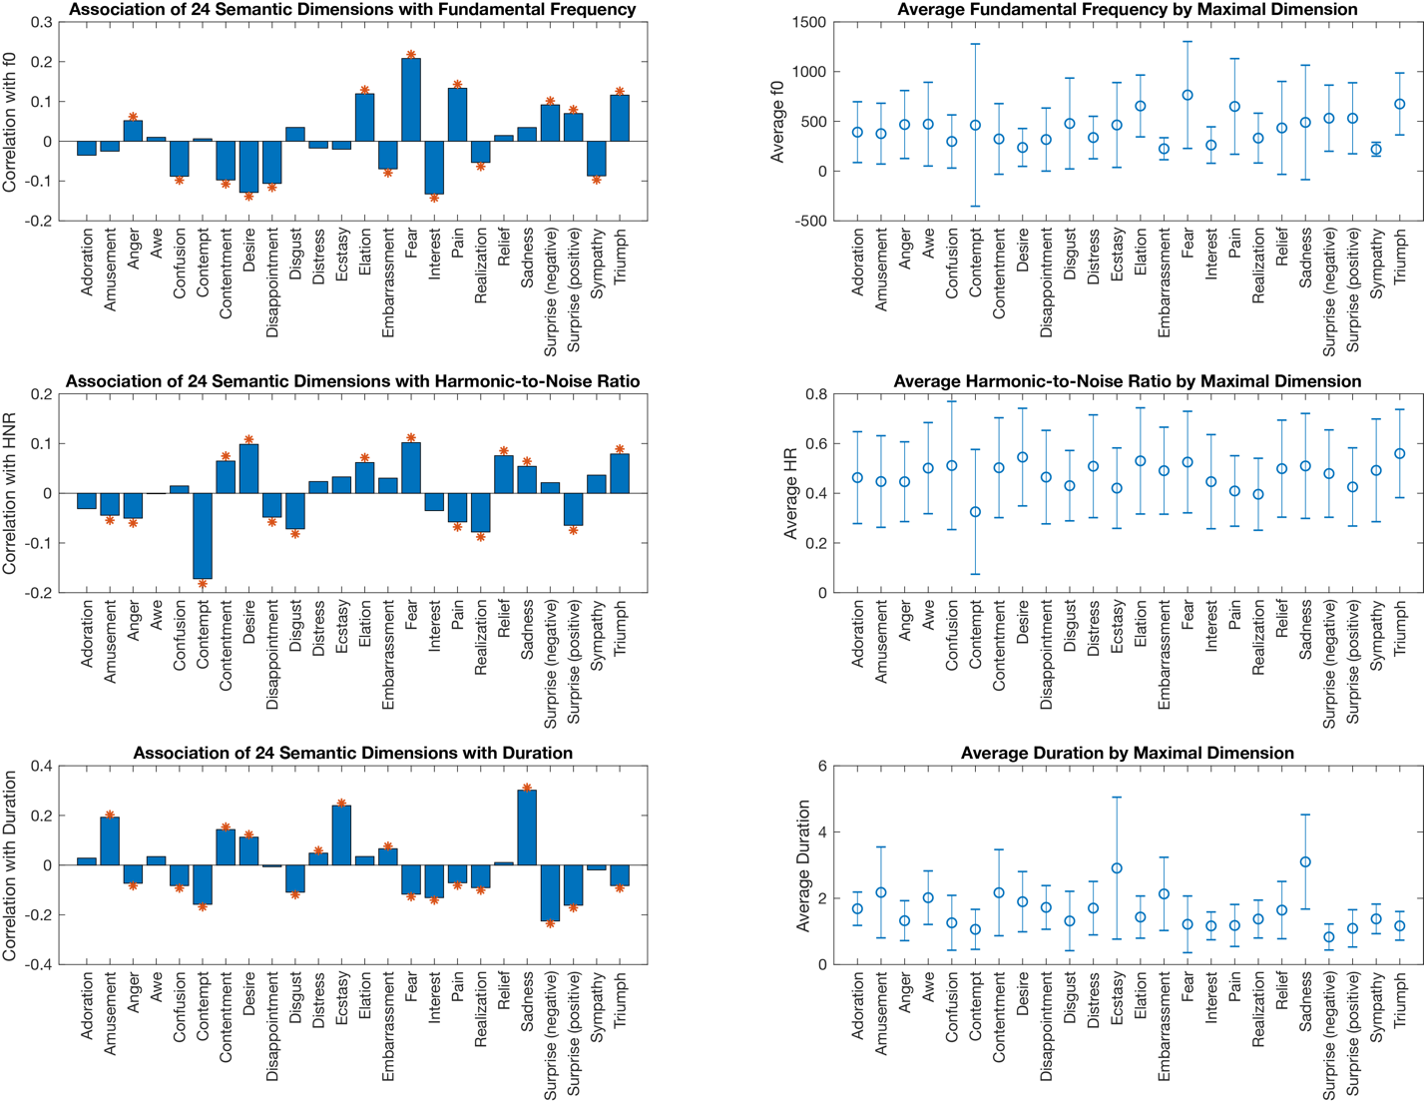
Figure S5. Association between emotion category and fundamental frequency (f0), harmonic-to-noise ratio (HNR), and audio duration. As an exploratory analysis that may be of interest to experimenters planning future studies of the acoustic properties of vocal bursts, we computed three properties of the auditory signal of each vocal burst: its fundamental frequency, harmonic-to-noise ratio, and duration. We then examined how these properties vary as a function of the 24 semantic dimensions uncovered in the present study (given that these dimensions explain categorical and appraisal judgments of the vocal bursts). Left. Significant but relatively small correlations are observed between fundamental frequency, harmonic-to-noise ratio, and audio duration and position along 24 semantic dimensions of emotion, across vocal bursts. * p < .05. Machine learning analyses will have to take into account many sources of variation in acoustics, as well as higher-level features. For example, it is likely that speaker demographics also strongly influence fundamental frequency. Right. Mean standard deviation in fundamental frequency, harmonic-to-noise ratio, and duration of vocal bursts positions maximally along each dimension. Within-category variance in low-level auditory characteristics is generally high, further illustrating the need for higher-level acoustic analyses, likely incorporating more data. The reliable perception of all 24 dimensions must ultimately be based on high-level acoustic features. Fundamental frequency and harmonic-to-noise ratio were computed using the Matlab Audio Analysis Library (Giannakopoulos, T., & Pikrakis, A. (2014). Introduction to audio analysis: a MATLAB® approach. Academic Press.)
Table S1. Vocal burst eliciting scenarios organized by potential emotion categories

These scenarios were sometimes adapted with minor variations from their original wording to allow the vocal burst recording process to unfold as naturally as possible. The interview process was semi-improvisational, with elaborations often provided to best suit the personal experiences or opinions of the encoders. The following 22 categories were targeted in this manner, yielding 1607 of the vocal bursts. The remaining 425 vocal bursts were taken from the VENEC corpus (Laukka et al., 2013), which additionally targeted distress, guilt, negative/positive surprise, pride, serenity, romantic love and shame using a similar methodology (the scenarios used to collect these 425 vocal bursts are described in Laukka et al., 2016).

Adoration
- You feel that a person/animal is adorable.
- You see a cute baby making funny faces.
- A cute dog is looking for its toy, failing to realize it is stuck to its paw.
- Your child/relative, a toddler, is taking his/her first steps.

Amusement
- You find something humorous.
- Your friend just told you a funny story.
- Your pet has done something silly.
- You are watching a funny movie.

Anger
- You are angry.
- You have been treated in a rude way deliberately.
- You were waiting for the bus when an obnoxious businessman speaking on a Bluetooth headphone knocks into you, causing you to spill your coffee.
- You are on a plane. A child is kicking the back of your seat. When you intervene, their mother defends the child.

Awe
- You are in awe.
- You are in the presence of something greater than yourself.
- You see the biggest waterfall in the world for the first time, and you are awed by how enormous and powerful it is.
- You witness a volcanic eruption from afar.
- You see an incredible meteor shower.

Confusion
- You are confused about something.
- You are reading something that does not make sense.
- Someone gives you instructions to do something, but the instructions are incredibly confusing.

Contempt
- You feel contempt toward someone.
- You feel superior to someone because they did something negative.
- You see a wealthy person throwing expensive clothing into the garbage.
- You are watching an interview with Donald Trump. He insists that the Mexican government will finance his plans to build a wall on the border.

Contentment
- You feel content.
- You have been resting comfortably on a peaceful day, and you feel contented.
- You are laying down on a very comfortable couch.
- You have just taken a sip of cold water on a hot day.
- You are getting into a hot tub on a cold day.

Desire (sensual or sexual)
- You see something that you strongly desire.
- You are sexually attracted to someone.
- You see someone who is sexually attractive, and you feel a strong desire to have sex with them.
- You see and smell some delicious food and you desperately want to taste it.
- You have just started eating and find that the food is overwhelmingly delicious.

Disappointment
- You are disappointed about something.
- Earlier you found out you had received a winning lottery ticket. Now that you are about to collect your winnings, somebody points out that one of your numbers was wrong, and you have won nothing.
- You receive a letter of rejection from a program you desperately wanted to attend.
- Your favorite sports team is playing their rivals. In the final second, your favorite player makes a game-winning point, but the point is recalled due to a dubious foul call. Your team loses.

Disgust
- You see something disgusting.
- You have just eaten rotten food and feel very disgusted.
- You see somebody eating feces.
- You see somebody eating a live rat.

Embarrassment
- You are embarrassed.
- Someone discovers that you have made a social gaffe.
- You had been passionately singing your favorite song until you realized your friends were watching.
- You are forced to dance in front of your coworkers.
- You had just spoken in front of an audience when somebody points out that you have toilet paper hanging from the seat of your pants.

Elation
- You are elated, excited, joyous.
- You and your family are at the hospital visiting a terminally ill family member. The doctor explains that your family member has been cured and will live a long life.
- You receive a tremendous gift.
- You find out your close family member, who had been at war, is now home. You rush to the door to greet them.

Ecstasy
- You experience ecstasy.
- You have just finished a difficult hike. You are under a waterfall. The water rushes over you and causes tingles down your spine. You stretch out your arms.
- You are receiving the best massage you have ever received. You feel as though your muscles are able to relax for the first time.
- You feel intense euphoric sensations, sending tingles through your whole body.

Fear
- You feel afraid.
- You encounter a terrifying animal.
- Someone seems to be following you through the street at night. When you turn around, they are just behind you with a knife.
- You are alone in front of the mirror, buttoning your shirt. When you look up, you see a pale old woman behind your shoulder, staring.
- It feels as though a bird has landed on your shoulder. When you turn toward it, you see that it is a large spider hanging from a web.

Interest
- You learn something new.
- You are curious about something and want to explore it.
- You are learning some useful information that you find interesting.
- You find an interesting family heirloom.

Pain
- You are in pain.
- You just stubbed your toe very hard on a rock and it feels very painful.
- You just burnt yourself on a hot pan.
- You hit yourself in the funny bone.
- You suddenly feel a sharp pain in your stomach.

Realization
- You realize something.
- You have just discovered something critical to a problem you’ve been trying to solve.
- You were deeply confused, but now you realize something and it all makes sense.
- You had been trying to solve a difficult jigsaw puzzle, but now you realize that you had been looking at it upside down the whole time.
- Your friend was behaving strangely, and you couldn’t figure out why. Now he/she tells you and it makes sense.

Relief
- You feel relieved.
- You have found your child/pet after they were lost and you feel very relieved.
- You have just narrowly escaped a dangerous situation.
- You thought you lost your wallet, but you find it in your jacket pocket.
- For a second, you had been teetering on the edge of a cliff, but then your friend grabbed you and helped you find your footing again.

Sadness
- You are very sad.
- You find out that a member of your family has died.
- You find out that your pet has been struck by a car.
- You are at the funeral of a close friend.

Surprise
- You are startled.
- You are very surprised by a bright flash in the middle of a clear night.
- You are walking alone and, as you turn the corner, are surprised to see someone standing right in front of you.
- You are reaching into your bag to find something. You are surprised when you feel something wet.

Sympathy
- You feel sympathy.
- You are moved by someone else’s suffering.
- You see someone with an injury, and you feel sympathy for them.
- You encounter a panicked child looking for his/her mom.
- You encounter an elderly person with Alzheimer’s disease on the street. They are clearly lost and look very distraught.

Triumph
- You feel a sense of triumph.
- You celebrate a victory.
- You have just won a very challenging competition and you feel triumphant.
- Your favorite sports team is playing their rivals. In the final second, your favorite player makes a game-winning point. Your team wins.

Table S2. Vocal burst eliciting scenarios organized by potential affective appraisals
Affective Appraisal | Low | High
approach | - It feels as though a bird has landed on your shoulder. When you turn toward it, you see that it is a large spider hanging from a web.  - You have just eaten rotten food and feel very disgusted.  - You see somebody eating feces.  - You see somebody eating a live rat. | - You see and smell some delicious food and you desperately want to taste it.  - You find out your close family member, who had been at war, is now home. You rush to the door to greet them.  - You encounter a panicked child looking for his/her mom.  - You are curious about something and want to explore it.  - Your pet has done something silly.
arousal | - You are receiving the best massage you have ever received. You feel as though your muscles are able to relax for the first time. | - You are alone in front of the mirror, buttoning your shirt. When you look up, you see a pale old woman behind your shoulder, staring.
attention | - You are laying down on a very comfortable couch.  - You have been resting comfortably on a peaceful day, and you feel contented. | - You are very surprised by a bright flash in the middle of a clear night.  - You learn something new.  - You are sexually attracted to someone.  - You witness a volcanic eruption from afar.  - You see an incredible meteor shower.  - You are watching a funny movie.
certainty | - You are reaching into your bag to find something. You are surprised when you feel something wet. | - Your friend was behaving strangely, and you couldn’t figure out why. Now he/she tells you and it makes sense.  - You are learning some useful information that you find interesting.  - You find something humorous.
commitment | - You feel superior to someone because they did something negative.  - You see a wealthy person throwing expensive clothing into the garbage. | - You are at the funeral of a close friend.  - You are moved by someone else’s suffering.  - You feel that a person/animal is adorable.  - You see a cute baby making funny faces.  - A cute dog is looking for its toy, failing to realize it is stuck to its paw.  - Your child/relative, a toddler, is taking his/her first steps.  - Your friend just told you a funny story.
control | - You are forced to dance in front of your coworkers.  - You are in the presence of something greater than yourself.  - You see the biggest waterfall in the world for the first time, and you are awed by how enormous and powerful it is. | - You have just discovered something critical to a problem you’ve been trying to solve.  - You were deeply confused, but now you realize something and it all makes sense.
dominance | - Someone discovers that you have made a social gaffe.  - You had been passionately singing your favorite song until you realized your friends were watching.  - You had just spoken in front of an audience when somebody points out that you have toilet paper hanging from the seat of your pants. | - You celebrate a victory.  - You have just won a very challenging competition and you feel triumphant.
fairness | - Your favorite sports team is playing their rivals. In the final second, your favorite player makes a game-winning point, but the point is recalled due to a dubious foul call. Your team loses. | - You and your family are at the hospital visiting a terminally ill family member. The doctor explains that your family member has been cured and will live a long life.
identity | - You have been treated in a rude way deliberately.  - You are watching an interview with Donald Trump. He insists that the Mexican government will finance his plans to build a wall on the border | - Your favorite sports team is playing their rivals. In the final second, your favorite player makes a game-winning point. Your team wins.  - You find an interesting family heirloom.
improvement | - Earlier you found out you had received a winning lottery ticket. Now that you are about to collect your winnings, somebody points out that one of your numbers was wrong, and you have won nothing.  - You receive a letter of rejection from a program you desperately wanted to attend. | - You have found your child/pet after they were lost and you feel very relieved.  - You have just narrowly escaped a dangerous situation.  - You thought you lost your wallet, but you find it in your jacket pocket.  - For a second, you had been teetering on the edge of a cliff, but then your friend grabbed you and helped you find your footing again.  - You are getting into a hot tub on a cold day.  - You had been trying to solve a difficult jigsaw puzzle, but now you realize that you had been looking at it upside down the whole time.
obstruction | - You have just taken a sip of cold water on a hot day. | - You were waiting for the bus when an obnoxious businessman speaking on a Bluetooth headphone knocks into you, causing you to spill your coffee.  - You are on a plane. A child is kicking the back of your seat. When you intervene, their mother defends the child.
safety | - You encounter a terrifying animal.  - Someone seems to be following you through the street at night. When you turn around, they are just behind you with a knife. | - You have been resting comfortably on a peaceful day, and you feel contented.
valence | - You just stubbed your toe very hard on a rock and it feels very painful.  - You just burnt yourself on a hot pan.  - You hit yourself in the funny bone.  - You suddenly feel a sharp pain in your stomach.  - You find out that a member of your family has died. | - You have just finished a difficult hike. You are under a waterfall. The water rushes over you and causes tingles down your spine. You stretch out your arms.  - You receive a tremendous gift.  - You feel intense euphoric sensations, sending tingles through your whole body.  - You have just started eating and find that the food is overwhelmingly delicious.

Table S3. Category information.
Category | References
Adoration | Cowen & Keltner, 2017
Amusement | Cordaro et al., 2016; Cowen & Keltner, 2017, Laukka et al., 2013; Sauter et al., 2010
Anger | Cordaro et al., 2016; Cowen & Keltner, 2017; Ekman, 2016; Laukka et al., 2013; Sauter et al., 2010
Awe | Cowen & Keltner, 2017
Confusion | Cowen & Keltner, 2017
Contempt | Cordaro et al., 2016; Cowen & Keltner, 2017; Laukka et al., 2013
Contentment | Cordaro et al., 2016
Desire | Cordaro et al., 2016; Cowen & Keltner, 2017
Disappointment | Lelieveld et al., 2012; Rozin & Cohen, 2003
Disgust | Cordaro et al., 2016; Cowen & Keltner, 2017; Ekman, 2016; Laukka et al., 2013; Sauter et al., 2010
Distress | Laukka et al., 2013; Reiss, 1991
Ecstasy | Cordaro et al., 2016; Sauter et al., 2010
Elation | Cordaro et al., 2016
Embarrassment | Cordaro et al., 2016; Cowen & Keltner, 2017
Fear | Cordaro et al., 2016; Cowen & Keltner, 2017; Sauter et al., 2010
Guilt | Laukka et al., 2013
Interest | Cordaro et al., 2016; Cowen & Keltner, 2017
Neutral | NA
Pain | Cordaro et al., 2016; Cowen & Keltner, 2017
Pride | Laukka et al., 2013
Realization | NA
Relief | Cordaro et al., 2016; Cowen & Keltner, 2017; Sauter et al., 2010
Romantic love | Cowen & Keltner, 2017
Sadness | Cordaro et al., 2016; Cowen & Keltner, 2017; Ekman, 2016; Laukka et al., 2013; Sauter et al., 2010
Serenity | Laukka et al., 2013
Shame | Laukka et al., 2013
Surprise (negative) | Egner, 2011; Laukka et al., 2013
Surprise (positive) | Egner, 2011; Laukka et al., 2013
Sympathy | Cordaro et al., 2016; Laukka et al., 2013
Triumph | Cordaro et al., 2016; Sauter et al., 2010; Tracy & Matsumoto, 2008

Table S4. Affective appraisal information.
Dimension | References | Q: To what extent does the speaker feel (1…9)
approach | Frijda et al., 1989 | …Like this is something you would want to approach? (desire to avoid…desire to approach)
arousal | Mehrabian & Russell, 1974; Russell, 2003 | …Stimulated? (more subdued…more stimulated)
attention | Smith & Ellsworth, 1985 | …Focused? (more unfocused…more focused)
certainty | Smith & Ellsworth, 1985 | ...Certain? (very uncertain…very certain)
commitment | Frijda et al., 1989 | ...A sense of commitment to an individual or creature? (lack of commitment to an individual/creature…strong commitment to an individual/creature)
control | Smith & Ellsworth, 1985 | …Like things are under control? (things seem out of control…things seem under control)
dominance | Mehrabian & Russell, 1974 | …Dominant? (more submissive…more dominant)
fairness | Frijda et al., 1989 | …Like things are fair? (sense of unfairness…sense of fairness)
identity | Smith & Mackie, 2008 | …Like you identify with a group of people? (lack of group identity…strong group identity)
improvement | Cowen & Keltner, 2017 | …His/her situation has improved? (situation has worsened…situation has improved)
obstruction | Smith & Ellsworth, 1985 | …Like you're obstructed by something? (very unobstructed…very obstructed)
safety | Smith & Lazarus, 1990 | …A sense of safety? (very unsafe…very safe)
valence | Mehrabian & Russell, 1974; Russell, 2003; Smith & Ellsworth, 1985 | …Pleasant? (very unpleasant…very pleasant)

Frijda, N. H., P. Kuipers, E. ter Schure, Relations among emotion, appraisal, and emotional action readiness. J. Pers. Soc. Psychol. (1989).
Laukka, P., Elfenbein, H. A., Thingujam, N. S., Rockstuhl, T., Iraki, F. K., Chui, W., & Althoff, J. The expression and recognition of emotions in the voice across five nations: A lens model analysis based on acoustic features. J. Pers. Soc. Psychol. (2016).
Smith, C.A., R. S. Lazarus, in Handbook of personality: Theory and research (1990).
Smith, E. R., D. M. Mackie, Intergroup emotions. Handb. Emot. (2008), doi:10.1037/14342-010.

Table S5. Values of Pearson correlation coefficients between 24 semantic dimensions derived from the category ratings and the free response terms used to rate each vocal burst. All correlations shown are significant (FDR < 10⁻⁸).
Adoration | .55 adoration | .48 loving sympathy | .43 sympathy | .35 awe
Amusement | .78 laughter | .74 amusement | .59 humor | .51 hysterical laughter
Anger | .81 anger | .57 frustration | .43 rage | .43 extreme anger
Awe | .59 awestruck realization | .52 amazement | .50 awe | .47 awestruck surprise
Confusion | .81 confusion | .41 interested confusion | .38 puzzlement | .38 distressful confusion
Contempt | .55 contempt | .36 annoyance | .32 contemptuous doubt | .32 disapproval
Contentment | .45 relaxation | .37 contentment | .35 deep relief | .32 relief
Desire | .57 desire | .47 sexual arousal | .40 sexual desire | .36 arousal
Disappointment | .61 disappointment | .26 annoyance | .22 frustration | .21 dread
Disgust | .90 disgust | .53 feeling grossed out | .46 extreme disgust | .46 angry disgust
Distress | .32 frustration | .21 annoyance | .16 anger | .14 distress
Ecstasy | .36 sexual gratification | .35 extreme pleasure | .30 sexual arousal | .25 ecstasy
Elation | .61 excitement | .58 elation | .46 extreme happiness | .44 overexcitement
Embarrassment | .37 nervous laughter | .37 nervousness | .28 embarrassment | .26 amused embarrassment
Fear | .70 fear | .68 feeling scared | .62 extreme fear | .49 fearful surprise
Interest | .56 interest | .52 curiosity | .47 contemplation | .38 contemplative interest
Pain | .85 pain | .50 feeling hurt | .45 severe pain | .44 angry pain
Realization | .69 realization | .26 awestruck realization | .23 interest | .22 pleasant surprise
Relief | .83 relief | .65 deep relief | .38 relieved contentment | .37 releasing tension
Sadness | .81 crying | .80 sadness | .76 extreme sadness | .40 grief
Surprise (neg.) | .65 shock | .60 surprise | .56 fearful surprise | .41 feeling scared
Surprise (pos.) | .66 surprise | .55 shock | .32 awestruck surprise | .31 fearful surprise
Sympathy | .43 loving sympathy | .42 sympathy | .41 disappointment | .40 adoration
Triumph | .55 elation | .53 triumph | .53 excitement | .38 extreme happiness

Table S6. Situations within YouTube videos used to gather vocal bursts in Experiment 2. Videos were searched using terms indicative of emotional content (e.g., puppy, hugged, falling, magic trick). We found 48 situations with spontaneous expressions in relative isolation, roughly balanced in terms of 24 emotion categories and richly varying in terms of affective appraisals.
Sound | Possible Category | YouTube ID | Description of Situation in Video (Search Terms for Each Video in Bold) | Possible Affective Appraisals
https://s3-us-west-1.amazonaws.com/vocs/EcoLettered/A_JvT2daG109I.mp3 | Adoration | JvT2daG109I | Man presented with puppy | Valence, commitment
https://s3-us-west-1.amazonaws.com/vocs/EcoLettered/A_Uamzpx2_7nw.mp3 | Adoration | Uamzpx2_7nw | Female stranger is hugged by baby | Approach, commitment
https://s3-us-west-1.amazonaws.com/vocs/EcoLettered/B_9uA_XDsB6i4_6.mp3 | Amusement | 9uA_XDsB6i4 | Father is entertained by baby falling off end of slide | Commitment, dominance
https://s3-us-west-1.amazonaws.com/vocs/EcoLettered/B_l57akFdwXis.mp3 | Amusement | l57akFdwXis | Mother is entertained by baby falling into box | Commitment, dominance
https://s3-us-west-1.amazonaws.com/vocs/EcoLettered/C_V5elqZjLNc0_1.mp3 | Anger | V5elqZjLNc0 | Man growls angrily at pranksters | Fairness (-), dominance
https://s3-us-west-1.amazonaws.com/vocs/EcoLettered/C_yc8tG_hYZvY_1.mp3 | Anger | yc8tG_hYZvY | Boy screams in frustration at video game | Obstruction, control (-)
https://s3-us-west-1.amazonaws.com/vocs/EcoLettered/D_-MHAqkXd3ag_3.mp3 | Awe | -MHAqkXd3ag | Woman responds to magic trick | Focus, control (-)
https://s3-us-west-1.amazonaws.com/vocs/EcoLettered/D_mkCq746KGc0_30.mp3 | Awe | mkCq746KGc0 | Man responds to magic trick | Focus, control (-)
https://s3-us-west-1.amazonaws.com/vocs/EcoLettered/E_O99nf2eoGkk.mp3 | Confusion | O99nf2eoGkk | Man signals uncertainty in conversation (huh?) | Certainty (-), obstruction
https://s3-us-west-1.amazonaws.com/vocs/EcoLettered/E_Xp7eHLH4J-0_5.mp3 | Confusion | Xp7eHLH4J-0 | Mother is asked to describe losing virginity to son | Control (-), arousal
https://s3-us-west-1.amazonaws.com/vocs/EcoLettered/F_-b2KWSQOmB4_1.mp3 | Contempt | -b2KWSQOmB4 | Male defendant scoffs at judge’s scrutiny | Fairness (-), obstruction
https://s3-us-west-1.amazonaws.com/vocs/EcoLettered/F_CfdlIMlPmuA.mp3 | Contempt | CfdlIMlPmuA | Woman responds to ex-bf’s admission of infidelity | Commitment, fairness (-)
https://s3-us-west-1.amazonaws.com/vocs/EcoLettered/G_pnAI_IozDaY_1.mp3 | Contentment | pnAI_IozDaY | Man relaxes after chiropractic treatment | Arousal (-), valence (+)
https://s3-us-west-1.amazonaws.com/vocs/EcoLettered/G_vP6Nw1_OGIg_5.mp3 | Contentment | vP6Nw1_OGIg | Woman relaxes after chiropractic treatment | Arousal (-), valence (+)
https://s3-us-west-1.amazonaws.com/vocs/EcoLettered/H_5r-jxlwpHKs_4.mp3 | Desire | 5r-jxlwpHKs | Man savors durian | Valence (+), attention
https://s3-us-west-1.amazonaws.com/vocs/EcoLettered/H_qEY5c-YmGe4_4.mp3 | Desire | qEY5c-YmGe4 | Man anticipates eating fast food | Approach, attention
https://s3-us-west-1.amazonaws.com/vocs/EcoLettered/I_PY7TFZS2bHc_5.mp3 | Disappointment | PY7TFZS2bHc | Woman loses challenge in reality TV competition | Improvement (-), obstruction
https://s3-us-west-1.amazonaws.com/vocs/EcoLettered/I_vTfgJY-YfK8.mp3 | Disappointment | vTfgJY-YfK8 | Teen finds out she has to read “awkward dad texts” | Improvement (-), approach (-)
https://s3-us-west-1.amazonaws.com/vocs/EcoLettered/J_Xp7eHLH4J-0_1.mp3 | Disgust | Xp7eHLH4J-0 | Mother reacts as daughter describes losing virginity | Improvement (-), control (-)
https://s3-us-west-1.amazonaws.com/vocs/EcoLettered/J_vTfgJY-YfK8.mp3 | Disgust | vTfgJY-YfK8 | Teenage girl reacts to creepy text from a dad | Valence (-), approach (-)
https://s3-us-west-1.amazonaws.com/vocs/EcoLettered/K_r8uuAK6gba8_4.mp3 | Distress | r8uuAK6gba8 | Man responds to magician piercing hand | Arousal, control (-)
https://s3-us-west-1.amazonaws.com/vocs/EcoLettered/K_tman91DuMjQ.mp3 | Distress | tman91DuMjQ | Nervous boy struggles to make TV announcement | Arousal, obstruction
https://s3-us-west-1.amazonaws.com/vocs/EcoLettered/L_KNc_w5d6IOg.mp3 | Ecstasy | KNc_w5d6IOg | Man reacts to head massage | Valence (+), control (-)
https://s3-us-west-1.amazonaws.com/vocs/EcoLettered/L_L2XyDI2WXn0.mp3 | Ecstasy | L2XyDI2WXn0 | Woman is induced to orgasm through hypnosis | Valence (+), arousal
https://s3-us-west-1.amazonaws.com/vocs/EcoLettered/M_SgJlxuQodtc.mp3 | Elation | SgJlxuQodtc | Man is presented with 70 dogs (corgis) | Improvement, certainty (-)
https://s3-us-west-1.amazonaws.com/vocs/EcoLettered/M_SgJlxuQodtc_2.mp3 | Elation | SgJlxuQodtc | Woman is presented with 70 dogs (corgis) | Improvement, certainty (-)
https://s3-us-west-1.amazonaws.com/vocs/EcoLettered/N_Xp7eHLH4J-0_1.mp3 | Embarrassment | Xp7eHLH4J-0 | Son describes losing his virginity to mother | Obstruction, dominance (-)
https://s3-us-west-1.amazonaws.com/vocs/EcoLettered/N_Xp7eHLH4J-0_2.mp3 | Embarrassment | Xp7eHLH4J-0 | Daughter describes losing her virginity to mother | Obstruction, dominance (-)
https://s3-us-west-1.amazonaws.com/vocs/EcoLettered/O_rpLVxo2Q43o_4.mp3 | Fear | rpLVxo2Q43o | Male prankster reacts as man brings out weapon | Safety (-), approach (-)
https://s3-us-west-1.amazonaws.com/vocs/EcoLettered/O_vNhkO6kJ-VI.mp3 | Fear | vNhkO6kJ-VI | Woman reacts as scared man pops balloon | Safety (-), control (-)
https://s3-us-west-1.amazonaws.com/vocs/EcoLettered/P_2nyCpVDbhGY_2.mp3 | Interest | 2nyCpVDbhGY | Man reacts to lesson about animals | Approach, attention
https://s3-us-west-1.amazonaws.com/vocs/EcoLettered/P_NxgD40qFjVs_4.mp3 | Interest | NxgD40qFjVs | Woman responds to biology lesson | Approach, attention
https://s3-us-west-1.amazonaws.com/vocs/EcoLettered/Q_EhzLv5tlxGY.mp3 | Pain | EhzLv5tlxGY | Man reacts to extreme back pain | Valence (-), control (-)
https://s3-us-west-1.amazonaws.com/vocs/EcoLettered/Q_V9VZ54lvPv0_7.mp3 | Pain | V9VZ54lvPv0 | Pregnant woman reacts to painful contractions | Valence (-), control (-)
https://s3-us-west-1.amazonaws.com/vocs/EcoLettered/R_7Q906R5N3j8_3.mp3 | Realization | 7Q906R5N3j8 | Male teenager finds out answer to trick question | Attention, certainty
https://s3-us-west-1.amazonaws.com/vocs/EcoLettered/R_Tfsnh4K_f2o.mp3 | Realization | Tfsnh4K_f2o | Male teenager learns about optical illusion | Attention, certainty
https://s3-us-west-1.amazonaws.com/vocs/EcoLettered/S_s20D-ov3YPc_1.mp3 | Relief | s20D-ov3YPc | Man relaxes after inducing “tantric orgasm” | Obstruction (-), control
https://s3-us-west-1.amazonaws.com/vocs/EcoLettered/S_vP6Nw1_OGIg_5.mp3 | Relief | vP6Nw1_OGIg | Woman reacts after injection relieves chronic pain | Improvement, control
https://s3-us-west-1.amazonaws.com/vocs/EcoLettered/T_MIS8YP1T5zQ_1.mp3 | Sadness | MIS8YP1T5zQ | Man mourns loss of old dogs as he receives new one | Commitment, control (-)
https://s3-us-west-1.amazonaws.com/vocs/EcoLettered/T_ytBFIQKFfII_7.mp3 | Sadness | ytBFIQKFfII | Woman reacts as her dog is put to sleep | Valence (-), commitment
https://s3-us-west-1.amazonaws.com/vocs/EcoLettered/U_gGQ2xKSF5VA_4.mp3 | Surprise (neg.) | gGQ2xKSF5VA | Woman reacts as child falls off of horse | Attention, improvement (-)
https://s3-us-west-1.amazonaws.com/vocs/EcoLettered/U_r8uuAK6gba8_5.mp3 | Surprise (neg.) | r8uuAK6gba8 | Woman reacts as magician pierces hand | Valence (-), attention
https://s3-us-west-1.amazonaws.com/vocs/EcoLettered/V_Tfsnh4K_f2o_7.mp3 | Surprise (pos.) | Tfsnh4K_f2o | Teenage girl reacts to change in optical illusion | Attention, approach
https://s3-us-west-1.amazonaws.com/vocs/EcoLettered/V_XJZgHAyPq6I.mp3 | Surprise (pos.) | XJZgHAyPq6I | Man is surprised with new puppy | Attention, valence (+)
https://s3-us-west-1.amazonaws.com/vocs/EcoLettered/W_Xp7eHLH4J-0_2.mp3 | Sympathy | Xp7eHLH4J | Mother reacts to son’s embarrassment | Commitment, attention
https://s3-us-west-1.amazonaws.com/vocs/EcoLettered/W_ojL4R4VEg3g_2.mp3 | Sympathy | ojL4R4VEg3g | Woman reacts as baby falls and begins to cry | Commitment, arousal
https://s3-us-west-1.amazonaws.com/vocs/EcoLettered/X_bFxCVtvm0fY_18.mp3 | Triumph | bFxCVtvm0fY | Man reacts to beating video game | Improvement, control
https://s3-us-west-1.amazonaws.com/vocs/EcoLettered/X_i3NIZMKj6WM_1.mp3 | Triumph | i3NIZMKj6WM | Male fan reacts to football team victory | Improvement, control
Dataset S1: 600 free response items

a surge of pride, abhorrence, admiration, adoration, adrenaline rush, aesthetic appreciation, affection, aggression, agitation, agony, alarm, alertness, alienation, amazement, amused elation, amused embarrassment, amusement, anger, angry contempt, angry disgust, angry pain, angry surprise, anguish, animosity, annoyance, anticipation, anxiety, apathy, appreciation, arousal, astonishment, attentiveness, attraction, awe, awestruck realization, awestruck surprise, awkwardness, bafflement, basking, befuddlement, bewilderment, bitterness, bliss, blushing, boiling with anger, boldness, bone-chilling terror, boredom, brotherly love, butterflies in stomach, calmness, camaraderie, captivation, caring, caution, certainty, challenge, charm, cheer, cheerfulness, childlike curiosity, chills down spine, choking up, chuckling, cold sweats, comfort, commitment to someone, compassion, concentration, concern, confidence, confusion, contemplation, contemplative interest, contempt, contemptuous doubt, contentment, courage, crankiness, craving, cringing, crying, crying tears of joy, curiosity, cynicism, dark humor, daze, dedication, deep concentration, deep contemplation, deep focus, deep relief, defeat, defensiveness, defiance, dejection, delight, demoralization, depression, desire, desire to approach, desire to avoid, desolation, despair, desperation, despising someone, despondency, detachment, determination, detestation, devastation, devotion, disagreement, disappointment, disapproval, disbelief, discomfort, discontentment, discouragement, disdain, disenchantment, disgrace, disgruntlement, disgust, disgusted contempt, disgusted surprise, dishonor, disillusionment, disinterest, dislike, dismay, displeasure, dissatisfaction, distaste, distraction, distress, distressful confusion, distressful sympathy, distrust, divine inspiration, dizziness, dominance, doubt, dread, drowsiness, dumbfoundedness, eagerness, earnestness, ecstasy, ecstatic desire, edginess, egotism, elation, elevation, embarrassed relief, embarrassment, empathic pain, empowerment, emptiness, enchantment, enjoyment, enthusiasm, entrancement, envy, epiphany, euphoria, excitement, exhaustion, exhilaration, existential dread, expectancy, extreme anger, extreme awe, extreme disappointment, extreme disgust, extreme distress, extreme doubt, extreme embarrassment, extreme fear, extreme happiness, extreme interest, extreme pleasure, extreme sadness, extreme shame, extreme surprise, exuberance, fascination, fatigue, fear, fear of missing out, fearful anger, fearful awe, fearful disgust, fearful surprise, fearlessness, feeling absorbed, feeling active, feeling alone, feeling anguished, feeling antipathy, feeling appalled, feeling appreciated, feeling apprehensive, feeling at ease, feeling attacked, feeling bashful, feeling belittled, feeling betrayed, feeling bittersweet, feeling blameworthy, feeling blue, feeling bored to tears, feeling burdened, feeling caged, feeling cheated, feeling competitive, feeling cool, feeling coy, feeling creeped out, feeling crushed, feeling daring, feeling deceived, feeling delirious, feeling disheartened, feeling disinhibited, feeling disoriented, feeling distraught, feeling dominant, feeling downhearted, feeling dreamy, feeling dreary, feeling dull, feeling dumb, feeling emasculated, feeling empty, feeling energetic, feeling engaged, feeling engrossed, feeling excluded, feeling fearless, feeling fidgety, feeling flirtatious, feeling flustered, feeling foggy, feeling free, feeling grossed out, feeling heartened, feeling hollow, feeling horny, feeling hurt, feeling ignored, feeling important, feeling impressed, feeling in control, feeling inhibited, feeling inquisitive, feeling insecure, feeling insulted, feeling intimidated, feeling intrigued, feeling invincible, feeling irritable, feeling isolated, feeling jaded, feeling jittery, feeling lazy, feeling let down, feeling liberated, feeling lively, feeling lost, feeling loved, feeling mad, feeling mischievous, feeling mortified, feeling naughty, feeling obstructed, feeling offended, feeling oppressed, feeling out of place, feeling overjoyed, feeling overwhelmed, feeling perplexed, feeling petrified, feeling pissed off, feeling powerful, feeling pumped, feeling ready, feeling reassured, feeling refreshed, feeling repentant, feeling revitalized, feeling safe, feeling satiated, feeling scared, feeling secretive, feeling sexy, feeling shaky, feeling silly, feeling small, feeling smart, feeling sorry, feeling startled, feeling stimulated, feeling strong, feeling stuck, feeling stunned, feeling subdued, feeling taken aback, feeling threatened, feeling thwarted, feeling timid, feeling torn, feeling trapped, feeling tricked, feeling unappreciated, feeling unobstructed, feeling unready, feeling unsafe, feeling uplifted, feeling upset, feeling used, feeling valued, feeling violated, feeling vulnerable, feeling weak, feeling worn out, fierce loyalty, flinching, focus, fondness, forgiveness, freezing with terror, frustration, fulfillment, fuming, fury, giddiness, giddy anticipation, giggling, gladness, glee, gloating, gloom, glory, going ballistic, goosebumps, gratification, gratitude, great triumph, grief, grimacing, grit, grouchiness, grudging respect, grumpiness, guilt, guilty joy, guilty pleasure, happiness, happy disgust, happy surprise, hate, hatred, having fun, heart sinking, heartache, heartbreak, heavenly bliss, helplessness, hesitancy, hesitation, high spirits, honor, hope, hopelessness, horror, hostility, humiliation, humor, hunger, hysterical laughter, ill temper, impatience, inadequacy, indecision, indifference, indignation, inferiority, insight, inspiration, intense desire, interest, interested confusion, intimacy, invigoration, irony, irritation, jealousy, joking, joy, lack of focus, laughter, lightheadedness, loathing, loneliness, longing, love, loving sympathy, low spirits, loyalty, lust, marveling, maternal love, melancholy, mild joy, misery, mistrust, moral repugnance, mournfulness, mystification, nausea, nervous breakdown, nervous laughter, nervousness, nirvana, nonchalance, nostalgia, not feeling in control, numbness, optimism, orgasm, out-of-body experience, outrage, overexcitement, pain, panic, panic attack, paranoia, passion, patriotism, peacefulness, pensiveness, perseverance, pessimism, pity, playfulness, pleasant surprise, pleasure, pondering, powerlessness, pride, pride in country, pride in family, pride in self, profound disapproval, puzzlement, queasiness, rage, rapture, realization, redemption, regret, rejuvenation, relaxation, releasing tension, relief, relieved contentment, relishing, reluctance, reminiscence, remorse, repugnance, resentment, resignation, respect, restlessness, reverence, revulsion, righteous indignation, romance, romantic jealousy, romantic love, rumination, sad anger, sad disgust, sad fear, sad surprise, sadness, sarcasm, satiation of hunger, satiation of thirst, satisfaction, savoring, scorn, seething hatred, self-anger, self-confidence, self-consciousness, self-disgust, self-dissatisfaction, self-doubt, self-loathing, self-love, self-pity, sense of agreement, sense of belonging, sense of failure, sense of fairness, sense of flourishing, sense of improvement, sense of inertia, sense of injustice, sense of justice, sense of mystery, sense of narrow escape, sense of security, sense of unfairness, sensory pleasure, serenity, severe pain, sexual arousal, sexual desire, sexual frustration, sexual gratification, sexual tension, shame, sheepishness, shock, shuddering, shyness, skepticism, sleepiness, sluggishness, smiling, smugness, snarkiness, sneering contempt, social anxiety, solidarity, sorrow, spiritual epiphany, spite, strain, stress, stupor, submissiveness, suffering, sulkiness, sullenness, superiority, surprise, suspicion, sympathy, tearing up laughing, tenderness, tension, terror, thankfulness, thirst, thoughtfulness, thrill, tiredness, torment, torture, tranquility, transcendence, trauma, treasuring the moment, trembling with fear, triumph, triumphant amusement, triumphant anger, trust, turmoil, uncertainty, unease, unhappiness, unspeakable horror, urge to attack, urge to be creative, urge to escape, urge to explore, urge to provide care, urge to provide help, utter contempt, utter despair, utter disbelief, vengefulness, vigor, vindication, vitality, vulnerability, warmth, weakness, weariness, wonder, worry, wrath, yearning, zeal

