Supplementary Materials
Attentional Bias Towards Alcohol Advertising Causes Increased Consumption of Alcohol Through Its Impact on Craving
Supplementary Materials

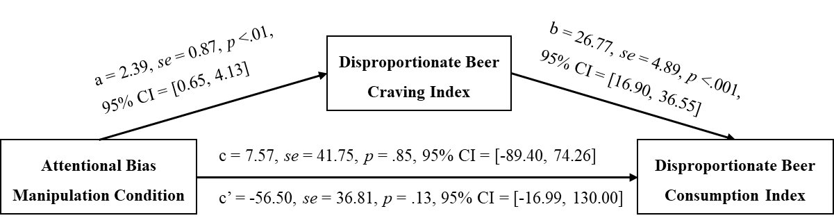

Figure S1. Diagram of mediation analysis of manipulation condition on disproportionate beer consumption through disproportionate beer craving. Unstandardized OLS regression path coefficients are shown; for attentional bias manipulation condition, the beer adverts avoid group was coded as 0 and beer adverts attend group as 1; c is total effect of manipulation condition on disproportionate beer consumption index that does not consider the mediator while c’ is direct effect model with mediator included. The bootstrapped confidence interval for the indirect pathway was entirely above zero (18.19 to 112.90), indicating that the indirect effect was statistically significant.

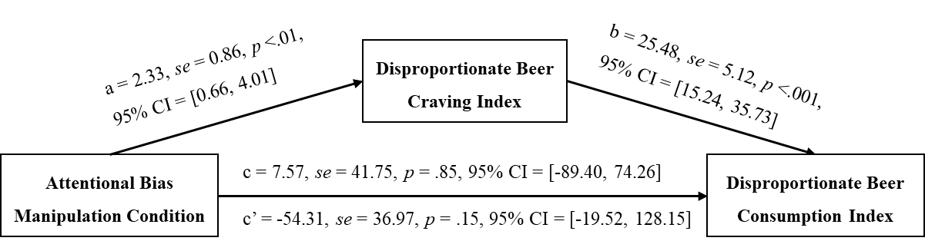

Figure S2. Diagram of mediation analysis of manipulation condition on disproportionate beer consumption through disproportionate beer craving controlling for AUDIT scores. Unstandardized OLS regression path coefficients are shown; for attentional bias manipulation condition, the beer adverts avoid group was coded as 0 and beer adverts attend group as 1; c is total effect of manipulation condition on disproportionate beer consumption index that does not consider the mediator while c’ is direct effect model with mediator included. The bootstrapped confidence interval for the indirect pathway was entirely above zero (18.49 to 102.65), indicating that the indirect effect was statistically significant.

In this mediation model, AUDIT scores were included as a covariate. AUDIT scores were a significant positive predictor of disproportionate beer craving, b = 0.21, SE = 0.09, p = .016, 95% CI [0.04, 0.38], indicating that higher habitual alcohol use was associated with greater disproportionate beer craving. AUDIT scores did not a significantly predict disproportionate beer consumption, b = 3.22, SE = 3.73, p = .39, 95% CI [–4.23, 10.67].

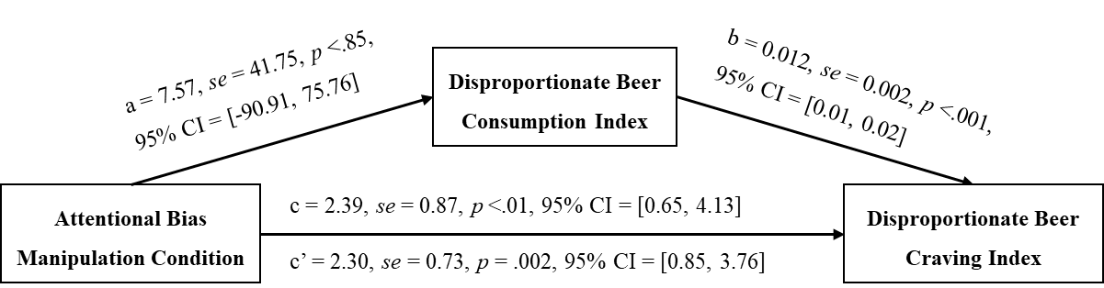

Figure S3. Diagram of mediation analysis of manipulation condition on disproportionate beer craving through disproportionate beer consumption. Unstandardized OLS regression path coefficients are shown; for attentional bias manipulation condition, the beer adverts avoid group was coded as 0 and beer adverts attend group as 1; c is total effect of manipulation condition on disproportionate beer carving index that does not consider the mediator while c’ is direct effect model with mediator included. The bootstrapped confidence interval for the indirect pathway included zero (-1.03 to 0.93), indicating that the indirect effect was not statistically significant.

