Supplementary Materials
Section A. Results of the grid search performed to find the optimal number of topics. Figure S1 shows the results produced by the “searchK” function of the stm package applied to the data with the following parameters:
- K = seq(4,40,1)
- Seed = 1234L
- Emtol = 2e-05
- Max.em.its = 100L

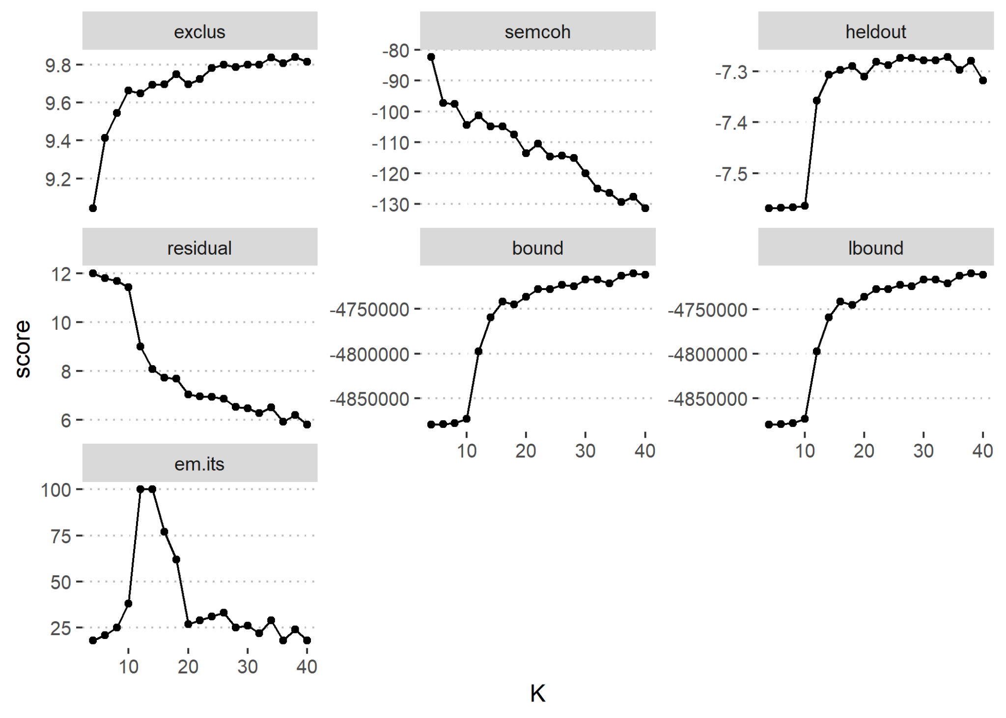
Figure S1. Results of the grid search. Each panel shows a model fit statistic based on the results of searchK function.
Section B. Words describing each topic based on alternative labeling algorithms.
Table S1. Topic terms retrieved using different labeling algorithms.
topic | metric | 1 | 2 | 3 | 4 | 5
1 | prob | account | site | deposit | bank | open
2 | prob | tell | know | help | family | thing
3 | prob | now | get | post | advice | bookie
4 | prob | money | debt | get | pay | lose
5 | prob | addiction | read | make | help | take
6 | prob | block | not | phone | just | gamcare
7 | prob | feel | really | think | just | get
8 | prob | lose | bet | win | play | loss
9 | prob | life | not | year | never | now
10 | prob | people | recovery | many | thing | life
1 | frex | account | withdraw | email | withdrawal | open
2 | frex | wife | family | partner | tell | talk
3 | frex | bookie | advice | appreciate | local | recently
4 | frex | loan | pay | bill | rent | payday
5 | frex | brain | book | journey | demon | listen
6 | frex | block | software | app | advert | gamban
7 | frex | urge | feeling | stay | positive | gamblefree
8 | frex | football | roulette | win | poker | bet
9 | frex | you | life | mentalhealth | ruin | depression
10 | frex | healthy | action | group | industry | justtoday
1 | lift | arrange | refund | lender | verify | pende
2 | lift | enjoyable | fiance | adore | husband | embarrassment
3 | lift | blog | fiancee | bandit | hypnotherapy | reset
4 | lift | recognise | consolidation | paydayloan | paybill | rent
5 | lift | press | lurk | shape | chemical | coaster
6 | lift | blocking | prescribe | android | gamblock | possibility
7 | lift | title | succumb | joe | roullette | shine
8 | lift | newbie | golf | match | poker | tournament
9 | lift | destine | shatter | you | reputation | childhood
10 | lift | association | spiritual | theme | merely | recognize
1 | score | account | arrange | email | deposit | withdraw
2 | score | enjoyable | partner | family | tell | wife
3 | score | blog | bookie | selfexclude | shop | advice
4 | score | recognise | loan | debt | pay | parent
5 | score | press | brain | recovery | book | read
6 | score | possibility | block | software | phone | app
7 | score | title | urge | feeling | feel | really
8 | score | win | bet | lose | roulette | football
9 | score | you | life | relationship | ruin | love
10 | score | merely | spiritual | recovery | justtoday | healthy

