**Supplemental Materials**

**Perceived School Climate and Problematic Internet Use Among Chinese Adolescents: Psychological Insecurity and Negative Peer Affiliation as Mediators**

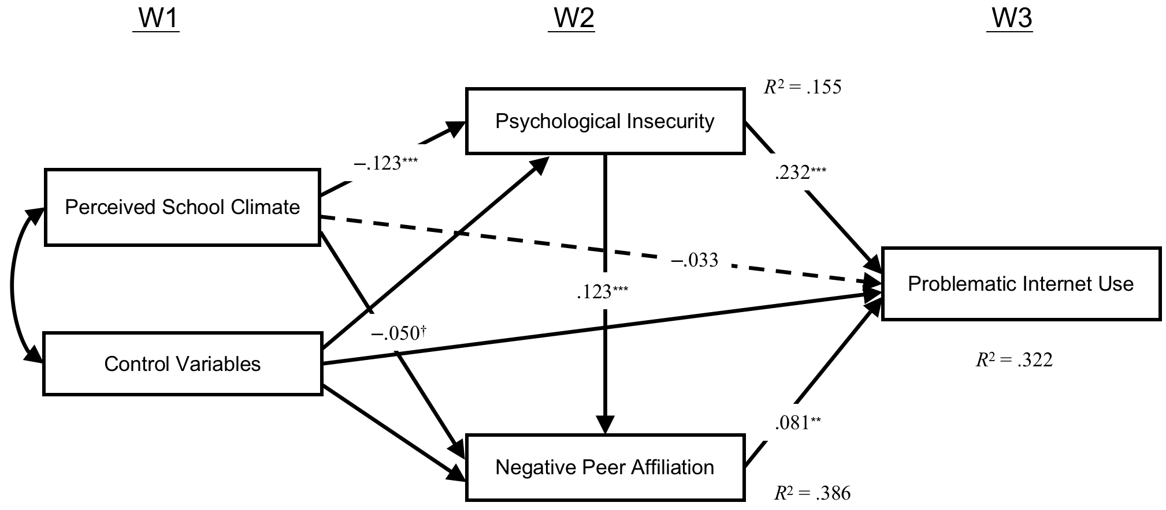

*Figure S1*. Unconstrained model. Structural equation model examining process associations among perceived school climate (W1), psychological insecurity (W2), negative peer affiliation (W2), and PIU (W3). Parameter estimates for the paths are standardized. Dashed lines indicate nonsignificant paths.

\*\*\**p* < .001, \*\**p* < .01, †*p* < .10.

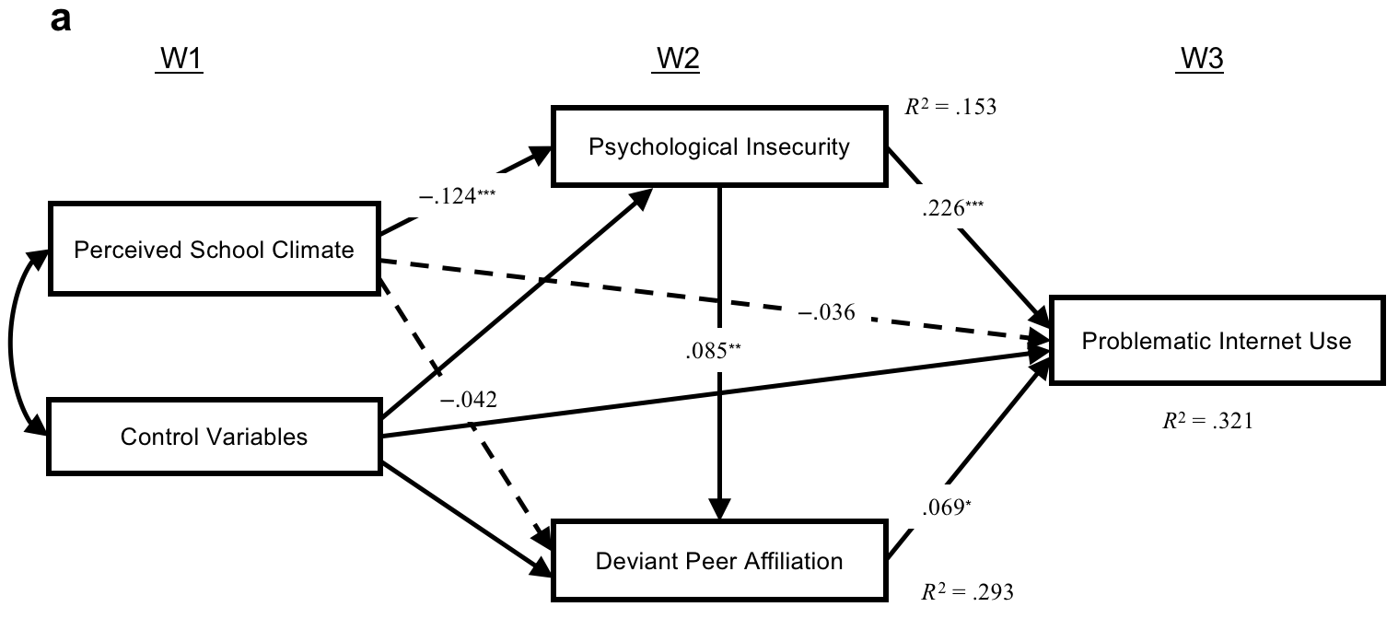

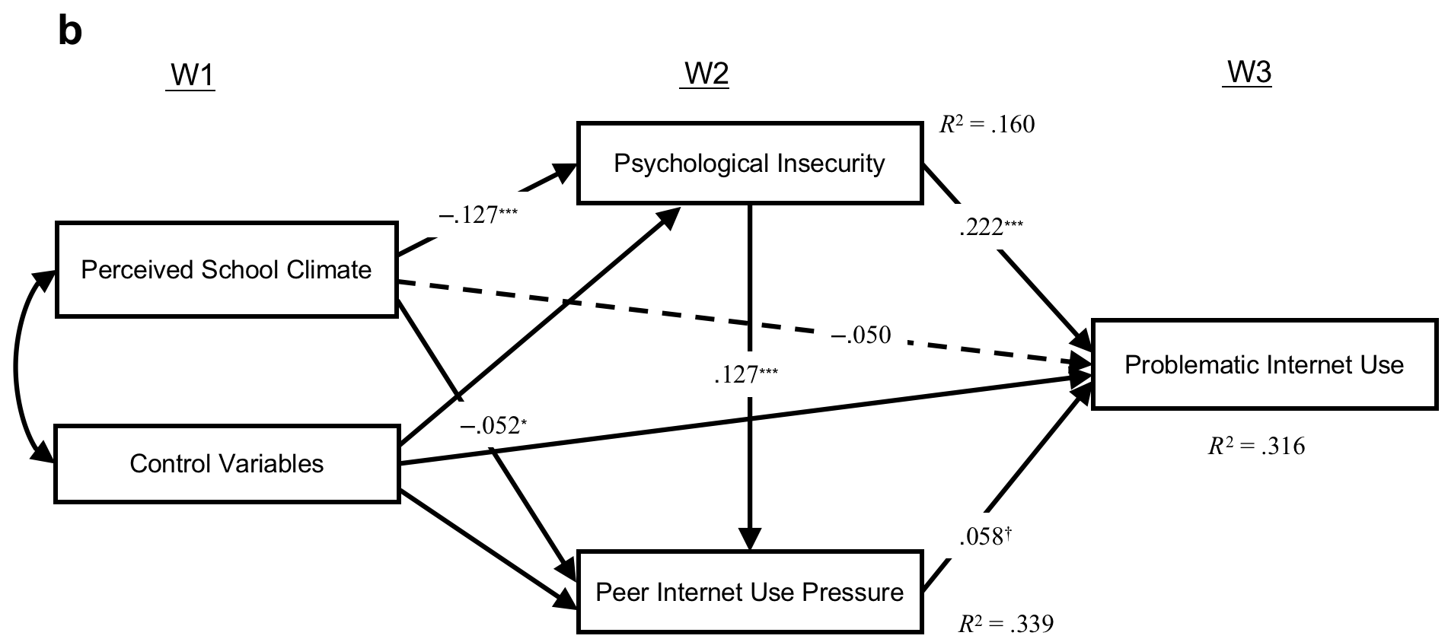

*Figure S2*. Supplementary analyses of the multiple mediation model, separately for (a) deviant peer affiliation and (b) the peer Internet use pressure.Dashed lines indicate nonsignificant paths.

\*\*\**p* < .001, \*\**p* < .01, \**p* < .05, †*p* < .10.