Figure S1.
Evolution and Distributions of Cumulative RTs.
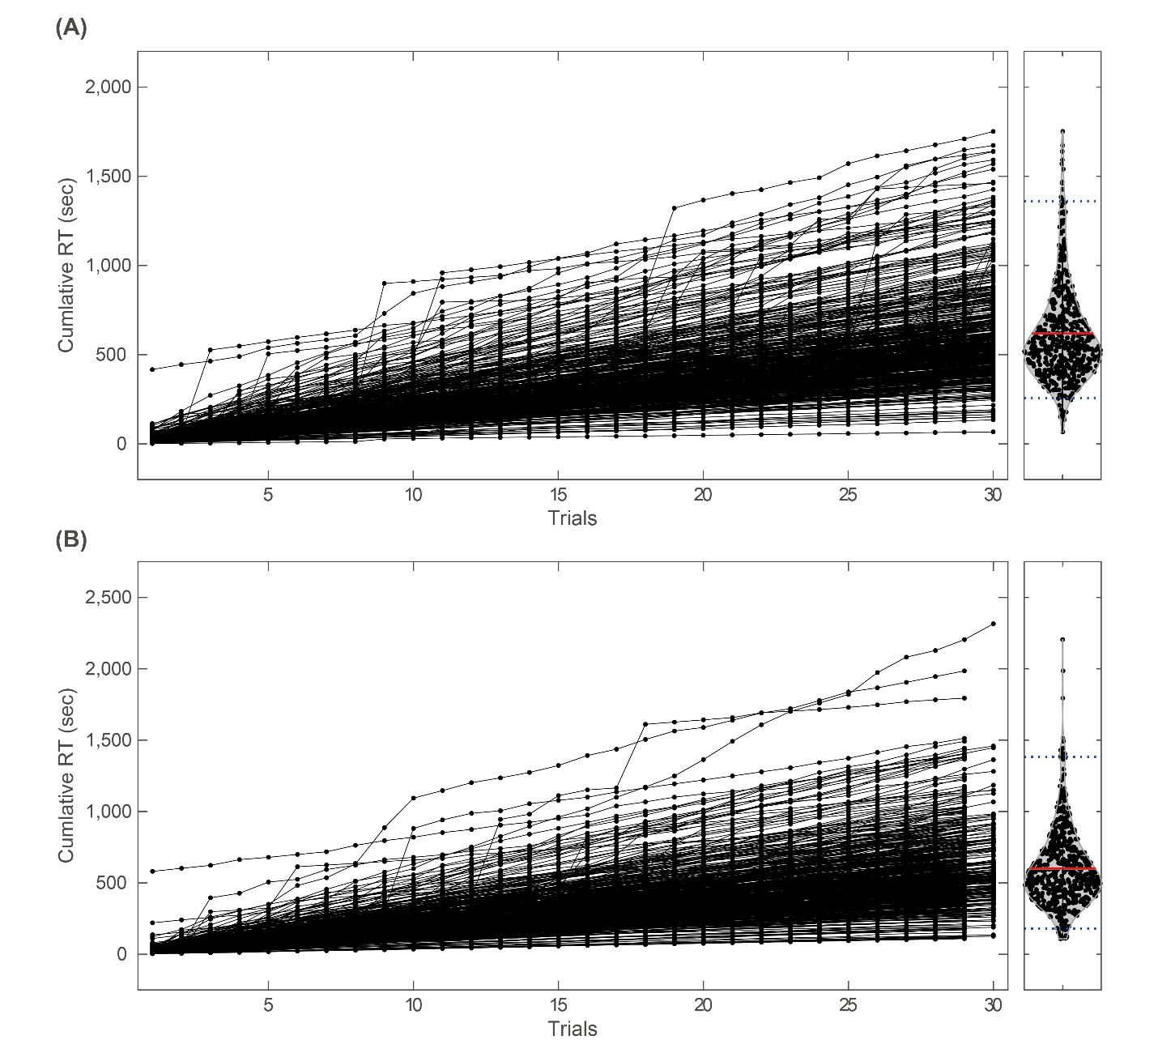
Note. (A) Left panel: an evolution of cumulative RTs across 30 trials in the first experiment. Each line represents the data for each participant. Right panel: a distribution (violin plot) of cumulative RTs after the last trial (30 trials) of the first experiment. Horizontal red line indicates the average, while dotted lines indicate upper and lower thresholds of the dataset to be used for the analyses (from bottom to top 2.5%). (B) Left panel: an evolution of cumulative RTs across 29 or 30 trials in the second experiment (the number of trials varied between stimulus set which participants were assigned). Right panel: a distribution of cumulative RTs at 29th trial of the second experiment. Horizontal red line indicates the average, while dotted lines indicate upper and lower thresholds of the dataset to be used for the analyses (from bottom to top 2.5%).

Figure S2.
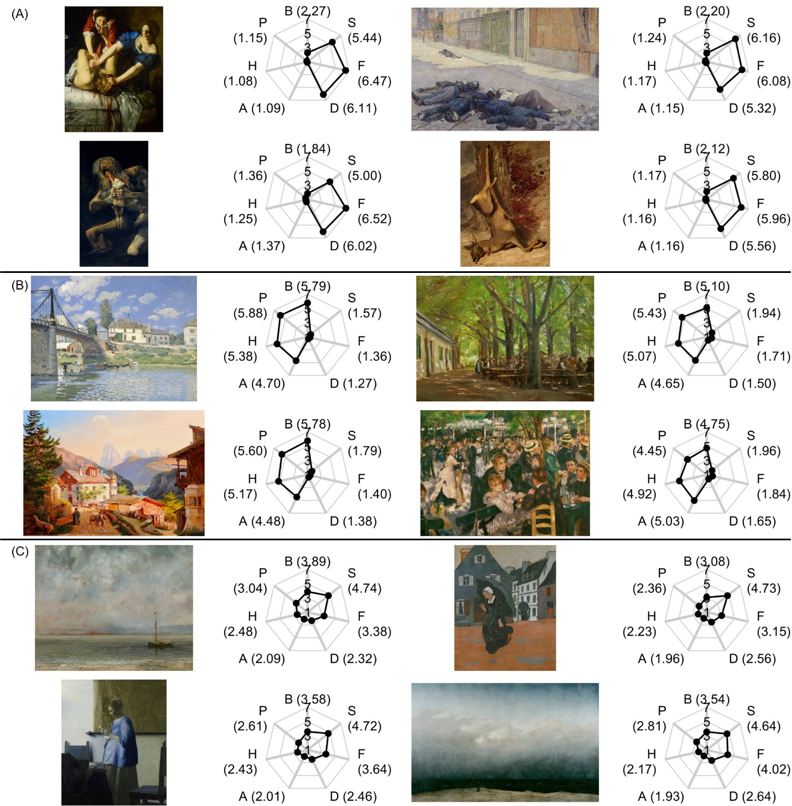
Top Four Paintings with Highest PCs (Six-Component Model)
VAPS ID: 10604
[Luce, Maximilien Jules, A Street in Paris in May 1871, 1903-06]
(LINK)
VAPS ID: 30501
[Liebermann, Max, County Inn at Brannenburg, Bavaria, 1983]
(LINK)
VAPS ID: 10632
[Sérusier, Paul, The Downpour, 1983]
(LINK)
Note. Each panel shows the paintings selected for each PC: (A) PC1, (B) PC2, and (C) PC3. A spider plot beside the painting shows the average basic and aesthetic emotional scores. Copyrighted materials are masked, with the following information provided where available: the artist’s name, title, year, and a link to the online material. PC: principal component, S: sadness, F: fear, D: disgust, A: amusement, H: happiness, P: pleasure, B: a feeling of beauty.
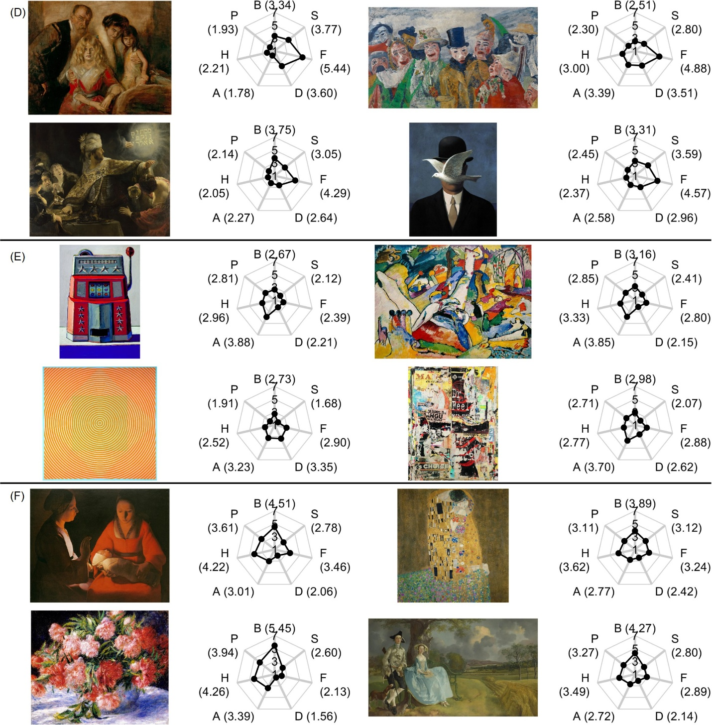
Figure S2. (cont.)
VAPS ID: 10619
[Ensor, James, The Intrigue, 1890]
(LINK)
VAPS ID: 21105
[Magritte, René, Man in a Bowler Hat (Man mit Melone), 1964]
(LINK)
VAPS ID: 41014
[Thiebaud, Wayne, Jackpot Machine, 1962]
(LINK)
VAPS ID: 30728
[Kandinsky, Wassily, Sketch for "Composition II", 1909-10]
(LINK)
VAPS ID: 50939
[Anuszkiewicz, Richard, Squaring the Circl, 1963]
VAPS ID: 51013
[Villeglé de la, Jacques, Dr Feel Good - Clermont Ferrand (Décollage), 2000]
Note. Each panel shows the paintings selected for each PC: (D) PC4, (E) PC5, and (F) PC6.

Figure S3.
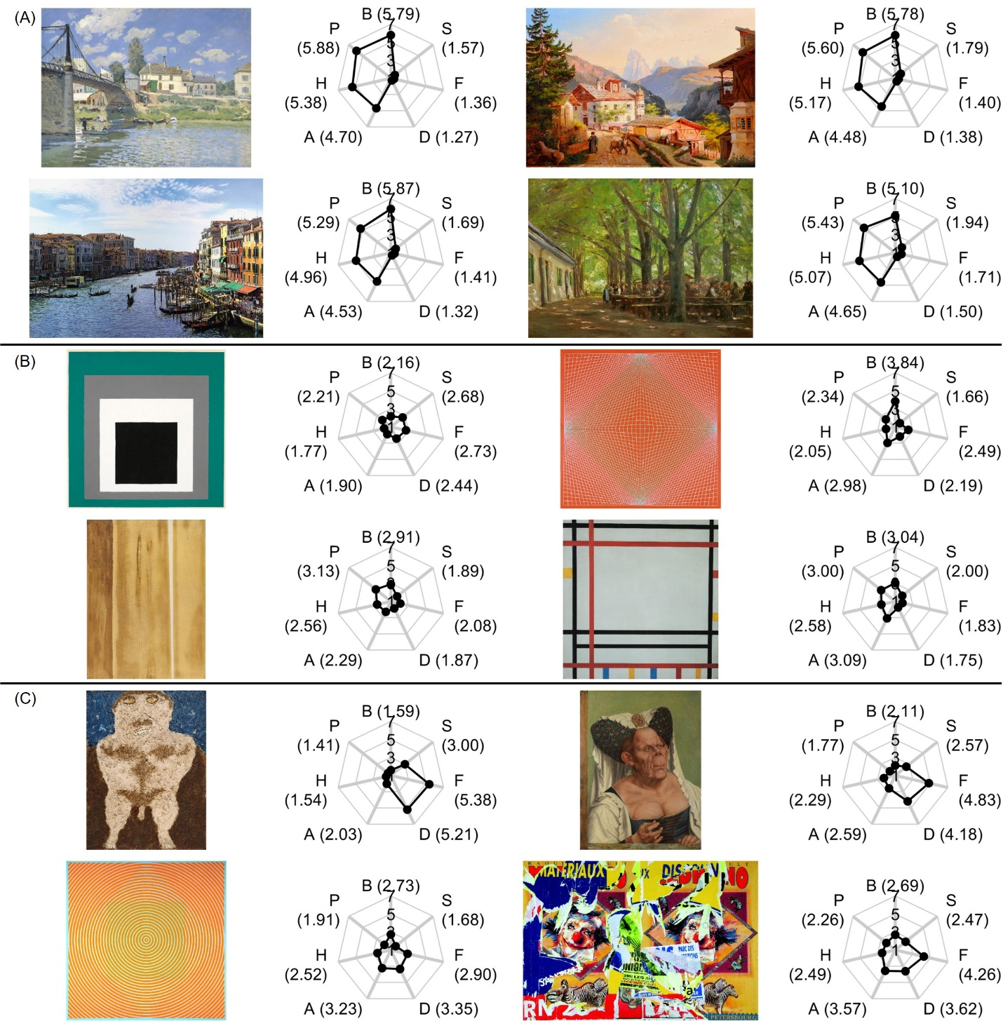
Bottom Four Paintings with Lowest PCs (Six-Component Model)
VAPS ID: 31019
[Spence, Raphaella, Grand Canal, 2007]
(LINK)
VAPS ID: 30501
[Liebermann, Max, County Inn at Brannenburg, Bavaria, 1893]
(LINK)
VAPS ID: 51322
[Albers, Josef, Homage to the Square, Decided, 1951]
VAPS ID: 50916
[Mondrian, Piet, New York, 1941-42]
(LINK)
VAPS ID: 50938
[Anuszkiewicz, Richard, Convexity, 1966]
VAPS ID: 51323
[Newman, Barnett, Two Edges, 1948]
(LINK)
VAPS ID: 20626
[Dubuffet, Jean, Will to Power, 1946]
(LINK)
VAPS ID: 50939
[Anuszkiewicz, Richard, Squaring the Circl, 1963]
VAPS ID: 51014
[Villeglé de la, Jacques, unknown, unknown]
Note. Each panel shows the paintings selected for each PC: (A) PC1, (B) PC2, and (C) PC3. A spider plot beside the painting shows the average basic and aesthetic emotional scores. Copyrighted materials are masked, with the following information provided where available: the artist’s name, title, year, and a link to the online material. PC: principal component, S: sadness, F: fear, D: disgust, A: amusement, H: happiness, P: pleasure, B: a feeling of beauty.
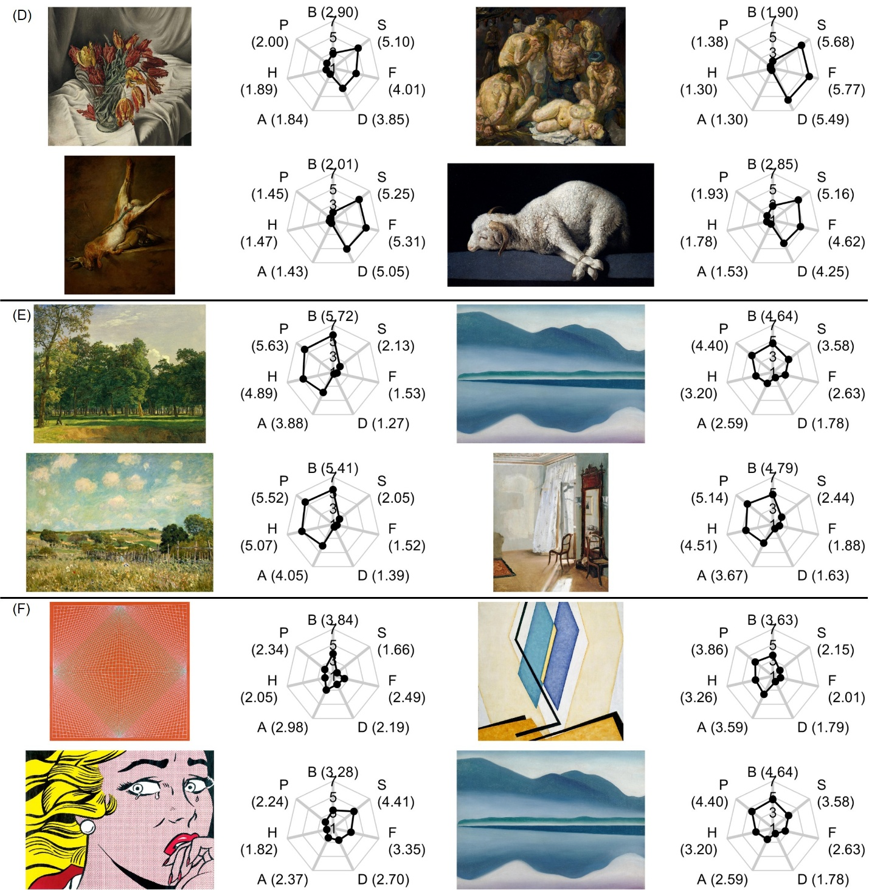
Figure S3. (cont.)
VAPS ID: 41004
[Barraud, François, Tulips perroquets, 1931]
(LINK)
VAPS ID: 10709
[Beckmann, Max, The Prisoners, 1910]
(LINK)
VAPS ID: 31006
[O`Keeffe, Giorgia, Lake George (formerly Reflection Seascape), 1922]
(LINK)
VAPS ID: 50938
[Anuszkiewicz, Richard, Convexity, 1966]
VAPS ID: 50933
[Kupka, František, Two Blues I, 1955]
VAPS ID: 21017
[Lichtenstein, Roy, Crying Girl, 1963]
(LINK)
VAPS ID: 31006
[O`Keeffe, Giorgia, Lake George (formerly Reflection Seascape), 1922]
(LINK)
Note. Each panel shows the paintings selected for each PC: (D) PC4, (E) PC5, and (F) PC6.

Figure S4.
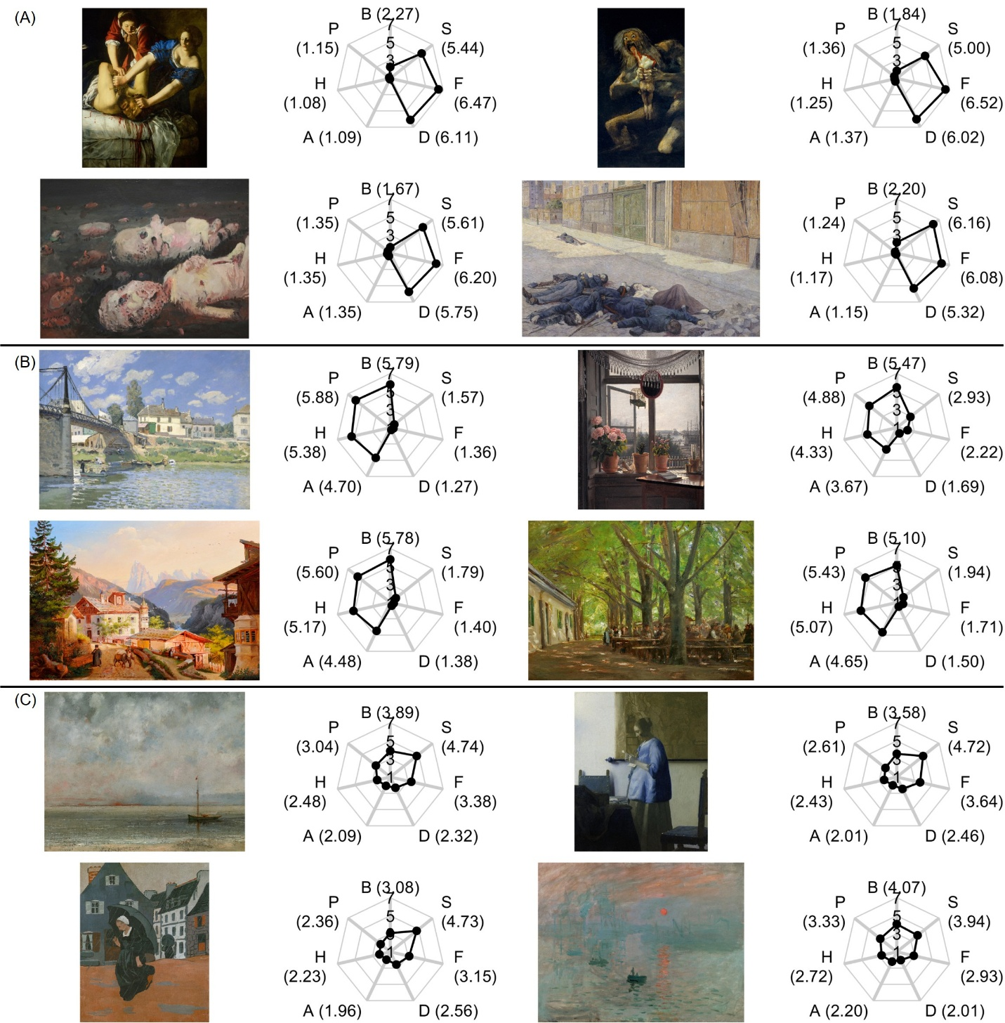
Top Four Paintings with Highest PCs (Seven-Component Model)
VAPS ID: 10726
[Baselitz, Georg, Acker, 1962]
(LINK)
VAPS ID: 10604
[Luce, Maximilien Jules, A Street in Paris in May 1871, 1903-06]
(LINK)
VAPS ID: 30501
[Liebermann, Max, County Inn at Brannenburg, Bavaria, 1893]
(LINK)
VAPS ID: 10632
[Sérusier, Paul, The Downpour, 1893]
(LINK)
VAPS ID: 30504
[Monet, Claude, Impression, Sunrise, 1872-73]
(LINK)
Note. Each panel shows the paintings selected for each PC: (A) PC1, (B) PC2, and (C) PC3. A spider plot beside the painting shows the average basic and aesthetic emotional scores. Copyrighted materials are masked, with the following information provided where available: the artist’s name, title, year, and a link to the online material. PC: principal component, S: sadness, F: fear, D: disgust, A: amusement, H: happiness, P: pleasure, B: a feeling of beauty.
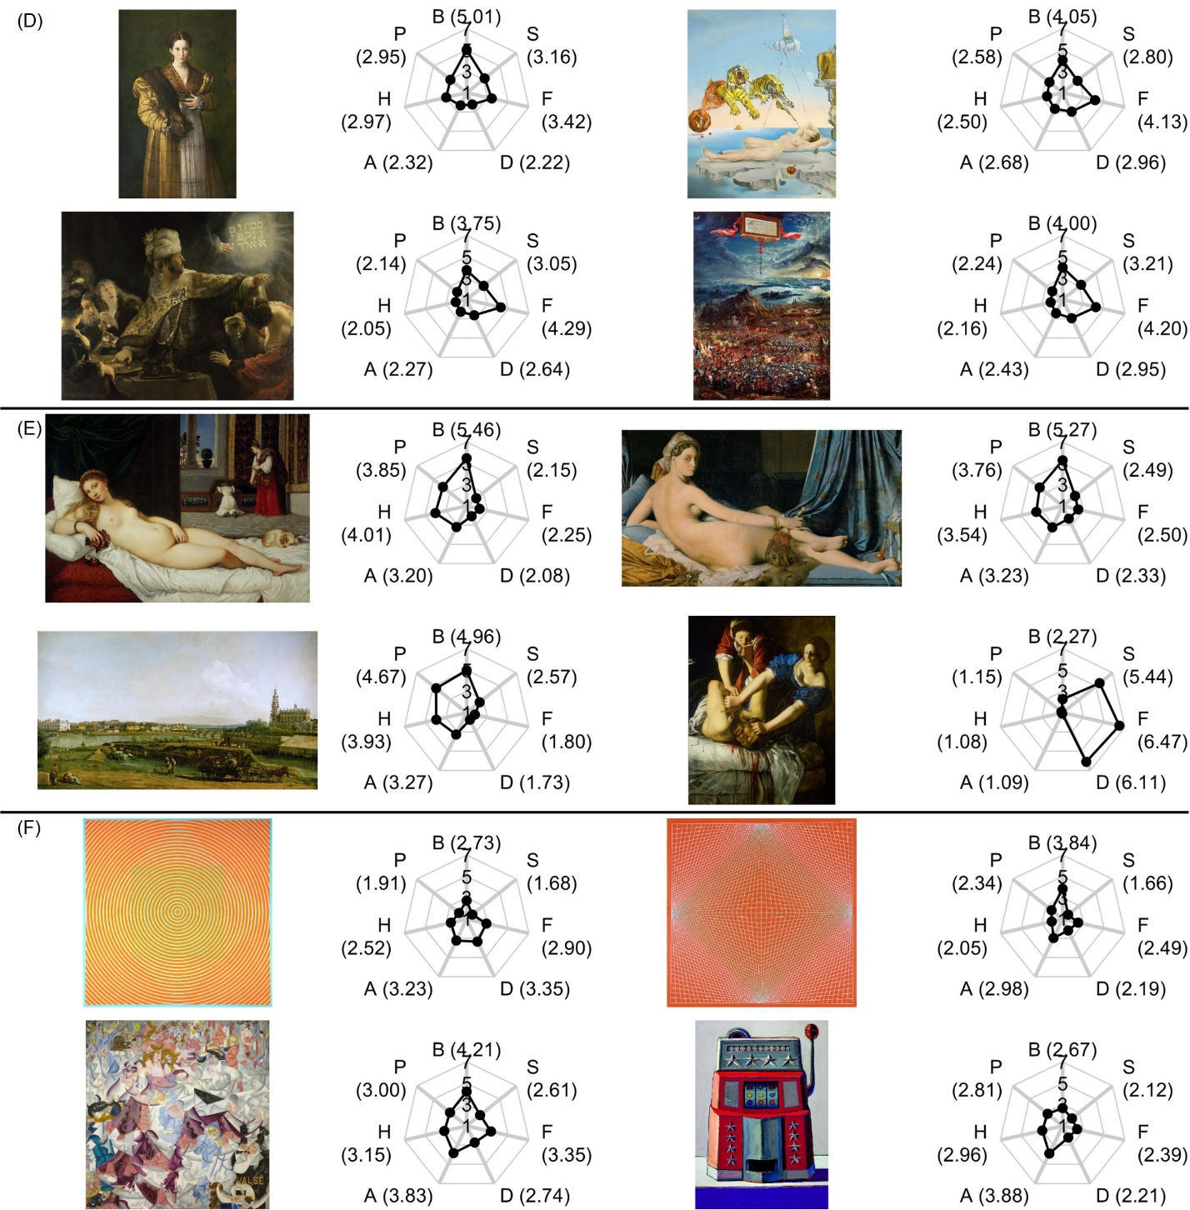
Figure S4. (cont.)
VAPS ID: 11105
[Dalí, Salvador, Dream Caused by the Flight of a Bee Around a Pomegranate a Second Before Awakening, 1944]
(LINK)
VAPS ID: 50939
[Anuszkiewicz, Richard, Squaring the Circl, 1963]
VAPS ID: 50938
[Anuszkiewicz, Richard, Convexity, 1966]
VAPS ID: 10814
[Severini, Gino, Dynamic Hieroglyphic of the Bal Tabarin, 1912]
(LINK)
VAPS ID: 41014
[Thiebaud, Wayne, Jackpot Machine, 1962]
(LINK)
Note. Each panel shows the paintings selected for each PC: (D) PC4, (E) PC5, and (F) PC6.

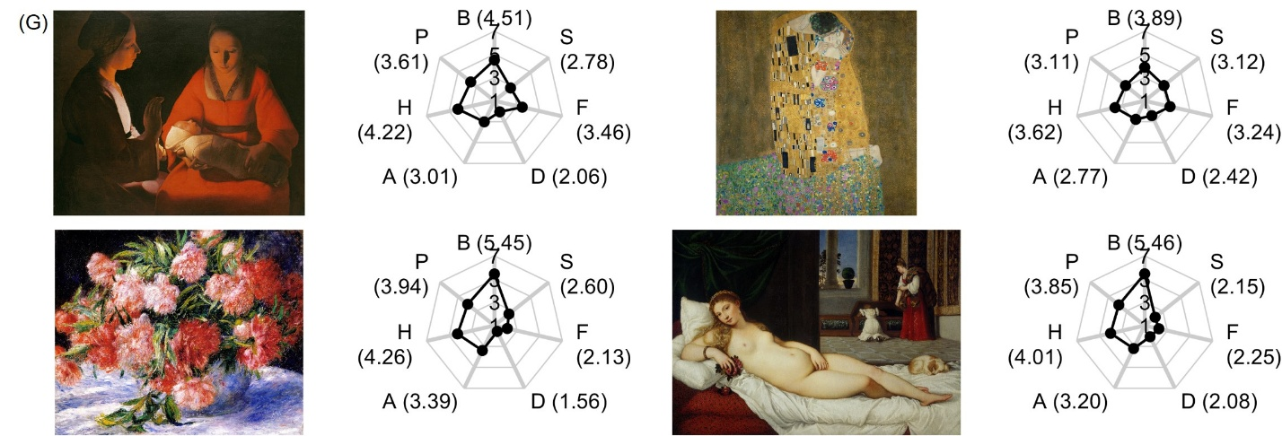
Figure S4. (cont.)
Note. Each panel shows the paintings selected for each PC: (G) PC7.

Figure S5.
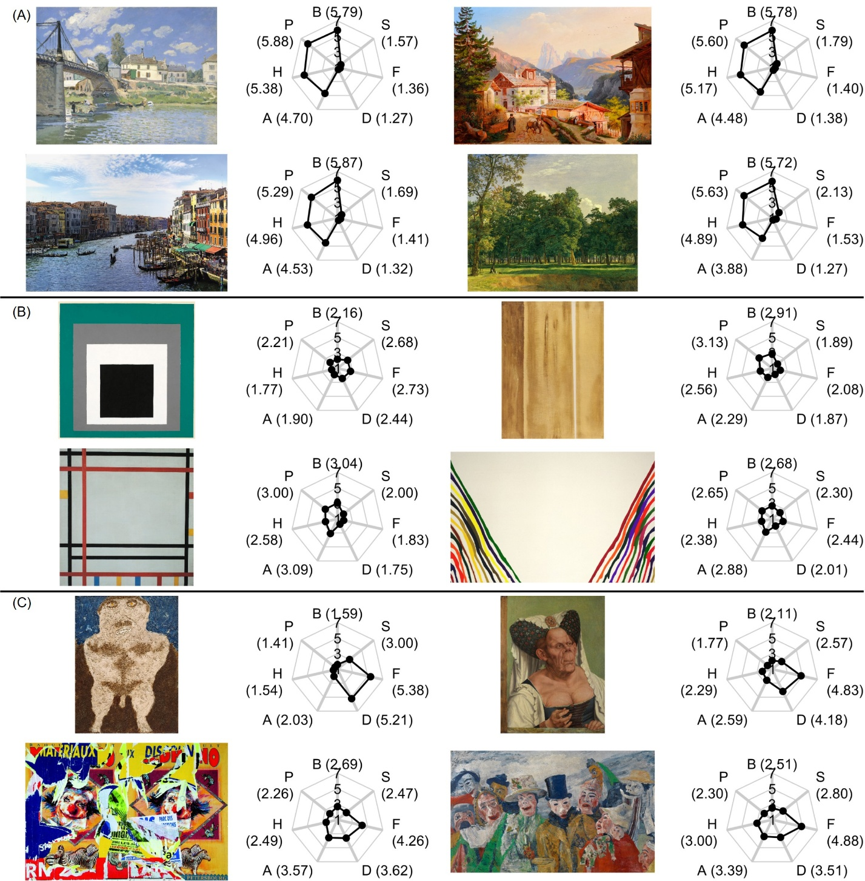
Bottom Four Paintings with Lowest PCs (Seven-Component Model)
VAPS ID: 31019
[Spence, Raphaella, Grand Canal, 2007]
(LINK)
VAPS ID: 51322
[Albers, Josef, Homage to the Square, Decided, 1951]
VAPS ID: 51323
[Newman, Barnett, Two Edges, 1948]
(LINK)
VAPS ID: 50916
[Mondrian, Piet, New York, 1941-42]
(LINK)
VAPS ID: 51324
[Morris, Louis, Beta Lambda, 1961]
(LINK)
VAPS ID: 20626
[Dubuffet, Jean, Will to Power, 1946]
(LINK)
VAPS ID: 51014
[Villeglé de la, Jacques, unknown, unknown]
VAPS ID: 10619
[Ensor, James, The Intrigue, 1890]
(LINK)
Note. Each panel shows the paintings selected for each PC: (A) PC1, (B) PC2, and (C) PC3. A spider plot beside the painting shows the average basic and aesthetic emotional scores. Copyrighted materials are masked, with the following information provided where available: the artist’s name, title, year, and a link to the online material. PC: principal component, S: sadness, F: fear, D: disgust, A: amusement, H: happiness, P: pleasure, B: a feeling of beauty.
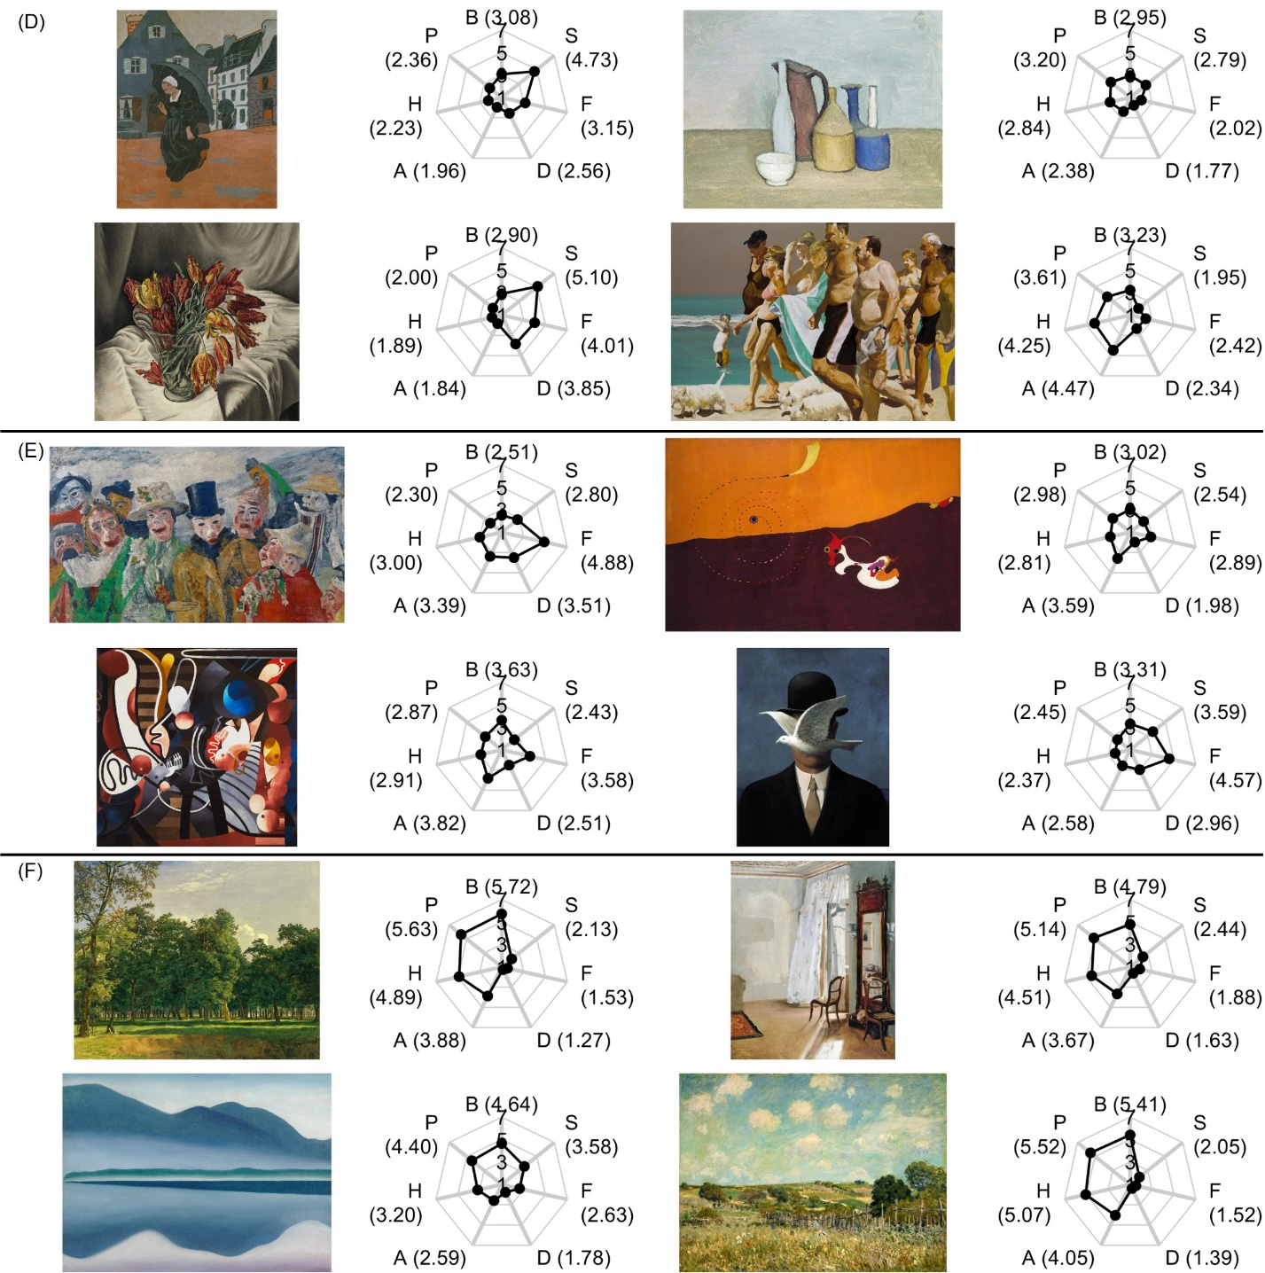
Figure S5. (cont.)
VAPS ID: 10632
[Sérusier, Paul, The Downpour, 1893]
(LINK)
VAPS ID: 40716
[Morandi, Giorgio, Still Life, 1952]
VAPS ID: 41004
[Barraud, François, Tulips perroquets, 1931]
(LINK)
VAPS ID: 11027
[Fischl, Eric, Scenes from Late Paradise: The Parade, 2006-07]
(LINK)
VAPS ID: 10619
[Ensor, James, The Intrigue, 1890]
(LINK)
VAPS ID: 51114
[Miro, Joan, Landscape, The Hare, 1927]
(LINK)
VAPS ID: 50807
[Picabia, Francis, Comic Wedlock, 1914]
(LINK)
VAPS ID: 21105
[Magritte, René, Man in a Bowler Hat (Man mit Melone), 1964]
(LINK)
VAPS ID: 31006
[O`Keeffe, Giorgia, Lake George (formerly Reflection Seascape), 1922]
(LINK)
Note. Each panel shows the paintings selected for each PC: (D) PC4, (E) PC5, and (F) PC6.

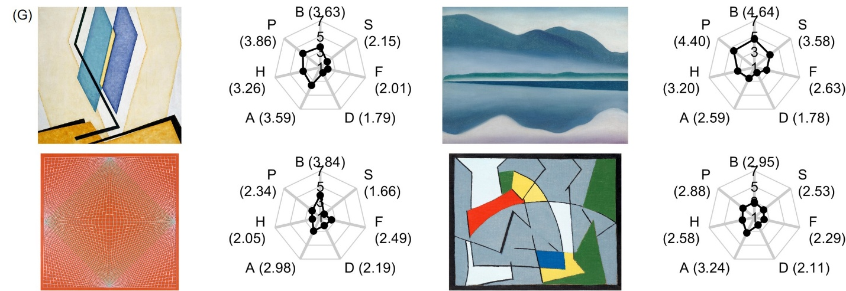
Figure S5. (cont.)
VAPS ID: 50933
[Kupka, František, Two Blues I, 1955]
VAPS ID: 31006
[O`Keeffe, Giorgia, Lake George (formerly Reflection Seascape), 1922]
(LINK)
VAPS ID: 50938
[Anuszkiewicz, Richard, Convexity, 1966]
VAPS ID: 50934
[Mortensen, Richard, Sans Titre, 1953]
Note. Each panel shows the paintings selected for each PC: (G) PC7.

Figure S6.
Correlations Between PCs (Seven-Component Model) and MIs
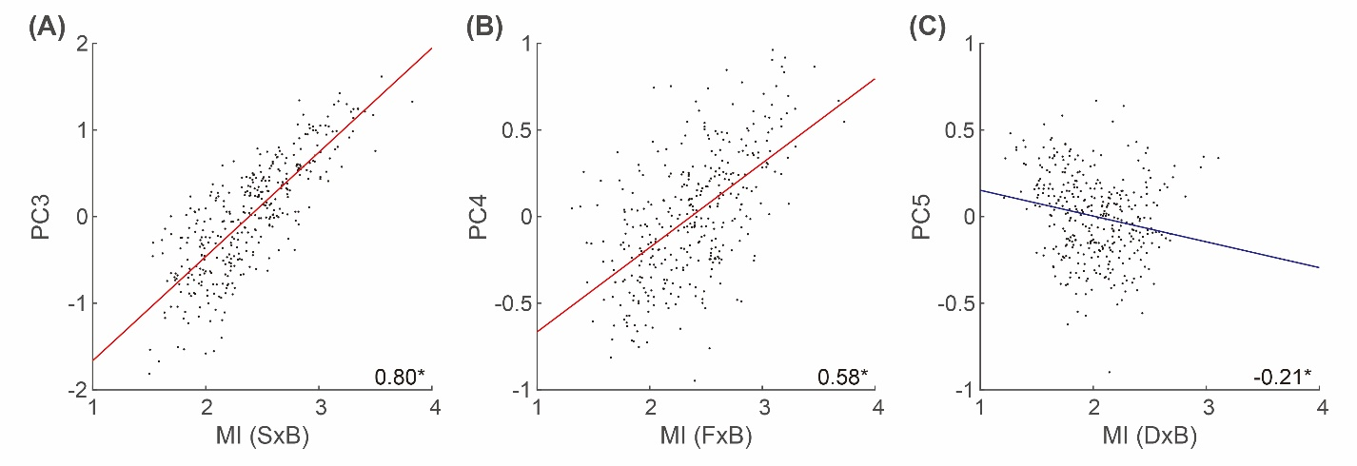
Note. Each panel shows the correlations between PCs in the seven-component model and MIs computed for pair of aesthetic and basic negative emotional scores: (A) PC3 and S×B, (B) PC4 and F×B, and (C) PC5 and D×B. The least-squares line was added for significant correlations (red: positive correlation, blue: negative correlation). The Spearman’s coefficient (averaged across bootstrap iterations) is shown in the right-bottom corner of each panel. An asterisk indicates a significant correlation. PC: principal component, MI: minimum index, S: sadness, B: the feeling of beauty, F: fear, D: disgust.

Table S1.
Styles and Contents of the Stimuli
 | Content
Style | Scenes | Portrait | Landscape | Still life | Toward Abstraction | Total
Renaissance and Mannerism | 15 | 10 | 0 | 0 | 0 | 25
Baroque and Rococo | 17 | 7 | 10 | 17 | 0 | 51
Idealistic tendencies | 10 | 5 | 8 | 9 | 0 | 32
Realistic tendencies I. (19th century) | 2 | 1 | 10 | 2 | 0 | 15
Impressionistic tendencies | 6 | 1 | 9 | 3 | 0 | 19
Postimpressionistic tendencies | 22 | 6 | 21 | 4 | 0 | 53
Expressionistic tendencies | 10 | 7 | 9 | 3 | 3 | 32
Cubistic tendencies | 7 | 0 | 1 | 3 | 7 | 18
Constructivist tendencies | 0 | 0 | 0 | 0 | 11 | 11
Realistic tendencies II. (20-21th century) | 14 | 13 | 6 | 9 | 6 | 48
Surrealistic tendencies | 14 | 2 | 6 | 2 | 6 | 30
Informel tendencies | 0 | 0 | 0 | 0 | 9 | 9
Abstract expressionistic tendencies | 0 | 0 | 0 | 0 | 13 | 13
Total | 117 | 52 | 80 | 52 | 55 | 356

