Supplementary Material 1 – Boxplots of Figures 2 and 3

Figure SM 1.1: Boxplot of the data shown in Figure 2.

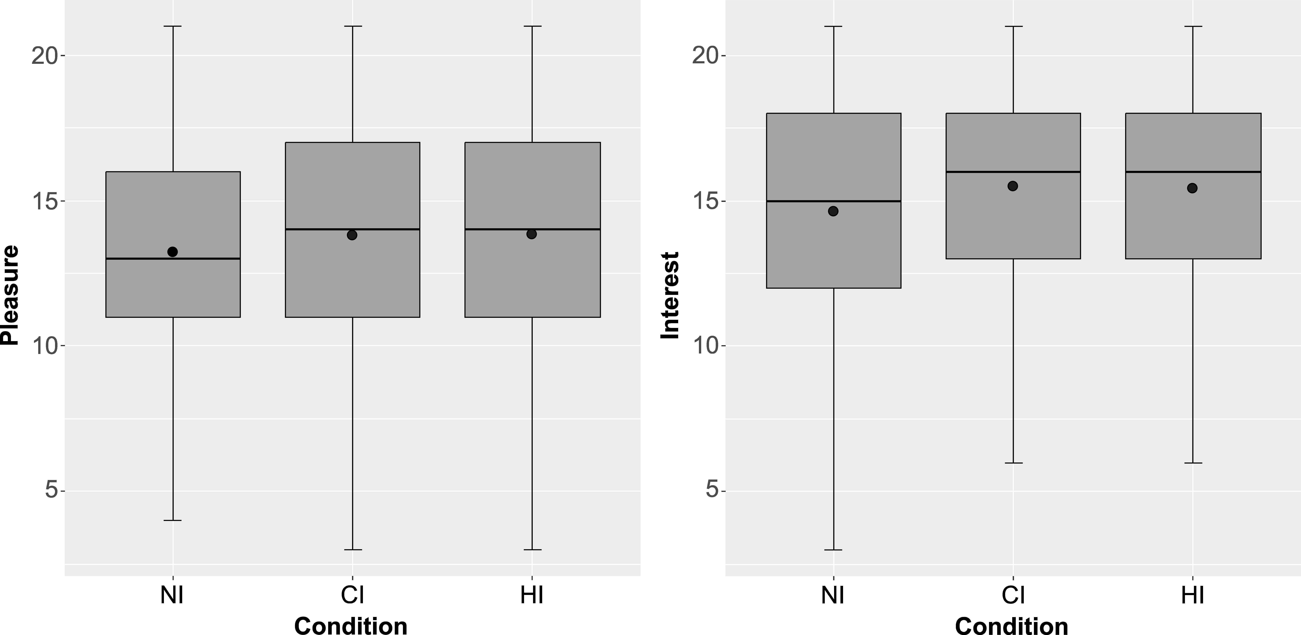

Figure SM 1.2 - Boxplot of the data shown in Figure 3.

Supplementary Material (SM 2) - Correlation matrixes of the models shown in Figures 4 to 7.

Table SM2.1 - Correlation matrix referred to Figure 4 (NI condition)

 | Overall  Aesthetic  Judgement | Intellectual  Curiosity | Aesthetic  Sensitivity | Creative  Imagination | Joyous  Exploration | Deprivation  Sensitivity | Art  Familiarity
Intellectual Curiosity | 0.094
Aesthetic Sensitivity | 0.207 | 0.431***
Creative Imagination | 0.121 | 0.471*** | 0.376***
Ioyous exploration | 0.101 | 0.433*** | 0.259* | 0.345***
Deprivation Sensitivity | -0.047 | 0.103 | -0.129 | -0.035 | 0.271**
Art Familiarity | 0.226* | 0.272** | 0.748*** | 0.283** | 0.172 | -0.077
Attitude Beauty in Art | -0.144 | -0.446*** | -0.415*** | -0.186 | -0.081 | 0.037 | -0.248*

Table SM2.2 - Correlation matrix referred to Figure 4 (CI condition)

 | Overall  Aesthetic  Judgement | Intellectual  Curiosity | Aesthetic  Sensitivity | Creative  Imagination | Joyous  Exploration | Deprivation  Sensitivity | Art  Familiarity
Intellectual Curiosity | 0.141
Aesthetic Sensitivity | 0.171 | 0.600***
Creative Imagination | 0.160 | 0.340*** | 0.299**
Ioyous exploration | 0.241* | 0.458*** | 0.336*** | 0.259*
Deprivation Sensitivity | 0.236* | 0.174 | 0.198 | 0.250* | 0.391***
Art Familiarity | 0.314** | 0.465*** | 0.744*** | 0.387*** | 0.240* | 0.165
Attitude Beauty in Art | -0.198 | -0.337*** | -0.302** | -0.250* | -0.129 | -0.013 | -0.227*

Table SM2.3 - Correlation matrix referred to Figure 4 (HI condition)

 | Overall  Aesthetic  Judgement | Intellectual  Curiosity | Aesthetic  Sensitivity | Creative  Imagination | Joyous  Exploration | Deprivation  Sensitivity | Art  Familiarity
Intellectual Curiosity | -0.155
Aesthetic Sensitivity | 0.058 | 0.558***
Creative Imagination | 0.065 | 0.429*** | 0.126
Ioyous exploration | 0.136 | 0.414*** | 0.030 | 0.368***
Deprivation Sensitivity | 0.027 | 0.201 | 0.084 | 0.190 | 0.296**
Art Familiarity | 0.173 | 0.398*** | 0.713*** | 0.221* | -0.011 | 0.064
Attitude Beauty in Art | -0.159 | -0.220* | -0.229* | -0.021 | -0.050 | 0.178 | -0.205

Table SM2.4 - Correlation matrix referred to Figure 5 (NI condition)

 | Feeling of Enrichment | Intellectual  Curiosity | Aesthetic  Sensitivity | Creative  Imagination | Joyous  Exploration | Deprivation  Sensitivity | Art  Familiarity
Intellectual Curiosity | -0.069
Aesthetic Sensitivity | 0.422*** | 0.431***
Creative Imagination | 0.065 | 0.471*** | 0.376***
Ioyous exploration | 0.129 | 0.433*** | 0.259* | 0.345***
Deprivation Sensitivity | -0.085 | 0.103 | -0.129 | -0.035 | 0.271**
Art Familiarity | 0.440*** | 0.272** | 0.748*** | 0.283** | 0.172 | -0.077
Attitude Beauty in Art | -0.164 | -0.446*** | -0.415*** | -0.186 | -0.081 | 0.037 | -0.248*

Table SM2.5 - Correlation matrix referred to Figure 5 (CI condition)

 | Feeling of Enrichment | Intellectual  Curiosity | Aesthetic  Sensitivity | Creative  Imagination | Joyous  Exploration | Deprivation  Sensitivity | Art  Familiarity
Intellectual Curiosity | 0.097
Aesthetic Sensitivity | 0.448*** | 0.600***
Creative Imagination | 0.077 | 0.340*** | 0.299**
Ioyous exploration | 0.302** | 0.458*** | 0.336*** | 0.259*
Deprivation Sensitivity | 0.216* | 0.174 | 0.198 | 0.250* | 0.391***
Art Familiarity | 0.411*** | 0.465*** | 0.744*** | 0.387*** | 0.240* | 0.165
Attitude Beauty in Art | -0.221* | -0.337*** | -0.302** | -0.250* | -0.129 | -0.013 | -0.227*

Table SM2.6 - Correlation matrix referred to Figure 5 (HI condition)

 | Feeling of Enrichment | Intellectual  Curiosity | Aesthetic  Sensitivity | Creative  Imagination | Joyous  Exploration | Deprivation  Sensitivity | Art  Familiarity
Intellectual Curiosity | 0.232*
Aesthetic Sensitivity | 0.210* | 0.558***
Creative Imagination | 0.157 | 0.429*** | 0.126
Ioyous exploration | 0.230* | 0.414*** | 0.030 | 0.368***
Deprivation Sensitivity | 0.177 | 0.201 | 0.084 | 0.190 | 0.296**
Art Familiarity | 0.226* | 0.398*** | 0.713*** | 0.221* | -0.011 | 0.064
Attitude Beauty in Art | -0.055 | -0.220* | -0.229* | -0.021 | -0.050 | 0.178 | -0.205

Table SM2.7 - Correlation matrix referred to Figure 6 (NI condition)

 | Feeling of  Mastery/  Virtuosity | Intellectual  Curiosity | Aesthetic  Sensitivity | Creative  Imagination | Joyous  Exploration | Deprivation  Sensitivity | Art  Familiarity
Intellectual Curiosity | -0.116
Aesthetic Sensitivity | 0.286** | 0.431***
Creative Imagination | 0.032 | 0.471*** | 0.376***
Ioyous exploration | 0.058 | 0.433*** | 0.259* | 0.345***
Deprivation Sensitivity | -0.164 | 0.103 | -0.129 | -0.035 | 0.271**
Art Familiarity | 0.146 | 0.272** | 0.748*** | 0.283** | 0.172 | -0.077
Attitude Beauty in Art | -0.017 | -0.446*** | -0.415*** | -0.186 | -0.081 | 0.037 | -0.248*

Table SM2.8 - Correlation matrix referred to Figure 6 (CI condition)

 | Feeling of  Mastery/  Virtuosity | Intellectual  Curiosity | Aesthetic  Sensitivity | Creative  Imagination | Joyous  Exploration | Deprivation  Sensitivity | Art  Familiarity
Intellectual Curiosity | -0.005
Aesthetic Sensitivity | 0.202 | 0.600***
Creative Imagination | -0.030 | 0.340*** | 0.299**
Ioyous exploration | 0.028 | 0.458*** | 0.336*** | 0.259*
Deprivation Sensitivity | -0.068 | 0.174 | 0.198 | 0.250* | 0.391***
Art Familiarity | 0.203 | 0.465*** | 0.744*** | 0.387*** | 0.240* | 0.165
Attitude Beauty in Art | -0.011 | -0.337*** | -0.302** | -0.250* | -0.129 | -0.013 | -0.227*

Table SM2.9 - Correlation matrix referred to Figure 6 (HI condition)

 | Feeling of  Mastery/  Virtuosity | Intellectual  Curiosity | Aesthetic  Sensitivity | Creative  Imagination | Joyous  Exploration | Deprivation  Sensitivity | Art  Familiarity
Intellectual Curiosity | -0.094
Aesthetic Sensitivity | 0.120 | 0.558***
Creative Imagination | 0.109 | 0.429*** | 0.126
Ioyous exploration | 0.236* | 0.414*** | 0.030 | 0.368***
Deprivation Sensitivity | 0.123 | 0.201 | 0.084 | 0.190 | 0.296**
Art Familiarity | 0.213* | 0.398*** | 0.713*** | 0.221* | -0.011 | 0.064
Attitude Beauty in Art | -0.006 | -0.220* | -0.229* | -0.021 | -0.050 | 0.178 | -0.205

Table SM2.10 - Correlation matrix referred to Figure 7 (NI condition)

 | Boredom | Intellectual  Curiosity | Aesthetic  Sensitivity | Creative  Imagination | Joyous  Exploration | Deprivation  Sensitivity | Art  Familiarity
Intellectual Curiosity | 0.178
Aesthetic Sensitivity | -0.470*** | 0.431***
Creative Imagination | -0.310** | 0.471*** | 0.376***
Ioyous exploration | -0.129 | 0.433*** | 0.259* | 0.345***
Deprivation Sensitivity | 0.208* | 0.103 | -0.129 | -0.035 | 0.271**
Art Familiarity | -0.262** | 0.272** | 0.748*** | 0.283** | 0.172 | -0.077
Attitude Beauty in Art | 0.366*** | -0.446*** | -0.415*** | -0.186 | -0.081 | 0.037 | -0.248*

Table SM2.11 - Correlation matrix referred to Figure 7 (CI condition)

 | Boredom | Intellectual  Curiosity | Aesthetic  Sensitivity | Creative  Imagination | Joyous  Exploration | Deprivation  Sensitivity | Art  Familiarity
Intellectual Curiosity | -0.081
Aesthetic Sensitivity | -0.386*** | 0.600***
Creative Imagination | -0.213* | 0.340*** | 0.299**
Ioyous exploration | 0.385*** | 0.458*** | 0.336*** | 0.259*
Deprivation Sensitivity | -0.296** | 0.174 | 0.198 | 0.250* | 0.391***
Art Familiarity | -0.311** | 0.465*** | 0.744*** | 0.387*** | 0.240* | 0.165
Attitude Beauty in Art | 0.206* | -0.337*** | -0.302** | -0.250* | -0.129 | -0.013 | -0.227*

Table SM2. 12 - Correlation matrix referred to Figure 7 (HI condition)

 | Boredom | Intellectual  Curiosity | Aesthetic  Sensitivity | Creative  Imagination | Joyous  Exploration | Deprivation  Sensitivity | Art  Familiarity
Intellectual Curiosity | -0.074
Aesthetic Sensitivity | 0.114 | 0.558***
Creative Imagination | 0.012 | 0.429*** | 0.126
Ioyous exploration | -0.369*** | 0.414*** | 0.030 | 0.368***
Deprivation Sensitivity | -0.119 | 0.201 | 0.084 | 0.190 | 0.296**
Art Familiarity | -0.189 | 0.398*** | 0.713*** | 0.221* | -0.011 | 0.064
Attitude Beauty in Art | -0.267* | -0.220* | -0.229* | -0.021 | -0.050 | 0.178 | -0.205

