Table S1
Correlations Between Different Emotions Experienced – Frequentist
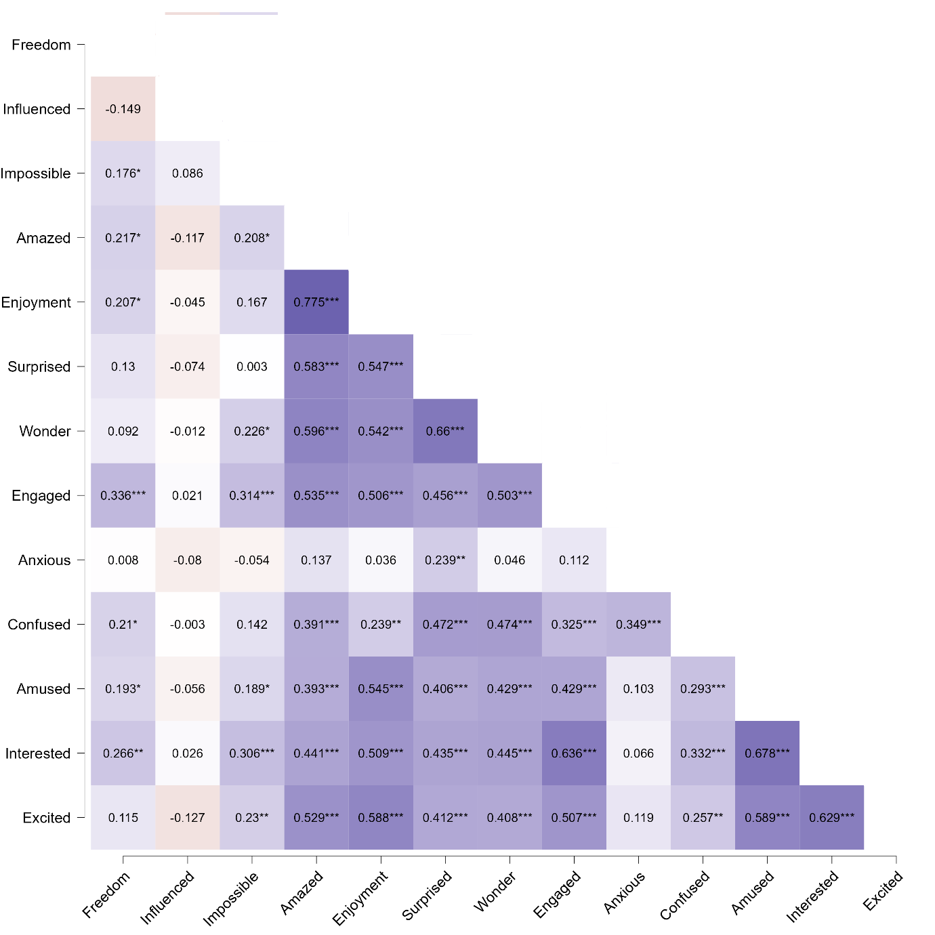
Note. Pearson correlations between the variables *p < .05, **p < .01, ***p < .001. Degrees of freedom: n = 134. The stronger the shade of purple, the stronger is the correlation between the experienced emotions.

Table S2
Correlations Between Different Emotions Experienced – Bayesian

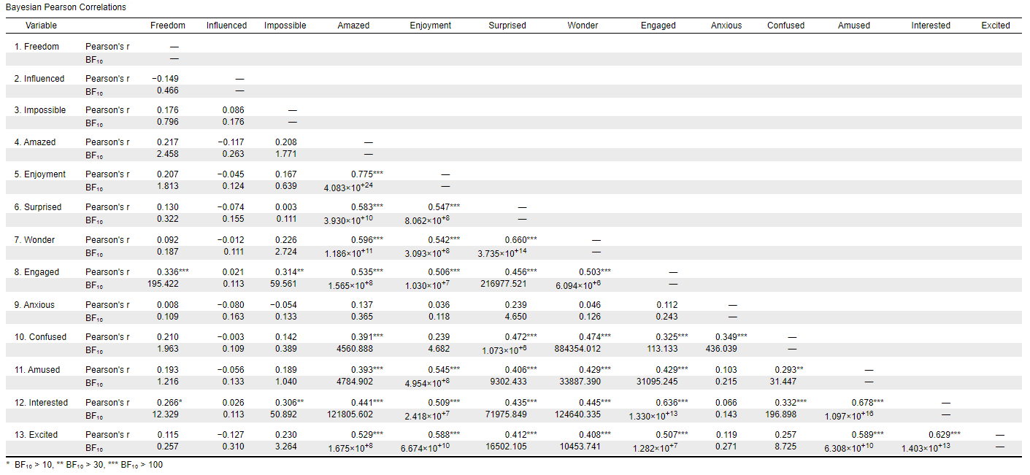
Table S3
Correlational Matrix Between the Different Emotions
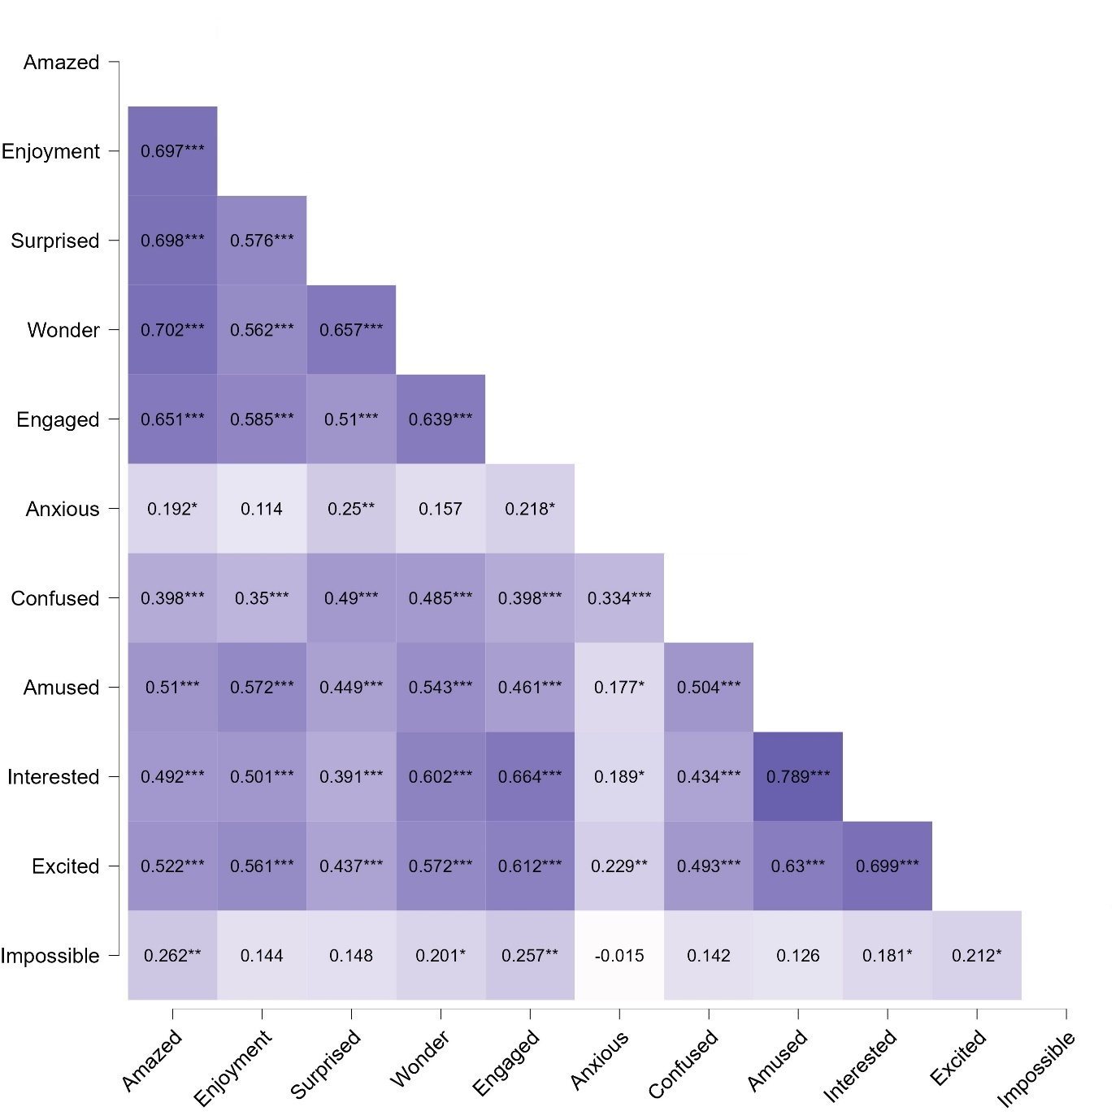
Note. Pearson correlations between the variables *p < .05, **p < .01, ***p < .001. Degrees of freedom: n = 134. The stronger the shade of purple, the stronger is the correlation between the experienced emotions.

Table S4
Correlations Between Different Emotions Experienced – Bayesian

