Supplementary

This supplementary consists of demographic information and statistic not included in the main paper.

Table 1
Participants Demographic by Country of Origin
Nationality | Regions | No. Participants | Percentage(%)
Angola | Non Europe | 1 | 0.25
Vietnam | Non Europe | 1 | 0.25
Venezuela, Bolivarian Republic of | Non Europe | 1 | 0.25
Uganda | Non Europe | 1 | 0.25
Turkey | Non Europe | 1 | 0.25
Sri Lanka | Non Europe | 1 | 0.25
Russian Federation | Europe | 1 | 0.25
Norway | Europe | 1 | 0.25
Zambia | Non Europe | 1 | 0.25
Kazakhstan | Non Europe | 1 | 0.25
Iran | Non Europe | 1 | 0.25
India | Non Europe | 1 | 0.25
Korea | Non Europe | 1 | 0.25
Colombia | Non Europe | 1 | 0.25
Dominican Republic | Non Europe | 1 | 0.25
Zimbabwe | Non Europe | 2 | 0.49
Brazil | Non Europe | 2 | 0.49
Romania | Europe | 2 | 0.49
Denmark | Europe | 2 | 0.49
Bangladesh | Non Europe | 2 | 0.49
New Zealand | Non Europe | 2 | 0.49
Finland | Europe | 3 | 0.74
Estonia | Europe | 3 | 0.74
Argentina | Non Europe | 3 | 0.74
France | Europe | 3 | 0.74
Czech Republic | Europe | 3 | 0.74
Netherlands | Europe | 4 | 0.98
Ireland | Europe | 4 | 0.98
Chile | Non Europe | 4 | 0.98
Israel | Non Europe | 5 | 1.23
Canada | Non Europe | 5 | 1.23
Latvia | Europe | 6 | 1.47
Slovenia | Europe | 8 | 1.96
Hungary | Europe | 8 | 1.96
Mexico | Non Europe | 9 | 2.21
United States | Non Europe | 9 | 2.21
Spain | Europe | 11 | 2.70
Greece | Europe | 19 | 4.66
Italy | Europe | 27 | 6.62
United Kingdom | Europe | 31 | 7.60
Not Avalible |  | 32 | 7.84
South Africa | Non Europe | 54 | 13.24
Portugal | Europe | 57 | 13.97
Poland | Europe | 73 | 17.89
Total |  | 408 | 100
Note. *: This table shows the country of origin of all Participants. In total 65.44% of participants are from Europe 26.96% are not from Europe and 7.6% did not indicate where they were from. The split between European and non-European countries were to determine if there is a cultural bias towards our dataset which are largely painted by European artists.

Table 2
The adjusted R², AIC and Beta estimates of each model fitted to the Emotion Categories
 | Model top 5 | Model bottom 5 | Model All 35
adjR | 0.38 | 0.15 | 0.5
AIC | 61641 | 66750 | 57893
(Intercept) | 3.96* | 4.54* | 3.97*
Interest | 0.68* |  | 0.44*
Aesthetic Appreciation | 0.94* |  | 0.64*
Calmness | 0.66* |  | 0.44*
Confusion | -0.48* |  | -0.36*
Admiration | 0.76* |  | 0.37*
Joy |  |  | 0.4*
Fear |  |  | 0.05
Nostalgia |  |  | 0.41*
Anxiety |  |  | -0.12*
Adoration |  |  | 0.14*
Satisfaction |  |  | 0.34*
Sadness |  |  | 0.21*
Excitement |  |  | 0.48*
Awe |  |  | 0.36*
Awkwardness |  |  | -0.35*
Amusement |  |  | 0.16*
Boredom |  |  | -0.63*
Pride |  |  | 0.07
Entrancement |  |  | 0.45*
Sympathy |  |  | 0.32*
Romance |  |  | 0.12*
Surprise |  |  | 0.18*
Horror |  |  | -0.08*
Nothing |  |  | -0.74*
Empathic Pain |  |  | 0.31*
Triumph |  |  | 0.13*
Contempt |  |  | -0.06
Disgust |  |  | -0.73*
Disappointment |  |  | -0.44*
Relief |  |  | 0.27*
Sexual Desire |  | 0.48* | 0.17*
Anger |  | -0.7* | -0.04
Guilt |  | -0.05 | 0.32*
Craving |  | 0.58* | 0.25*
Envy |  | 0.3* | 0.13*
Note. *: significant effect of the variable while controlling for other variables. This table is results modelled on the emotion categories with the top 5 and bottom 5 concordance rates. Also the model with all 35 emotions was used as a comparison. The columns of the table represent the four models while the rows represent the estimates, conditional R², and AIC.

Table 3
The _{conditional}R², AIC and Beta estimates of each model fitted to with varying random effects based on Individual differences
Model | Formal |  |  | Subjective
Random effects | Regions | Participants | Art Experience | Regions | Participants | Art Experience
_{conditional}R² | 0.01 | 0.16 | 0.04 | 0.55 | 0.61 | 0.55
AIC | 27804 | 26911 | 27666 | 21863 | 21230 | 21863
(Intercept) | 4.82* | 4.69* | 4.77* | 0.42* | 0.4* | 0.45*
Hue | -0.09 | -0.08 | -0.11
Saturation | -0.04 | 0 | -0.05
Value | -0.02 | -0.02 | -0.02
SIGMA | -0.08 | 0.18 | -0.01
Self-similarity | -0.03 | -0.01 | -0.04
2nd Order Entropy | -0.12 | 0.08 | -0.13
Edge Density | 0.02 | 0.21 | 0
SymmetryLR | -0.28* | -0.26* | -0.24
SymmetryUD | 0.08 | -0.04 | 0.1
Curvature | 0.09 | -0.21 | 0.08
Valence |  |  |  | 0.66* | 0.63* | 0.66*
Familiarity |  |  |  | 0.11* | 0.12* | 0.1*
Intensity |  |  |  | 0.21* | 0.21* | 0.21*
Realism |  |  |  | 0.04* | 0.04* | 0.04*
EmoSpread |  |  |  | 0.07* | 0.11* | 0.07*
Adoration
Aest. App.
Calmness
Confusion
Interest
Note. *: The _{conditional}R², AIC and Beta estimates of each model fitted to with varying random effects based on Individual differences. The model based on subjective features and the all features performed the best. Modelling the random effect based on participant rather than group properties provided the biggest effect size for all models. The table continues on the next page

 | Emotions |  |  | All
Random effects | Regions | Participants | Art Experience | Regions | Participants | Art Experience
adjR | 0.25 | 0.39 | 0.26 | 0.57 | 0.62 | 0.57
AIC | 25729 | 24697 | 25628 | 21570 | 20924 | 21568
(Intercept) | 4.1* | 4.02* | 4.08* | 0.83* | 0.67* | 0.85*
Hue |  |  |  | -0.12 | -0.07 | -0.12
Saturation |  |  |  | 0.04 | 0.11 | 0.04
Value |  |  |  | 0.12 | 0.15* | 0.13
SIGMA |  |  |  | -0.16 | -0.07 | -0.15
Self-similarity |  |  |  | -0.04 | 0 | -0.03
2nd Order Entropy |  |  |  | -0.15 | 0 | -0.15
Edge Density |  |  |  | 0.06 | 0.05 | 0.06
SymmetryLR |  |  |  | 0.04 | 0.01 | 0.04
SymmetryUD |  |  |  | -0.1 | -0.11 | -0.09
Curvature |  |  |  | 0.12 | 0.02 | 0.1
Valence |  |  |  | 0.59* | 0.56* | 0.59*
Familiarity |  |  |  | 0.12* | 0.12* | 0.11*
Intensity |  |  |  | 0.23* | 0.23* | 0.22*
Realism |  |  |  | 0.02* | 0.02* | 0.02*
EmoSpread |  |  |  | 0.04* | 0.07* | 0.04*
Adoration | 0.75* | 0.71* | 0.72* | 0.02 | -0.04 | 0.02
Aest. App. | 0.93* | 0.99* | 0.91* | 0.33* | 0.34* | 0.34*
Calmness | 0.55* | 0.63* | 0.54* | 0.11* | 0.15* | 0.12*
Confusion | -0.61* | -0.53* | -0.62* | -0.3* | -0.29* | -0.3*
Interest | 0.66* | 0.67* | 0.65* | 0.26* | 0.26* | 0.26*
Note. *: The _{conditional}R², AIC and Beta estimates of each model fitted to with varying random effects based on Individual differences. The model based on subjective features and the all features performed the best. Modelling the random effect based on participant rather than group properties provided the biggest effect size for all models. The table ends here.

Table 4
The adjusted R², AIC and Beta estimates of each model fitted to the Emotion Components
Parameters | Model 1 | Model 2 | Model 3 | Model 4 | Model 5 | Model 6 | Model 7
adjR | 0.28 | 0.43 | 0.46 | 0.59 | 0.65 | 0.65 | 0.66
AIC | -1033 | -1332 | -1403 | -1755 | -1952.59 | -1951 | -1973
(Intercept) | 0.22* | 0.57* | 0.42* | 0.53* | 0.66* | 0.67* | 0.63*
PC1 | 0.49* | 0.2* | 0.27* | 0.36* | 0.35* | 0.34* | 0.33*
PC2 |  | -0.35* | -0.31* | -0.26* | -0.27* | -0.27* | -0.28*
PC3 |  |  | 0.17* | 0.2* | 0.19* | 0.19* | 0.19*
PC4 |  |  |  | -0.39* | -0.39* | -0.38* | -0.38*
PC5 |  |  |  |  | -0.27* | -0.27* | -0.26*
PC6 |  |  |  |  |  | -0.02 | -0.02
PC7 |  |  |  |  |  |  | 0.1*
PC8
PC9
PC10
PC11
PC12
PC13
PC14
PC15
PC16
PC17
PC18
PC19
PC20
PC21
PC22
PC23
PC24
PC25
PC26
Note. *: This extended table shows all 26 models that were fitted to predict aesthetic appeal by the Emotion Principle components(PCn). This first section of the table shows the first 7 linear models that were. The other models are continued on the next pages

 | Model 8 | Model 9 | Model 10 | Model 11 | Model 12 | Model 13 | Model 14
adjR | 0.66 | 0.66 | 0.68 | 0.69 | 0.69 | 0.69 | 0.69
AIC | -1986 | -1989 | -2065 | -2086 | -2095 | -2093 | -2093
(Intercept) | 0.6* | 0.62* | 0.76* | 0.83* | 0.85* | 0.85* | 0.86*
PC1 | 0.32* | 0.33* | 0.26* | 0.24* | 0.26* | 0.26* | 0.26*
PC2 | -0.28* | -0.28* | -0.32* | -0.33* | -0.32* | -0.32* | -0.32*
PC3 | 0.18* | 0.18* | 0.17* | 0.16* | 0.17* | 0.17* | 0.17*
PC4 | -0.39* | -0.39* | -0.38* | -0.37* | -0.38* | -0.38* | -0.38*
PC5 | -0.26* | -0.26* | -0.27* | -0.27* | -0.27* | -0.27* | -0.27*
PC6 | -0.03 | -0.03 | -0.04 | -0.04* | -0.04* | -0.04* | -0.04*
PC7 | 0.1* | 0.1* | 0.11* | 0.11* | 0.11* | 0.11* | 0.11*
PC8 | 0.07* | 0.07* | 0.08* | 0.08* | 0.08* | 0.08* | 0.08*
PC9 |  | -0.04* | -0.04* | -0.04* | -0.04* | -0.04* | -0.04*
PC10 |  |  | -0.18* | -0.18* | -0.18* | -0.18* | -0.18*
PC11 |  |  |  | -0.1* | -0.09* | -0.09* | -0.1*
PC12 |  |  |  |  | -0.07* | -0.07* | -0.07*
PC13 |  |  |  |  |  | -0.01 | -0.01
PC14 |  |  |  |  |  |  | -0.03
PC15
PC16
PC17
PC18
PC19
PC20
PC21
PC22
PC23
PC24
PC25
PC26
Note. *: This extended table shows all 26 models that were fitted to predict aesthetic appeal by the Emotion Principle components(PCn). This section of the table shows linear models 8-14. The other models are continued on the next pages

 | Model 15 | Model 16 | Model 17 | Model 18 | Model 19 | Model 20 | Model 21
adjR | 0.69 | 0.69 | 0.69 | 0.69 | 0.69 | 0.69 | 0.69
AIC | -2092 | -2091 | -2090 | -2088 | -2090 | -2090 | -2094
(Intercept) | 0.86* | 0.87* | 0.86* | 0.87* | 0.84* | 0.83* | 0.85*
PC1 | 0.26* | 0.26* | 0.26* | 0.26* | 0.26* | 0.25* | 0.25*
PC2 | -0.32* | -0.32* | -0.32* | -0.32* | -0.32* | -0.32* | -0.32*
PC3 | 0.17* | 0.16* | 0.16* | 0.16* | 0.16* | 0.16* | 0.16*
PC4 | -0.38* | -0.37* | -0.37* | -0.37* | -0.37* | -0.37* | -0.37*
PC5 | -0.27* | -0.27* | -0.27* | -0.27* | -0.27* | -0.27* | -0.27*
PC6 | -0.04* | -0.04* | -0.04* | -0.04* | -0.04* | -0.04* | -0.04*
PC7 | 0.11* | 0.11* | 0.11* | 0.11* | 0.11* | 0.11* | 0.11*
PC8 | 0.08* | 0.08* | 0.08* | 0.08* | 0.08* | 0.08* | 0.08*
PC9 | -0.04* | -0.04* | -0.04* | -0.04* | -0.04* | -0.04* | -0.04*
PC10 | -0.18* | -0.18* | -0.18* | -0.18* | -0.18* | -0.18* | -0.18*
PC11 | -0.1* | -0.1* | -0.1* | -0.1* | -0.1* | -0.1* | -0.1*
PC12 | -0.07* | -0.07* | -0.06* | -0.06* | -0.06* | -0.06* | -0.06*
PC13 | -0.01 | -0.01 | -0.01 | -0.01 | -0.01 | -0.01 | -0.01
PC14 | -0.03 | -0.03 | -0.03 | -0.03 | -0.03 | -0.03 | -0.03
PC15 | 0.01 | 0.01 | 0.01 | 0.01 | 0.01 | 0.01 | 0.01
PC16 |  | -0.02 | -0.02 | -0.02 | -0.02 | -0.02 | -0.02
PC17 |  |  | 0.02 | 0.02 | 0.02 | 0.02 | 0.02
PC18 |  |  |  | -0.01 | -0.01 | -0.01 | -0.01
PC19 |  |  |  |  | 0.04 | 0.04 | 0.04
PC20 |  |  |  |  |  | 0.04 | 0.04
PC21 |  |  |  |  |  |  | -0.05*
PC22
PC23
PC24
PC25
PC26
Note. *: This extended table shows all 26 models that were fitted to predict aesthetic appeal. This section of the table shows linear models 15-21. The other models are continued on the next page

 | Model 22 | Model 23 | Model 24 | Model 25 | Model 26
adjR | 0.69 | 0.69 | 0.69 | 0.69 | 0.69
AIC | -2092 | -2091 | -2090 | -2092 | -2091
(Intercept) | 0.85* | 0.84* | 0.86* | 0.87* | 0.86*
PC1 | 0.25* | 0.25* | 0.25* | 0.25* | 0.24*
PC2 | -0.32* | -0.32* | -0.33* | -0.32* | -0.33*
PC3 | 0.16* | 0.16* | 0.16* | 0.16* | 0.16*
PC4 | -0.37* | -0.37* | -0.37* | -0.37* | -0.37*
PC5 | -0.27* | -0.27* | -0.27* | -0.27* | -0.27*
PC6 | -0.04* | -0.04* | -0.04* | -0.04* | -0.04*
PC7 | 0.11* | 0.11* | 0.11* | 0.11* | 0.11*
PC8 | 0.08* | 0.08* | 0.08* | 0.08* | 0.08*
PC9 | -0.04* | -0.04* | -0.04* | -0.04* | -0.04*
PC10 | -0.18* | -0.18* | -0.18* | -0.18* | -0.18*
PC11 | -0.1* | -0.1* | -0.1* | -0.1* | -0.1*
PC12 | -0.06* | -0.06* | -0.06* | -0.06* | -0.06*
PC13 | -0.01 | -0.01 | -0.01 | -0.01 | -0.01
PC14 | -0.03 | -0.03 | -0.03 | -0.03 | -0.03
PC15 | 0.01 | 0.01 | 0.01 | 0.01 | 0.01
PC16 | -0.02 | -0.02 | -0.02 | -0.02 | -0.03
PC17 | 0.02 | 0.02 | 0.02 | 0.02 | 0.02
PC18 | -0.01 | -0.01 | -0.01 | -0.01 | -0.01
PC19 | 0.04 | 0.04 | 0.04 | 0.04 | 0.04
PC20 | 0.04 | 0.04 | 0.04 | 0.04 | 0.04
PC21 | -0.05* | -0.05* | -0.05* | -0.05* | -0.05*
PC22 | 0 | 0 | 0 | 0 | 0
PC23 |  | 0.02 | 0.03 | 0.03 | 0.03
PC24 |  |  | -0.02 | -0.02 | -0.02
PC25 |  |  |  | -0.04 | -0.04
PC26 |  |  |  |  | 0.02
Note. *: This extended table shows all 26 models that were fitted to predict aesthetic appeal by the Emotion Principle components(PCn). This section of the table shows linear models 22-26. This is the last section of the table.

Table 5
The loading of the emotions on the 5 principle components from the Principal Component Analysis
Emotions | PC 1 | PC 2 | PC 3 | PC 4 | PC 5
Admiration | 27.51 | -11.42 | 0.79 | -13.85 | 8.29
Adoration | 8.62 | -14.42 | -4.63 | -5.80 | -2.70
Amusement | -1.06 | -2.34 | -12.51 | -0.57 | -2.77
Anger | -19.95 | 1.75 | 2.44 | -2.04 | 0.72
Awe | -0.40 | -4.22 | 0.93 | -5.47 | -2.45
Awkwardness | -6.48 | 11.36 | -3.87 | 5.58 | 3.46
Boredom | -1.85 | -1.86 | 1.60 | 19.03 | 15.74
Calmness | 49.58 | -20.96 | 19.42 | 21.73 | -8.62
Confusion | 20.82 | 56.19 | -17.14 | 13.63 | -4.80
Contempt | -11.08 | -3.85 | -1.39 | 3.41 | 2.02
Craving | -15.74 | -6.49 | -4.08 | 2.00 | -1.45
Disappointment | -14.57 | 0.47 | 1.02 | 5.72 | 4.06
Disgust | -17.56 | 6.40 | 0.03 | 1.90 | -0.96
Empathic Pain | -15.95 | 1.30 | 13.20 | -4.21 | 2.18
Entrancement | -3.50 | -2.22 | -2.84 | -1.71 | -4.82
Envy | -17.96 | -7.52 | -2.71 | 0.97 | 0.75
Excitement | 2.19 | -1.22 | -13.83 | -7.21 | -5.92
Fear | -5.89 | 25.23 | 22.25 | -13.52 | -7.20
Guilt | -19.36 | -1.11 | 4.38 | -0.65 | 0.82
Horror | -17.37 | 12.74 | 10.31 | -6.34 | -7.72
Interest | 48.88 | 17.05 | -6.50 | -12.28 | 12.37
Joy | 14.97 | -13.49 | -12.98 | -0.11 | -15.58
Nostalgia | 11.40 | -12.43 | 11.92 | 8.27 | -6.70
Pride | -3.39 | -9.45 | -3.45 | -7.33 | 14.48
Relief | -10.15 | -11.83 | 0.39 | 6.19 | -5.11
Romance | -5.11 | -12.83 | -7.33 | -3.73 | -5.69
Sadness | -3.46 | 7.10 | 27.25 | -0.46 | 6.42
Satisfaction | 8.27 | -10.29 | -6.64 | 0.79 | -3.93
Sexual Desire | -16.06 | -7.11 | -12.00 | -3.46 | -3.01
Surprise | -7.79 | 5.84 | -10.44 | 1.34 | -2.30
Sympathy | -4.52 | -8.47 | 4.13 | 0.30 | 1.69
Triumph | -11.30 | -6.89 | -3.57 | -7.83 | 9.16
Aesthetic Appreciation | 46.25 | -1.72 | 2.68 | -10.69 | 2.66
Anxiety | -3.30 | 25.05 | 9.99 | -0.83 | -5.96
Nothing | -4.69 | 1.65 | -6.82 | 17.22 | 12.86
Note. *: This shows all the loading of each emotion component on the 5 principal components. Each components consists of a linear combination of all 35 emotion categories and have arbitrary units. The absolute loadings determines how much each emotion loads on to a principal component.

Figure 1
Experimental Setup
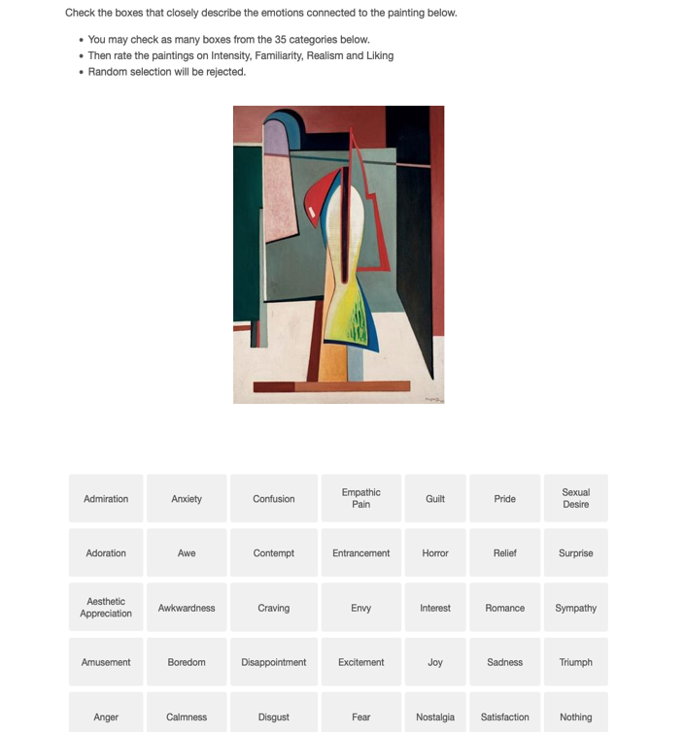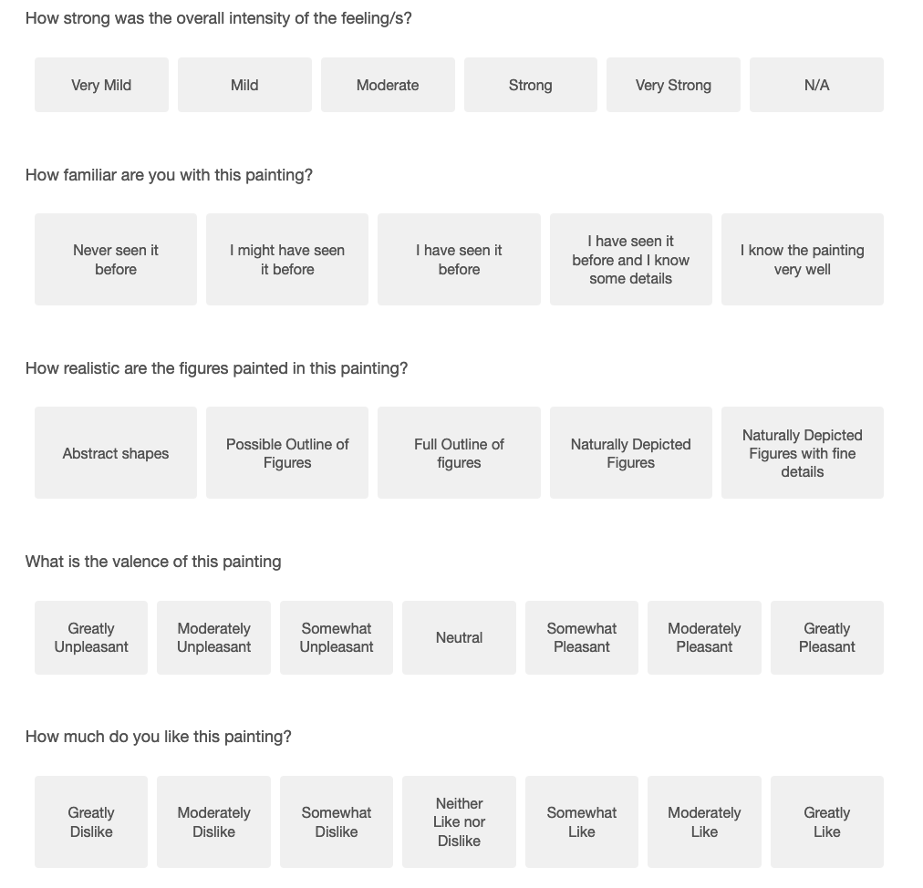

Note. This is a screen grab of what participants had to do. The painting, Incantation by Alberto Magnelli,, 1935, is taken form Wikiart.org and is covered under fair use which allows for the use of low-resolution images readily available on the internet for informational and educational purposes https://www.wikiart.org/en/alberto-magnelli/incantation-1935.

