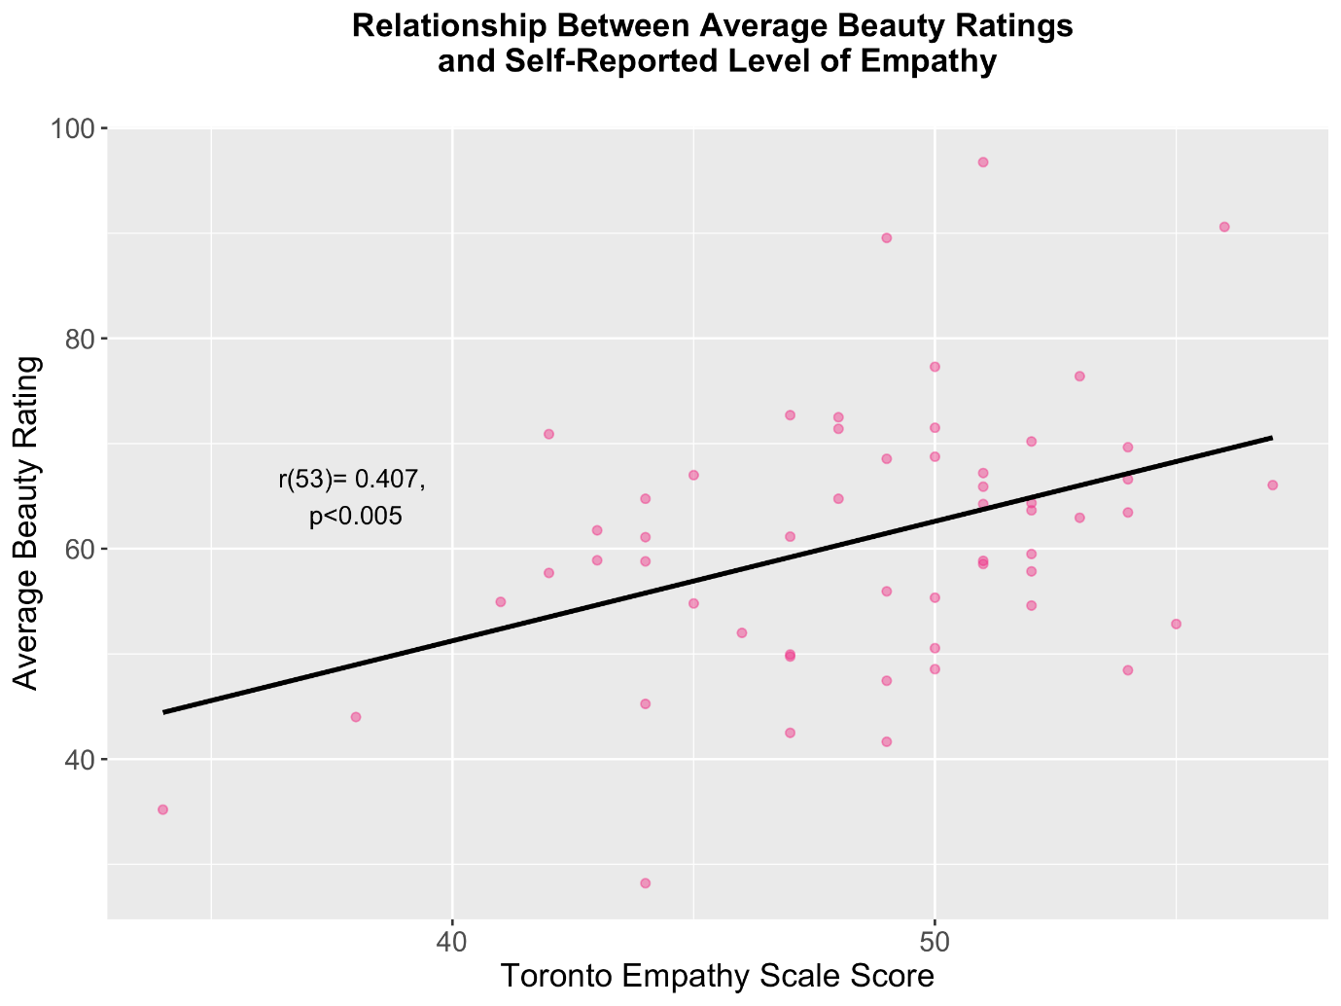
Supplementary Figure 1: A Visualisation of the relationship between trait empathy (as measured by the Toronto Empathy Scale), and average beauty ratings provided by observers.
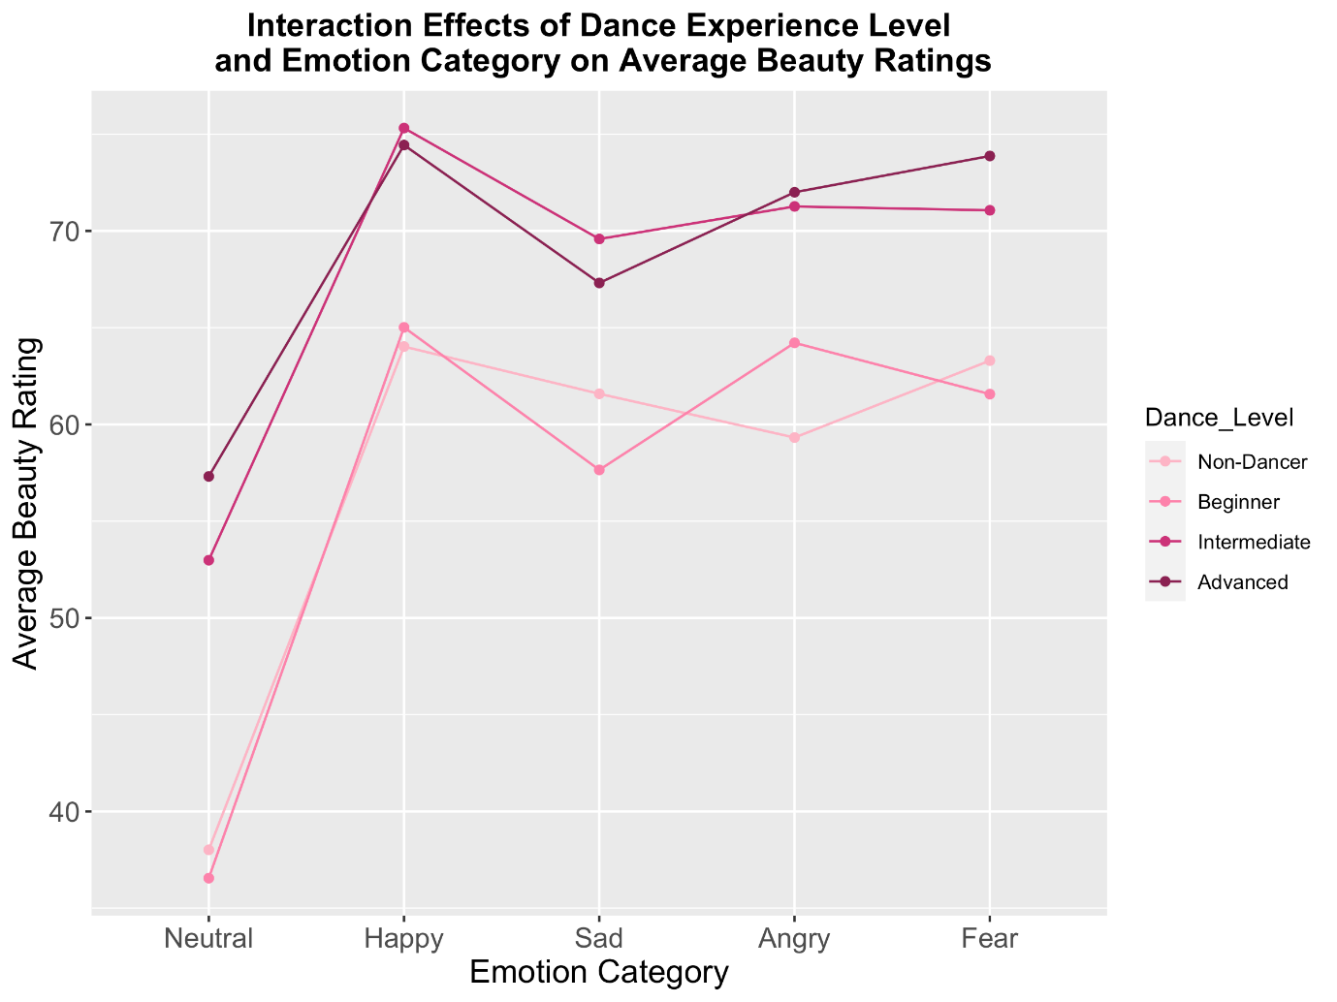
Supplementary Figure 2: A visualisation of the interaction between self-reported level of previous dance experience and emotional expressivity of the clip on average beauty judgements provided by participants in this experiment.
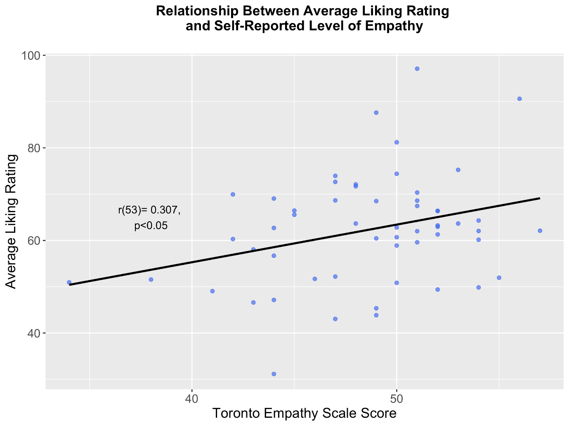
Supplementary Figure 3: Visualisation of the relationship between trait empathy (as measured by the Toronto Empathy Scale), and average liking ratings provided by observers.
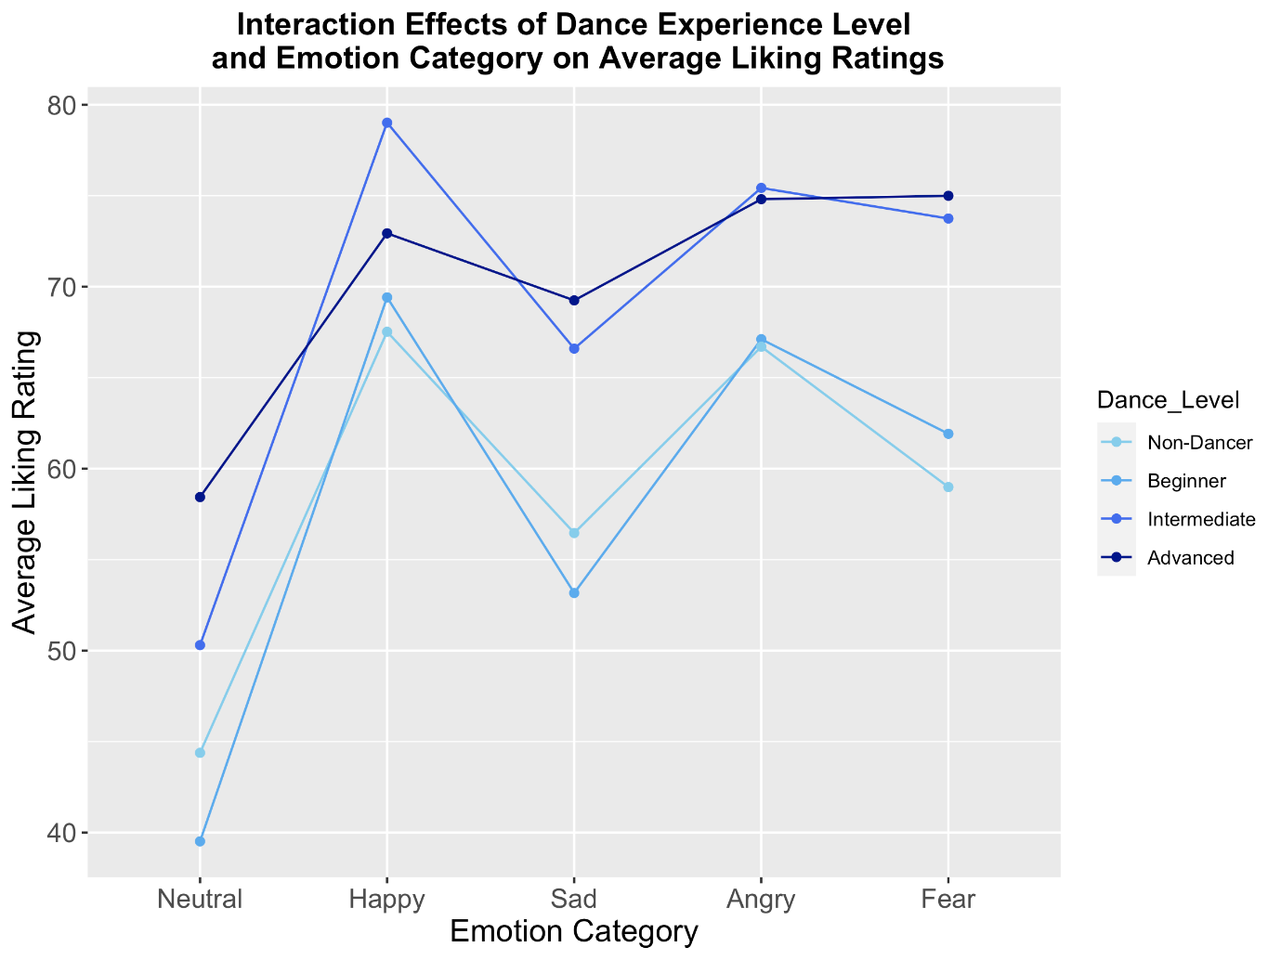
Supplementary Figure 4: A visualisation of the interaction between self-reported level of previous dance experience and emotional expressivity of the clip on average liking judgements provided by participants in this experiment.

