Supplement
Automatic Scores using Multiplicative Composition Have an Oscillatory Pattern with Elaboration
We found oscillations in analyzing the role of elaboration in the automated scoring algorithms. Specifically, for the algorithms based on multiplicative composition of multi-word responses, we found oscillations that peaked on even numbers of words in ideas (see Figure 11). This pattern was strongest for pattern m_l and also observable for m_s. We ran simulations based on the following semantic spaces to see if such an oscillatory pattern would be observed for any of the used spaces: a) a CBOW space, b) an LSA space based on the TASA corpus, c) a HAL space, d) a second LSA space, e) and a GloVe space. The spaces a) to d) were taken from Fritz Günther’s repository of semantic spaces (https://sites.google.com/site/fritzgntr/software-resources/semantic_spaces) and the GloVe space was taken from the webpage of the GloVe team (https://nlp.stanford.edu/projects/glove/). We obtained 10,000 random word vectors for each of the seven levels of number of words (2, 3, 4, 5, 6, 7, or 8) and each of the semantic spaces (in total 5 × 7 × 10,000 = 350,000 runs). According to recent advances in relation to the elaboration-bias (Forthmann et al., 2020) it was likely that this pattern could be attributed to a special case of the elaboration-bias, yet it was not clear which of the semantic spaces caused this pattern. The only simulation for which we found such a pattern was the GloVe semantic space (see Figure S4-1). The median of random semantic distances oscillated across the word counts. The zig-zag pattern was more strongly pronounced for the smaller number of words as compared to larger numbers (cf. Figure 11 and the patterns for m_l and m_s). Hence, we argue that the oscillation stems mainly from the GloVe space implemented in SemDis as GloVe spaces seem to have column means that imply such a pattern of the elaboration-bias (cf. Forthmann et al., 2020). To further bolster our argumentation, another mock up space was created in which the oscillatory pattern was reproduced.

Figure B1
GloVe Random Word Distances
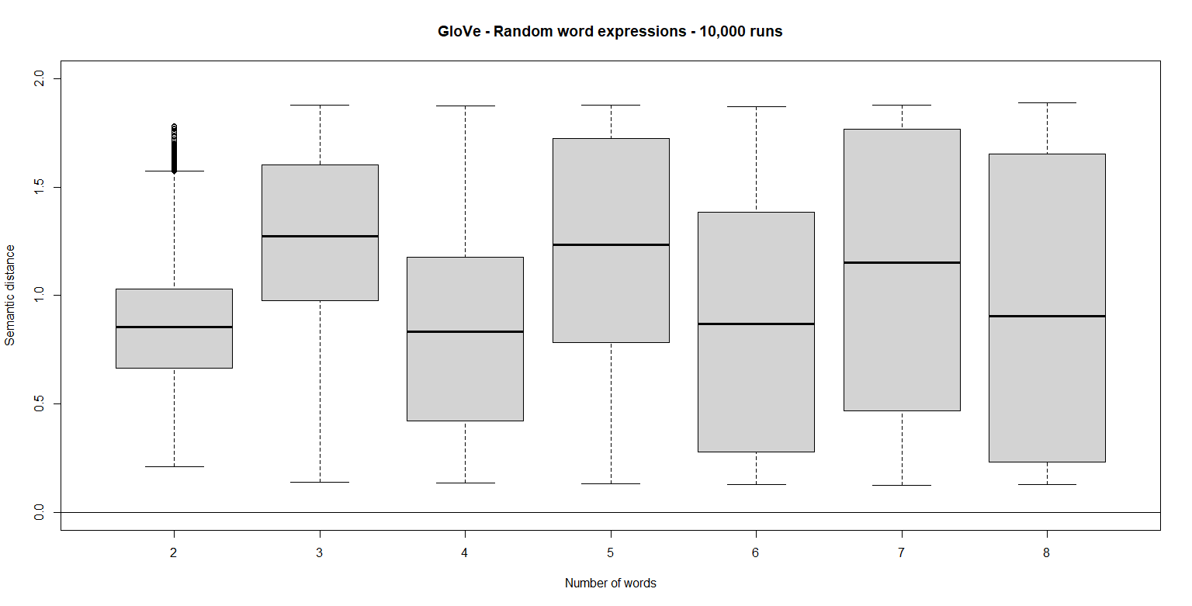
Notes. On the y-axis, the semantic distances are depicted. On the x-axis, the number of words in the random word vector is depicted (analogous to the assessment reported in the main text, the reference vector had a constant number of words in the simulations).

The main point is that the column means in GloVe spaces tend to vary across the dimensions (and the range goes from negative to positive numbers), while at the same time for each column the variation is quite small (i.e., within-column variation). Thus, for even numbers the fluctuation of the column means is counteracted because negative numbers turn positive and the vector based on the product (recall that we used multiplicative vector composition) is less similar to any other vector in the space. This behavior is illustrated in Figure B2. The simulation was run analogous to the simulations described above. Here we used a mock up space that was created the following way: We draw 100 random variates from a multivariate normal distribution with an oscillatory mean vector µ = (5, -5, 5, -5, 5, -5), unit variance, and the variates being uncorrelated. The full simulation script and all results can be found in an Open Science Framework repository (https://osf.io/56xbq/)

Figure B2
Mock-up Random Word Distances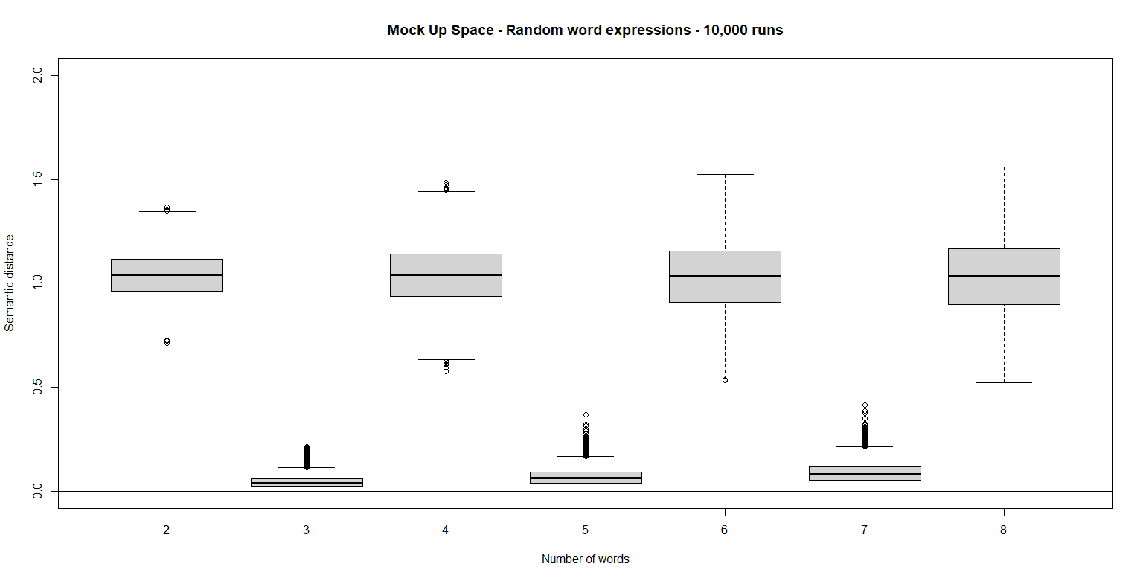
Notes. On the y-axis the semantic distances are depicted. On the x-axis the number of words in the random word vector is depicted (analogous to the assessment reported in the main text, the reference vector had a constant number of words in the simulations).

