Supplementary materials: Music-evoked pleasantness modulates theta synchronization within a fronto-temporal music-related network
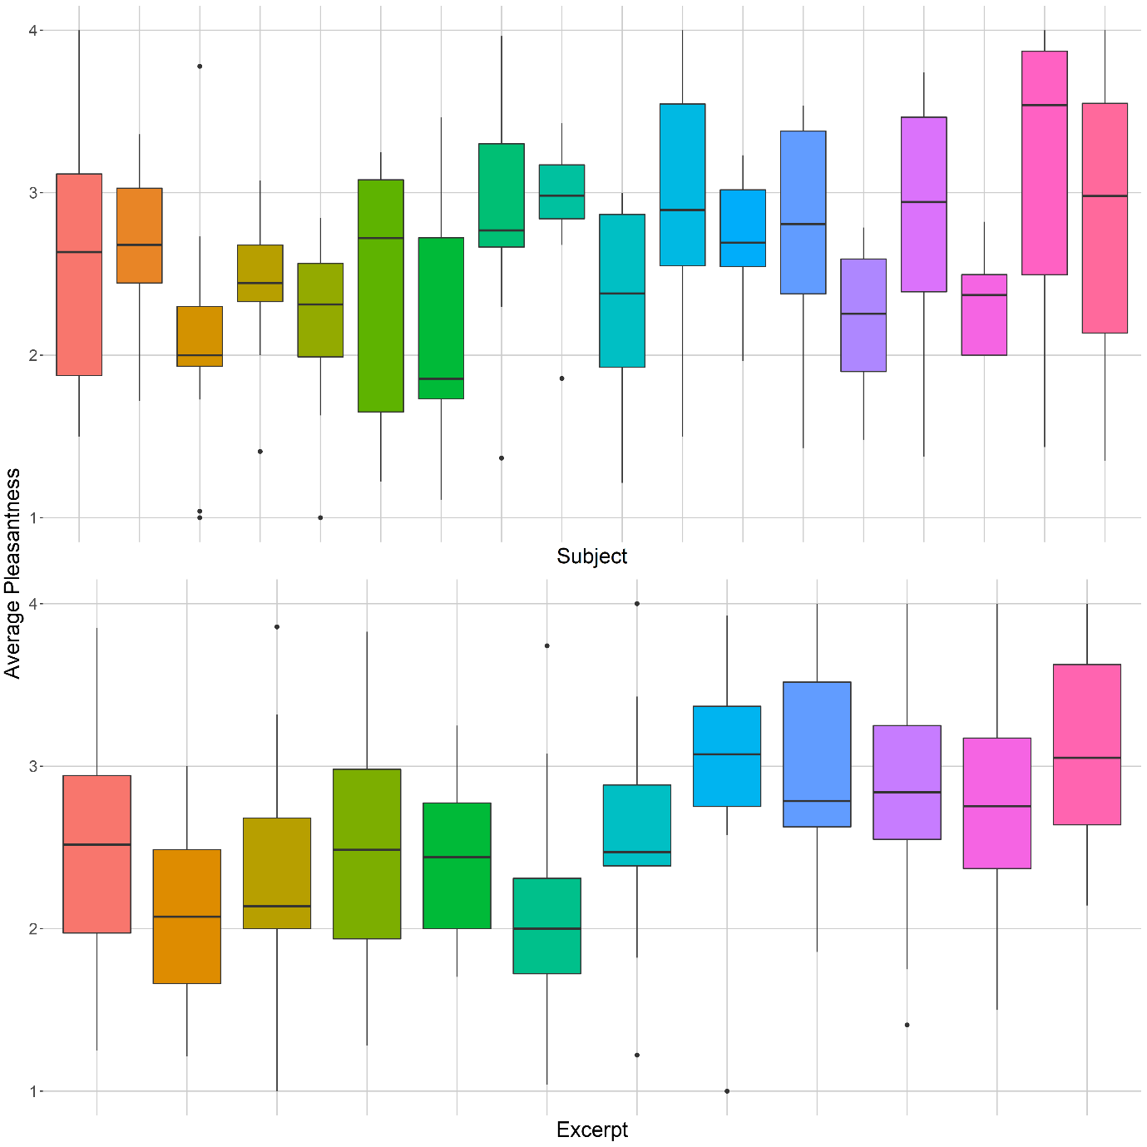
Figure S1. Distribution of time-weighted average (ratings weighted for the time of each rating) reported pleasantness per subject (top) and excerpt (bottom). Excerpts ID, from left to right: (1) Mazurka No.13, Op.17, No.4 (Chopin); (2) The Firebird Suite, Op.8, Finale (Stravinsky); (3) Symphony No.4, Op.60, Mov.2 (Beethoven); (4) Symphony No.38, Hob I:38, Mov.3 (Haydn); (5) Sonata for Violin and Piano No.1, Op.13, Mov.1 (Fauré); (6) The Planets, Op.32, 2. Venus, The Bringer of Peace (Holst); (7) Symphony No.9, Op.125, Mov.2 (Beethoven); (8) New World Symphony, Op.95, Mov.4 (Dvorak); (9) The Nutcracker, Op.71, Dance of the Sugar Plum Fairy (Tchaikovsky); (10) The Four Seasons, Op. 8, Spring Mov.1 (Vivaldi); (11) The Four Seasons, Op.8, Winter Mov.1 (Vivaldi); (12) Für Elise, WoO 59 Bia 515 (Beethoven).

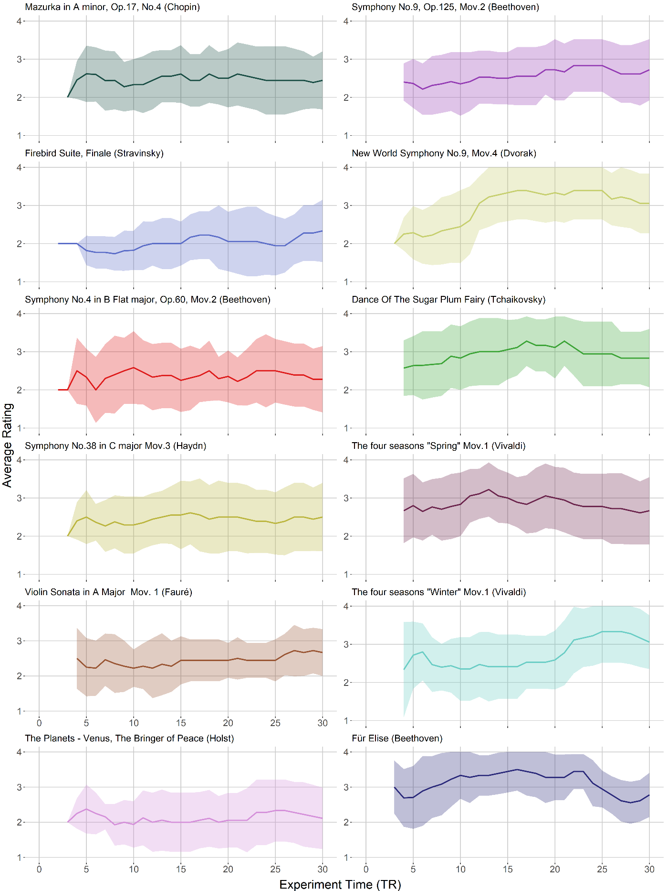
Figure S2. Average pleasantness time courses given for each excerpt. Straight lines represent the mean rating across participants at each time point (in TRs) and the ribbons around them represent these expectations ± their associated standard deviations.

 | θ ~ liking | θ ~ music gIC | θ ~ liking × music gIC
p < 0.05 | 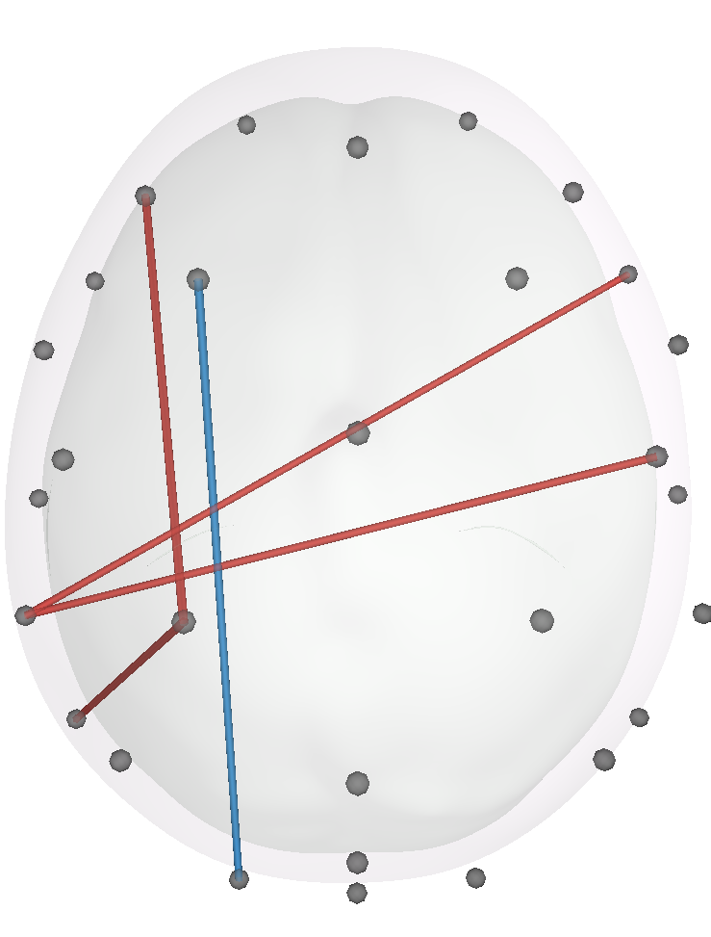 | 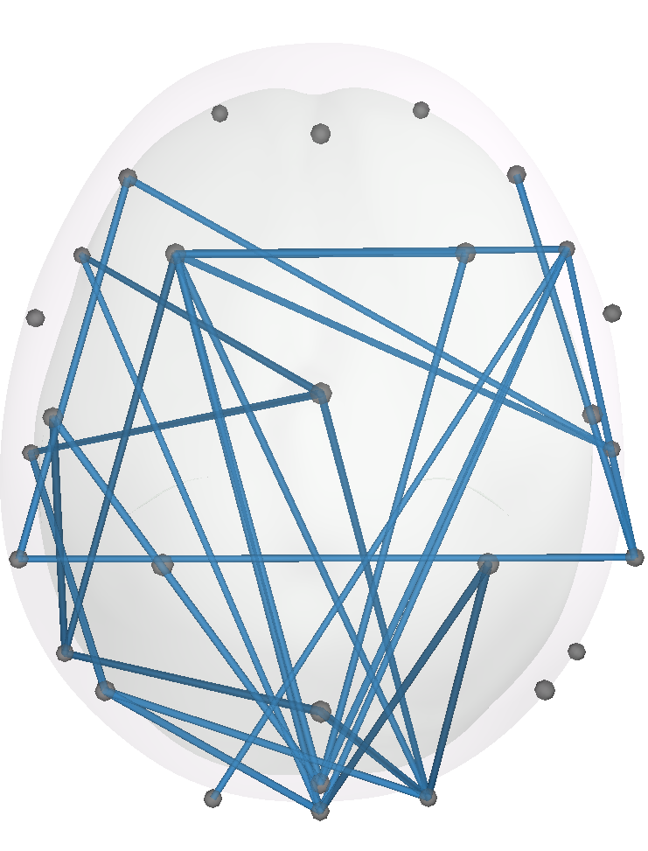 | 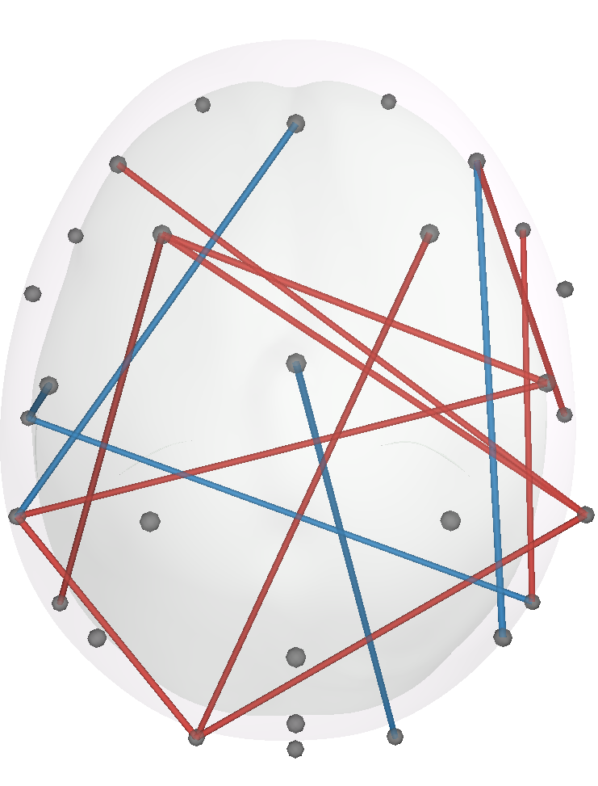
p < 0.01 |  | 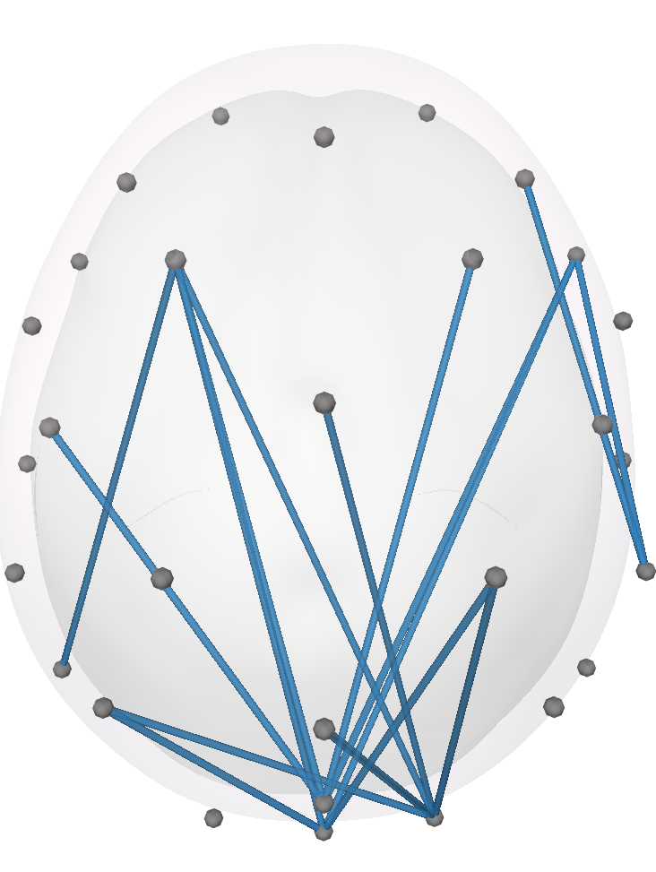 | 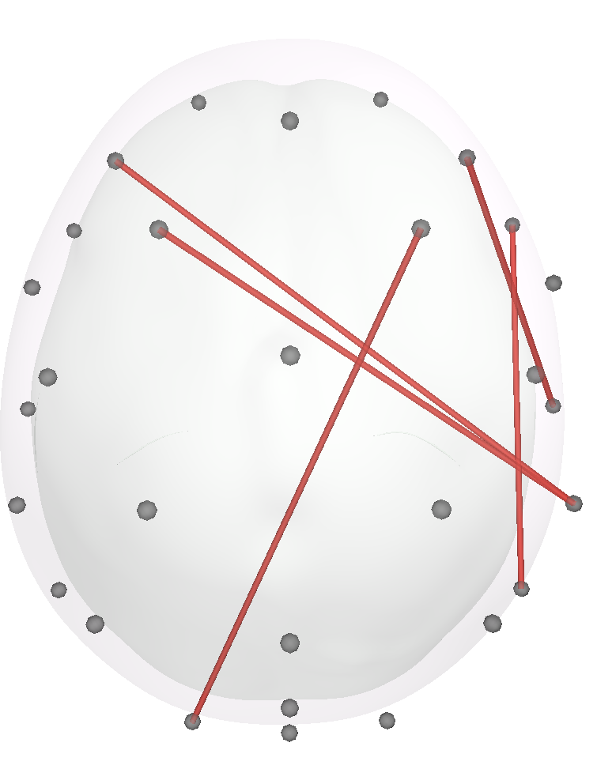
p < 0.005 |  | 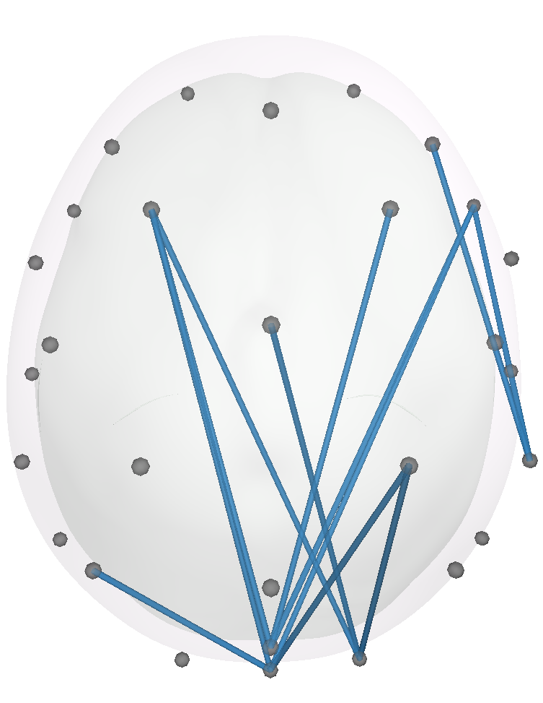 | 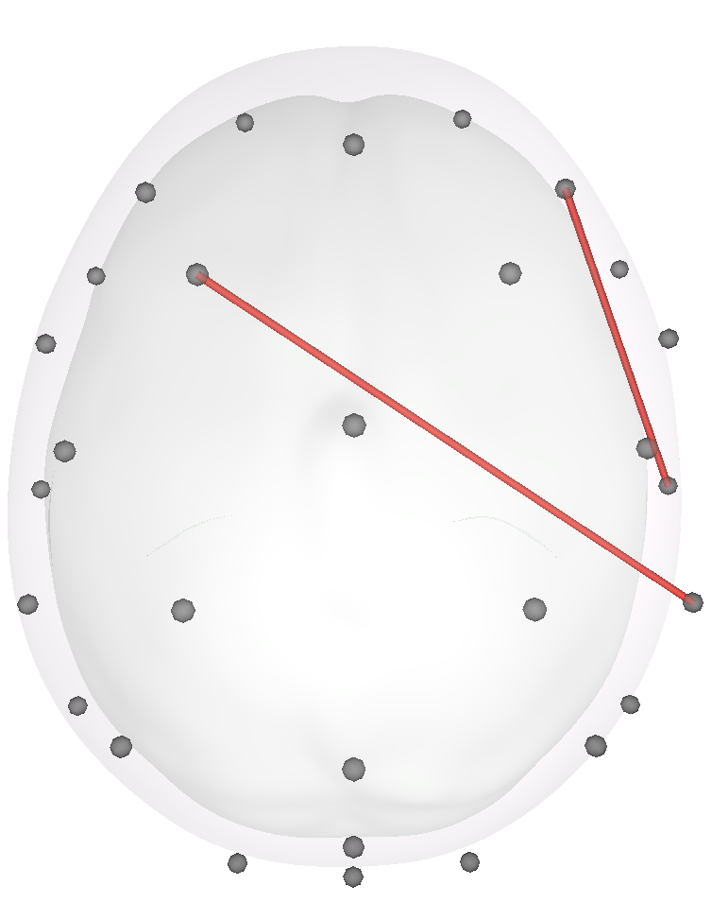
p < 0.001 |  | 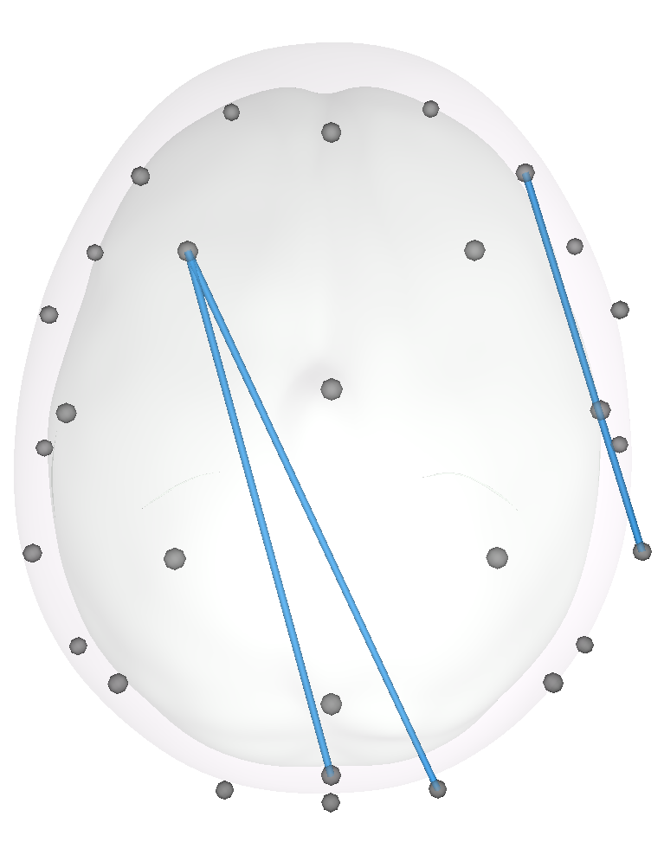 | 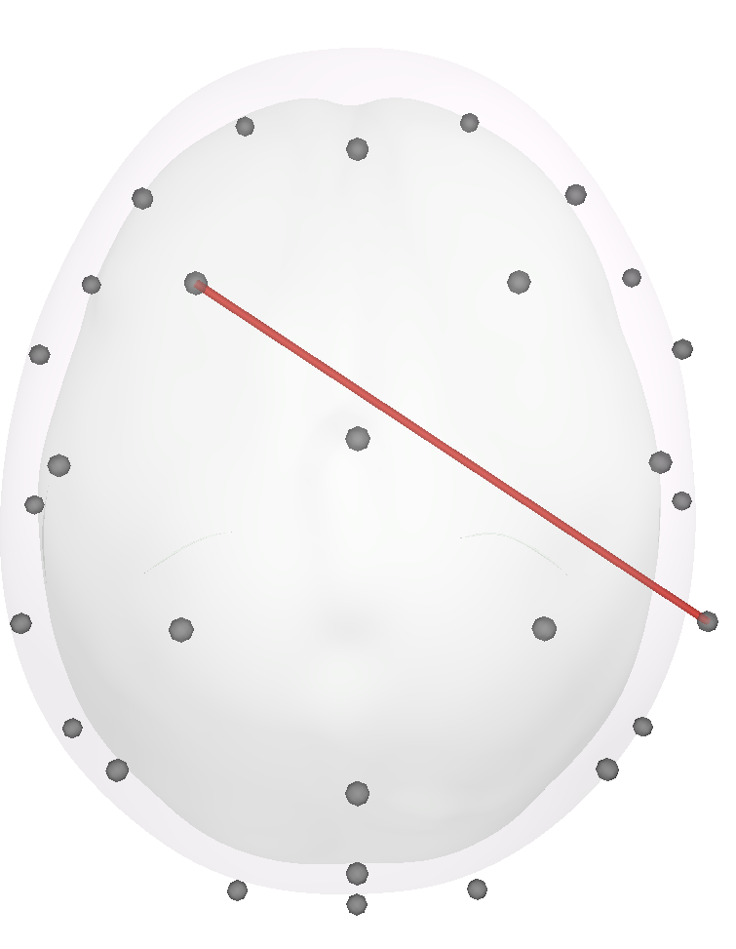
Figure S3. Significant connections in theta under the frequentist framework with different alpha levels for A) main effects of liking, B) main effects of music-related brain function and C) the interaction between the two. Red lines indicate positive relationships and bluelines negative relationships. No connection survived standard family-wise error or false discovery rate corrections. Models were implemented with R package glmmTMB.

