Supplemental Materials

1. Picture of Duncker Candle Problem used in Study 2

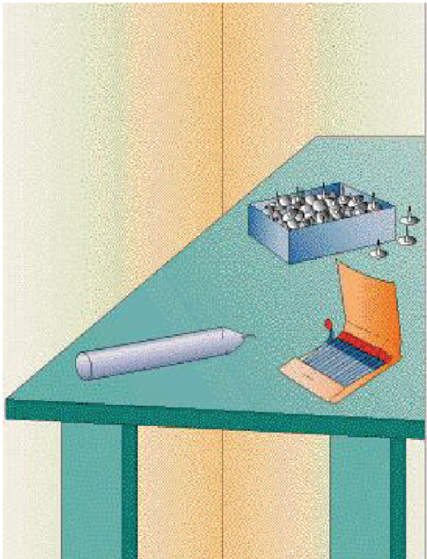

2. Number and percentage of “Yes, definitely” for each creative behavior across the whole diary.

1. Today, I wrote a short story (26 / 4.2%)
2. Today, I wrote a novel or a section towards a novel (23 / 3.7%)
3. Today, I organized an event, show, performance or activity (37 / 6.0%)
4. Today, I produced a TV/play script (7 / 1.1%)
5. Today, I designed and produced a textile product (e.g. made an item of clothing or household object) (21 / 3.4%)
6. Today, I redesigned and redecorated a bedroom, kitchen, personal space, etc., (54 / 8.7%)
7. Today, I invented and made a product that can be used (13 / 2.1%)
8. Today, I drew a cartoon (21 / 3.4%)
9. Today, I started a club, association or group (10 / 1.6%)
10. Today, I produced a picture, i.e. NOT a doodle (using paint, pencils, charcoal, acrylic, etc.,) (18 / 2.9%)
11. Today, I had an article published (11 / 1.8%)
12. Today, I formed a sculpture using any suitable materials (8 / 1.3%)
13. Today, I recognized where an accepted scientific theory/approach does not explain what it purports to (31 / 5.0%)
14. Today, I produced my own food recipes (83 / 13.4%)
15. Today, I produced a short film (10 / 1.6%)
16. Today, I produced my own website (13 / 2.1%)
17. Today, I produced a theory to explain a phenomenon (22 / 3.5%)
18. Today, I invented a game or other form of entertainment (27 / 4.3%)
19. Today, I selected to lead/manage others (101 / 16.3%)
20. Today, I made someone a present (65 / 10.5%)
21. Today, I composed a poem (27 / 4.3%)
22. Today, I adapted an item and used it in a way that it was not designed to be, in what I consider to be an ingenious way (61 / 9.8%)
23. Today, I published research (16 / 2.6%)
24. Today, I choreographed a dance (17 / 2.7%)
25. Today, I designed and planted a garden (41 / 6.6%)
26. Today, I produced a portfolio of photographs (NOT photographs of a holiday, party, etc.,) (11 / 1.8%)
27. Today, I acted in a dramatic production (8 / 1.3%)
28. Today, I delivered a speech (22 / 3.5%)
29. Today, I mentored/coached someone else to improve their performance (111 / 17.9%)
30. Today, I devised an experiment to help understand something (33 / 5.3%)
31. Today, I made up a joke (149 / 24%)
32. Today, I was a leader/captain of a team/group (e.g. debating society chairperson, captain of the hockey team, etc.,) (60 / 9.7%)
33. Today, I composed a piece of music (14 / 2.3%)
34. Today, I made a collage (17 / 2.7%)

