Supplemental Material
Participants
Downsampling Procedure
To address the biases found for outcome severity scores, we separately downsampled the training data based on self-rated PHQ-9 and GAD-7 scores, aiming to reduce PHQ-9/GAD-7 bias by providing the ridge regression with roughly equal numbers of observations for the total score. Because the distribution of PHQ-9 scores in both the training and validation sets was right-skewed (see Figure 2), accuracy may have been adversely affected, likely contributing to the significant PHQ-9 coefficient observed in the robust regression. Due to fewer responses with higher PHQ-9 scores, each PHQ-9 total score was randomly sampled with 17 observations from the total training data. Two total scores contained only 14 and 15 observations (PHQ-9 = 19 and 20), resulting in a downsampled training data set of n = 386, compared to the total training data of n = 1060. For GAD-7, we randomly sampled 17 observations for each total score of GAD-7, with the exception of one total score, which only had 13 observations, resulting in a downsampled GAD-7 training set of n = 370. To achieve the largest possible size for the downsampled GAD-7 training set, we sampled from the entire training data, without removing individuals with total PHQ-9 scores > 22.
Results
Differences in Model Performance Metrics
There are no significant differences between the three metrics (r, disattenuated r, MSE) for either PHQ-9 or GAD-7 models, though the downsampled models do achieve slightly higher Pearson correlation coefficients (r = .71; r = .66) and disattenuated correlations (rd = .76; rd = .69) than the original models. Similarly, no significant differences were found between the MAE of the downsampled (3.74 and 4.00 points, respectively) and original models’ PHQ-9/GAD-7 predictions, with the latter ones resulting in slightly lower average errors (3.52 and 3.63 points, respectively). Though these differences are non-significant with overlapping confidence intervals, they nominally point in different directions, as the higher correlation coefficients in the downsampled model indicate higher accuracy, while higher MAEs indicate poorer accuracy.
Data Quality

Data Quality Assessment
Data quality was assessed using both prospective and post-hoc indicators. Attention checks were embedded within the PHQ-9 and GAD-7 as directed-response items instructing participants to select a specific response option. Pass rates were 99.0% on the PHQ-9 attention check (1,398/1,412) and 99.5% on the GAD-7 attention check (1,308/1,315), with failure rates too low to warrant exclusions.
Post-hoc screening examined completion time, response completeness, and response patterns. The median survey completion time was 34.0 minutes (SD = 17.1; minimum = 10.7 minutes), with no respondents completing the survey in less than 10 minutes. All open-ended text responses were non-empty, non-duplicate, and contained at least 19 words (M = 53.3, SD = 34.1). No duplicate Prolific IDs were detected. Straightlining (the practice of selecting the same response option across all items in a scale without meaningfully engaging with item content) on the PHQ-9 and GAD-7 was examined by flagging cases with zero item-level variance; such cases were nearly exclusively respondents endorsing the lowest severity level (0) on all items, consistent with the expected response pattern for the general population subsample comprising 50% of participants. The full screening script is available on OSF.

Table 1
Phrasings of All Questions Used in Survey
General Mental Health | How is your mental health? Please describe how you have been over the last two weeks? You can, for example, write about your emotions, thoughts, behaviours, and/or symptoms related to your health. Write at least one paragraph.
Gender Identity | To which gender identity do you most identify? *  Please choose only one of the following:  Female  Male  Transgender Female  Transgender Male  Gender variant/Non-conforming  Prefer not to say  Other
Age | How old are you? *  Your answer must be between 0 and 120 Only an integer value may be entered in this field.  Please write your answer here:
Education | Which level of education are you currently in? *  Please choose only one of the following:  Secondary education (e.g. GED/GCSE)  High school diploma/A-levels  Technical/community college  Undergraduate degree (BA/BSc/other)  Graduate degree (MA/MSc/MPhil/other)  Doctorate degree (PhD/other)  Don't know / not applicable  Other
Employment Status | I am: *  Select all that apply  Please choose all that apply:  A student  Unemployed  Employed  Retired  Other:
Annual Income | My annual income is approximately: *  Please choose only one of the following:  £0 - £10 000  £10 001 - £20 000  £20 001 - £30 000  £30 001 - £40 000  £40 001 - £50 000  £50 001 - £60 000  £60 001 - £70 000  £80 001 - £90 000  £90 000 - £100 000  More than £100 000

Table 2
Predictors Associated With Absolute Assessment Differences for PHQ-9 Model using a Random Sample of N = 50
Predictor | Std. β | Std. Error | t value | p-value | p (BH)
Gender (ref. Women) | -0.031 | 0.066 | -0.473 | 0.6368 | 0.7571
Age | 0.029 | 0.065 | 0.449 | 0.6538 | 0.7571
Education (ref. Bachelor’s degree): Secondary education | 0.039 | 0.077 | 0.513 | 0.6082 | 0.7571
Education (ref. Bachelor’s degree): Postgraduate degree | -0.049 | 0.075 | -0.657 | 0.5117 | 0.7571
Education (ref. Bachelor’s degree): Don’t know / Other | 0.022 | 0.071 | 0.311 | 0.7558 | 0.8314
Employment Status (ref. Employed): Unemployed | 0.152 | 0.070 | 2.180 | 0.0304 | 0.2588
Employment Status (ref. Employed): Other | -0.016 | 0.069 | -0.236 | 0.8136 | 0.8524
Employment Status (ref. Employed): Student | 0.081 | 0.069 | 1.171 | 0.2431 | 0.7571
Employment Status (ref. Employed): Retired | 0.063 | 0.070 | 0.899 | 0.3697 | 0.7571
Annual Income (ref. £30–60k): Less than £30k | 0.144 | 0.068 | 2.120 | 0.0353 | 0.2588
Annual Income (ref. £30–60k): More than £60k | 0.120 | 0.067 | 1.808 | 0.0722 | 0.3971
Outcome Severity (PHQ-9) | 0.448 | 0.066 | 6.811 | 0.0000 | 0.0000
Word count | 0.051 | 0.066 | 0.764 | 0.4458 | 0.7571
Average word length | 0.111 | 0.066 | 1.688 | 0.0929 | 0.4090
Spelling Errors | -0.032 | 0.066 | -0.491 | 0.6242 | 0.7571
Emotion | 0.039 | 0.065 | 0.593 | 0.5537 | 0.7571
Tone | -0.078 | 0.067 | -1.166 | 0.2451 | 0.7571
Negations | -0.033 | 0.065 | -0.512 | 0.6091 | 0.7571
1st person singular (I) | -0.033 | 0.066 | -0.503 | 0.6153 | 0.7571
1st person plural (We) | -0.054 | 0.065 | -0.833 | 0.4058 | 0.7571
“the” | -0.055 | 0.067 | -0.819 | 0.4140 | 0.7571
Big words (6+) | -0.003 | 0.067 | -0.039 | 0.9693 | 0.9693

Table 3
Predictors Associated With Absolute Assessment Differences for PHQ-9 Model using a Random Sample of N = 100
Predictor | Std. β | Std. Error | t value | p-value | p (BH)
Gender (ref. Women) | -0.073 | 0.061 | -1.195 | 0.2334 | 0.6582
Age | 0.054 | 0.060 | 0.902 | 0.3679 | 0.7358
Education (ref. Bachelor’s degree): Secondary education | 0.040 | 0.071 | 0.565 | 0.5728 | 0.7876
Education (ref. Bachelor’s degree): Postgraduate degree | -0.068 | 0.070 | -0.980 | 0.3285 | 0.7226
Education (ref. Bachelor’s degree): Don’t know / Other | 0.042 | 0.065 | 0.641 | 0.5222 | 0.7659
Employment Status (ref. Employed): Unemployed | 0.113 | 0.066 | 1.707 | 0.0894 | 0.4021
Employment Status (ref. Employed): Other | 0.024 | 0.064 | 0.369 | 0.7125 | 0.8215
Employment Status (ref. Employed): Student | 0.001 | 0.066 | 0.008 | 0.9935 | 0.9935
Employment Status (ref. Employed): Retired | 0.042 | 0.066 | 0.643 | 0.5210 | 0.7659
Annual Income (ref. £30–60k): Less than £30k | 0.138 | 0.064 | 2.136 | 0.0340 | 0.2490
Annual Income (ref. £30–60k): More than £60k | 0.053 | 0.063 | 0.841 | 0.4015 | 0.7361
Outcome Severity (PHQ-9) | 0.467 | 0.065 | 7.157 | 0.0000 | 0.0000
Word count | 0.104 | 0.061 | 1.696 | 0.0914 | 0.4021
Average word length | 0.085 | 0.061 | 1.385 | 0.1675 | 0.6143
Spelling Errors | -0.019 | 0.061 | -0.310 | 0.7569 | 0.8215
Emotion | 0.029 | 0.061 | 0.475 | 0.6351 | 0.8215
Tone | -0.149 | 0.062 | -2.415 | 0.0167 | 0.1834
Negations | -0.063 | 0.060 | -1.041 | 0.2992 | 0.7226
1st person singular (I) | -0.072 | 0.061 | -1.180 | 0.2393 | 0.6582
1st person plural (We) | 0.043 | 0.060 | 0.714 | 0.4761 | 0.7659
“the” | -0.017 | 0.062 | -0.274 | 0.7842 | 0.8215
Big words (6+) | 0.024 | 0.062 | 0.392 | 0.6953 | 0.8215

Table 4
Predictors Associated With Absolute Assessment Differences for PHQ-9 Model using a Random Sample of N = 200
Predictor | Std. β | Std. Error | t value | p-value | p (BH)
Gender (ref. Women) | -0.055 | 0.061 | -0.892 | 0.3735 | 0.9387
Age | 0.040 | 0.061 | 0.657 | 0.5120 | 0.9387
Education (ref. Bachelor’s degree): Secondary education | 0.013 | 0.071 | 0.179 | 0.8581 | 0.9984
Education (ref. Bachelor’s degree): Postgraduate degree | -0.102 | 0.070 | -1.451 | 0.1485 | 0.5890
Education (ref. Bachelor’s degree): Don’t know / Other | 0.009 | 0.065 | 0.140 | 0.8887 | 0.9984
Employment Status (ref. Employed): Unemployed | 0.116 | 0.066 | 1.761 | 0.0798 | 0.4387
Employment Status (ref. Employed): Other | 0.000 | 0.064 | 0.004 | 0.9968 | 0.9984
Employment Status (ref. Employed): Student | 0.020 | 0.066 | 0.312 | 0.7557 | 0.9984
Employment Status (ref. Employed): Retired | 0.055 | 0.066 | 0.844 | 0.3995 | 0.9387
Annual Income (ref. £30–60k): Less than £30k | 0.157 | 0.064 | 2.445 | 0.0154 | 0.1689
Annual Income (ref. £30–60k): More than £60k | 0.045 | 0.063 | 0.724 | 0.4697 | 0.9387
Outcome Severity (PHQ-9) | 0.484 | 0.066 | 7.322 | 0.0000 | 0.0000
Word count | 0.088 | 0.062 | 1.408 | 0.1606 | 0.5890
Average word length | 0.070 | 0.062 | 1.129 | 0.2602 | 0.8178
Spelling Errors | -0.046 | 0.061 | -0.747 | 0.4560 | 0.9387
Emotion | 0.029 | 0.061 | 0.469 | 0.6396 | 0.9953
Tone | -0.126 | 0.062 | -2.024 | 0.0443 | 0.3252
Negations | -0.004 | 0.061 | -0.057 | 0.9543 | 0.9984
1st person singular (I) | -0.034 | 0.062 | -0.556 | 0.5788 | 0.9795
1st person plural (We) | 0.025 | 0.061 | 0.415 | 0.6786 | 0.9953
“the” | 0.000 | 0.063 | -0.006 | 0.9953 | 0.9984
Big words (6+) | 0.000 | 0.063 | -0.002 | 0.9984 | 0.9984

Table 5
Predictors Associated With Absolute Assessment Differences for PHQ-9 Model using a Random Sample of N = 400
Predictor | Std. β | Std. Error | t value | p-value | p (BH)
Gender (ref. Women) | -0.006 | 0.067 | -0.090 | 0.9281 | 0.9723
Age | 0.033 | 0.067 | 0.491 | 0.6240 | 0.8840
Education (ref. Bachelor’s degree): Secondary education | 0.029 | 0.077 | 0.375 | 0.7084 | 0.9167
Education (ref. Bachelor’s degree): Postgraduate degree | -0.073 | 0.076 | -0.962 | 0.3374 | 0.6747
Education (ref. Bachelor’s degree): Don’t know / Other | -0.062 | 0.071 | -0.876 | 0.3823 | 0.6815
Employment Status (ref. Employed): Unemployed | 0.108 | 0.072 | 1.501 | 0.1350 | 0.5998
Employment Status (ref. Employed): Other | -0.033 | 0.070 | -0.464 | 0.6429 | 0.8840
Employment Status (ref. Employed): Student | 0.036 | 0.071 | 0.510 | 0.6104 | 0.8840
Employment Status (ref. Employed): Retired | 0.060 | 0.072 | 0.839 | 0.4027 | 0.6815
Annual Income (ref. £30–60k): Less than £30k | 0.105 | 0.070 | 1.496 | 0.1363 | 0.5998
Annual Income (ref. £30–60k): More than £60k | -0.011 | 0.069 | -0.159 | 0.8737 | 0.9723
Outcome Severity (PHQ-9) | 0.368 | 0.069 | 5.331 | 0.0000 | 0.0000
Word count | 0.075 | 0.067 | 1.115 | 0.2661 | 0.6747
Average word length | 0.114 | 0.067 | 1.710 | 0.0888 | 0.5998
Spelling Errors | -0.070 | 0.066 | -1.051 | 0.2947 | 0.6747
Emotion | 0.013 | 0.066 | 0.194 | 0.8463 | 0.9723
Tone | -0.119 | 0.068 | -1.765 | 0.0791 | 0.5998
Negations | -0.009 | 0.066 | -0.140 | 0.8886 | 0.9723
1st person singular (I) | -0.092 | 0.066 | -1.382 | 0.1687 | 0.6185
1st person plural (We) | 0.067 | 0.066 | 1.021 | 0.3084 | 0.6747
“the” | 0.001 | 0.067 | 0.022 | 0.9826 | 0.9826
Big words (6+) | 0.068 | 0.068 | 1.000 | 0.3184 | 0.6747

Table 6
Predictors Associated With Absolute Assessment Differences for PHQ-9 Model using a Random Sample of N = 600
Predictor | Std. β | Std. Error | t value | p-value | p (BH)
Gender (ref. Women) | -0.027 | 0.066 | -0.415 | 0.6788 | 0.8327
Age | 0.027 | 0.066 | 0.411 | 0.6813 | 0.8327
Education (ref. Bachelor’s degree): Secondary education | 0.020 | 0.076 | 0.265 | 0.7911 | 0.8702
Education (ref. Bachelor’s degree): Postgraduate degree | -0.069 | 0.075 | -0.924 | 0.3566 | 0.7132
Education (ref. Bachelor’s degree): Don’t know / Other | -0.078 | 0.071 | -1.099 | 0.2732 | 0.6011
Employment Status (ref. Employed): Unemployed | 0.112 | 0.072 | 1.563 | 0.1196 | 0.5262
Employment Status (ref. Employed): Other | -0.049 | 0.070 | -0.709 | 0.4793 | 0.8111
Employment Status (ref. Employed): Student | 0.034 | 0.070 | 0.488 | 0.6263 | 0.8327
Employment Status (ref. Employed): Retired | 0.030 | 0.072 | 0.422 | 0.6734 | 0.8327
Annual Income (ref. £30–60k): Less than £30k | 0.099 | 0.070 | 1.417 | 0.1580 | 0.5794
Annual Income (ref. £30–60k): More than £60k | -0.002 | 0.068 | -0.031 | 0.9752 | 0.9882
Outcome Severity (PHQ-9) | 0.352 | 0.070 | 5.049 | 0.0000 | 0.0000
Word count | 0.104 | 0.065 | 1.592 | 0.1130 | 0.5262
Average word length | 0.106 | 0.066 | 1.600 | 0.1111 | 0.5262
Spelling Errors | -0.073 | 0.066 | -1.114 | 0.2666 | 0.6011
Emotion | -0.022 | 0.066 | -0.336 | 0.7369 | 0.8533
Tone | -0.120 | 0.067 | -1.803 | 0.0729 | 0.5262
Negations | -0.001 | 0.066 | -0.015 | 0.9882 | 0.9882
1st person singular (I) | -0.087 | 0.066 | -1.325 | 0.1867 | 0.5868
1st person plural (We) | 0.073 | 0.065 | 1.119 | 0.2643 | 0.6011
“the” | 0.030 | 0.066 | 0.449 | 0.6540 | 0.8327
Big words (6+) | 0.057 | 0.067 | 0.858 | 0.3922 | 0.7190

Table 7
Predictors Associated With Absolute Assessment Differences for PHQ-9 Model using a Random Sample of N = 800
Predictor | Std. β | Std. Error | t value | p-value | p (BH)
Gender (ref. Women) | -0.008 | 0.065 | -0.130 | 0.8963 | 0.9860
Age | 0.025 | 0.065 | 0.383 | 0.7024 | 0.8558
Education (ref. Bachelor’s degree): Secondary education | 0.034 | 0.076 | 0.452 | 0.6514 | 0.8437
Education (ref. Bachelor’s degree): Postgraduate degree | -0.077 | 0.075 | -1.027 | 0.3057 | 0.7611
Education (ref. Bachelor’s degree): Don’t know / Other | -0.048 | 0.070 | -0.677 | 0.4991 | 0.8437
Employment Status (ref. Employed): Unemployed | 0.129 | 0.071 | 1.818 | 0.0706 | 0.4513
Employment Status (ref. Employed): Other | -0.051 | 0.069 | -0.734 | 0.4637 | 0.8437
Employment Status (ref. Employed): Student | 0.041 | 0.069 | 0.591 | 0.5555 | 0.8437
Employment Status (ref. Employed): Retired | 0.035 | 0.071 | 0.487 | 0.6269 | 0.8437
Annual Income (ref. £30–60k): Less than £30k | 0.121 | 0.069 | 1.748 | 0.0820 | 0.4513
Annual Income (ref. £30–60k): More than £60k | 0.002 | 0.068 | 0.035 | 0.9725 | 0.9903
Outcome Severity (PHQ-9) | 0.356 | 0.068 | 5.217 | 0.0000 | 0.0000
Word count | 0.090 | 0.065 | 1.396 | 0.1642 | 0.5160
Average word length | 0.101 | 0.065 | 1.547 | 0.1236 | 0.5160
Spelling Errors | -0.054 | 0.065 | -0.826 | 0.4100 | 0.8201
Emotion | -0.029 | 0.065 | -0.452 | 0.6519 | 0.8437
Tone | -0.126 | 0.066 | -1.910 | 0.0577 | 0.4513
Negations | 0.001 | 0.065 | 0.012 | 0.9903 | 0.9903
1st person singular (I) | -0.093 | 0.065 | -1.429 | 0.1546 | 0.5160
1st person plural (We) | 0.065 | 0.064 | 1.015 | 0.3113 | 0.7611
“the” | 0.022 | 0.065 | 0.334 | 0.7391 | 0.8558
Big words (6+) | 0.058 | 0.066 | 0.885 | 0.3775 | 0.8201

Table 8
Predictors Associated With Absolute Assessment Differences for GAD-7 Model using a Random Sample of N = 50
Predictor | Std. β | Std. Error | t value | p-value | p (BH)
Gender (ref. Women) | 0.056 | 0.067 | 0.840 | 0.4017 | 0.8035
Age | 0.032 | 0.066 | 0.488 | 0.6262 | 0.8610
Education (ref. Bachelor’s degree): Secondary education | -0.011 | 0.075 | -0.150 | 0.8810 | 0.9230
Education (ref. Bachelor’s degree): Postgraduate degree | -0.200 | 0.074 | -2.682 | 0.0079 | 0.0874
Education (ref. Bachelor’s degree): Don’t know / Other | 0.012 | 0.069 | 0.171 | 0.8642 | 0.9230
Employment Status (ref. Employed): Unemployed | 0.138 | 0.069 | 2.005 | 0.0463 | 0.2039
Employment Status (ref. Employed): Other | 0.125 | 0.070 | 1.784 | 0.0760 | 0.2469
Employment Status (ref. Employed): Student | -0.019 | 0.071 | -0.266 | 0.7907 | 0.9230
Employment Status (ref. Employed): Retired | 0.039 | 0.070 | 0.546 | 0.5854 | 0.8586
Annual Income (ref. £30–60k): Less than £30k | 0.124 | 0.070 | 1.768 | 0.0786 | 0.2469
Annual Income (ref. £30–60k): More than £60k | -0.006 | 0.069 | -0.088 | 0.9300 | 0.9300
Outcome Severity (GAD-7) | 0.369 | 0.069 | 5.324 | 0.0000 | 0.0000
Word count | 0.045 | 0.068 | 0.657 | 0.5121 | 0.8586
Average word length | 0.066 | 0.066 | 0.995 | 0.3209 | 0.7620
Spelling Errors | 0.136 | 0.065 | 2.089 | 0.0380 | 0.2039
Emotion | -0.027 | 0.066 | -0.401 | 0.6890 | 0.8916
Tone | -0.157 | 0.065 | -2.400 | 0.0174 | 0.1273
Negations | -0.038 | 0.066 | -0.569 | 0.5697 | 0.8586
1st person singular (I) | 0.014 | 0.066 | 0.208 | 0.8358 | 0.9230
1st person plural (We) | 0.063 | 0.067 | 0.944 | 0.3463 | 0.7620
“the” | -0.046 | 0.069 | -0.671 | 0.5028 | 0.8586
Big words (6+) | 0.065 | 0.066 | 0.988 | 0.3241 | 0.7620

Table 9
Predictors Associated With Absolute Assessment Differences for GAD-7 Model using a Random Sample of N = 100
Predictor | Std. β | Std. Error | t value | p-value | p (BH)
Gender (ref. Women) | 0.084 | 0.069 | 1.218 | 0.2245 | 0.5659
Age | -0.021 | 0.068 | -0.310 | 0.7571 | 0.9082
Education (ref. Bachelor’s degree): Secondary education | -0.094 | 0.078 | -1.200 | 0.2315 | 0.5659
Education (ref. Bachelor’s degree): Postgraduate degree | -0.161 | 0.077 | -2.076 | 0.0392 | 0.2873
Education (ref. Bachelor’s degree): Don’t know / Other | -0.082 | 0.072 | -1.129 | 0.2601 | 0.5722
Employment Status (ref. Employed): Unemployed | 0.098 | 0.072 | 1.355 | 0.1769 | 0.5659
Employment Status (ref. Employed): Other | 0.102 | 0.072 | 1.403 | 0.1622 | 0.5659
Employment Status (ref. Employed): Student | 0.036 | 0.074 | 0.491 | 0.6243 | 0.9082
Employment Status (ref. Employed): Retired | 0.020 | 0.074 | 0.274 | 0.7844 | 0.9082
Annual Income (ref. £30–60k): Less than £30k | 0.023 | 0.073 | 0.320 | 0.7490 | 0.9082
Annual Income (ref. £30–60k): More than £60k | -0.034 | 0.071 | -0.473 | 0.6367 | 0.9082
Outcome Severity (GAD-7) | 0.353 | 0.069 | 5.131 | 0.0000 | 0.0000
Word count | 0.062 | 0.068 | 0.916 | 0.3606 | 0.7211
Average word length | 0.022 | 0.068 | 0.318 | 0.7512 | 0.9082
Spelling Errors | 0.081 | 0.068 | 1.201 | 0.2314 | 0.5659
Emotion | -0.023 | 0.068 | -0.338 | 0.7358 | 0.9082
Tone | -0.182 | 0.067 | -2.711 | 0.0073 | 0.0805
Negations | -0.006 | 0.068 | -0.084 | 0.9330 | 0.9453
1st person singular (I) | -0.022 | 0.068 | -0.326 | 0.7446 | 0.9082
1st person plural (We) | 0.089 | 0.067 | 1.315 | 0.1902 | 0.5659
“the” | 0.005 | 0.069 | 0.069 | 0.9453 | 0.9453
Big words (6+) | 0.015 | 0.068 | 0.217 | 0.8282 | 0.9110

Table 10
Predictors Associated With Absolute Assessment Differences for GAD-7 Model using a Random Sample of N = 200
Predictor | Std. β | Std. Error | t value | p-value | p (BH)
Gender (ref. Women) | 0.069 | 0.064 | 1.087 | 0.2782 | 0.5519
Age | 0.003 | 0.063 | 0.054 | 0.9567 | 0.9567
Education (ref. Bachelor’s degree): Secondary education | -0.062 | 0.073 | -0.847 | 0.3978 | 0.5834
Education (ref. Bachelor’s degree): Postgraduate degree | -0.171 | 0.072 | -2.379 | 0.0183 | 0.1344
Education (ref. Bachelor’s degree): Don’t know / Other | -0.072 | 0.067 | -1.079 | 0.2821 | 0.5519
Employment Status (ref. Employed): Unemployed | 0.057 | 0.067 | 0.858 | 0.3921 | 0.5834
Employment Status (ref. Employed): Other | 0.092 | 0.068 | 1.355 | 0.1769 | 0.5519
Employment Status (ref. Employed): Student | -0.042 | 0.069 | -0.601 | 0.5487 | 0.6707
Employment Status (ref. Employed): Retired | -0.020 | 0.068 | -0.294 | 0.7692 | 0.8906
Annual Income (ref. £30–60k): Less than £30k | 0.096 | 0.067 | 1.435 | 0.1528 | 0.5519
Annual Income (ref. £30–60k): More than £60k | 0.005 | 0.066 | 0.078 | 0.9381 | 0.9567
Outcome Severity (GAD-7) | 0.407 | 0.064 | 6.371 | 0.0000 | 0.0000
Word count | 0.087 | 0.062 | 1.394 | 0.1649 | 0.5519
Average word length | 0.065 | 0.062 | 1.037 | 0.3010 | 0.5519
Spelling Errors | 0.101 | 0.062 | 1.641 | 0.1024 | 0.5519
Emotion | -0.040 | 0.063 | -0.640 | 0.5231 | 0.6707
Tone | -0.189 | 0.062 | -3.074 | 0.0024 | 0.0266
Negations | -0.007 | 0.063 | -0.103 | 0.9178 | 0.9567
1st person singular (I) | -0.056 | 0.062 | -0.903 | 0.3676 | 0.5834
1st person plural (We) | 0.080 | 0.063 | 1.280 | 0.2020 | 0.5519
“the” | 0.065 | 0.063 | 1.041 | 0.2992 | 0.5519
Big words (6+) | 0.050 | 0.063 | 0.800 | 0.4246 | 0.5839

Table 11
Predictors Associated With Absolute Assessment Differences for GAD-7 Model using a Random Sample of N = 400
Predictor | Std. β | Std. Error | t value | p-value | p (BH)
Gender (ref. Women) | 0.037 | 0.066 | 0.570 | 0.5696 | 0.8354
Age | 0.093 | 0.064 | 1.444 | 0.1502 | 0.4721
Education (ref. Bachelor’s degree): Secondary education | -0.027 | 0.074 | -0.369 | 0.7129 | 0.8713
Education (ref. Bachelor’s degree): Postgraduate degree | -0.186 | 0.073 | -2.554 | 0.0114 | 0.0836
Education (ref. Bachelor’s degree): Don’t know / Other | 0.002 | 0.068 | 0.029 | 0.9767 | 0.9895
Employment Status (ref. Employed): Unemployed | 0.070 | 0.067 | 1.034 | 0.3025 | 0.7395
Employment Status (ref. Employed): Other | 0.058 | 0.069 | 0.843 | 0.4005 | 0.7629
Employment Status (ref. Employed): Student | -0.062 | 0.071 | -0.873 | 0.3836 | 0.7629
Employment Status (ref. Employed): Retired | 0.034 | 0.069 | 0.491 | 0.6238 | 0.8577
Annual Income (ref. £30–60k): Less than £30k | 0.133 | 0.068 | 1.954 | 0.0522 | 0.2869
Annual Income (ref. £30–60k): More than £60k | -0.042 | 0.067 | -0.619 | 0.5368 | 0.8354
Outcome Severity (GAD-7) | 0.308 | 0.068 | 4.491 | 0.0000 | 0.0003
Word count | 0.120 | 0.065 | 1.847 | 0.0662 | 0.2913
Average word length | 0.001 | 0.065 | 0.013 | 0.9895 | 0.9895
Spelling Errors | 0.079 | 0.065 | 1.219 | 0.2243 | 0.6169
Emotion | -0.102 | 0.064 | -1.579 | 0.1160 | 0.4253
Tone | -0.182 | 0.064 | -2.844 | 0.0049 | 0.0543
Negations | 0.047 | 0.065 | 0.712 | 0.4770 | 0.8073
1st person singular (I) | 0.017 | 0.065 | 0.255 | 0.7988 | 0.9249
1st person plural (We) | 0.053 | 0.065 | 0.815 | 0.4161 | 0.7629
“the” | 0.029 | 0.066 | 0.433 | 0.6657 | 0.8614
Big words (6+) | -0.002 | 0.065 | -0.029 | 0.9765 | 0.9895

Table 12
Predictors Associated With Absolute Assessment Differences for GAD-7 Model using a Random Sample of N = 600
Predictor | Std. β | Std. Error | t value | p-value | p (BH)
Gender (ref. Women) | 0.019 | 0.065 | 0.295 | 0.7683 | 0.8736
Age | 0.077 | 0.064 | 1.205 | 0.2296 | 0.6295
Education (ref. Bachelor’s degree): Secondary education | -0.068 | 0.074 | -0.925 | 0.3561 | 0.7122
Education (ref. Bachelor’s degree): Postgraduate degree | -0.179 | 0.073 | -2.445 | 0.0154 | 0.1128
Education (ref. Bachelor’s degree): Don’t know / Other | -0.025 | 0.068 | -0.360 | 0.7189 | 0.8736
Employment Status (ref. Employed): Unemployed | 0.014 | 0.068 | 0.210 | 0.8339 | 0.8736
Employment Status (ref. Employed): Other | 0.077 | 0.069 | 1.113 | 0.2670 | 0.6295
Employment Status (ref. Employed): Student | -0.057 | 0.070 | -0.813 | 0.4170 | 0.7646
Employment Status (ref. Employed): Retired | 0.016 | 0.069 | 0.232 | 0.8168 | 0.8736
Annual Income (ref. £30–60k): Less than £30k | 0.095 | 0.068 | 1.403 | 0.1621 | 0.6295
Annual Income (ref. £30–60k): More than £60k | -0.037 | 0.066 | -0.556 | 0.5787 | 0.8736
Outcome Severity (GAD-7) | 0.319 | 0.068 | 4.669 | 0.0000 | 0.0001
Word count | 0.077 | 0.065 | 1.194 | 0.2341 | 0.6295
Average word length | 0.024 | 0.064 | 0.381 | 0.7040 | 0.8736
Spelling Errors | 0.072 | 0.064 | 1.126 | 0.2614 | 0.6295
Emotion | -0.094 | 0.064 | -1.456 | 0.1469 | 0.6295
Tone | -0.160 | 0.064 | -2.507 | 0.0130 | 0.1128
Negations | 0.002 | 0.064 | 0.028 | 0.9776 | 0.9776
1st person singular (I) | -0.021 | 0.064 | -0.329 | 0.7428 | 0.8736
1st person plural (We) | 0.068 | 0.064 | 1.069 | 0.2861 | 0.6295
“the” | 0.044 | 0.065 | 0.681 | 0.4965 | 0.8402
Big words (6+) | 0.019 | 0.064 | 0.303 | 0.7621 | 0.8736

Table 13
Predictors Associated With Absolute Assessment Differences for GAD-7 Model using a Random Sample of N = 800
Predictor | Std. β | Std. Error | t value | p-value | p (BH)
Gender (ref. Women) | 0.030 | 0.064 | 0.472 | 0.6372 | 0.8980
Age | 0.053 | 0.063 | 0.836 | 0.4044 | 0.8426
Education (ref. Bachelor’s degree): Secondary education | -0.055 | 0.073 | -0.757 | 0.4499 | 0.8426
Education (ref. Bachelor’s degree): Postgraduate degree | -0.168 | 0.072 | -2.338 | 0.0204 | 0.1494
Education (ref. Bachelor’s degree): Don’t know / Other | -0.026 | 0.067 | -0.394 | 0.6939 | 0.8980
Employment Status (ref. Employed): Unemployed | 0.029 | 0.067 | 0.435 | 0.6643 | 0.8980
Employment Status (ref. Employed): Other | 0.050 | 0.068 | 0.741 | 0.4596 | 0.8426
Employment Status (ref. Employed): Student | -0.061 | 0.069 | -0.873 | 0.3835 | 0.8426
Employment Status (ref. Employed): Retired | -0.012 | 0.068 | -0.178 | 0.8589 | 0.9082
Annual Income (ref. £30–60k): Less than £30k | 0.103 | 0.067 | 1.540 | 0.1250 | 0.6878
Annual Income (ref. £30–60k): More than £60k | -0.035 | 0.065 | -0.538 | 0.5910 | 0.8980
Outcome Severity (GAD-7) | 0.329 | 0.067 | 4.887 | 0.0000 | 0.0000
Word count | 0.080 | 0.063 | 1.264 | 0.2077 | 0.7616
Average word length | 0.011 | 0.063 | 0.171 | 0.8647 | 0.9082
Spelling Errors | 0.061 | 0.063 | 0.973 | 0.3318 | 0.8426
Emotion | -0.088 | 0.063 | -1.405 | 0.1616 | 0.7110
Tone | -0.167 | 0.062 | -2.700 | 0.0076 | 0.0831
Negations | 0.037 | 0.063 | 0.586 | 0.5582 | 0.8980
1st person singular (I) | -0.005 | 0.063 | -0.076 | 0.9393 | 0.9393
1st person plural (We) | 0.048 | 0.063 | 0.768 | 0.4434 | 0.8426
“the” | 0.013 | 0.064 | 0.209 | 0.8350 | 0.9082
Big words (6+) | 0.011 | 0.063 | 0.168 | 0.8669 | 0.9082

Figure 1
Predictors Associated With Absolute Assessment Differences Using the Entire Training Data and RoBERTa for PHQ-9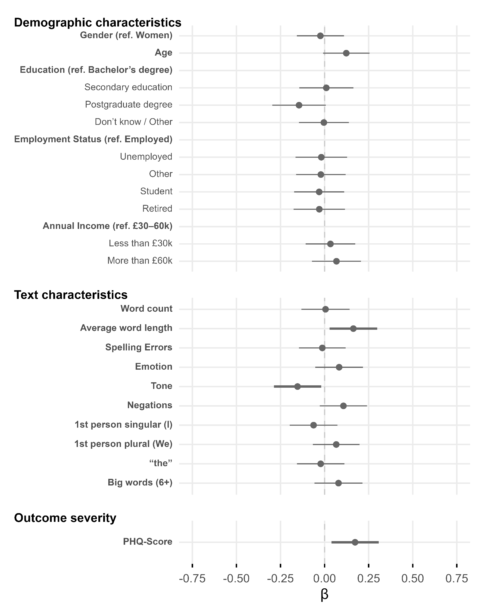

Figure 2
Predictors Associated With Absolute Assessment Differences Using the Entire Training Data and RoBERTa for GAD-7
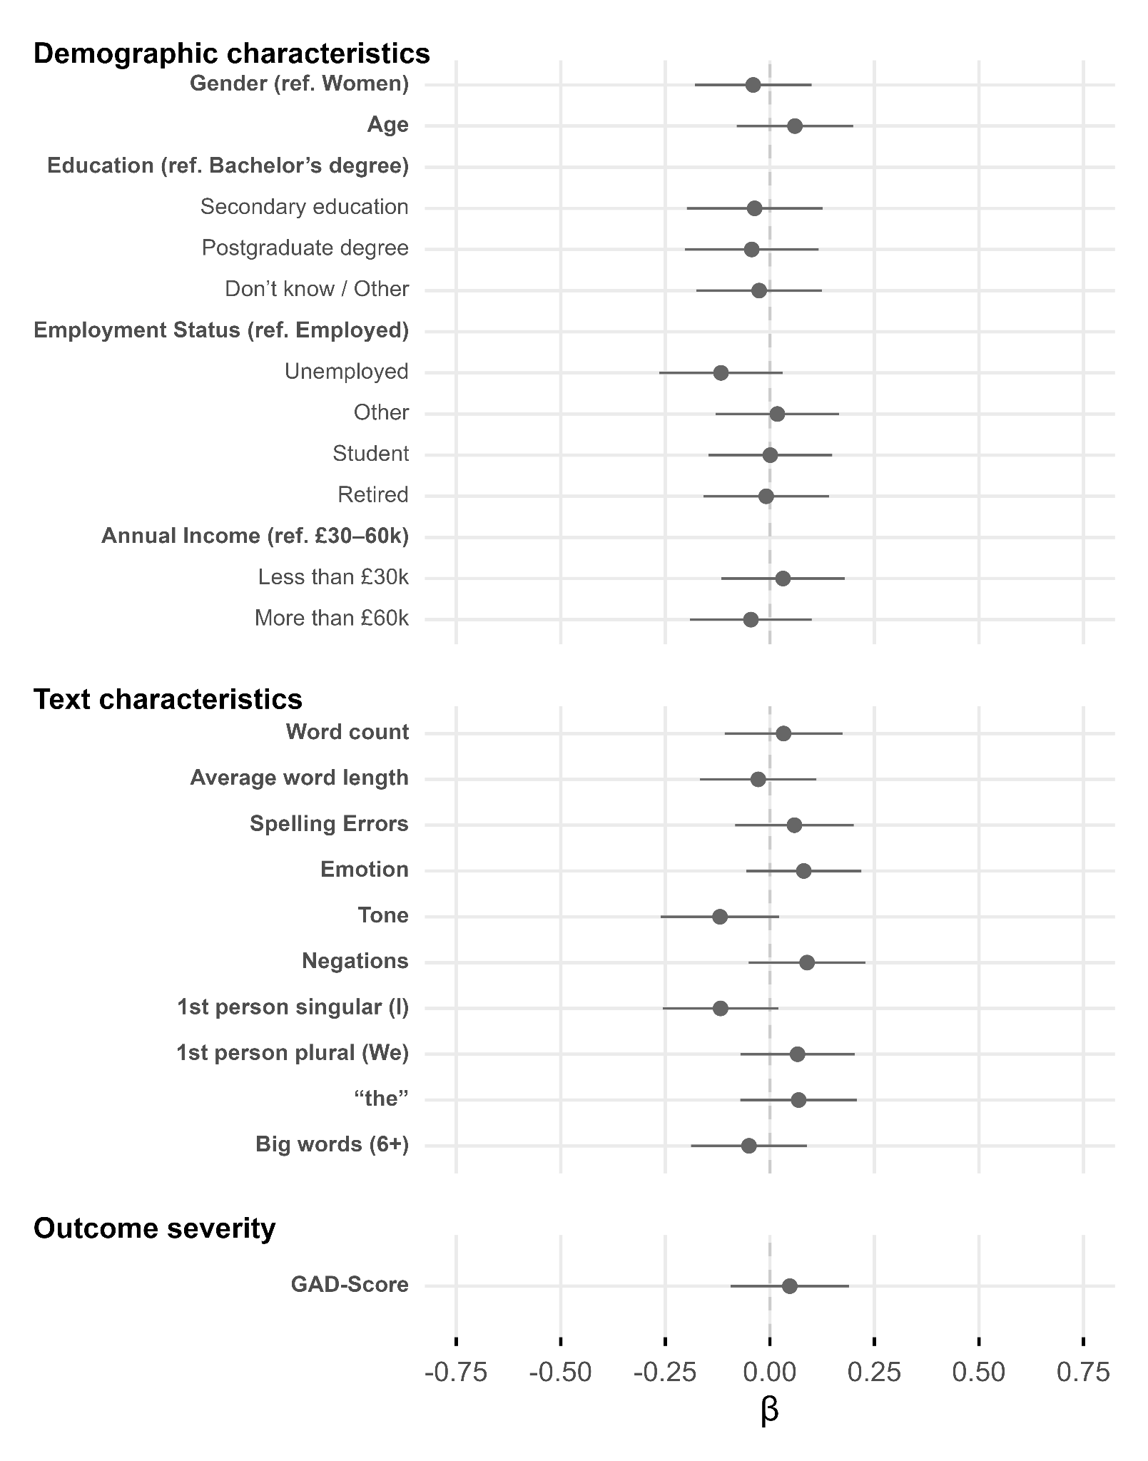
Figure 3
Predictors Associated With Absolute Assessment Differences Using the Downsampled PHQ-9 data and RoBERTa
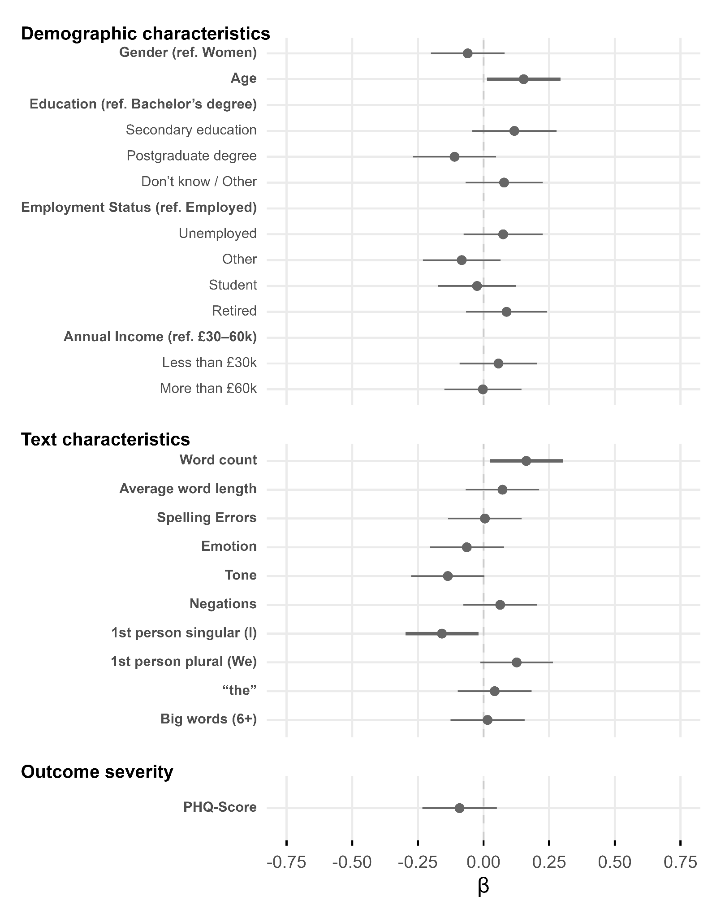
Figure 4
Predictors Associated With Absolute Assessment Differences Using the Downsampled GAD-7 data and RoBERTa
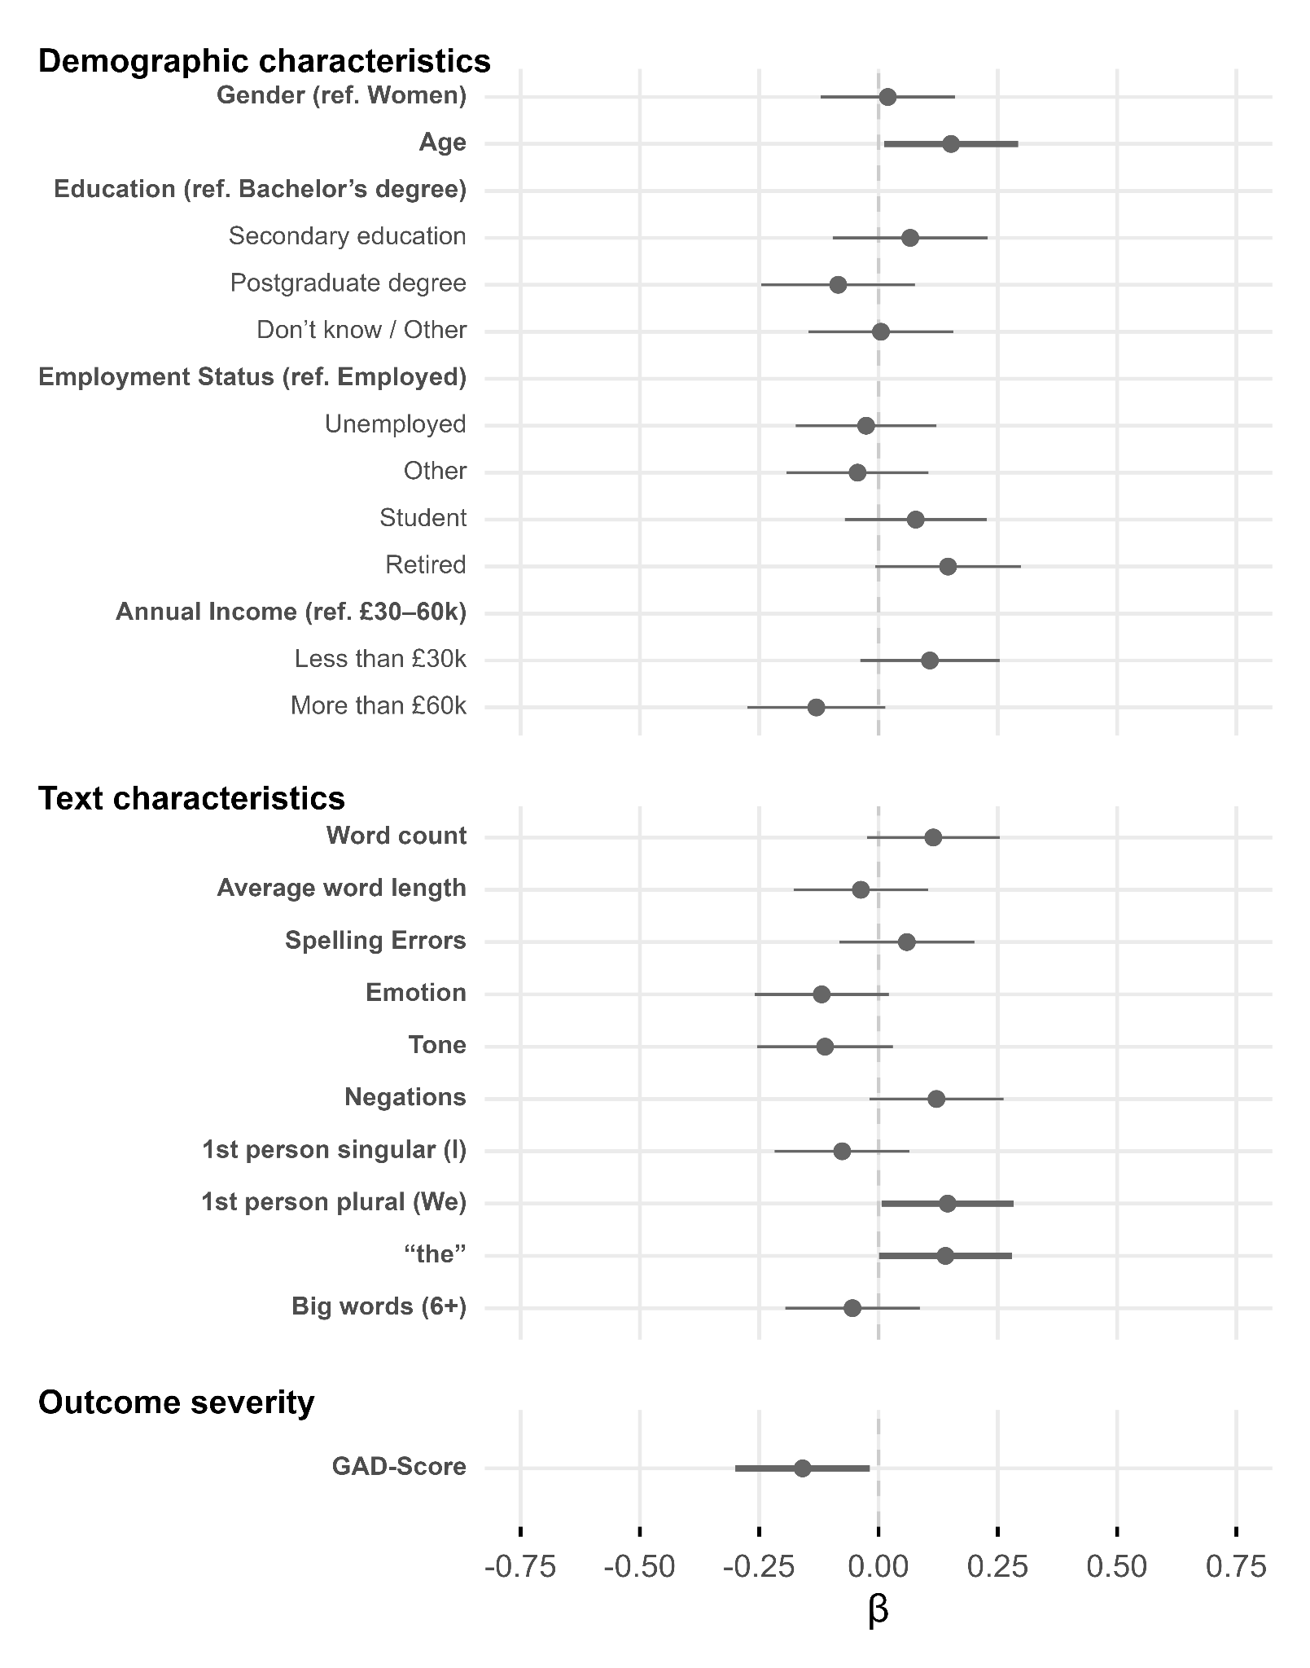
Figure 5
Predictors Associated With Absolute Assessment Differences Using the Entire Training Data and Anscombe-Loss and Predictive Redistribution for PHQ-9
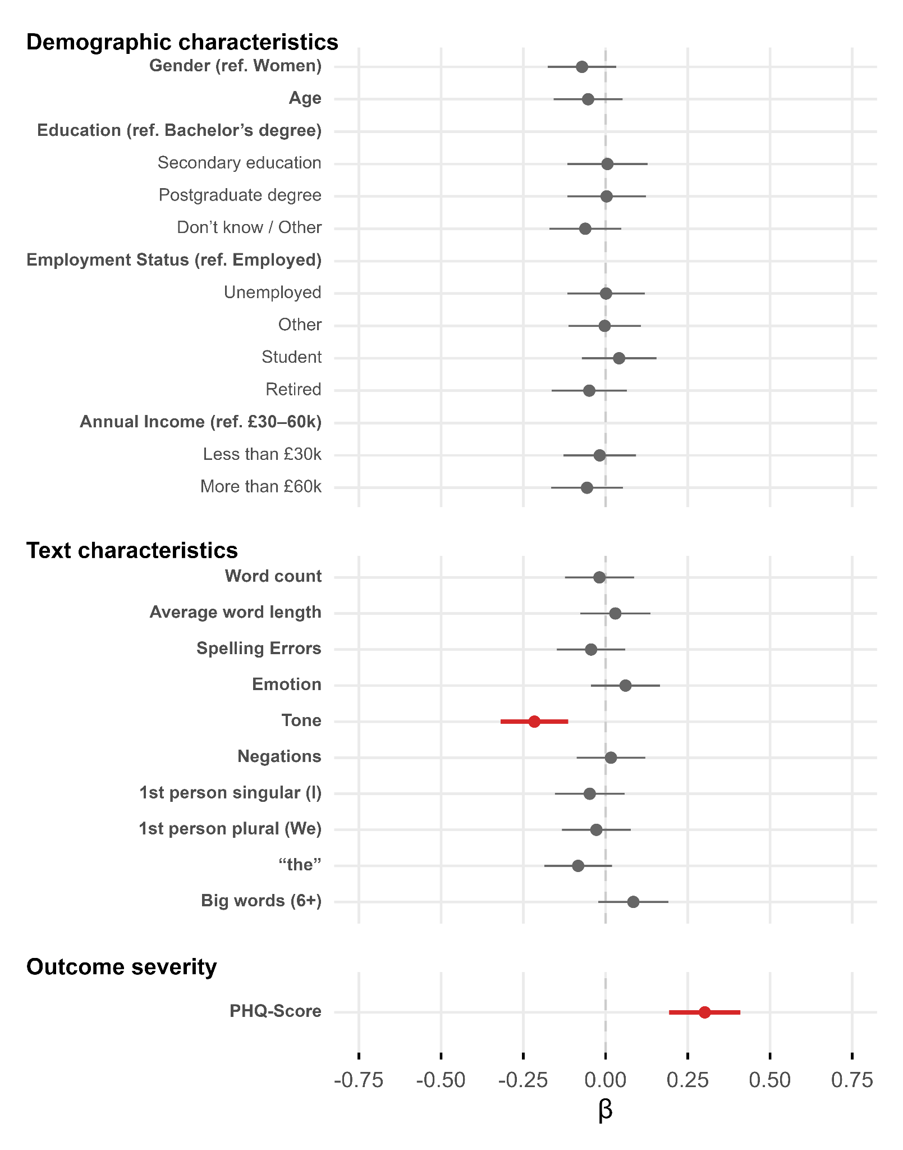
Figure 6
Predictors Associated With Absolute Assessment Differences Using the Entire Training Data and Anscombe-Loss and Predictive Redistribution for GAD-7
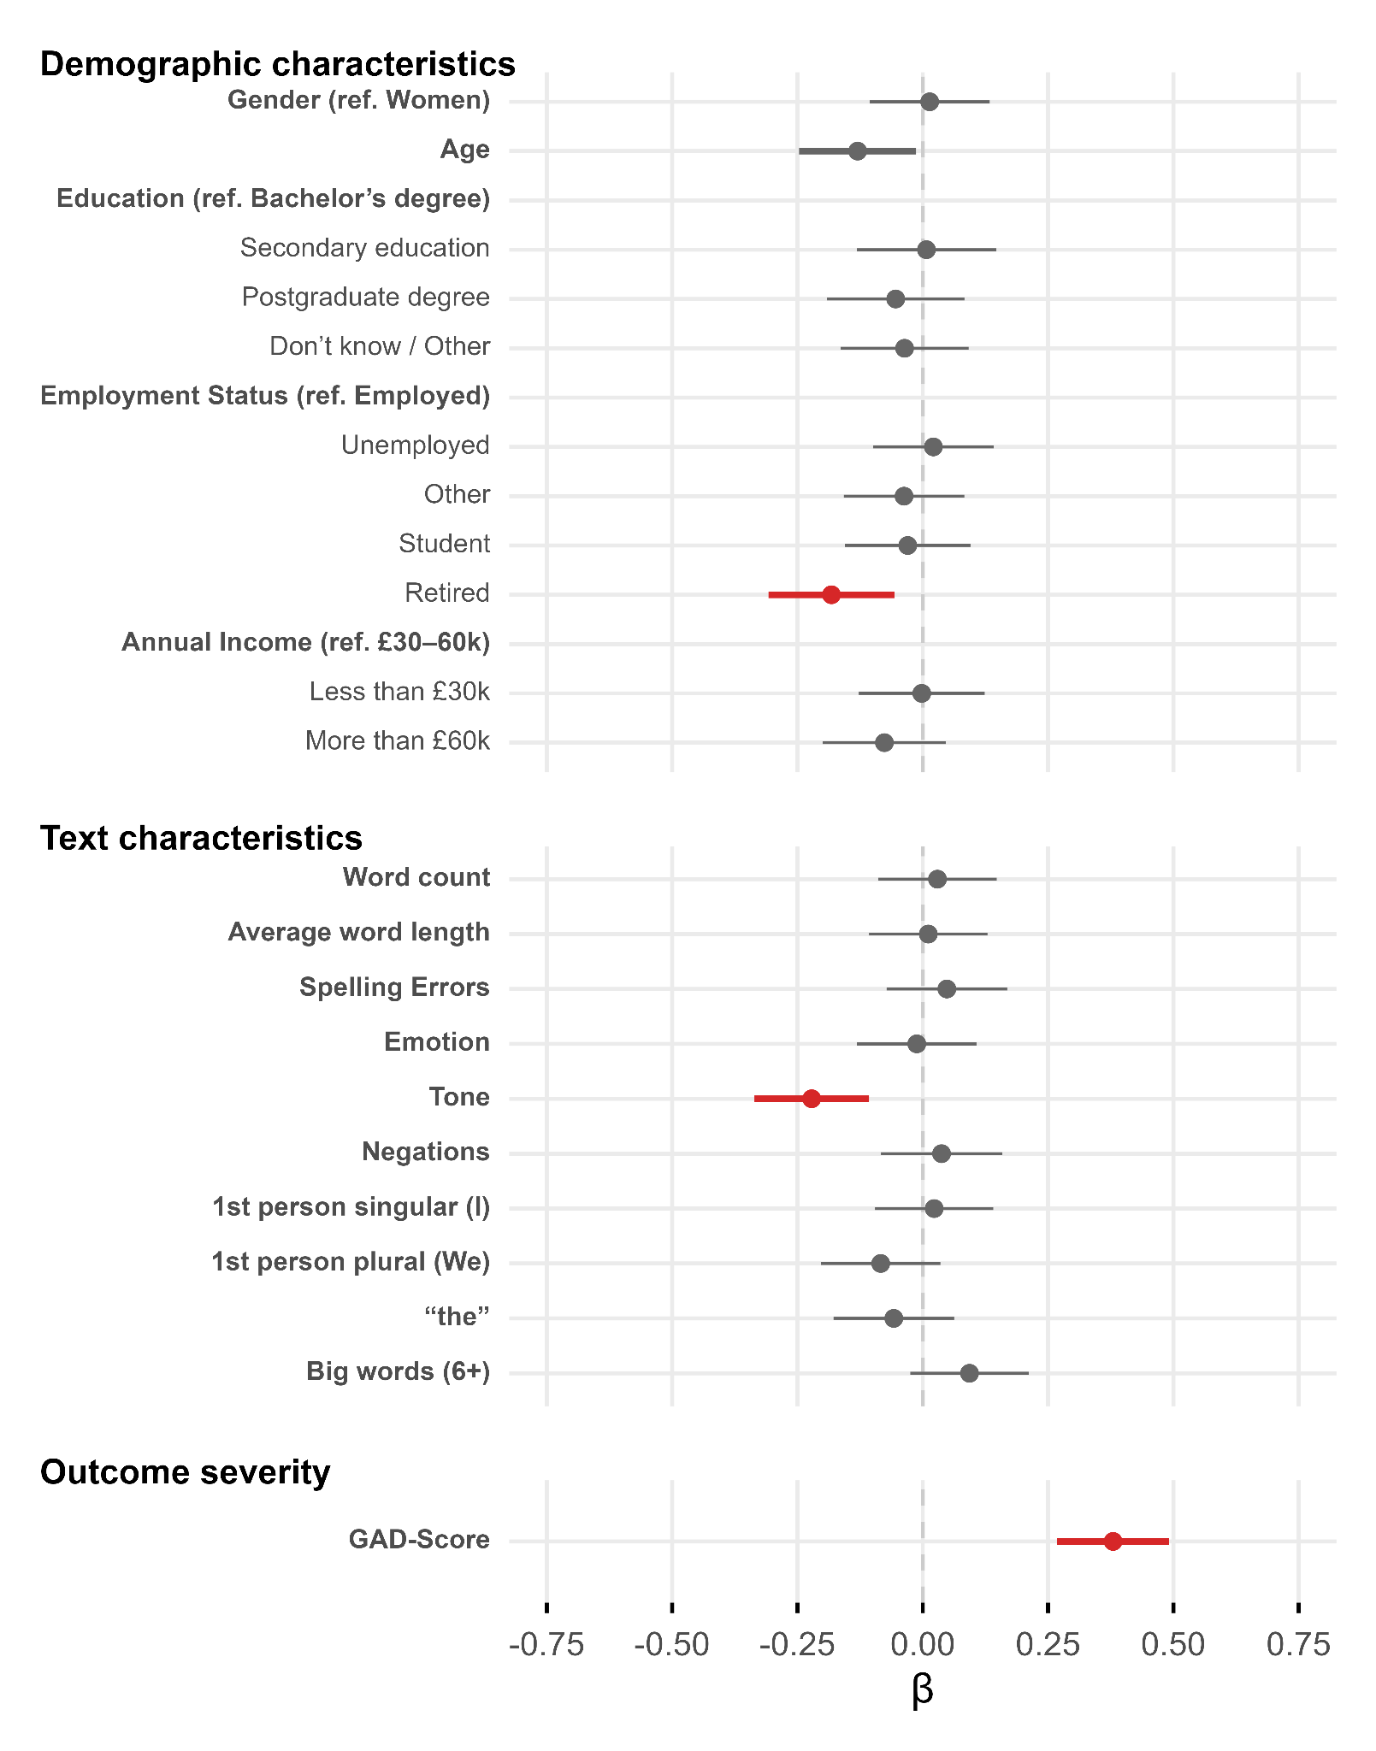
Figure 7
Distributions of Total GAD-7 Scores in Full Training, GAD-7 Downsampled, and Validation Data Sets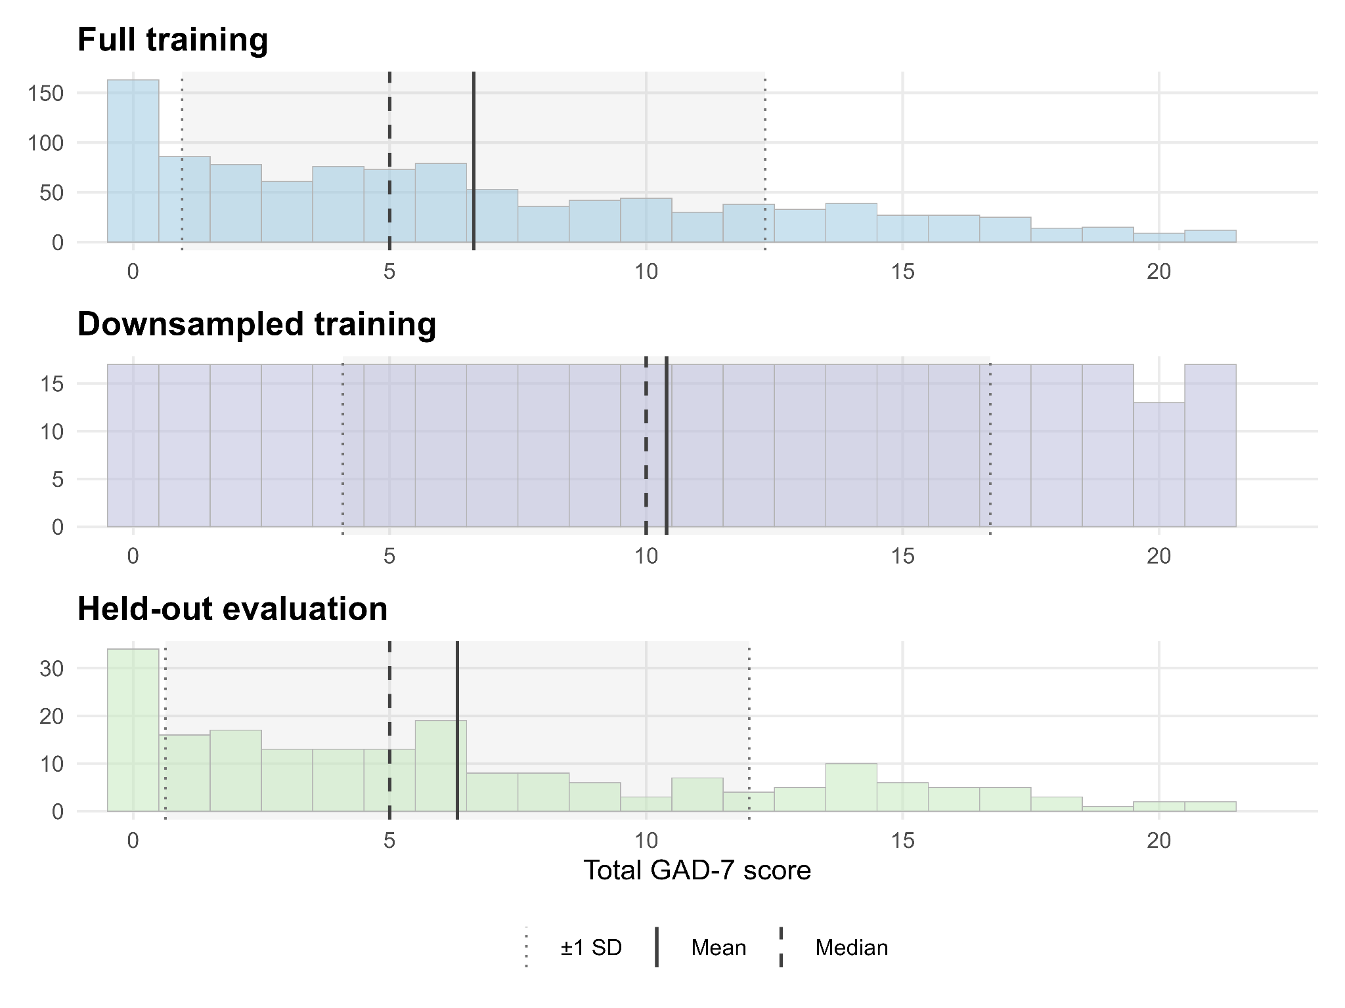
Figure 8
Mean Absolute Error per level of PHQ-9 in the Validation Set
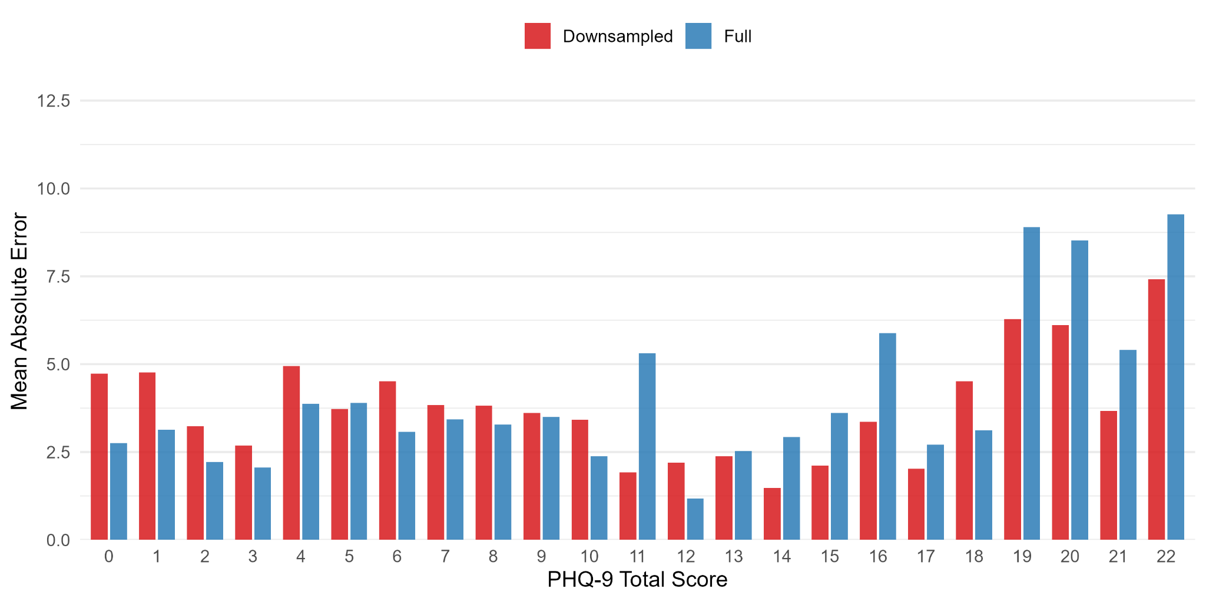
Figure 9
Mean Absolute Error per level of GAD-7 in the Validation Set
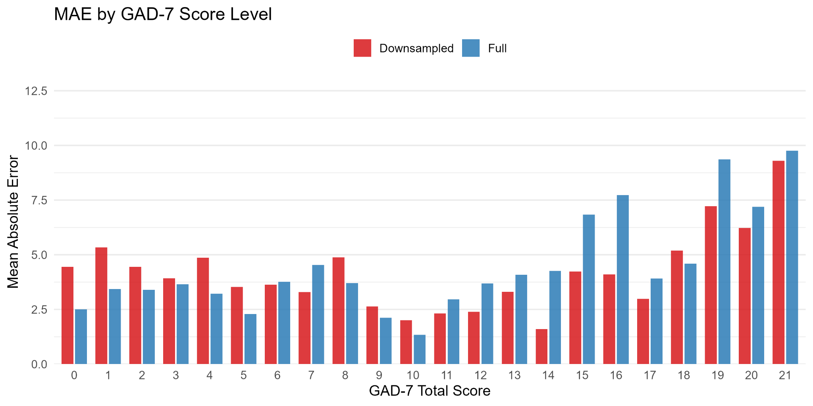
Table 14
ICC(2,1) for PHQ-9: Two-way random, absolute agreement

Comparison | ICC | CI_low | CI_high | F_value | p_value | N
PHQ-9 vs Full model | 0.671 | 0.588 | 0.741 | 5.087 | 0.0000 | 200
PHQ-9 vs Balanced model | 0.652 | 0.489 | 0.758 | 5.517 | 0.0000 | 200
PHQ-9 vs Anscombe model | 0.679 | 0.596 | 0.747 | 5.201 | 0.0000 | 200

Table 15
ICC(2,1) for GAD-7: Two-way random, absolute agreement

Comparison | ICC | CI_low | CI_high | F_value | p_value | N
GAD-7 vs Full model | 0.613 | 0.518 | 0.692 | 4.146 | 0.0000 | 200
GAD-7 vs Balanced model | 0.571 | 0.358 | 0.707 | 4.386 | 0.0000 | 200
GAD-7 vs Anscombe model | 0.641 | 0.551 | 0.716 | 4.591 | 0.0000 | 200

Table 16
The 15 Most Over- and Underestimated Responses for the Downsampled PHQ-9 Model

ID | PHQ-9 | LBA | Δ | General mental health description
Overestimations
1 | 0 | 13.02 | 13.02 | My mental health seems to be pretty stable, I lead a pretty quiet life really with regular overnight visits from my family who all live at a distance. I find that my moods are affected by the weather, extreme cold makes me uncomfortable and extreme heat makes me irritable. This has possibly increased more with age. I have cats, some of whom live outside on my ex-smallholding, and one who lives indoors with me, she is very loving and great company since I was widowed in 2016. I have progressive osteoarthritis and had 3 joint replacements since 2018, as feet legs and ankles are all affected my mobility is not too good, arms and hands are deteriorating too, i manage unaided but sometimes struggle a bit. My eldest son and his partner are planning to move here in late September so that will make things easier, particularly in the winter.
2 | 5 | 16.51 | 11.51 | My emotions are all over the place because my adult son, who has bipolar and an alcoholic became homeless and moved back home with us... This has proved difficult on many levels.
3 | 9 | 20.16 | 11.16 | Every day is a struggle with my depression and anxiety. My anger is getting worse and I snap for no reason but i cant control it, Its hard at the minute.
4 | 4 | 15.05 | 11.05 | Fairly stable. Currently settling into a new job, attempting to push a house move through and also finishing off a Masters degree course so do have some periods of feeling overhelmed and struggling for motivation. I have a history of buckling under too much pressure and having periods of poor mental health where i struggle to get out of bed, engage with people and look after myself. These periods usually last around 5-6 days before i get back towards normal again.
5 | 4 | 14.22 | 10.22 | Living life during this epidemic is distressing for all. But for the elderly it is worse. I have not seen my children or grandchildren for over 2 years and it is totally demoralising.
6 | 5 | 15.21 | 10.21 | I have felt depressed a lot of the time as I have an alcoholic daughter and the only way to stop her turning to alcohol is for me to physically be at her home. I have been staying there for a few weeks now. I tried going home and she immediately started drinking again. I worry about the mental health of my granddaughter who is 17 years old. When I am home I am happy to see my husband and cats, and I enjoy spending time in my garden.
7 | 4 | 13.87 | 9.87 | My mental health has been up and down. I wake lots during the night and find myself eating out of boredom. I have hot sweats, shakes and get angry or frustrated easily.
8 | 4 | 13.65 | 9.65 | I have been preoccupied with my treatment for cancer, diagnosed in March. I have started to have radiotherapy and am now on hormone therapy - both have side effects which are not yet evident, but I have been told by my Oncologist to expect some. I think my diagnosis has made me think more about my life and priorities, and whilst things have not necessarily changed (and perhaps don't need to) I feel somewhat uncomfortable with my situation at present. I have been able to concentrate less than normal, and do not really feel like engaging with people (even family) as I'd rather work through things on my own - I do feel isolated but it is self-induced, because I don't think that even my husband truly understands the mental struggle with coming to terms with a cancer diagnosis.
9 | 1 | 10.63 | 9.63 | I have felt mainly optimistic but have felt a little bit down on a few days with no real motivation to do much. I thnk this may be due to the fact that my dad is seriously ill in hospital at the moment.
10 | 1 | 10.58 | 9.58 | Over the last 2 weeks my mental health has been getting better, due to the Covid restrictions being relaxed, but i dont feel i am back to where i was as i am still working at home, and still not really seeing many people. I have had moments of sadness and upset and frustration, mainly due to work issues which i feel if i was in an office environment i wouldnt have.
11 | 6 | 15.54 | 9.54 | Generally feeling a bit low, Some days worse than others. Have been actively trying to alleviate feelings of pointlessness, sadness, grief, guilt, anger and resentment by exercising more and taking myself alone out of house
12 | 3 | 11.18 | 8.18 | I have been feeling a little isolated and that I need more friends/people to talk to. I don't work outside of the home, have only my husband for company most of the time and feel that I need to get out/mix with more people. Perhaps I need a job outside of the home but am concerned about Covid. I suffer with asthma and so don't want to mix with too many people.
13 | 4 | 12.15 | 8.15 | Overall well, the weather and DIY work around my house has been getting me down though. It's extremely warm and I'd like to have windows open but DIY noise at unsociable hours prevents me from doing this.
14 | 2 | 10.04 | 8.04 | Generally good mental health. I previously have had depressive episodes when at university but have never felt i had a mental health condition. I sometimes find I have a very short temper and can get extremely frustrated over small things. I think this is because I bottle up my emotions.
15 | 8 | 16.01 | 8.01 | I've been having some issues with my mental health lately. I'm trying to lose some weight and start eating healthier but I can't seem to get motivated. I'm pretty sure it has something to do with my depression and I need to talk to my doctor about maybe changing my medication.
Underestimations
1 | 20 | 10.61 | -9.39 | The past two weeks have been better than previous weeks mentally as i fought the urge to want to hurt myself in an way. However before falling asleep my mind seemed to be racing a lot with negative thoughts.
2 | 22 | 13.07 | -8.93 | I’ve been feeling nervous and exhausted, I’ve often been trying to distract myself to avoid dissociating. I’m worried that I’m alone and I frequently have chest and stomach pains.
3 | 19 | 10.96 | -8.04 | I have been feeling quite emotional and upset at times. I have been able to continue with my usual daily activities, but have had times when I feel like crying with no particular reason. I have also felt anxious about work, and at times avoided doing some tasks. I have contacted my doctor and am waiting for an appointment.
4 | 16 | 8.38 | -7.62 | I have been feeling stressed over the past couple of weeks due to my job. I quit on a whim yesterday and feel happier as a result. The job was making me really anxious.
5 | 20 | 12.51 | -7.49 | My moods have been up and down these last 2 weeks. I can have days where I'm happy and have very low days the next and can't seem to shift the blues.
6 | 19 | 11.86 | -7.14 | My mental health over the last 2 weeks have been poor. Today I feel the best I’ve felt in a long time but previously I have felt scared, anxious and depressed
7 | 19 | 11.93 | -7.07 | I am quite sad, because of not seeing my friends (because the Covid-19 risk here is very high) but also because of a feeling of purposelessness. This usually coincides with my being on summer break from my work, and normally I try to overcome it by learning something new or just relaxing to take pressure off myself. However, this year I cannot focus on anything for very long, and experience a lot of fatigue.
8 | 22 | 16.11 | -5.89 | right now im struggling with very poor mental health. I have a history if depression, i am on tablets and have to actively manage my mood
9 | 20 | 14.27 | -5.73 | I feel a roller coaster of emotions. One minute I feel jubilant and then I watch the news and immediately feel sad again. I feel that I am not moving forward, the world is not moving forward... everything is stagnating. As the months go by it feels that life is just passing me by and that it almost has no purpose and that my best years are just being wasted
10 | 16 | 10.31 | -5.69 | I'm struggling with my mental heath at the moment, even just making a easy decision about what to have for dinner is very stressful for me.
11 | 21 | 15.58 | -5.42 | feeling very low. stuck in a situation looking after elderly relative. unable to buy a home because house prices have soared. caught in a heatwvave generally nothing to do
12 | 18 | 12.98 | -5.02 | Generally poor, not helped by heatwave and cramped home situation and subsequent impact on my own productivity and ability to perform everyday tasks; sleep is poorer than usual, appetite is reduced, low energy, and brain fog associated with flare up of chronic pain; however, nothing that I am not capable of coping with, given my lengthy experience with such symptoms
13 | 13 | 8.36 | -4.64 | For the previous two weeks my mental health has been better. I'm not feeling as bad about myself recently, less black and white thinking. I feel more productive and I'm getting the things done I need to.
14 | 20 | 15.48 | -4.52 | Not very good. Feel overwhelmed by everything. Worried about the future. Trouble falling asleep, very irritable, depressed, tired. Worry a lot of the time. Not at all productive, procrastinate a lot.
15 | 7 | 2.97 | -4.03 | I have been okay for the most part. There have been moments in days when I have been feeling a little down, but overall, I have been able to function and enjoy what I am doing.

Table 17
The 15 Most Over- and Underestimated Responses for the Downsampled GAD-7 Model

ID | GAD-7 | LBA | Δ | General mental health description
Overestimations
1 | 1 | 12.45 | 11.45 | I've been having some issues with my mental health lately. I'm trying to lose some weight and start eating healthier but I can't seem to get motivated. I'm pretty sure it has something to do with my depression and I need to talk to my doctor about maybe changing my medication.
2 | 1 | 12.30 | 11.30 | My mental health seems to be pretty stable, I lead a pretty quiet life really with regular overnight visits from my family who all live at a distance. I find that my moods are affected by the weather, extreme cold makes me uncomfortable and extreme heat makes me irritable. This has possibly increased more with age. I have cats, some of whom live outside on my ex-smallholding, and one who lives indoors with me, she is very loving and great company since I was widowed in 2016. I have progressive osteoarthritis and had 3 joint replacements since 2018, as feet legs and ankles are all affected my mobility is not too good, arms and hands are deteriorating too, i manage unaided but sometimes struggle a bit. My eldest son and his partner are planning to move here in late September so that will make things easier, particularly in the winter.
3 | 5 | 15.67 | 10.67 | My emotions are all over the place because my adult son, who has bipolar and an alcoholic became homeless and moved back home with us... This has proved difficult on many levels.
4 | 2 | 11.80 | 9.80 | due to my sons breakup it has been getting more and more difficult as I am getting to be used against him and my wife by his former partner
5 | 1 | 10.23 | 9.23 | I’ve been fine over the past two weeks by and large but this week I’ve just felt a bit overwhelmed. Mainly by news events such as flooding and fires and extreme weather conditions. I’m angry that governments aren’t taking climate change more seriously. Also angry with our government for being so incompetent
6 | 3 | 12.22 | 9.22 | I haven't felt the best in the last two weeks, I have often had thoughts that I had no hope about the future or the world getting better the way it is and that I don't picture myself making it with my headspace in the 'real world'. These thoughts have made me feel quite low and lonely, these thoughts especially get bad when I don't have anything to do on a certain day. This has just left me laying in bed and not eating very much, I'm not sure if my low appetite is contributing but recently I'm not eating very much.
7 | 4 | 13.08 | 9.08 | Living life during this epidemic is distressing for all. But for the elderly it is worse. I have not seen my children or grandchildren for over 2 years and it is totally demoralising.
8 | 0 | 8.95 | 8.95 | I have felt mainly optimistic but have felt a little bit down on a few days with no real motivation to do much. I thnk this may be due to the fact that my dad is seriously ill in hospital at the moment.
9 | 4 | 12.48 | 8.48 | Variable from feeling ok to feeling desperate that I don’t want to go on. This has been compounded with having various visitors staying over that time and husband not connecting with them at all and leaving it to me totally to entertain them.
10 | 3 | 11.17 | 8.17 | Generally feeling a bit low, Some days worse than others. Have been actively trying to alleviate feelings of pointlessness, sadness, grief, guilt, anger and resentment by exercising more and taking myself alone out of house
11 | 6 | 14.06 | 8.06 | I am always on the edge of depressed. I have health conditions which hang over me like a cloud. Covid limits my life at a time where I may not be able to do things in the future so I feel my life is slipping away. I have no work and feel life is to a degree pointless.
12 | 0 | 8.01 | 8.01 | My mental health is pretty good I think. I deal with problems well, with out getting over stressed. I don't sleep well though. Tend to wake up very early eg. 4/5 am and cant get back to sleep.
13 | 2 | 9.96 | 7.96 | I have relatively well however i have been irritated easily and lash out occasionally, i have a lack of energy everyday
14 | 1 | 8.76 | 7.76 | My mental health is good but I am having cognitive behavioural therapy to get rid of my fear of heights and sitting as a passenger in a car. I have found this very beneficial.
15 | 0 | 7.71 | 7.71 | I have been relatively mentally stable over the last two weeks. This, despite the prospect of upheaval due to selling the family home
Underestimations
1 | 21 | 11.38 | -9.62 | Ive felt drained for little to no reason, hard to focus on anything and i keep putting off tasks that i need to do.
2 | 15 | 5.39 | -9.61 | For the previous two weeks my mental health has been better. I'm not feeling as bad about myself recently, less black and white thinking. I feel more productive and I'm getting the things done I need to.
3 | 18 | 8.47 | -9.53 | I am quite sad, because of not seeing my friends (because the Covid-19 risk here is very high) but also because of a feeling of purposelessness. This usually coincides with my being on summer break from my work, and normally I try to overcome it by learning something new or just relaxing to take pressure off myself. However, this year I cannot focus on anything for very long, and experience a lot of fatigue.
4 | 16 | 6.72 | -9.28 | I have been feeling stressed over the past couple of weeks due to my job. I quit on a whim yesterday and feel happier as a result. The job was making me really anxious.
5 | 20 | 10.96 | -9.04 | I feel a roller coaster of emotions. One minute I feel jubilant and then I watch the news and immediately feel sad again. I feel that I am not moving forward, the world is not moving forward... everything is stagnating. As the months go by it feels that life is just passing me by and that it almost has no purpose and that my best years are just being wasted
6 | 21 | 12.02 | -8.98 | I suffer from generalised Anxiety and Health anxiety and over the past 2 weeks, the health side has been more prolific as I've sort help from a consultant. In doing so it has unveiled issues with my jaw that were worse than I thought and I've been incredibly anxious. The treatment to fix it is also expensive and money is now a concern. I feel a bit hopeless if I'm honest.
7 | 13 | 4.51 | -8.49 | My mental health has been okay last two weeks because I have been on holiday with my friends for one of my friends weddings. So I have felt very content, happy, excited and joyous. Also very stressed as traveling during pandemic is a lot of hassle and stressful. Have also been a bit irritable at times and haven't slept well.
8 | 11 | 3.12 | -7.88 | Over the past two weeks I have generally felt okay more happier days than not on occasion my mental health has spiralled slightly but I have been conscious to not let it get too out of control to best of my ability.
9 | 19 | 11.78 | -7.22 | My mental health over the last 2 weeks have been poor. Today I feel the best I’ve felt in a long time but previously I have felt scared, anxious and depressed
10 | 7 | 0.10 | -6.90 | I have felt great over the last two weeks, I have done a lot of exercise, healthy eating, and am happily pursing goals and hobbies.
11 | 15 | 9.76 | -5.24 | I am dealing with aging issues -- health and otherwise that are relatively new to my existence and I focus on fear of dying way too much. I have bronchiectasis and emphysema and, while I have done pretty well with it, I am currently dealing with a bad cough and a bacteria in my lungs that requires special medication to get rid of that I simply cannot afford (almost $2K despite good health insurance coverage), plus my pulmonologist is away this week so that alone makes me anxious and fearful, but there is back up and I am being helped to deal with this issue. Putting that aside, I am grateful to be alive and active and hopeful that this particular issue will be resolved.
12 | 16 | 11.54 | -4.46 | I'm struggling with my mental heath at the moment, even just making a easy decision about what to have for dinner is very stressful for me.
13 | 4 | 0.03 | -3.97 | Fine feeling well balanced with all things reasonably under control and my hobbies keep me aborbed and occupied. There are small problems as always but nothing out of the ordinary.
14 | 17 | 13.04 | -3.96 | It has been 'wobbly'. Some days I am fine, other days I am incredibly anxious. I can feel the anxiety approaching, sometimes I can divert it, other times, especially at night, I cannot. I am losing lots of sleep. I am also very tearful.
15 | 13 | 9.10 | -3.90 | I have been feeling quite emotional and upset at times. I have been able to continue with my usual daily activities, but have had times when I feel like crying with no particular reason. I have also felt anxious about work, and at times avoided doing some tasks. I have contacted my doctor and am waiting for an appointment.

