Supplementary Material

Supplementary Table 1. Linear mixed-effects models predicting suicidal ideation at the same measurement point based on within- and between-person loneliness and deficits in personality functioning in the population and patient sample
 | Population sample |  |  |  | Patient sample
Predictor | Estimate (B) | SE | t | p | Estimate (B) | SE | t | p
Intercept | 0.509 | 0.241 | 2.11 | .035 | -0.540 | 0.385 | -1.40 | .161
Fixed effects
Loneliness (within-person) | -0.007 | 0.049 | -0.15 | .882 | -0.035 | 0.110 | -0.32 | .752
Loneliness (within-person) × OPD-SQS Sum Score | 0.004 | 0.002 | 2.07 | .038 | 0.012 | 0.003 | 3.66 | < .001
Loneliness (between-person) | 0.248 | 0.075 | 3.32 | .001 | 0.298 | 0.066 | 4.49 | < .001
OPD-SQS Sum Score | 0.018 | 0.011 | 1.65 | .103 | 0.062 | 0.011 | 5.64 | < .001
Random effects
σ₀ (Intercept) | 0.902 |  |  |  | 1.074
σ₁ (Slope: loneliness within) | 0.143 |  |  |  | 0.327
σₑ (Residual) | 0.415 |  |  |  | 0.760
ϕ (AR(1) autocorrelation) | 0.317 |  |  |  | 0.221
Legend: Population sample: Marginal R² (fixed effects) = .14; Conditional R² (fixed + random effects) = .85; Patient sample: Marginal R² (fixed effects) = .38; Conditional R² (fixed + random effects) = .81.

Supplementary Table 2. Linear mixed-effects models predicting suicidal ideation at the next measurement point based on lagged within-person loneliness, between-person loneliness, and deficits in personality functioning in the population and patient sample
 | Population sample |  |  |  | Patient sample
Predictor | Estimate (B) | SE | t | p | Estimate (B) | SE | t | p
Intercept | 0.479 | 0.243 | 1.97 | .049 | -1.220 | 0.404 | -3.02 | .003
Fixed effects
Lagged Loneliness (within-person) | -0.007 | 0.033 | -0.21 | .837 | 0.038 | 0.067 | 0.56 | .574
Lagged Loneliness (within-person) × OPD-SQS Sum Score | 0.001 | 0.001 | 0.49 | .628 | -0.002 | 0.002 | -0.99 | .320
Loneliness (between-person) | 0.290 | 0.082 | 3.53 | .001 | 0.552 | 0.088 | 6.26 | < .001
OPD-SQS Sum Score | 0.016 | 0.011 | 1.37 | .174 | 0.052 | 0.011 | 4.79 | < .001
Random effects
σ₀ (Intercept) | 0.902 |  |  |  | 1.02
σ₁ (Slope: loneliness within) | 0.069 |  |  |  | 0.154
σₑ (Residual) | 0.449 |  |  |  | 0.984
ϕ (AR(1) autocorrelation) | 0.361 |  |  |  | 0.182
Legend: Population sample: Marginal R² (fixed effects) = .15; Conditional R² (fixed + random effects) = .83; Patient sample: Marginal R² (fixed effects) = .39; Conditional R² (fixed + random effects) = .71.
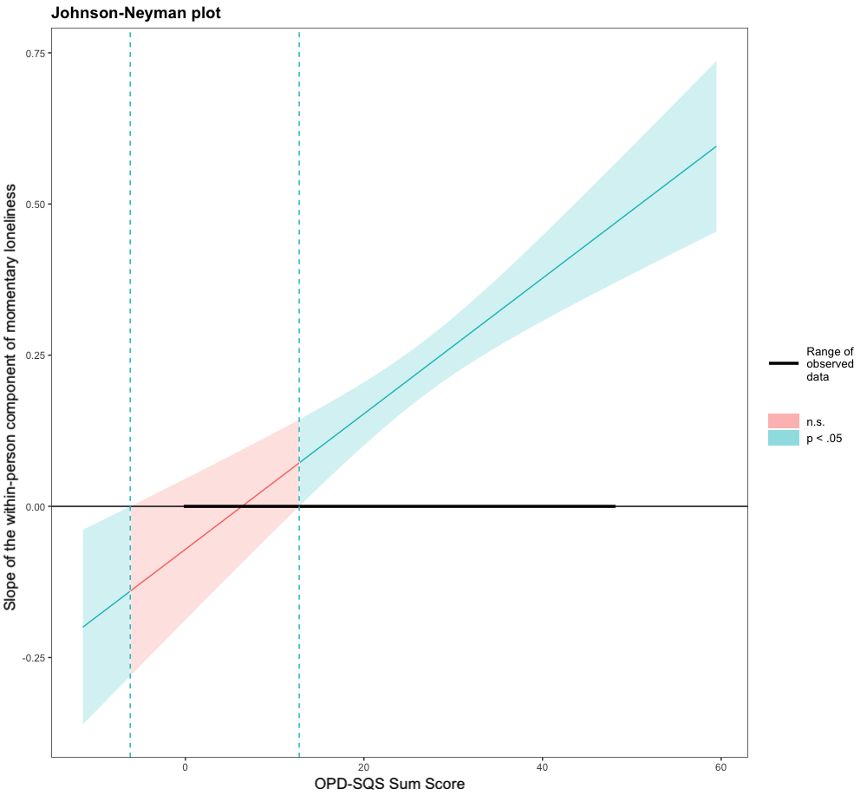
Supplementary Figure 1. Johnson-Neyman plot illustrating the conditional effect of within-person loneliness on suicidal ideation as a function of personality functioning (OPD-SQS)

Figure legend: The solid line represents the estimated slope of within-person loneliness at different levels of OPD-SQS, with shaded areas indicating 95% confidence intervals. The blue-shaded regions mark ranges where the effect is statistically significant (p < .05); the red-shaded region denotes non-significant effects. Vertical dashed lines indicate the Johnson-Neyman significance thresholds. The thick black line on the x-axis shows the observed range of OPD-SQS values in the data.

