Supplementary material: Histograms and IRT Plot

Material S1. Frequencies for answer categories of depression and PF items.
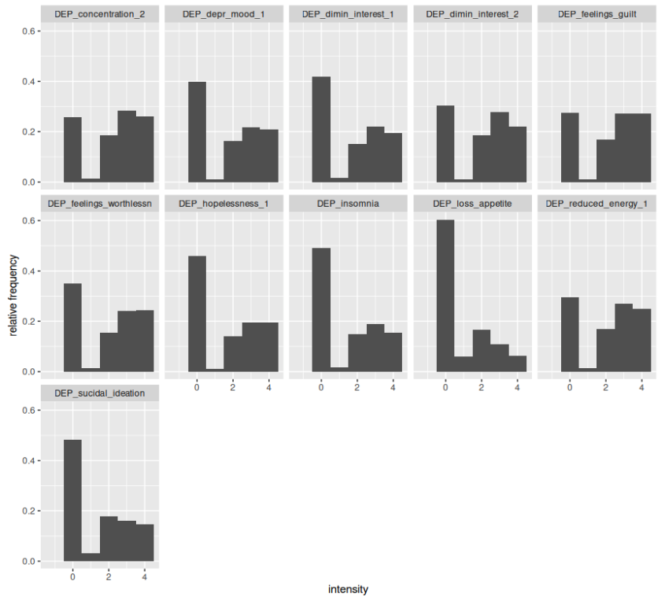
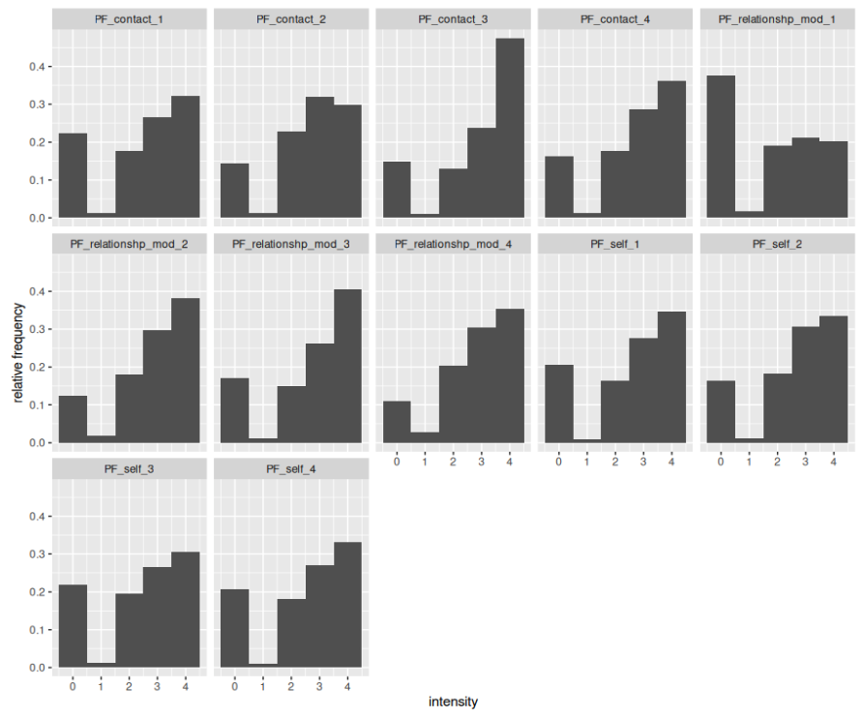

Material S2: IRT plot of OPD-SQS anchor items
