Supplementary Materials
Data Screening in the Pandemic Cohort
Responses were carefully screened for potentially fraudulent participation. We investigated responses to identify invalid data (i.e., a non-existent zip code), if the baby’s birth date was more than two weeks discrepant from the originally provided due date, if the prenatal and three-month surveys did not match (i.e., respondents stated that they themselves were pregnant during the prenatal survey but that their partner gave birth on the three-month survey), if the participant’s zip code did not match their IP address, or if participants completed the survey more than once. We contacted participants directly to clarify discrepancies in cases of suspected fraud, and dropped participants whose discrepancies were not resolved.
Depressive symptoms and ethnic minority status
We used a one-way analysis of variance (ANOVA) and Tukey’s Honest Significant Difference (HSD) test to evaluate differences in depressive symptoms at each time point with respect to each participant’s ethnicity (i.e., American Indian or Alaskan Native, Asian, Black, Latinx, Other, or White). We found no significant differences in depressive symptoms at any time point between any pair of ethnic groups. We also conducted a one-way ANOVA after dichotomizing participants’ ethnicity as either “1” = ethnic minority (i.e., American Indian or Alaskan Native, Asian, Black, Latinx, or Other) or “0” = White. We found that depressive symptoms during pregnancy were significantly lower in participants who identify as an ethnic minority, F(1, 757) = 5.98, p = .02). Therefore, we elected to include the minority variable as a covariate in our focal analysis rather than including separate covariates for each category of the ethnic minority variable.
Dyadic Adjustment Scale (DAS)
The full Dyadic Adjustment Scale (DAS) is a 32-item questionnaire with four subscales including dyadic consensus (the degree of agreement with a partner), dyadic satisfaction (the degree of satisfaction with a partner), dyadic cohesion (the degree of participation in joint activities), and affectional expression (the degree of agreement with partner in relation to emotional affection) (Spanier, 1976). When scored together, these scales produce a combined Global Adjustment Score, with higher scores suggesting a greater degree of positive dyadic adjustment.
In prior studies, the DAS demonstrates high content and criterion validity as well as satisfactory internal consistency (Carey et al., 1993; Graham et al., 2006; Spanier, 1976). In the pandemic sample, a 7-item version of the DAS (DAS-7; Sharpley & Rogers, 1984; Items 8, 10, 11, 25, 27, 28, 31), which has been validated in prior studies (Hunsley et al., 2001; Sabourin et al., 2005), was used to keep the full questionnaire brief. In the DAS-7, six of the items are scored on a six-point Likert type scale, and one is scored on a seven-point Likert type scale. Although the full 32-item DAS was used in the pre-pandemic sample, we only scored the 7-item version to maintain consistency across cohorts. The DAS-7 was highly correlated with the full 32-item DAS in the pre-pandemic sample (r = .86), suggesting the DAS-7 was an adequate proxy for the full-scale DAS in this sample.
Covariance Pattern Modeling
The primary difference between covariance pattern modeling and traditional multigroup growth modeling is that rather than partitioning within- (Θ_{ig}) and between-level (Ψ_{g}) variance in each group g using random-effects (i.e., Var(y_{i}) = Σ_{ig} = Λ(Γ_{g} Φg Γ_{g}ᵀ + Ψ_{g})Λᵀ + Θ_{ig} ), the marginal covariance among the repeated measures is modeled directly by estimating the elements of a residual variance-covariance matrix (i.e., ϵ_{i} ~ MVN(0, Σ_{i}), where the covariance matrix Σ follows a pattern prespecified by the researcher. For example, one such pattern (or structure) could be that all repeated measures separated by n measurement occasions share correlation ρ_{n} (i.e., Toeplitz structure). By forgoing the estimation of within-group random effects, covariance pattern models often lead to fewer nonconvergence issues without sacrificing information needed to test between-group differences in marginal growth trajectories (Diallo et al., 2016; Liu & Hancock, 2014). Moreover, explicitly modeling the covariance among repeating measures (i.e., ϵ_{i} ~ MVN(0, Σ_{i})) avoids the need to assume residuals are homoscedastic and independent (e.g., ϵ ~ ^{i.i.d} N(0, σ²; McNeish & Harring, 2020).
We chose a covariance pattern approach for two primary reasons. First, while we acknowledge symptom trajectories appear to vary within each cohort of our sample (e.g., Figure 2), we do not need to partition within- and between-level variance using subject-specific random effects to test our focal hypotheses regarding the marginal growth trajectories of each cohort (Hypothesis 1) conditional on between-person covariates (Hypothesis 2). Second, estimating subject-specific random effects would most likely increase the chance of nonconvergence issues and inadmissible solutions given the comparatively smaller sample size of our pre-pandemic cohort (n = 99) relative to our pandemic cohort (n = 615; McNeish & Harring, 2020). In sum, the covariance pattern approach is easier to estimate than a traditional growth model, makes fewer assumptions about the data, and sufficiently tests Hypotheses 1 and 2 (Jennrich & Schluchter, 1986; McNeish & Harring, 2020).
Missing Data and the Diggle-Kenward Component
Conducting a sensitivity analysis for missingness not at random (MNAR) consists of creating a missing indictor m_{it} (1 = “missing”; 0 = “not missing”) for focal outcome y_{it} (i.e., depressive symptoms of person i at time t) and regressing m_{it} on to y_{it} and y_{it} at the previous measurement occasion (i.e., y_{it-1}; Diggle & Kenward, 1994; McNeish, 2024). The Diggle-Kenward component assesses if missingness tends to occur more often when participants report more depressive symptoms. Clearly, y_{it} is missing any time m_{it} = “1”, so the model must make distributional assumptions of y_{it} (i.e., normally distributed, in the case of continuous outcomes) in order to be identifiable. Because we lack the ability to verify these distributional assumptions of y_{it}, we employ the Diggle-Kenward component as a sensitivity analysis for MAR but not a definitive test of the mechanisms by which data are missing not at random (i.e., MNAR; Enders, 2023).
After adding the Diggle-Kenward component to the models testing Hypotheses 1 and 2, we find evidence that our data may be missing not at random (MNAR). Namely, missingness is positively associated with our focal outcome such that participants with higher depressive symptoms at the current timepoint (t) and previous timepoint (t – 1) were more likely to drop out of our study. When plotting the trajectory of models that account for MNAR in depressive symptoms (via the Diggle-Kenward component), we find that depressive symptoms in the pandemic cohort were predicted to be greater at all four time points compared to the model that did not include the Diggle-Kenward component. Moreover, the model which included the Diggle-Kenward component predicted that depressive symptoms trajectories in the pandemic cohort tend to increase curvilinearly from pregnancy to six-months postpartum, before declining thereafter (see Figure S2). These results suggest that failing to account for the positive association between missingness and participants’ depression symptoms may cause us to underestimate the severity of depressive symptoms in the pandemic cohort. Given that the Diggle-Kenward component assumes that the repeated measures are normally distributed (McNeish et al., 2024), we cannot rely on these finds as a definitive test of the MNAR assumption. Nonetheless, we report the findings from this MNAR sensitivity analysis to provide evidence that that participants with higher depressive symptoms may have been more likely to drop out of our study (https://osf.io/bsdak/files/osfstorage; León et al., 2025).
Factor Score Estimation
To estimate factor scores for the Beck Depression Inventory (BDI-II) and the Dyadic Adjustment Scale (DAS-7), we first compared the fit of a parallel factor model and a congeneric factor model for both the BDI-II and DAS-7. A parallel factor model constrains factor loadings and error variances to be equal across all items, which assumes that all items are mathematically interchangeable and measure the latent construct with the same precision. The parallel factor model is the implicitly assumed factor structure when sum scores or mean scores are derived from a scale (McNeish & Wolf, 2020). Parallel factor models are highly restrictive and are unlikely to capture differences in the associations between each item and the latent construct. An alternative to the parallel factor model is the congeneric factor model, which allows factor loadings and error variances to vary freely across items and accounts for measurement error. Congeneric factor models often outperform parallel factor models in empirical samples and are preferred because they account for between-item differences in precision and reliability (McNeish & Wolf, 2020). In our sample, we used the comparative fit index (CFI), root mean squared error of approximation (RMSEA), and the Bayesian Information Criteria (BIC) to evaluate differences in model fit between parallel and congeneric factor models for both the BDI-II and DAS-7. In our total sample, we confirmed that the congeneric factor model (CFI = .82; RMSEA = .098; BIC = 71395.7) had a superior fit to the parallel factor model (CFI = .73; RMSEA = .088; BIC = 70361.1) for the BDI-II. Similarly, the congeneric factor model (CFI = .67; RMSEA = .19; BIC = 13003.35) had a marginally better fit to the DAS-7 compared to the parallel factor model (CFI = .55; RMSEA = .17; BIC = 13090.6). We proceeded with estimating factor scores from the congeneric model rather than computing sum or mean scores from the parallel factor model which fit our data demonstratively worse. However, we acknowledge that model fit of both the congeneric model and parallel factor model was relatively poor. Full model summaries of the parallel and congeneric fits are publicly available through the Open Science Framework (https://osf.io/bsdak/files/osfstorage; León et al., 2025).
Measurement invariance
Next, we conducted a formal test of measurement invariance to validate that the congeneric factor structure of the BDI-II and DAS-7 were consistent across time (i.e., pregnancy to 12-months postpartum) and cohorts (i.e., pandemic and pre-pandemic). We tested measurement invariance with respect to eight groups (i.e., two cohorts by four timepoints) in stepwise order starting with configural invariance (equivalent factor structure), metric invariance (equivalent factor loadings), and scalar invariance (equivalent factor loadings and intercepts across groups). Given scalar invariance is required to justify comparison in factor scores across group and time, we used the Bayesian information criteria (BIC), Comparative Fit Index (CFI), and root mean square error of approximation (RMSEA) to evaluate change in model fit after constraints were applied to the model parameters (see van de Schoot et al., 2012). Measurement invariance testing and factor score estimation was conducted using the ‘lavaan’ package in R 4.4.2 (R Core Team, 2024; Rosseel, 2012).
We tested for configural invariance (i.e., equal factor structure), metric invariance (i.e., equal factor loadings), and scalar invariance (i.e., equal factor loadings and intercepts). Scalar invariance is required to compare change in factor scores across time/groups because it ensures that the observed scores reflect the same latent construct in the entire sample and not time/group specific measurement biases (van de Schoot et al., 2012). We used the CFI, McDonald’s non-centrality index (MNCI; McDonald, 1989), RMSEA, and BIC to evaluate model fit across the three invariance conditions. We chose to report ΔMNCI in addition to ΔCFI because simulation studies suggest that ΔMNCI tends to be unaffected by changes in measurement quality (and sample size) and is therefore a more stable indicator of invariance across contexts compared to ΔCFI (Cheung & Rensvold, 2002; Kang et al., 2016). ΔCFI values suggestive of measurement invariance tend to change as a function of factor loading magnitude, the number of indicators per factor, and the sample size – leading Kang et al. to discourage the use of ΔCFI for testing measurement invariance (Kang et al., 2016, p. 557). We do not employ stringent ΔRMSEA, ΔCFI, ΔMNCI, and ΔBIC cutoff values when assessing model fit given that cutoff values indicative of invariance derived from simulated empirical distributions that may not be broadly generalizable (Kang et al., p. 538). Nonetheless, we favor models with the lowest BIC and ΔRMSEA, and ΔCFI and ΔMNCI less than .01 (Chen et al., 2007; Kang et al., 2016).
Results from the measurement invariance tests provide acceptable evidence that scalar invariance holds for both the BDI and CFA. ΔCFI was moderately large when constraining intercepts of the BDI (ΔCFI from metric to scalar= .034), but ΔMNCI and ΔRMSEA were both in acceptable ranges (ΔMNCI from metric to scalar = -.008; ΔRMSEA from metric to scalar = -.002). Furthermore, the BIC was lowest for the scalar fit, indicating better model fit (BIC = 70056.077). Changes in model fit was near .01 for all fit indexes and BIC was the lowest when constraining loadings and intercepts of the DAS, providing acceptable evidence for scalar invariance. Fit measures are reported below in Table S1. Full model summaries are available through the Open Science Framework (https://osf.io/bsdak/files/osfstorage; León et al., 2025). For the BDI, the scalar invariance model fit yielded factor loadings that ranged from .52 to .86. For the DAS, factor loadings ranged from .58 to .90.
Table S1. Measurement Invariance Testing – BDI-II and DAS-7
Beck Depression Inventory - II (BDI-II)
 | configural | ΔMetric | metric | ΔScalar | scalar
npar | 472.000 |  | 339.000 |  | 206.000
Chisq | 4945.667 |  | 5238.950 |  | 5862.494
df | 1368.000 |  | 1501.000 |  | 1634.000
CFI | 0.769 | 0.004 | 0.765 | 0.034 | 0.731
RMSEA | 0.100 | 0.003 | 0.097 | -0.002 | 0.099
BIC | 71144.914 | 709.549 | 70435.365 | 379.288 | 70056.077
MNCI | 0.723 | 0.010 | 0.713 | -0.008 | 0.721
Dyadic Adjustment Scale, 7-item (DAS-7)
 | configural | ΔMetric | metric | ΔScalar | scalar
npar | 40.000 |  | 34.000 |  | 28.000
Chisq | 427.538 |  | 451.553 |  | 464.578
df | 30.000 |  | 36.000 |  | 42.000
CFI | 0.641 | 0.015 | 0.626 | 0.006 | 0.620
RMSEA | 0.198 | 0.014 | 0.184 | 0.012 | 0.172
BIC | 13095.395 | 14.874 | 13080.521 | 25.864 | 13054.657
MNCI | 0.930 | 0.010 | 0.920 | 0.011 | 0.910

Descriptions of covariance structures
Compound symmetry is the simplest structure which assumes all repeated measures covary equally:
Compound symmetry
$$\left[\begin{matrix}1 & & & \\ ρ & 1 & & \\ ρ & ρ & 1 & \\ ρ & ρ & ρ & 1\end{matrix}\right]$$
The first-order autoregressive (AR-1) structure assumes that pairs of repeated measures separated by one measurement occasion (i.e., lagged by one) are equally correlated. Repeated measures of lag n are assumed to be less correlated based on an exponential function of the single-lag correlation ρ raised to the n power:
First Order Autoregressive
$$\left[\begin{matrix}1 & & & \\ ρ & 1 & & \\ ρ^{2} & ρ & 1 & \\ ρ^{3} & ρ^{2} & ρ & 1\end{matrix}\right]$$
In the Toeplitz structure, correlations among repeated measures are estimated uniquely for each off diagonal:
Toeplitz
$$\left[\begin{matrix}1 & & & \\ ρ_{1} & 1 & & \\ ρ_{2} & ρ_{1} & 1 & \\ ρ_{3} & ρ_{2} & ρ_{1} & 1\end{matrix}\right]$$
Finally, an unstructured pattern contains unique estimates for each correlation, and is therefore the most complex and least parsimonious correlation structure:
Unstructured
$$\left[\begin{matrix}1 & & & \\ ρ_{21} & 1 & & \\ ρ_{31} & ρ_{32} & 1 & \\ ρ_{41} & ρ_{42} & ρ_{43} & 1\end{matrix}\right]$$
We proceeded with the covariance structure which yielded the lowest SA-BIC (Tofighi & Enders, 2008; Yang, 2006).

Table S2. Correlation Matrix (full sample)
Variable | Cohort | BDI PN | BDI 3pp | BDI 6pp | BDI 12pp | Age | Wks.Preg. | Minority | Education | Income | First Child
Cohort
BDI PN | 0.23***
BDI 3pp | 0.15** | 0.61***
BDI 6pp | 0.11* | 0.55*** | 0.71***
BDI 12pp | 0.14** | 0.53*** | 0.68*** | 0.69***
Age | 0.09* | -0.15*** | -0.10* | -0.16** | -0.11*
Wks.Preg. | -0.12** | -0.09* | 0.06 | 0.03 | 0.05 | 0.01
Minority | -0.26*** | -0.10** | -0.06 | 0.02 | -0.02 | -0.08* | -0.01
Education | -0.01 | -0.19*** | -0.12* | -0.13* | -0.13* | 0.36*** | 0.01 | -0.04
Income | 0.03 | -0.26*** | -0.11* | -0.17** | -0.14* | 0.41*** | 0.06 | -0.07 | 0.54***
First Child | 0.30*** | 0.04 | 0.08 | 0.01 | 0.01 | 0.21*** | 0.11** | -0.08* | -0.07 | 0.01
Note. * = p < .05, ** = p < .01, ** = p < .001; Cohort = Sample type [0 = Pre-pandemic sample, 1 = Pandemic sample]; BDI = Beck Depression Inventory-II; PN = Prenatal; 3pp = Three-months postpartum; 6pp = Six-months postpartum; 12pp = Twelve-months postpartum; Age = Age of participant; Wks.Preg. = Weeks pregnant during the prenatal survey; Minority = Minority status [1 = Racial/ethnic minority, 0 = White]; Income = Yearly household income; First Child = Participant was pregnant with their first child during the prenatal survey

Table S3. Correlation Matrix (Pre-Pandemic Sample)
Variable | BDI PN | BDI 3pp | BDI 6pp | BDI 12pp | Age | Wks.Preg. | Minority | Education | Income
BDI PN
BDI 3pp | 0.67***
BDI 6pp | 0.33** | 0.45***
BDI 12pp | 0.29* | 0.32* | 0.73***
Age | -0.05 | 0.01 | 0.05 | 0.13
Wks.Preg. | -0.06 | -0.18 | -0.10 | 0.01 | 0.04
Minority | -0.10 | -0.24* | -0.06 | -0.14 | -0.26* | 0.06
Education | -0.13 | -0.03 | 0.01 | 0.04 | 0.37*** | 0.11 | -0.21*
Income | -0.03 | 0.18 | -0.18 | -0.06 | 0.47** | -0.20 | -0.26 | 0.50***
Note. * = p < .05, ** = p < .01, ** = p < .001; BDI = Beck Depression Inventory-II; PN = Prenatal; 3pp = Three-months postpartum; 6pp = Six-months postpartum; 12pp = Twelve-months postpartum; Age = Age of participant; Wks.Preg. = Weeks pregnant during the prenatal survey; Minority = Minority status [1 = Racial/ethnic minority, 0 = White]; Income = Yearly household income; First Child variable is omitted because all mothers in the pre-pandemic sample were first-time mothers.

Table S4. Correlation matrix (Pandemic Sample)
Variable | BDI PN | BDI 3pp | BDI 6pp | BDI 12pp | Age | Wks.Preg. | Minority | Education | Income | First Child
BDI PN
BDI 3pp | 0.59***
BDI 6pp | 0.58*** | 0.73***
BDI 12pp | 0.53*** | 0.7*** | 0.68***
Age | -0.2*** | -0.14** | -0.22*** | -0.17**
Wks.Preg. | -0.06 | 0.10 | 0.06 | 0.08 | 0.01
Minority | -0.04 | 0.02 | 0.08 | 0.06 | -0.02 | -0.06
Education | -0.2*** | -0.14** | -0.17** | -0.17** | 0.37*** | -0.01 | -0.01
Income | -0.29*** | -0.14** | -0.19** | -0.16** | 0.41*** | 0.08 | -0.04 | 0.54***
First Child | -0.03 | 0.03 | -0.03 | -0.04 | 0.20*** | 0.16*** | 0.01 | -0.08 | 0.01
Note. * = p < .05, ** = p < .01, ** = p < .001; BDI = Beck Depression Inventory-II; PN = Prenatal; 3pp = Three-months postpartum; 6pp = Six-months postpartum; 12pp = Twelve-months postpartum; Age = Age of participant; Wks.Preg. = Weeks pregnant during the prenatal survey; Minority = Minority status [1 = Racial/ethnic minority, 0 = White]; Income = Yearly household income; First Child variable is omitted because all mothers in the pre-pandemic sample were first-time mothers. First Child = Participant was pregnant with their first child during the prenatal survey

Figure S1. Density plot of relationship quality across cohorts
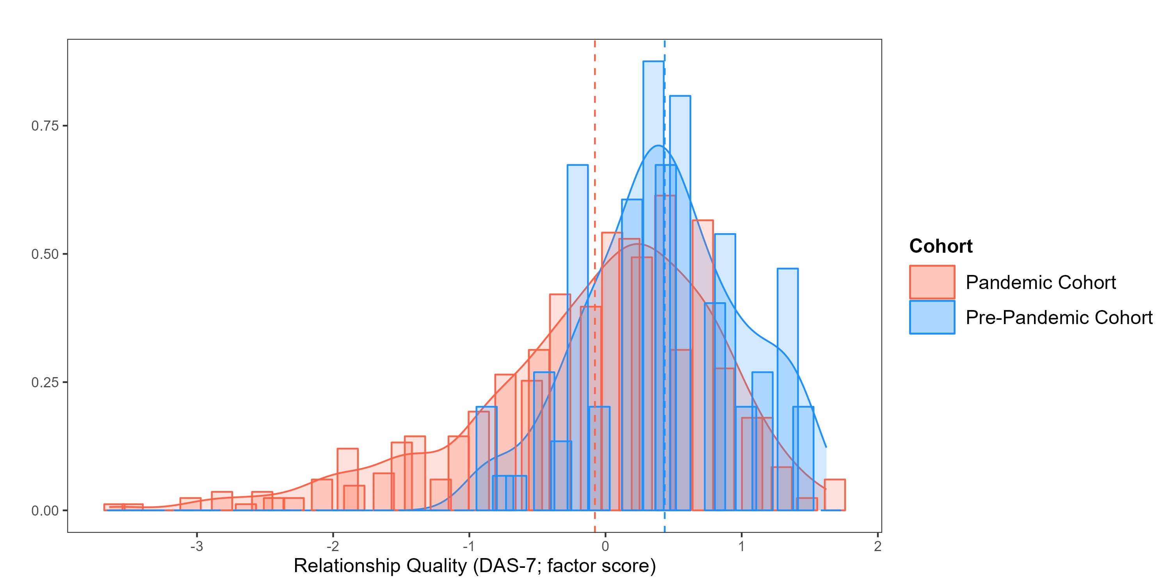
Note. Standardized factor scores of relationship quality are plotted with a mean of zero. Mean factor scores for each group are depicted as vertical dotted lines. Relationship quality was significantly higher in the pre-pandemic cohort, t(196.62) = 7.38, p < .001.

Figure S2. Marginal trajectory with the addition of the Diggle-Kenward component
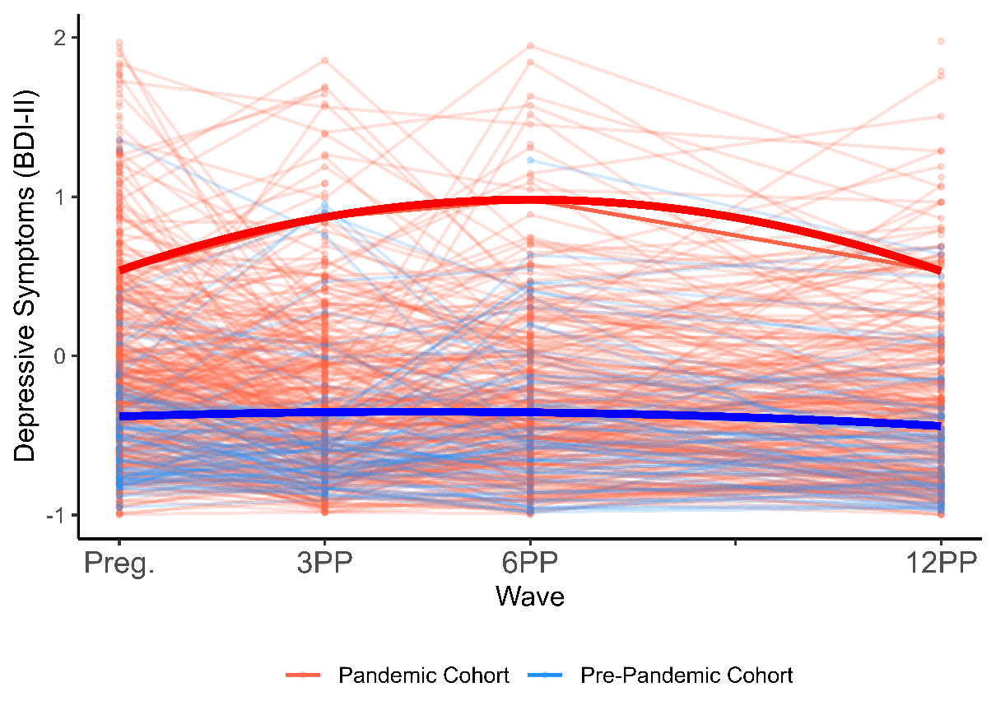
Note. This plot replicates the model depicted in Figure 2 with the addition of the Diggle-Kenward component to account for the correlation between missingness and participants’ depressive symptoms at the current (t) and prior timepoint (t – 1). Plots include the model-implied marginal fit for each group in bolded red and blue lines, respectively. Marginal fits are conditional on mothers’ age, ethnic/racial minority status, number of weeks pregnant, and education (see Table 3, Model 2, α1 – α3). Empirical data for each cohort are displayed in the background using transparent lines. BDI-II = Beck Depression Inventory-II standardized factor scores centered at zero; Pandemic cohort (n = 615 mothers); Pre-pandemic cohort (n = 99 mothers); Preg., 3PP, 6PP, and 12PP = prenatal, three-, six-, and twelve-month waves, respectively.

References
Carey, M. P., Spector, I. P., Lantinga, L. J., & Krauss, D. J. (1993). Reliability of the dyadic adjustment scale. Psychological Assessment, 5(2), 238.
Cheung, G. W. & Rensvold, R. B. (2002). Evaluating goodness-of-fit indexes for testing measurement invariance. Structural Equation Modeling, 9(2), 233-255.
Diallo, T. M., Morin, A. J., & Lu, H. (2016). Impact of misspecifications of the latent variance–covariance and residual matrices on the class enumeration accuracy of growth mixture models. Structural Equation Modeling, 23, 507–531. https://doi.org/10.1080/10705511.2016.1169188
Diggle, P. J., Heagerty, P., Liang, K.Y., & Zeger, S. L. (2002). Analysis of longitudinal data (2nd). New York, NY: Oxford University Press.
Diggle, P. J. & Kenward, M. G. (1994). Informative drop-out in longitudinal data analysis. Applied Statistics, 43(1), 49-73.
Graham, J. M., Liu, Y. J., & Jeziorski, J. L. (2006). The dyadic adjustment scale: A reliability generalization meta‐analysis. Journal of marriage and family, 68(3), 701-717.
Hunsley, J., Best, M., Lefebvre, M., & Vito, D. (2001). The seven-item short form of the Dyadic Adjustment Scale: Further evidence for construct validity. American Journal of family therapy, 29(4), 325-335.
Jennrich, R. I., & Schluchter, M. D. (1986). Unbalanced repeated-measures models with structured covariance matrices. Biometrics, 805-820.
Kang, Y., McNeish, D. M., & Hancock, G. R. (2016). The role of measurement quality on practical guidelines for assessing measurement and structural invariance. Educational and Psychological Measurement, 76(4), 533-561. doi: 10.1177/0013164415603764
León, G., Waizman, Y., Aviv, E., & Saxbe, D. (2025, January 15). Impact of the COVID-19 pandemic-related lockdowns, disruptions in social connection, and loneliness on depressive symptom trajectories across the transition to motherhood. Retrieved from osf.io/bsdak
Liu, M., & Hancock, G. R. (2014). Unrestricted mixture models for class identification in growth mixture modeling. Educational and Psychological Measurement, 74, 557–584. https://doi.org/10.1177/0013164413519798
McNeish, D. M. (2024). Missing not at random intensive longitudinal data: Diggle-Kenward selection for dynamic structural equation models. Preprint from PsyArXiv. https://doi.org/10.31234/osf.io/h3er7
McNeish, D., & Harring, J. (2020). Covariance pattern mixture models: Eliminating random effects to improve convergence and performance. Behavior Research Methods, 52, 947-979.
McNeish, D., & Wolf, M. G. (2020). Thinking twice about sum scores. Behavior Research Methods, 52(6), 2287–2305. https://doi.org/10.3758/s13428-020-01398-0
R Core Team (2024). R: A language and environment for statistical computing. R Foundation for Statistical Computing, Vienna, Austria. https://www.R-project.org
Rosseel, Y. (2012). lavaan: An R Package for Structural Equation Modeling. Journal of Statistical Software, 48(2). https://doi.org/10.18637/jss.v048.i02
Sabourin, S., Valois, P., & Lussier, Y. (2005). Development and validation of a brief version of the dyadic adjustment scale with a nonparametric item analysis model. Psychological assessment, 17(1), 15-27. DOI: 10.1037/1040-3590.17.1.15
Sharpley, C. F., & Rogers, H. J. (1984). Preliminary validation of the abbreviated Spanier Dyadic Adjustment Scale: Some psychometric data regarding a screening test of marital adjustment. Educational and Psychological Measurement, 44, 1045–1049. doi:10.1177/0013164484444029
Spanier, G. B. (1976). Measuring dyadic adjustment: New scales for assessing the quality of marriage and similar dyads. Journal of Marriage and the Family, 38(1), 15. https://doi.org/10.2307/350547

