Supplemental Materials for
A Matter of Timing? Effects of Parent-Adolescent Conflict on Adolescent Negative Affect and Depressive Symptoms on Six Timescales

Anne Bülow¹, Savannah Boele¹, Jessica P. Lougheed², Jaap J. A. Denissen³, Eeske van Roekel⁴, & Loes Keijsers¹
¹ Department of Psychology, Education & Child Studies, Erasmus University Rotterdam
² Department of Psychology, University of British Columbia Okanagan
³ Department of Developmental Psychology, Utrecht University
⁴ Department of Developmental Psychology, Tilburg University

Author Note
Anne Bülow https://orcid.org/0000-0003-3335-7447
Savannah Boele https://orcid.org/0000-0003-2821-1312
Jessica P. Lougheed https://orcid.org/0000-0001-8645-9493
Jaap J. A. Denissen https://orcid.org/0000-0002-6282-4107
Eeske van Roekel https://orcid.org/0000-0002-0829-8089
Loes Keijsers https://orcid.org/0000-0001-8580-6000
Table of Contents
Literature Overview 3
MPLUS Syntax 4
Exploratory Analysis 5
References 17

Literature Overview
Table S1
Overview of previous studies on within-family associations between parental warmth and adolescent ill-being – ordered per timescale
Study | Design |  |  |  |  | Association
 | Time interval | N | t | Age (T1) | Ill-being | Concurrent | Lagged | Lagged (revere)
(Bülow et al., 2022) | 3 hours | 124 | 55 | 15.80 | negative affect | pos | pos | ns
(Bai et al., 2017; Reynolds et al., 2016; Robles et al., 2016) | 1 day | 47 | 56 | 11.28 | negative affect | pos/pos
(Chiang et al., 2023, 2024) | 1 day | 163 | 10 | 12.79 | negative affect | pos (pos)
(Chung et al., 2009) | 1 day | 415 | 14 | 14.9/17.8 | negative affect | pos/pos
(Timmons & Margolin, 2015) | 1 day | 106 | 14 | 15.4 | negative affect | pos/pos (pos/pos) | ns | ns
(Fosco & Lydon-Staley, 2020) | 1 day | 151 | 21 | 14.60 | 1. depressed mood  2. angry mood  3. anxious mood | 1. pos(ns)  2. pos(pos)  3. pos(ns)
(Mastrotheodoros et al., 2020)ª | 1 day | 443 | 5 | 13.02 | 1. sadness  2. anger | 1. pos  2. pos | 1. pos  2. pos | 1. pos  2. pos
(Silva et al., 2020) | 1 day | 120 | 7 | 14.36 | negative affect | pos/pos
(LoBraico et al., 2019) | 1 day | 151 | 21 | 14.60 | anger |  | pos(ns) | ns(ns)
(Arslan et al., 2024) | 3 months | 244 | 3 | 13.8 | negative affect | pos/pos | ns/ns | pos/pos
(Zhang et al., 2018) | 6 months | 1126 | 4 | 14.0 | depressive mood | pos
(Mastrotheodoros et al., 2020) ª | 1 year | 443 | 5 | 13.02 | 1. sadness  2. anger | 1. pos  2. pos | 1. pos  2. ns | 1. pos  2. pos
(Lougheed et al., 2022) | 1 year | 1026 | 4 | 3rd grade | Internalizing problems | pos | ns | ns
Note. Lagged Associations: association from conflict (t) to subsequent ill-being (t+1), Lagged reversed: association from ill-being (t) to conflict (t+1). Ns = non-significant, pos = positive significant association. Associations in brackets depict parent reported conflict. Associations divided with a slash represent conflict reported separately for mothers and fathers.

MPLUS Syntax
TITLE: MULTILEVEL STRUCTURE EQUATION MODEL ML-VAR;

DATA:
FILE = DATA.dat; !Name Datafile, Variables are previously aggregated to timescale of investigation and lagged

VARIABLE:
NAMES = ID time X Y X_lag Y_lag; !Y_lag= Y(t-1)! All variable names in datafile
USEVARIABLE = X Y X_lag Y_lag; ! Variables used for this analysis
CLUSTER = ID; ! Define Participant Identifier
MISSING ALL(999); ! Define missings

ANALYSIS:
TYPE = TWOLEVEL; !Two-level model

MODEL:
%WITHIN% !within-family component of the model
!auto-regressive effects
X ON X_lag;
Y ON Y_lag;

!cross-lagged effects
X ON Y_lag; ! Y(t-1) -> X(t)
Y ON X_lag; ! X(t-1) -> Y(t)

!T1 correlation
X WITH Y;

!correlated change
X_lag WITH Y_lag;

%BETWEEN% !between-family component of the model
!person mean centered with latent mean
[X Y X_lag Y_lag];

!Correlation Random Intercepts
X with Y;

OUTPUT: SAMPSTAT STDYX TECH1 TECH3 TECH4 TECH8 ;

Exploratory Analysis
Differences Across Timescales
Table S2
Differences in cross lagged associations of Ill-being with next moments Conflict across Timescales
 | Parameter |  |  | Differences between parameters Δβ (Z)
 | β | SE |  | 1 | 2 | 3 | 4 | 5 | 6 | 7
Study 1
1 Daily | .01 | 0.01 |  | -
2 Weekly | .07 | 0.03 |  | .06 (1.89) | -
3 Biweekly | .10 | 0.06 |  | .09 (1.48) | .03 (.44) | -
Study 2
4 Biweekly | .08 | 0.02 |  | .07 (3.13) | .01 (0.28) | .02 (0.32) | -
5 Monthly | .03 | 0.03 |  | .02 (0.63) | .04 (0.94) | .07 (1.04) | .05 (1.39) | -
6 Bimonthly | -.02 | 0.05 |  | .03 (0.59) | .09 (1.54) | .12 (1.54) | .10 (1.86) | .05 (0.86) | -
7 Three-monthly | -.02 | 0.08 |  | .03 (0.37) | .09 (1.05) | .12 (1.20) | .10 (1.21) | .05 (0.59) | .00 (0.00) | -
Note. Bold values indicate significant parameters or differences. Z> 1.96 is significant at p>.05
Table S3
Differences in concurrent associations of Conflict with Ill-being across Timescales
 | Parameter |  |  | Differences between parameters Δr (Z)
 | r | SE |  | 1 | 2 | 3 | 4 | 5 | 6 | 7
Study 1
1 Daily | .25 | 0.02 |  | -
2 Weekly | .26 | 0.03 |  | .01 (0.28) | -
3 Biweekly | .24 | 0.06 |  | .01 (0.16) | .02 (0.38) | -
Study 2
4 Biweekly | .19 | 0.02 |  | .06 (2.68) | .07 (2.21) | .05 (0.82) | -
5 Monthly | .29 | 0.04 |  | .04 (0.89) | .03 (0.60) | .03 (0.69) | .10 (2.43) | -
6 Bimonthly | .37 | 0.05 |  | .12 (2.23) | .11 (1.89) | .11 (1.66) | .18 (3.53) | .08 (1.25) | -
7 Three-monthly | .45 | 0.06 |  | .20 (0.03) | .19 (0.03) | .21 (0.03) | .26 (.04) | .16 (0.03) | .08 (0.01) | -
Note. Bold values indicate significant parameters or differences. Z> 1.96 is significant at p>.05
Multi-informant Models
In both studies also parents reported on conflicts they had with their participating child.
Method
Study 1 (Daily Diary). In Study 2, 159 parents reported on 100 consecutive days about their conflict with their adolescent child. Most parents were biological mothers (79%). Other parents were biological fathers (19%) or another caregiver (n = 1 adoption mother, n = 1 second mother, n = 1 stepfather). The average age of the parents was 45.34 years (SD = 4.54, range = 33 years). Regarding educational attainment, 62% of parents reported having higher education (a college or university degree), 25% had medium-level education (vocational or technical training), and 10% reported lower education (a high school diploma). An additional 3% provided insufficient information for classification. Most parents (87%) were born in the Netherlands, while others were born in different regions: 6% in other European countries, 3% in Asia, and 1% each in North America, South America, Africa, and Australia.
Study 2 (Meso-longitudinal Study). In Study 2, 177 parents reported at 26 bi-weekly measurements on their conflict with their adolescent child. Parents were biological mothers (82%) or biological fathers (18%). The average age of the parents was 46.88 years (SD = 5.12, range = 47 years). Regarding educational attainment, 51% of parents reported having higher education (a college or university degree), 34% had medium-level education (vocational or technical training), and 12% reported lower education (a high school diploma). One parent completed primary education, and one parent did not disclose their educational attainment. Most parents (90%) were born in the Netherlands, while others were born in different regions: 4% in other European countries, 2% Africa and 1% in Asia. Three precent did not disclose their birth country.
Result
Table S4 depicts the descriptive statistics of the parent-reported conflict. Parent-reported conflict correlated strongly with adolescent-reported data on the between family level (Study 1: r = .42; Study 2 r = .49) and the within-family level (Study 1: r = .36; Study 2 r = .23). Identical ML-SEM models as in the main analysis were re-run with the parent-reported conflict and adolescent-reported ill-being. In Study 1, conflict did not predict negative affect at any timescale (see Table S5). Conversely, negative affect predicted conflict the following week (β = .05, a small effect) but not the next day or two weeks later. Therefore, the result pattern as with the adolescent-reported data was replicated. In Study 2, conflict did not predict depressive symptoms at any timescale, nor did depressive symptoms predict conflict (see Table S6). The parent-reported conflict did not replicate the effects of adolescent-reported conflict on depressive symptoms on a monthly and three-monthly timescale, nor the biweekly effect of depressive symptoms on adolescent-reported conflict.
We compared lagged effects across models, as depicted in Figure S1. Comparing models within the same study and between studies did not reveal significant differences in effect size of the lagged effect between conflict and next moments ill-being (see Table S7).

Table S4
Descriptive Statistics for Parent reported Conflict
 | M | SD | Range | ICC | observations | t_{mean} | N
Daily (Study 1) | 7.61 | 12.46 | 0.00 – 100.00 | .34 | 14,696 | 92 | 159
Weekly (Study 1) | 7.71 | 8.89 | 0.00 – 72.40 | .67 | 2,203 | 14 | 159
Biweekly (Study 1) | 7.73 | 8.27 | 0.00 – 48.00 | .78 | 1,105 | 7 | 159
Biweekly (Study 2) | 1.95 | 0.73 | 1.00 – 5.00 | .69 | 3,900 | 22 | 177
Monthly (Study 2) | 1.95 | 0.69 | 1.00 – 5.00 | .75 | 2,015 | 11 | 177
Bimonthly (Study 2) | 1.96 | 0.66 | 1.00 – 4.17 | .81 | 955 | 5 | 177
Three-monthly (Study 2) | 1.96 | 0.65 | 1.00 – 4.00 | .86 | 649 | 4 | 177
Note. ICC = intraclass correlation coefficient (percentage of variance due to between-family differences), t_{mean} = average number of assessments per person, N = number of participants

Table S5
Standardized Model Results Study 1 (100 days diaries)
 |  | Daily |  |  |  | Weekly |  |  |  | Biweekly
 |  | β/r | SE | p |  | β/r | SE | p |  | β/r | SE | p
Within-family
Conflict(t) -> Negative Affect (t+1) [H1] |  | .00 | 0.01 | .883 |  | -.03 | 0.03 | .316 |  | .01 | 0.06 | .859
Negative Affect (t) -> Conflict (t+1) |  | .00 | 0.01 | .661 |  | .05 | .02 | .032 |  | .00 | 0.05 | .962
Conflict(t) & Negative Affect (t) |  | .13 | .02 | .000 |  | .09 | .02 | .000 |  | .14 | .03 | .000
Conflict(t) -> Conflict(t+1) |  | .15 | 0.02 | .000 |  | .08 | .04 | .045 |  | .08 | .06 | .232
Negative Affect (t) -> Negative Affect (t+1) |  | .26 | 0.02 | .000 |  | .27 | .06 | .000 |  | .23 | .07 | .000
Between-family
Conflict & Negative Affect |  | .14 | 0.08 | .099 |  | .13 | 0.08 | .115 |  | .13 | 0.08 | .127
Note. Bold values indicate significant parameters.

Table S6
Standardized Model Results Study 2 (26 biweekly assessments)
 |  | Biweekly |  |  |  | Monthly |  |  |  | Bimonthly |  |  |  | Three-monthly
 |  | β/r | SE | p |  | β/r | SE | p |  | β/r | SE | p |  | β/r | SE | p
Within-family
Conflict(t) -> Depressive Symptoms (t+1) [H1] |  | .00 | 0.02 | .814 |  | .05 | 0.03 | .059 |  | .05 | 0.04 | .140 |  | .02 | 0.06 | .733
Depressive Symptoms (t) -> Conflict (t+1) |  | .04 | 0.03 | .125 |  | .06 | 0.03 | .055 |  | .03 | 0.06 | .634 |  | .08 | 0.06 | .206
Conflict(t) & Depressive Symptoms (t) |  | .10 | 0.03 | .000 |  | .07 | 0.03 | .019 |  | .12 | 0.04 | .003 |  | .15 | 0.05 | .005
Conflict(t) -> Conflict(t+1) |  | .26 | 0.03 | .000 |  | .23 | 0.04 | .000 |  | .12 | 0.05 | .019 |  | -.02 | 0.05 | .646
Depressive Symptoms(t) -> Depressive Symptoms(t+1) |  | .42 | 0.05 | .000 |  | .42 | 0.05 | .000 |  | .25 | 0.09 | .005 |  | .14 | 0.12 | .241
Between-family
Conflict & Depressive Symptoms |  | .23 | 0.08 | .004 |  | .24 | 0.08 | .003 |  | .25 | 0.08 | .003 |  | .24 | 0.09 | .004
Note. Bold values indicate significant parameters.

Table S7
Differences in cross lagged associations of Conflict with next moments Ill-being across Timescales (H2)
 | Parameter |  |  |  | Differences between parameters Δβ (Z)
 | β | SE | CI |  | 1 | 2 | 3 | 4 | 5 | 6 | 7
Study 1
1 Daily | .00 | 0.01 | [-.02; .02] |  | -
2 Weekly | -.03 | 0.03 | [-.09; .03] |  | .03 (0.95) | -
3 Biweekly | .01 | 0.06 | [-.11;.13] |  | .01 (0.16) | .04 (0.60) | -
Study 2
4 Biweekly | .00 | 0.02 | [-.04;.04] |  | .00 (0.00) | .03 (.83) | .01 (0.16) | -
5 Monthly | .05 | 0.03 | [-.01;.11] |  | .05 (1.58) | .08 (1.89) | .04 (1.60) | .05 (1.39) | -
6 Bimonthly | .05 | 0.04 | [-.03;.13] |  | .05 (1.21) | .08 (1.60) | .04 (0.55) | .05 (1.12) | .00 (0.00) | -
7 Three-monthly | .02 | 0.06 | [-.10;.14] |  | .02 (0.33) | .05 (0.75) | .01 (0.12) | .02 (0.32) | .03 (0.44) | .03 (0.42) | -
Note. Bold values indicate significant parameters or differences. β = standardized lagged associations (STDXY standardization); CI = Confidence Interval; Z> 1.96 is significant at p>.05
Figure S1
Associations between parent-reported conflict and ill-being across different timescales
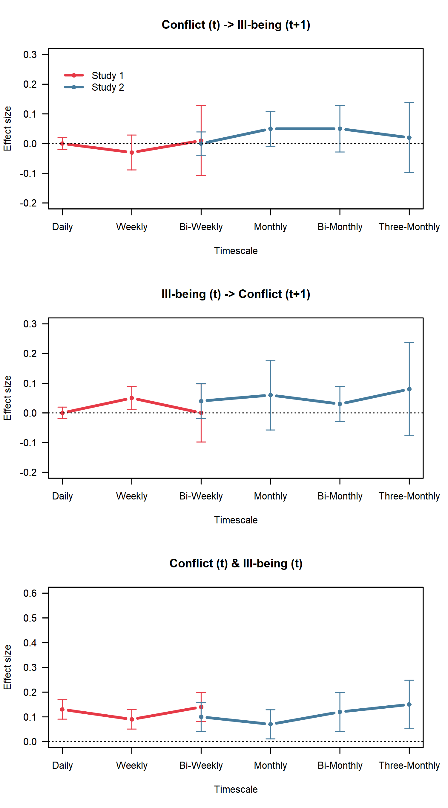
Discussion
When comparing the result pattern between adolescent-reported conflict and parent-reported conflict, similarities and differences can be noted. Results seem similar in the effect sign of effect (mostly positive associations), and for the relationship between ill-being and later conflict, the weekly effect could be replicated with independent reporters, strengthening this conclusion – suggesting it is not only in the eye of the adolescent beholder. Results diverge in the effect size (especially correlated residuals are smaller in size) which might one the one hand be explained by differences in perception. It is to be expected that adolescents’ perceptions of conflict should be more strongly associated with the impact on their ill-being. In terms of the significance, fewer parents in Study 2 participated, which decreased the power to find significant effects. Taking these considerations into account we conclude that the result pattern replicates well across informants.
Models with Random Effects
Families might differ on the extent to which conflict is associated with subsequent ill-being and vice versa. To account for this potential heterogeneity between families, we ran models with random effects. We did so for the daily and weekly models for Study 1 as well as the biweekly and monthly models for Study 2. The monthly model did not converge.
Inspecting the random slopes revealed substantial variance in all models (Bolger et al., 2019), indicating that families vary substantially in the extend how conflict is associated with ill-being and vice versa (see Table S8 and Figure S2).
When comparing the ML-SEM models from the main analysis with these DSEM models with random effects, effect sizes seem comparable, but two effects of conflict on subsequent ill-being reached significance in the models with random effects, which were not significant in the main analysis. While the daily model’s effect size (β = .02) is below our preregistered smallest effect size of interest (SESOI = .03), only the biweekly effect (β = .05) is interpreted as a meaningful effect. Therefore, we conclude that results replicated well between both model specifications (5/6 effects, 83%).

Table S8
Effect Heterogeneity
 | b | β | Var | √𝑉𝑎𝑟/𝑏 | 100% HI
Conflict -> Ill-being
Daily | 0.02 | .02 | 0.01 | 3.21 | [-.09; .22]
Weekly | 0.01 | .01 | 0.03 | 12.58 | [-.44; .24]
Biweekly | 0.03 | .05 | 0.02 | 3.60 | [-.22; .54]
Ill-being -> Conflict
Daily | 0.02 | .02 | 0.01 | 4.67 | [-0.13; .15]
Weekly | 0.10 | .12 | 0.02 | 1.47 | [-0.14; .94]
Biweekly | 0.15 | .10 | 0.14 | 2.50 | [-0.68; .63]
Note. b = unstandardized estimate, bold estimates indicate significant estimates, β = standardized effect, Var = Variance, √𝑉𝑎𝑟/𝑏 = value >0.25 is the criterium for a significant variance (Bolger et al., 2019) indicated in bold, 100% HI = 100% heterogeneity interval, that is range of family-specific effects.
Figure S2
Distribution of family-specific effects
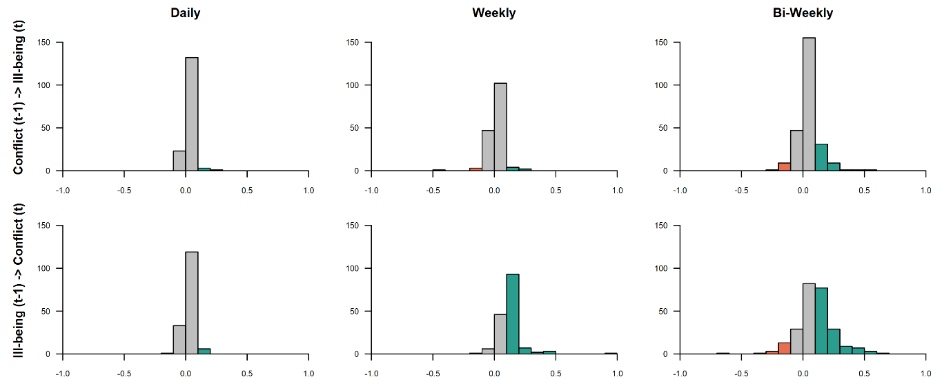

References
Arslan, İ. B., Boele, S., Dietvorst, E., Lucassen, N., & Keijsers, L. (2024). Within-family associations of parent–adolescent relationship quality and adolescent affective well-being. Journal of Adolescence, January, 1–17. https://doi.org/10.1002/jad.12299
Bai, S., Reynolds, B. M., Robles, T. F., & Repetti, R. L. (2017). Daily links between school problems and youth perceptions of interactions with parents: A diary study of school‐to‐home spillover. Social Development, 26, 813–830. https://doi.org/10.111/sode.12229
Bolger, N., Zee, K. S., Rossignac-Milon, M., & Hassin, R. R. (2019). Causal processes in psychology are heterogeneous. Journal of Experimental Psychology: General, 148(4), 601–618. https://doi.org/10.1037/xge0000558
Bülow, A., Van Roekel, E., Boele, S., Denissen, J., & Keijsers, L. (2022). Parent-adolescent interaction quality and adolescent affect - an experience sampling study on effect heterogeneity. Child Development, 93(3), 315–331. https://doi.org/https://doi.org/10.1111/cdev.13733
Chiang, S. C., Chen, W. C., & Liu, T. H. (2023). Emotional Reactivity to Daily Family Conflicts: Testing the Within-Person Sensitization. Journal of Research on Adolescence, 33(1), 361–368. https://doi.org/10.1111/jora.12802
Chiang, S. C., Ting, S. J., Hung, Y. F., Sung, Y. H., & Chen, W. C. (2024). The Role of Family Conflict and School Problems in Adolescent Emotion Dynamics. Journal of Child and Family Studies, 33(3), 877–887. https://doi.org/10.1007/s10826-024-02797-z
Chung, G. H., Flook, L., & Fuligni, A. J. (2009). Daily family conflict and emotional distress among adolescents from Latin American, Asian, and European backgrounds. Developmental Psychology, 45, 1406–1415. https://doi.org/https://doi.org/10.1037/a0014163
Fosco, G. M., & Lydon-Staley, D. M. (2020). Implications of family cohesion and conflict for adolescent mood and well-being: Examining within- and between-family processes on a daily timescale. Family Process, 59(4), 1672–1689. https://doi.org/doi: 10.1111/famp.12515
LoBraico, E. J., Brinberg, M., Ram, N., & Fosco, G. M. (2019). Exploring processes in day-to-day parent–adolescent conflict and angry mood: Evidence for circular causality. Family Process, 59, 1–16. https://doi.org/10.1111/famp.12506
Lougheed, J. P., Duncan, R. J., Keskin, G., & Marceau, K. (2022). Longitudinal associations between mother-child conflict and child internalizing problems in mid-childhood. Development and Psychopathology, 34(1), 263–272. https://doi.org/10.1017/S0954579420000863
Mastrotheodoros, S., Van Lissa, C. J., Van der Graaff, J., Dekovic, M., Meeus, W. H. J., & Branje, S. J. T. (2020). Day-to-day spillover and long-term transmission of interparental conflict to adolescent-mother conflict: The role of mood. Journal of Family Psychology, 34(8), 893–904. https://doi.org/10.1037/fam0000649
Reynolds, B. M., Robles, T. F., & Repetti, R. L. (2016). Measurement reactivity and fatigue effects in daily diary research with families. Developmental Psychology, 52(3), 442–456. https://doi.org/10.1037/dev0000081
Robles, T. F., Carroll, J. E., Bai, S., Reynolds, B. M., Esquivel, S., & Repetti, R. L. (2016). Emotions and family interactions in childhood: Associations with leukocyte telomere length emotions, family interactions, and telomere length. Psychoneuroendocrinology, 63, 343–350. https://doi.org/10.1016/j.psyneuen.2015.10.018
Silva, K., Ford, C. A., & Miller, V. (2020). Daily parent-teen conflict and parent and adolescent well-being: The moderating role of daily and person-level warmth. Journal of Youth and Adolescence, 49(8), 1601–1616. https://doi.org/https://dx.doi.org/10.1007/s10964-020-01251-9
Timmons, A. C., & Margolin, G. (2015). Family conflict, mood, and adolescents’ daily school problems: Moderating roles of internalizing and externalizing symptoms. Child Development, 86, 241–258. https://doi.org/10.1111/cdev.12300
Zhang, S., Baams, L., van de Bongardt, D., & Dubas, J. S. (2018). Intra- and inter-individual differences in adolescent depressive mood: The role of relationships with parents and friends. Journal of Abnormal Child Psychology, 46(4), 811–824. https://doi.org/10.1007/s10802-017-0321-6

