Supplemental Table 1. Expanded Patient Demographics and Match Statistics

 | Pandemic-Exposed OUD | Pre-Pandemic OUD | SMD
N | 53,803 | 53,803
Urban (vs rural) | 73% | 73% | 0.002
Men | 93% | 93% | < 0.001
Age |  |  | < 0.001
18 – 29 | 4.1% | 4.1%
30 – 39 | 18.1% | 18.1%
40 – 49 | 11.7% | 11.7%
50 – 64 | 39.5% | 39.5%
65+ | 26.6% | 26.6%
Race |  |  | 0.063
White | 70.5% | 68.0%
Black | 19.2% | 21.7%
Hispanic/Latino | 5.0% | 5.0%
Asian | 0.2% | 0.2%
American Indian/Alaskan Native | 0.6% | 0.6%
Native Hawaiian/Pacific Islander | 0.4% | 0.4%
Multiple | 0.7% | 0.7%
Unknown | 3.5% | 3.5%
Patient State |  |  | < 0.001
Alaska | 0.2% | 0.2%
Alabama | 1.9% | 1.9%
Arkansas | 1.3% | 1.3%
Arizona | 1.6% | 1.6%
California | 8.2% | 8.2%
Colorado | 1.4% | 1.4%
Connecticut | 1.3% | 1.3%
Washington D.C.¹ | 0.4% | 0.4%
Deleware | 0.2% | 0.2%
Florida | 8.5% | 8.5%
Georgia | 2.4% | 2.4%
Hawaii | 0.3% | 0.3%
Iowa | 0.6% | 0.6%
Idaho | 0.8% | 0.8%
Illinois | 3.1% | 3.1%
Indiana | 2.1% | 2.1%
Kansas | 0.9% | 0.9%
Kentucky | 2.3% | 2.3%
Louisiana | 1.6% | 1.6%
Massachusetts | 2.4% | 2.4%
Maryland | 2.0% | 2.0%
Maine | 0.7% | 0.7%
Michigan | 3.0% | 3.0%
Minnesota | 1.3% | 1.3%
Missouri | 2.4% | 2.4%
Mississippi | 0.7% | 0.7%
Montana | 0.5% | 0.5%
North Carolina | 3.2% | 3.2%
North Dakota | 0.2% | 0.2%
Nebraska | 0.5% | 0.5%
New Hampshire | 0.5% | 0.5%
New Jersey | 1.7% | 1.7%
New Mexico | 1.1% | 1.1%
Nevada | 1.9% | 1.9%
New York | 4.1% | 4.1%
Ohio | 4.7% | 4.7%
Oklahoma | 1.5% | 1.5%
Oregon | 2.3% | 2.3%
Other¹ | 0.0% | 0.0%
Pennsylvania | 5.5% | 5.5%
Puerto Rico¹ | 0.4% | 0.4%
Rhode Island | 0.2% | 0.2%
South Carolina | 1.3% | 1.3%
South Dakota | 0.2% | 0.2%
Tennessee | 3.2% | 3.2%
Texas | 5.6% | 5.6%
Utah | 1.0% | 1.0%
Virginia | 2.8% | 2.8%
Vermont | 0.2% | 0.2%
Washington | 2.5% | 2.5%
Wisconsin | 1.8% | 1.8%
West Virginia | 1.6% | 1.6%
Wyoming | 0.3% | 0.3%
Psychiatric Diagnosis Groups (PDG)² | 2.83(2.13) | 2.95(2.10) | 0.058
Charlson Comorbidity Index (CCI)² | 1.90(2.79) | 2.11(2.91) | 0.071
Note. SMD – Standardized mean difference
¹Non-state territories, including Washington D.C., Puerto Rico, and other non-classified states (n = 8 per group).
²Non-match variable. Included here for descriptive purposes and to demonstrate balance despite lack of inclusion in the match.

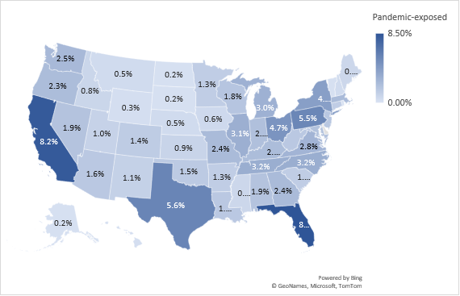
Supplemental Figure 1a. Distribution of Veterans in Across the United States in the Pandemic-Exposed Cohort

Supplemental Figure 1b. Distribution of Veterans in Across the United States in the Pandemic-Exposed Cohort

