Accurately assessing the overlap of personality traits and psychopathology using multi-informant data: Two sides of the same coin?
Supplementary Material 1
- Sample composition
We used data from the Estonian Biobank (EstBB). EstBB is an open cohort and at the time of the Personality Study (PS) and Mental Health Online Survey (MHoS) data collections, more than 200 000 participants had joined EstBB, representing nearly 20% of adults in Estonia (Milani et al., 2024; Ojalo et al., 2024). For both PS and MHoS, participants were recruited by sending personal invitations to all living EstBB participants with valid e-mail addresses and the studies were widely advertised among the public.
Our sample size was determined by the number of participants in the PS and MHoS studies, yielding sufficient statistical power to estimate associations. Out of all EstBB participants, more than 80 000 took part in the online survey-based PS between November 2021 and April 2022. As a baseline, our study sample had N = 80 116 participants with self-reported personality data. Here we only included data from participants who responded in Estonian (n = 76 158). We opted against including data from participants who responded in Russian, since this subsample would have been too small for independent analysis, and we wanted to avoid confounding effects. This sample was then filtered for participants who had invited an informant to complete surveys on their behalf (n = 20 926).
We then merged this dataset with psychopathology data collected via the online MHoS in March–July 2021, creating a sample of n = 16 319 participants. Finally, we removed participants with more than ten missing responses in either self- or informant-rated personality or mental health, arriving at a final sample size of n = 16 226 (see Supplementary Figure 1). Remaining missing values (< 10 per participant; 0.01% in self-rated and < 0.0001% in informant-rated data) were replaced by the median.
- Sample characteristics
In our analytic sample, participants with a higher education were over-represented, making up 69.99% (see more data in the main manuscript file, Table 1; post-secondary education includes post-high school vocational education). Similarly, 73.35% of participants were employed at a position that required complex problem-solving skills and expertise (ISCO 08 Skills 3 and 4). These biases are reflective of the entire MHoS cohort (Ojalo et al., 2024), and indicative of both biobank study compositions internationally (Stamatakis et al., 2021) and the higher proportion of university-educated women in the Estonian population.
To ensure our results were not impacted by this imbalance, we ran supplemental analyses on a stratified subsample (n = 7504) based on gender and education (with or without higher education). Participants were allocated randomly to similarly sized subgroups, where possible, with the aim of maximising use of existing data (3 out of the 4 groups have n = 2034 participants, due to men with lower education being underrepresented, the size of this subgroup was n = 1402; see also Supplementary Figure 1).
All analysis results for the stratified sample are presented in Supplementary Material 5. We found no qualitatively significant divergences in the stratified sample in comparison to the full sample.

Supplemetary Figure 1
Estonian Biobank participants included in the study
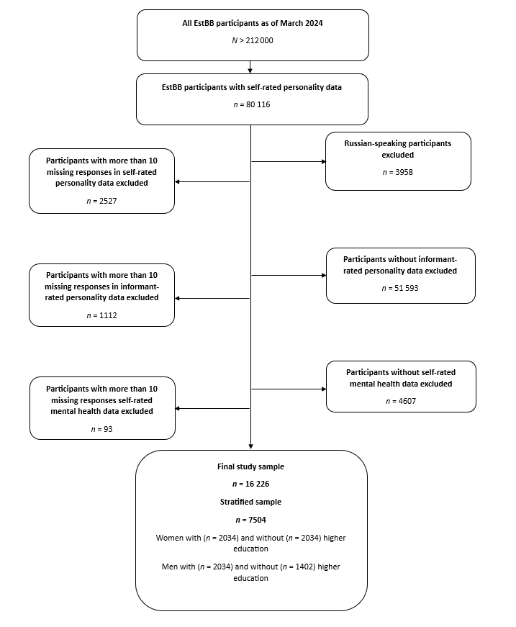

References
Milani, L., Alver, M., Laur, S., Reisberg, S., Haller, T., Aasmets, O., ... & Metspalu, A. (2024). From Biobanking to Personalized Medicine: the journey of the Estonian Biobank. medRxiv, 2024-09. https://doi.org/10.1101/2024.09.22.24313964
Ojalo, T., Haan, E., Kõiv, K., Kariis, H. M., Krebs, K., Uusberg, H., ... & Lehto, K. (2024). Cohort Profile Update: Mental Health Online Survey in the Estonian Biobank (EstBB MHoS). International Journal of Epidemiology, 53(2), dyae017.
Stamatakis, E., Owen, K. B., Shepherd, L., Drayton, B., Hamer, M., & Bauman, A. E. (2021). Is Cohort Representativeness Passé? Poststratified Associations of Lifestyle Risk Factors with Mortality in the UK Biobank. Epidemiology (Cambridge, Mass.), 32(2), 179–188. https://doi.org/10.1097/EDE.0000000000001316

