Supplementary Methods

Participants, study design and exclusion criteria
We combined the Autism Brain Imaging Data Exchange (ABIDE) repositories I (Di Martino et al., 2014) (http://fcon_1000.projects.nitrc.org/indi/abide/abide_I.html) and II (Di Martino et al., 2017) (http://fcon_1000.projects.nitrc.org/indi/abide/abide_II.html) for all the analyses conducted in the present study. ABIDE I includes in total 1112 participants (539 autism, 573 non-autistic individuals [NAI]) from 17 different sites, and ABIDE II includes 1114 participants (521 autism, 593 NAI) from 19 different sites, with ages ranging from 5 to 64 years. Institutional Review Board (IRB) approval to participate, or explicit waiver to provide fully anonymized data, was required prior to data contribution. All contributions were based on studies approved by local IRBs. For the autism group, autism diagnosis was determined by clinician’s consensus supported by either one or both ‘gold-standard’ diagnostic instruments, i.e., an Autism Diagnostic Observation Schedule (ADOS) (Lord et al., 2000) and/or the Autism Diagnostic Interview-Revised, (ADI-R) (Lord et al., 1994) in all sites but two (UCD and Stanford sites only used diagnostic cut-offs of ADOS and/or ADI-R for inclusion).

Sites with same/highly similar imaging acquisition protocols (as outlined and recommended on the website) were merged across ABIDE I and ABIDE II into one single site to increase sample sizes per site (i.e., KKI and ABIDEII-KKI; NYU and ABIDEII-NYU_1; SDSU and ABIDEII-SDSU; and UCLA_1 and ABIDEII-UCLA_1). Detailed information on imaging acquisition parameters can be found on the above websites.

For primary analyses, we excluded female participants due to scarce availability across sites (N autism=130, N NAI=280) and participants whose ADOS-Generic (ADOS-G) had not been administered by research-reliable personnel (as indicated in the phenotypic file; N autism=65). For the clustering analysis in autistic individuals (based on clinical scores), we further excluded participants with missing ADOS-G scores (N autism=348) and full-scale IQ (FIQ; N autism=55). This resulted in a sample of 499 autistic individuals who were included in the clustering analysis. For the normative modeling analysis (based on neuroimaging data), we further applied the following exclusion criteria: a) individuals who did not have available neuroimaging data (N autism=71, N NAI=37); b) participants who had low image quality as assessed by both visual inspection and the Euler number (N autism=15, N NAI=7). The Euler number is related to the number of holes in the reconstructed surface, and represents its complexity (Dale et al., 1999). In line with previous reports that also utilized ABIDE I and ABIDE II (Bethlehem et al., 2020), we excluded individuals with values smaller than -300; c) corrupted preprocessing, meaning e.g., participants with cortical thickness (CT) values of zero (N autism=4, N NAI=1); d) participants with missing FIQ values (as this was a covariate in the normative model, N autism=47, N NAI=66); and e) sites that contained less than ten individuals per diagnostic group to provide sufficient samples per sites and group for the training of the normative model (Bayer et al., 2022; Gaiser et al., 2023) (IP: autism N=11, NAI N=1; KUL: N autism=28; NYU_2: N autism=24; SBL autism: N=5; SDSU, N autism=1, N NAI=14). This resulted in a sample of 690 autistic and 744 non-autistic individuals between 5-64 years who were included in the normative modeling analysis. A flowchart depicting the selection process for each analytical step is visualized in Figure S1.

Model-based clustering
To identify clinically distinct subgroups in autism, we applied model-based clustering (Banerjee & Shan, 2011) to the three subscores of the Autism Diagnostic Observation Schedule Generic (ADOS-G) (Lord et al., 2000), i.e., social interaction, communication, and restricted and repetitive behaviours (RRBs). While different ADOS-versions (i.e., ADOS-G [N=622] and ADOS-2 [N=560]) are available in ABIDE, ADOS-G has higher numbers thus not further limiting sample size.

First, we z-standardized the three ADOS-G sub-scores to account for differences in scale between them. Unlike other studies that performed clustering analyses on non-residualized clinical measures (Bitsika et al., 2008; Cholemkery et al., 2016; Georgiades et al., 2013; Hu & Steinberg, 2009; Lefort-Besnard et al., 2020; Lombardo et al., 2016), here we explicitly made sure to account for confounding variables, such as age, acquisition site, FIQ, the ADOS-G module, and the other two subscores using a General Linear Model (GLM) (see 1-3). The ADOS-G module (i.e., in this case module 2-4) indicated the specific ADOS-G test used, which differs for age groups and the expressive language level of the participant (Lord et al., 2000). The residuals from the GLMs were used for the subsequent analyses.

1) ADOS $social interaction subscore \sim age+site+FIQ+ ADOS module+ADOS communication subscore+ADOS stereotyped behaviour subscore$

2) ADOS $communication subscore \sim age+site+IQ+ ADOS module+ADOS social interaction subscore+ ADOS stereotyped behaviour subscore$
3) ADOS $stereotyped behaviour subscore \sim age+site+IQ+ ADOS module+ADOS social interaction subscore+ ADOS communication subscore$

Next, we employed a model-based, unsupervised data-driven clustering method (Banerjee & Shan, 2011) to identify clinical subgroups in autistic individuals. In contrast to more traditional, heuristic-based clustering algorithms (such as e.g., k-means clustering) with hard cluster assignments, model-based clustering provides a probability and uncertainty for each cluster. It further has the benefit of also automatically identifying the optimal number of clusters by comparing a range of different Gaussian mixture models. Each mixture model consists of a unique covariance matrix with a specific geometric interpretation of the clusters. This covariance matrix determines the volume, shape and orientation of each cluster. Here, the volume is constrained to be equal (E) or vary (V) across clusters; the shape can be equal (E) or vary (V), or the clusters can be spherical (I); the orientation of the clusters can be equal (E), vary (V) or spherical (I). All combinations of these geographic shapes are tested. The optimal number of clusters and mixture model is determined according to the Bayesian Information Criterion (BIC). Here, we used the ’mclust’ package in Rstudio (version 2022.12.0+353) (Scrucca et al., 2016) where the density estimation is based on parameterized finite Gaussian mixture models which are estimated by EM algorithm initialized by hierarchical model-based agglomerative clustering. Further, to assess the stability of the clustering results, we performed bootstrapping with 10.000 iterations using the ‘fpc’ package in Rstudio (Tian et al., 2021). Stability was assessed with the Jaccard similarity index ranging between 0 and 1. A cluster can be considered stable if its mean score is greater than 0.75 (Hennig, 2007, 2008).

Finally, we tested for differences in subscores between the identified subgroups using Wilcoxon signed-rank tests. To avoid inflation of the Type I error rate (as in this case the null hypothesis is a function of the data) (Gao et al., 2022), we additionally used the ‘clusterpval’ package in RStudio with 10.000 draws to determine the significant differences in means between the clusters (Gao et al., 2022; Winter & Hahn, 2022).

Image processing and quality control
We processed the T1-weighted images from the ABIDE datasets using the FreeSurfer software (version 7.3.2) (Fischl, 2012). For the full pipeline and documentation, please refer to the following website: https://surfer.nmr.mgh.harvard.edu/. In brief, the FreeSurfer pipeline consists of intensity normalization, skull stripping and grey (GM) and white matter (WM) surface segmentation, resulting in a tessellated representation of the GM/WM boundary. The resulting surfaces were corrected for topological abnormalities and registered to a spherical atlas based on individual cortical folding patterns. CT was defined as the shortest distance between the vertices of the GM/WM boundary and the pial surface. CT was extracted for each individual using the Destrieux parcellation scheme consisting of 74 regions in each hemisphere (Destrieux et al., 2010). Participants who had low image quality as assessed by both visual inspection and the Euler number were excluded.

To label subcortical tissue classes, we further applied the volume-based stream. After affine registration with MNI305 space, initial volumetric labeling, B1 bias field intensity correction, a high dimensional nonlinear volumetric alignment to the MNI305 atlas was performed and the volume was labeled according to the ASEG atlas (Fischl et al., 2002).

Normative modeling
Normative modeling is a novel statistical framework that allows to compare individual neuroanatomical measures (i.e., CT and subcortical volumes) to a reference population on an individual basis (Marquand et al., 2016, 2019; Rutherford et al., 2022, 2023). This method yields coherent measures of predictive confidence in addition to point estimates, meaning we can predict both the expected CT and subcortical changes and the associated predictive uncertainty for each individual allowing us to quantify the regional deviation of CT and subcortical volume from the neurotypical range.

Here, we performed normative modelling using the PCNtoolkit (version 0.26) in Python (version 3.9.16). We used a 3-knot B-spline Bayesian Linear Regression (BLR) model with SinArcinh likelihood warping and Powell optimisation, allowing us to calculate error measures in a warped space and describe deviations under a Gaussian error distribution (Fraza et al., 2021; Rutherford et al., 2022). Included covariates in the normative model were age, site, FIQ, and the Euler number and also intracranial volume for the subcortical volume based normative modeling. The dataset was split into a training set consisting of 90% of NAI and a test set consisting of all autistic individuals and the remaining 10% of NAI. We also ensured that age, FIQ and site were evenly distributed across the training and test sets. A separate normative model was built for each of the 148 CT ROIs and 23 subcortical ROIs independently. Figure S3 depicts an example of a centile map and the model’s trajectory for the left occipital pole.

Next, we computed normative probability maps, which quantify the deviation of each participant from the normative model in each ROI. These subject-specific deviation Z-scores provide a statistical estimate of how much each individual’s true CT (subcortical) value differs from the predicted CT (subcortical) value with reference to the neurotypical pattern in each ROI. More specifically, this deviation score ($Xij$) is calculated for each subject ($i$) at each ROI ($j$) and is defined as the difference in true CT ($yij$) and predicted CT ($\hat{y}ij$) while accounting for the variance of the model ($σ_{nj}$) and the expected variance ($σ_{ij}$):

$$Zij= \frac{y_{ij}- {\hat{y}}_{ij}}{\sqrt{σ_{ij}^{2}+ σ_{nj}^{2}}}$$

Because we estimate a separate noise parameter for each ROI, this should accommodate regional differences in population variation (for example, the estimated variance parameter will be higher in the regions where there is greater variation across individuals). Also, the Bayesian statistical model takes various sources of uncertainty into account, automatically making inferences more conservative in regions where data are sparse.

To evaluate the model performance, we generated the standardised mean squared error (SMSE), explained variance (EV), mean standardised log loss (MSLL) and the Pearson correlation between true and predicted responses (Rho) based on the NAI from the test set, as seen in Figure S4.

Characterizing neuroanatomical homogeneity and heterogeneity
To further characterize the output from the normative model, normative probability maps (NPM) were thresholded at an absolute value of Z>|2.6| (i.e., P <0.005) (Floris et al., 2021; Segal et al., 2023; Wolfers et al., 2018, 2020). Based on this fixed threshold, we defined extreme positive and extreme negative deviations for each participant. Here, a positive deviation score indicated higher CT (subcortical) values compared to the reference model, and thus, a thicker cortex or increased subcortical volume. A negative deviation score indicated lower CT (subcortical) values compared to the reference model, and thus, a thinner cortex or reduced subcortical volume. To illustrate the heterogeneity in the entire autism group and the two clinical subgroups, we visualized the individual NPMs for the top ten participants with the highest deviation scores (see Figure S5). To assess whether clinical subgrouping has increased neuroanatomical homogeneity in autism, we generated spatial overlap maps separately for positive and negative deviations. This was done by summing up the number of extreme deviations in each ROI for each individual which were then divided by the total number of individuals (multiplied by 100) using the ‘nilearn’ package in Python for cortical thickness [Nilearn version: 0.10.1; Python version: 3.9.16] (Abraham et al., 2014) and the ggseg package for subcortical volume in Rstudio (Mowinckel & Vidal-Piñeiro, 2019). These spatial overlap maps represent the percentage of extreme positive and negative deviations per ROI (Floris et al., 2021; Wolfers et al., 2018). Regions with highest overlap depict where participants within each group (i.e., NAI, entire autism group, clinical subgroups) share common deviations and thus show a more consistent (homogenous) neuroanatomical signature (see Figure 2). We did this separately in the high-RRB subgroup, the low-RRB subgroup and the entire autism group which in this case was composed of the autistic individuals making up the high- and low-RRB groups and additionally those autistic individuals that had not been included in the clustering analysis (for reasons stated above). We then subtracted the entire autism group overlap map from the overlap maps of each autism subgroup to obtain overlap difference maps for each subgroup. Next, we permuted the group labels 10.000 times to derive a distribution of random overlap differences and computed for each ROI the p-values as the proportion of random values that exceed the real overlaps. Significant ROIs were corrected for multiple comparisons using FDR-correction (p_{FDR}<0.05, one-tailed). Given our hypothesis, that we expected increased homogeneity within subgroups, one-tailed tests were applied.

Sensitivity analysis

Analyses across both males and females

Model-based clustering
Given the importance of studying both autistic males and females, we conducted additional supplementary analyses where we considered both sexes. Due to the scarce availability of female datasets (i.e., 62 autistic females for clustering) and sample size recommendations for clustering analyses, we did not conduct sex-stratified analyses (Dolnicar et al., 2014; Sarstedt & Mooi, 2019), but ran model-based clustering jointly across autistic males and females. As in the main analyses based on males only, autistic females with non-reliable ADOS scores (N=4) and with missing data in the ADOS-G or FIQ were excluded (ADOS-G, N=65; FIQ, N=12). This resulted in a sample of 62 autistic females. Together with 499 autistic males, the total sample size for clustering was 561 individuals.

As in the main analyses, we aimed to identify distinct clinical subgroups using the ADOS-G subscores. Before the classification, the subscores were z-score standardised and confounding effects by age, sex, site, FIQ, ADOS-G module, and the other two subscores were accounted for by a GLM. The residuals from this GLM were used in subsequent analyses. We employed a model-based clustering method where the optimal number of clusters was determined according to the BIC. The stability of clusters was assessed by a bootstrapping test with 10.000 iterations, and we computed the JI. We tested the difference in subscores between the identified subgroups using Wilcoxon signed-rank tests in combination with the ‘clusterpval’ package with 10.000 draws to determine the significant differences in means between the clusters.

Normative modeling
For the normative modeling analysis (based on neuroimaging data), we applied the same exclusion criteria in autistic females as in autistic males previously: a) participants with lacking neuroimaging data (N autism=40, N NAI=15); b) low image quality (N autism=15, N NAI=7); c) corrupted preprocessing (N autism=4, N NAI=1); d) participants missing FIQ information (N autism=59, N NAI=94); and e) sites with less than ten individuals per diagnostic group (Bayer et al., 2022; Gaiser et al., 2023) (N autism=83, N NAI=77). This resulted in a sample of 790 autistic (690 males and 100 females) and 972 NAI (744 males and 228 females) between 5.22 - 54 years who were included in the normative modeling analysis.

All data for female participants were preprocessed with the same methods as for the males in the main analysis. A new normative model was created, including both males and females. This model included all covariates previously used for the main analysis. However, for this specific analysis, sex was added as a covariate in the model. For normative models based on subcortical volume, intracranial volume was added as an additional covariate. Next, as in the main analysis, deviation scores were derived for each participant. All following steps to test for neuroanatomical homogeneity are equivalent to those conducted in the main analysis.

Different subgrouping approaches
Given that identified subgroups differed in symptom severity on RRBs and communication subscores, we compared our data-driven, unsupervised clustering approach with a hypothesis-driven method to identify subgroups of individuals with high and low symptom severity. For this, we generated two new sets of subgroups by applying a median-split (MS) on a) the RRB subscores (MS group 1) and b) the communication subscores (MS group 2). This resulted in a) N=250 individuals in the high-RRB subgroup and N=249 individuals in the low-RRB subgroup in the MS group 1; and b) N=250 individuals in the high-communication subgroup and N=249 individuals in the low-communication subgroup in the MS group 2. Next, to compare the overlap of individuals across our original and the MS groups, we computed how many individuals were common to the same subgroups of the originally employed data-driven clustering and the hypothesis-driven median split approaches. Neuroanatomical results were also compared.

Robustness of Z-threshold
Normative probability maps (NPM) in the main analysis were thresholded at an absolute value of Z>|2.6| (Wolfers et al., 2018) based on the following rationale: 1) a fixed threshold simplifies the comparison across individuals, which is complicated when controlling the false discovery rate (FDR) separately for each NPM; 2) FDR-correction is insensitive to an overall shift in deviations from the normative model in each subject, meaning if one subject has small deviations across the entire cortex, they may seem to have a typical pattern when using FDR-thresholding, because the overall distribution of deviations is shifted. Nevertheless, to check the robustness of our results to different thresholding thresholds, we also repeated the analyses using FDR-correction of individual NPMs.

SVM classification
To assess the biological separability of the subgroups, we used a classification algorithm, specifically a Support Vector Machine (SVM). SVM is a supervised classification algorithm that can identify data patterns in order to assign labels to each participant (Cervantes et al., 2020; Pisner & Schnyer, 2020). We implemented the SVM using the scikit-learn package (Pedregosa et al., 2011) (version 1.2.2) in Python (version 3.10.10). The deviation Z-scores derived from the normative model for all ROIs were used as features for the classification. We used a Gaussian radial basis function as kernel, and the penalty parameter was set to the default value of 1. Further, we used class-weighting to account for the differences in sample sizes between the groups. We determined the optimal classification threshold using threshold tuning, and evaluated the classification performance using five-fold cross-validation. We utilized a one-tailed binomial test of balanced accuracy relative to the bigger class proportion (null-information rate) to test if the model performed better than chance.The SVM was first used to classify the entire autism group and NAI and next, to classify each subgroup from NAI to test whether subgrouping would increase homogeneity and classification performance. Finally, we used the SVM to classify the two subgroups from each other to evaluate the biological separability.

The code used for all analyses and vizualisation is available on GitHub: https://github.com/JenteMeijer1/Autism-heterogeneity

Supplementary Results

Sensitivity analyses

Analyses across both males and females

Model-based clustering
Using model-based clustering based on ADOS-G subscores, the BIC identified the EEV model (i.e., the best cluster representation was equal in volume and shape and varies in orientation between clusters), as best-fitting Gaussian model and two as the optimal cluster number (see Figure S7A). The cluster was stable for the low-RRB subgroup (JI low-RRB subgroup=0.91) but unstable for the high-RRB subgroup (JI high-RRB subgroup=0.68). The clusterpval package showed that the two subgroups did not significantly differ across the core clinical ADOS-subscores (Euclidean distance=1.514, p=0.732). However, the individual subscore tests did show a significant difference between the subgroups for both RRB (W=4888, p<0.001) and, to a lesser extent, communication scores (W=21241, p=0.004), as depicted in Figure S7B and Table S1. Specifically, subgroup 1 showed significantly higher RRBs, while subgroup 2 demonstrated significantly higher communication scores (Table S1). The subgroups did further not differ in age, FIQ, or ADOS-G module (see Table S1).

Characterizing neuroanatomical homogeneity and heterogeneity
The analysis whether subgrouping increases biological homogeneity in autism including both males and females revealed for positive deviations (i.e., thicker CT) that the high-RRB subgroup showed greater overlap in bilateral cerebellum (left p_{FDR}=0.009; right p_{FDR}=0.009), while the low-RRB subgroup showed greater overlap in the left cerebellum (p_{FDR}=0.009) and the subcallosal cortex (p_{FDR}=0.009). For negative deviations (i.e., thinner CT, lower volume) that survived FDR-correction, only the low-RRB subgroups showed greater overlap in left postcentral gyrus (p_{FDR}=0.006), bilateral occipital fusiform cortex (left p_{FDR}=0.009; right p_{FDR}=0.014), left amygdala (p_{FDR}=0.006), left accumbens (p_{FDR}=0.037) and long insular gyrus and central sulcus of the insula (p_{FDR}=0.006) than the entire autism group (see Figure S8).

Different subgrouping approaches
In total, N=150 individuals (i.e., 30%) were assigned to different subgroups when comparing the data-driven clustering and the hypothesis-driven approach based on the RRB median split (MS group 1); and N=225 individuals (i.e., 45%) were assigned to different subgroups when comparing the data-driven clustering and the hypothesis-driven approach based on the communication median split (MS group 2). This demonstrates that employing different subgrouping approaches leads to different subgroups of individuals.

The neuroanatomical results showed that there was an overlap of 67% for the high-RRB subgroup and 15% for the low RRB subgroup when comparing the areas previously found using the data-driven clustering approach with those found when applying a median split based on the RRBs. For the median split on the communication subscore, there was an overlap of 67% for the low-communication subgroup (corresponding to the high-RRB subgroup) and 14% for the high-communication subgroup (corresponding to the low-RRB subgroup) when comparing the areas previously found using the data-driven clustering approach with those found when applying a median split based on the communication subscores. This demonstrates that employing different data-driven vs. hypothesis-driven subgrouping approaches also leads to different neuroanatomical profiles in the identified subgroups.

Robustness of Z-threshold
The analysis using individual FDR corrections to test whether subgrouping increases biological homogeneity in autism revealed for positive deviations (i.e., thicker CT) that the high-RRB subgroup showed greater overlap in the bilateral cerebellum (left p_{FDR}=0.009; right p_{FDR}=0.009), while the low-RRB subgroup showed greater overlap in the right cerebellum (p_{FDR}=0.017). For negative deviations (i.e., thinner CT, lower volume), the high-RRB subgroup showed greater overlap in the left thalamus (p_{FDR}=0.017) while the low-RRB subgroup showed greater overlap in the bilateral occipital fusiform cortex (left p_{FDR}=0.015; right p_{FDR}=0.006), right occipital pole (p_{FDR}=0.002), left superior occipital gyrus (p_{FDR}=0.002), left inferior temporal gyrus (p_{FDR}=0.025), left pericallosal sulcus (p_{FDR}=0.022), short insular(p_{FDR}=0.037) gyrus, central sulcus of the insula (p_{FDR}=0.015), left amygdala (p_{FDR}=0.002), left hippocampus (p_{FDR}=0.035), left pallidum (p_{FDR}=0.002), right accumbens (p_{FDR}=0.043) and bilateral caudate (left p_{FDR}=0.002; right p_{FDR}=0.002) than the entire autism group (see Figure S6).

Supplementary Figures
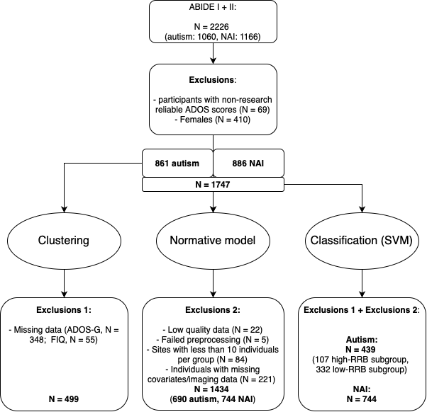
Figure S1. Exclusions flowchart. The ABIDE dataset consisted of 2226 participants. We excluded females because of an uneven distribution across sites, and we excluded participants from whom the clinical tests were unreliably obtained. For the clustering analysis, we used the autism group and excluded all participants with missing data for the ADOS-G and FIQ. For the normative model, we used all participants with both available MRI and covariate data, and with high-quality and successfully processed MRI scans; and sites with at least 10 participants. For the classification analyses, we applied both sets of exclusion criteria. Abbreviations: NAI=non-autistic individuals, FIQ=full-scale IQ.

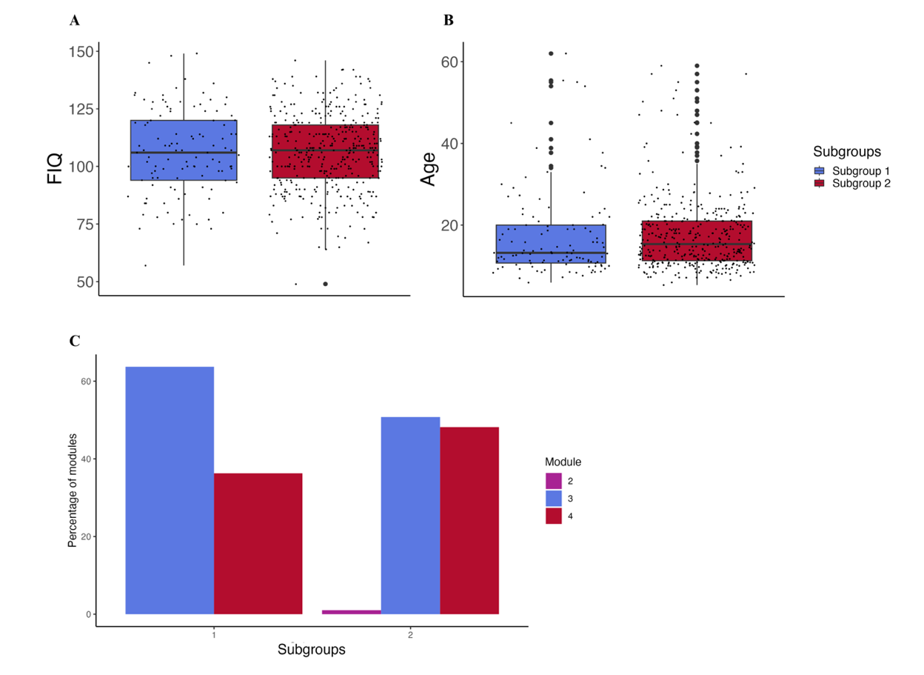
Figure S2. Differences in demographics between clinical subgroups. A: Full-scale Intelligence quotient (FIQ); B: Age; C: Percentage of module used. There were no significant differences in the demographics between the two clinical subgroups.

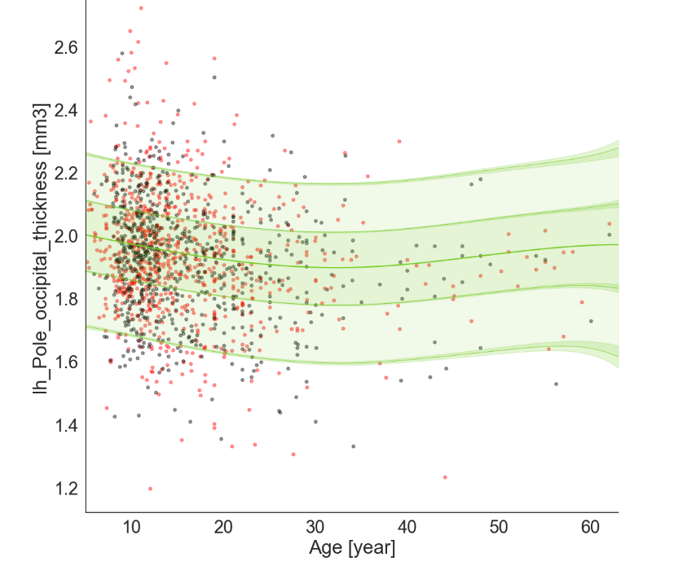
Figure S3. Example centile map normative model. This figure shows the centile map for the left Occipital pole, which was randomly chosen as an example. The black dots represent the train set, and the red dots the test set. The map shows the 0.25, 0.75, 0.05 and 0.95 centiles.

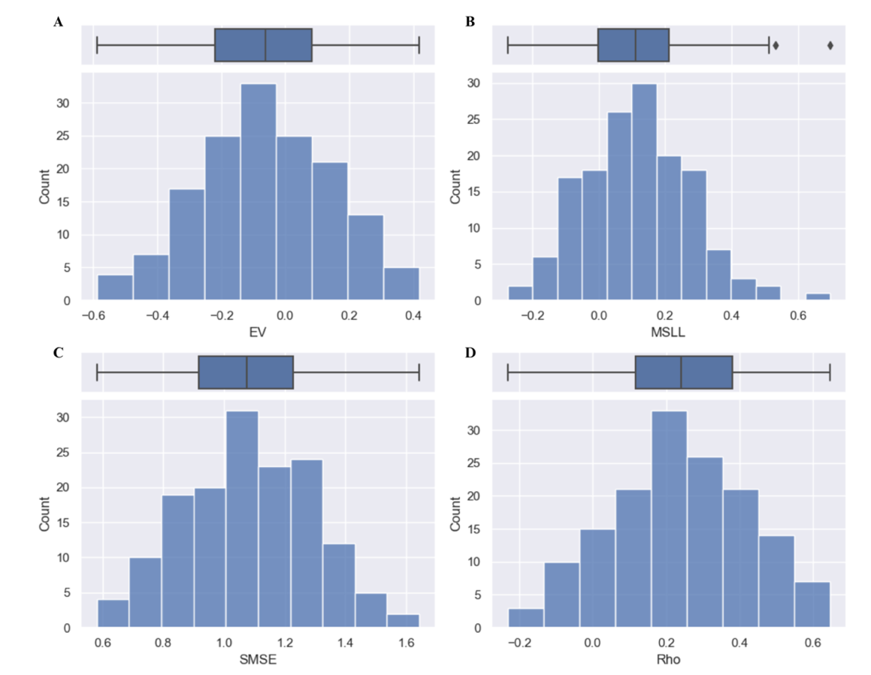
Figure S4. Evaluation metrics normative model. A: Explained variance (EV), closer to 1 = better model performance. B: Mean standardised log loss (MSLL), more negative = better model performance. C: Standardised mean squared error (SMSE), Closer to 0 = better model performance. D: Pearson correlation between true and predicted responses (Rho), closer to 1 = better model performance.

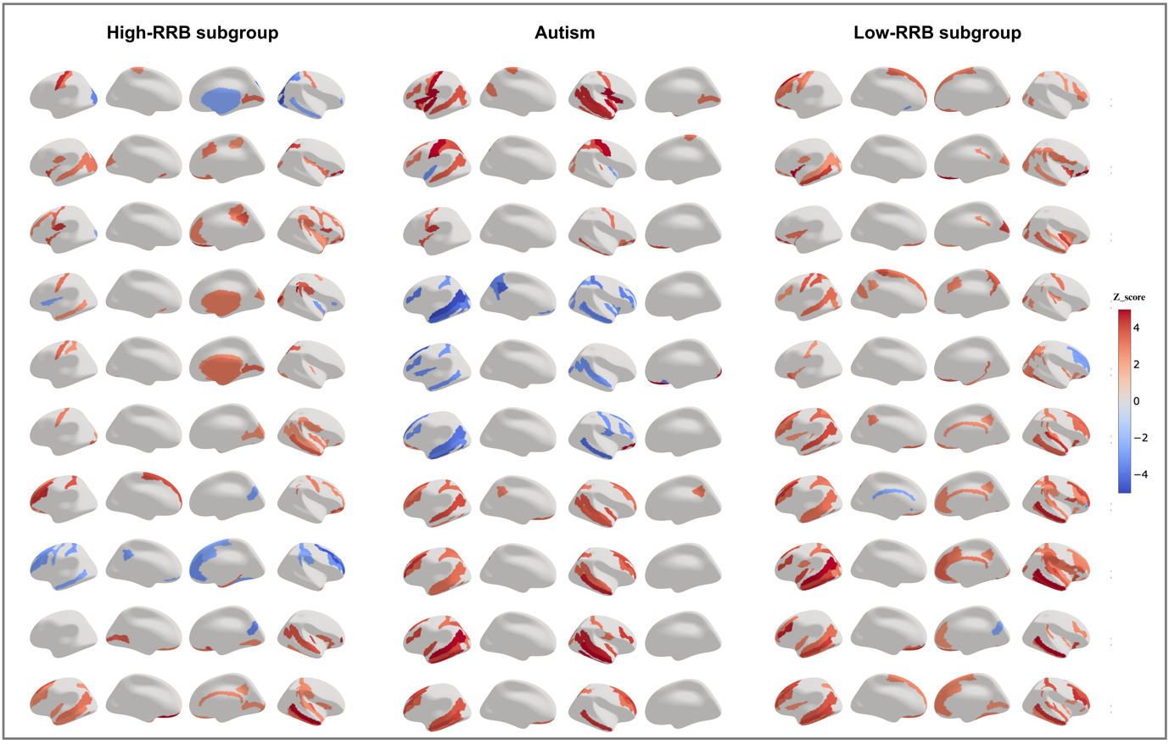
Figure S5. Individual normative probability maps for the top 10 deviating participants per group. In red positive deviations, and in blue negative deviations.

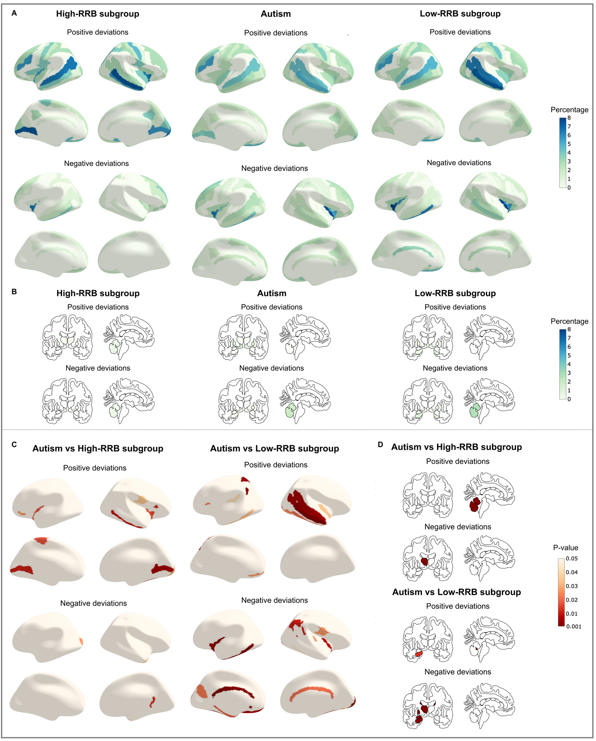
Figure S6. Overlap in deviation scores when using individual FDR correction. A) Overlap in extreme (individual thresholds) cortical thickness deviations in percentage. B) Overlap in extreme subcortical volume deviations in percentage. C) Uncorrected p-values from permutation-based comparisons of overlap in cortical thickness between the subgroups and the entire autism group. D) Uncorrected p-values from permutation-based comparisons of overlap in subcortical volume between the subgroups and the entire autism group.

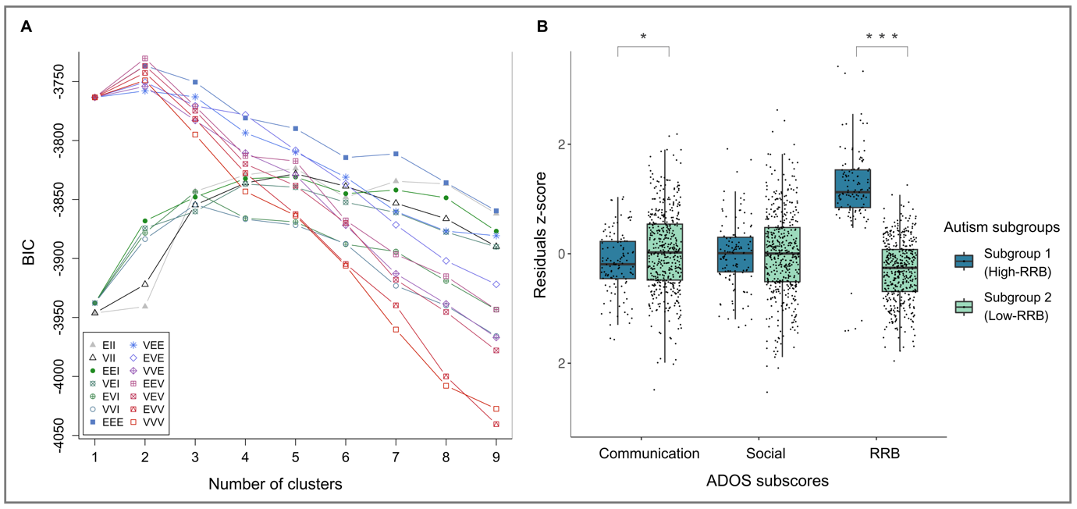
Figure S7. Clustering results, including both males and females. A) Model-based clustering, BIC. BIC = Bayesian Information Criterion. Cluster solutions between 1 and 9 are shown. Each line represents a possible model used in the model-based clustering and the three-letter code represents different combinations of geometric shapes for the clusters. The first letter indicates if the volume is constrained to be equal (E) or varies (V) across clusters. The second letter denotes if the shape is equal (E) or varies (V), or if the clusters are spherical (I). The third letter refers to the orientation of the clusters and can be equal (E), varied (V) or spherical (I). All combinations of these geographic shapes are tested (see SI). B) Differences in subscores of the ADOS-G between the two subgroups identified by model-based clustering. Subgroup 1 showed significantly higher RRBs, while subgroup 2 demonstrated significantly higher communication scores.

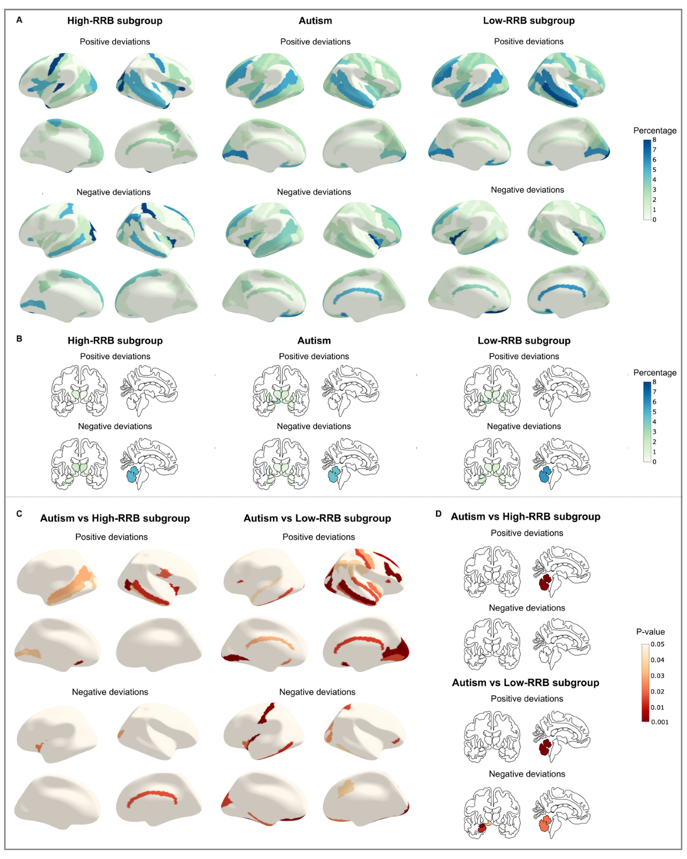
Figure S8. Overlap in deviation scores, including both males and females. A) Overlap in extreme (individual thresholds) cortical thickness deviations in percentage. B) Overlap in extreme subcortical volume deviations in percentage. C) Uncorrected p-values from permutation-based comparisons of overlap in cortical thickness between the subgroups and the entire autism group. D) Uncorrected p-values from permutation-based comparisons of overlap in subcortical volume between the subgroups and the entire autism group.

Table S1. Demographics subgroups including males and females. F=females; ADOS-G = Autism Diagnostic Observation Schedule Generic. RRB = restrictive and repetitive behaviours. Residualized ADOS-G subscores are depicted (after regressing out age, site, FIQ, ADOS module and the other two respective ADOS-G subscores).
 | High-RRB subgroup |  |  | Low-RRB subgroup
 | (N = 115; F=0) |  |  | (N = 446; F=62)
 | Mean | SD | Range | Mean | SD | Range | p-value
Age | 16.898 | 9.77 | 5.92–62 | 17.613 | 9.428 | 5.22–59 | 0.115
FIQ | 105.81 | 19.6 | 57–149 | 106.31 | 16.55 | 49–146 | 0.796
ADOS-G
Social | -0.008 | 0.61 | -1.34–1.92 | 0.002 | 0.785 | -2.53–2.63 | 0.786
Communication | -0.174 | 0.56 | -1.57–1.04 | 0.045 | 0.74 | -2.49–2.19 | 0.004
RRB | 1.191 | 0.77 | -1.41–3.42 | -0.307 | 0.561 | -1.96–1.26 | <0.001

Table S2. Evaluation metrics for the classification

 | Autism vs NAI | High-RRB vs NAI | Low-RRB vs NAI
Accuracy | 0.61 | 0.77 | 0.60
Balanced accuracy | 0.65 | 0.66 | 0.65
ROC AUC | 0.70 | 0.70 | 0.69

References

Abraham, A., Pedregosa, F., Eickenberg, M., Gervais, P., Mueller, A., Kossaifi, J., Gramfort, A., Thirion, B., & Varoquaux, G. (2014). Machine learning for neuroimaging with scikit-learn. Frontiers in Neuroinformatics, 8. https://doi.org/10.3389/fninf.2014.00014
Banerjee, A., & Shan, H. (2011). Model-Based Clustering. In C. Sammut & G. I. Webb (Eds.), Encyclopedia of Machine Learning (pp. 686–689). Springer US. https://doi.org/10.1007/978-0-387-30164-8_554
Bayer, J. M. M., Dinga, R., Kia, S. M., Kottaram, A. R., Wolfers, T., Lv, J., Zalesky, A., Schmaal, L., & Marquand, A. (2022). Accommodating site variation in neuroimaging data using normative and hierarchical Bayesian models. NeuroImage, 264, 119699. https://doi.org/10.1016/j.neuroimage.2022.119699
Bethlehem, R. A. I., Seidlitz, J., Romero-Garcia, R., Trakoshis, S., Dumas, G., & Lombardo, M. V. (2020). A normative modelling approach reveals age-atypical cortical thickness in a subgroup of males with autism spectrum disorder. Communications Biology, 3(1), Article 1. https://doi.org/10.1038/s42003-020-01212-9
Bitsika, V., Sharpley, C. F., & Orapeleng, S. (2008). An exploratory analysis of the use of cognitive, adaptive and behavioural indices for cluster analysis of ASD subgroups. Journal of Intellectual Disability Research, 52(11), 973–985. https://doi.org/10.1111/j.1365-2788.2008.01123.x
Cervantes, J., Garcia-Lamont, F., Rodríguez-Mazahua, L., & Lopez, A. (2020). A comprehensive survey on support vector machine classification: Applications, challenges and trends. Neurocomputing, 408, 189–215. https://doi.org/10.1016/j.neucom.2019.10.118
Cholemkery, H., Medda, J., Lempp, T., & Freitag, C. M. (2016). Classifying Autism Spectrum Disorders by ADI-R: Subtypes or Severity Gradient? Journal of Autism and Developmental Disorders, 46(7), 2327–2339. https://doi.org/10.1007/s10803-016-2760-2
Dale, A. M., Fischl, B., & Sereno, M. I. (1999). Cortical surface-based analysis. I. Segmentation and surface reconstruction. NeuroImage, 9(2), 179–194. https://doi.org/10.1006/nimg.1998.0395
Destrieux, C., Fischl, B., Dale, A., & Halgren, E. (2010). Automatic parcellation of human cortical gyri and sulci using standard anatomical nomenclature. NeuroImage, 53(1), 1–15. https://doi.org/10.1016/j.neuroimage.2010.06.010
Di Martino, A., O’Connor, D., Chen, B., Alaerts, K., Anderson, J. S., Assaf, M., Balsters, J. H., Baxter, L., Beggiato, A., Bernaerts, S., Blanken, L. M. E., Bookheimer, S. Y., Braden, B. B., Byrge, L., Castellanos, F. X., Dapretto, M., Delorme, R., Fair, D. A., Fishman, I., … Milham, M. P. (2017). Enhancing studies of the connectome in autism using the autism brain imaging data exchange II. Scientific Data, 4(170010). https://doi.org/10.1038/sdata.2017.10
Di Martino, A., Yan, C. G., Li, Q., Denio, E., Castellanos, F. X., Alaerts, K., Anderson, J. S., Assaf, M., Bookheimer, S. Y., Dapretto, M., Deen, B., Delmonte, S., Dinstein, I., Ertl-Wagner, B., Fair, D. A., Gallagher, L., Kennedy, D. P., Keown, C. L., Keysers, C., … Milham, M. P. (2014). The autism brain imaging data exchange: Towards a large-scale evaluation of the intrinsic brain architecture in autism. Molecular Psychiatry, 19(6), 659–667. https://doi.org/10.1038/mp.2013.78
Fischl, B. (2012). FreeSurfer. NeuroImage, 62(2), 774–781. https://doi.org/10.1016/j.neuroimage.2012.01.021
Fischl, B., Salat, D. H., Busa, E., Albert, M., Dieterich, M., Haselgrove, C., van der Kouwe, A., Killiany, R., Kennedy, D., Klaveness, S., Montillo, A., Makris, N., Rosen, B., & Dale, A. M. (2002). Whole Brain Segmentation: Automated Labeling of Neuroanatomical Structures in the Human Brain. Neuron, 33(3), 341–355. https://doi.org/10.1016/S0896-6273(02)00569-X
Floris, D. L., Wolfers, T., Zabihi, M., Holz, N. E., Zwiers, M. P., Charman, T., Tillmann, J., Ecker, C., Dell’Acqua, F., Banaschewski, T., Moessnang, C., Baron-Cohen, S., Holt, R., Durston, S., Loth, E., Murphy, D. G. M., Marquand, A., Buitelaar, J. K., Beckmann, C. F., … Zwiers, M. P. (2021). Atypical Brain Asymmetry in Autism—A Candidate for Clinically Meaningful Stratification. Biological Psychiatry: Cognitive Neuroscience and Neuroimaging, 6(8), 802–812. https://doi.org/10.1016/j.bpsc.2020.08.008
Fraza, C. J., Dinga, R., Beckmann, C. F., & Marquand, A. F. (2021). Warped Bayesian linear regression for normative modelling of big data. NeuroImage, 245, 118715. https://doi.org/10.1016/j.neuroimage.2021.118715
Gaiser, C., Berthet, P., Kia, S. M., Frens, M. A., Beckmann, C. F., Muetzel, R. L., & Marquand, A. (2023). Estimating cortical thickness trajectories in children across different scanners using transfer learning from normative models (p. 2023.03.02.530742). bioRxiv. https://doi.org/10.1101/2023.03.02.530742
Gao, L. L., Bien, J., & Witten, D. (2022). Selective Inference for Hierarchical Clustering. Journal of the American Statistical Association, 0(0), 1–11. https://doi.org/10.1080/01621459.2022.2116331
Georgiades, S., Szatmari, P., Boyle, M., Hanna, S., Duku, E., Zwaigenbaum, L., Bryson, S., Fombonne, E., Volden, J., Mirenda, P., Smith, I., Roberts, W., Vaillancourt, T., Waddell, C., Bennett, T., Thompson, A., & Pathways in ASD Study Team. (2013). Investigating phenotypic heterogeneity in children with autism spectrum disorder: A factor mixture modeling approach: ASD factor mixture model. Journal of Child Psychology and Psychiatry, 54(2), 206–215. https://doi.org/10.1111/j.1469-7610.2012.02588.x
Hennig, C. (2007). Cluster-wise assessment of cluster stability. Computational Statistics & Data Analysis, 52(1), 258–271.
Hennig, C. (2008). Dissolution point and isolation robustness: Robustness criteria for general cluster analysis methods. Journal of Multivariate Analysis, 99(6), 1154–1176. https://doi.org/10.1016/j.jmva.2007.07.002
Hu, V. W., & Steinberg, M. E. (2009). Novel clustering of items from the Autism Diagnostic Interview-Revised to define phenotypes within autism spectrum disorders. Autism Research, 2(2), 67–77. https://doi.org/10.1002/aur.72
Lefort-Besnard, J., Vogeley, K., Schilbach, L., Varoquaux, G., Thirion, B., Dumas, G., & Bzdok, D. (2020). Patterns of autism symptoms: Hidden structure in the ADOS and ADI-R instruments. Translational Psychiatry, 10(1), 257. https://doi.org/10.1038/s41398-020-00946-8
Lombardo, M. V., Lai, M.-C., Auyeung, B., Holt, R. J., Allison, C., Smith, P., Chakrabarti, B., Ruigrok, A. N. V., Suckling, J., Bullmore, E. T., MRC AIMS Consortium, Bailey, A. J., Baron-Cohen, S., Bolton, P. F., Bullmore, E. T., Carrington, S., Catani, M., Chakrabarti, B., Craig, M. C., … Baron-Cohen, S. (2016). Unsupervised data-driven stratification of mentalizing heterogeneity in autism. Scientific Reports, 6(1), 35333. https://doi.org/10.1038/srep35333
Lord, C., Risi, S., Lambrecht, L., Cook, Jr., E. H., Leventhal, B. L., DiLavore, P. C., Pickles, A., & Rutter, M. (2000). The Autism Diagnostic Observation Schedule-Generic: A standard Measure of Social and Communication Deficits Associated with the Spectrum of Autism. Journal of Autism and Developmental Disorders, 30(3), 205–223. https://doi.org/10.1023/A:1005592401947
Lord, C., Rutter, M., & Le Couteur, A. (1994). Autism Diagnostic Interview-Revised: A revised version of a diagnostic interview for caregivers of individuals with possible pervasive developmental disorders. Journal of Autism and Developmental Disorders, 24(5), 659–685.
Marquand, A. F., Kia, S. M., Zabihi, M., Wolfers, T., Buitelaar, J. K., & Beckmann, C. F. (2019). Conceptualizing mental disorders as deviations from normative functioning. Molecular Psychiatry, 24(10), 1415–1424. https://doi.org/10.1038/s41380-019-0441-1
Marquand, A. F., Rezek, I., Buitelaar, J., & Beckmann, C. F. (2016). Understanding Heterogeneity in Clinical Cohorts Using Normative Models: Beyond Case-Control Studies. Biological Psychiatry, 80(7), 552–561. https://doi.org/10.1016/j.biopsych.2015.12.023
Mowinckel, A. M., & Vidal-Piñeiro, D. (2019). Visualisation of Brain Statistics with R-packages ggseg and ggseg3d. https://doi.org/10.48550/ARXIV.1912.08200
Pedregosa, F., Varoquaux, G., Gramfort, A., Michel, V., Thirion, B., Grisel, O., Blondel, M., Prettenhofer, P., Weiss, R., Dubourg, V., Vanderplas, J., Passos, A., & Cournapeau, D. (2011). Scikit-learn: Machine Learning in Python. MACHINE LEARNING IN PYTHON.
Pisner, D. A., & Schnyer, D. M. (2020). Support vector machine. In Machine Learning (pp. 101–121). Elsevier. https://doi.org/10.1016/B978-0-12-815739-8.00006-7
Rutherford, S., Barkema, P., Tso, I. F., Sripada, C., Beckmann, C. F., Ruhe, H. G., & Marquand, A. F. (2023). Evidence for embracing normative modeling. eLife, 12, e85082. https://doi.org/10.7554/eLife.85082
Rutherford, S., Kia, S. M., Wolfers, T., Fraza, C., Zabihi, M., Dinga, R., Berthet, P., Worker, A., Verdi, S., Ruhe, H. G., Beckmann, C. F., & Marquand, A. F. (2022). The normative modeling framework for computational psychiatry. Nature Protocols, 17(7), 1711–1734. https://doi.org/10.1038/s41596-022-00696-5
Scrucca, L., Fop, M., Murphy, T. B., & Raftery, A. E. (2016). mclust 5: Clustering, Classification and Density Estimation Using Gaussian Finite Mixture Models. The R Journal, 8(1), 289–317.
Segal, A., Parkes, L., Aquino, K., Kia, S. M., Wolfers, T., Franke, B., Hoogman, M., Beckmann, C. F., Westlye, L. T., Andreassen, O. A., Zalesky, A., Harrison, B. J., Davey, C. G., Soriano-Mas, C., Cardoner, N., Tiego, J., Yücel, M., Braganza, L., Suo, C., … Fornito, A. (2023). Regional, circuit and network heterogeneity of brain abnormalities in psychiatric disorders. Nature Neuroscience, 1–17. https://doi.org/10.1038/s41593-023-01404-6
Tian, M., Blair, R. H., Mu, L., Bonner, M., Browne, R., & Yu, H. (2021). A framework for stability‐based module detection in correlation graphs. Statistical Analysis and Data Mining: The ASA Data Science Journal, 14(2), 129–143. https://doi.org/10.1002/sam.11495
Winter, N. R., & Hahn, T. (2022). Significance and stability of deep learning-based identification of subtypes within major psychiatric disorders. Molecular Psychiatry, 27(4), 1858–1859. https://doi.org/10.1038/s41380-022-01482-1
Wolfers, T., Beckmann, C. F., Hoogman, M., Buitelaar, J. K., Franke, B., & Marquand, A. F. (2020). Individual differences v. the average patient: Mapping the heterogeneity in ADHD using normative models. Psychological Medicine, 50(2), 314–323. https://doi.org/10.1017/S0033291719000084
Wolfers, T., Doan, N. T., Kaufmann, T., Alnæs, D., Moberget, T., Agartz, I., Buitelaar, J. K., Ueland, T., Melle, I., Franke, B., Andreassen, O. A., Beckmann, C. F., Westlye, L. T., & Marquand, A. F. (2018). Mapping the Heterogeneous Phenotype of Schizophrenia and Bipolar Disorder Using Normative Models. JAMA Psychiatry, 75(11), 1146. https://doi.org/10.1001/jamapsychiatry.2018.2467

