Supplementary Materials
Munsch, S., Messerli-Bürgy, N., Meyer, A. H., Humbel, N., Schopf, K., Wyssen, A., Forrer, F., Biedert, E., Lennertz, J., Trier, S., Isenschmid, B., Milos, G., Claussen, M., Whinyates, K., Adolph, D., Margraf, J., Assion, H-J., Teismann, T., Ueberberg, B., Juckel, G., Müller, J., Klauke, B., & Schneider, S. Consequences of Exposure to the Thin Ideal in Mass Media Depend on Moderators in Young Women: An Experimental Study.

Corresponding author:
Simone Munsch
Clinical Psychology and Psychotherapy, Department of Psychology
University of Fribourg
Rue P.-A. de-Faucigny 2, 1700 Fribourg, Switzerland
Email: simone.munsch@unifr.ch (SM)

Supplemental Table S1
Participants and Procedure
Characteristics | Women  with AN  (n = 58) | Women  with BN  (n = 54) | Women  with MMD  (n = 62) | Healthy  women  (n = 101) | p
Age, M (SD) (n = 275) | 22.5 (4.2) | 23.3 (4.1) | 25.4 (4.7) | 21.5 (2.2) | <.001
Nationality, % (n) (n = 274)  Swiss  German  Other | 48.3 (28)  50.0 (29)  1.7 (1) | 46.3 (25)  50.0 (27)  3.7 (2) | 48.4 (30)  40.3 (25)  9.7 (6) | 47.5 (48)  43.6 (44)  8.9 (9) | .483
Education, % (n) (n = 274)  Still in school  Compulsory education  HS diploma or job training  University degree | 3.4 (2)  13.8 (8)  63.8 (37)  19.0 (11) | 3.6 (2)  25.9 (14)  55.6 (30)  16.7 (9) | 1.6 (1)  14.5 (9)  56.5 (35)  26.2 (16) | 1.0 (1)  4.9 (5)  86.1 (87)  7.9 (8) | <.001
In Relationship, % (n) (n = 275)  Yes | 43.1 (25) | 46.3 (25) | 62.9 (39) | 46.5 (47) | .112
Employed, % (n) (n = 275)  Yes | 46.6 (27) | 37.7 (20) | 30.6 (19) | 24.8 (25) | .037
Psychopathology, questionnaires, M (SD)  Body Mass Index (n = 269)  EDE-Q (n = 274)  BDI (n = 274)  BAI (n = 274)  SOMS (n = 228)  PEPQ (n = 256)  SATAQ (n = 274)  TSF-B (n = 274)  VAS mood (n = 274)  VAS body image dissatisfaction (n = 274) | 17.2 (1.6)  3.7 (1.2)  25.5 (11.6)  20.1 (10.9)  11.0 (7.5)  22.4 (20.8)  20.2 (4.2)  24.6 (11.1)  55.7 (19.3)  65.9 (16.8) | 22.7 (2.6)  4.2 (1.3)  26.6 (11.9)  19.7 (9.0)  10.1 (6.5)  25.6 (21.9)  19.9 (4.3)  25.5 (10.1)  55.9 (18.0)  71.2 (17.8) | 24.6 (6.6)  1.6 (1.3)  25.1 (9.6)  22.3 (10.4)  8.9 (5.9)  14.5 (17.2)  17.0 (5.3)  10.5 (10.4)  53.8 (16.8)  44.0 (21.7) | 22.1 (2.7)  0.6 (0.6)  3.4 (4.0)  4.4 (4.2)  1.8 (2.8)  7.5 (12.8)  14.7 (3.9)  4.9 (4.2)  75.2 (13.9)  23.4 (15.7) | <.001  <.001  <.001  <.001  <.001  <.001  <.001  <.001  <.001  <.001
VAS engage in dysfunct. eating behavior | 43.3 (19.0) | 49.2 (19.6) | 18.7 (13.9) | 13.3 (10.2) | <.001
(n = 259)
Mental illness related information  Duration of disorder, M (SD) (n = 108)  Comorbidity, % (n) (n = 174)  Psychopharmaceutics, % (n) (n = 275) | 5.1 (4.7)  48.3 (28)  24.1 (14) | 6.6 (4.6)  53.7 (29)  40.7 (22) | 4.7 (5.0)  70.1 (44)  61.3 (38) | 1.0 (1) | .221  .031  <.001
Cigarette smoking, % (n) (n = 274)  Yes | 37.9 (22) | 44.4 (24) | 53.2 (33) | 31.7 (32) | .047
Vividness of imagery, M (SD) (n = 271)  For control group, M (SD) (n = 133)  For experimental group, M (SD) (n = 138) | 7.3 (1.9)  7.6 (1.9)  7.1 (1.9) | 7.1 (2.1)  7.2 (2.0)  7.0 (2.2) | 6. (1.9)  7.3 (1.7)  5.8 (1.9) | 6.7 (2.0)  7.1 (1.7)  6.2 (2.1) | .088  <.001ª
Implicit memory test (n = 256)  Correct recognition/rejection, % (M) | 75.0 (15.0) | 75.0 (15.0) | 74.5 (14.9) | 77.0 (15.4) | .669
Psychophysiological Data^{b}  Cortisol (n = 274)  Amylase (n = 275)  HFHR (n = 244) | 9.6 (5.6)  125.8 (98.4)  2580.9 (5751.5) | 7.5 (5.2)  100.1 (82.2)  1166.5 (1316.9) | 5.7 (3.3)  122.3 (97.5)  606.4 (682.0) | 7.7 (4.3)  80.0 (85.0)  1699.0 (2760.9) | <.001  .005  .013

Note. All values are based on untransformed variables. P-values based on comparisons among the four groups AN, BN, MMD, and Healthy using analysis of variance (continuous outcomes) or χ²-test (categorical outcomes). MMD = Mixed mental disorders; EDE-Q = Eating Disorder Examination Questionnaire; BDI = Beck Depression Inventory; BAI = Beck Anxiety Inventory; SOMS = Somatic Symptoms Scale; PEPQ = Post-event Processing Questionnaire; SATAQ = Sociocultural Attitudes Towards Appearance Questionnaire; TSF-B = Thought Shape Fusion: Eating and Body related cognitive distortions; VAS = Visual Analogue Scale; HS= High school; HFHR = High frequency heart rate.

ª Main effect for the factor condition (control vs experimental). ^{b} Psychophysiological date derive from the day of the laboratory experiment, while all other data is assessed at baseline.

Supplemental Figure S1
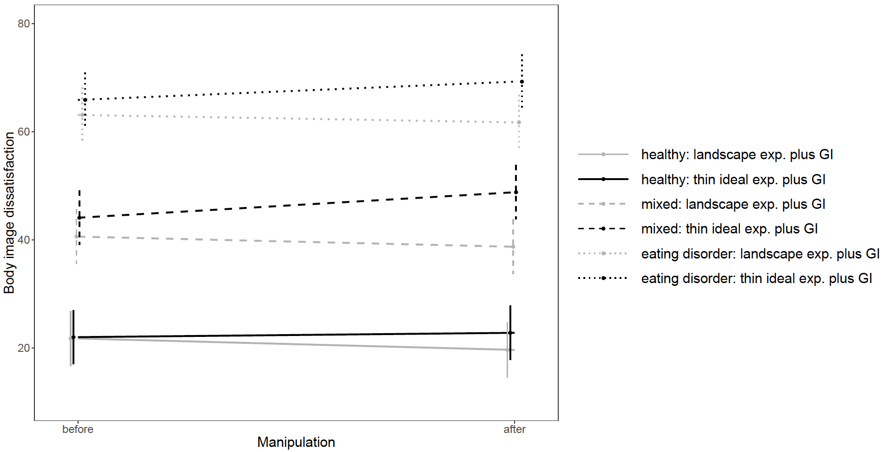
Effects of Exposure plus Guided Imagery and Group on Body Image Dissatisfaction

Note. Changes in body image dissatisfaction following exposure type and guided imagery, in women with eating disorder, mixed mental disorder other than eating disorder, or healthy controls. Values denote predicted values from a multilevel model.

Supplemental Figure S2
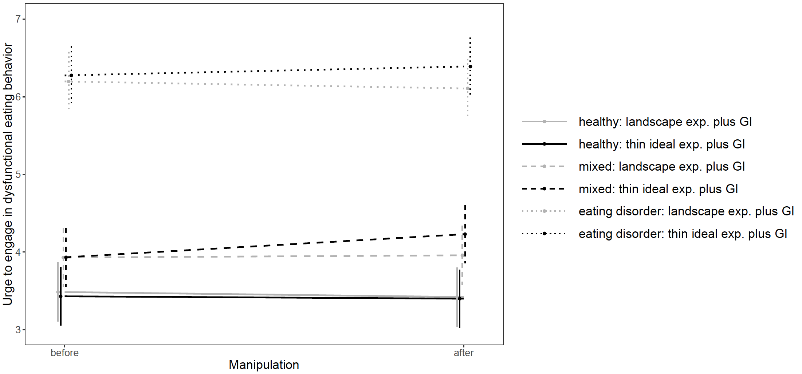
Effects of Exposure plus Guided Imagery and Group on Urge to Engage in Dysfunctional Eating Behavior

Note. Changes in urge to engage in dysfunctional eating behavior following exposure type and guided imagery, in women with eating disorder, mixed mental disorder other than eating disorder, or healthy controls. Values denote predicted values from a multilevel model.

