Supplemental Materials
Networks of Loss: Relationships Among Symptoms of Prolonged Grief Following Spousal and Parental Loss
by F. Maccallum et al., 2017, Journal of Abnormal Psychology
http://dx.doi.org/10.1037/abn0000287

Figure S1: Bootstrapped 95% Confidence Intervals Around Network Edges in Estimated Spousal Loss Network
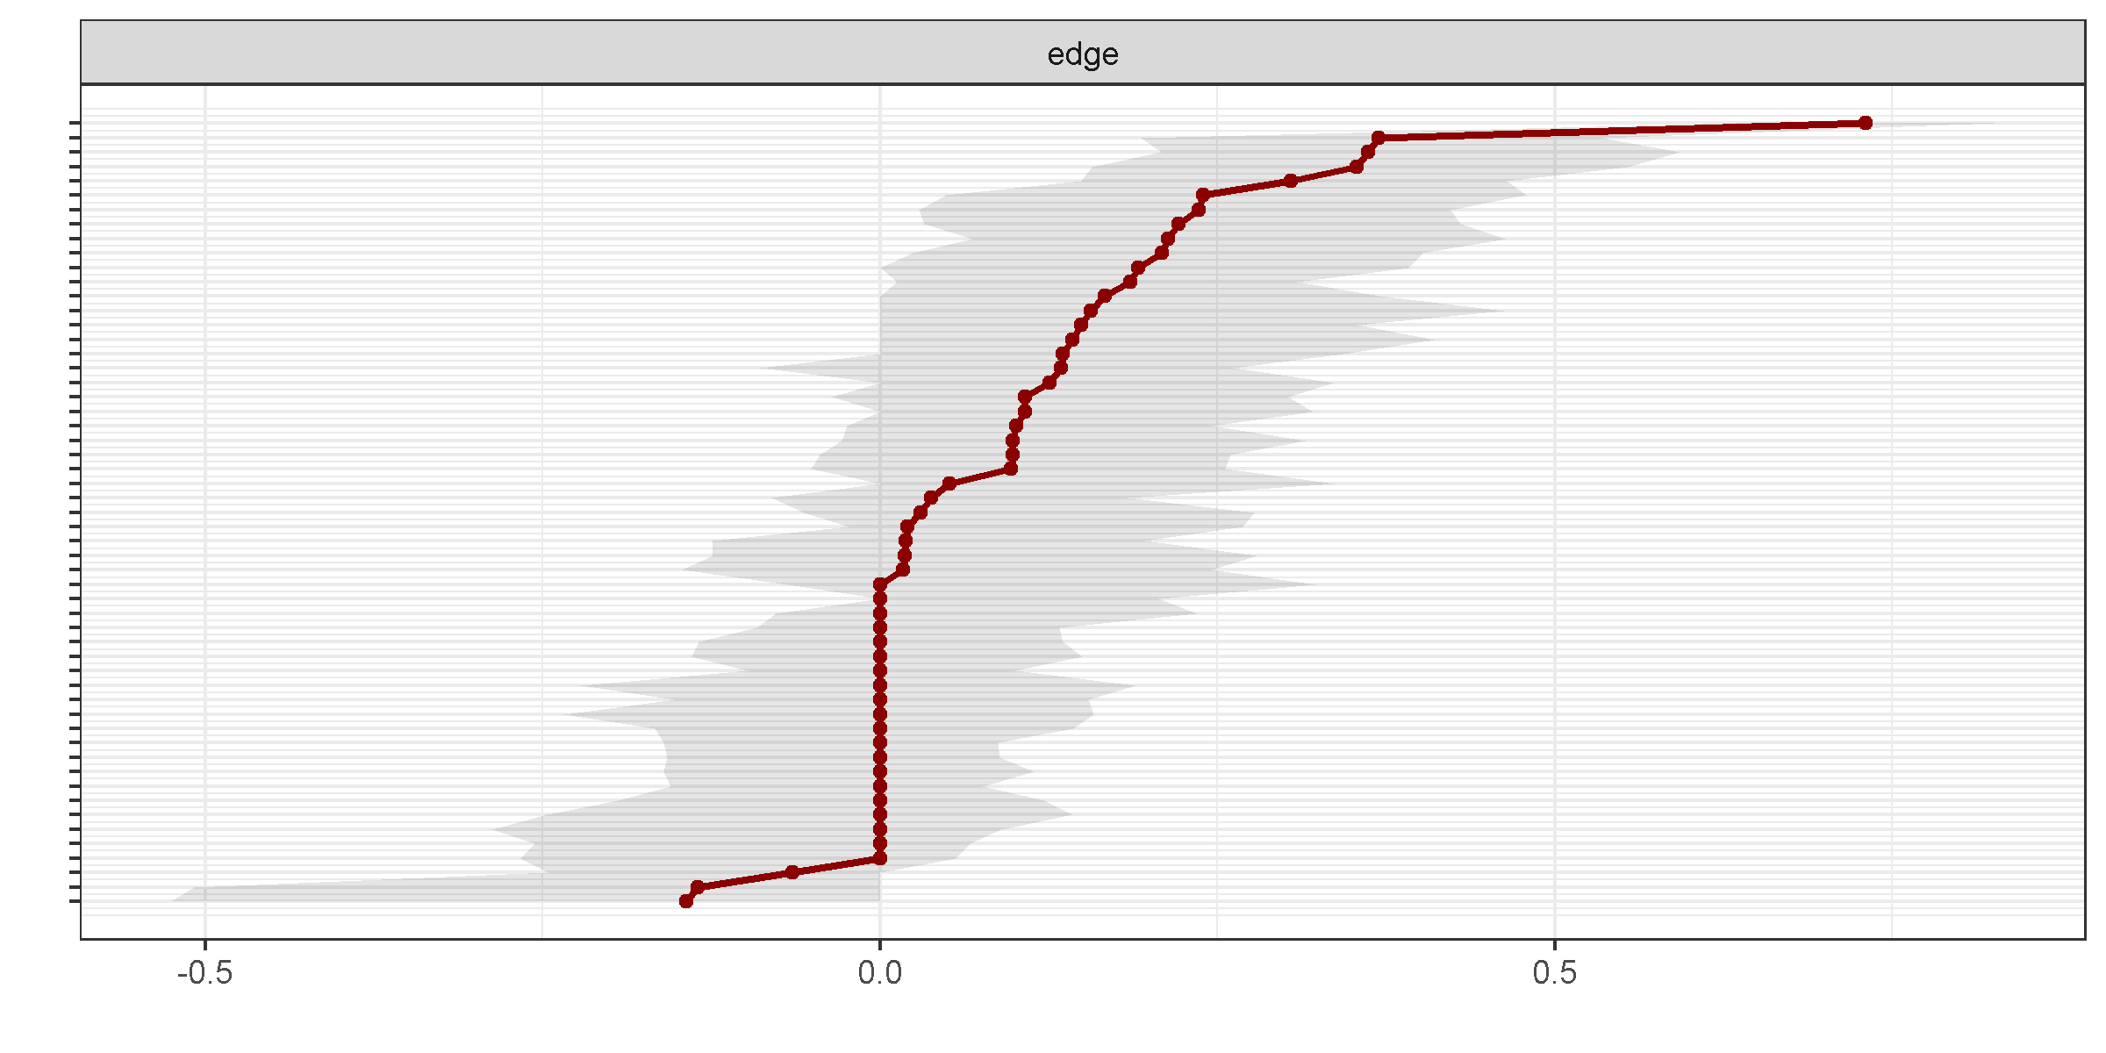
A

Figure S2. Bootstrapped Significance of Differences Between Non-Zero Edges in Estimated Spousal Loss Network
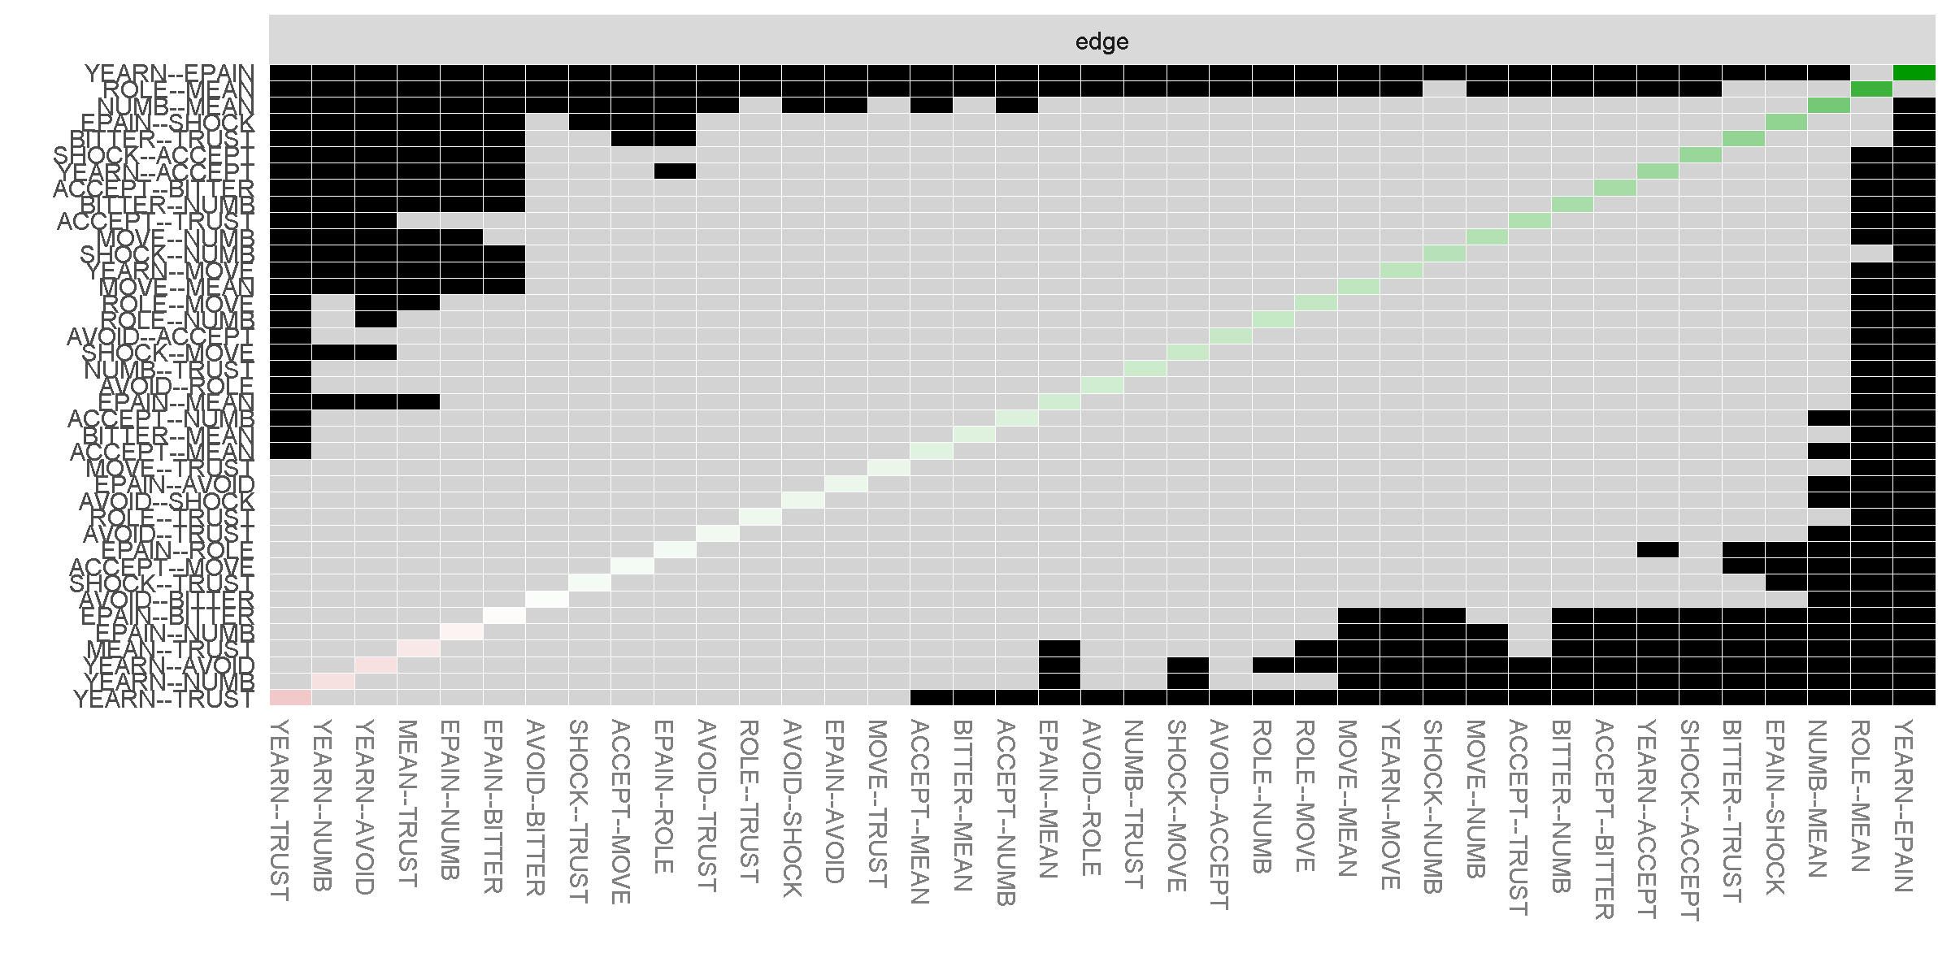
Note: Gray boxes indicate edges that do not differ significantly from one-another (p <.05) and black boxes represent edges that do differ significantly from one-another. Colored boxes in the edge-weight plot correspond to the color of the edge in Figure 1a
Figure S3: Bootstrapped Stability of Centralities Indices When % Cases Removed in Estimated Spousal Loss Network
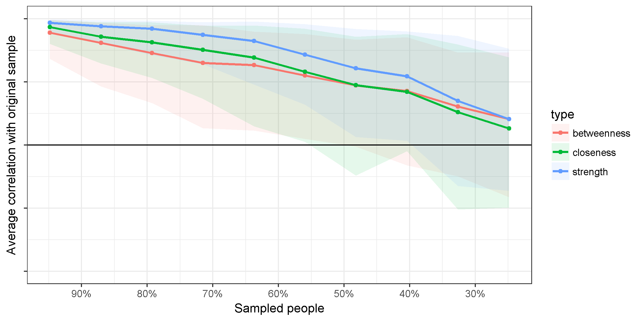
Note: the x-axis represents the % of the original sample used to calculate the centrality indices

Figure S4: Bootstrapped Significant Differences in Strength Centrality in Estimated Spousal Loss Network
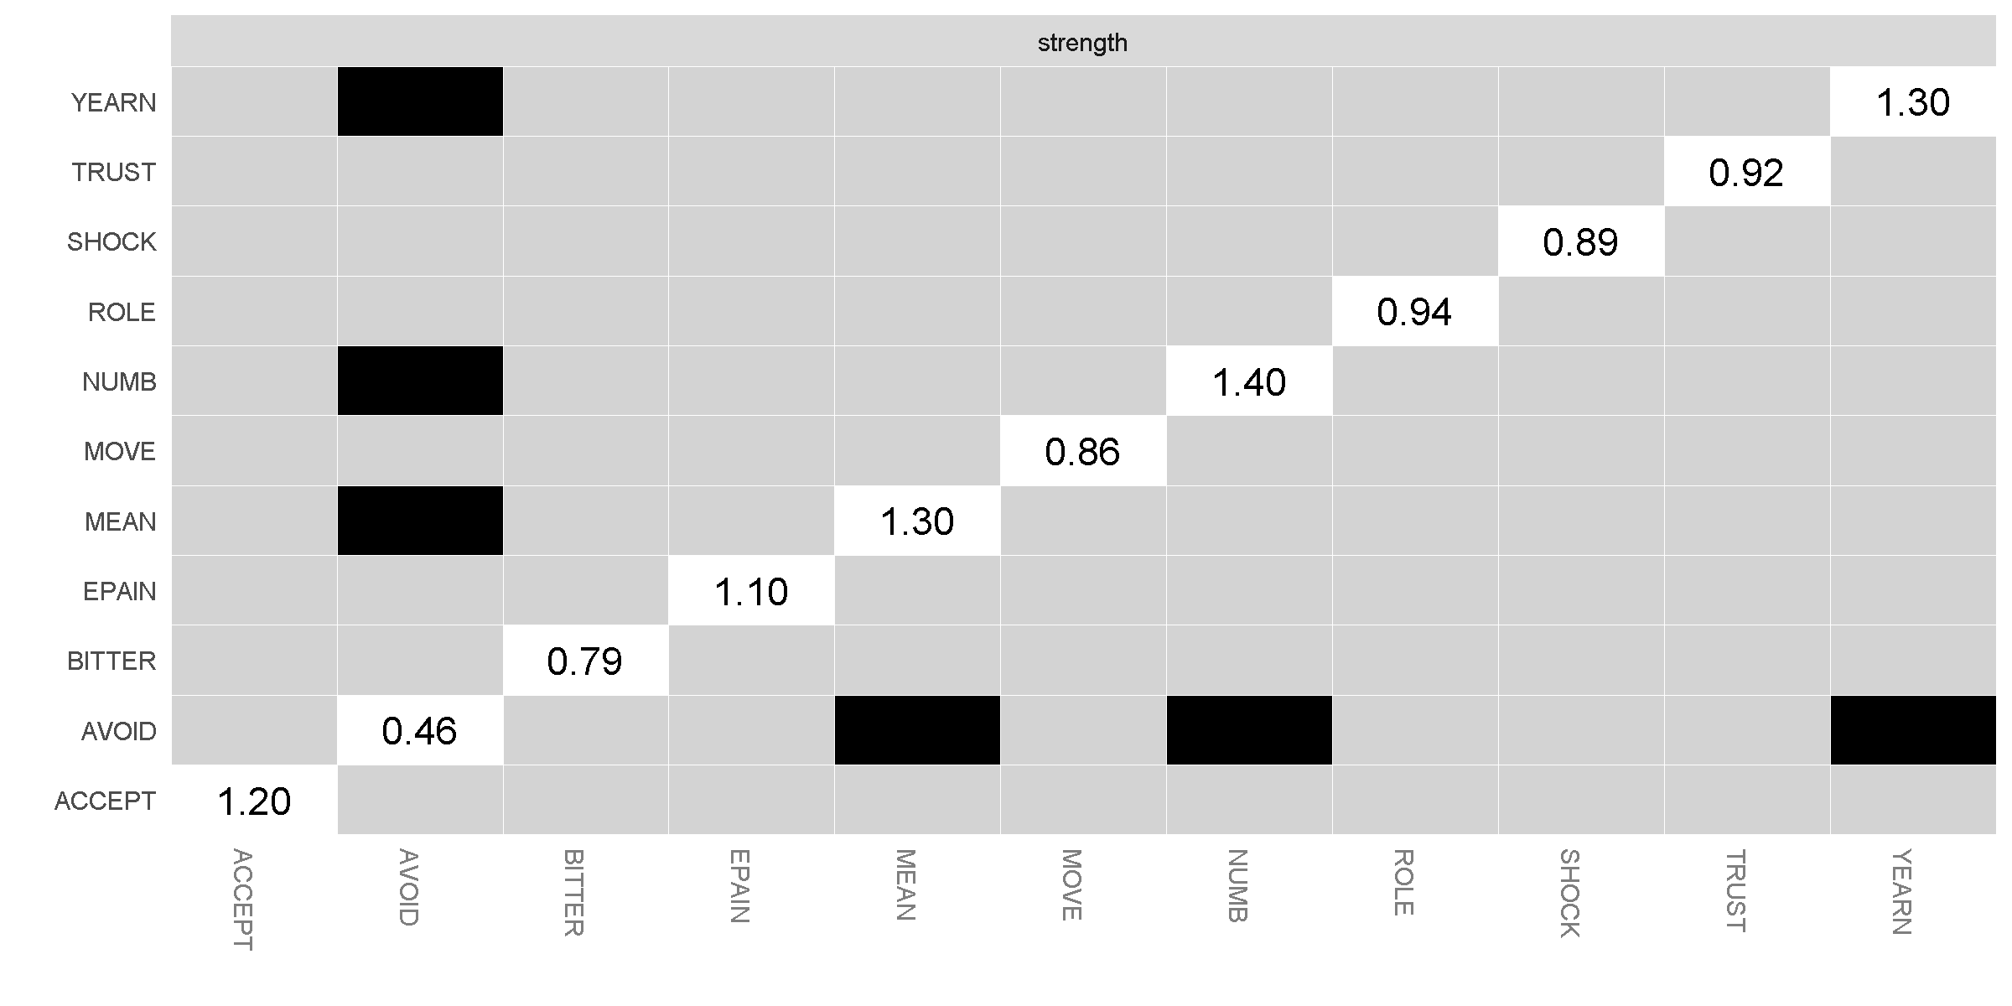
Note: Gray boxes indicate nodes that do not differ significantly from one-another (p <.05) and black boxes represent nodes that do differ significantly from one-another. White boxes in the centrality plot show the value of node strength

Figure S5: Bootstrapped 95% Confidence Intervals Around Network Edges in Estimated Spousal Loss Network including PG-13 and CES-D items.

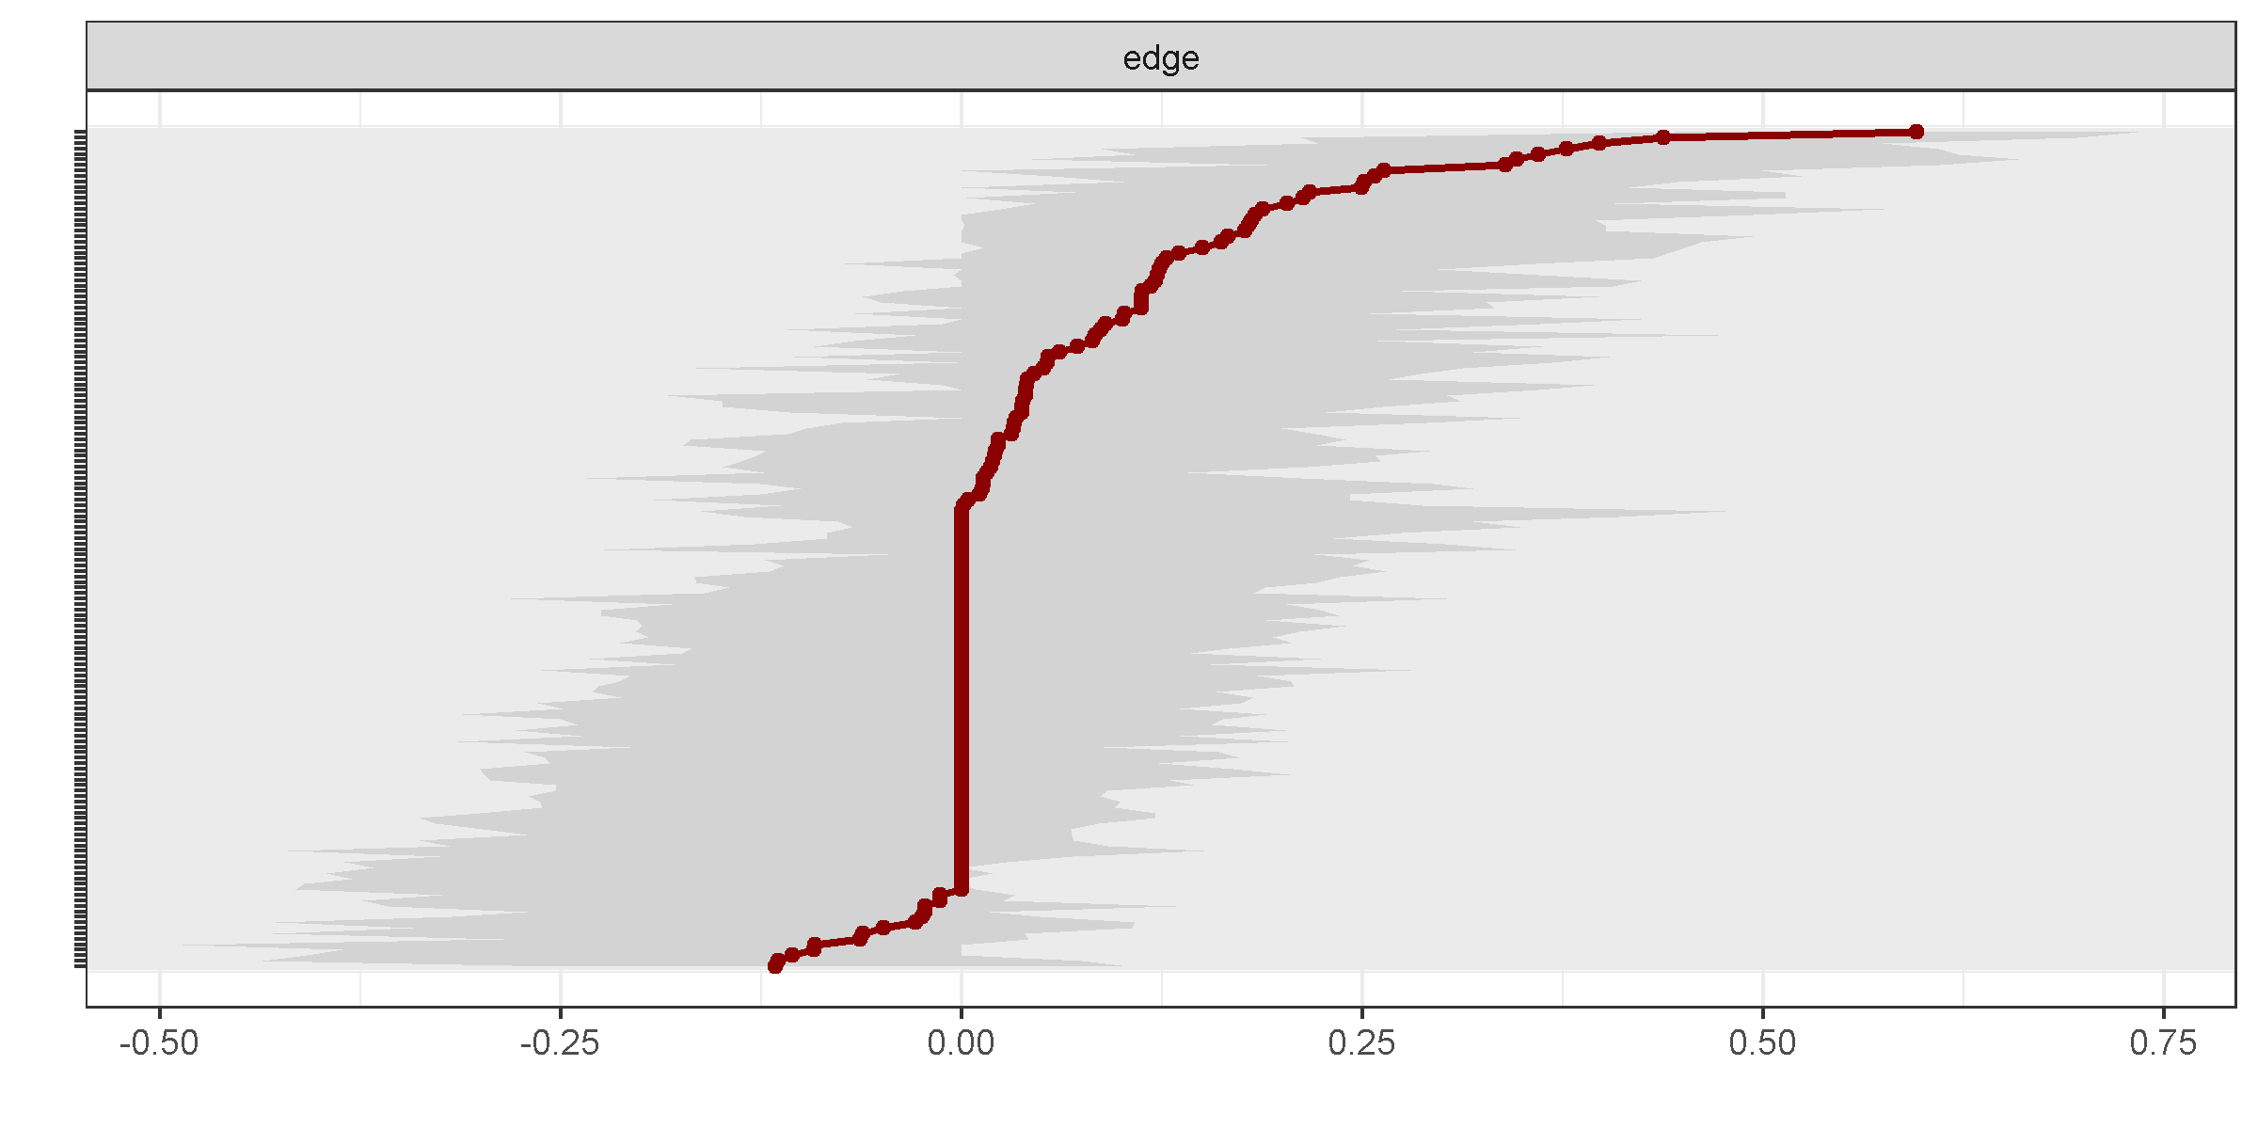

Figure S6: Bootstrapped 95% Confidence Intervals Around Network Edges in Estimated Parent Loss Network
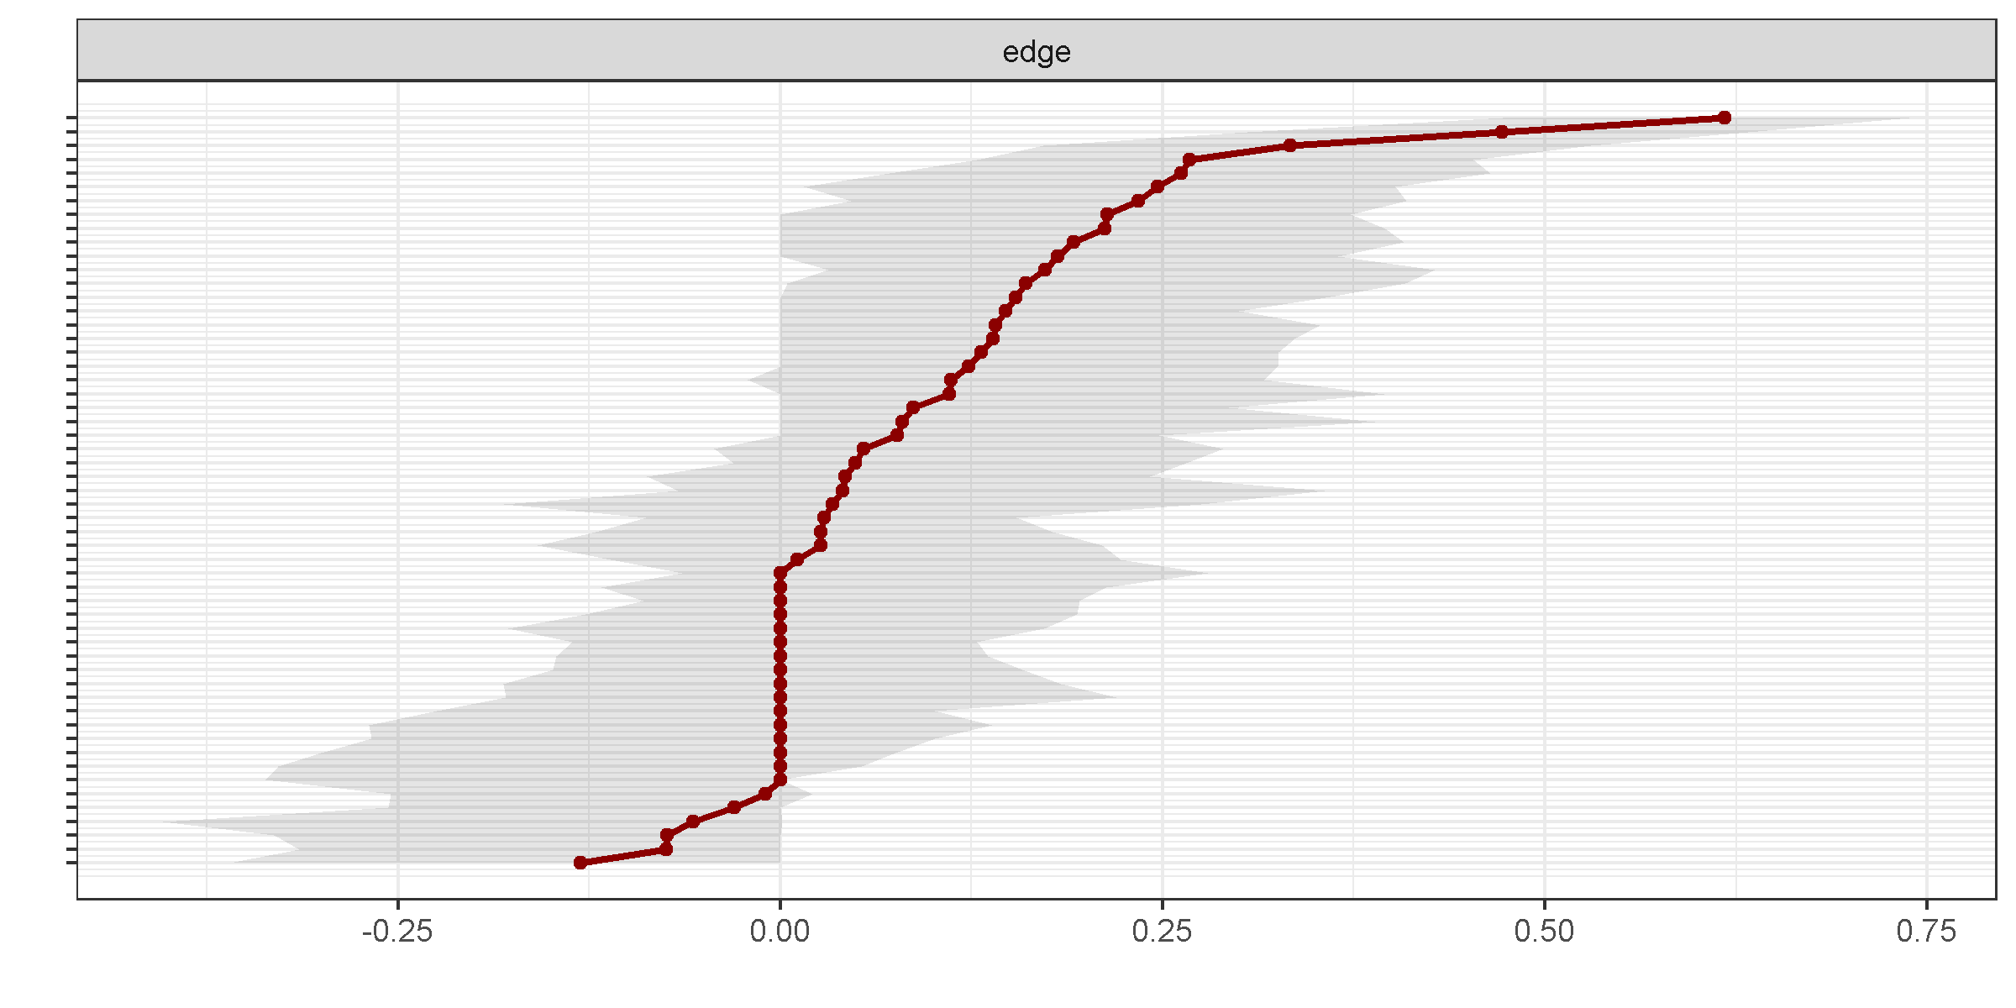
B

Figure S7. Bootstrapped Significance of Differences Between Non-Zero Edges in Estimated Parent Loss Network
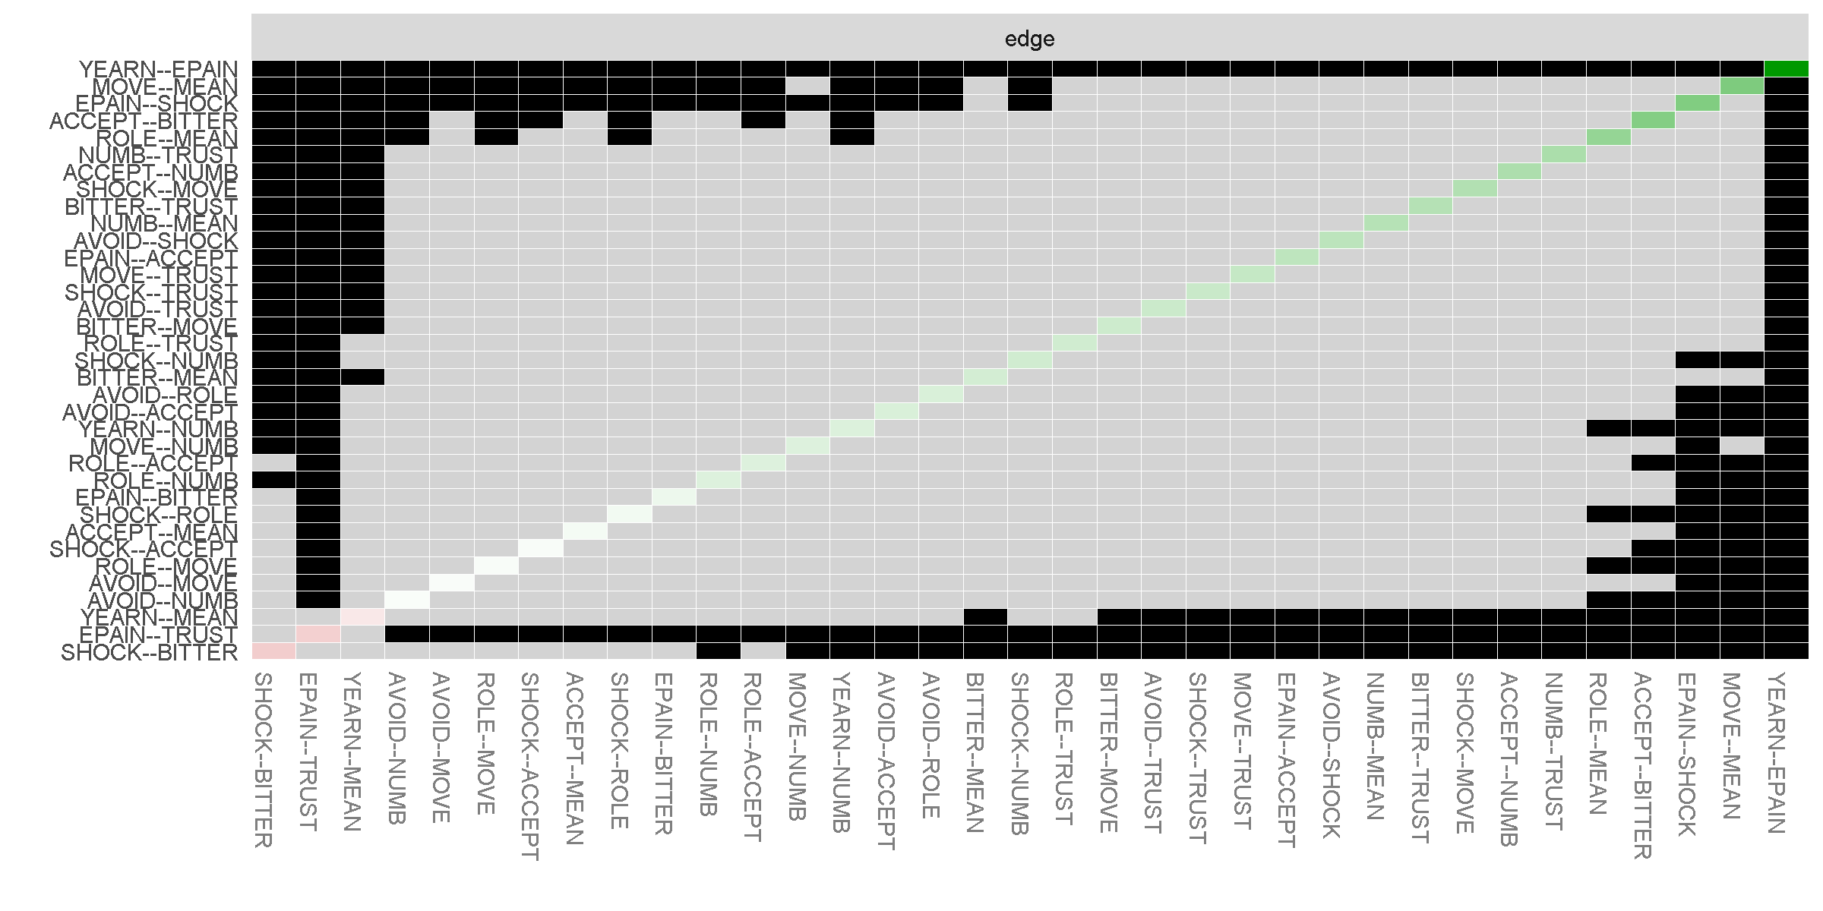
Note: Gray boxes indicate edges that do not differ significantly from one-another (p <.05) and black boxes represent edges that do differ significantly from one-another. Colored boxes in the edge-weight plot correspond to the color of the edge in Figure 1b

Figure S8: Bootstrapped Stability of Centralities Indices When % Cases Removed in Estimated Parent Loss Network
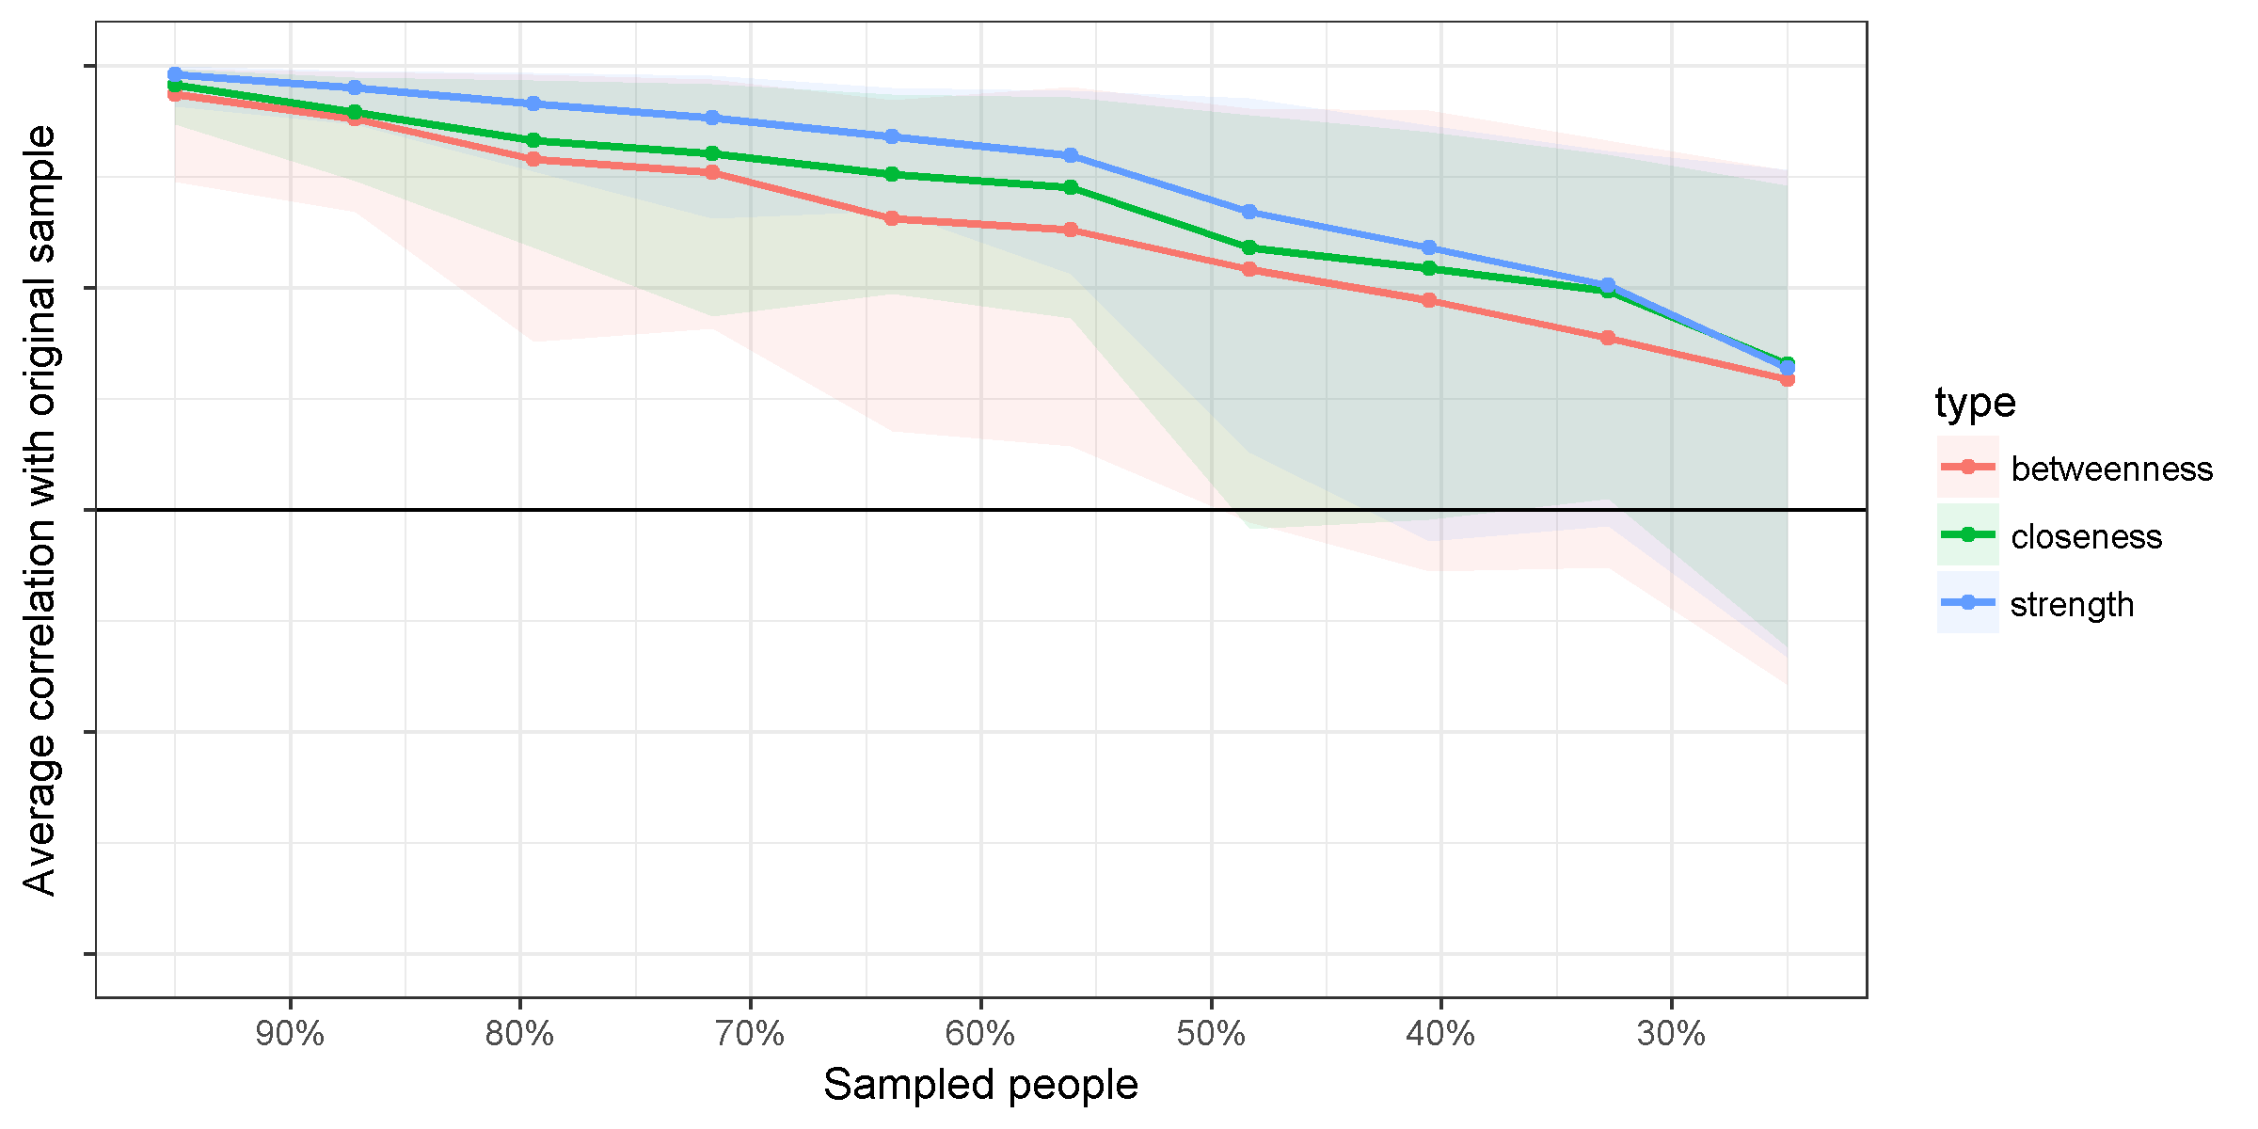
Note: the x-axis represents the % of the original sample used to calculate the centrality indices

Figure S9: Bootstrapped Significant Differences in Strength Centrality in Estimated Parent Loss Network

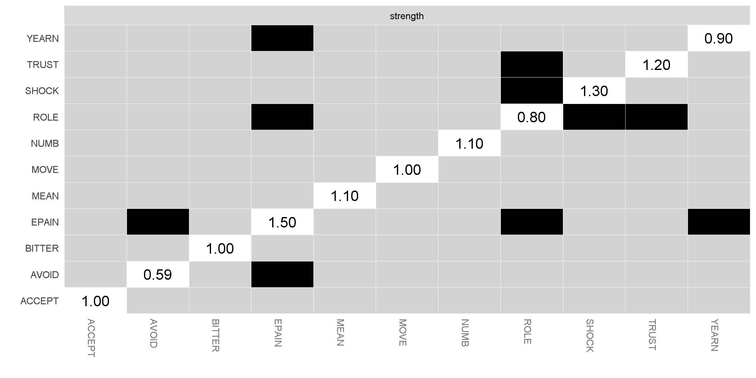
Note: Gray boxes indicate nodes that do not differ significantly from one-another (p <.05) and black boxes represent nodes that do differ significantly from one-another. White boxes in the centrality plot show the value of node strength

Figure S10: Bootstrapped 95% Confidence Intervals Around Network Edges in Estimated Parental Loss Network including PG-13 and CES-D items.
