**Supplemental Materials**

**Identifying Highly Influential Nodes in the Complicated Grief Network**

**by D. J. Robinaugh et al., 2016, *Journal of Abnormal Psychology***

**http://dx.doi.org/10.1037/abn0000181**

**Supplementary Materials A**

**Aim 1: Simulated Single-Node Interventions**

To evaluate centrality and expected influence indices as measures of node importance, we simulated single-node interventions in randomly generated networks. We performed this process in three steps.

**In Step 1,** we randomly generated networks. First, we used the erdos.renyi.game random graph generation tool from the R package igraph to create an unweighted and undirected adjacency matrix. We used the G (n, p) variant of the Erdős-Rényi graph model, with n (the number of nodes) set to 13 and p (the probability of an edge being present) set to .50. We chose these parameters so that the generated networks would have unweighted density comparable to the lasso network of complicated grief symptoms that was the focus of our Aim 2 analyses. The result of this generation tool is an unweighted and undirected network where edges indicate the presence of a relationship between two nodes, but not the strength of those relationships.

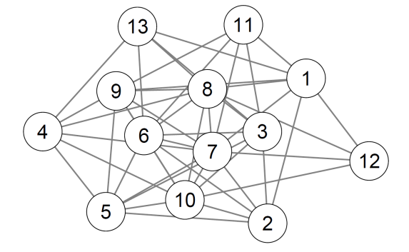

We next assigned edge weights by multiplying the unweighted adjacency matrix produced by the Erdős-Rényi generation tool by a matrix of values randomly sampled from a gamma distribution (shape = .85, rate = 12) where the vertical asymptote of the distribution was set to .05. We chose this distribution so that the distribution of edge weights was comparable to the lasso network of complicated grief symptoms that was the focus of our Aim 2 analyses. In the figure below, greater edge thickness signifies greater edge weight. Nodes with stronger edges are pushed to the center for the network by the Fruchterman-Reingold algorithm.

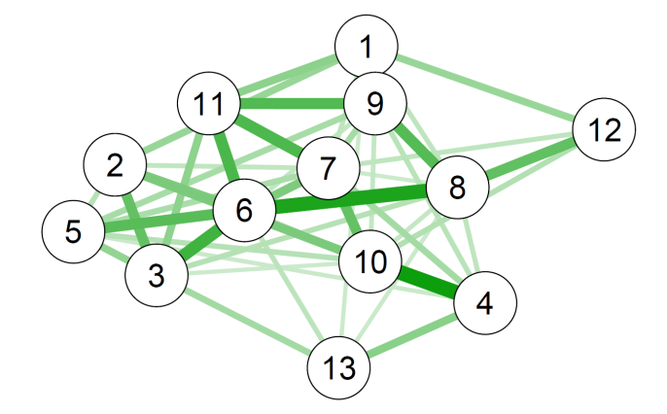

As a final step in generating the network, we randomly assigned a specified proportion of edge weights to be negative. We randomly generated networks in each of 4 conditions: 0%, 5%, 10%, and 25% negative edges. In the example network presented here, 5% of edges are negative. In the figure below, positive edges appear in green and negative edges appear in red.

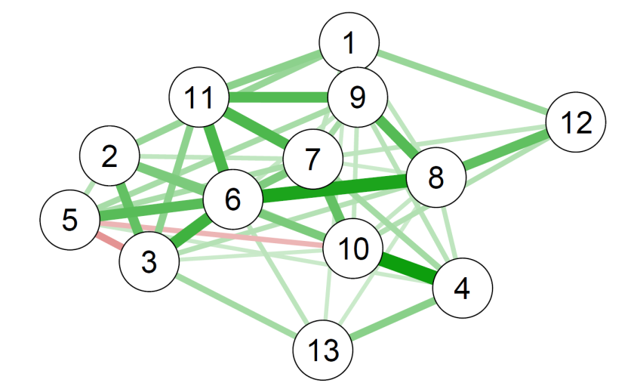

|  |  |  |  |  |  |
| --- | --- | --- | --- | --- | --- |
| **Table A1.** Centrality and expected influence indices for sample network | | | | | |
| Node | Closeness | Betweenness | Strength | EI1 | EI2 |
| 1 | 0.00624 | 2 | 0.739 | 0.739 | 1.296 |
| 2 | 0.00670 | 8 | 0.640 | 0.640 | 1.127 |
| 3 | 0.00687 | 6 | 0.767 | 0.557 | 1.067 |
| 4 | 0.00577 | 6 | 0.623 | 0.623 | 1.063 |
| 5 | 0.00620 | 0 | 0.633 | 0.277 | 0.596 |
| 6 | 0.00836 | 26 | 1.199 | 1.199 | 2.015 |
| 7 | 0.00690 | 4 | 0.948 | 0.948 | 1.658 |
| 8 | 0.00739 | 16 | 0.898 | 0.898 | 1.615 |
| 9 | 0.00684 | 6 | 0.941 | 0.941 | 1.662 |
| 10 | 0.00663 | 18 | 0.904 | 0.759 | 1.366 |
| 11 | 0.00731 | 6 | 0.741 | 0.741 | 1.420 |
| 12 | 0.00550 | 0 | 0.392 | 0.392 | 0.721 |
| 13 | 0.00467 | 0 | 0.373 | 0.373 | 0.657 |

To conclude step 1, we calculated the centrality and expected influence indices of the nodes in the network (see Table A1). In this example network, nodes 6 through 10 are highly central to the network, while other nodes (e.g., Nodes 12 and 13) have fewer and weaker edges connecting it to the rest of the network.

The example of Node 5 is of particular relevance to the current study. Most nodes in this network have exclusively positive edges and, thus, their strength is equal to their EI1. However, for nodes with negative edges, such as Node 5, these measures diverge. Node 5 has relatively moderate node strength. However, because of its mix of positive and negative edges, Node 5 has the lowest expected influence scores of any node in the network. In other words, the strength index identifies Node 5 as having some modest importance within the network. The expected influence indices do not.

**In Step 2,** we simulated the dynamics of the network by iteratively calculating the activation of each node at Time 2 (xit) as a function of the value of all remaining nodes in the network at Time 1 (xjt-1) weighted by the edges shared between node i and node j ($a_{ij}w_{ij}$). In doing so, we made several assumptions about nodes, edges, and networks. First, we assumed that nodes cannot have negative activation and that nodes cannot increase in severity indefinitely. We further assumed that increases in activation are not linear and that, at high levels of node activation, more incoming influence from other nodes is needed to increase node activation than is needed at lower levels of node activation. We made no such assumption as node activation approaches 0. To incorporate these assumption into the simulation, we used an arctangent function multiplied by 2/pi to constrain node activation below 1 and a domain restriction to constrain node activation above 0. For these simulations, we defined the value of node i at Time 2 purely as a function of the remaining nodes in the network and did not incorporate external influence or self-loops.

$$x_{it}=\frac{2}{π} \tan^{-1}{(2.5 \sum_{j=1}^{N}{\tan{(\frac{π}{2}x_{jt-1}}a_{ij}w_{ij})})}$$

|  |  |  |
| --- | --- | --- |
| **Table A2.** Node activation in example network | | |
| Node | Start | Iteration 30 | |
| 1 | 0.50 | 0.71 | |
| 2 | 0.50 | 0.67 | |
| 3 | 0.50 | 0.66 | |
| 4 | 0.50 | 0.66 | |
| 5 | 0.50 | 0.46 | |
| 6 | 0.50 | 0.81 | |
| 7 | 0.50 | 0.77 | |
| 8 | 0.50 | 0.76 | |
| 9 | 0.50 | 0.77 | |
| 10 | 0.50 | 0.73 | |
| 11 | 0.50 | 0.73 | |
| 12 | 0.50 | 0.54 | |
| 13 | 0.50 | 0.51 | |
| **Network Activation** | **6.50** | **8.78** | |

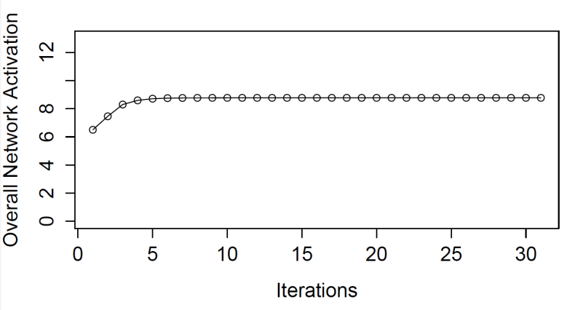We assigned all nodes an initial starting value of .50 and performed 30 iterations of this network to allow it to reach of point of stable activation in which the amount of incoming influence for the nodes in the network is insufficient to further increase activation of those nodes.

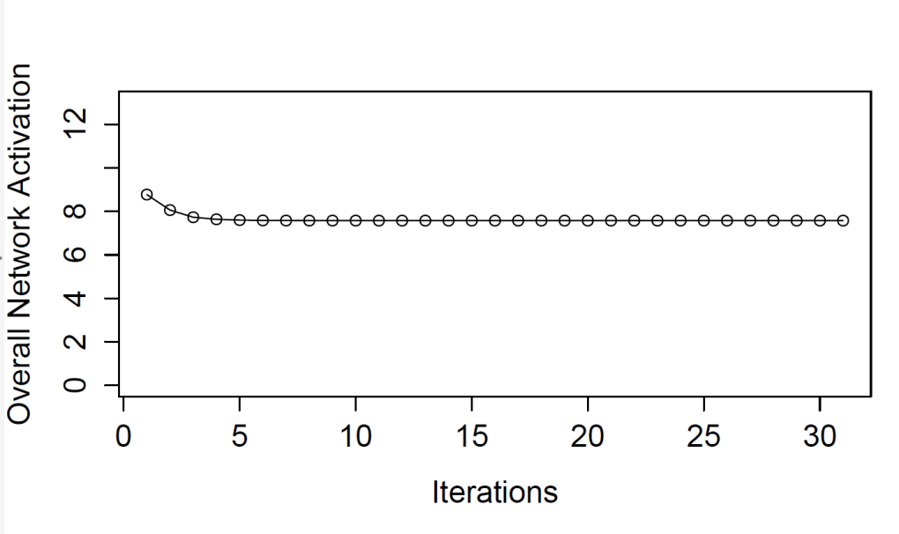**In Step 3,** we evaluated the effect of “deactivating” a single node by setting the activation of the target node to 0 and then repeating the simulation of the network dynamics as described in Step 2. We again performed 30 iterations of this network to allow the network to reach a new point of stability. The figure below depicts the effect on overall network activation induced by intervening on Node 1.

|  |  |  |  |  |  |  |  |
| --- | --- | --- | --- | --- | --- | --- | --- |
| **Table A3.** Centrality, expected influence, and observed node influence in example network | | | | | | | |
|  | Centrality | | | Expected influence | | Observed Influence | |
| Node | Closeness | Betweenness | Strength | EI1 | EI2 | Overall Change | Remainder Change |
| 1 | 0.00624 | 2 | 0.739 | 0.739 | 1.296 | 1.20 | 0.49 |
| 2 | 0.00670 | 8 | 0.640 | 0.640 | 1.127 | 1.05 | 0.38 |
| 3 | 0.00687 | 6 | 0.767 | 0.557 | 1.067 | 0.92 | 0.26 |
| 4 | 0.00577 | 6 | 0.623 | 0.623 | 1.063 | 1.06 | 0.40 |
| 5 | 0.00620 | 0 | 0.633 | 0.277 | 0.596 | 0.52 | 0.06 |
| 6 | 0.00836 | 26 | 1.199 | 1.199 | 2.015 | 1.97 | 1.16 |
| 7 | 0.00690 | 4 | 0.948 | 0.948 | 1.658 | 1.49 | 0.72 |
| 8 | 0.00739 | 16 | 0.898 | 0.898 | 1.615 | 1.44 | 0.68 |
| 9 | 0.00684 | 6 | 0.941 | 0.941 | 1.662 | 1.49 | 0.72 |
| 10 | 0.00663 | 18 | 0.904 | 0.759 | 1.366 | 1.26 | 0.53 |
| 11 | 0.00731 | 6 | 0.741 | 0.741 | 1.420 | 1.13 | 0.40 |
| 12 | 0.00550 | 0 | 0.392 | 0.392 | 0.721 | 0.69 | 0.14 |
| 13 | 0.00467 | 0 | 0.373 | 0.373 | 0.657 | 0.66 | 0.15 |

Deactivating Node 1 led to an overall change in network activation of 1.20. However, much of that change in overall network activation was due to the removal of Node 1 itself, which was reduced from .71 to 0. To avoid any confounding effects of incorporating the target node into our assessment of network change, we then calculated the change in the remainder of the network (1.20 - 0.71 = 0.49). We repeated this process for each node in the network. Table A3 includes the centrality and expected influence indices from Step 1 and the observed influence of “treating” each node.

Finally, to conclude step 3, we calculated the correlation of each of the centrality and expected influence indices with observed influence. In this example network, closeness, *r* (11) = .77, betweenness, *r* (11) = .78, and strength, *r* (11) = .90 were all strongly correlated with observed node influence. However, one-step expected influence, *r* (11) = .98, and two-step expected influence, *r* (11) = .96, exhibited notably higher correlations. The reason for this stronger correlation can be seen in the figures below.

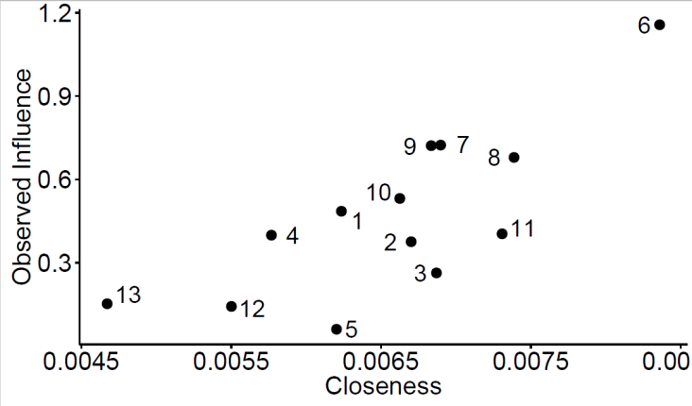

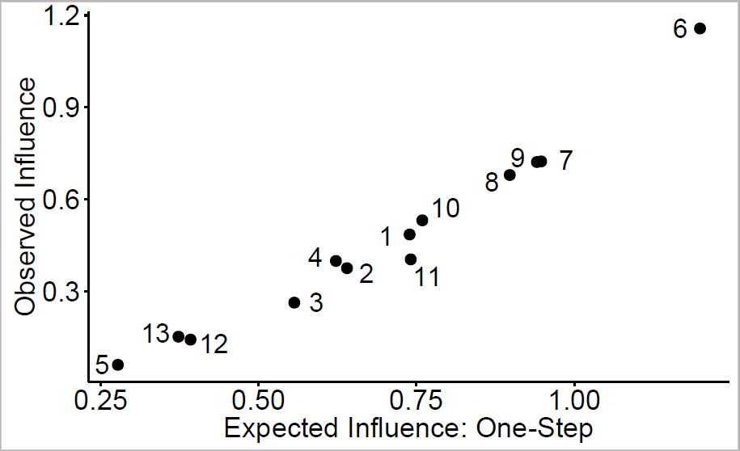

As previously noted, the centrality and expected influence indices make different predictions about the importance of Node 5. The centrality and expected influence indices diverge for this node because it has negative edges. The closeness index identifies Node 5 has having some modest importance, assigning it greater importance than three other nodes in the network. In contrast, EI1 identifies it as the least important node in the network. Consistent with this latter prediction, Node 5 exhibited the lowest observed influence on the network. That is, “treating” Node 5 had minimal cumulative impact on the other nodes and less impact than treating any other node in the network. The closeness index failed to predict this low observed influence because it failed to distinguish between positive and negative edges. A similar pattern can be observed for Node 3, another node with a strong negative edge. Together, these finding illustrate the advantage of the expected influence indices in identifying influential nodes.

To obtain a reliable estimate of centrality and expected influence and their relation to observed node influence, we repeated this single node intervention 500 times in each of our four conditions (0%, 5%, 10, and 25% negative edges). The results of these analyses appear in Figure 1 in the manuscript text. The figure below presents the findings for closeness and one-step expected influence in networks with all positive edges and in networks with 25% negative edges. In networks with positive edges, expected influence was consistently very strongly associated with observed node influence, *M =* .96 (.03) and tended to remain strongly correlated with it even in networks with 25% negative edges, *M =* .80 (.16). In contrast, closeness was strongly correlated with observed influence in networks with positive edges, *M =* .82 (.09)*,* but is, on average, only moderately correlated with observed node influence in networks with 25% negative edges. Moreover, as seen in the distribution in the lower left panel of the figure below, the correlation was not even minimal (*r* = .10) in a non-trivial number of trials. In other words, in networks with a high proportion of negative edges, closeness was not consistently strongly correlated with observed node influence.

*M=*.82 (.09)

*M=*.96 (.03)

*M=*.45 (.30)

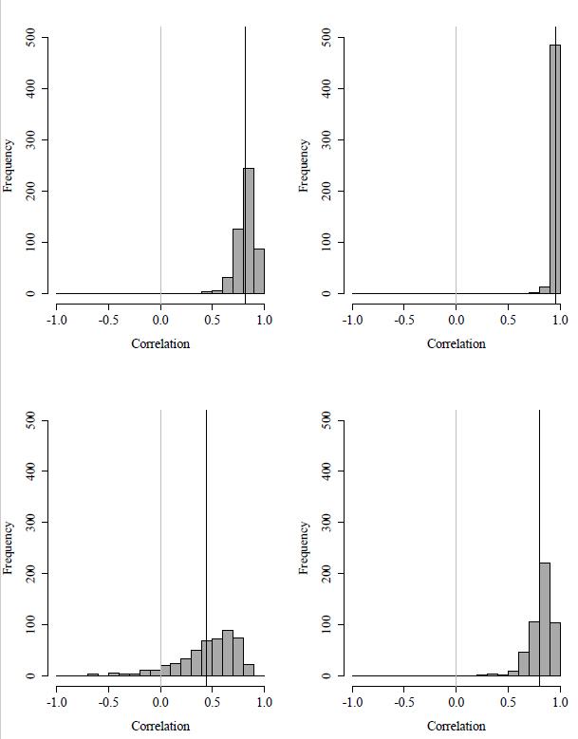

**Positive Edges Only**

**25% Negative Edges**

**EI1**

**Closeness**

*M=*.80 (.16)

**Supplementary Materials B**

**Aim 2: Node Change and Network Change**

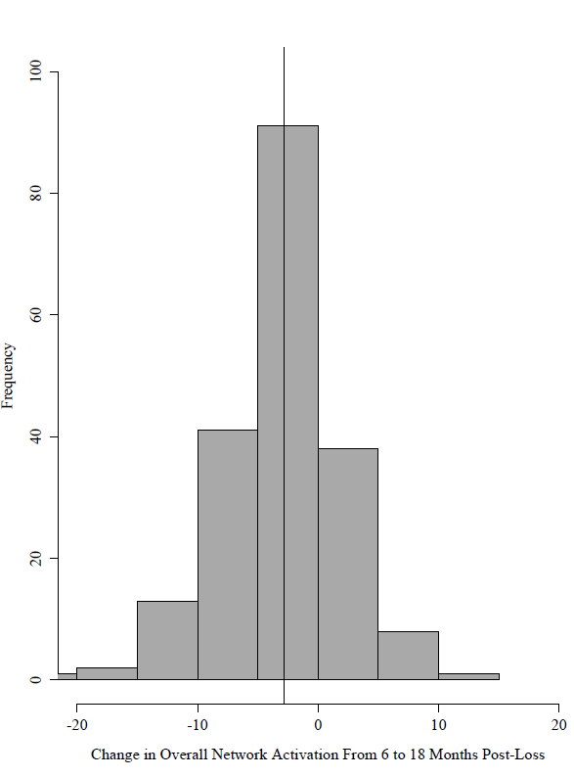

M (SD) = -2.86 (4.88)

*Figure B1.* Histogram depicting the change in overall network activation from 6 to 18-months post loss.

Table B1

|  |  |  |  |  |
| --- | --- | --- | --- | --- |
|  | Node Change | | Correlation Between Node Change and Change in the Rest of the Network | |
|  | M | SD | *r* [95% CI] | *p* |
| B1_Yearning | -0.20 | 1.25 | .25 [.11, .37] | .001 |
| B2_Emotional Pain | -0.46 | 0.76 | .31 [.18, .43] | < .001 |
| B3_Thoughts Person | -0.21 | 0.60 | .13 [-.01, .27] | .062 |
| B4_Thoughts Death | -0.14 | 1.17 | .21 [.08, .34] | .003 |
| C1_Difficulty Accepting | -0.30 | 1.01 | .34 [.21, .46] | < .001 |
| C2_Numbness/Disbelief | -0.25 | 0.89 | .18 [.04, .31] | .014 |
| C4_Bitterness about loss | -0.08 | 0.71 | .29 [.16, .42] | < .001 |
| C5_Regret | 0.01 | 0.78 | .19 [.05, .32] | .009 |
| C6_Avoidance | -0.06 | 0.82 | .05 [-.09, .19] | .489 |
| C9_Loneliness | -0.14 | 0.69 | .15 [.01, .28] | .039 |
| C10_Life Empty | -0.30 | 0.86 | .44 [.33, .55] | < .001 |
| C11_Diminished Identity | -0.54 | 1.21 | .26 [.12, .38] | < .001 |
| C12_Future | -0.12 | 1.00 | .15 [.01, .28] | .042 |

*Mean and standard deviation of individual node change from Time 1 to Time 2 and correlations between node activation change and change in activation of the remainder of the network from Time 1 to Time 2*

*Note.* Change in the rest of the network was calculated as overall network change – change in the node of interest. Accordingly the “network change” variable differs for each node.

**Supplementary Materials C**

**Aim 2: Lasso Network Findings**

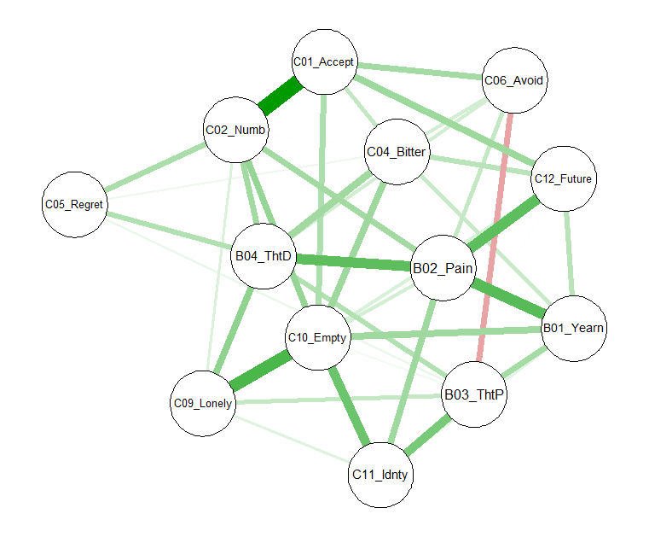

*Figure C1.* Lasso network for nodes of CG at 6 months post-loss. Each node represents a symptom of CG. Each edge represents the L1-regularized covariance between two nodes after accounting statistically for the effect of the remaining nodes in the network between two nodes. Thicker edges signify stronger associations. Nodes with stronger inter-node associations appear in the center for the network.

Table C1

*Reliability Assessment of Centrality and Expected influence Indices at 6-months post-loss in Lasso Network*

|  |  |  |  |
| --- | --- | --- | --- |
| Centrality/EI Index | *M* | *SD* |  |
| Closeness | 0.48 | 0.20 |  |
| Strength | 0.42 | 0.20 |  |
| Betweenness | 0.37 | 0.23 |  |
| EI1 | 0.58 | 0.18 |  |
| EI2 | 0.54 | 0.17 |  |

*Note.* To examine the reliability of centrality indices within Time 1, we conducted Spearman correlation permutation tests (cf. Courrieu, Brand-D’Abrescia, Peereman, Spieler, & Rey, 2010 ). Similar analyses have been used to test the reproducibility of network metrics in neuroimaging research (Telesford et al., 2010 ). For this analysis, we divided the Time 1 dataset into two equally sized samples composed of independent subjects. Then, following the identical procedures as the main analysis in the current study, we calculated network centrality indices separately for each sample and conducted the Spearman correlation between these indices to test whether the two samples resulted in similar centrality metrics for each node. We then permuted this process - conducting the Spearman correlation on the centrality metrics of two randomly divided Time 1 samples – 10,000 times to establish a distribution of Spearman correlation values for the Time 1 network centrality indices. Computer code for the analyses was written in R using the qgraph package and Python, using packages pandas 0.16.2 (McKinney, 2010), numpy 1.9.2 (van der Walt, Colbert, and Varoquaux, 2011), scipy 0.15.1 (Millman & Aivazis, 2011). The reliability analyses were carried out in R and Python.

**References**

Courrieu, P., Brand-D'Abrescia, M., Peereman, R., Spieler, D., & Rey, A. (2011). Validated intraclass correlation statistics to test item performance models. Behavior Research Methods, 43, 37-55. doi: 10.3758/s13428-010-0020-5

McKinney, W. (2010) Data Structures for Statistical Computing in Python, Proceedings of the 9th Python in Science Conference, 51-56

Millman, K.J. & Aivazis, M. (2011) Python for Scientists and Engineers, Computing in Science & Engineering, 13, 9-12, doi:10.1109/MCSE.2011.36

Telesford, Q. K., Morgan, A. R., Hayasaka, S., Simpson, S. L., Barret, W., Kraft, R. A., . . . Laurienti, P. J. (2010). Reproducibility of graph metrics in FMRI networks. *Front Neuroinform, 4*, 117. doi: 10.3389/fninf.2010.00117

van der Walt, S., Colbert, S.C. & Varoquaux, G. (2011) The NumPy Array: A Structure for Efficient Numerical Computation, Computing in Science & Engineering, 13, 22-30, doi:10.1109/MCSE.2011.37

**Supplementary Materials D**

**Aim 2: Association Network Findings**

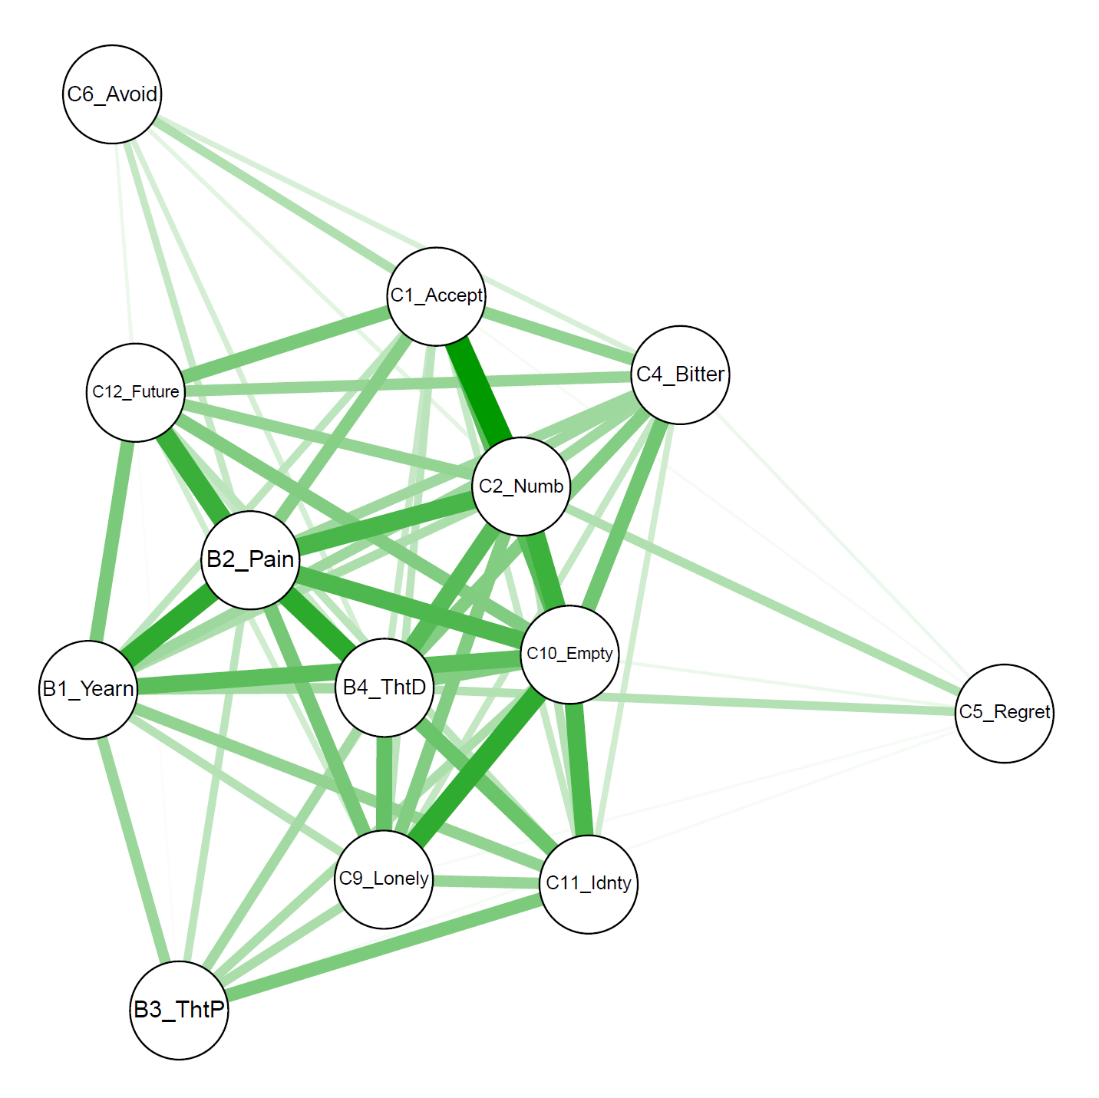

*Figure D1.* Association network for nodes of CG at 6 months post-loss. Each node represents a symptom of CG. Each edge represents the zero-order Pearson product-moment correlation between two nodes. Thicker edges signify stronger correlations. Edges not statistically significant were omitted from the network. Nodes with stronger inter-node associations appear in the center for the network.

Table D1

*Indices of Node Centrality for the Association Network of Complicated Grief Symptoms at 6 Months Post-loss*

|  |  |  |  |  |  |
| --- | --- | --- | --- | --- | --- |
|  | Time 1: 6 Months Post-Loss | | | | |
|  | Strength | Closeness | Betweenness | EI1 | EI2 |
| B1_Yearning | 3.543 | 0.022 | 2 | 3.543 | 15.956 |
| B2_Emotional Pain | 4.419 | 0.028 | 8 | 4.419 | 19.366 |
| B3_Thoughts Person | 2.565 | 0.018 | 0 | 2.271 | 10.811 |
| B4_Thoughts Death | 3.867 | 0.025 | 10 | 3.867 | 16.917 |
| C1_Difficulty Accepting | 3.566 | 0.023 | 2 | 3.566 | 15.935 |
| C2_Numbness/Disbelief | 4.119 | 0.026 | 8 | 4.118 | 18.181 |
| C4_Bitterness about loss | 3.250 | 0.021 | 0 | 3.250 | 14.544 |
| C5_Regret | 1.803 | 0.014 | 0 | 1.803 | 8.304 |
| C6_Avoidance | 1.774 | 0.014 | 0 | 1.439 | 7.051 |
| C9_Loneliness | 3.391 | 0.022 | 0 | 3.391 | 15.552 |
| C10_Life Empty | 4.365 | 0.027 | 4 | 4.364 | 19.248 |
| C11_Diminished Identity | 3.266 | 0.021 | 0 | 3.225 | 14.786 |
| C12_Future | 3.208 | 0.021 | 0 | 3.208 | 14.798 |

*Note.* EI1 = one-step expected influence. EI2 = two-step expected influence.

Table D2

|  |  |  |  |
| --- | --- | --- | --- |
| Centrality Index | *M* | *SD* |  |
| Closeness | 0.71 | 0.10 |  |
| Strength | 0.72 | 0.10 |  |
| Betweenness | 0.46 | 0.22 |  |
| EI1 | 0.74 | 0.09 |  |
| EI2 | 0.72 | 0.10 |  |

*Reliability Assessment of Centrality and Expected influence Indices at 6-months post-loss in Association Network*

*Note.* To examine the reliability of centrality indices within Time 1, we conducted Spearman correlation permutation tests (cf. Courrieu, Brand-D’Abrescia, Peereman, Spieler, & Rey, 2010 ). For further details, see Supplementary Materials C: Table C1.

Table D3

*Correlations with 95% Confidence Intervals Among Centrality Indices, Expected Influence Indices, and the Strength of Association Between CG Node Activation Change and CG Network Activation Change from 6- to 18-months Post-loss*

|  |  |  |  |  |  |
| --- | --- | --- | --- | --- | --- |
|  | Centrality | | | Expected influence | |
|  | Closeness | Betweenness | Strength | EI1 | EI2 |
| Betweenness | .74 [.32,.92] |  |  |  |  |
| Strength | >.99 [.98,1.00] | .69 [.22,.90] |  |  |  |
| EI1 | .99 [.96,1.00] | .67 [.20,.89] | >.99 [.98,1.00] |  |  |
| EI2 | .98 [.94,1.00] | .64 [.14,.88] | .99 [.98,1.00] | >.99 [.98,1.00] |  |
| Node-Network Association | .65 [.15, 88] | .52 [-.04., .83] | .67 [.18, 89] | .68 [.21, .90] | .67 [.19, .89] |

*Note*. We calculated the centrality and expected influence indices from an association network of CG symptoms at 6 months post-loss. All indices were strongly correlated with one another. Two of the three centrality indices and both expected influence indices were strongly and significantly associated with the strength of association between node change and network change. Although betweenness exhibited a strong correlation with the node change-network change association, this finding was not statistically significant.