**Supplementary Figure Captions**

*Supplementary Figure 1.*Ventral striatum region-of-interest (ROI) used to extract percent-signal-change values for Group (BD, HC) x Task (MID, SID) ANOVAs during reward anticipation and receipt. ROI was defined using the Nucleus Accumbens mask from the Harvard-Oxford Subcortical Structural Atlas. Values were extracted using the FeatQuery tool in FSL.

*Supplementary Figure 2.* Orbitofrontal cortex region-of-interest (ROI) used to extract percent-signal-change values for Group (BD, HC) x Task (MID, SID) ANOVAs during reward anticipation and receipt. ROI was defined using the Frontal Orbital Cortex mask from the Harvard-Oxford Subcortical Structural Atlas. Values were extracted using the FeatQuery tool in FSL.

*Supplementary Figure 3.*Full illustration of axial slices with significant activations reflecting a main effect of Group during reward receipt, emerging from a BD (Win - No Win) > HC (Win - No Win) contrast across monetary and social reward types. No significant regions emerged where HC > BD using the same contrast.

**Supplementary Figure 1.**

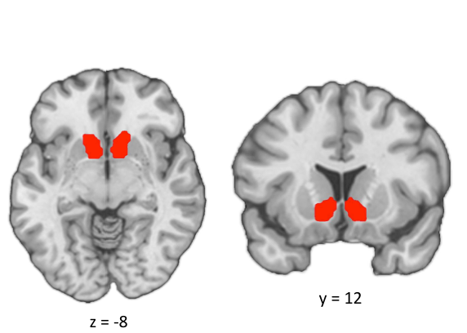

**Supplementary Figure 2.**

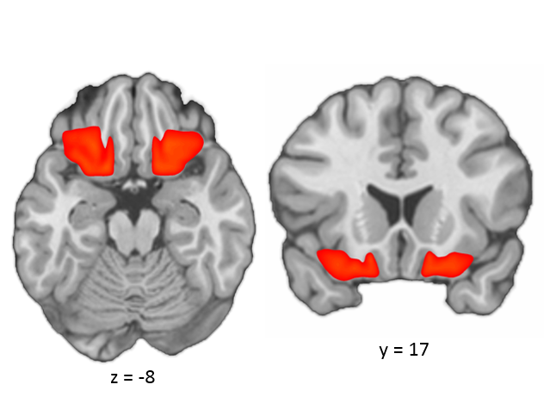

**Supplementary Figure 3.**

