**Supplemental Materials**

**Genotyping Methods and Quality Control**

**CATS.** Genotyping was performed at Johns Hopkins Center for Inherited Disease Research (CIDR) using the Illumina Human660W-Quad BeadChip. Of the 559,348 SNPs for which genotyping was attempted, data were released for 557,425 (99.7%). Quality control measures were excellent, with concordance rates of 99.9% for blind duplicates and 99.8% for HapMap control samples. Further data cleaning included the application of standard filters for deviation from Hardy-Weinberg Equilibrium (*p* > 10-6), minor allele frequency (MAF > 0.01), SNP call rate (>99%), sample genotyping (>99%), and GenomeStudio genotype quality score (>0.7).

**SAGE.** DNA was extracted from the blood sample, and cell lines were developed as an additional DNA source. Samples were genotyped using lllumina Human1Mv1_CBeadChip at the Johns Hopkins Center for Inherited Disease Research (CIDR). Extensive and rigorous data cleaning was employed resulting in quality controlled genotypic data for 948,658 single nucleotide polymorphisms (SNPs) in 859 European-American participants with child abuse and cannabis use data (Laurie et al., 2010).

**DNS.** DNA was isolated from saliva derived from Oragene DNA self-collection kits (DNA Genotek) customized for 23andMe (www.23andme.com). DNA extraction and genotyping were performed by the National Genetics Institute (NGI), a CLIA-certified clinical laboratory and subsidiary of Laboratory Corporation of America. The Illumina HumanOmniExpress BeadChips and a custom array containing an additional ~300,000 SNPs were used to provide genome-wide data. To account for differences in ancestral background in the EA sample, ancestrally-informative principal components were generated using EIGENSTRAT (v. 5.0.1; Price, Zaitlen, Reich, & Patterson, 2010); plotting and visual inspection of a scree plot of the top 10 components revealed that the top 2 principal components accounted for divergent ancestry within the population.

**DNS BOLD fMRI Procedures**

**BOLD fMRI Acquisition.** Participants were scanned using a research-dedicated GE MR750 3T scanner equipped with high-power high-duty-cycle 50-mT/m gradients at 200 T/m/s slew rate, and an eight-channel head coil for parallel imaging at high bandwidth up to 1MHz at the Duke-UNC Brain Imaging and Analysis Center. A semi-automated high-order shimming program was used to ensure global field homogeneity. A series of 34 interleaved axial functional slices aligned with the anterior commissure-posterior commissure (AC-PC) plane were acquired for full-brain coverage using an inverse-spiral pulse sequence to reduce susceptibility artifact [TR/TE/flip angle=2000 ms/30 ms/60; FOV=240 mm; 3.75×3.75×4 mm voxels (selected to provide whole brain coverage while maintaining adequate signal-to-noise and optimizing acquisition times); interslice skip=0]. Four initial RF excitations were performed (and discarded) to achieve steady-state equilibrium. To allow for spatial registration of each participant’s data to a standard coordinate system, high-resolution three-dimensional structural images were acquired in 34 axial slices co-planar with the functional scans (TR/TE/flip angle=7.7 s/3.0 ms/12; voxel size=0.9×0.9×4 mm; FOV=240 mm, interslice skip=0).

**BOLD fMRI data analysis.** The general linear model of Statistical Parametric Mapping 8 (SPM8; http://www.fil.ion.ucl.ac.uk/spm) was used for whole-brain image analysis. Individual participant data were first realigned to the first volume in the time series to correct for head motion before being spatially normalized into the standard stereotactic space of the Montreal Neurological Institute (MNI) template using a 12-parameter affine model. Next, data were smoothed to minimize noise and residual differences in individual anatomy with a 6mm FWHM Gaussian filter. Voxel-wise signal intensities were ratio normalized to the whole-brain global mean. Then the ARTifact Detection Tool (ART; http://www.nitrc.org/projects/artifact_detect/) was used to generate regressors accounting for images due to large motion (i.e., >0.6mm relative to the previous time frame) or spikes (i.e., global mean intensity 2.5 standard deviations from the entire time series). Participants for whom more than 5% of acquisition volumes were flagged by ART (n=3) were removed from analyses. An ROI mask (AAL atlas) from the Wake Forest University PickAtlas (http://www.fmri.wfubmc.edu/download.htm; Maldjian, Laurienti, Kraft, & Burdette, 2003) was used to ensure adequate amygdala coverage. Participants who had less than 90% coverage of the amygdala (n=6) were excluded from analyses. Following preprocessing steps outlined above, linear contrasts employing canonical hemodynamic response functions were used to estimate task-specific BOLD responses for each individual. Amygdala habituation to threat-related stimuli was calculated as the linear decrease over successive face-matching blocks (that is, block 1 > block 2 > block 3 > block 4). Individual contrast images (i.e., weighted sum of the beta images) were used in second-level random effects models accounting for scan-to-scan and participant-to-participant variability to determine mean contrast-specific responses using one-sample t-tests. A voxel-level statistical threshold of P < 0.05, family wise error corrected for multiple comparisons across the left and right basolatoral amygdala regions of interest, and a cluster-level extent threshold of 10 contiguous voxels were applied to these analyses. Regions of interest (ROIs) were defined using anatomical probability maps (Amunts et al., 2005).

**Post-hoc SEM Methods**

Within an Opioid Relapse section of the CATS interview, participants meeting criteria for opioid dependence (*n* = 1,189) responded to several questions relating to their use of substances to control mood, for which 1,182 participants provided complete responses. The questions are as follows:

Do you frequently use drugs to control your mood?

(If Yes): Have you often alternated or chased one drug with another that affected your mood differently?

Please look again at Card F. Have you frequently used a drug from the List to control your mood or to chase another drug? How about List 2? List 3? List 4? List 5?

Participants who responded “no” to the first question (*n* = 551) were coded as “0” for analysis purposes. The first follow-up question was not used for these analyses. Card F contained lists of colloquial substance names that could be characterized as: 1) marijuana, 2) sedatives, 3) stimulants, 4) cocaine, 5) opioids, and 6) other drugs; participants who responded to the second follow-up question that they used a substance on the marijuana list for the purposes of controlling mood or chasing another drug (*n* = 408) were coded as “1,” while all others (*n* = 223) were coded as “0.” Use of the other drug categories (i.e., sedatives, stimulants, cocaine, and opioids) to control mood were coded in the same manner for the purposes of follow-up specificity. Given the reductions in power due to smaller sample size and a dichotomous mediator, genotype was coded based on presence or absence of the minor A allele (i.e., GG vs AA/AG).

The full structural equation model (SEM; Figure 4) was constructed using Mplus (v7.11; Muthén & Muthén, 2012). Model goodness of fit was assessed using root mean square residual (RMSEA < 0.05), weighted root mean square residual (WRMR < 0.90), comparative fit index (CFI > 0.90; Schermelleh-Engel, Moosbrugger, & Müller, 2003), and relative χ2 (relative χ2 < 5; Schumacker & Lomax, 2004). Consistent with the initial interaction analyses performed in the CATS sample, sex, age quintile, three ancestrally informative principal components, and their interactions with rs604300and CSA were entered as covariates in the model. Effects were estimated using 5000 bootstrapped samples.

**Epigenetic Annotation**

We first focused on H3K4me [methylation of the 4th residue (lysine) from the N-terminus (start) of the histone H3 protein] because H3K4me is tightly correlated with the promoters of genes and regulates gene transcription by promoting transcriptional enhancer and reducing transcriptional suppressor binding; it is one of the most studied histone modifications. A tissue-specific pattern of H3K4me1 [i.e., monomethylation of the 4th residue (lysine) from the N-terminus of the histone H3 protein] was observed (Figure S8). This epigenetic histone modification is located just upstream of rs604300 (i.e., toward the 5’ region; length ~1kbp, including one *MGLL* exon) within *MGLL* and functions as an enhancer that upregulates gene expression. Across tissue types, the strongest H3K4me1 enrichment came from neurospheres (i.e., neural stem cells). H3K4me1 enrichment was absent in blood cells, suggesting that this epigenetic enhancer is most prevalent in brain tissue and may be particularly important during early development.

Following this tissue-specific evidence of epigenetically-regulated *MGLL* enhancement, we examined DNA methylation (whole genome bisulfite sequencing) as well as H3K4me1 (enhancer associated histone modification) and H3K27ac [i.e., acetylation of the 27th residue (lysine) from the start of the H3 protein; an active enhancer associated histone modification) enrichment around rs604300 in brain and blood cell samples (Figure 4A). Low levels of DNA methylation are present in brain samples, accompanied by highly enriched H3K4me1 and H3K27ac histone modification that would both serve to enhance MGLL gene expression. Conversely, hematopoietic stem cells were highly methylated in this region and peripheral blood mononuclear cells showed no evidence of H3K4me1 or H3K27ac enrichment (Figure 4B). The lack of methylation just upstream of this SNP combined with the presence of enhancer histone modification may allow for *MGLL* to be expressed in brain, but not in blood. More broadly, this suggests that methylation and histone modification in this epigenetically-regulated enhancer region of *MGLL* might play a large role in *MGLL* transcription. As such, it is possible that environmentally-mediated individual differences in methylation and histone modification-related enhancement of this region may produce differential *MGLL* expression in the brain. rs604300 is located near this epigenetically-regulated enhancer; while we are unable to test for genotype-dependent differences in methylation and histone modification with the data available to us, this annotation suggests that rs604300 genotype or a SNP that it is in LD with, may impact *MGLL* expression by affecting epigenetic modification within or near this *MGLL* enhancer.

References

Amunts, K., Kedo, O., Kindler, M., Pieperhoff, P., Mohlberg, H., Shah, N. J., … Zilles, K. (2005). Cytoarchitectonic mapping of the human amygdala, hippocampal region and entorhinal cortex: Intersubject variability and probability maps. *Anatomy and Embryology*, *210*(5-6), 343–52. doi:10.1007/s00429-005-0025-5

Maldjian, J. A., Laurienti, P. J., Kraft, R. A., & Burdette, J. H. (2003). An automated method for neuroanatomic and cytoarchitectonic atlas-based interrogation of fMRI data sets. *NeuroImage*, *19*(3), 1233–1239. doi:10.1016/S1053-8119(03)00169-1

Muthén, L. K., & Muthén, B. O. (2012). *Mplus User’s Guide. Seventh Edition.* Los Angeles, CA: Muthén & Muthén.

Price, A. L., Zaitlen, N. A., Reich, D., & Patterson, N. (2010). New approaches to population stratification in genome-wide association studies. *Nature Reviews: Genetics*, *11*(7), 459–463. doi:10.1038/nrg2813

Schermelleh-Engel, K., Moosbrugger, H., & Müller, H. (2003). Evaluating the fit of structural equation models: Tests of significance and descriptive goodness-of-fit measures, *Methods of Psychological Research Online*,8(2), 23–74.

Schumacker, R. E., & Lomax, R. G. (2004). *A beginner's guide to structural equation modeling.* Psychology Press.

Table S1

*Distributions of Child Sexual Abuse, rs604300, and Cannabis Dependence Symptoms in CATS*

|  |  |  |  |  |  |  |
| --- | --- | --- | --- | --- | --- | --- |
|  |  | Cannabis Dependence Symptoms | | | |  |
| CSAa | Genotype | 0 | 1-2 | 3-4 | 5-6 | Total |
| 0 | GG | 149 | 151 | 160 | 180 | 640 |
|  | AG | 26 | 41 | 43 | 45 | 155 |
|  | AA | 2 | 3 | 2 | 4 | 11 |
| 1-2 | GG | 57 | 53 | 57 | 70 | 237 |
|  | AG | 12 | 15 | 17 | 14 | 58 |
|  | AA | 1 | 2 | 0 | 0 | 3 |
| 3-4 | GG | 28 | 44 | 39 | 61 | 172 |
|  | AG | 17 | 11 | 9 | 14 | 51 |
|  | AA | 0 | 1 | 0 | 1 | 2 |
| 5-6 | GG | 22 | 38 | 36 | 87 | 183 |
|  | AG | 8 | 13 | 5 | 20 | 46 |
|  | AA | 0 | 0 | 0 | 0 | 0 |
| Total |  | 322 | 372 | 368 | 496 | 1558 |

*Note.* CATS = Comorbidity and Trauma Study; CSA = childhood sexual abuse.

aNumber of types of CSA reported.

Table S2

*Gene Characteristics*

|  |  |  |  |  |
| --- | --- | --- | --- | --- |
| Gene | Chr | Starting BP | Ending BP | *N* SNPs |
| *CNR1* | 6 | 88849585 | 88875767 | 16 |
| *CNR2* | 1 | 24200460 | 24239817 | 0 |
| *DAGLA* | 11 | 61447905 | 61514474 | 13 |
| *DAGLB* | 7 | 6448747 | 6487643 | 4 |
| *FAAH* | 1 | 46859939 | 46879520 | 5 |
| *MGLL* | 3 | 127407905 | 127541725 | 24 |
| *NAPEPLD* | 7 | 102740023 | 102789569 | 3 |

*Note.* Chr = chromosome number; BP = basepair (for hg19).

Table S3

*Distributions of Child Abuse, rs604300, and Cannabis Dependence Symptoms in SAGE*

|  |  |  |  |  |  |  |  |
| --- | --- | --- | --- | --- | --- | --- | --- |
|  |  | Cannabis Dependence Symptoms | | | | |  |
| Child Abuse | Genotype | Never Used | 0 | 1-2 | 3-4 | 5-6 | Total |
| No | GG | 196 | 140 | 40 | 31 | 26 | 433 |
|  | AG | 46 | 31 | 5 | 13 | 19 | 114 |
|  | AA | 0 | 1 | 0 | 0 | 1 | 2 |
| Yes | GG | 38 | 86 | 36 | 35 | 55 | 250 |
|  | AG | 14 | 12 | 8 | 11 | 9 | 54 |
|  | AA | 1 | 2 | 0 | 2 | 1 | 6 |
| Total |  | 295 | 272 | 89 | 92 | 111 | 859 |

*Note.* SAGE = Study of Addiction: Genetics and Environment.

Table S4

*Distributions of ELS, rs604300, and Amygdala Habituation in DNS*

|  |  |  |  |
| --- | --- | --- | --- |
| CTQ Quartile | Genotype | *N* | Amygdala Habituationa *M* (*SD*) |
| 1 | GG | 69 | 0.06 (0.24) |
|  | AA/AG | 20 | -0.05 (0.17) |
| 2 | GG | 63 | 0.07 (0.22) |
|  | AA/AG | 15 | 0.08 (0.24) |
| 3 | GG | 60 | 0.07 (0.23) |
|  | AA/AG | 11 | 0.0009 (0.25) |
| 4 | GG | 59 | 0.04 (0.19) |
|  | AA/AG | 15 | 0.11 (0.23) |

*Note.* ELS = early life stress; DNS = Duke Neurogenetics Study; CTQ = Childhood Trauma Questionnaire.

aAmygdala habituation in the right basolateral amygdala to threat-related stimuli.

Table S5

*Regression Model Predicting DSM-IV Cannabis Dependence Symptoms in CATS*

|  |  |  |  |  |  |  |  |  |
| --- | --- | --- | --- | --- | --- | --- | --- | --- |
|  | Step 1 | | Step 2 | | Step 3 | | Step 4 | |
| Variable | *b\** | *P* | *b\** | *P* | *b\** | *P* | *b\** | *p* |
| Sex | -0.15 | < .001 | -0.19 | < .001 | -0.19 | < .001 | -0.19 | < .001 |
| Case | 0.25 | < .001 | 0.23 | < .001 | 0.23 | < .001 | 0.23 | < .001 |
| Age Q1 | -0.01 | .72 | -0.02 | .49 | -0.02 | .49 | -0.02 | .42 |
| Age Q2 | -0.09 | .004 | -0.10 | .002 | -0.10 | .001 | -0.11 | < .001 |
| Age Q3 | -0.14 | < .001 | -0.15 | < .001 | -0.15 | < .001 | -0.16 | < .001 |
| Age Q4 | -0.25 | < .001 | -0.25 | < .001 | -0.25 | < .001 | -0.26 | < .001 |
| PC1 | 0.06 | .02 | 0.05 | .03 | 0.05 | .02 | 0.05 | .02 |
| PC2 | -0.04 | .09 | -0.04 | .13 | -0.04 | .06 | -0.04 | .08 |
| PC3 | 0.03 | .14 | 0.04 | .12 | 0.03 | .22 | 0.03 | .18 |
| rs604300 |  |  | -0.02 | .32 | -0.03 | .26 | -0.03 | .22 |
| CSA |  |  | 0.13 | < .001 | 0.14 | < .001 | 0.14 | < .001 |
| rs604300 x Sex |  |  |  |  | 0.004 | .88 | 0.03 | .23 |
| rs604300 x Case |  |  |  |  | -0.02 | .38 | -0.007 | .78 |
| rs604300 x Age Q1 |  |  |  |  | -0.02 | .58 | -0.01 | .63 |
| rs604300 x Age Q2 |  |  |  |  | -0.06 | .05 | -0.06 | .04 |
| rs604300 x Age Q3 |  |  |  |  | 0.002 | .96 | -0.01 | .74 |
| rs604300 x Age Q4 |  |  |  |  | -0.06 | .06 | -0.07 | .04 |
| rs604300 x PC1 |  |  |  |  | 0.04 | .13 | 0.04 | .10 |
| rs604300 x PC2 |  |  |  |  | -0.04 | .08 | -0.04 | .10 |
| rs604300 x PC3 |  |  |  |  | -0.01 | .68 | -0.01 | .67 |
| CSA x Sex |  |  |  |  | 0.02 | .51 | 0.01 | .55 |
| CSA x Case |  |  |  |  | -0.03 | .16 | -0.04 | .13 |
| CSA x Age Q1 |  |  |  |  | -0.03 | .33 | -0.03 | .29 |
| CSA x Age Q2 |  |  |  |  | -0.01 | .73 | -0.02 | .59 |
| CSA x Age Q3 |  |  |  |  | 0.01 | .73 | 0.008 | .81 |
| CSA x Age Q4 |  |  |  |  | 0.01 | .73 | 0.006 | .84 |
| CSA x PC1 |  |  |  |  | 0.02 | .45 | 0.02 | .47 |
| CSA x PC2 |  |  |  |  | 0.01 | .69 | 0.01 | .60 |
| CSA x PC3 |  |  |  |  | -0.04 | .11 | -0.04 | .12 |
| rs604300 x CSA |  |  |  |  |  |  | -0.09 | < .001 |
| Model *R2* |  | .13 |  | .15 |  | .16 |  | .16 |
| Model Adjusted *R2* |  | .12 |  | .14 |  | .14 |  | .15 |
| Model *F* |  | 25.65 |  | 23.92 |  | 9.82 |  | 10.03 |
| Model *p* |  | < .001 |  | < .001 |  | < .001 |  | < .001 |

*Note.* CATS = Comorbidity and Trauma Study; PC = ancestrally-informative principal component; CSA = childhood sexual abuse.

Table S6

*Regression Model Predicting DSM-IV Cannabis Dependence Symptoms in SAGE*

|  |  |  |  |  |  |  |  |  |
| --- | --- | --- | --- | --- | --- | --- | --- | --- |
|  | Step 1 | | Step 2 | | Step 3 | | Step 4 | |
| Variable | *b\** | *P* | *b\** | *P* | *b\** | *P* | *b\** | *p* |
| PC | 0.04 | .18 | 0.04 | .17 | 0.03 | .46 | 0.03 | .55 |
| Age Q1 | 0.22 | < .001 | 0.19 | < .001 | 0.20 | < .001 | 0.21 | < .001 |
| Age Q2 | 0.18 | < .001 | 0.15 | < .001 | 0.17 | < .001 | 0.17 | < .001 |
| Age Q3 | 0.15 | < .001 | 0.13 | < .001 | 0.14 | < .001 | 0.14 | < .001 |
| Study | -0.05 | .21 | -0.05 | .16 | -0.05 | .20 | -0.04 | .21 |
| Sex | -0.22 | < .001 | -0.23 | < .001 | -0.22 | < .001 | -0.22 | < .001 |
| rs604300 |  |  | 0.07 | .03 | 0.07 | .04 | 0.07 | .04 |
| CA |  |  | 0.24 | < .001 | 0.24 | < .001 | 0.23 | < .001 |
| rs604300 x PC |  |  |  |  | 0.000 | .99 | -0.007 | .86 |
| rs604300 x Age Q1 |  |  |  |  | 0.10 | .03 | 0.11 | .01 |
| rs604300 x Age Q2 |  |  |  |  | 0.04 | .31 | 0.05 | .18 |
| rs604300 x Age Q3 |  |  |  |  | 0.05 | .20 | 0.05 | .15 |
| rs604300 x Study |  |  |  |  | 0.01 | .74 | 0.02 | .68 |
| rs604300 x Sex |  |  |  |  | -0.03 | .32 | -0.02 | .51 |
| CA x PC |  |  |  |  | 0.02 | .63 | 0.02 | .61 |
| CA x Age Q1 |  |  |  |  | 0.03 | .43 | 0.04 | .41 |
| CA x Age Q2 |  |  |  |  | 0.03 | .44 | 0.03 | .45 |
| CA x Age Q3 |  |  |  |  | 0.07 | .06 | 0.07 | .05 |
| CA x Study |  |  |  |  | -0.05 | .12 | -0.05 | .12 |
| CA x Sex |  |  |  |  | 0.03 | .38 | 0.03 | .40 |
| rs604300 x CA |  |  |  |  |  |  | -0.07 | .03 |
| Model *R2* |  | .09 |  | .16 |  | .17 |  | .18 |
| Model Adjusted *R2* |  | .09 |  | .15 |  | .15 |  | .16 |
| Model *F* |  | 14.69 |  | 19.72 |  | 8.61 |  | 8.48 |
| Model *p* |  | < .001 |  | < .001 |  | < .001 |  | < .001 |

*Note.* SAGE = Study of Addiction: Genetics and Environment; PC = ancestrally-informative principal component; CA = childhood abuse (physical and/or sexual).

Table S7

*Regression Model Predicting R BL Amygdala Habituation in DNS*

|  |  |  |  |  |  |  |  |  |
| --- | --- | --- | --- | --- | --- | --- | --- | --- |
|  | Step 1 | | Step 2 | | Step 3 | | Step 4 | |
| Variable | *b\** | *P* | *b\** | *P* | *b\** | *P* | *b\** | *p* |
| Sex | -0.03 | .58 | -0.03 | .64 | -0.03 | .65 | -0.02 | .69 |
| PC1 | -0.04 | .52 | -0.04 | .51 | -0.04 | .65 | -0.04 | .49 |
| PC2 | 0.04 | .43 | 0.05 | .37 | 0.12 | .23 | 0.11 | .27 |
| rs604300 |  |  | -0.06 | .33 | -0.07 | .29 | -0.06 | .31 |
| CTQ |  |  | 0.09 | .11 | 0.08 | .19 | 0.08 | .19 |
| rs604300 x Sex |  |  |  |  | -0.03 | .58 | -0.03 | .65 |
| rs604300 x PC1 |  |  |  |  | -0.04 | .58 | -0.04 | .60 |
| rs604300 x PC2 |  |  |  |  | -0.12 | .53 | -0.05 | .79 |
| CTQ x Sex |  |  |  |  | -0.11 | .07 | -0.12 | .05 |
| CTQ x PC1 |  |  |  |  | -0.004 | .95 | 0.005 | .93 |
| CTQ x PC2 |  |  |  |  | -0.05 | .73 | -0.003 | .98 |
| rs604300 x CTQ |  |  |  |  |  |  | 0.12 | .05 |
| Model *R2* |  | .004 |  | .02 |  | .03 |  | .04 |
| Model Adjusted *R2* |  | -.006 |  | -.001 |  | -.004 |  | .006 |
| Model *F* |  | 0.43 |  | 0.96 |  | 0.89 |  | 1.16 |
| Model *p* |  | .73 |  | .44 |  | .55 |  | .32 |

*Note.* R BL = right basolateral; DNS = Duke Neurogenetics Study; PC = ancestrally-informative principal component; CTQ = Childhood Trauma Questionnaire.

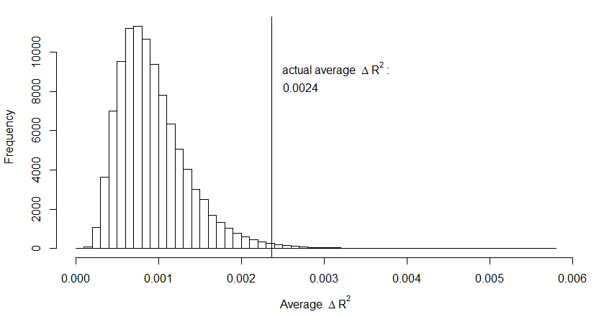

*Figure S1*. Empirical null distribution of MGLL x Childhood Sexual Abuse (CSA) analysis. Null distribution for the absolute test statistic, averaged across the maximum number of nominally significant (*p* < 0.05) SNPs obtained across a single permutation for 100,000 label-swapping permutations for the MGLL x CSA analysis. The actual test statistic (0.0024) is shown using a vertical line.

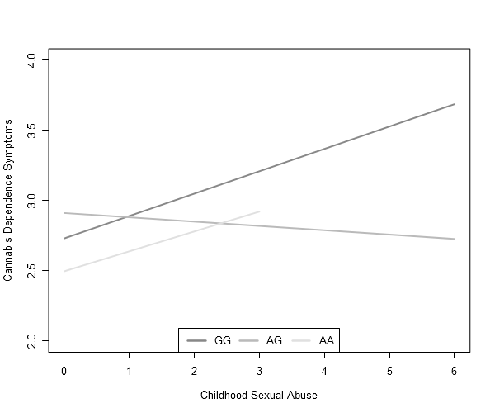

*Figure S2.* Raw data plot of the interaction of rs604300 with childhood sexual abuse (CSA) to predict cannabis dependence symptoms in CATS. X-axis denotes the number of CSA types endorsed by a participant, while y-axis indicates the number of DSM-IV cannabis dependence symptoms.

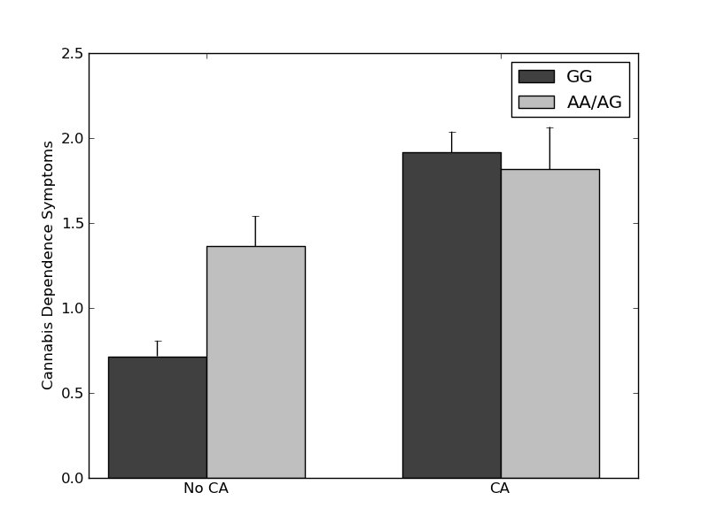

*Figure S3.* Raw data plot of the interaction of rs604300 with childhood abuse to predict cannabis dependence symptoms in SAGE. X-axis denotes whether or not a participant experienced abuse before the age of 18, while y-axis indicates number of DSM-IV cannabis dependence symptoms endorsed by that participant. Error bars represent the SEM. CA = childhood abuse.

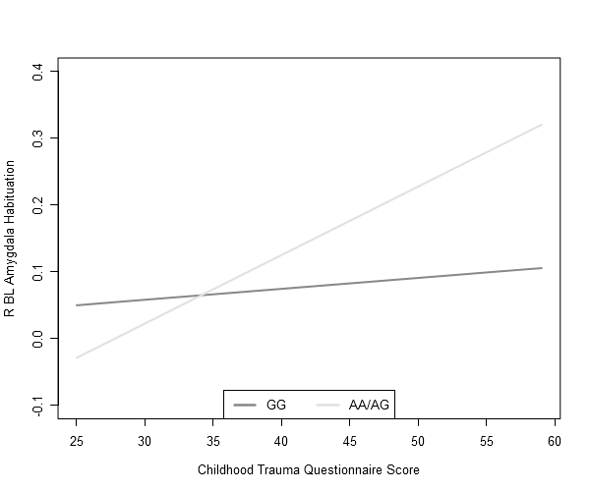

*Figure S4.* Raw data plot of the interaction of rs604300 with early life stress to predict right basolateral amygdala habituation to threat-related stimuli in DNS. X-axis denotes a participant’s score on the Childhood Trauma Questionnaire—Short Form (CTQ), while y-axis indicates amount of neural reactivity to socially-relevant stimuli early in the course of the task relative to later in the task. R BL = right basolateral.

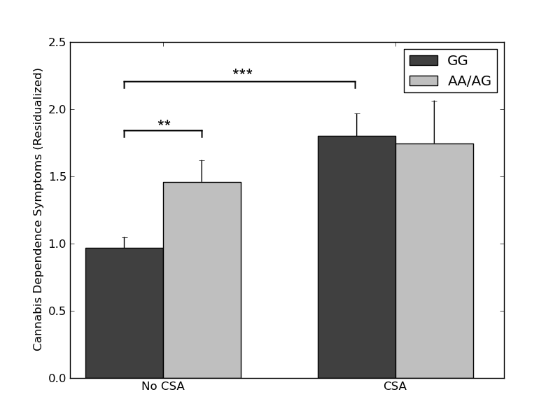

*Figure S5.* Interaction of rs604300 genotype with childhood sexual abuse to predict cannabis dependence symptoms in SAGE. X-axis denotes whether or not a participant experienced sexual abuse before the age of 18, while y-axis indicates residualized number of DSM-IV cannabis dependence symptoms endorsed by that participant. Though not significant (*bGxE* = -0.55, 95% CI [-1.34, 0.25], *ΔR2* = .002, *ΔF*(1, 820) = 1.80, *p* = .180), the direction of the effect is consistent with what was found by using a combined (physical and sexual) child abuse measure. Error bars represent the SEM. CSA = childhood sexual abuse.

* *p* < .05. ** *p* < .01. *** *p* < .001.

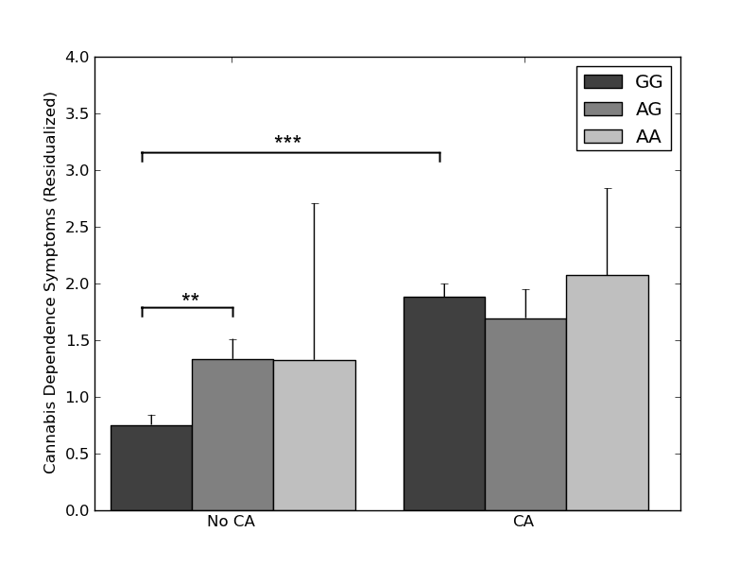

*Figure S6.* Interaction of additive rs604300 genotype with childhood abuse to predict cannabis dependence symptoms in SAGE. X-axis denotes whether or not a participant experienced abuse before the age of 18, while y-axis indicates residualized number of DSM-IV cannabis dependence symptoms endorsed by that participant. Though significant and in the same direction as reported in the main manuscript (*bGxE* = -0.65, 95% CI [-1.25, -0.05], *ΔR2* = .005, *ΔF*(1, 837) = 4.59, *p* = .033), the small cell sizes (e.g., minor homozygotes with no child abuse *n* = 2) reduced confidence in these findings. Error bars represent the SEM. CA = childhood abuse.

* *p* < .05. ** *p* < .01. *** *p* < .001.

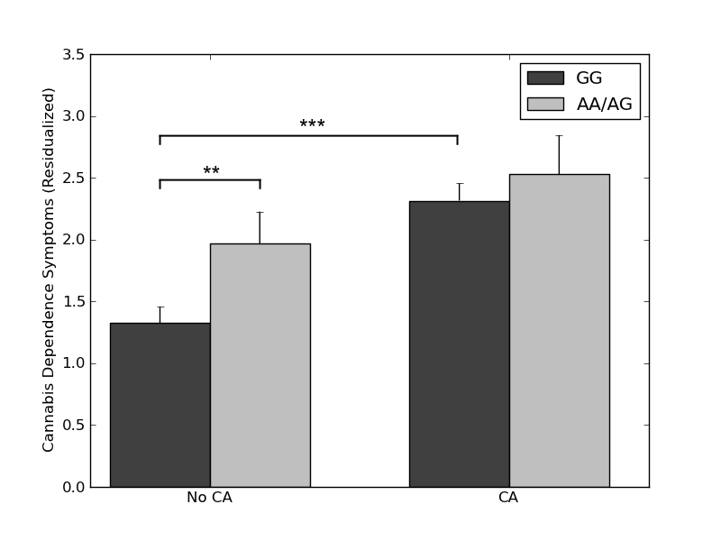

*Figure S7.* Interaction of rs604300 with childhood abuse to predict cannabis dependence symptoms among people who had ever used cannabis in SAGE (*n* = 564). X-axis denotes whether or not a participant experienced abuse before the age of 18, while y-axis indicates residualized number of DSM-IV cannabis dependence symptoms endorsed by that participant. Though not significant (*bGxE* = -0.43, 95% CI [-1.34, 0.48], *ΔR2* = .001, *ΔF*(1, 542) = 0.86, *p* = .354), the direction of the effect is consistent with what was found by coding nonusers at having “0” cannabis dependence symptoms in the full sample. Error bars represent the SEM. CA = childhood abuse.

* *p* < .05. ** *p* < .01. *** *p* < .001.



*Figure S8***.** Evidence of differential H3K4me1 by tissue type. The orange line is the location of rs604300 within *MGLL*. The shaded region represents a region of H3K4me1 enrichment just upstream of rs604300. The blue box on the gene tracks represents a *MGLL* exon. Green represents H3K4me1 enrichment. H3K4me1 enrichment, which was most observed in neurospheres, upregulates gene expression.