Wanting to Maximize the Positive and Minimize the Negative:
Implications for Mixed Affective Experience in American and Chinese Contexts
Supplemental Materials
- Are Cultural Differences in Ideal Affect Driven By Ideal Positive,
Ideal Negative, or Both?
In our primary analyses, for parsimony, we use the difference score between momentary ideal positive and negative affect as our dependent variable. Below, we include analyses of momentary ideal positive affect and momentary ideal negative affect treated as separate dependent variables. All analyses are controlling for age, gender, and SES (Studies 1 and 2). Findings from these analyses are consistent with analyses of difference scores reported in the main paper.
Study 1 Supplemental Results
Cultural Differences in Mean Levels of Momentary Ideal Positive and Negative Affect
To examine whether there were cultural differences in mean levels of momentary ideal positive and ideal negative affect, we conducted a 2 (Culture [European Americans, Chinese Americans]) X 2 (Ideal Affect [Positive, Negative]) repeated measures analysis of covariance (ANCOVA) controlling for age.
Analyses revealed a significant culture X ideal affect interaction, F (1, 132) = 32.16, p < .001, η_{p}² = .196. Although both cultural groups valued positive more than negative affect, European Americans valued positive more than negative affect (Ideal Positive M = 3.69, SE = .07 vs. Ideal Negative M = 1.10, SE = .05) to a greater degree than did Chinese Americans (Ideal Positive M = 3.22, SE = .07 vs. Ideal Negative M = 1.32, SE = .05). See Figure S1.
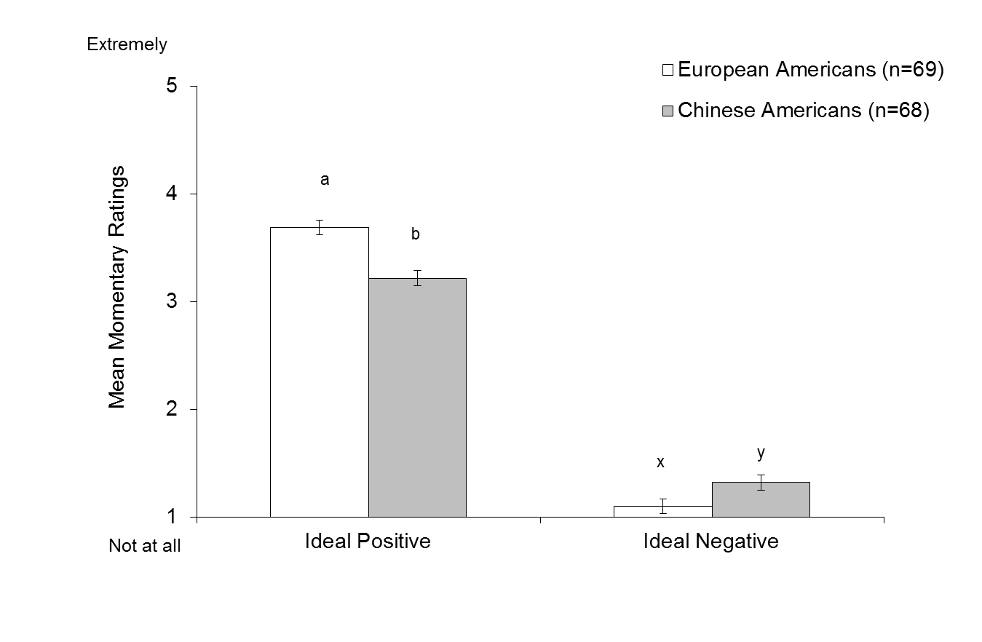
Figure S1. Study 1. Mean ratings of momentary ideal positive and negative affect averaged across sampling occasions by cultural group. Note: Different letters indicate significant differences between groups, p < 0.01.
Contrasts revealed that European Americans valued positive affect more, F (1, 132) = 22.47, p < .001, η_{p}² = .145, and negative affect less, F (1, 132) = 10.87, p = .001, η_{p}² = .076, than Chinese Americans. Because ideal negative affect was positively skewed, we performed a non-parametric Mann-Whitney U test and confirmed that European Americans wanted to feel less negative affect than Chinese Americans, p = .001 (European American mean rank = 55.24, Chinese American mean rank = 82.96).
Study 2 Supplemental Results
Cultural Differences in Mean Levels of Momentary Ideal Positive and Negative Affect
We conducted a 4 (Culture [European Americans, Chinese Americans, Hong Kong Chinese, Beijing Chinese]) X 2 (Ideal Affect [Positive, Negative]) ANCOVA, with momentary ideal positive affect and momentary ideal negative affect treated as repeated measures dependent variables. Analyses revealed a significant culture X ideal affect interaction, F (3, 348) = 66.28, p < .001, η_{p}² = .364. As illustrated in Figure S2, both cultural groups valued positive affect more than negative affect: however, European Americans valued positive more than negative affect (Ideal Positive M = 3.76, SE = .07 vs. Ideal Negative M = 1.21, SE = .05) to a greater degree than did Chinese Americans (Ideal Positive M = 3.56, SE = .06 vs. Ideal Negative M = 1.23, SE = .04), who valued positive more than negative affect to a greater degree than did Hong Kong Chinese (Ideal Positive M = 2.83, SE =.06 vs. Ideal Negative M = 1.48, SE = .04), and Beijing Chinese (Ideal Positive M = 2.83, SE = .06 vs. Ideal Negative M = 1.38, SE = .04).
Contrasts revealed a significant effect of culture for both momentary ideal positive, F (3, 347) = 63.11, p < .001, η_{p}² = .353, and momentary ideal negative affect, F (3, 347) = 9.57, p < .001, η_{p}² = .076. Pairwise comparisons indicated that European Americans valued positive affect more than Chinese Americans, p = .023, who valued positive affect more than Hong Kong Chinese and Beijing Chinese, ps < .001. Hong Kong and Beijing Chinese did not significantly differ from each other, p = .950. Conversely, European Americans valued negative affect similar to Chinese Americans, p = .717, who valued negative affect significantly less than Hong Kong Chinese, p < .001, and Beijing Chinese, p = .010. Hong Kong and Beijing Chinese marginally differed in ideal negative affect, p = .073. Because ideal negative affect was positively skewed, we performed a non-parametric Kruskal-Wallis test to compare distributions of ideal negative affect between cultural groups. Results confirmed a significant effect of culture, p < .001. Based on these findings we collapsed across cultural groups within each nationality and found a significant difference between the overall American (N = 162) and Chinese samples (N = 192), p < .001 (American mean rank = 137.88, Chinese mean rank = 210.93).
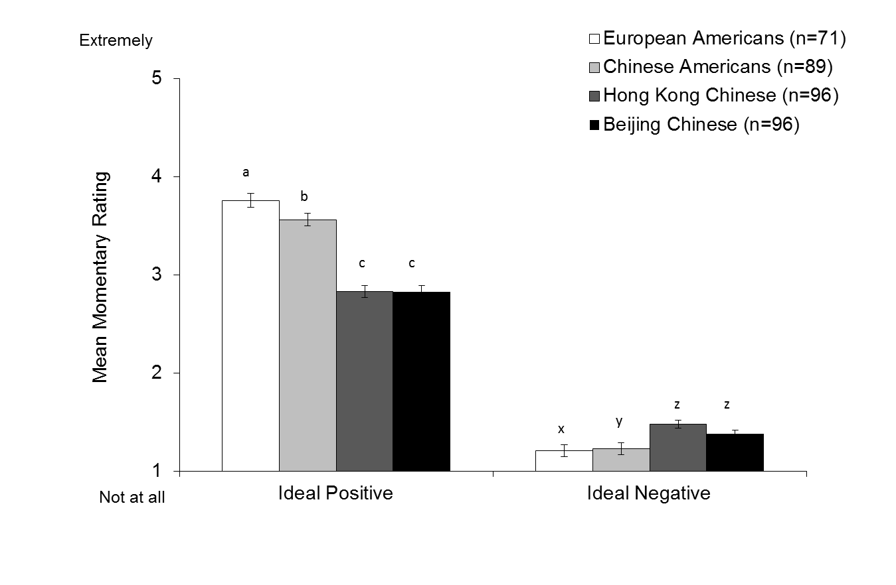Figure S2. Study 2. Mean ratings of momentary ideal positive and negative affect averaged across sampling occasions by cultural group. Note: Different letters indicate significant differences between groups, p < 0.01.
Study 3 Supplemental Results
Cultural Differences in Global Ideal Positive and Negative Affect
To examine cultural differences in global ideal affect, we conducted a 2 (Culture [American, Hong Kong Chinese) x 2 (Ideal Affect [Ideal Positive, Ideal Negative]) repeated measures ANCOVA in which Culture was entered as the fixed factor and global ideal positive and negative affect were entered as the repeated measures. As with Studies 1 and 2, we found a significant culture X ideal affect interaction, F (1, 190) = 41.16, p < .001, η_{p}² = .178. While both cultural groups valued positive affect more than negative affect, Americans valued positive more than negative affect (Ideal Positive M = 4.18, SE = .08 vs. Ideal Negative M = 1.23, SE = .07) to a greater degree than did Hong Kong Chinese (Ideal Positive M = 3.43, SE = .08 vs. Ideal Negative M = 1.92, SE = .07). See Figure S3.
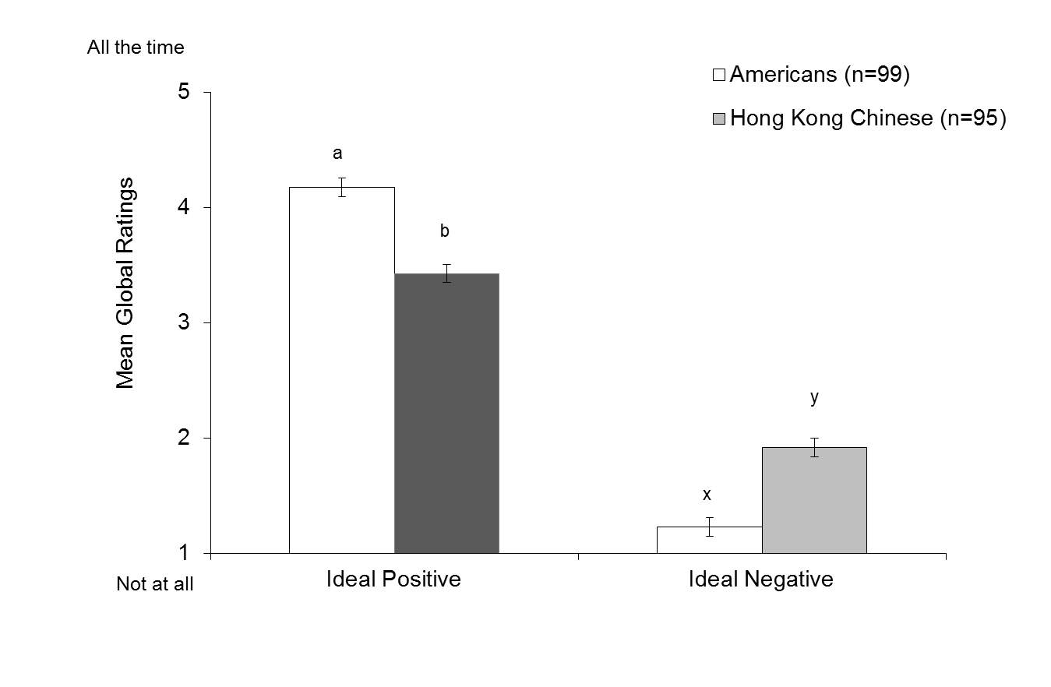
Figure S3. Study 3. Mean global ideal positive and negative affect ratings by cultural group. Note: Different letters indicate significant differences between groups, p < 0.05
Contrasts revealed that Americans valued positive affect more than Hong Kong Chinese, F (1, 190) = 32.21, p < .001, η_{p}² = .145, and Americans valued negative affect less than Hong Kong Chinese, F (1, 190) = 35.79, p < .001, η_{p}² = .159. As with the previous studies, ideal negative affect was positively skewed, and we were unable to normalize the data using standard transformation techniques. Thus, we performed non-parametric Mann-Whitney comparison, which confirmed the significant cultural difference in ideal negative affect, p < .001 (American mean rank = 71.50, Chinese mean rank = 124.59).
Study 4 Supplemental Results
The Effect of Experimental Condition on Ideal Positive and Negative Affect
We conducted a repeated measures MANOVA in which momentary ideal positive and ideal negative affect were the dependent within-subjects factors, and condition (Enhance Difference, Reduce Difference) and culture (American, Chinese) were the between-subjects factors. This analysis revealed a significant interaction between momentary ideal affect and condition F (1, 96) = 12.88, p = .001, η_{p}² = .118. There was no ideal affect X condition X culture interaction, F (1, 96) = 0.30, p = .583, η_{p}² = .003, indicating this interaction held across cultures. Specifically, participants in the Enhance Difference condition wanted to feel positive more than negative (ideal positive M = 3.94, SE = .09 versus ideal negative M = 1.22, SE = .05) to a greater degree than did participants in the Reduce Difference condition (ideal positive M = 3.58, SE = .09, versus ideal negative M = 1.37, SE = .05) See Figure S4.
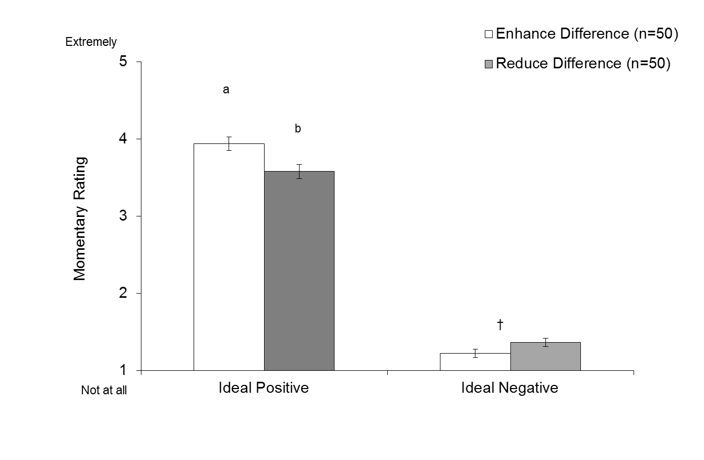Figure S4. Study 4. Mean momentary ideal positive and negative affect ratings by experimental condition. Note: Different letters indicate significant differences between groups, p < 0.05; †p < .10.
Contrasts revealed that participants in the Enhance Difference condition valued positive affect more than those in the Reduce Difference condition, F(1, 96) = 8.21, p = .005, η_{p}² = .079. There was also a marginal effect of condition on ideal negative affect, F(1, 96) = 3.67, p = .058, η_{p}² = .037. We performed non-parametric Mann-Whitney comparison within cultures and confirmed differences between condition for ideal negative affect among Hong Kong Chinese, p = .039 (Enhance mean rank = 21.30, Reduce mean rank = 29.70), and Americans, although this effect was marginal, p = .099 (Enhance mean rank = 28.54, Reduce mean rank = 22.46). This may speak to the difficulty in increasing the value placed on negative affect among American college students who do not value negative affect to begin with (Koopmann-Holm & Tsai, 2014).
Summary
In sum, across Studies 1-4, analyses revealed that effects related to the difference between ideal positive and negative affect were driven by both momentary ideal positive affect and ideal negative affect. This pattern of results is consistent with the findings reported in the main manuscript.

II. Do Pleasant, Unpleasant, and Mixed Experiences Influence Ideal Affect?
Consistent with AVT, we found that ideal affect influenced actual affect in Study 4. However, AVT does not preclude the possibility that actual affect may also shape ideal affect. To explore how actual affect shapes ideal affect across cultures, we conducted a preliminary study in which we experimentally manipulated the degree to which people actually feel positive relative to negative states to assess the influence of actual affect on how much people want to maximize the positive and minimize the negative. In Study 4, across cultures, we observed that the pleasant clip elicited more positive than negative feelings, the unpleasant clip elicited more negative than positive feelings, and the combined clip elicited an equal amount of positive and negative feelings. Therefore, in this preliminary study, participants were shown the same television clips and reported the extent to which they ideally wanted to feel positive and negative multiple times during each clip.
Preliminary Study Method
Participants
Fifty-one undergraduate students (28 American, 23 Hong Kong Chinese; 59% female) were paid either US$10 or HK$50 to participate in a study about rating television clips. There were no significant differences between cultures in number of female versus male participants across conditions, Χ² (1) = 0.09, p = .762. 6 HK participants did not follow instructions and therefore were excluded from the analyses.
Instruments
Momentary Ideal Affect During Clips. Similar to Study 4, throughout the clips, participants were probed six times every 30 seconds. In this study, however, each probe asked participants to rate “how positive do you ideally want to feel right now” and “how negative do you ideally want to feel right now” on a five point scale ranging from 1 = Not at all and 5 = Extremely. The order in which participants rated ideal positive and ideal negative affect was counterbalanced.
Dialectical Self Scale. As with Studies 3 and 4, participants rated 32 items assessing how dialectical they viewed themselves. Internal consistency for the overall dialectical self score was moderately high across cultures (U.S. α = .75; H.K. α = .71).
Procedure
We used the same stimuli as in Study 4. Participants were asked to watch the clips and rate how they want to feel when prompted during the clip as honestly as possible. Similar to the previous study, they were asked to imagine themselves in the shoes of the people in the clips and refrain from judging their performance or ability. Participants were randomly assigned to first view either a pleasant or unpleasant practice test clip to familiarize them with the ideal affect probes. Participants then watched the pleasant, unpleasant, and combined pleasant-unpleasant clip as well as the filler clip. We counterbalanced the presentation order of the clips. After viewing all of the clips, participants then gave overall ratings of each clip at the end of the task. Participants were then debriefed.
Preliminary Study Results
Effect of Actual Affect on Ideal Affect
We conducted a between-subjects ANOVA in which the difference between momentary ideal positive and negative affect was the dependent variable, clip type (Pleasant, Unpleasant, Combined) was a within subjects factor, and culture was a between-subjects factor. There was a significant culture X clip type interaction, F (1, 49) = 10.56, p < 0.001, η_{p}² = 0.177. See Figure S5.
For Americans, there was a significant main effect of clip type, F (3, 47) = 12.57, p < .001, η_{p}² = .445. Americans wanted to feel positive more than negative affect to a greater degree during the pleasant clip (M_{Ideal Pos-Neg} = 2.61, SE = .15) compared to the unpleasant clip (M_{Ideal Pos-Neg} = 1.72, SE =.22), p = .001, and combined pleasant and unpleasant clip (M_{Ideal Pos-Neg} = 1.30, SE = .22), p < .001, whereas the unpleasant and combined clips only marginally differed, p = .061.
For Hong Kong Chinese, here was also a significant effect of clip type, F (3, 47) = 41.46, p < .001, η_{p}² = .724. Similar to Americans, Hong Kong Chinese wanted to feel positive more than negative affect during the pleasant clip (M_{Ideal Pos-Neg} = 2.48, SE = .17) more than during the unpleasant (M_{Ideal Pos-Neg} = -0.42, SE =.24), p < .001, and combined clips (M_{Ideal Pos-Neg} = 0.17, SE = .24), p < .001. However, Hong Kong Chinese ideal affect also differed between unpleasant and combined clips, p = .017. Thus, Hong Kong Chinese differentiated between the unpleasant and combined clips more than Americans.

Figure S5. Influence of actual affect as elicited by emotional television clips on desire to maximize positive and minimize negative as measured by mean difference in ideal positive and negative ratings across six probes during each clip type.
Furthermore, across clips, Americans wanted to feel positively more than negative affect (95% CIs pleasant: [2.31, 2.92], unpleasant [1.28, 2.17], combined [0.86, 1.74]), whereas Hong Kong Chinese wanted to feel positive more than negative affect only for the pleasant clip (95% CI [2.14, 2.82]) , but want to feel positive and negative to a similar degree in the unpleasant (95% CI [-0.91, 0.07]) and combined clips (95% CI [-0.31, 0.66]).
Finally, examining ideal positive and negative affect separately, effects were generally driven by differences in both. For Americans, ideal positive affect was significantly higher for the pleasant clip (M = 4.23, SE = .10) compared the unpleasant (M = 3.74, SE = .13), p = .001 and combined clips (M = 3.52, SE = .14), p < .001, which only marginally differed from each other, p = .099. In contrast, ideal negative affect was significantly lower for the pleasant clip (M = 1.61, SE = .09) compared the unpleasant (M = 2.02, SE = .13), p = .009 and combined clips (M = 2.22, SE = .12), p < .001, which only marginally differed from each other, p = .082.
For Hong Kong Chinese, ideal positive affect was significantly higher for the pleasant clip (M = 3.95, SE = .11) compared the unpleasant (M = 2.46, SE = .14), p < .001 and combined clips (M = 2.65, SE = .16), p < .001, which did not differ from each other, p = .201. In contrast, ideal negative affect was significantly lower for the pleasant clip (M = 1.47, SE = .10) compared the unpleasant (M = 2.88, SE = .14), p < .001 and combined clips (M = 2.48, SE = .14), p < .001, which significantly differed from each other, p = .002. These results indicate that the difference in ideal positive vs. negative affect between the unpleasant and combined clip was due to the difference in ideal negative affect. Otherwise, differences between clips were due to differences in both ideal positive and negative affect across cultures.
Preliminary Study Discussion
While Study 4 from the main text demonstrates that people’s ideal affect influences their actual affect, these preliminary findings suggest that people’s actual affect also influences their ideal affect. Across cultures, participants wanted to feel positive more than negative to a greater degree when they were watching pleasant clip compared to when they watched an unpleasant or combined pleasant and unpleasant clip. Whereas ideal affect influenced actual affect similarly across cultures (Study 4 in main text), actual affect shaped ideal affect in different ways for Americans and Hong Kong Chinese. Overall, Americans wanted to feel positive more than negative regardless of the type of clip they watched---what varied was the degree to which Americans wanted to feel positive over negative. In contrast, Hong Kong Chinese only wanted to feel positive more than negative when viewing the pleasant clip. During the unpleasant and combined pleasant and unpleasant clip, Hong Kong Chinese wanted to feel both positive and negative equally.
Finally, consistent with Studies 3 and 4, we did not find an association between ideal affect and ratings of dialectical self, indicating that actual affective experience can shape ideal affect independent of dialectical beliefs.

