**Supplemental Materials**

**Validity of the Short Mood and Feelings Questionnaire in Late Adolescence**

**by Nicholas Turner, Carol Joinson, Tim J. Peters, Nicola Wiles, & Glyn Lewis, 2014, *Psychological Assessment***

**http://dx.doi.org/10.1037/a0036572**

Figure S1. Item characteristic curves for the 13 items of the SMFQ

Item 8

Item 7

Item 6

Item 5

Item 4

Item 3

Item 2

Item 1

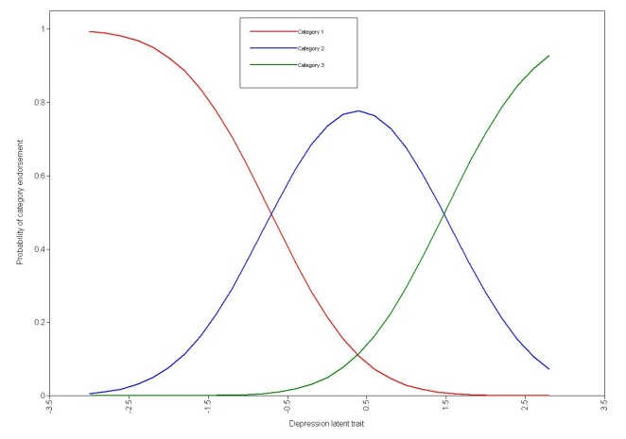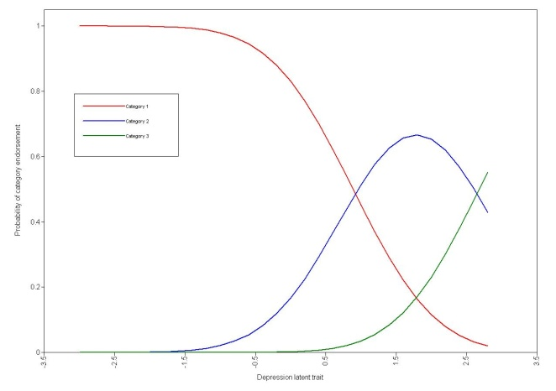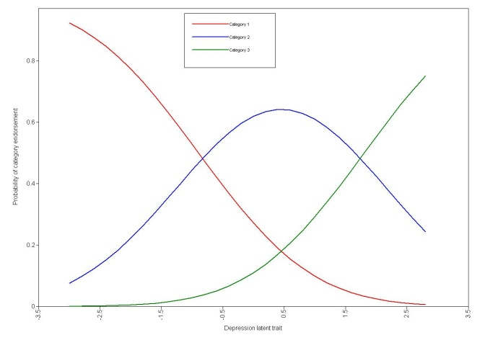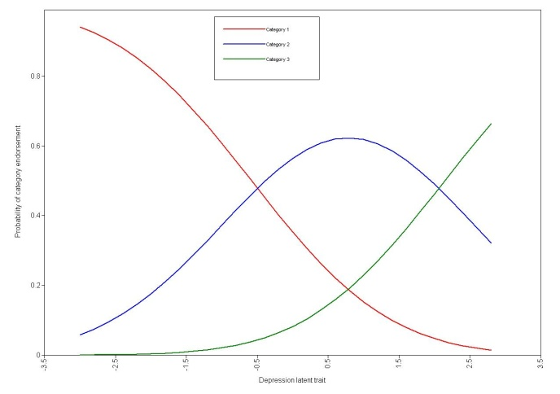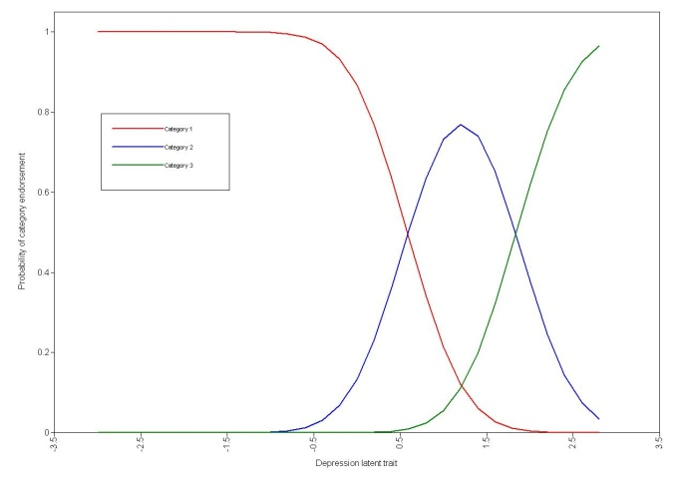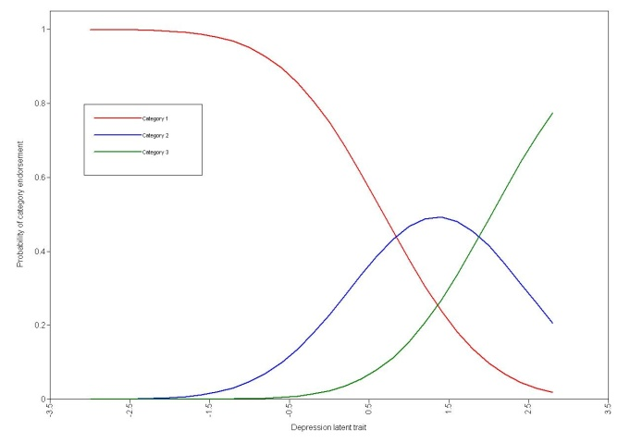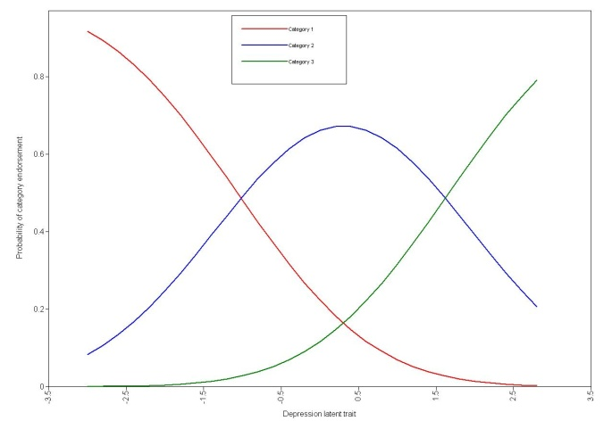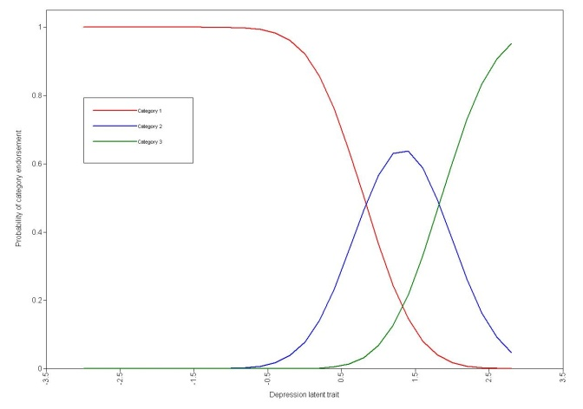

Item 13

Item 12

Item 11

Item 10

Item 9

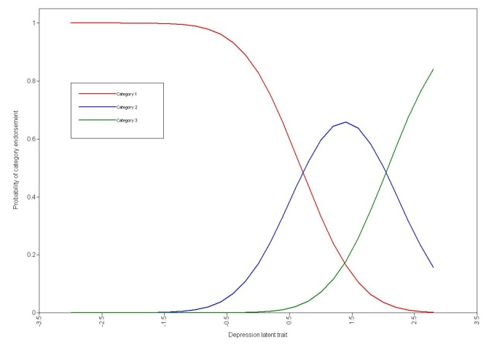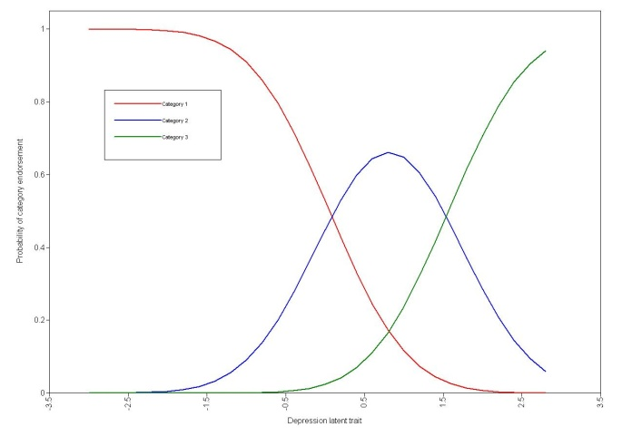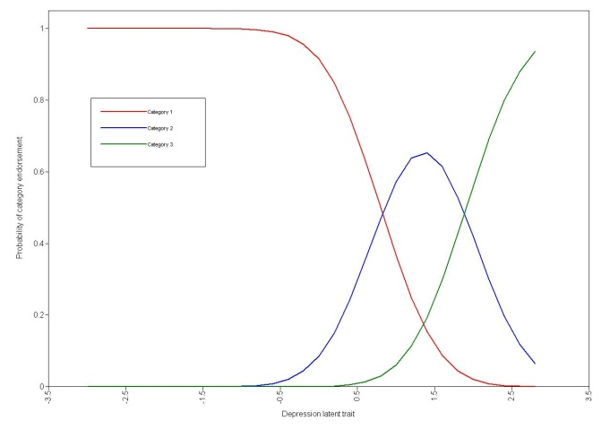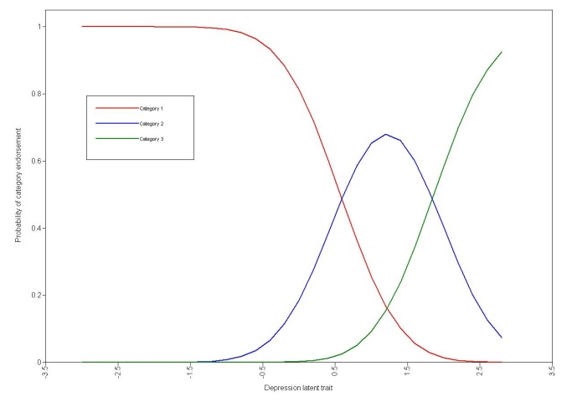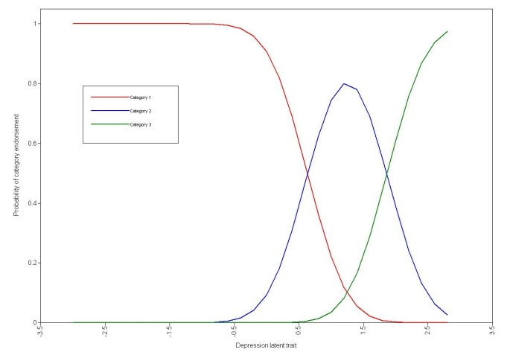

Figure S2. Test information curve

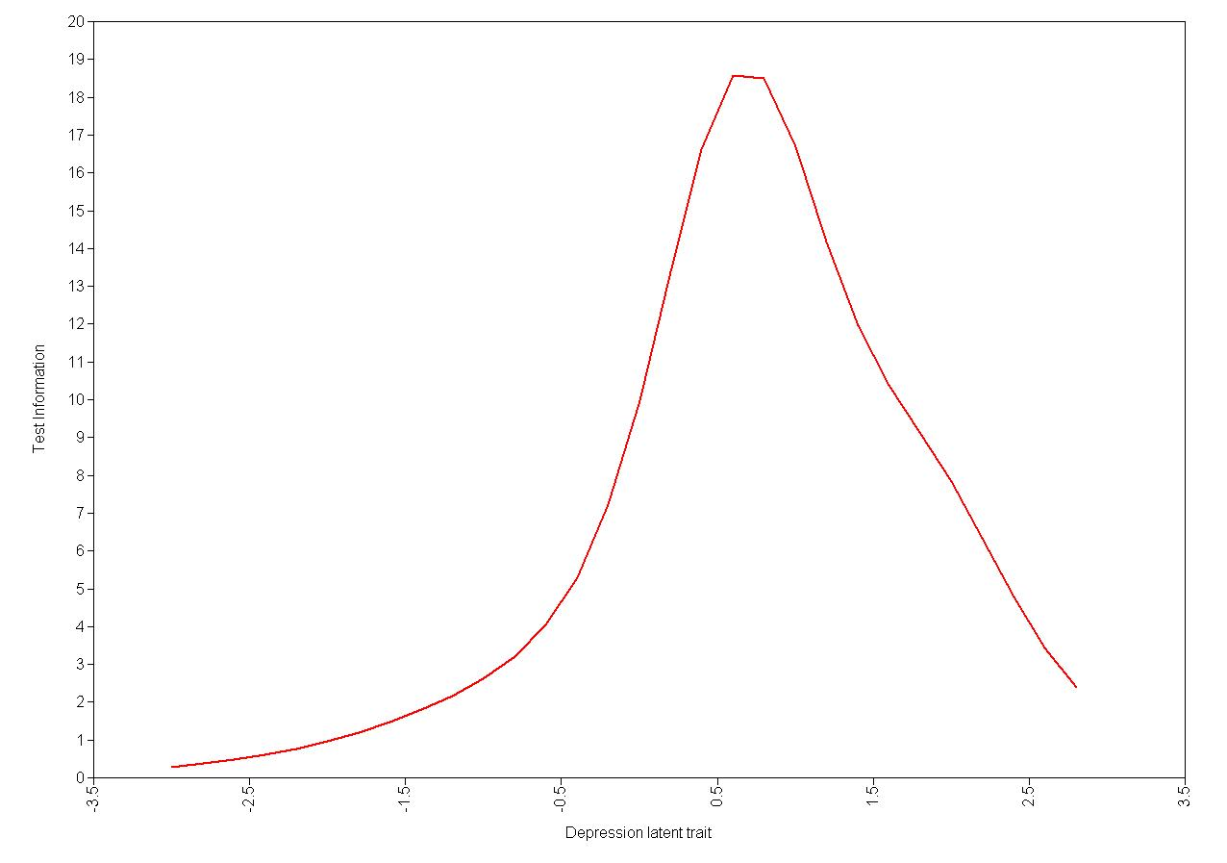

Figure S3. Tabulation of SMFQ items against the ICD–10 and *DSM–IV* depressive symptamatology



\**This depressive symptom is part of an ICD-10 identification of depression but is not part of the DSM–IV*

Figure S4. Predictive power of the SMFQ



*\*As determined by identification of depression according to the ICD-10 using the CIS-R*