Figure 1

Conditional Response Probabilities for 3-Class Solution (% at Risk).

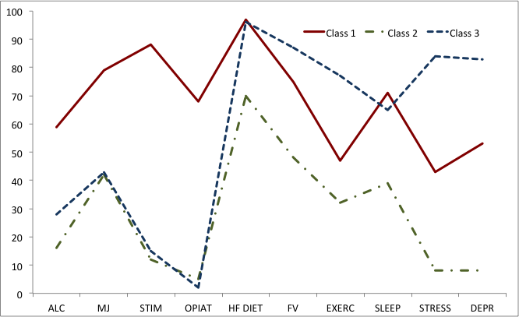
Notes. ALC (alcohol), MJ (marijuana), STIM (stimulants), OPIAT (nonprescribed opiates), HF DIET (high-fat diet), FV (fruit and vegetable consumption), EXERC (inactivity), SLEEP (poor sleep hygiene), STRESS (poor stress management), DEPR (poor depression prevention).

